Midweek Lent 1
ASH WEDNESDAY
“The Semblance of Legality”

tRINITY EVANGELICAL LUTHERAN CHURCH | Saline, Michigan
March 2, 2022

WELCOME TO WORSHIP

Thank you for joining us in God’s house today! We cordially ask that our Guests with us this morning sign one of the guestbooks located at either the front or back entryways.

THANK OFFERING: Members of Trinity give their offering as an expression of love and thankfulness to the Lord and to help support the Lord’s work in our community and around the world. Visitors need not feel obligated to participate in this offering which supports our ministry.

Restrooms are located at the back of the upper level (the annex), and in the basement (down the back stairs of the sanctuary or annex). Handicap access is available, please ask an usher for assistance.

Young Families / Toddler Bags – We are GLAD YOU BROUGHT YOUR CHILDREN to our worship service. Jesus said: “Let the little children come to me and do not hinder them, for the kingdom of God belongs to such as these.” We know that having little children in church can be a challenge, but DO NOT WORRY about it. Many of your fellow worshippers have been in your shoes and are just happy you brought your children with you. For your convenience, we have reserved the back rows of seating for parents with small children. These areas provide more flexibility for your family, as well as, easy access to move downstairs if necessary. A closed-circuit TV system allows families to continue participating in the service while downstairs. Pre-school toddler bags and children’s bulletins are available for their enjoyment. Ask an usher for one to use during the service and please return the toddler bag afterwards.

OPENING HYMN CW #406

406 In the Hour of Trial CW 406
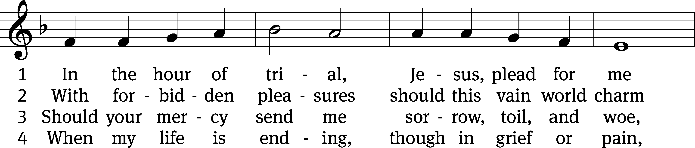
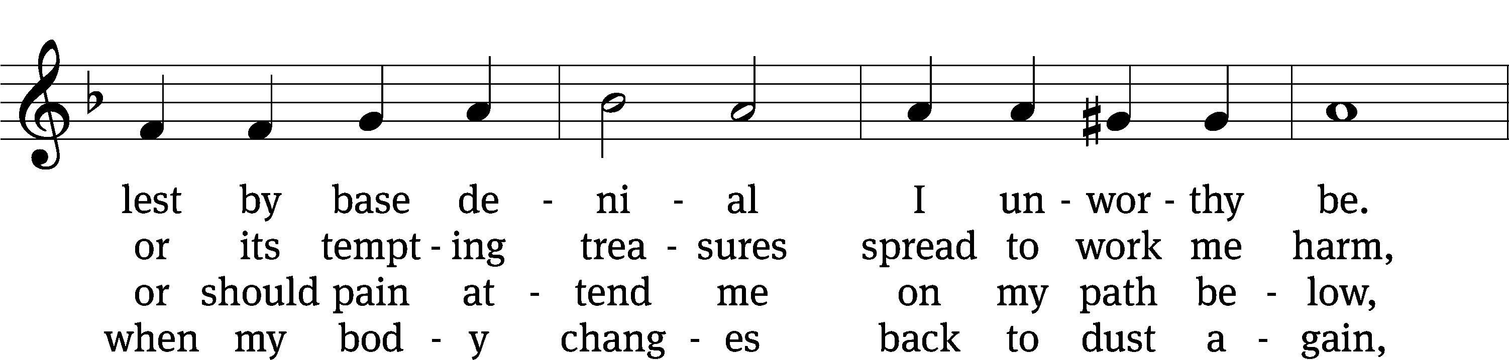
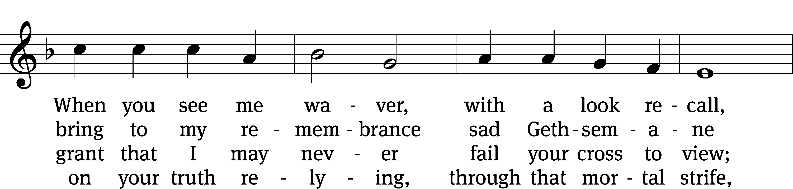
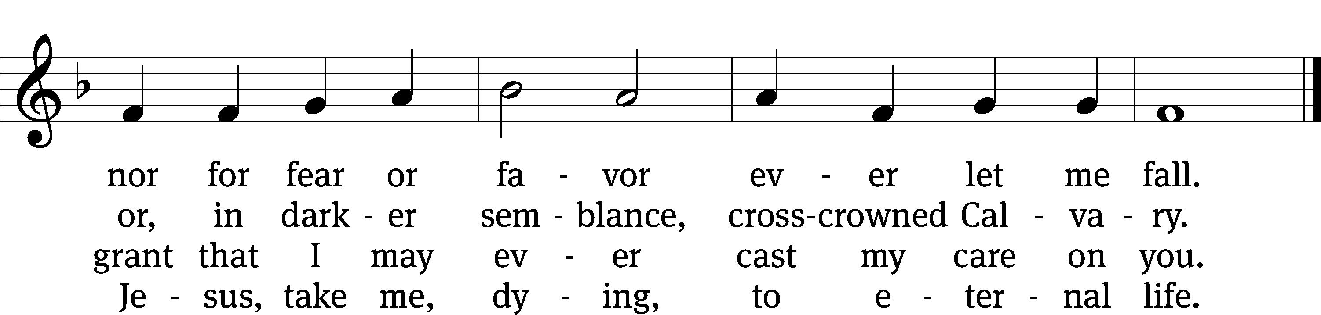
Text: James Montgomery, 1771–1854, alt.
Tune: John B. Dykes, 1823–1876
Text and tune: Public domain

invocation

Please stand, if you are able

M: In the name of the Father and of the Son (+) and of the Holy Spirit.
C: Amen.

CONFESSION

M: Dear friends, let us approach God with a true heart and confess our sins, asking him in the name of our Lord Jesus Christ to forgive us.
C: Lord of life, I confess that I am by nature dead in sin.
For faithless worrying and selfish pride, for sins of habit and sins of choice,
For the evil I have done and the good I have failed to do,
You should cast me away from your presence forever.
O Lord, I am sorry for my sins. Forgive me, for Jesus’ sake.

ABSOLUTION
M: Christ has died. Christ is risen. Christ will come again. In his great mercy, God made us alive in Christ even when we were dead in our sins. Hear the word of Christ through his called servant:
I forgive you all your sins in the name of the Father and of the Son (+) and of the Holy Spirit.

C: Amen.

PRAYER
M: Lord God, you have brought us safely to this hour of evening prayer. We thank you for providing all that we need for body and life. Bless us who have gathered in your name. Forgive our sins. Speak to our hearts. Dispel our sorrows with the comfort of your Word, and receive our hymns of thanks and praise, through Jesus Christ, our living Savior, who reigns with you and the Holy Spirit, one God, now and forever.
C: Amen.
Please be seated
PSALM Psalm 22

22D LORD, Why Have You Forsaken Me Psalm 22D
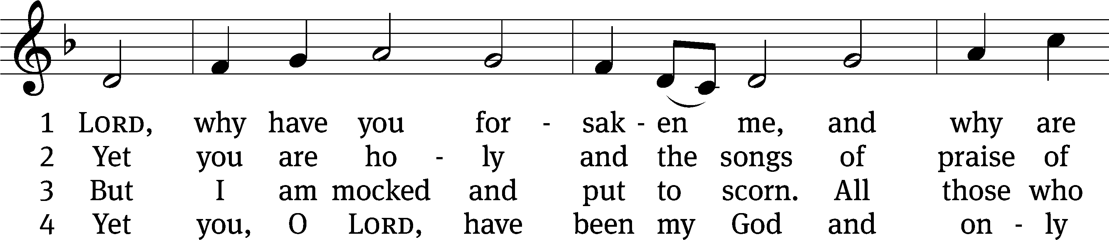
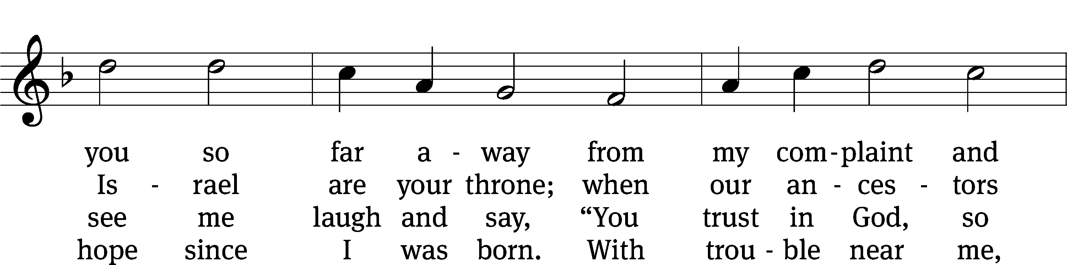
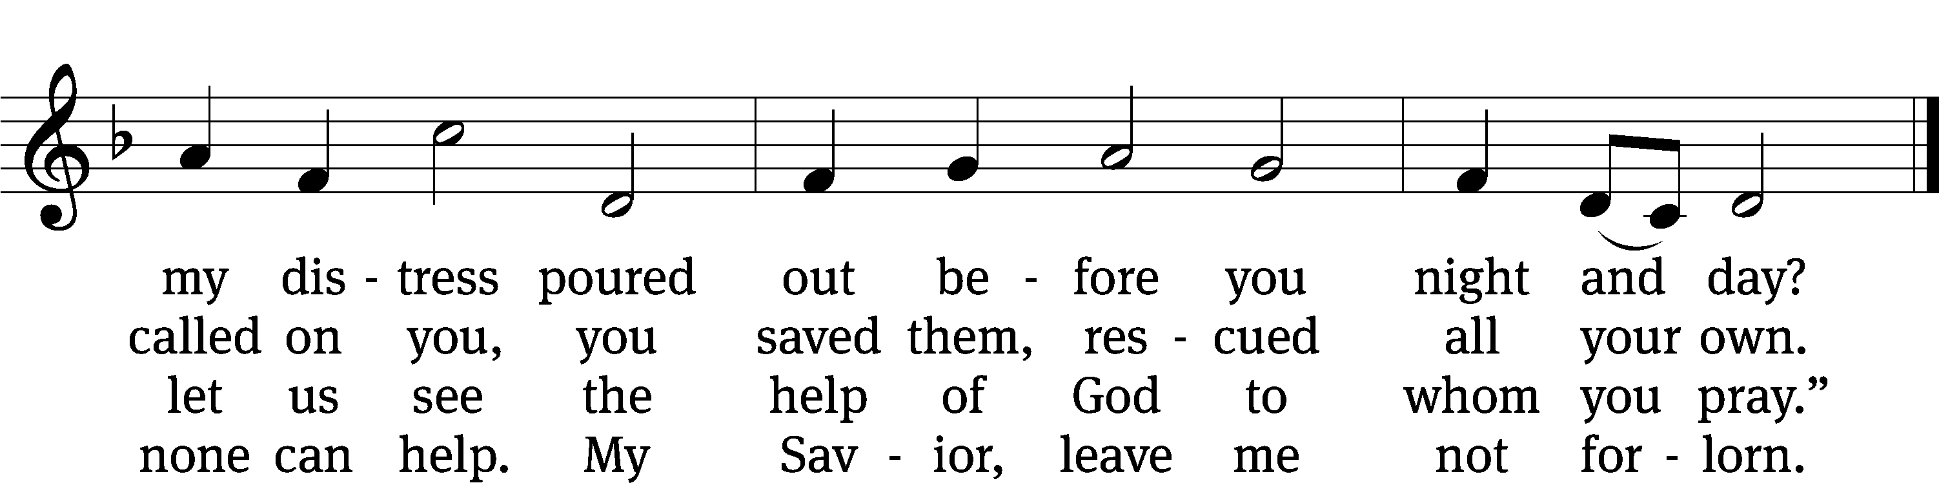
Text: Christopher L. Webber
Tune: Southern Harmony, 1835, ed. William Walker
Text: © 1968 Christopher L. Webber, admin. Church Publishing Inc. Used by permission: OneLicense no. 727703
Tune: Public domain

PSALM PRAYER

M: Almighty and merciful God, you never despise what you have made and always forgive those who turn to you. Create in us such new and contrite hearts that we may truly repent of our sins and obtain your full and gracious pardon; through your Son, Jesus Christ our Lord, who lives and reigns with you and the Holy Spirit, one God, now and forever.

C: Amen.

FIRST LESSON: 2 Samuel 12:1-13
So the Lord sent Nathan to David. He came and told him this:
There were two men in a city. One was rich and one poor. ² The rich man had a large number of flocks and herds. ³ The poor man did not own anything except one little ewe lamb, which he had bought. He raised it so that it grew up together with him and his children. It ate from his food and drank from his cup. It slept in his arms. It was like a daughter to him. ⁴ When a traveler came to the rich man, the rich man was unwilling to take an animal from his flock or from his herd to prepare a meal for the traveler who had come to him. So he took the lamb from the poor man and prepared it for the man who had come to him.
⁵ David’s anger flared up against that man. He said to Nathan, “As the Lord lives, the man who has done this is as good as dead. ⁶ In place of that lamb, he will restore four lambs, because he did this and had no pity.”
⁷ Nathan told David, “You are the man. This is what the Lord, the God of Israel, says.”
I anointed you king over Israel. I rescued you from the hand of Saul. ⁸ I gave the house of your master to you, and I gave the wives of your master into your embrace. I gave you the house of Israel and the house of Judah. If this was too little, I would have added even more. ⁹ Why have you despised the word of the Lord by doing evil in his eyes? You have struck down Uriah the Hittite with the sword. You have taken his wife as your own wife. You have killed him with the sword of the Ammonites. ¹⁰ So now the sword will not depart from your house forever, because you have despised me and have taken the wife of Uriah the Hittite to be your wife.
¹¹ This is what the Lord says. Look! I am raising up disaster against you from your own house. Right in front of your eyes I will take your wives and give them to your neighbor, and he will lie down with your wives in the sight of the sun. ¹² Because you acted in secret, I will do this in front of all Israel in broad daylight.
¹³ David said to Nathan, “I have sinned against the Lord.”
Nathan said to David, “The Lord himself has put away your sin. You will not die.

SECOND LESSON 2 Corinthians 5:20-6:2
²⁰ Therefore, we are ambassadors for Christ, inasmuch as God is making an appeal through us. We urge you, on Christ’s behalf: Be reconciled to God. ²¹ God made him, who did not know sin, to become sin for us, so that we might become the righteousness of God in him.
6 As fellow workers we also urge you not to receive God’s grace in vain. ² For he says:
At a favorable time I listened to you,
and in the day of salvation I helped you.
Look, now is the favorable time! See, now is the day of salvation!

Please stand, if you are able

GOSPEL LESSON Luke 18:9-14
⁹ Jesus told this parable to certain people who trusted in themselves (that they were righteous) and looked down on others: ¹⁰ “Two men went up to the temple courts to pray. One was a Pharisee, and the other was a tax collector. ¹¹ The Pharisee stood and prayed about himself like this: ‘God, I thank you that I am not like other people, robbers, evildoers, adulterers, or even like this tax collector. ¹² I fast twice a week. I give a tenth of all my income.’
¹³ “However the tax collector stood at a distance and would not even lift his eyes up to heaven, but was beating his chest and saying, ‘God, be merciful to me, a sinner!’
¹⁴ “I tell you, this man went home justified rather than the other, because everyone who exalts himself will be humbled, but the one who humbles himself will be exalted.”

M: The Word of the Lord
C: Thanks be to God

NICENE CREED
We believe in one God, the Father, the Almighty,
maker of heaven and earth,
of all that is,
seen and unseen.

We believe in one Lord, Jesus Christ, the only Son of God,
eternally begotten of the Father,
God from God, Light from Light, true God from true God,
begotten, not made,
of one being with the Father.
Through him all things were made.
For us and for our salvation, he came down from heaven,
was incarnate of the Holy Spirit and the Virgin Mary,
and became truly human.
For our sake he was crucified under Pontius Pilate.
He suffered death and was buried.
On the third day he rose again in accordance with the Scriptures.
He ascended into heaven
and is seated at the right hand of the Father.
He will come again in glory to judge the living and the dead,
and his kingdom will have no end.

We believe in the Holy Spirit,
the Lord, the giver of life,
who proceeds from the Father and the Son,
who in unity with the Father and the Son
is worshiped and glorified,
who has spoken through the prophets.
We believe in one holy Christian and apostolic Church.
We acknowledge one baptism for the forgiveness of sins.
We look for the resurrection of the dead
and the life of the world to come. Amen.

Please be seated

SERMON HYMN CWS #408
408 He Stood before the Court CW 408
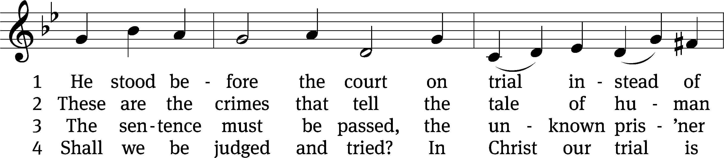
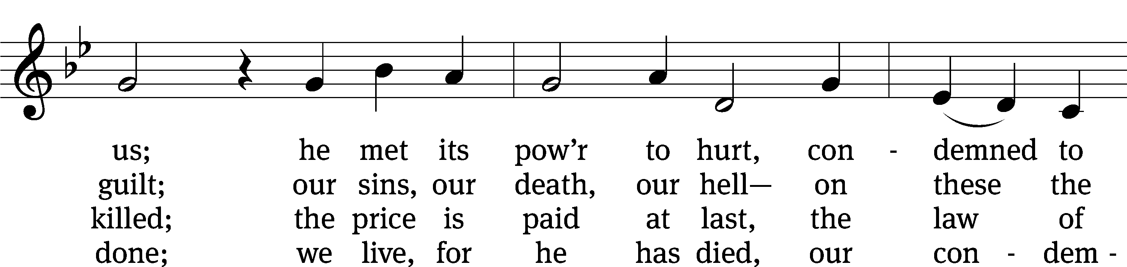
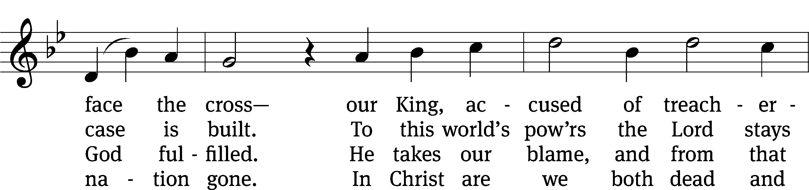
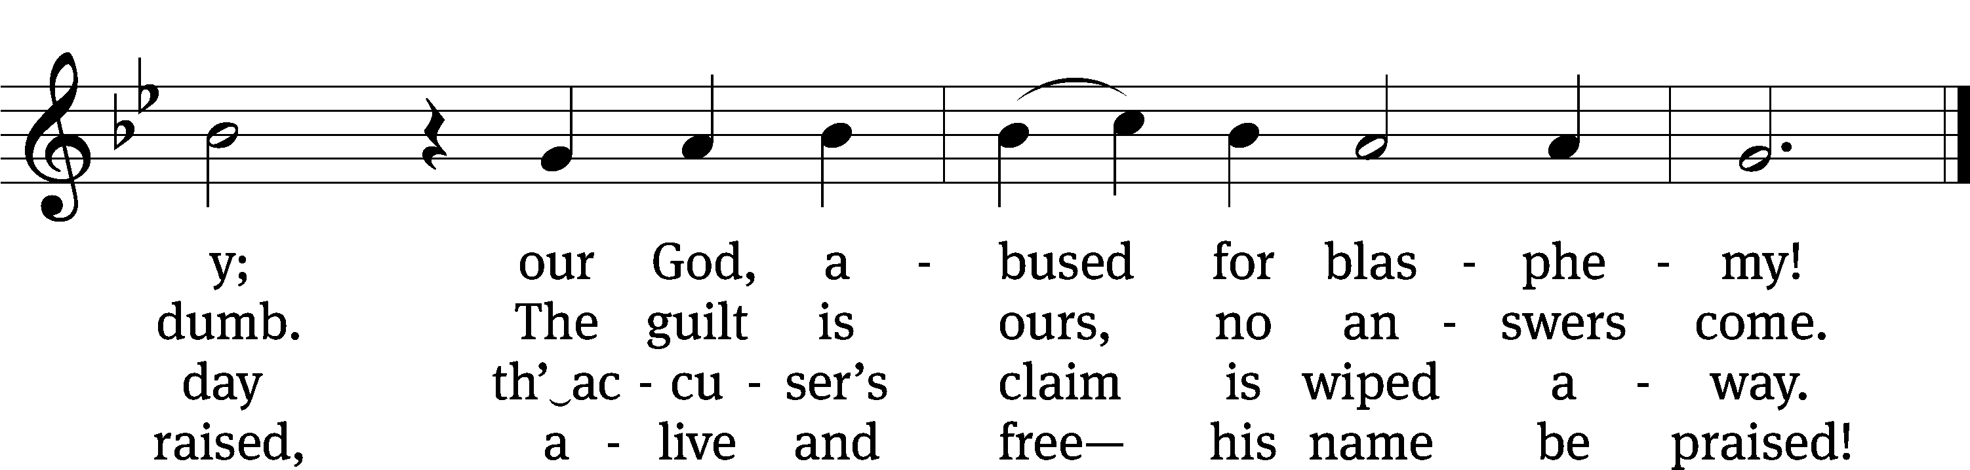
Text: Christopher M. Idle, b. 1938, alt.
Tune: Leland B. Sateren, 1913–2007
Text: © 1982 The Jubilate Group, admin. Hope Publishing Co. Used by permission: OneLicense no. 727703
Tune: © 1958 Service Book and Hymnal, admin. Augsburg Fortress. Used by permission: OneLicense no. 727703

SERMON TEXT: Luke 22:66
“As soon as it was day, the council of the elders of the people met together, both the chief priests and experts in the law. They brought him into their Sanhedrin.”
The Semblance of Legality
SENIOR CHOIR “Lenten Meditation”

OFFERTORY

Please stand, if you are able

PRAYER OF THE CHURCH

THE LORD’S PRAYER

Our Father, who art in heaven, hallowed be thy name, thy kingdom come, thy will be done on earth as it is in heaven. Give us this day our daily bread; and forgive us our trespasses, as we forgive those who trespass against us; and lead us not into temptation, but deliver us from evil. For thine is the kingdom and the power and the glory forever and ever. Amen.

THE CELEBRATION OF HOLY COMMUNION
Preface
The Lord be with you.
And also with you.

Lift up your hearts.
We lift them up to the Lord.

Let us give thanks to the Lord our God.
It is right to give him thanks and praise.

It is truly good and right that we should at all times and in all places give you thanks, O Lord, holy Father, almighty and everlasting God, through Jesus Christ our Lord, who brought the gift of salvation to all people by his death on the tree of the cross so that the devil, who overcame us by a tree, would in turn by a tree be overcome. Therefore, with all the saints on earth and hosts of heaven, we praise your holy name and join their glorious song:

Holy, Holy, Holy CW 167
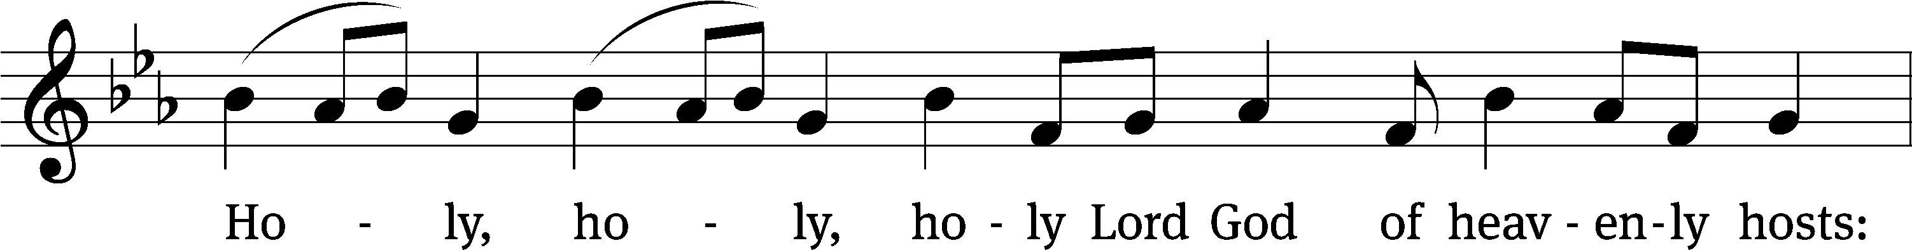
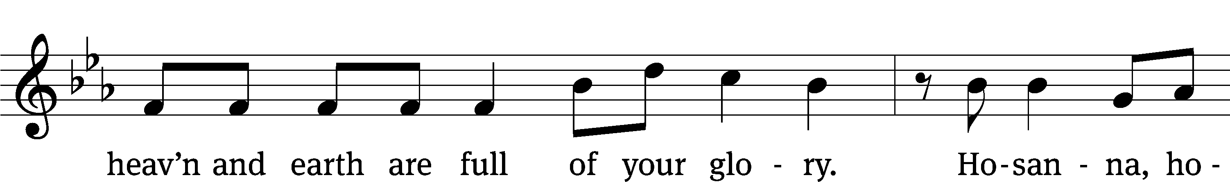
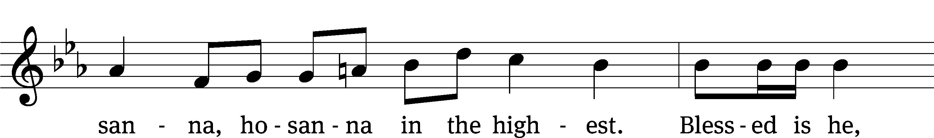
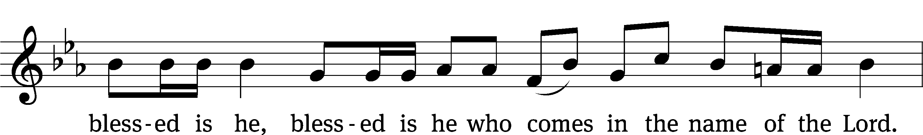
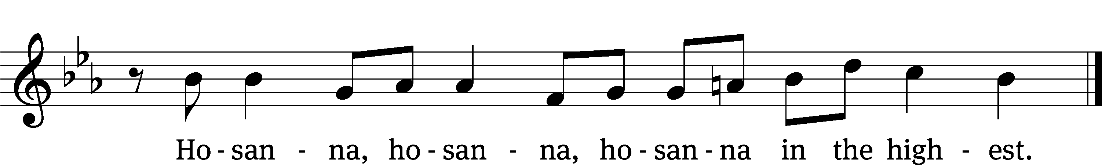

Prayer of Thanksgiving
We give thanks to you, O God, through your dear Son, Jesus Christ, whom you sent to be our Savior, our Redeemer, and the messenger of your grace. Through him you made all things; in him you are well pleased. He is the incarnate Word, conceived by the Holy Spirit and born of the Virgin Mary. To fulfill your promises, he stretched out his hands on the cross and released from eternal death all who believe in you.

As we remember Jesus’ death and resurrection, we thank you that you have gathered us together to receive your Son’s body and blood. Send us your Spirit, unite us as one, and strengthen our faith so that we may praise you in your Son, Jesus Christ. Through him, we glorify and honor you, O God our Father, with the Holy Spirit, one God, now and forever.
Amen.

Words of Institution
Our Lord Jesus Christ, on the night he was betrayed, took bread; and when he had given thanks, he broke it and gave it to his disciples, saying, “Take and eat; this is my T body, which is given for you. Do this in remembrance of me.”

Then he took the cup, gave thanks, and gave it to them, saying, “Drink from it, all of you; this is my T blood of the new covenant, which is poured out for you for the forgiveness of sins. Do this, whenever you drink it, in remembrance of me.”

The peace of the Lord be with you always.
Amen.

O Christ, Lamb of God CW 169
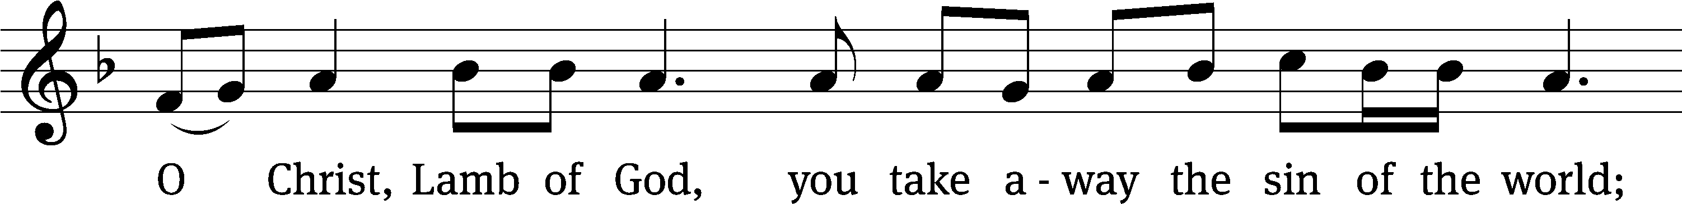
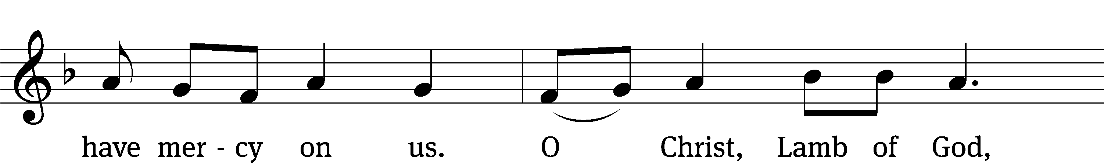
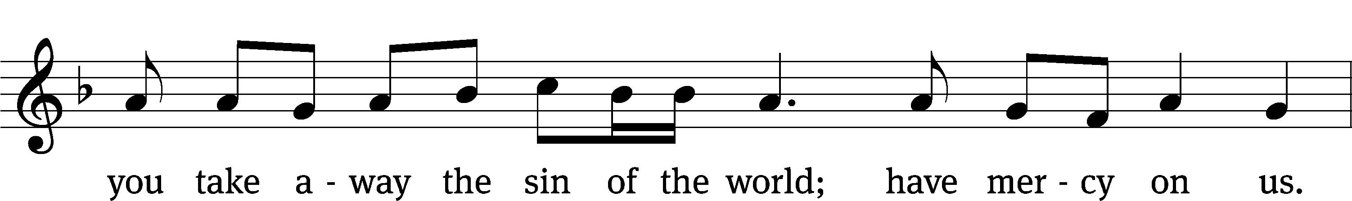
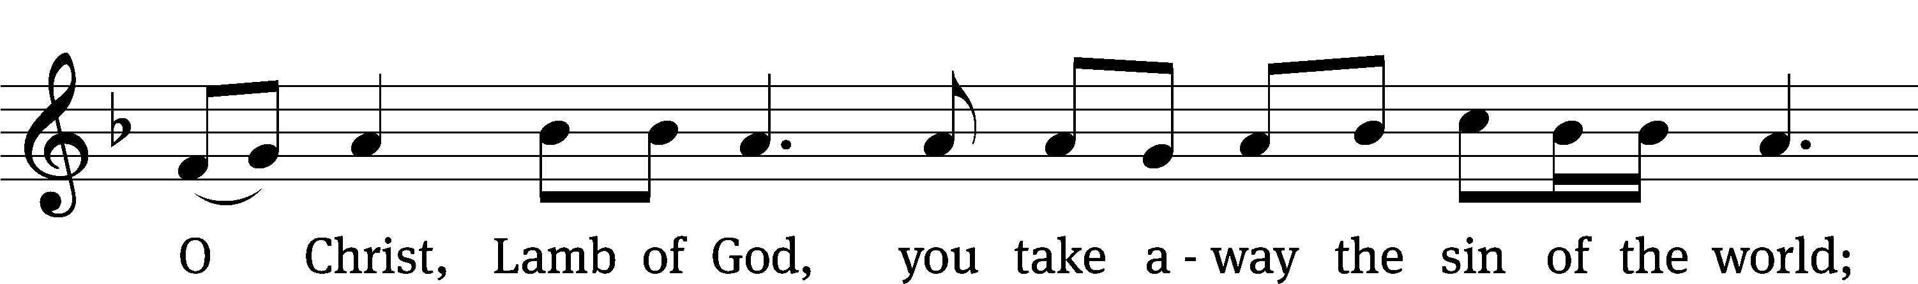
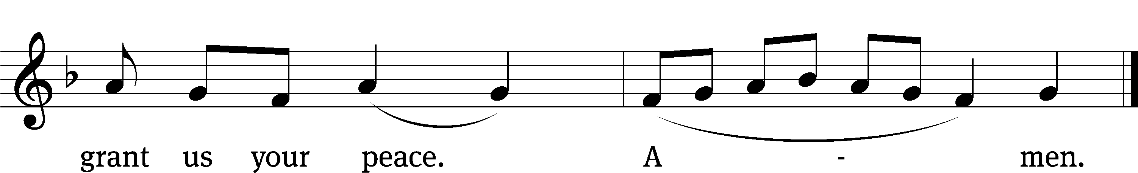

Please be seated

DISTRIBUTION
HYMN #432
432 O Dearest Jesus, What Law Have You Broken CW 432
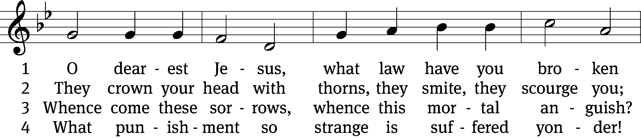
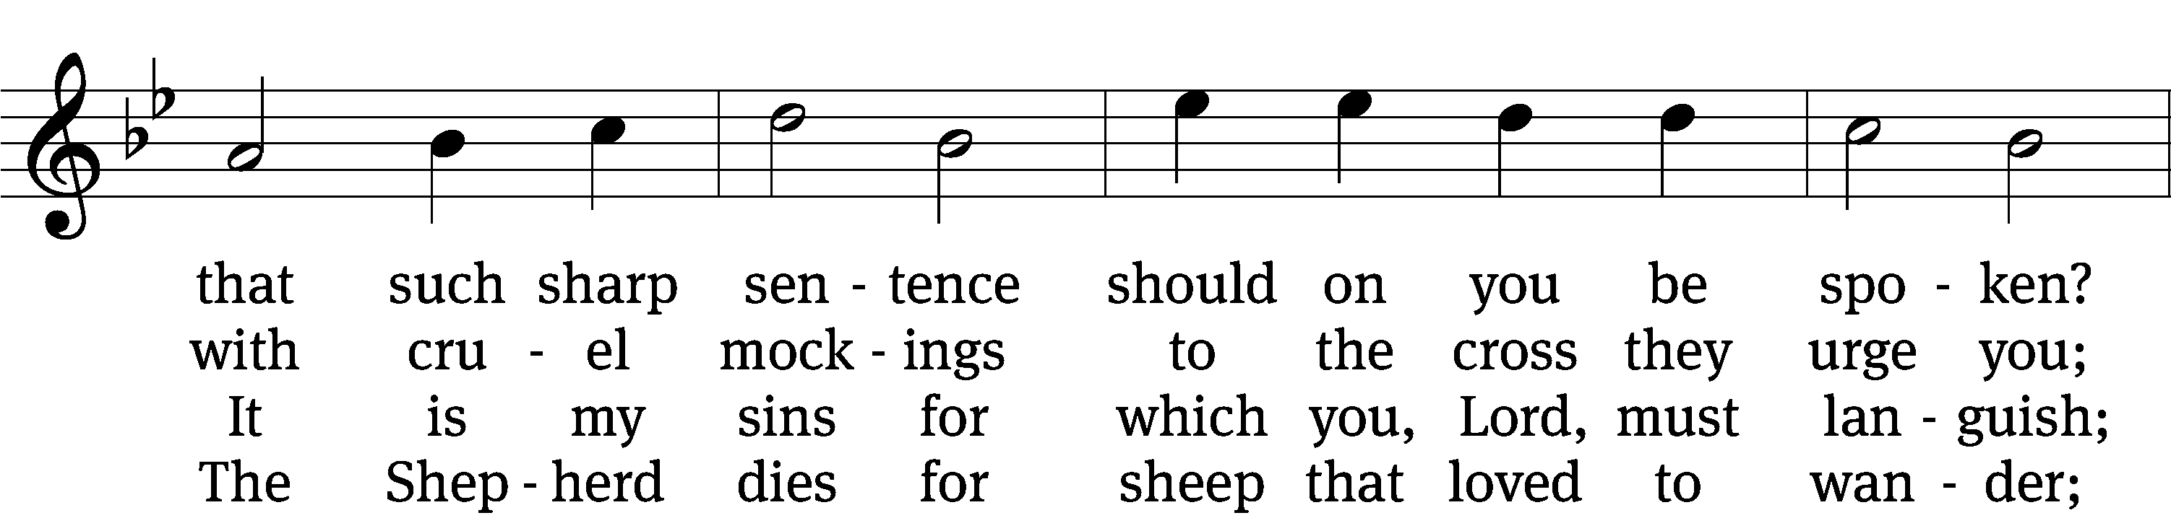
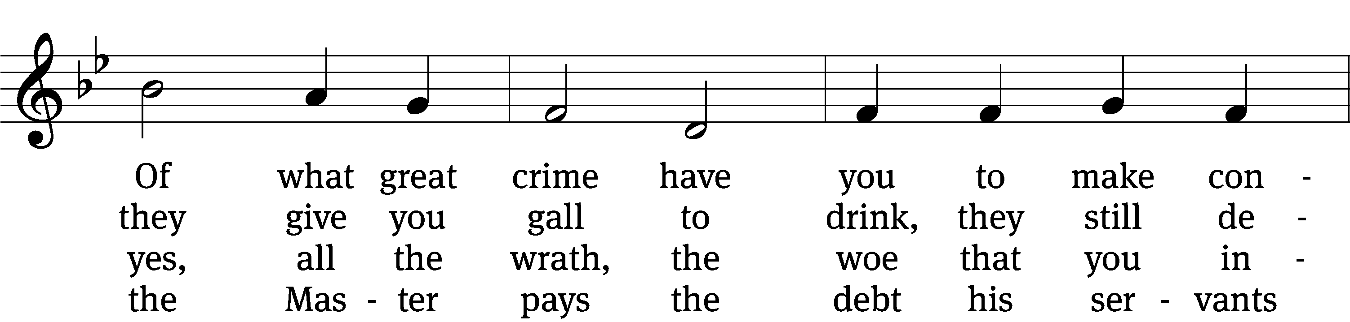
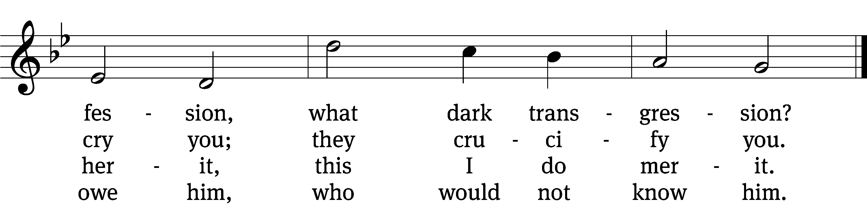

5 The sinless Son of God must die in sadness,
the sinful child of man may live in gladness;
we forfeited our lives, yet are acquitted;
God is committed.

6 I’ll think upon your mercy without ceasing,
that earth’s vain joys to me no more be pleasing;
to do your will shall be my sole endeavor
henceforth forever.

7 And when, dear Lord, before your throne in heaven
to me the crown of joy at last is given,
where sweetest hymns your saints forever raise you,
I too shall praise you.
Text: Johann Heermann, 1585–1647; (sts. 1–4, 6–7): tr. Catherine Winkworth, 1827–1878, alt.; (st. 5): tr. The Lutheran Hymnal, 1941, alt.
Tune: Johann Crüger, 1598–1662
Text and tune: Public domain

Please stand, if you are able

We give thanks, almighty God, that you have refreshed us with this saving gift. We pray that through it you will strengthen our faith in you and increase our love for one another. We ask this in the name of Jesus Christ our Lord, who lives and reigns with you and the Holy Spirit, one God, now and forever.
Amen.

BLESSING
The Lord bless you and keep you.
The Lord make his face shine on you and be gracious to you.
The Lord look on you with favor and T give you peace.
Amen.

Please be seated

CLOSING HYMN CW 783 (vv. 1,2,7)
783 Abide with Me CW 783 sts. 1–2, 7
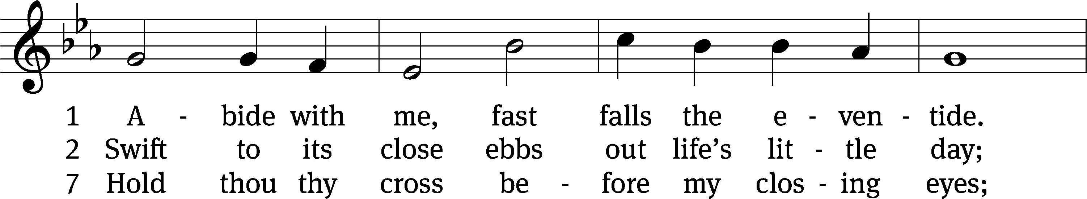
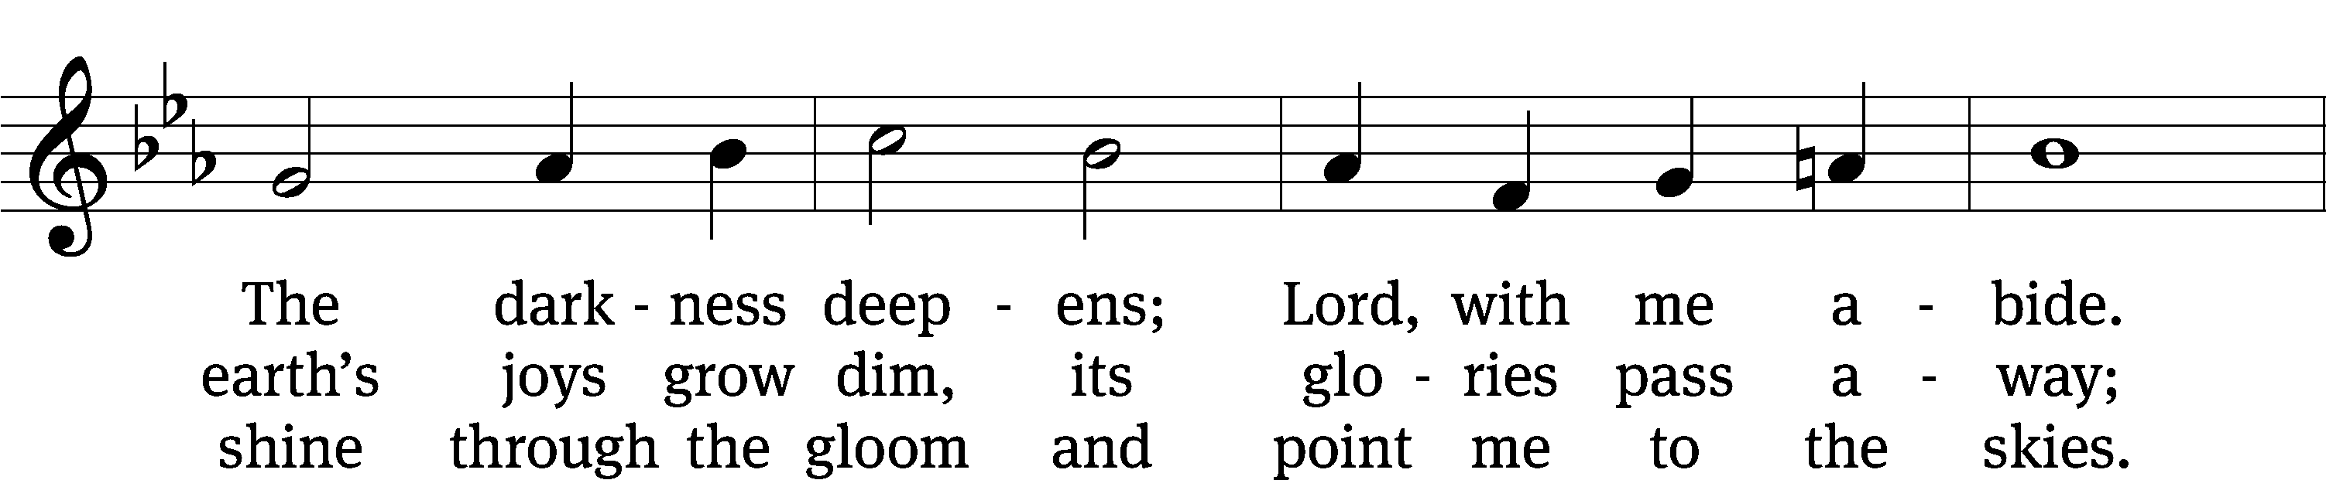
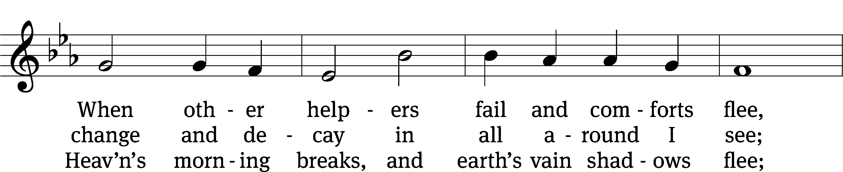
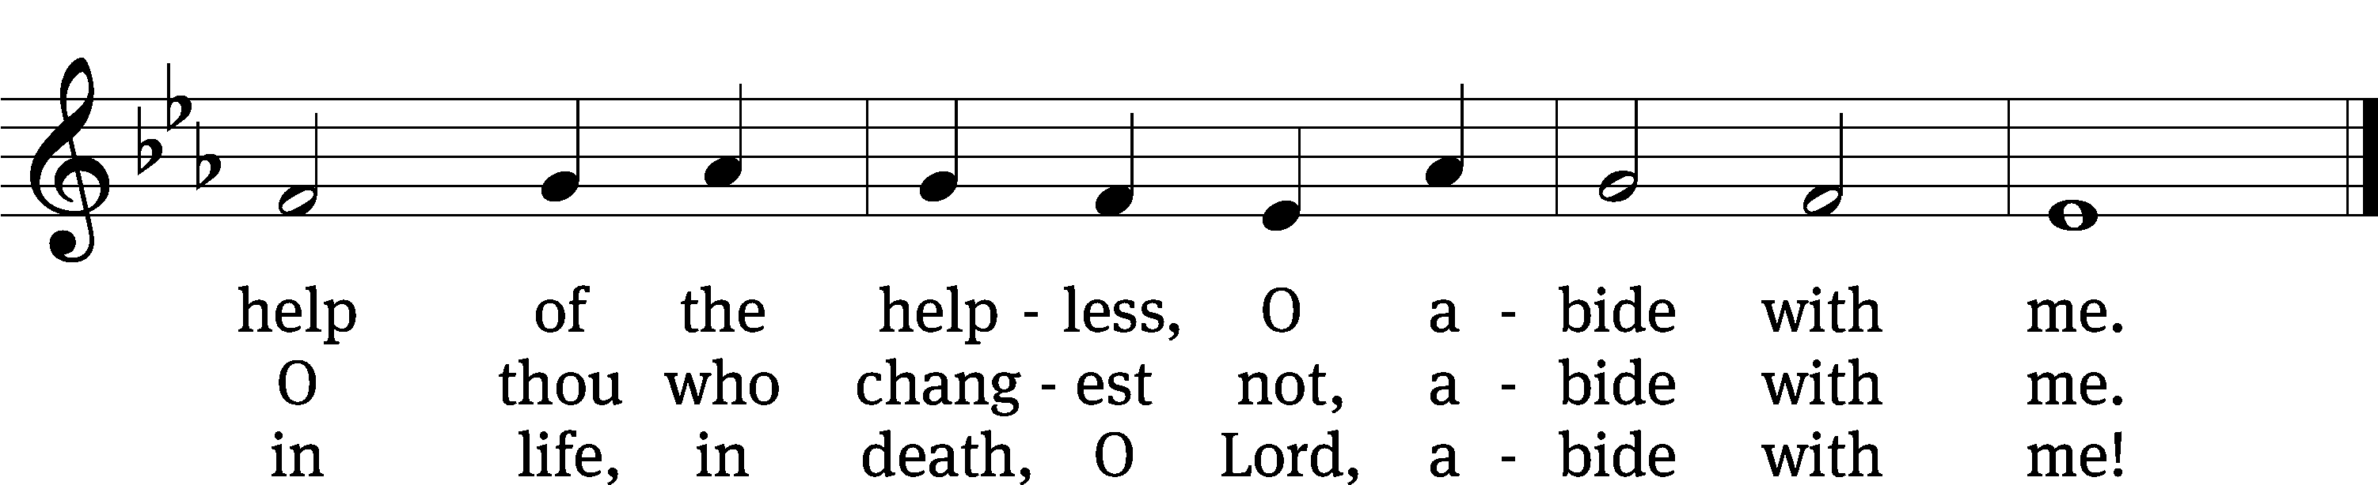
Text: Henry F. Lyte, 1793–1847, alt.
Tune: William H. Monk, 1823–1889
Text and tune: Public domain

Serving In Worship
Officiant Pastor Natsis
Organist Emily Wheeler
Choir Director Cynthia Natsis
Choir Accompanist Laura Sala
Deacons Dave Frey and Ed Wheeler
Altar Guild Shirley Klumpp and Ann Latowski
Videographer Cindy Dresch

Copyright information
Words and Music: All rights reserved. Reprinted with permission under ONE LICENSE #A-727703 and
CCLI #1151741/CSPL126093

