THE FIRST SUNDAY
AFTER EPIPHANY

TRINITY EVANGELICAL LUTHERAN CHURCH | Saline, Michigan
WELCOME TO WORSHIP January 7, 2024
Thank you for joining us in God’s house today! We cordially ask that our Guests sign one of the guestbooks located at either the front or back entryways, or fill out a “Let’s Get Acquainted” card located in the hymnal pew rack and place it in the collection plate.

Thank Offering: Members of Trinity give their offering as an expression of love and thankfulness to the Lord and to help support the Lord’s work in our community and around the world. Visitors need not feel obligated to participate in this offering .

Restrooms are located at the back of the upper level (the annex), and in the basement (down the back stairs of the sanctuary or annex). Handicap access is available, please ask an usher for assistance.

Young Families / Toddler Bags – We are GLAD YOU BROUGHT YOUR CHILDREN to our worship service. Jesus said: “Let the little children come to me and do not hinder them, for the kingdom of God belongs to such as these.” We know that having little children in church can be a challenge, but DO NOT WORRY about it. Many of your fellow worshippers have been in your shoes and are just happy you brought your children with you. For your convenience, we have reserved the back rows of seating for parents with small children. These areas provide more flexibility for your family, as well as, easy access to move downstairs if necessary. A closed-circuit TV system allows families to continue participating in the service while downstairs. Pre-school toddler bags and children’s bulletins are available for their enjoyment. Ask an usher for one to use during the service and please return the toddler bag afterwards.

Holy Communion – In His Word, God makes it clear that the Lord’s Supper is to be shared by people of a common proclamation of faith (1 Corinthians 11:26; 1 Corinthians 10:16-17). Without judging anyone’s hearts, we invite those who share in our confession by their membership in our congregation or another congregation of the Wisconsin Evangelical Lutheran Synod (WELS) or the Evangelical Lutheran Synod (ELS) and who are properly prepared (1 Corinthians 11;27-29) to receive the Sacrament. Page 295 in Christian Worship provides a guide for preparation.
Guests, we would love to have you join us in communion fellowship in the future, and for that to be possible, we ask that you speak with one of the pastors so that we may speak with you on how that would be possible. We thank you for respecting the way we celebrate the Lord’s Supper in our congregations.

the SERVICE – setting one - WITH HOLY COMMUNION CW, page 154
347 Angels from the Realms of Glory CW 347
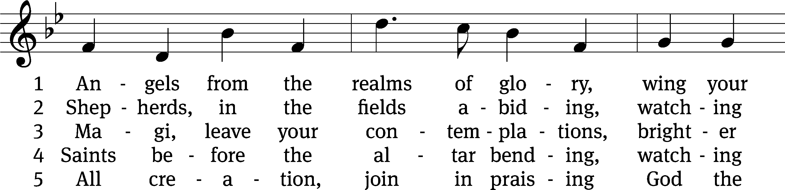
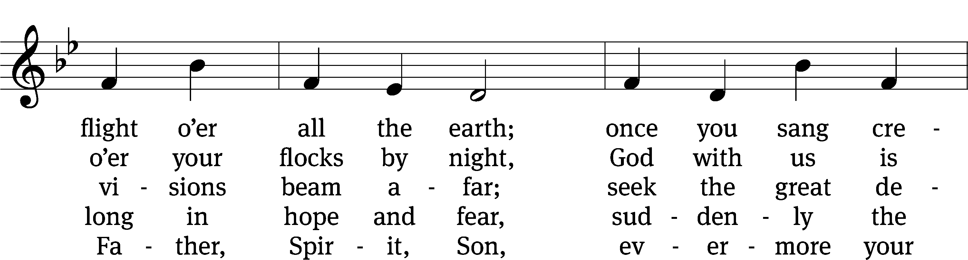
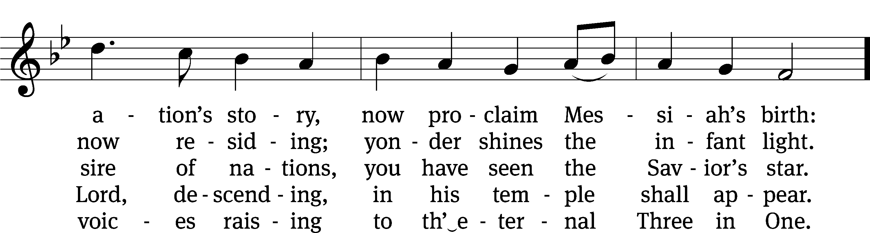
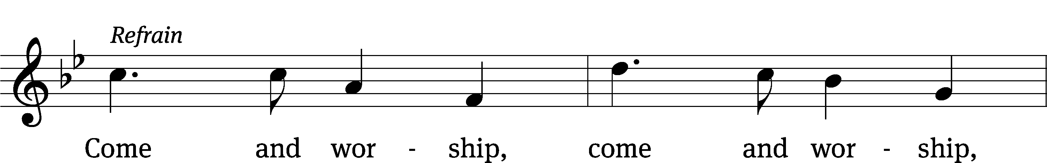
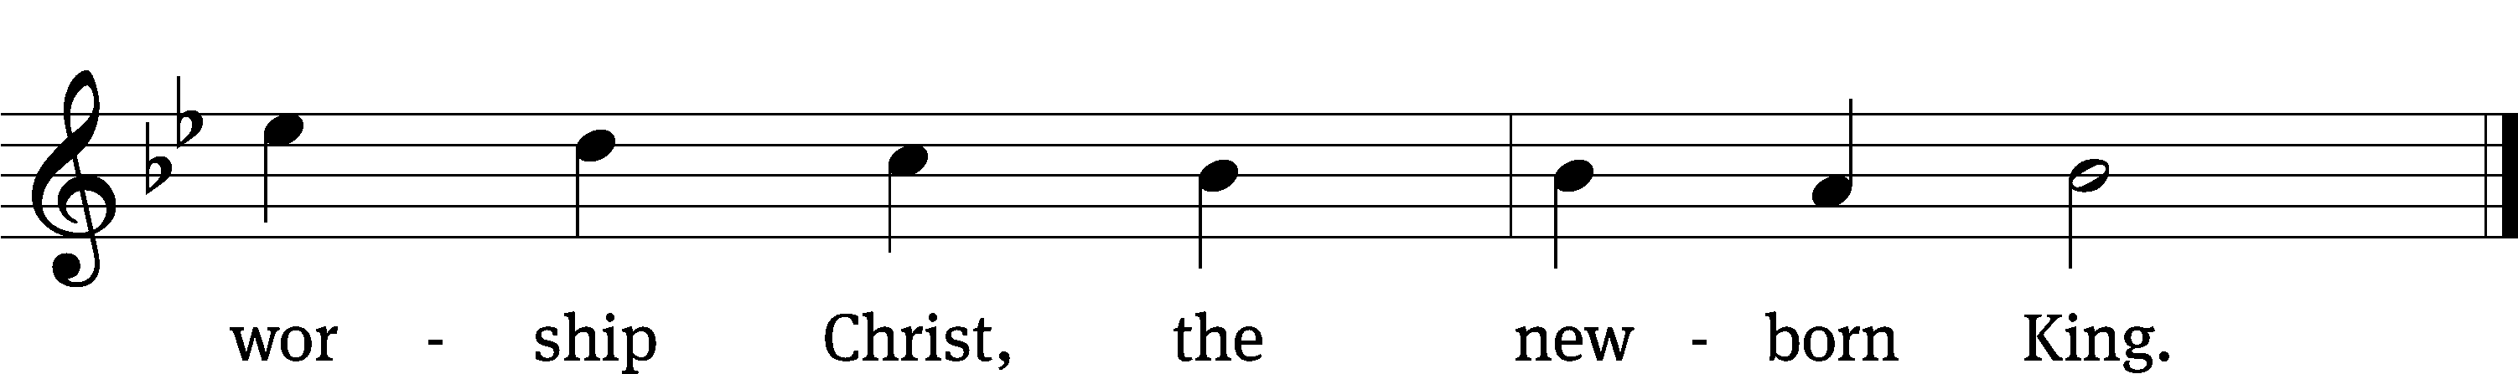
Text (sts. 1–3): James Montgomery, 1771–1854, alt.; (st. 4): Salisbury Hymn Book, 1857, alt.
Tune: Henry T. Smart, 1813–1879
Text and tune: Public domain

Please stand, if you are able
Invocation

In the name of the Father and of the Son and of the Holy Spirit.
Amen.

Confession

If we claim to be without sin, we deceive ourselves and the truth is not in us.
If we confess our sins, God is faithful and just
and will forgive us our sins
and purify us from all unrighteousness.

Let us confess our sins to the Lord.
Holy God, gracious Father,
I am sinful by nature
and have sinned against you in my thoughts, words, and actions.
I have not loved you with my whole heart;
I have not loved others as I should.
I deserve your punishment both now and forever.
But Jesus, my Savior, paid for my sins
with his innocent suffering and death.
Trusting in him, I pray: God, have mercy on me, a sinner.

Our gracious Father in heaven has been merciful to us. He sent his only Son, Jesus Christ, who gave his life as the atoning sacrifice for the sins of the whole world. Therefore, as a called servant of Christ and by his authority, I forgive you all your sins in the name of the Father and of the Son and of the Holy Spirit.
Amen.

Lord, Have Mercy

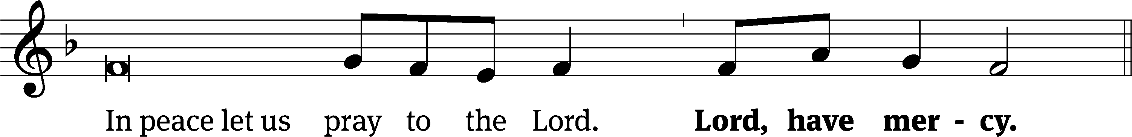
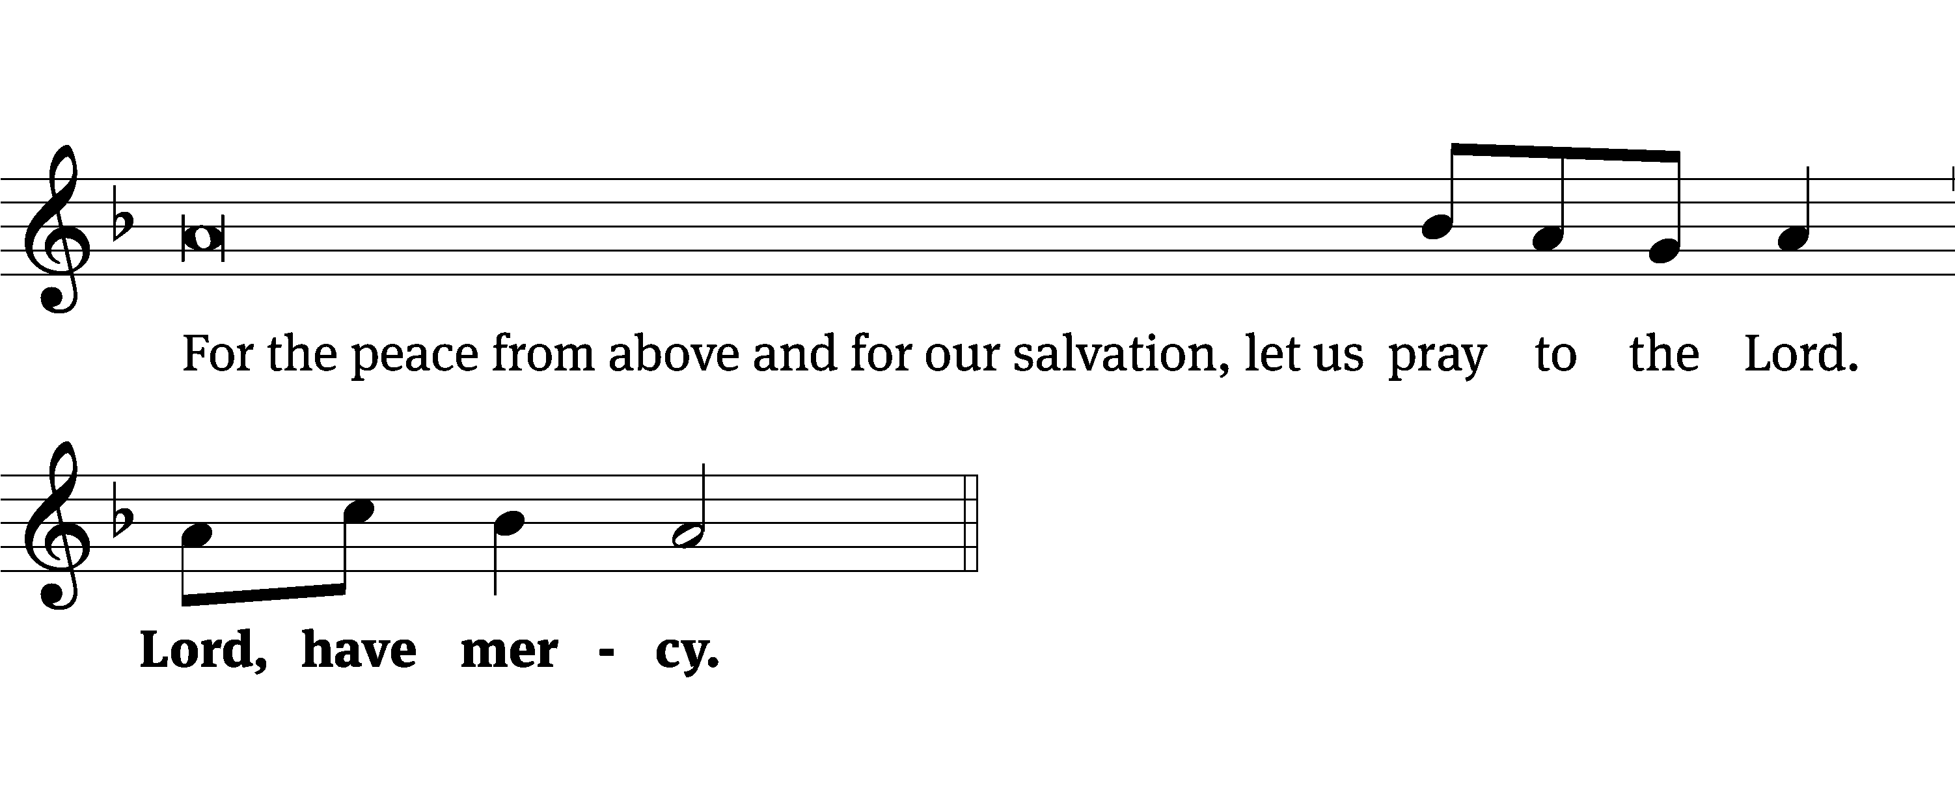
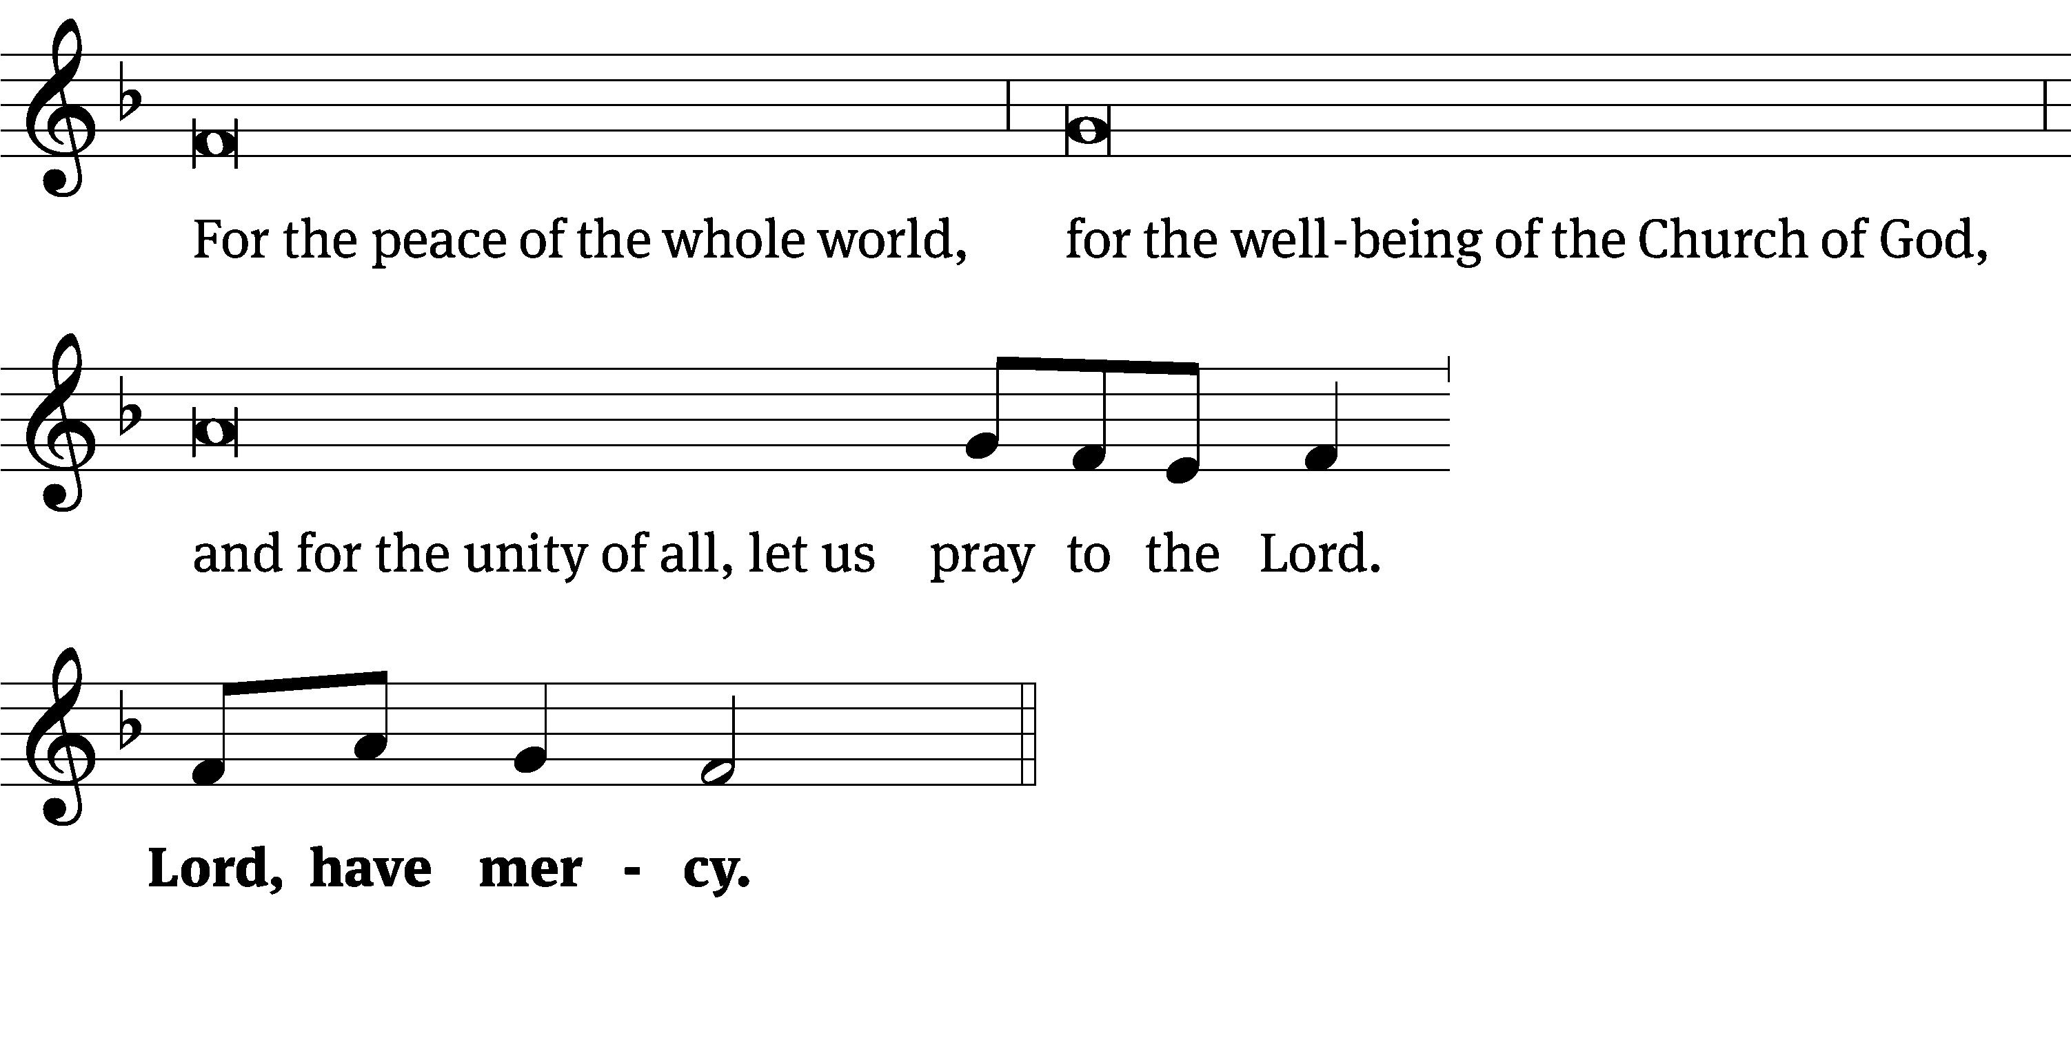
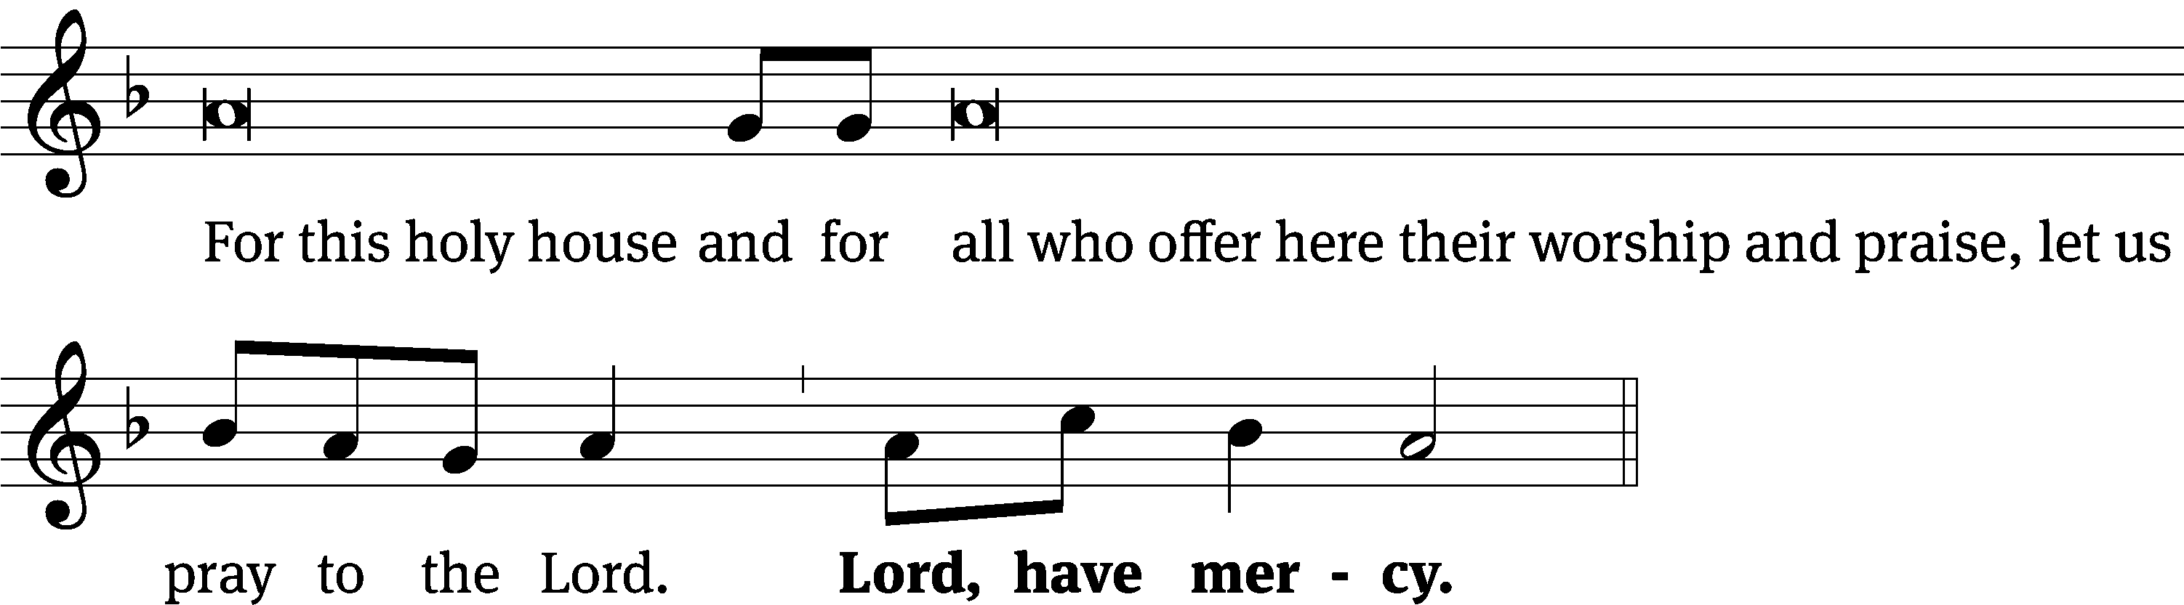
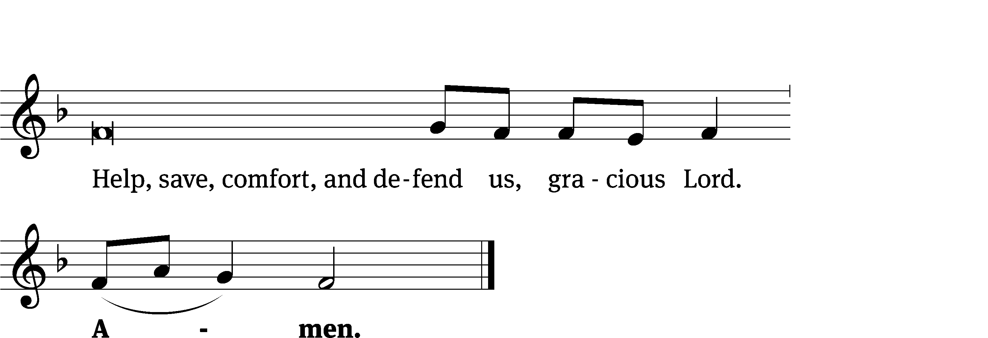
Glory Be to God on High CW 157
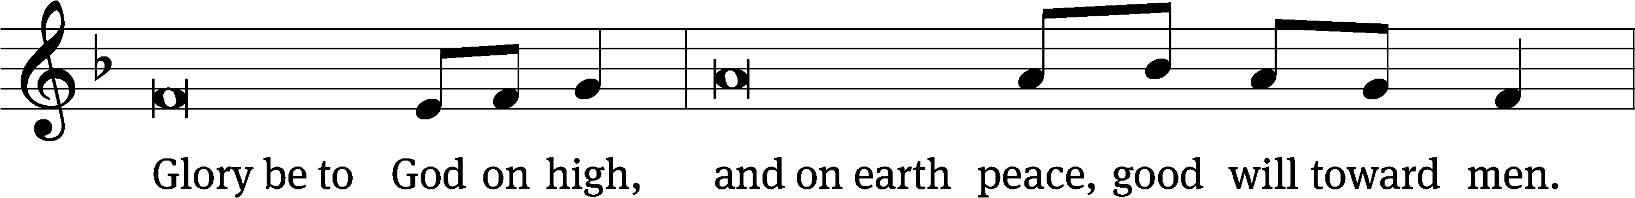
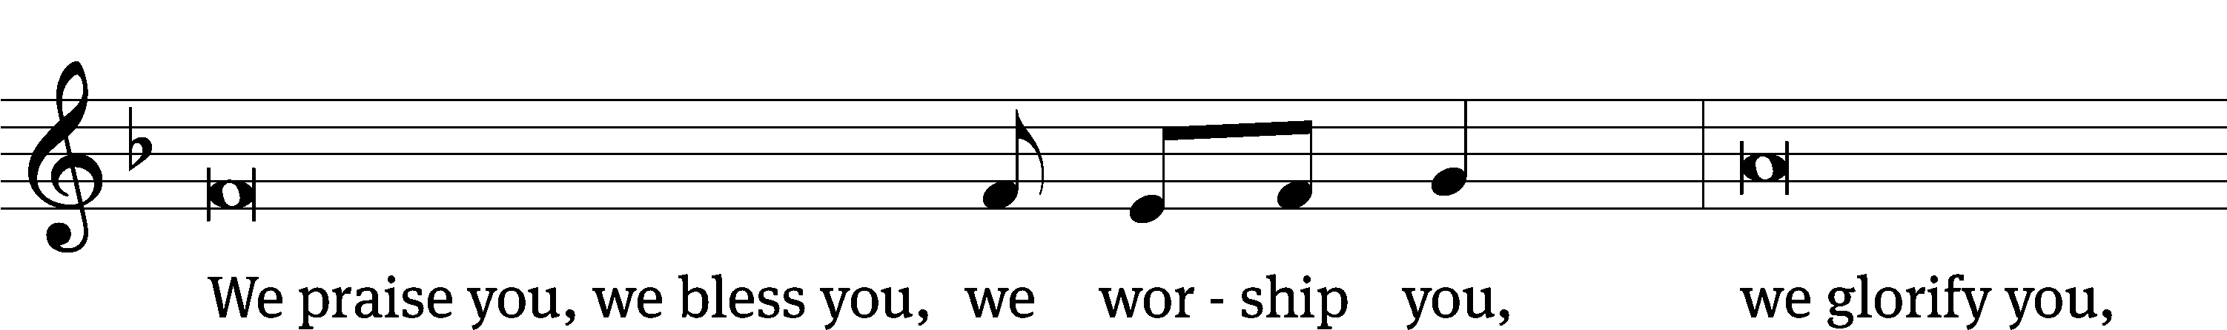
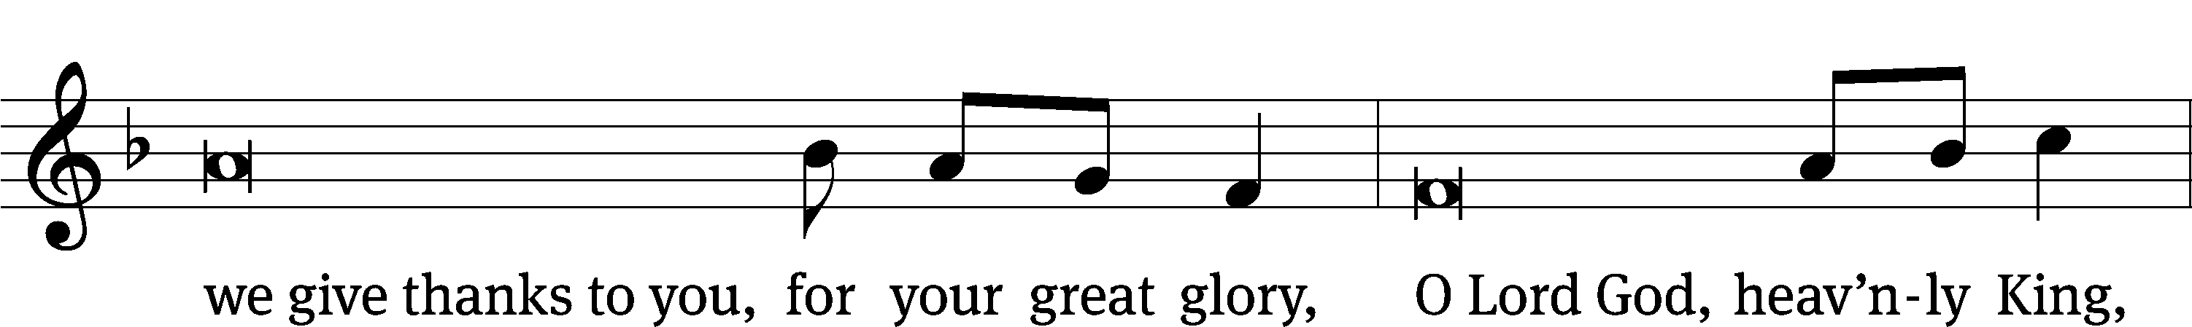
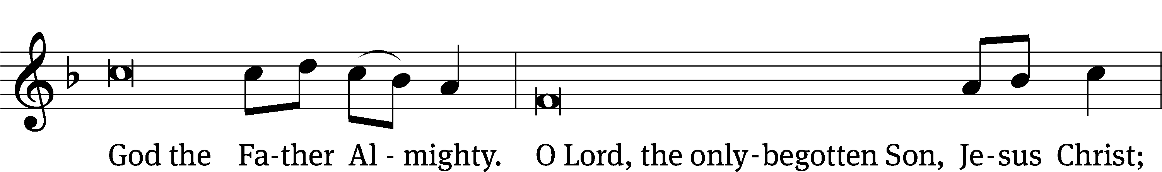
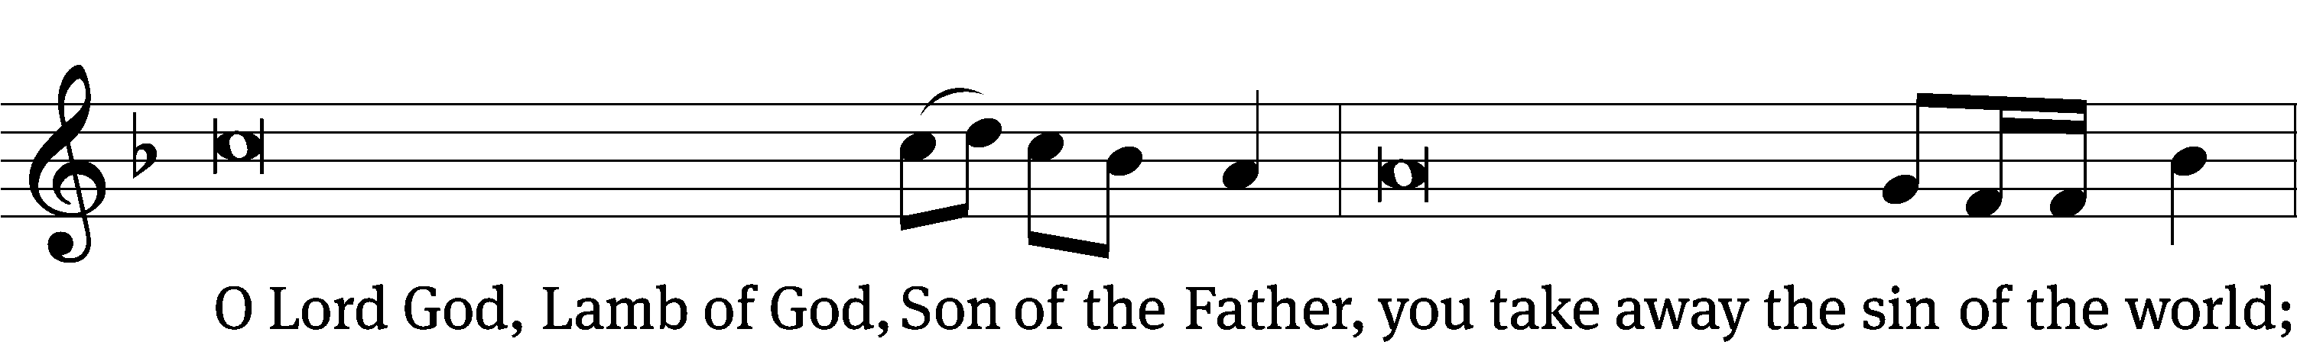
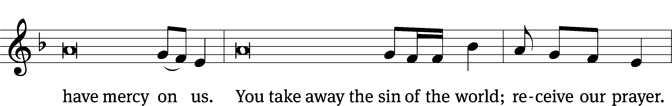
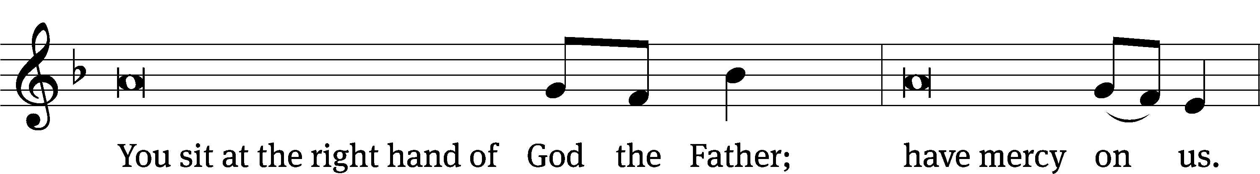
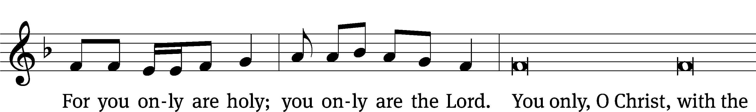
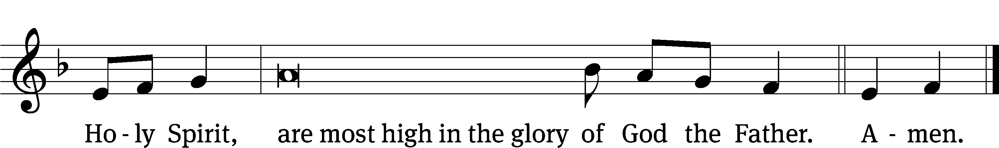

The Lord be with you.
And also with you.
Prayer of the Day
Let us pray.

Lord God, by the leading of a star, you once made known to the nations your one and only Son. Guide us, also, who know him now by faith to come at last to the perfect joy of your heavenly glory; through your Son, Jesus Christ our Lord, who lives and reigns with you and the Holy Spirit, one God, now and forever.
Amen.

Please be seated

First Reading Numbers 24:15-17a

¹⁵ Balaam took up his oracle and said:
The declaration of Balaam son of Beor,
the declaration of the man whose eye is open,
¹⁶ the declaration of the one who hears the words of God,
who receives knowledge from the Most High,
who sees the vision of the Almighty,
who is falling down, but his eyes are wide open:
¹⁷ I see him, but not now.
I behold him, but not near.
A star will come out of Jacob.
A scepter will rise up out of Israel.

The Word of the Lord.
Thanks be to God.

Psalm of the Day
72E Hail to the Lord’s Anointed Psalm 72E
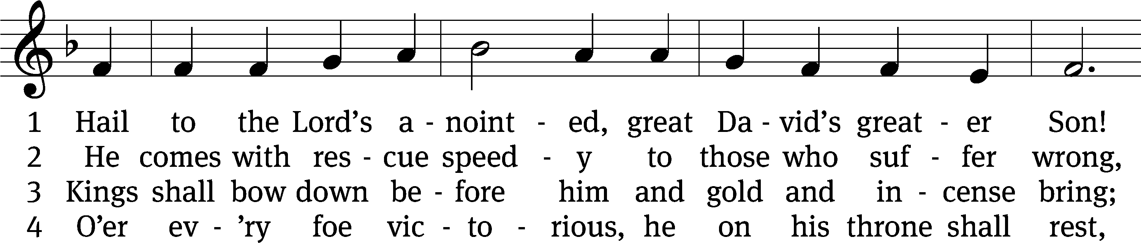
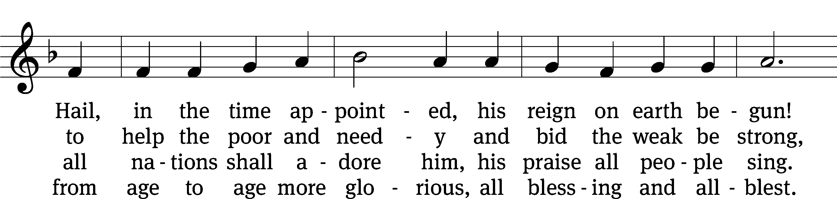
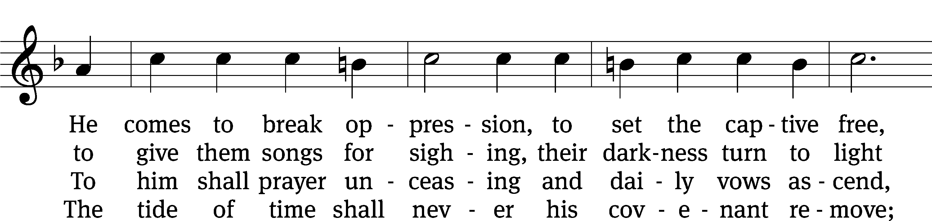
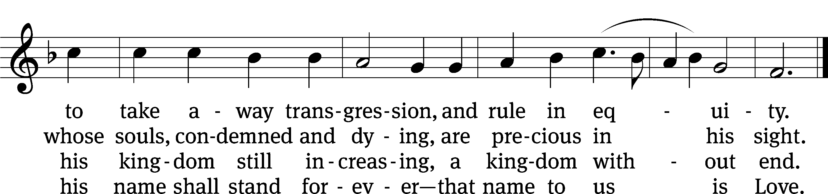
Text: James Montgomery
Tune: Leonhart Schröter
Text and tune: Public domain

Second Reading Romans 11:13-15, 28-32

¹³ I am speaking to you Gentiles. For as long as I am an apostle to the Gentiles, I am going to speak highly of my ministry. ¹⁴ Perhaps I may make my own people jealous, and so save some of them. ¹⁵ For if their rejection meant the reconciliation of the world, what does their acceptance mean other than the dead coming to life?
²⁸ In regard to the gospel, they are enemies for your sake. But, in regard to election, they are especially dear for the sake of the patriarchs, ²⁹ because God’s gracious gifts and call are not regretted. ³⁰ For just as you were once disobedient to God, but now have been shown mercy due to their disobedience, ³¹ so also now they have become disobedient, so that by the mercy shown to you they may be shown mercy too. ³² For God imprisoned all in disobedience so that he may show mercy to all.

The Word of the Lord.
Thanks be to God.

Please stand, if you are able
Gospel Acclamation Matthew 2:2
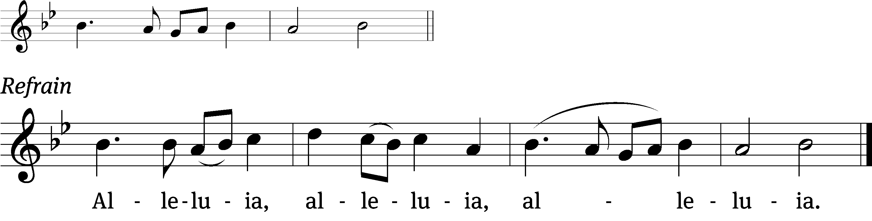
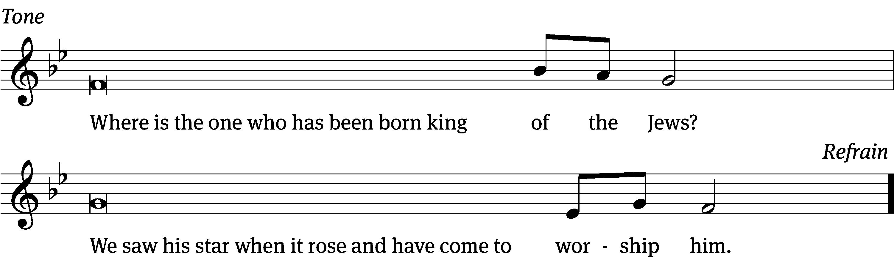
Tune: © 2021 Northwestern Publishing House. Used by permission: OneLicense no. 727703

Gospel Mathew 2:1-12
¹ After Jesus was born in Bethlehem of Judea, when Herod was king, Wise Men from the east came to Jerusalem. They asked, ² “Where is he who has been born King of the Jews? We saw his star when it rose and have come to worship him.” ³ When King Herod heard this, he was alarmed, and all Jerusalem with him. ⁴ He gathered together all the people’s chief priests and experts in the law. He asked them where the Christ was to be born. ⁵ They said to him, “In Bethlehem of Judea, because this was written through the prophet:
⁶ You, Bethlehem, in the land of Judah, are certainly not least among the rulers of Judah: because out of you will come a ruler, who will shepherd my people, Israel.”
⁷ Then Herod secretly summoned the Wise Men and found out from them exactly when the star had appeared. ⁸ He sent them to Bethlehem and said, “Go and search carefully for the child. When you find him, report to me, so that I may also go and worship him.”
⁹ After listening to the king, they went on their way. Then the star they had seen when it rose^{[c]} went ahead of them, until it stood still over the place where the child was. ¹⁰ When they saw the star, they rejoiced with overwhelming joy. ¹¹ After they went into the house and saw the child with Mary, his mother, they bowed down and worshipped him. Then they opened their treasures and offered him gifts: gold, frankincense, and myrrh. ¹² Since they had been warned in a dream not to return to Herod, they went back to their own country by another route.

The Gospel of the Lord.
Praise be to you, O Christ!

Please be seated

372 As with Gladness Men of Old CW 372
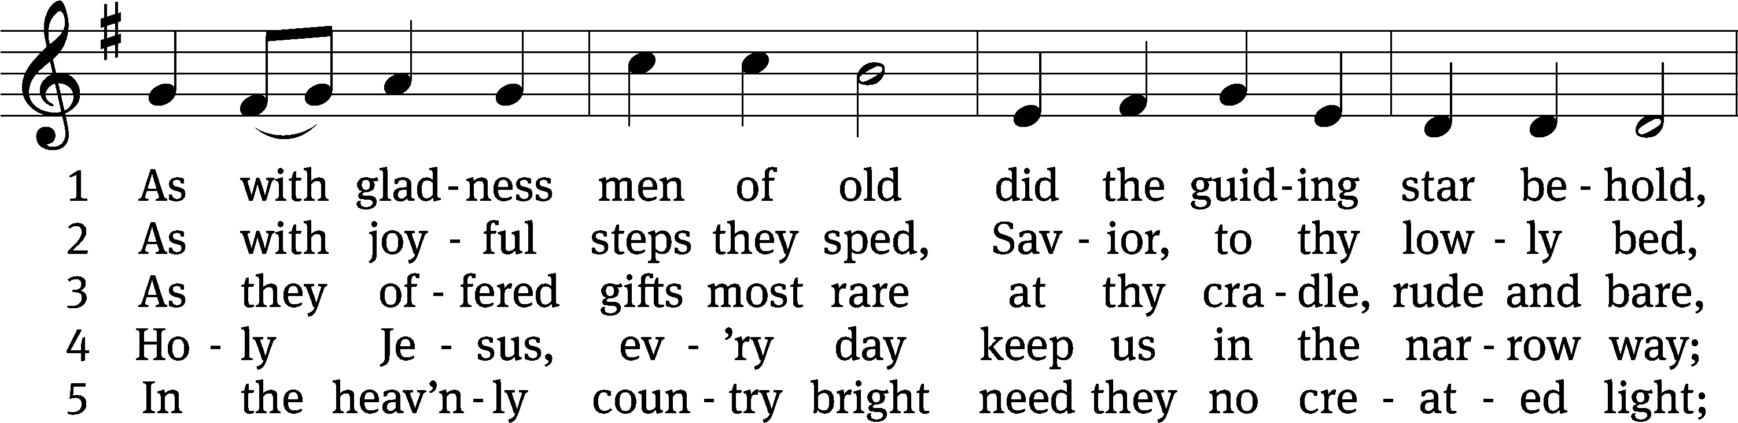
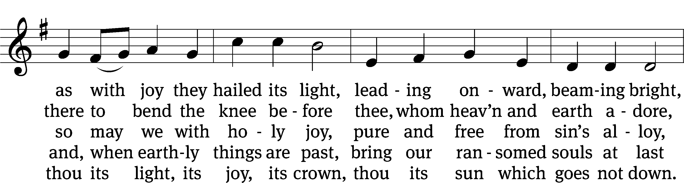
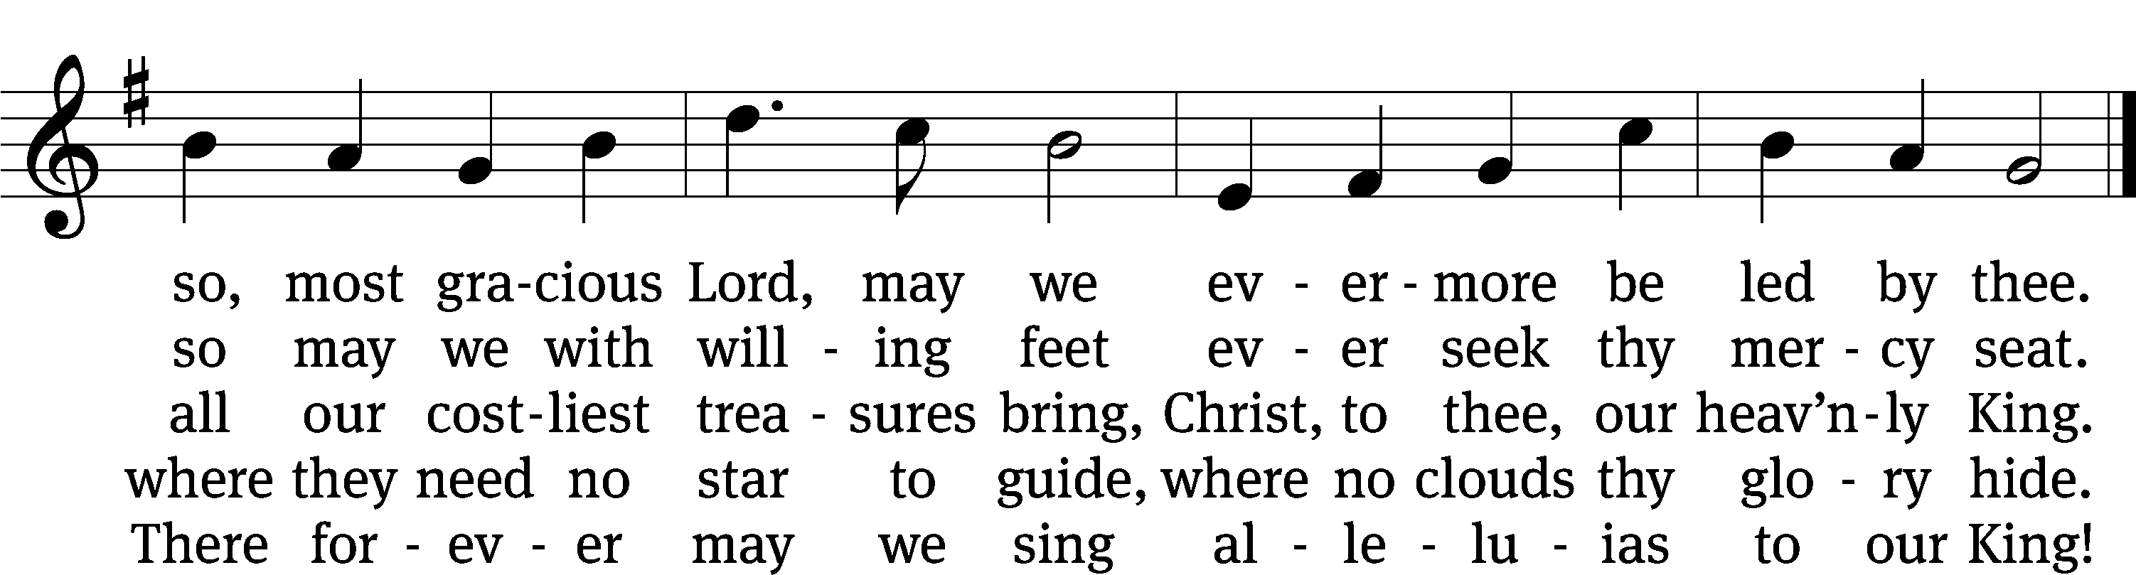
Text: William C. Dix, 1837–1898, alt.
Tune: Conrad Kocher, 1786–1872, alt.
Text and tune: Public domain

SERMON Matthew 2:1-12
“Copy the Worship of the Wise Men”

Please stand, if you are able

nicene creed
We believe in one God, the Father, the Almighty, maker of heaven and earth, of all that is, seen and unseen.
We believe in one Lord, Jesus Christ, the only Son of God, eternally begotten of the Father, God from God, Light from Light, true God from true God, begotten, not made, of one being with the Father. Through him all things were made. For us and for our salvation, he came down from heaven, was incarnate of the Holy Spirit and the virgin Mary, and became truly human. For our sake he was crucified under Pontius Pilate. He suffered death and was buried. On the third day he rose again in accordance with the Scriptures. He ascended into heaven and is seated at the right hand of the Father. He will come again in glory to judge the living and the dead, and his kingdom will have no end.
We believe in the Holy Spirit, the Lord, the giver of life, who proceeds from the Father and the Son, who in unity with the Father and the Son is worshiped and glorified, who has spoken through the prophets. We believe in one holy Christian and apostolic Church. We acknowledge one baptism for the forgiveness of sins. We look for the resurrection of the dead and the life of the world to come. Amen.

Prayer of the Church

The Sacrament
Preface CW 165

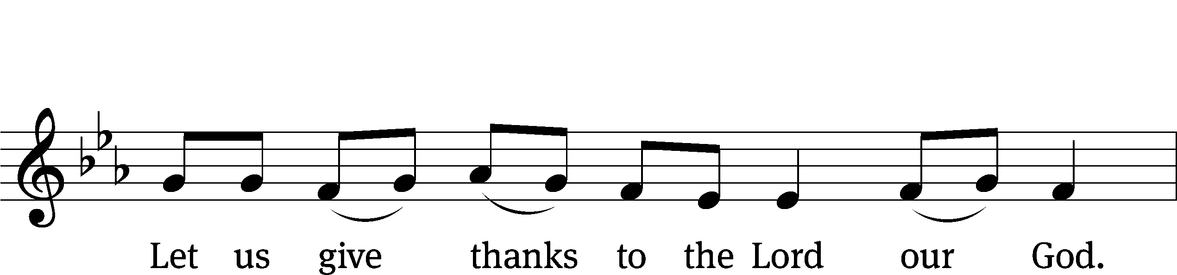
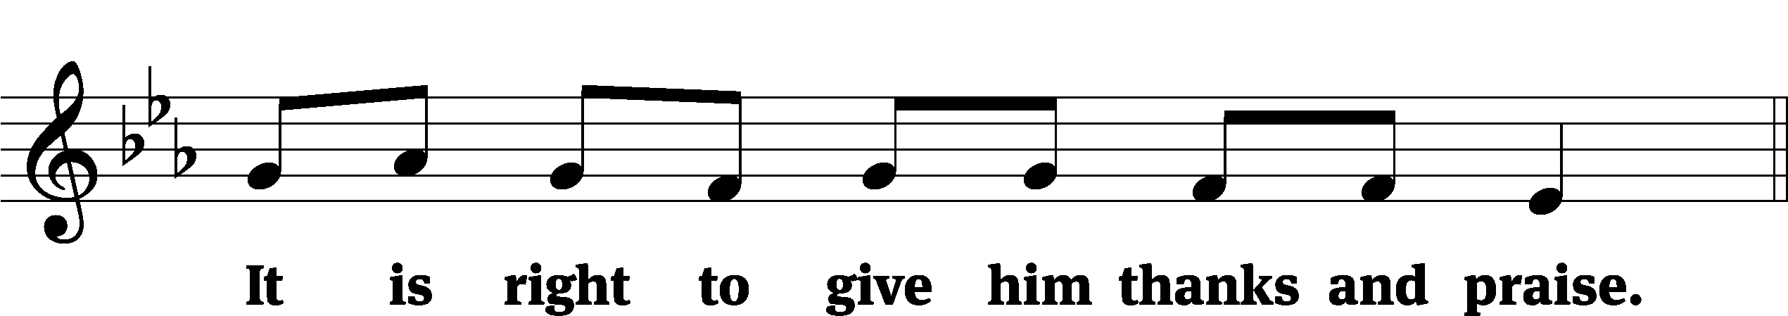

It is truly good and right that we should at all times and in all places give you thanks, O Lord, holy Father, almighty and everlasting God, through Jesus Christ our Lord, who by his willing sacrifice on the cross took away the sins of the world and by his glorious resurrection restored everlasting life. Therefore, with all the saints on earth and hosts of heaven, we praise your holy name and join their glorious song:

Holy, Holy, Holy CW 167
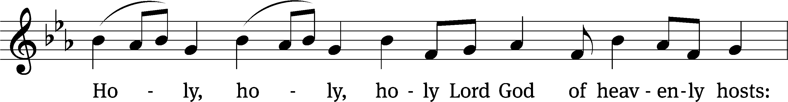
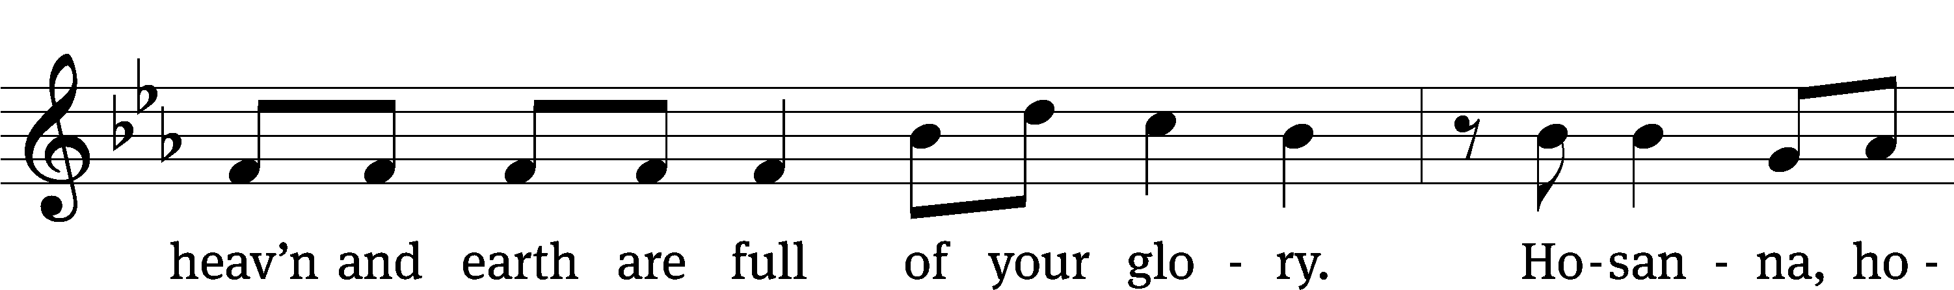
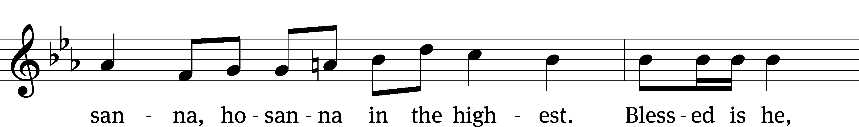
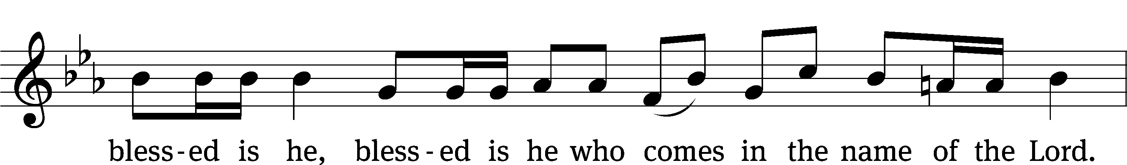
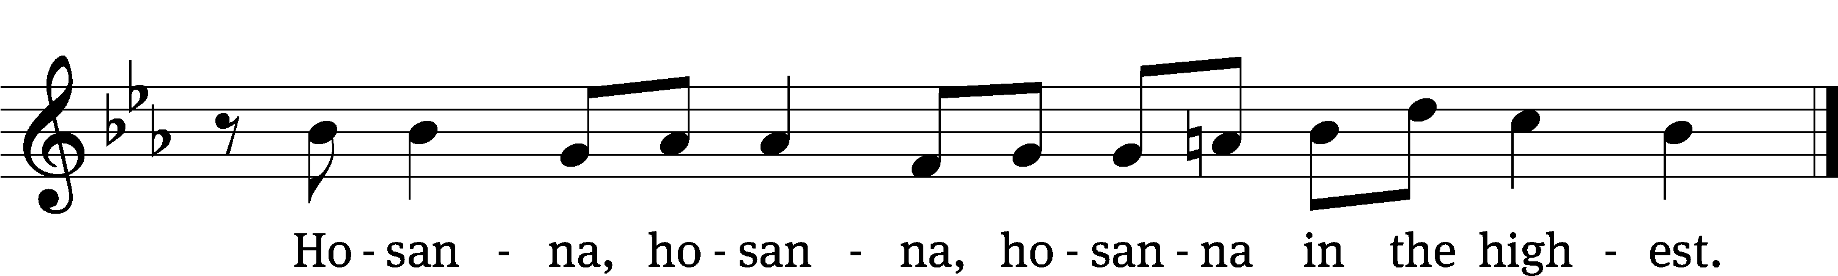

Prayer of Thanksgiving
We give thanks to you, O God, through your dear Son, Jesus Christ, whom you sent to be our Savior, our Redeemer, and the messenger of your grace. Through him you made all things; in him you are well pleased. He is the incarnate Word, conceived by the Holy Spirit and born of the Virgin Mary. To fulfill your promises, he stretched out his hands on the cross and released from eternal death all who believe in you.
As we remember Jesus’ death and resurrection, we thank you that you have gathered us together to receive your Son’s body and blood. Send us your Spirit, unite us as one, and strengthen our faith so that we may praise you in your Son, Jesus Christ. Through him, we glorify and honor you, O God our Father, with the Holy Spirit, one God, now and forever.
Amen.

Lord’s Prayer
Our Father, who art in heaven, hallowed be thy name, thy kingdom come, thy will be done on earth as it is in heaven. Give us this day our daily bread; and forgive us our trespasses, as we forgive those who trespass against us; and lead us not into temptation, but deliver us from evil. For thine is the kingdom and the power and the glory forever and ever. Amen.

Words of Institution
Our Lord Jesus Christ, on the night he was betrayed, took bread; and when he had given thanks, he broke it and gave it to his disciples, saying, “Take and eat; this is my body, which is given for you. Do this in remembrance of me.”
Then he took the cup, gave thanks, and gave it to them, saying, “Drink from it, all of you; this is my blood of the new covenant, which is poured out for you for the forgiveness of sins. Do this, whenever you drink it, in remembrance of me.”

The peace of the Lord be with you always.
Amen.
O Christ, Lamb of God CW 169
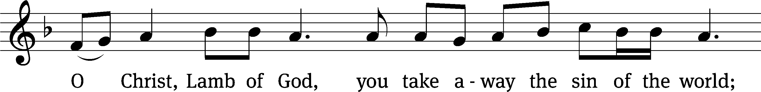
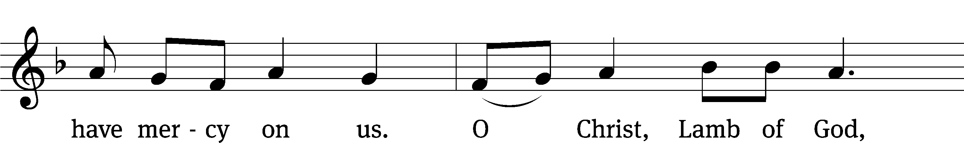
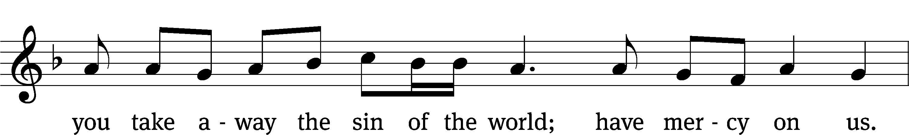
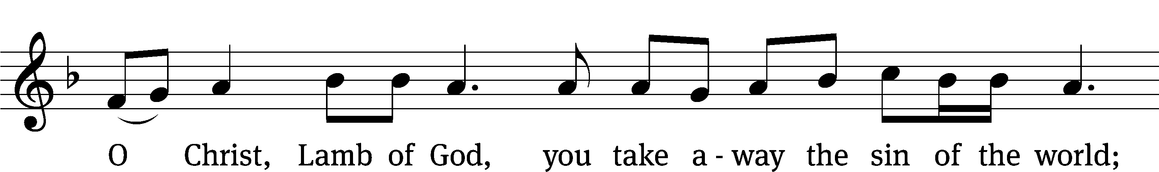
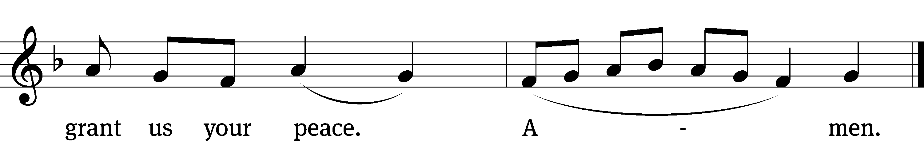
351 He Whose Praise the Shepherds Sounded CW 351
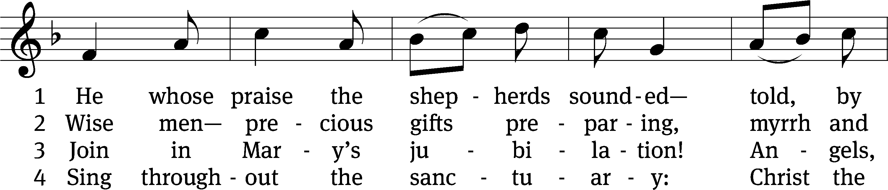
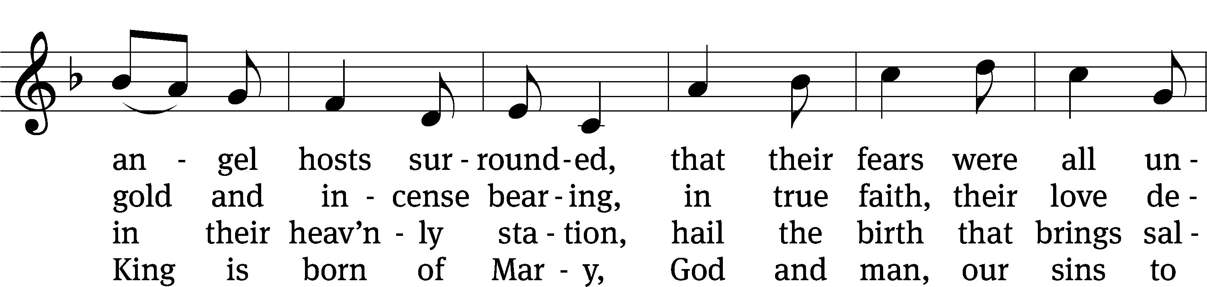
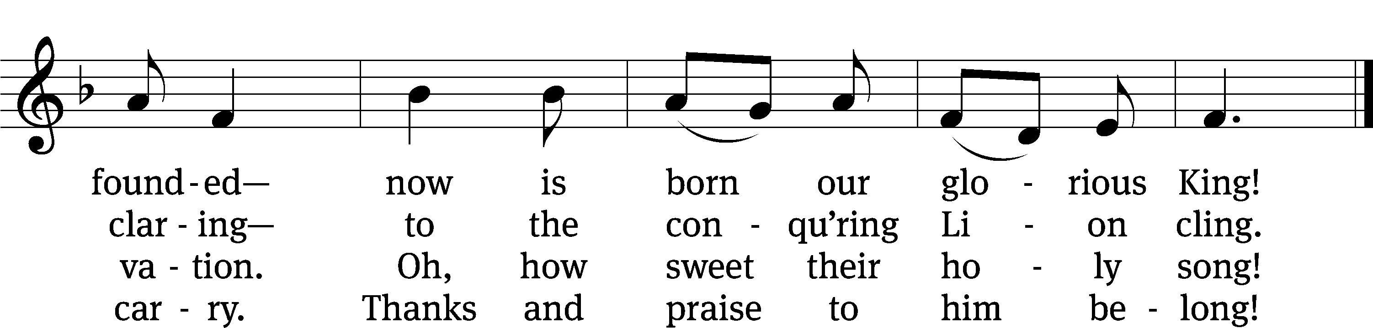
Text: tr. Michael D. Schultz, b. 1963; Latin, 15th cent.
Tune: German, 14th cent.
Text: © 2021 Northwestern Publishing House. Used by permission: OneLicense no. 727703
Tune: Public domain

370 How Lovely Shines the Morning Star CW 370
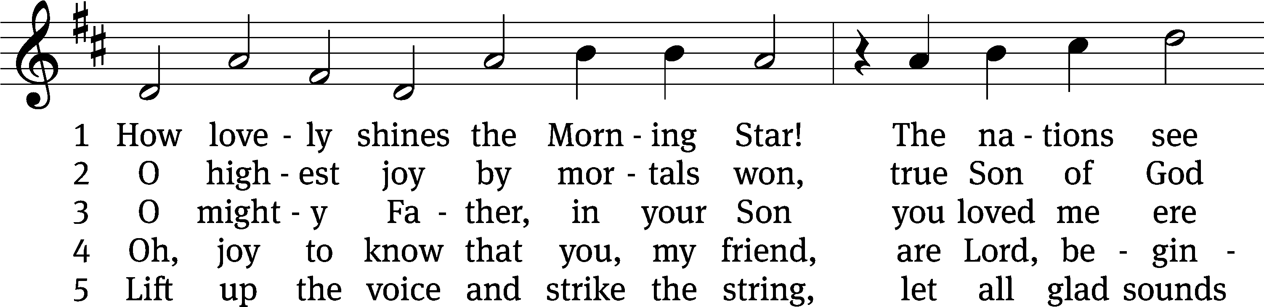
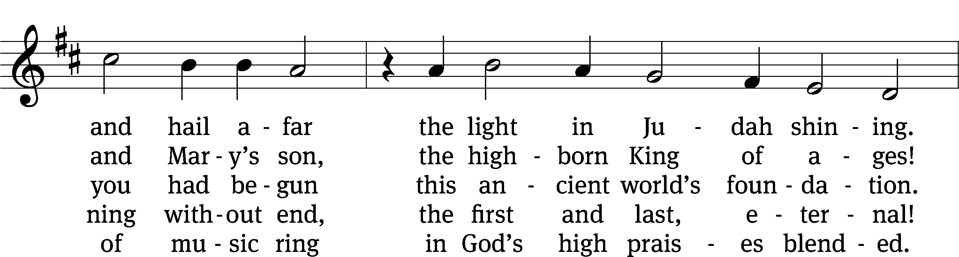
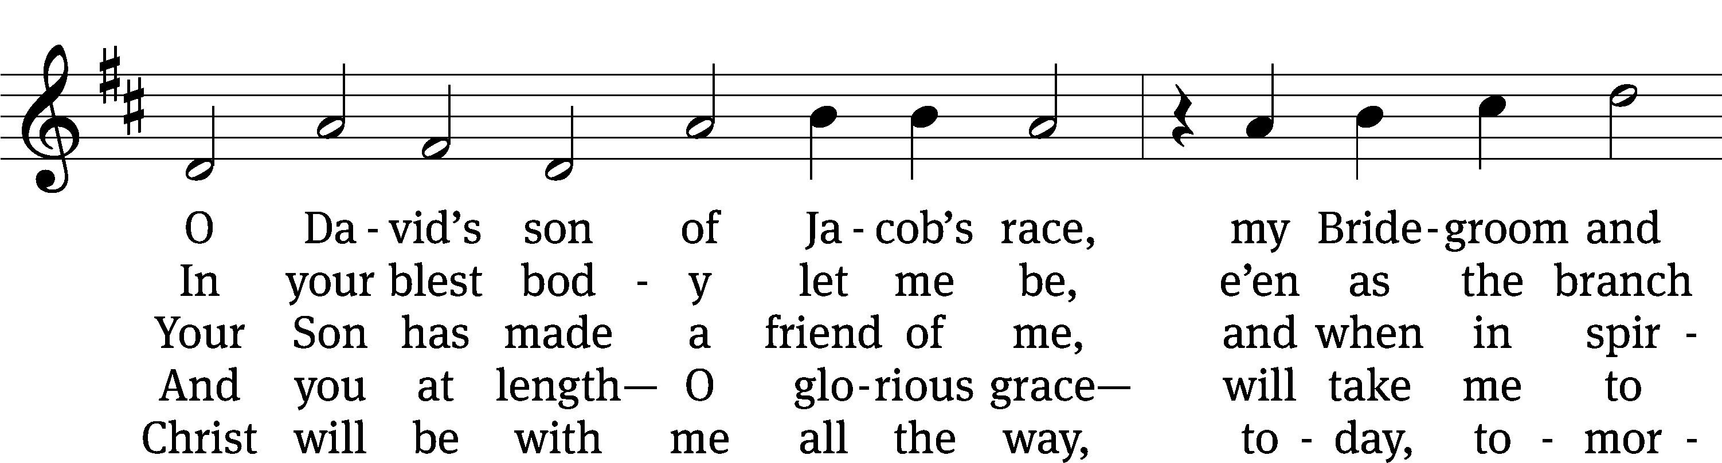
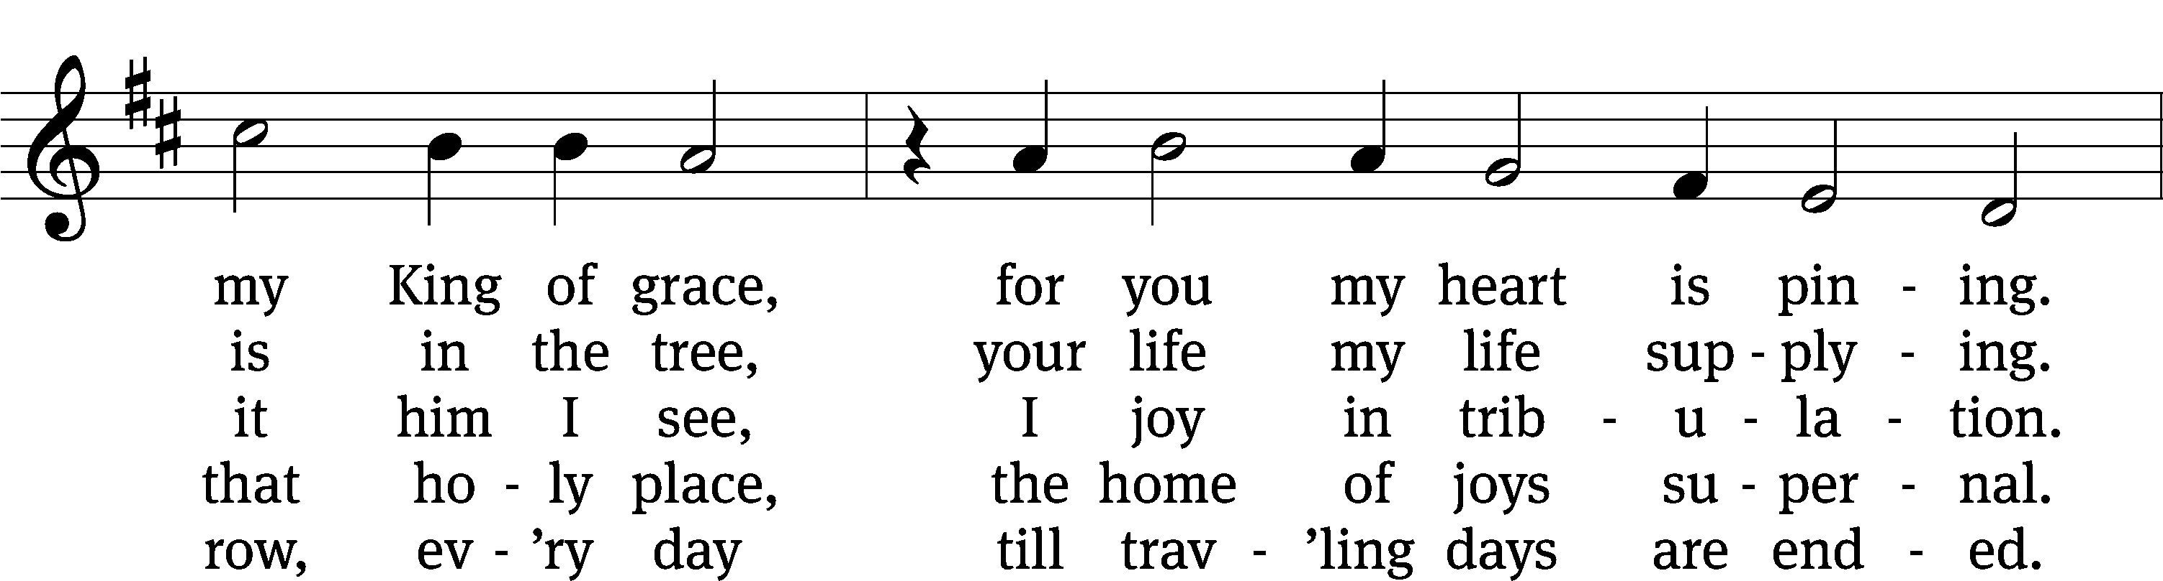
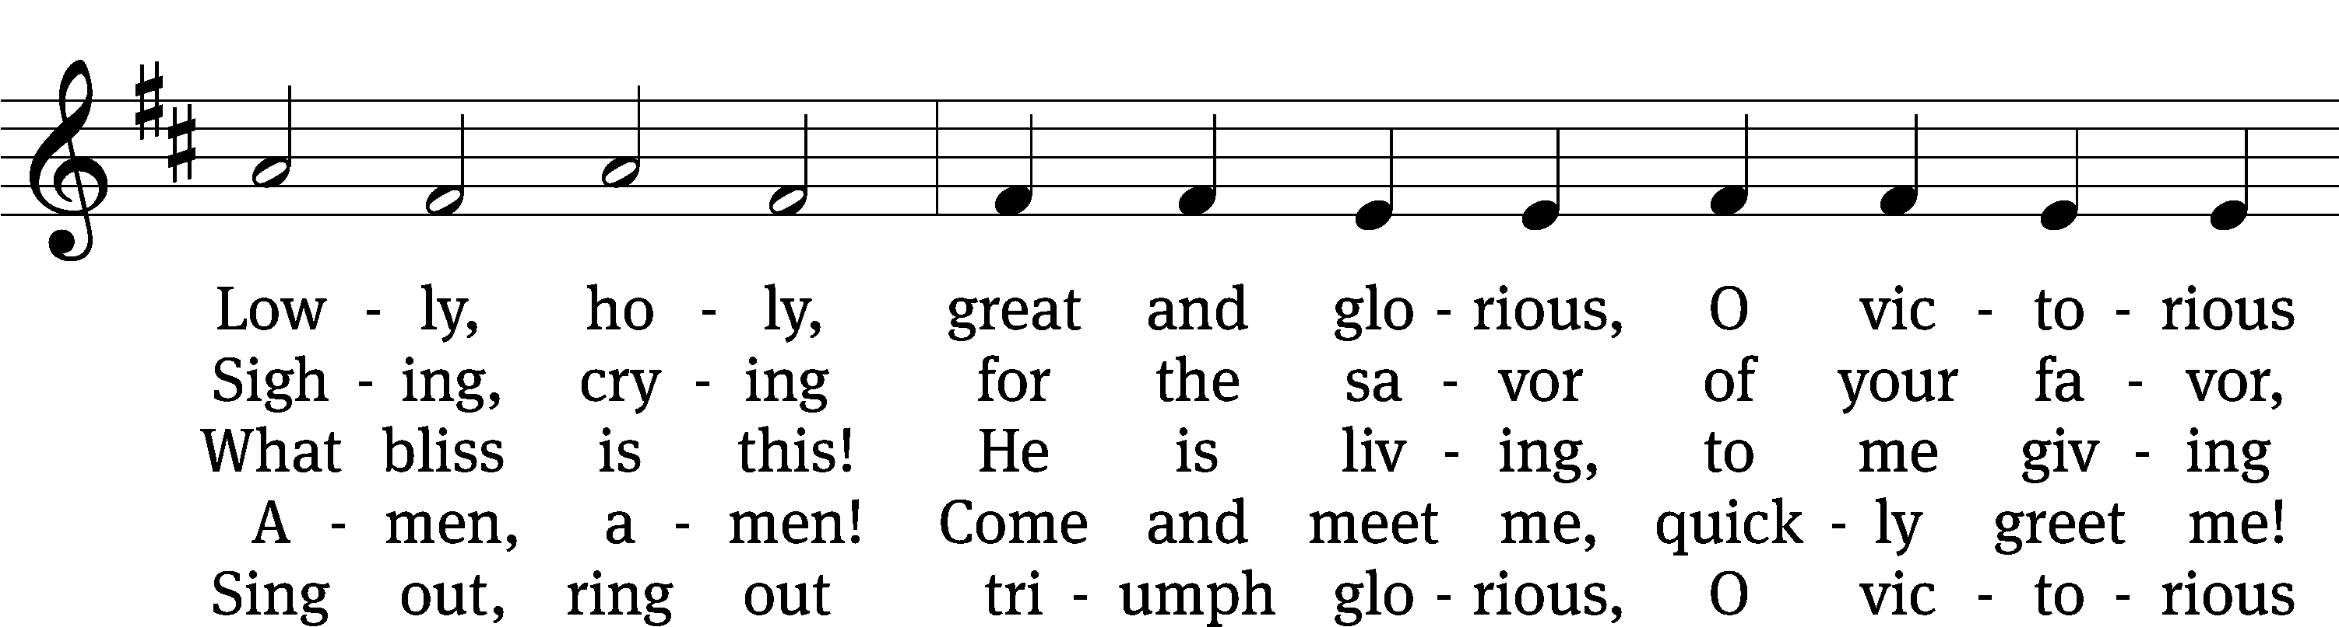
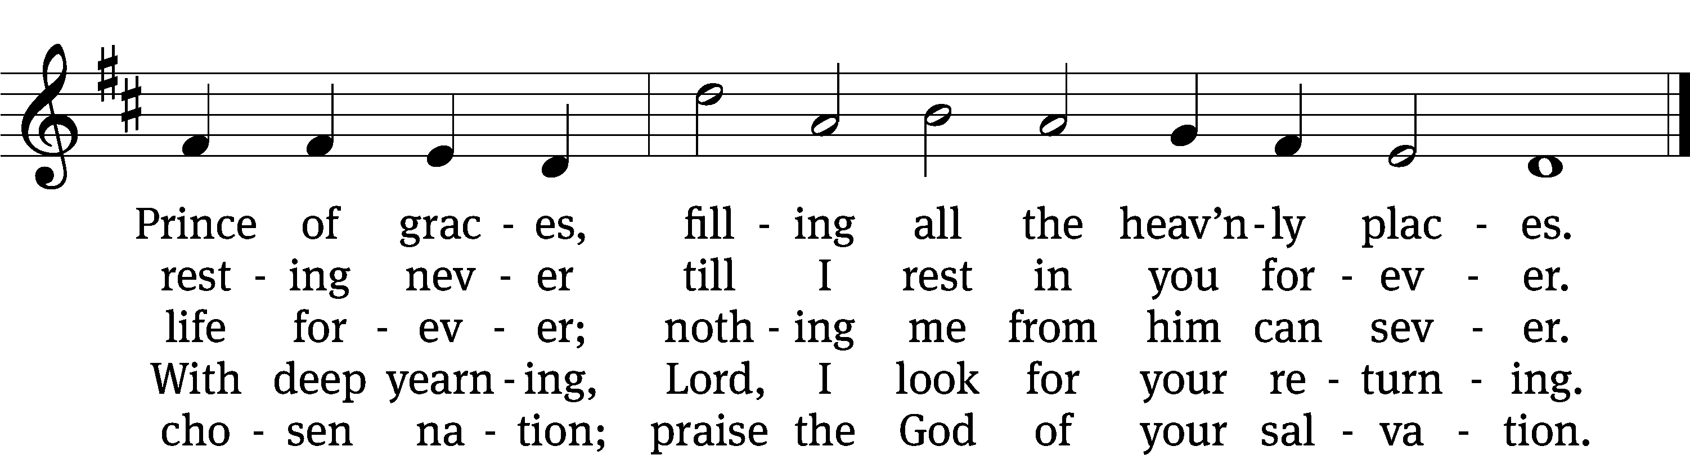
Text: tr. The Lutheran Hymnal, 1941, alt.; Philipp Nicolai, 1556–1608, abr., adapt
Tune: Philipp Nicolai, 1556–1608
Text and tune: Public domain

Please stand, if you are able

Give thanks to the Lord, for he is good;
his mercy endures forever.

Whenever we eat this bread and drink this cup,
we proclaim the Lord’s death until he comes.

We give thanks, almighty God, that you have refreshed us with this saving gift. We pray that through it you will strengthen our faith in you and increase our love for one another. We ask this in the name of Jesus Christ our Lord, who lives and reigns with you and the Holy Spirit, one God, now and forever.
Amen.

Blessing
The Lord bless you and keep you.
The Lord make his face shine on you and be gracious to you.
The Lord look on you with favor and give you peace.
Amen.

Please be seated

374 The Star Proclaims the King Is Here CW 374 sts. 1–2, 5
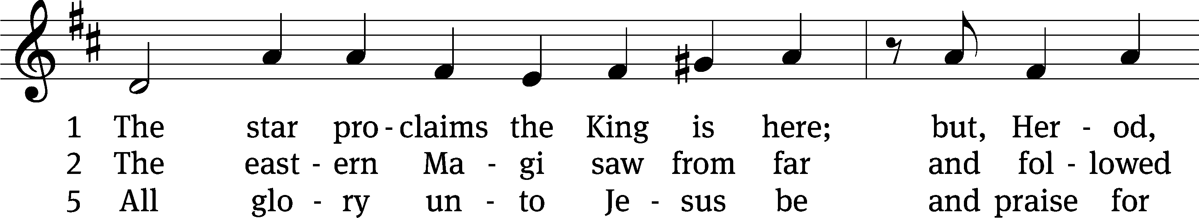
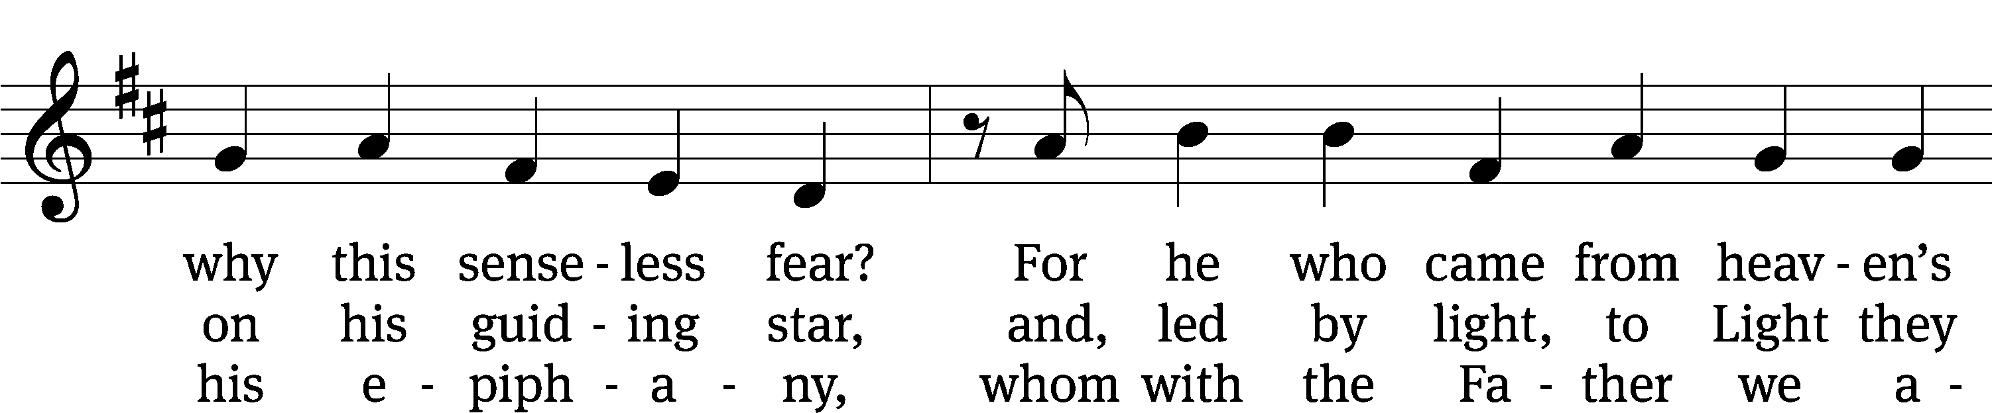
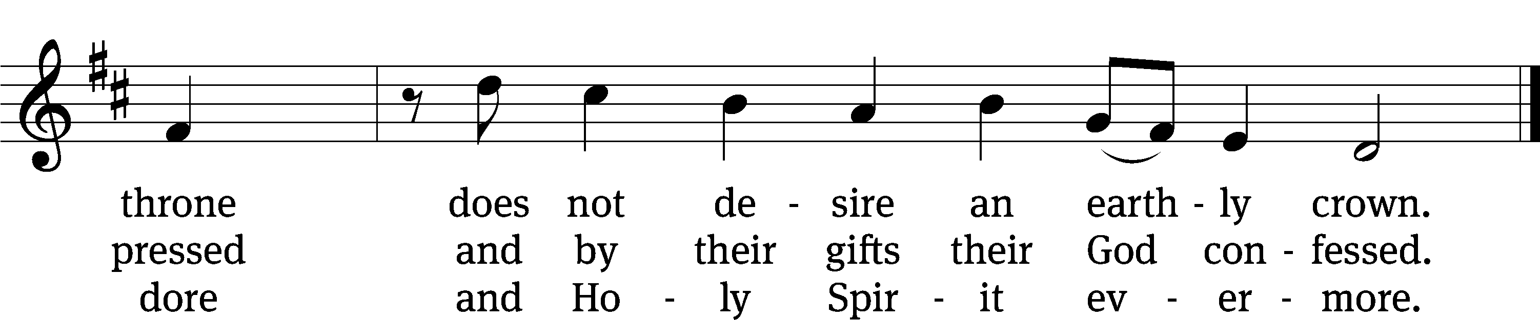
Text: tr. John Mason Neale, 1818–1866, alt.; Coelius Sedulius, 5th cent., abr.
Tune: Geistliche Lieder auffs new gebessert, Wittenberg, 1535, ed. Joseph Klug
Text and tune: Public domain

Acknowledgments
Setting One from Christian Worship
Software distributed in partnership with Northwestern Publishing House.
Created by Christian Worship: Service Builder © 2022 Concordia Publishing House.
Serving in Worship
Officiant Pastor Natsis
Organist Marcia Marion Ackling
Deacons (8:30) Ron Roehm and Dave Stevenson
Deacons (11:00) Dave Frey and Gary Knowlton
Ushers (8:30) Bob Newman and Henry Schneider
Ushers (11:00) Ed Sala and Al Whitley
Altar Guild Sharon Boswell and Laura Lindemann
Videographer Jake Vershum

