The third sunday in lent

TRINITY EVANGELICAL LUTHERAN CHURCH | Saline, Michigan
WELCOME TO WORSHIP March 3, 2024
Thank you for joining us in God’s house today! We cordially ask that our Guests sign one of the guestbooks located at either the front or back entryways, or fill out a “Let’s Get Acquainted” card located in the hymnal pew rack and place it in the collection plate.

Thank Offering: Members of Trinity give their offering as an expression of love and thankfulness to the Lord and to help support the Lord’s work in our community and around the world. Visitors need not feel obligated to participate in this offering .

Restrooms are located at the back of the upper level (the annex), and in the basement (down the back stairs of the sanctuary or annex). Handicap access is available, please ask an usher for assistance.

Young Families / Toddler Bags – We are GLAD YOU BROUGHT YOUR CHILDREN to our worship service. Jesus said: “Let the little children come to me and do not hinder them, for the kingdom of God belongs to such as these.” We know that having little children in church can be a challenge, but DO NOT WORRY about it. Many of your fellow worshippers have been in your shoes and are just happy you brought your children with you. For your convenience, we have reserved the back rows of seating for parents with small children. These areas provide more flexibility for your family, as well as, easy access to move downstairs if necessary. A closed-circuit TV system allows families to continue participating in the service while downstairs. Pre-school toddler bags and children’s bulletins are available for their enjoyment. Ask an usher for one to use during the service and please return the toddler bag afterwards.

Holy Communion – In His Word, God makes it clear that the Lord’s Supper is to be shared by people of a common proclamation of faith (1 Corinthians 11:26; 1 Corinthians 10:16-17). Without judging anyone’s hearts, we invite those who share in our confession by their membership in our congregation or another congregation of the Wisconsin Evangelical Lutheran Synod (WELS) or the Evangelical Lutheran Synod (ELS) and who are properly prepared (1 Corinthians 11;27-29) to receive the Sacrament. Page 295 in Christian Worship provides a guide for preparation.
Guests, we would love to have you join us in communion fellowship in the future, and for that to be possible, we ask that you speak with one of the pastors so that we may speak with you on how that would be possible. We thank you for respecting the way we celebrate the Lord’s Supper in our congregations.

the SERVICE – setting one - WITH HOLY COMMUNION CW, page 154
Sunday School Children “The King of Glory Comes”
548 The King of Glory Comes CW 548 sts. Ref–3
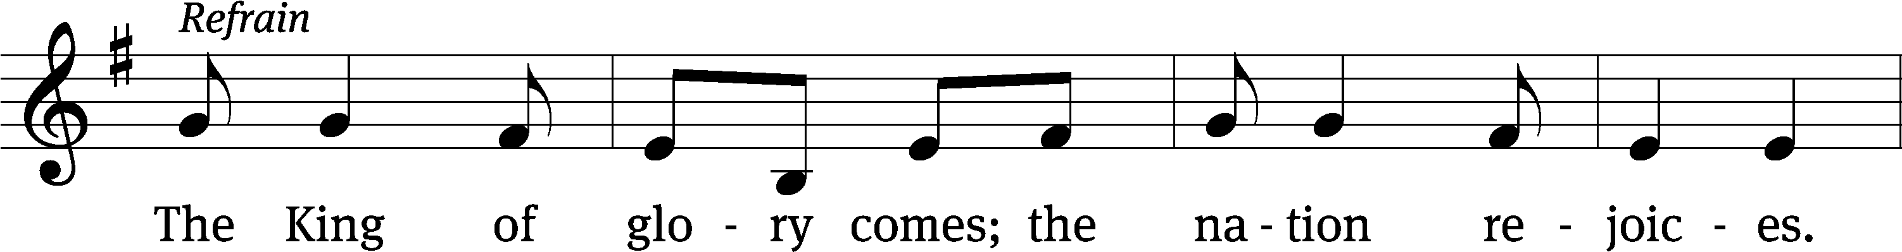
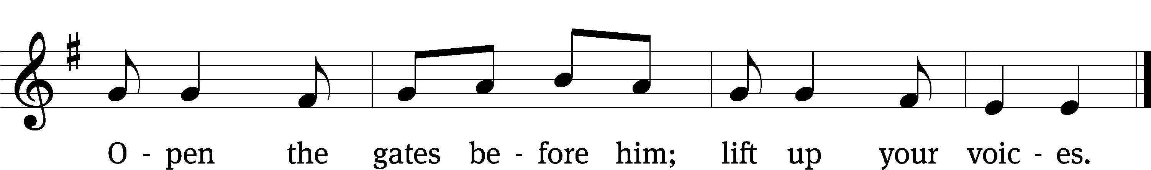
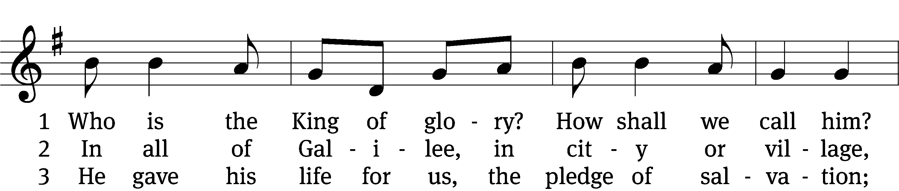
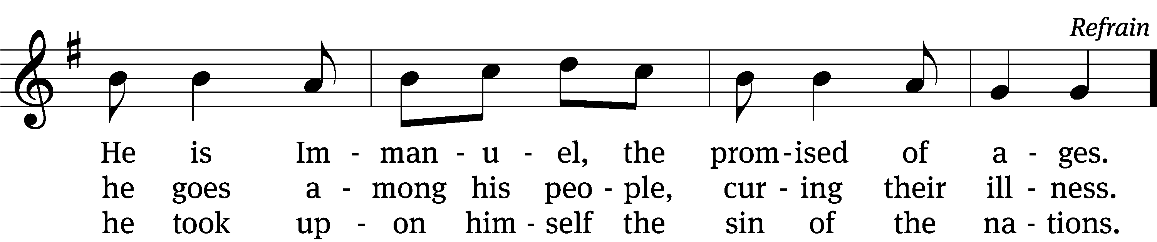
Text: Willard F. Jabusch, 1930–2018, alt.
Tune: Israeli, 20th cent.
Text: © 1966, 1985 Willard F. Jabusch, admin. OCP Publications. Used by permission: OneLicense no. 727703
Tune: Public domain

697 May We Your Precepts, Lord, Fulfill CW 697
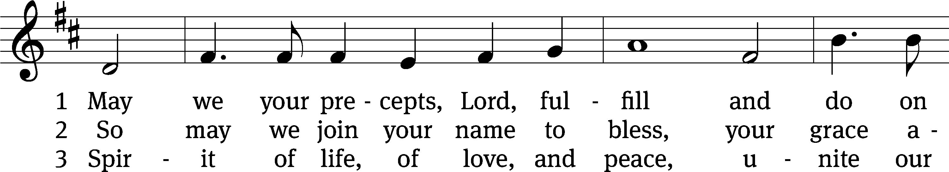
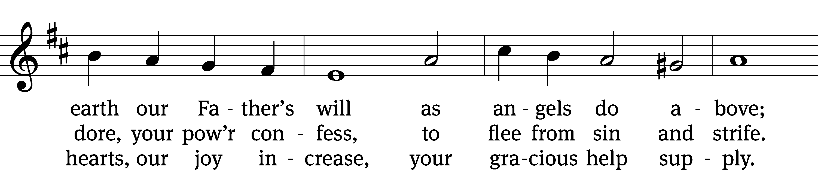
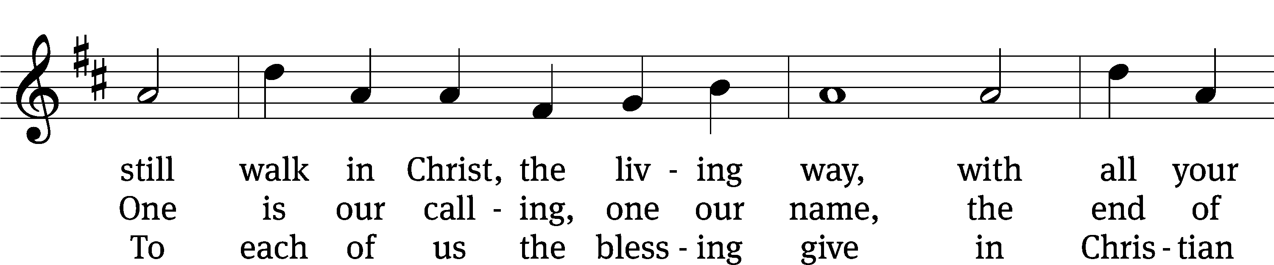
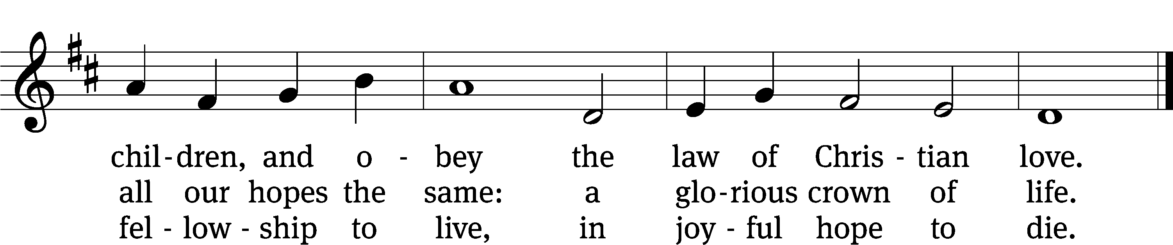
Text: Edward Osler, 1789–1863, alt.
Tune: Lowell Mason, 1792–1872
Text and tune: Public domain

Please stand, if you are able

Invocation

In the name of the Father and of the Son and of the Holy Spirit.
Amen.

Confession

If we claim to be without sin, we deceive ourselves and the truth is not in us.
If we confess our sins, God is faithful and just
and will forgive us our sins
and purify us from all unrighteousness.

Let us confess our sins to the Lord.
Holy God, gracious Father,
I am sinful by nature
and have sinned against you in my thoughts, words, and actions.
I have not loved you with my whole heart;
I have not loved others as I should.
I deserve your punishment both now and forever.
But Jesus, my Savior, paid for my sins
with his innocent suffering and death.
Trusting in him, I pray: God, have mercy on me, a sinner.

Our gracious Father in heaven has been merciful to us. He sent his only Son, Jesus Christ, who gave his life as the atoning sacrifice for the sins of the whole world. Therefore, as a called servant of Christ and by his authority, I forgive you all your sins in the name of the Father and of the Son and of the Holy Spirit.
Amen.

Lord, Have Mercy

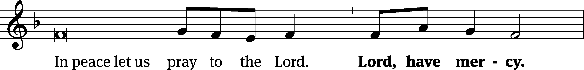
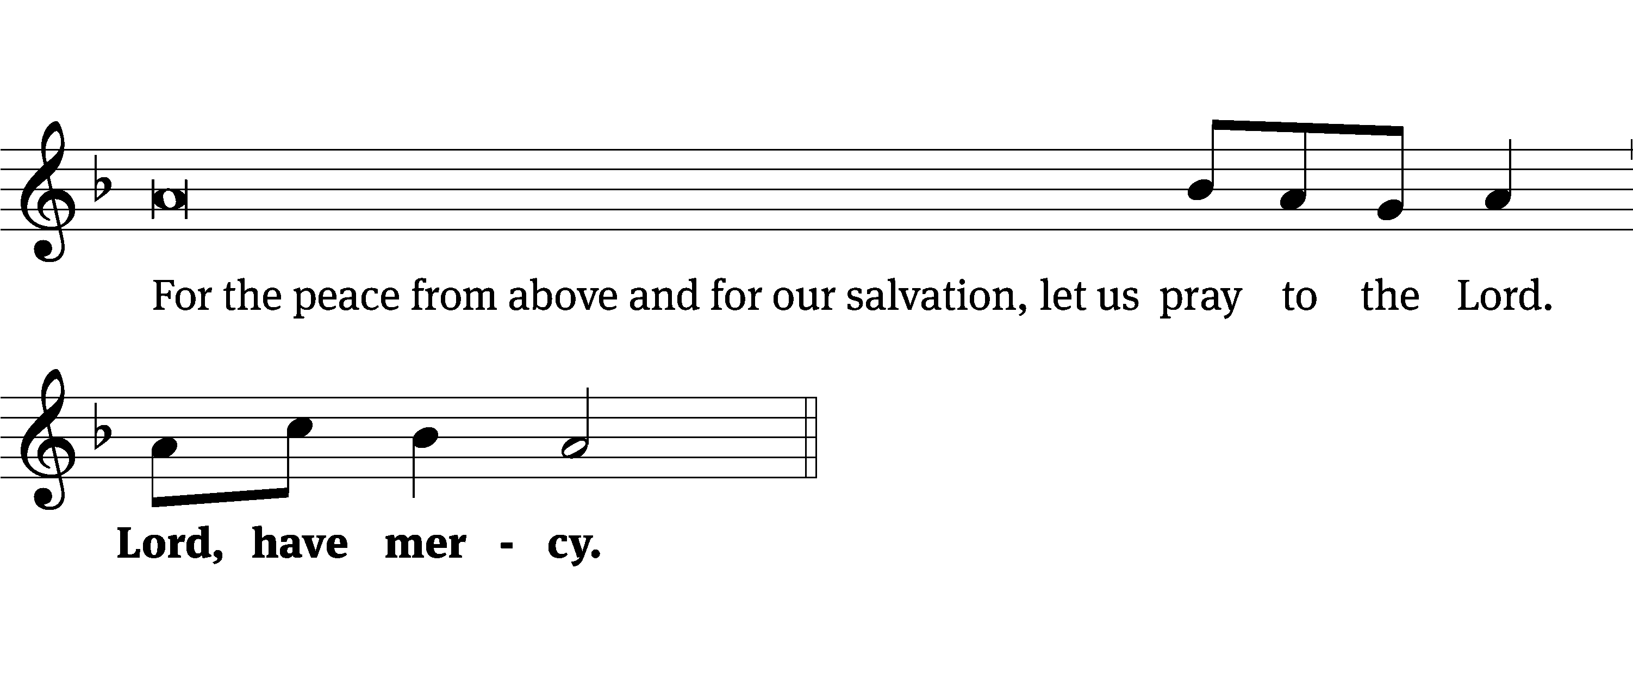
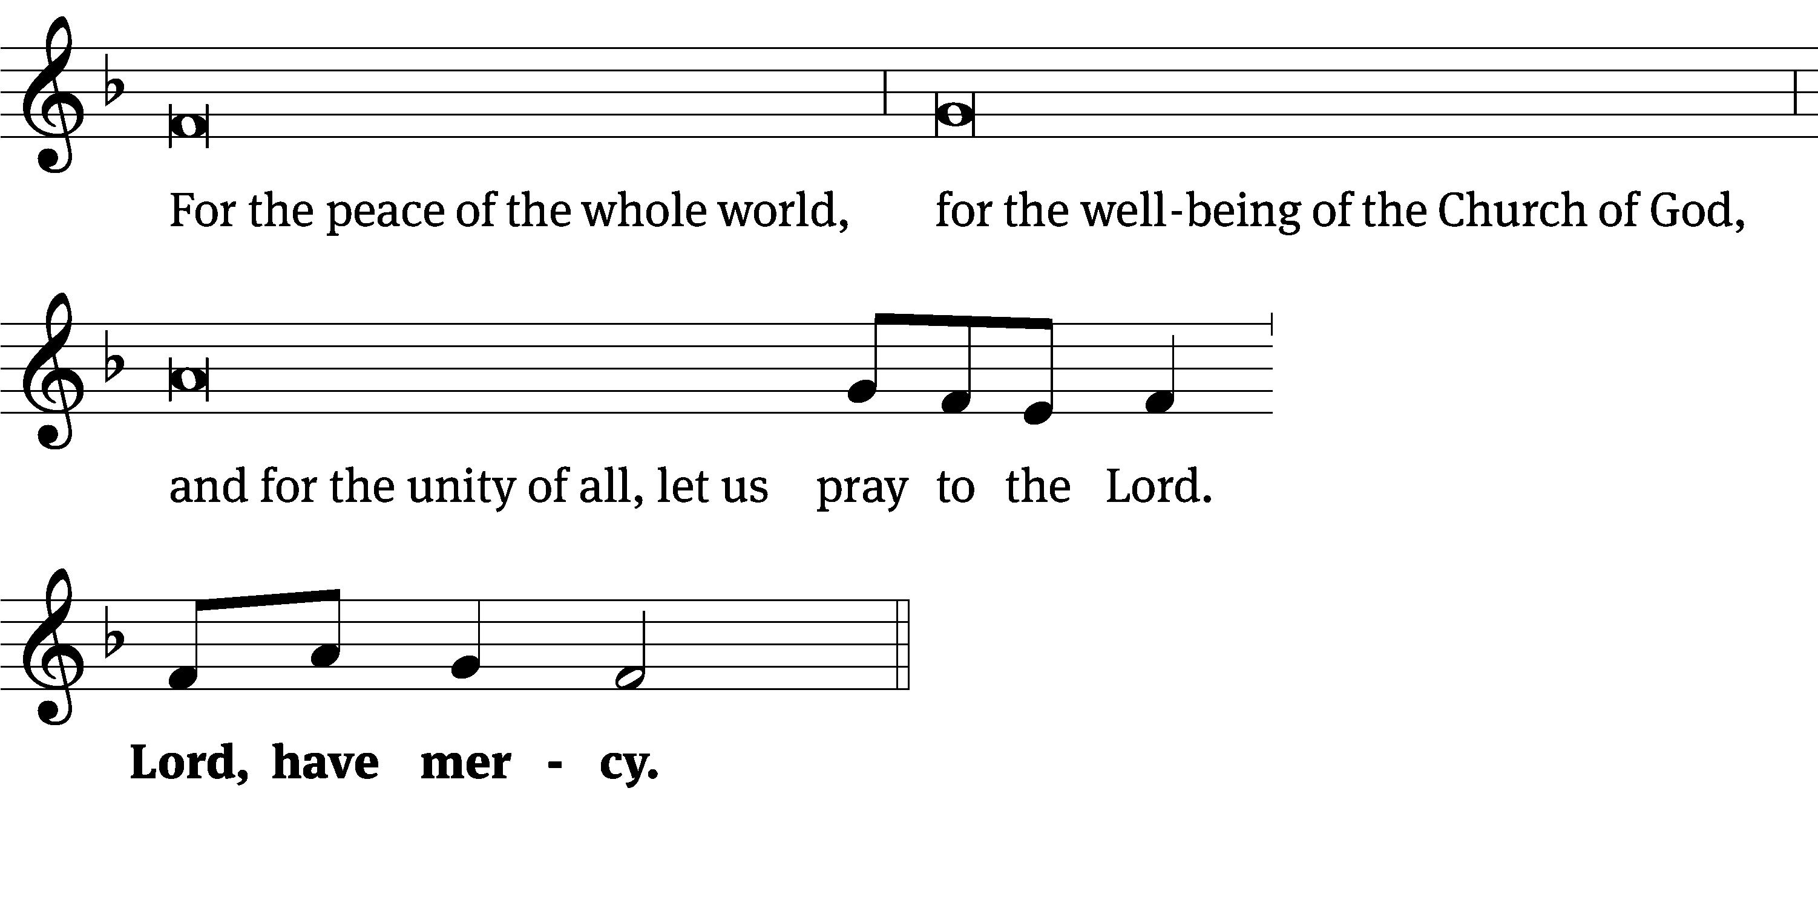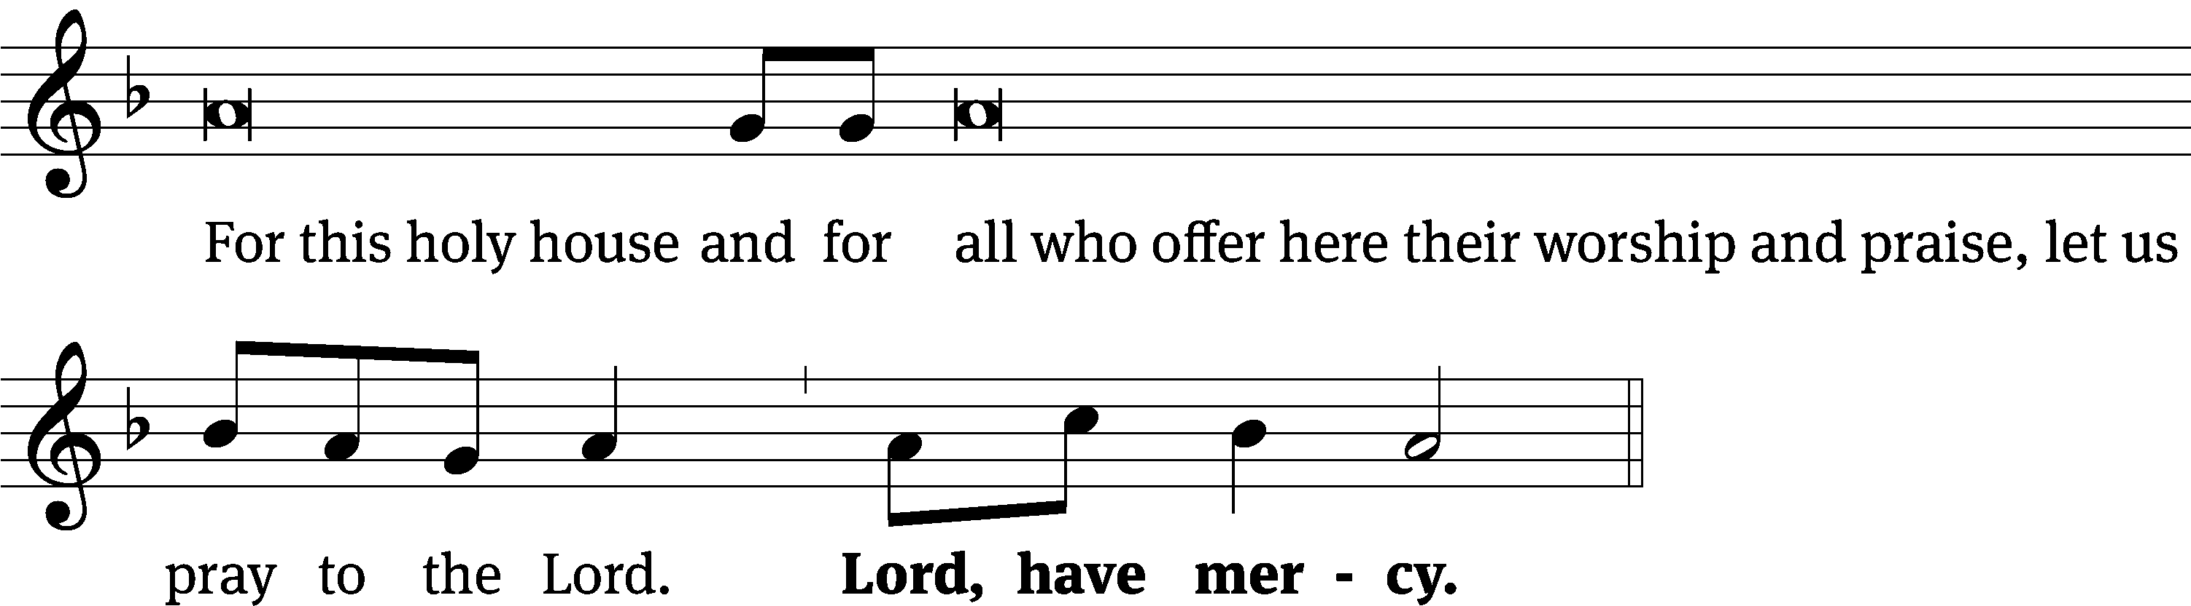
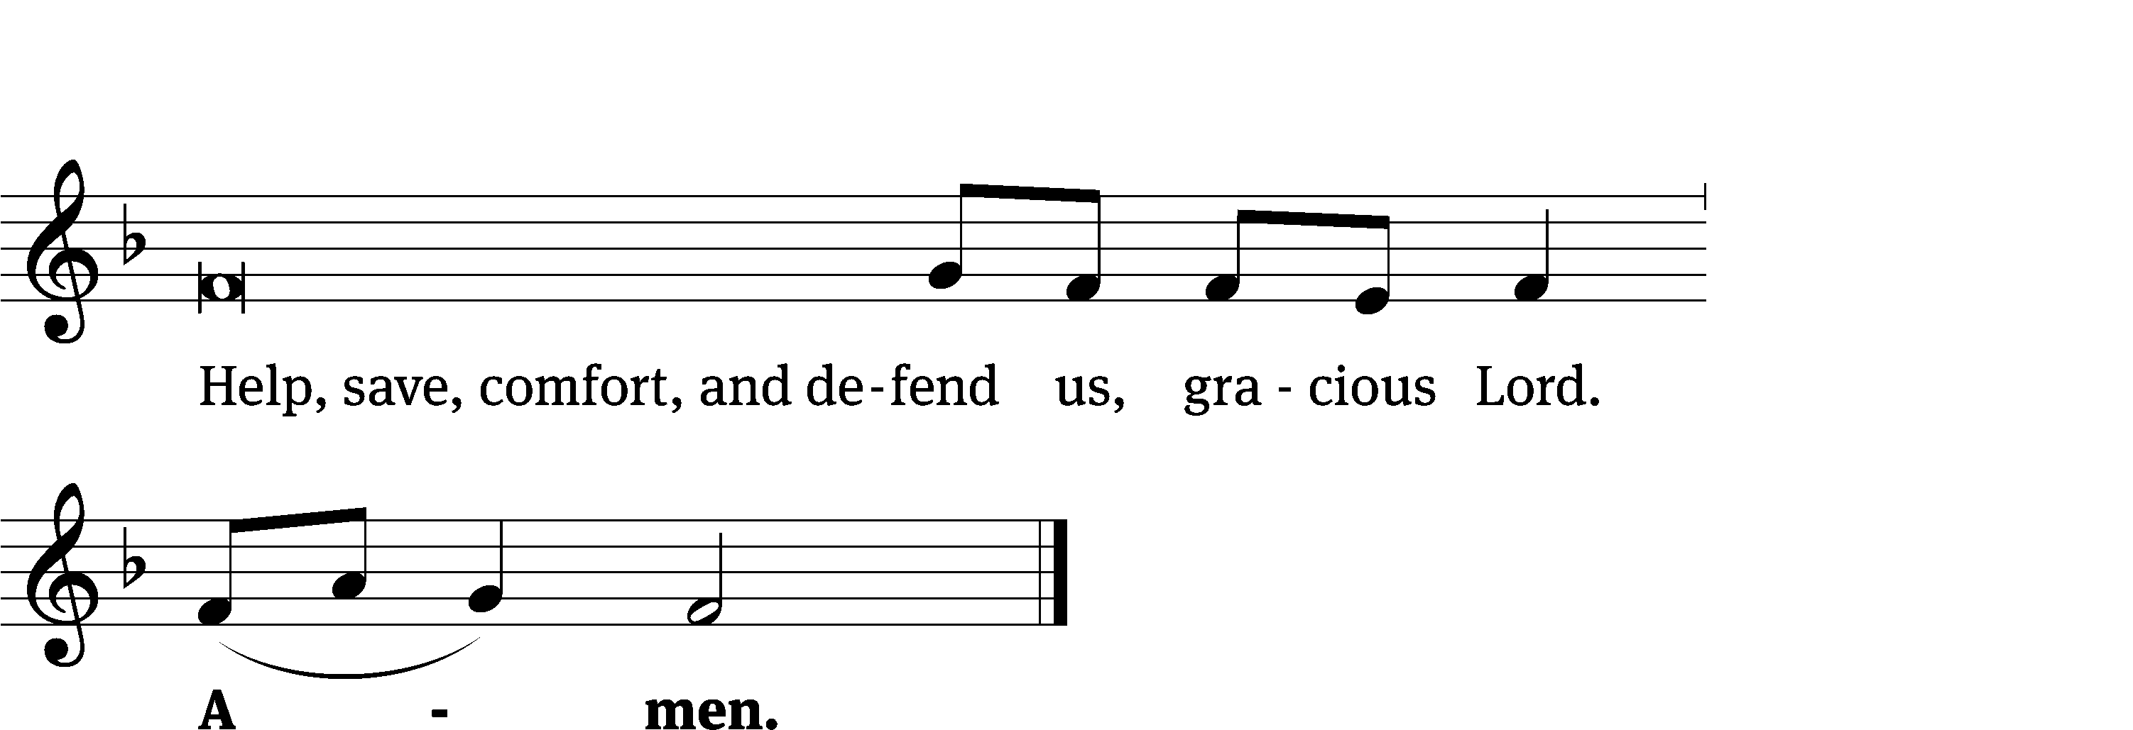

The Lord be with you.
And also with you.

Prayer of the Day
Let us pray.

Grant us, Lord, the spirit to think and do what is right that we, who cannot do anything that is good without you, may by your help be enabled to live according to your will; through your Son, Jesus Christ our Lord, who lives and reigns with you and the Holy Spirit, one God, now and forever.
Amen.

Please be seated

First Reading Exodus 20:1-17

20 Then God spoke all these words: ² I am the Lord your God, who brought you out from the land of Egypt, where you were slaves.
³ You shall have no other gods beside me. ⁴ You shall not make any carved image for yourself or a likeness of anything in heaven above, or on the earth below, or in the waters under the earth. ⁵ Do not bow down to them or be subservient to them, for I the Lord your God am a jealous God. I follow up on the guilt of the fathers with their children, their grandchildren, and their great-grandchildren, if they also hate me. ⁶ But I show mercy to thousands who love me and keep my commandments. ⁷ You shall not misuse the name of the Lord your God, for the Lord will not permit anyone who misuses his name to escape unpunished. ⁸ Remember the Sabbath day by setting it apart as holy. ⁹ Six days you are to serve and do all your regular work, ¹⁰ but the seventh day shall be a sabbath rest to the Lord your God. Do not do any regular work, neither you, nor your sons or daughters, nor your male or female servants, nor your cattle, nor the alien who is residing inside your gates, ¹¹ for in six days the Lord made the heavens and the earth, the sea, and everything that is in them, but he rested on the seventh day. In this way the Lord blessed the seventh day and made it holy. ¹² Honor your father and your mother so that you may spend many days on the land that the Lord your God is giving to you. ¹³ You shall not commit murder. ¹⁴ You shall not commit adultery. ¹⁵ You shall not steal. ¹⁶ You shall not give false testimony against your neighbor. ¹⁷ You shall not covet your neighbor’s house. You shall not covet your neighbor’s wife, his male servant, his female servant, his ox, his donkey, or anything else that belongs to your neighbor.
The Word of the Lord.
Thanks be to God.

19D God’s Glory Fills the Heavens Psalm 19D
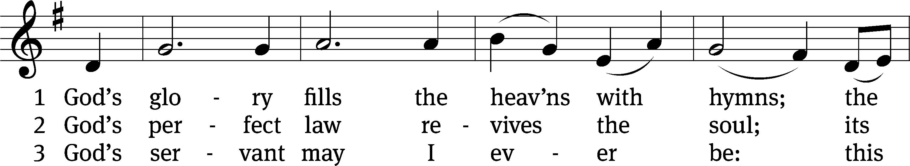
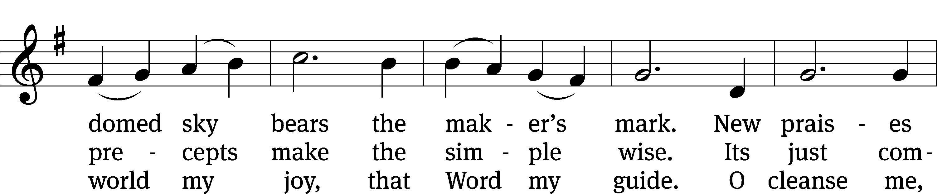
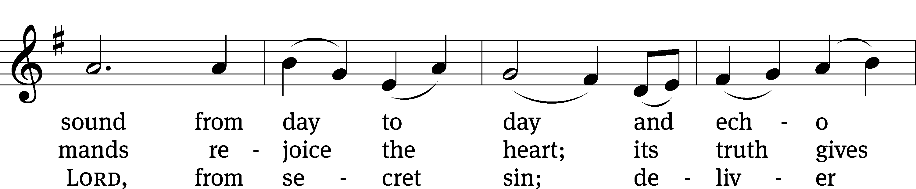
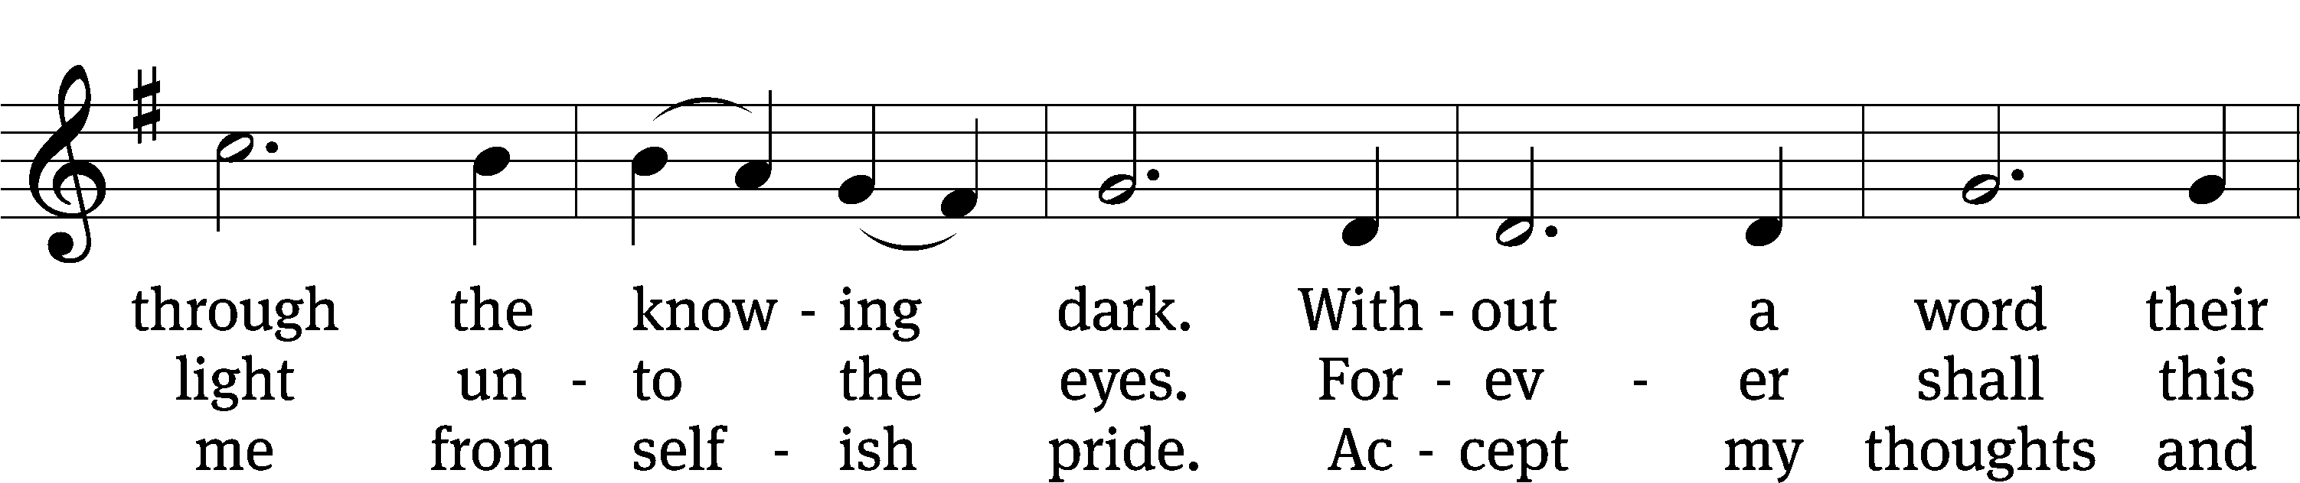
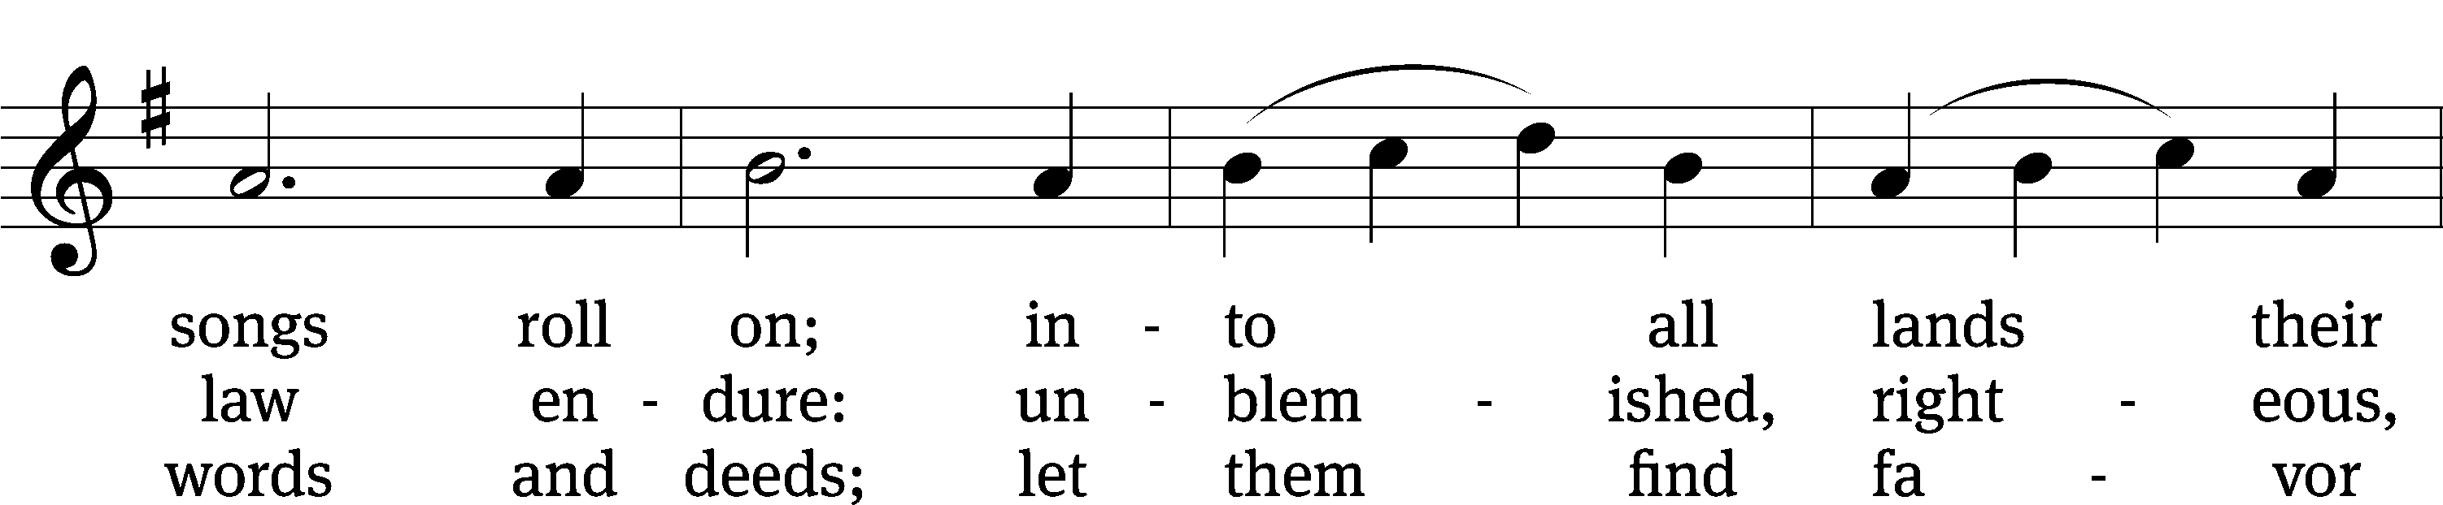
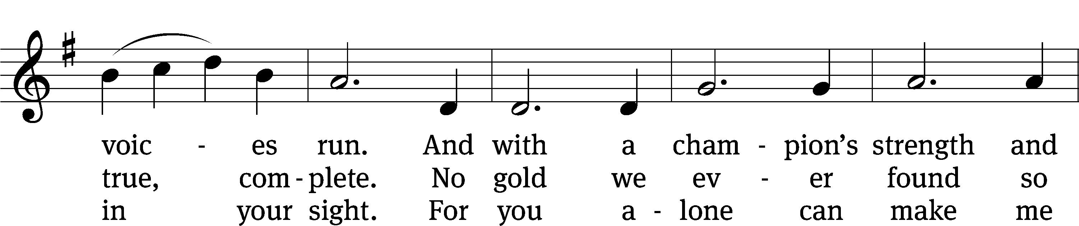
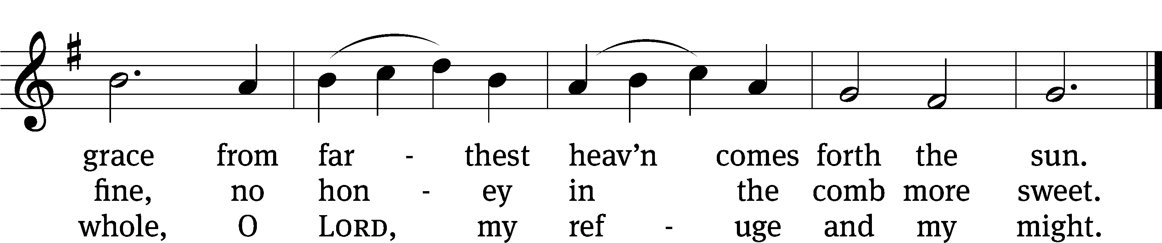
Text: Carl P. Daw, Jr.
Tune: Franz Joseph Haydn
Text: © 1989 Hope Publishing Co. Used by permission: OneLicense no. 727703
Tune: Public domain

Second Reading 1 Corinthians 1:18-25
¹⁸ For the message of the cross is foolishness to those who are perishing, but to us who are being saved, it is the power of God. ¹⁹ In fact, it is written: I will destroy the wisdom of the wise; the intelligence of the intelligent I will bring to nothing. ²⁰ Where is the wise man? Where is the expert in the Jewish law? Where is the probing thinker of the present age? Has God not shown that the wisdom of this world is foolish? ²¹ Indeed, since the world through its wisdom did not know God, God in his wisdom decided to save those who believe, through the foolishness of the preached message. ²² Yes, Jews ask for signs, Greeks desire wisdom, ²³ but we preach Christ crucified—which is offensive to Jews and foolishness to Greeks, ²⁴ but to those who are called, both Jews and Greeks, Christ is the power of God and the wisdom of God. ²⁵ We preach Christ crucified, because the foolishness of God is wiser than men, and the weakness of God is stronger than men.

The Word of the Lord.
Thanks be to God.
Please stand, if you are able

Gospel Acclamation Ezekiel 18:30,32
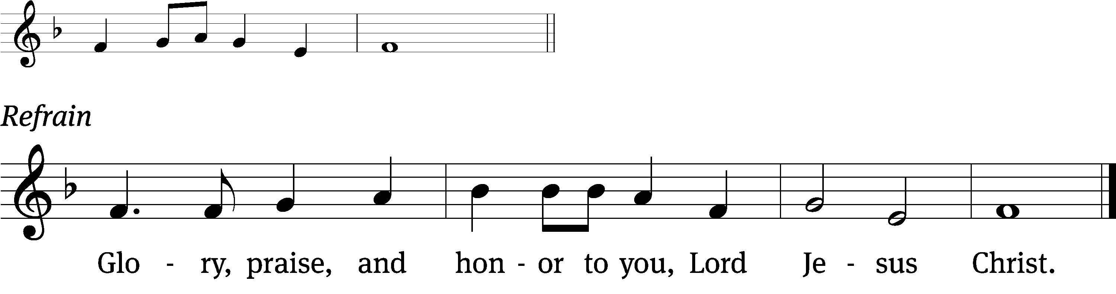
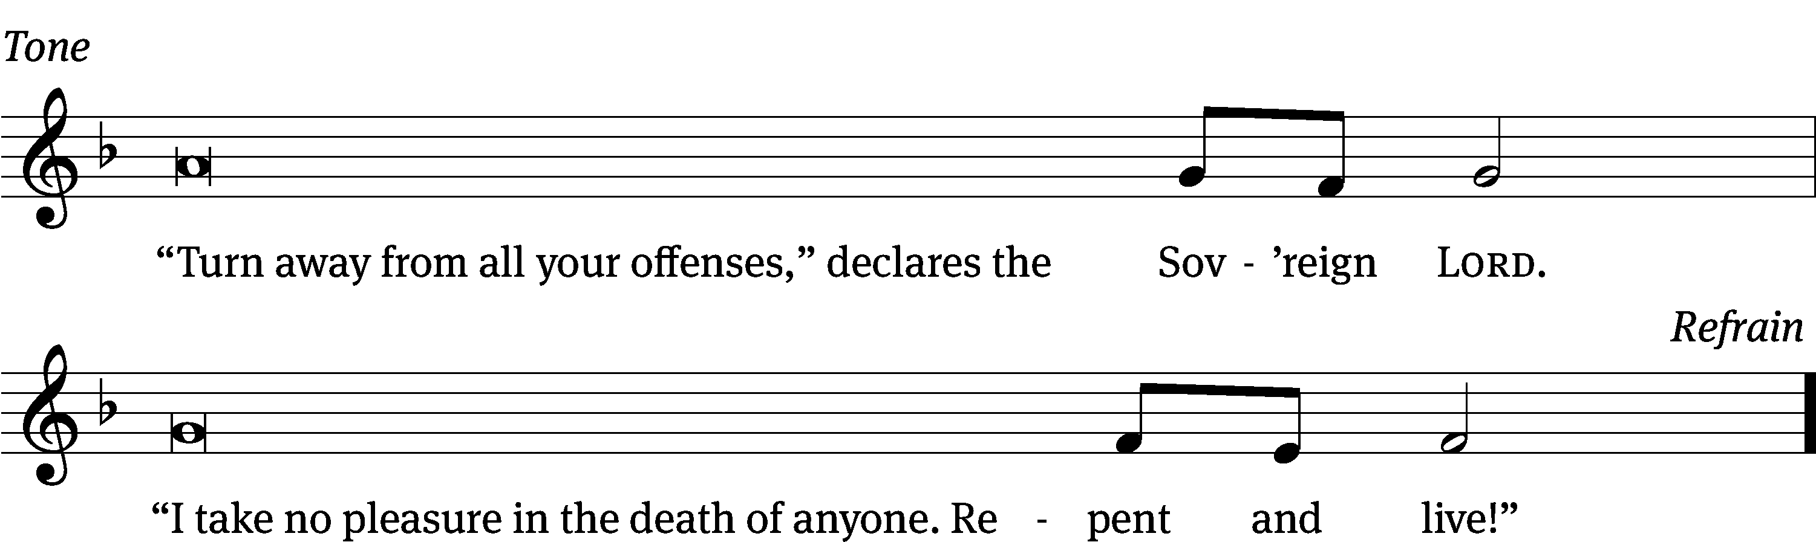
Tune: © 2021 Northwestern Publishing House. Used by permission: OneLicense no. 727703
Gospel John 2:13-22
¹³ The Jewish Passover was near, so Jesus went up to Jerusalem. ¹⁴ In the temple courts he found people selling cattle, sheep, and doves, and money changers sitting at tables. ¹⁵ He made a whip of cords and drove everyone out of the temple courts, along with the sheep and oxen. He scattered the coins of the money changers and overturned their tables. ¹⁶ To those selling doves he said, “Get these things out of here! Stop turning my Father’s house into a place of business!”¹⁷ His disciples remembered that it was written, “Zeal for your house will consume me.” ¹⁸ So the Jews responded, “What sign are you going to show us to prove you can do these things?” ¹⁹ Jesus answered them, “Destroy this temple, and in three days I will raise it up again.” ²⁰ The Jews said, “It took forty-six years to build this temple! And you are going to raise it in three days?” ²¹ But Jesus was speaking about the temple of his body. ²² When Jesus was raised from the dead, his disciples remembered that he had said this. Then they believed the Scripture and what Jesus had said.

The Gospel of the Lord.
Praise be to you, O Christ!

Please be seated

637 The Law of God Is Good and Wise CW 637
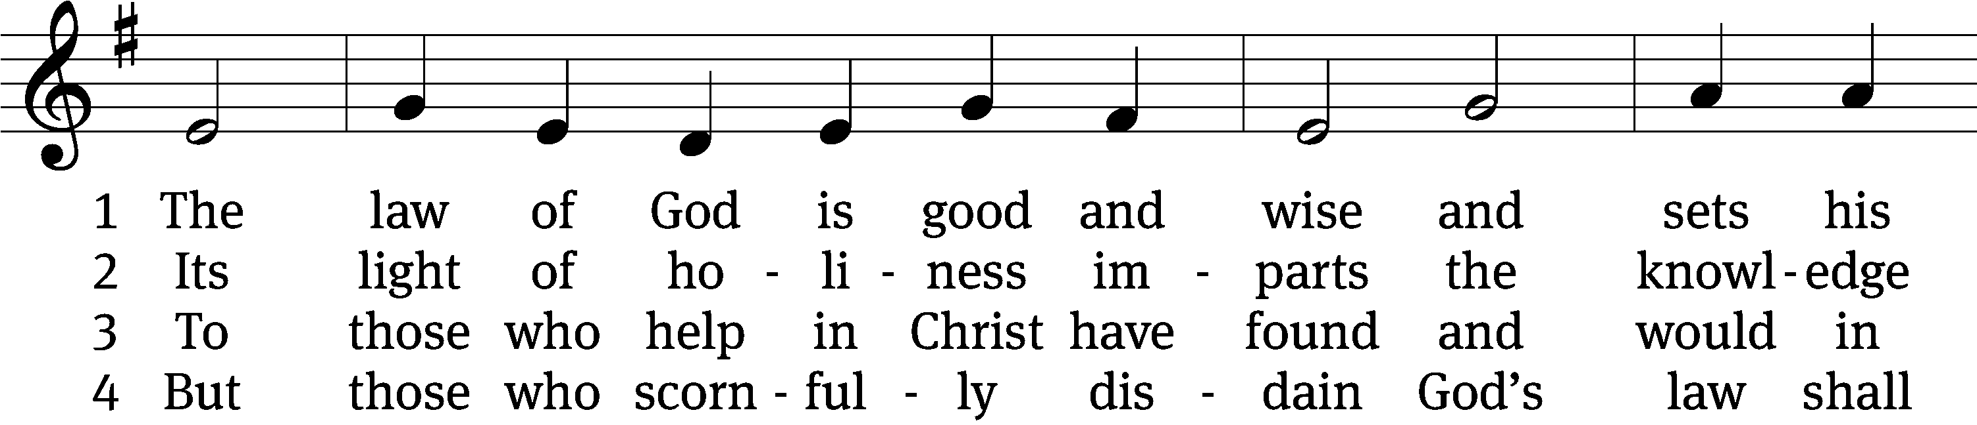
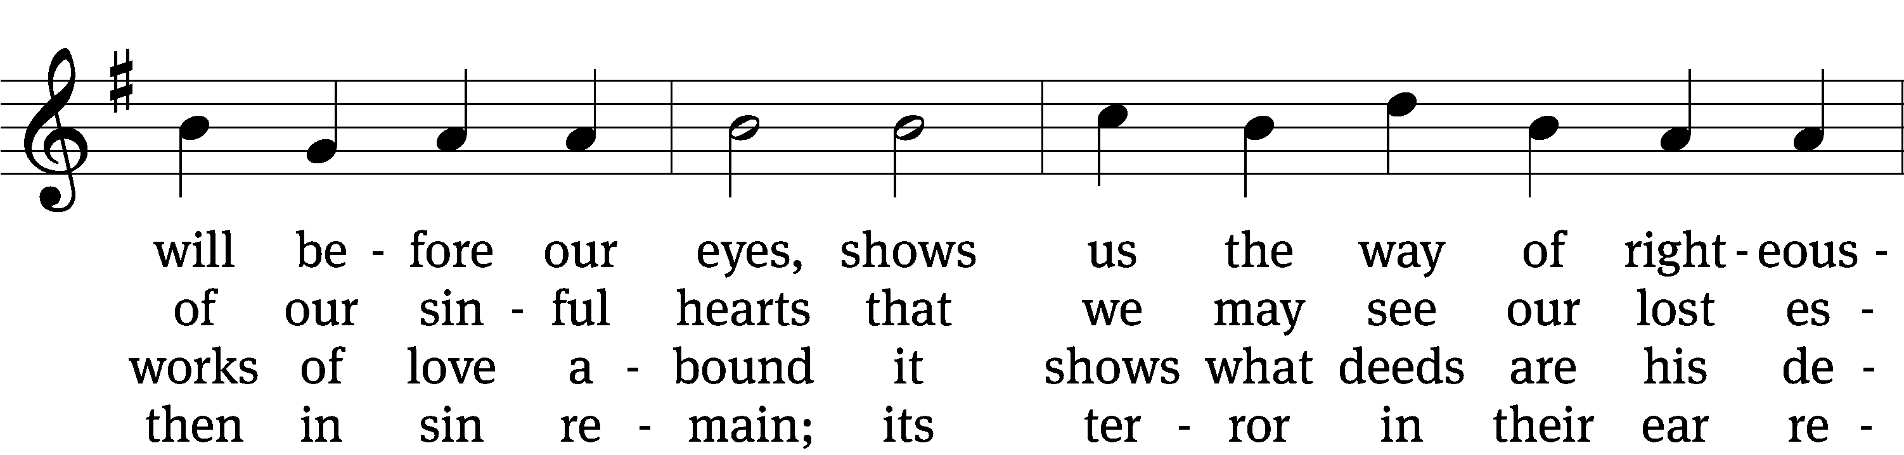
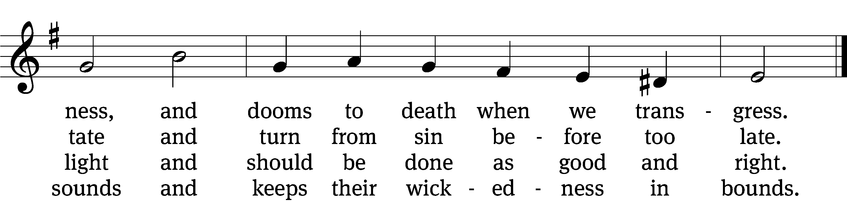

5 The law is good, but since the fall
its holiness condemns us all;
it dooms us for our sin to die
and has no pow’r to justify.

6 To Jesus we for refuge flee,
who from the curse has set us free,
and humbly worship at his throne,
saved by his grace through faith alone.
Text: Matthias Loy, 1828–1915, alt.
Tune: Geistliche Lieder zu Wittemberg, Wittenberg, 1543, ed. Joseph Klug
Text and tune: Public domain

SERMON Exodus 20:1-17
“What Does This Mean?”
Please stand, if you are able

nicene creed
We believe in one God, the Father, the Almighty, maker of heaven and earth, of all that is, seen and unseen.
We believe in one Lord, Jesus Christ, the only Son of God, eternally begotten of the Father, God from God, Light from Light, true God from true God, begotten, not made, of one being with the Father. Through him all things were made. For us and for our salvation, he came down from heaven, was incarnate of the Holy Spirit and the virgin Mary, and became truly human. For our sake he was crucified under Pontius Pilate. He suffered death and was buried. On the third day he rose again in accordance with the Scriptures. He ascended into heaven and is seated at the right hand of the Father. He will come again in glory to judge the living and the dead, and his kingdom will have no end.
We believe in the Holy Spirit, the Lord, the giver of life, who proceeds from the Father and the Son, who in unity with the Father and the Son is worshiped and glorified, who has spoken through the prophets. We believe in one holy Christian and apostolic Church. We acknowledge one baptism for the forgiveness of sins. We look for the resurrection of the dead and the life of the world to come. Amen.
Prayer of the Church

The Sacrament
Preface CW 165
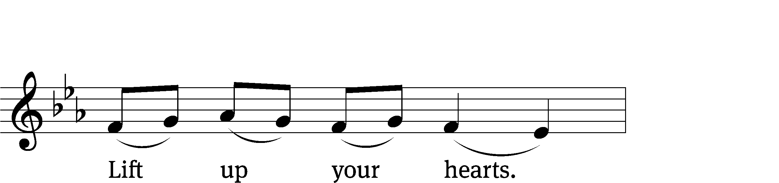
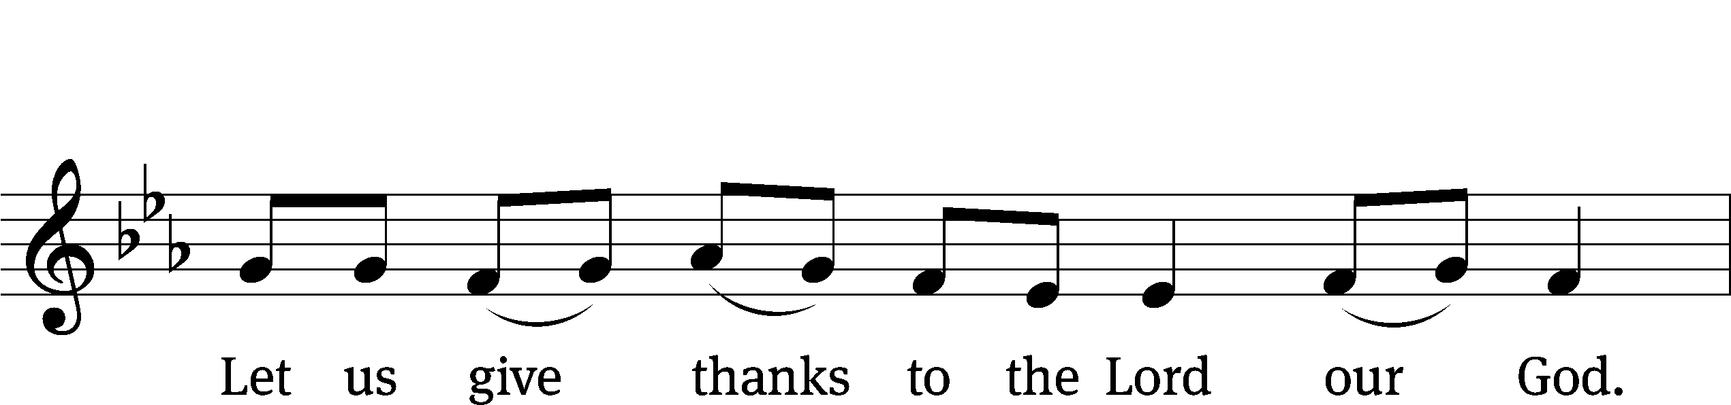
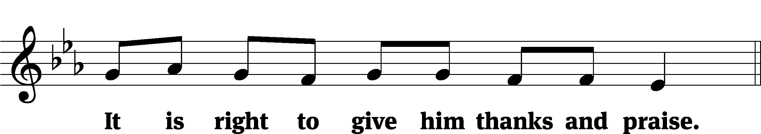

It is truly good and right that we should at all times and in all places give you thanks, O Lord, holy Father, almighty and everlasting God, through Jesus Christ our Lord, who by his willing sacrifice on the cross took away the sins of the world and by his glorious resurrection restored everlasting life. Therefore, with all the saints on earth and hosts of heaven, we praise your holy name and join their glorious song:

Holy, Holy, Holy CW 167
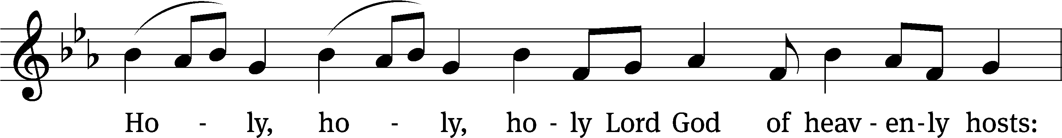
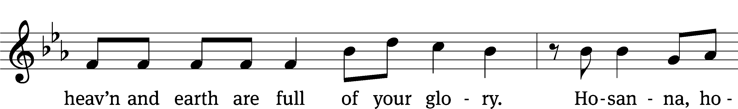
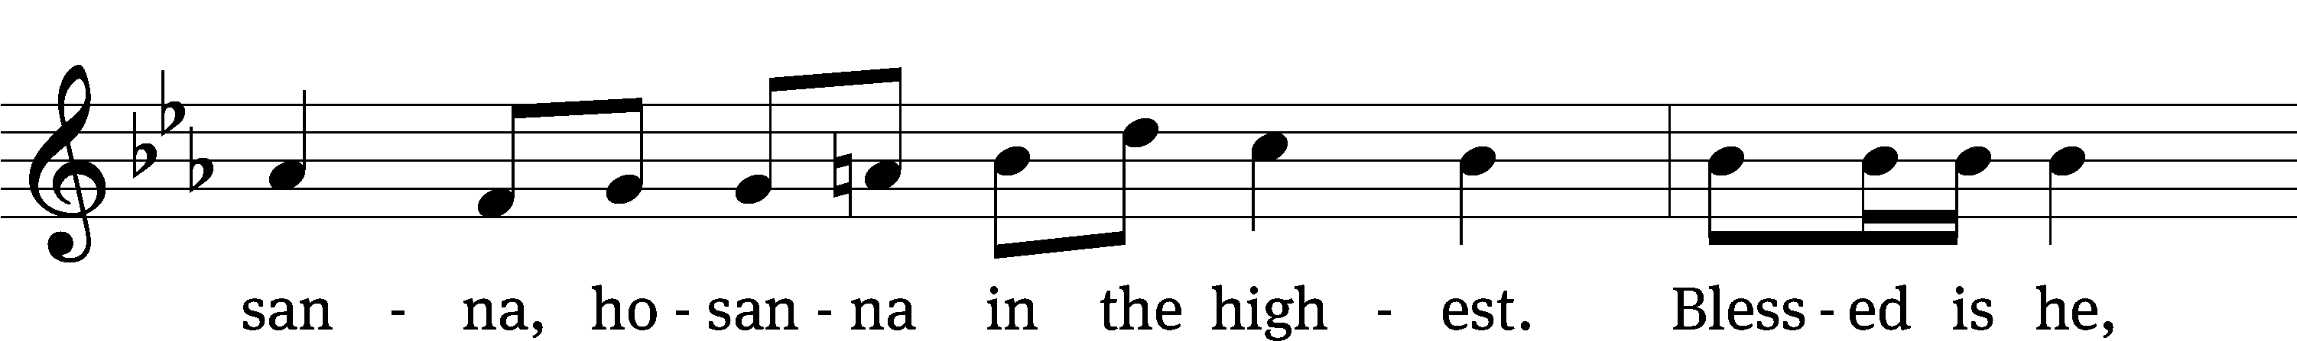
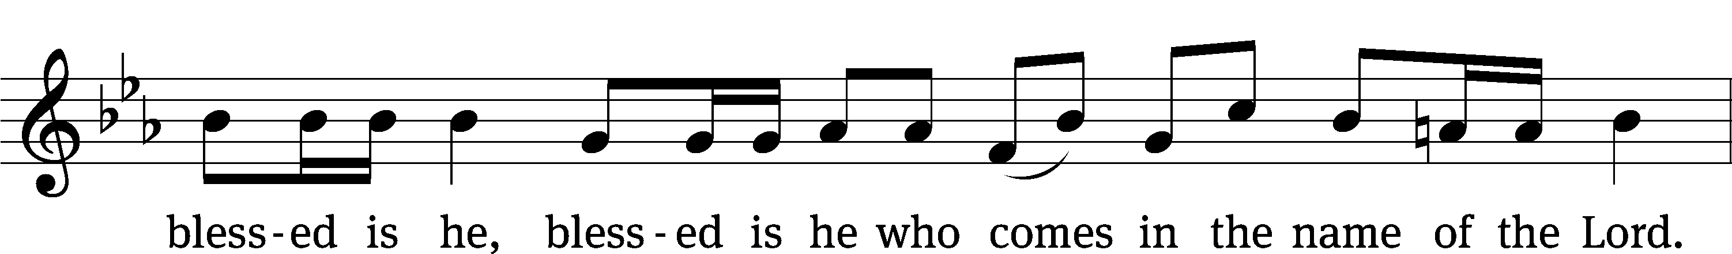
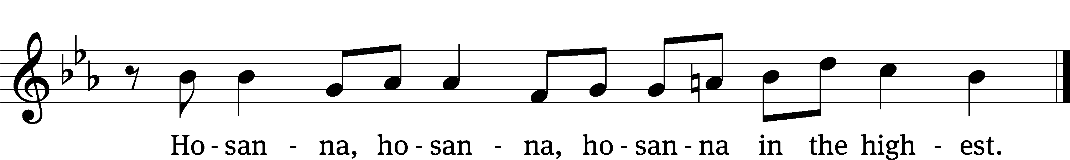

Prayer of Thanksgiving
We give thanks to you, O God, through your dear Son, Jesus Christ, whom you sent to be our Savior, our Redeemer, and the messenger of your grace. Through him you made all things; in him you are well pleased. He is the incarnate Word, conceived by the Holy Spirit and born of the Virgin Mary. To fulfill your promises, he stretched out his hands on the cross and released from eternal death all who believe in you.

As we remember Jesus’ death and resurrection, we thank you that you have gathered us together to receive your Son’s body and blood. Send us your Spirit, unite us as one, and strengthen our faith so that we may praise you in your Son, Jesus Christ. Through him, we glorify and honor you, O God our Father, with the Holy Spirit, one God, now and forever.
Amen.

Lord’s Prayer
Our Father, who art in heaven, hallowed be thy name, thy kingdom come, thy will be done on earth as it is in heaven. Give us this day our daily bread; and forgive us our trespasses, as we forgive those who trespass against us; and lead us not into temptation, but deliver us from evil. For thine is the kingdom and the power and the glory forever and ever. Amen.

Words of Institution
Our Lord Jesus Christ, on the night he was betrayed, took bread; and when he had given thanks, he broke it and gave it to his disciples, saying, “Take and eat; this is my body, which is given for you. Do this in remembrance of me.”
Then he took the cup, gave thanks, and gave it to them, saying, “Drink from it, all of you; this is my blood of the new covenant, which is poured out for you for the forgiveness of sins. Do this, whenever you drink it, in remembrance of me.”

The peace of the Lord be with you always.
Amen.

O Christ, Lamb of God CW 169
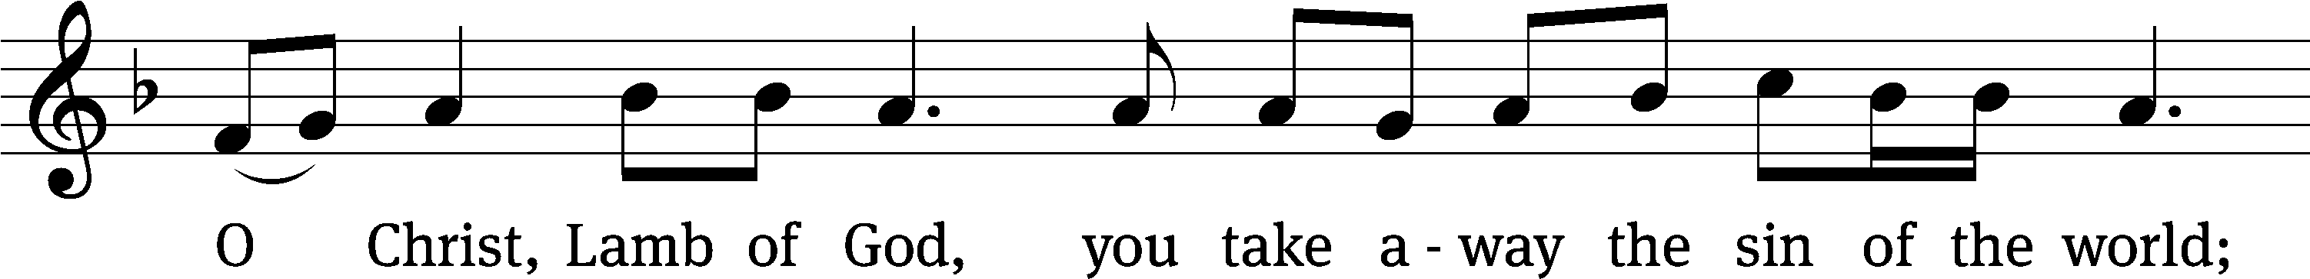
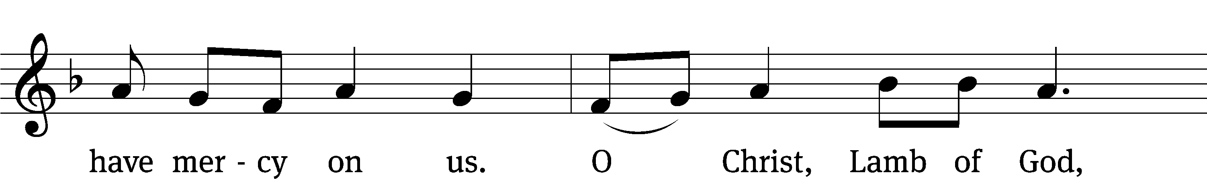
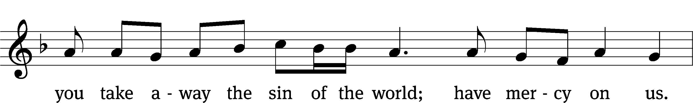
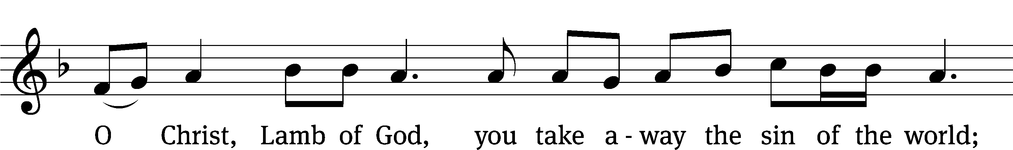
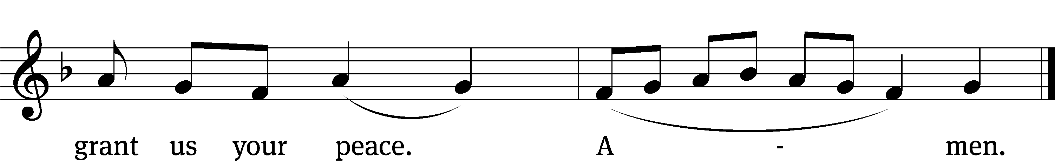
558 Salvation unto Us Has Come CW 558
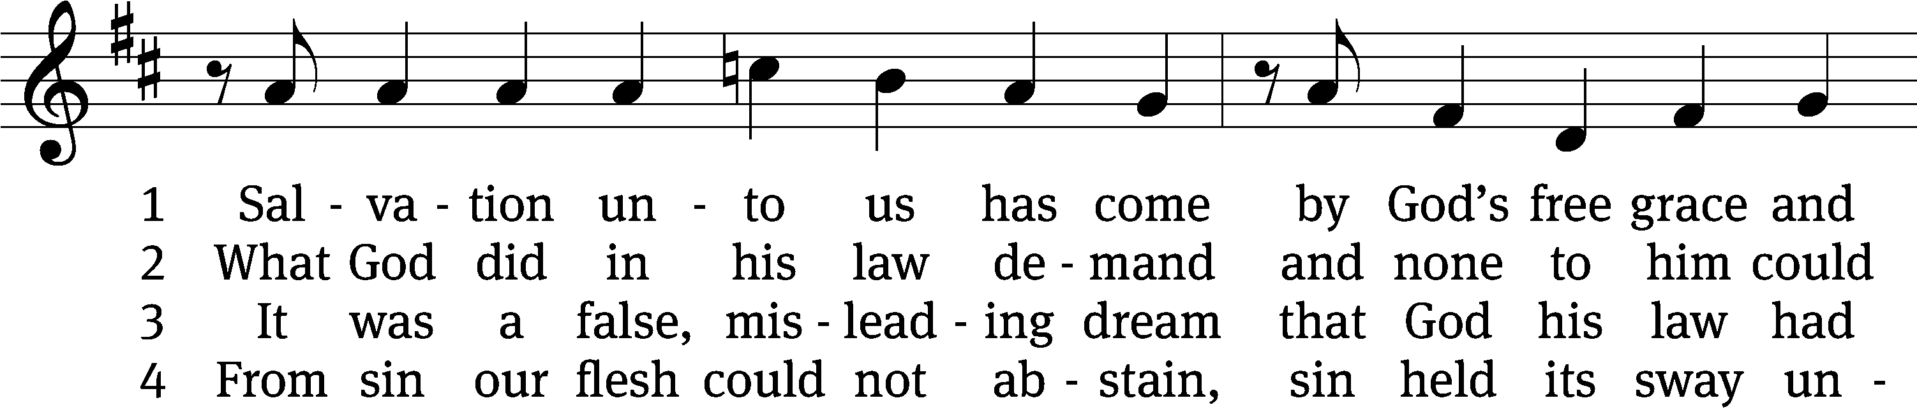
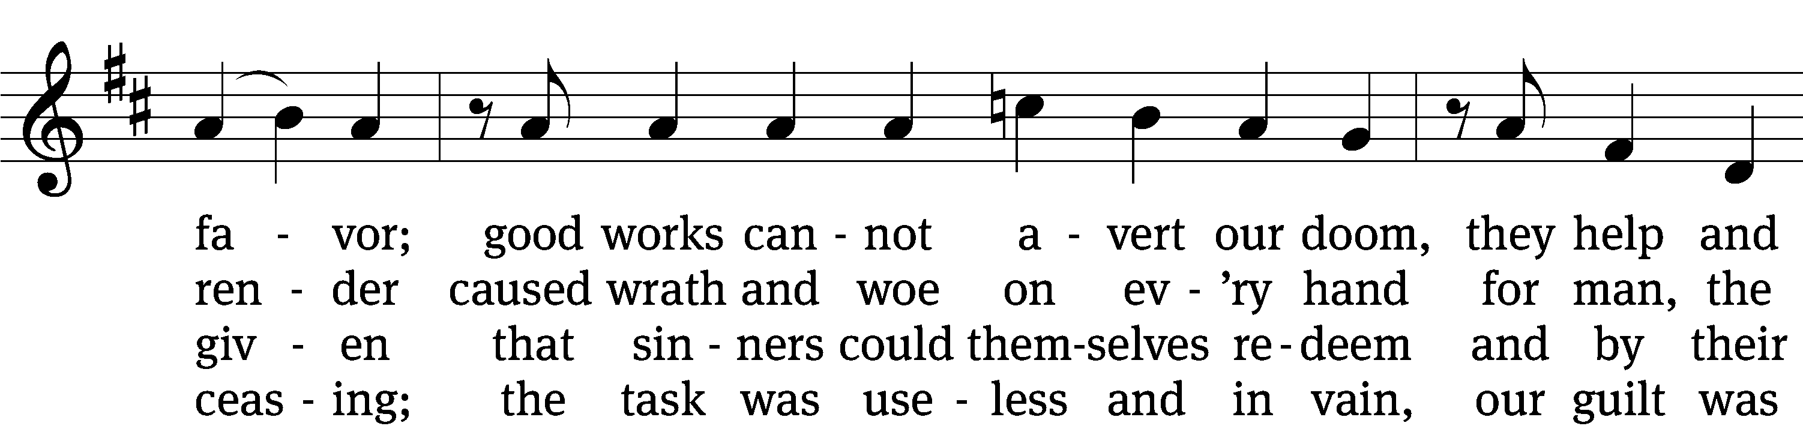
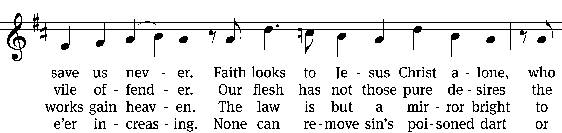
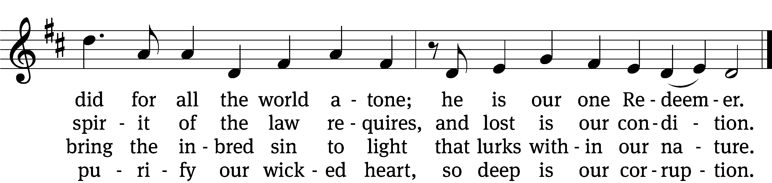

5 Yet as the law must be fulfilled
or we must die despairing,
Christ came and has God’s anger stilled,
our human nature sharing.
He has for us the law obeyed
and thus the Father’s vengeance stayed
which over us impended.

6 Since Christ has full atonement made
and brought to us salvation,
each Christian therefore may be glad
and build on this foundation.
Your grace alone, dear Lord, I plead,
your death is now my life indeed,
for you have paid my ransom.

7 Let me not doubt, but truly see
your Word cannot be broken;
your call rings out, “Come unto me!”
No falsehood have you spoken.
Baptized into your precious name,
my faith cannot be put to shame,
and I shall never perish.

8 The law reveals the guilt of sin
and makes us conscience-stricken;
but then the gospel enters in
the sinful soul to quicken.
Come to the cross, trust Christ, and live;
the law no peace can ever give,
no comfort and no blessing.

9 Faith clings to Jesus’ cross alone
and rests in him unceasing;
and by its fruits true faith is known,
with love and hope increasing.
For faith alone can justify;
works serve our neighbor and supply
the proof that faith is living.

10 All blessing, honor, thanks, and praise
to Father, Son, and Spirit,
the God who saved us by his grace;
all glory to his merit!
O triune God in heav’n above,
you have revealed your saving love;
your blessèd name be hallowed!
Text: tr. The Lutheran Hymnal, 1941, alt.; Paul Speratus, 1484–1551, abr., alt.
Tune: Etlich Cristlich lider, Wittenberg, 1524
Text and tune: Public domain

Please stand, if you are able

Give thanks to the Lord, for he is good;
his mercy endures forever.

Whenever we eat this bread and drink this cup,
we proclaim the Lord’s death until he comes.

We give thanks, almighty God, that you have refreshed us with this saving gift. We pray that through it you will strengthen our faith in you and increase our love for one another. We ask this in the name of Jesus Christ our Lord, who lives and reigns with you and the Holy Spirit, one God, now and forever.
Amen.

Blessing
The Lord bless you and keep you.
The Lord make his face shine on you and be gracious to you.
The Lord look on you with favor and give you peace.
Amen.

Please be seated

407 When I Survey the Wondrous Cross CW 407
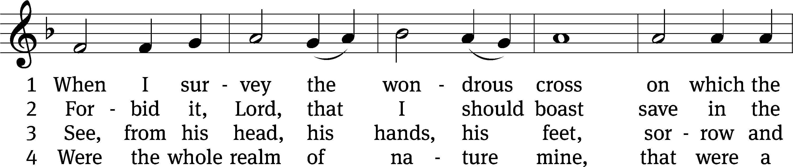
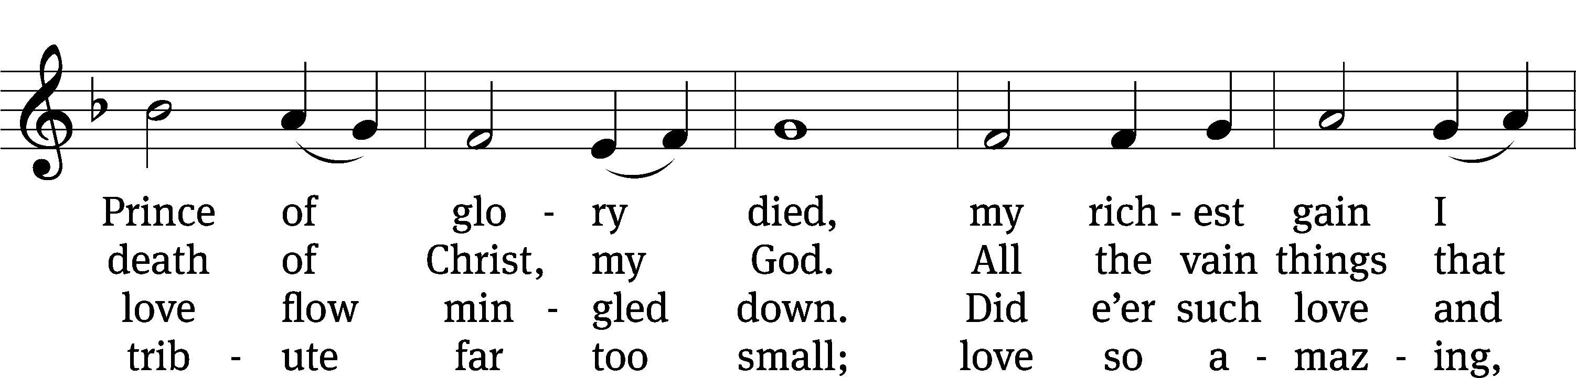
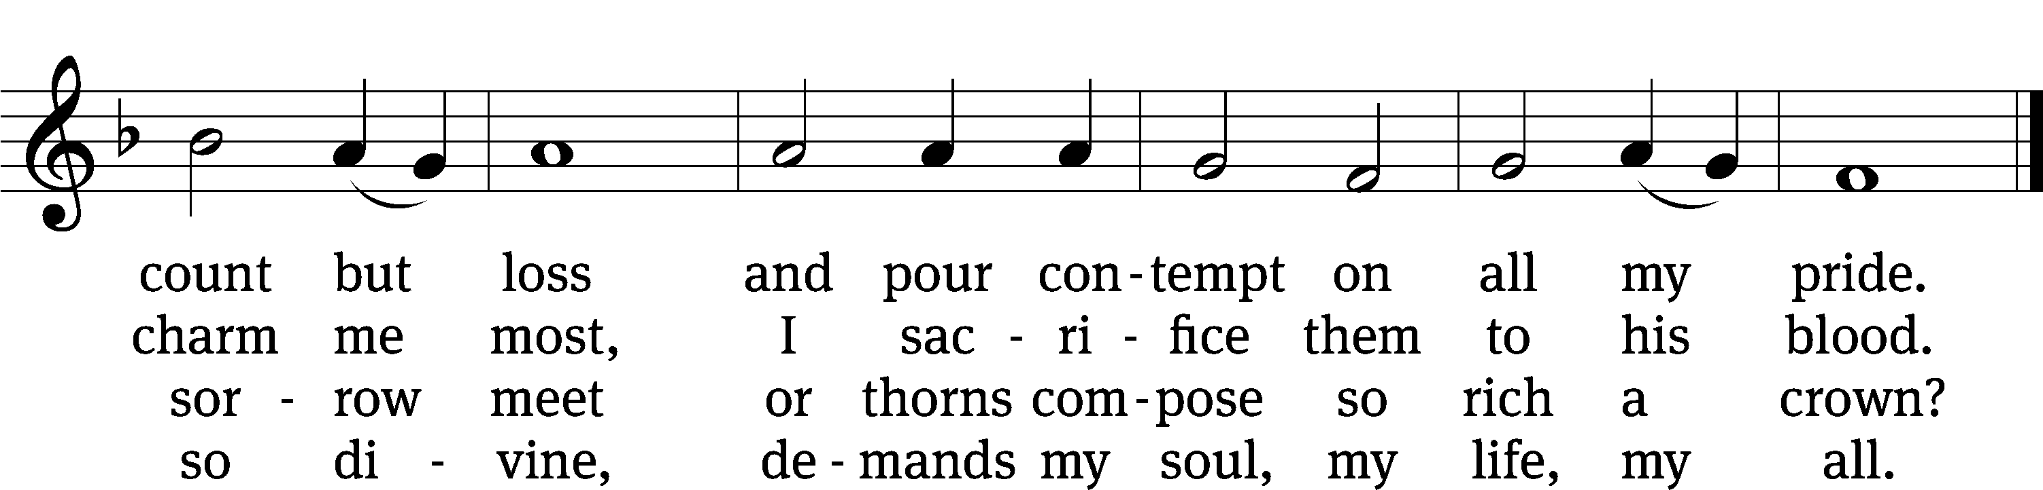
Text: Isaac Watts, 1674–1748, abr., alt.
Tune: Lowell Mason, 1792–1872
Text and tune: Public domain

Acknowledgments
Setting One from Christian Worship
Software distributed in partnership with Northwestern Publishing House.
Created by Christian Worship: Service Builder © 2022 Concordia Publishing House.
Serving in Worship
Officiant Pastor Natsis
Organist Sarah Hanke
Sunday School Director Marcia Marion
Soloist Ryan Phelps
Deacons (8:30) Duane Mason and Dave Stevenson
(11:00) Gary Knowlton and Robert Niethammer
Ushers (8:30) Dale Finkbeiner and Mark Finkbeiner
(11:00) Dave Boswell and Jake Vershum
Altar Guild Jean Fiegel and Ann Latowski
Videographer Jeff Neuburger

