THE Fifth SUNDAY
in lent

TRINITY EVANGELICAL LUTHERAN CHURCH | Saline, Michigan
WELCOME TO WORSHIP March 17, 2024

Thank you for joining us in God’s house today! We cordially ask that our guests sign one of the guestbooks located at either the front or back entryways.

THANK OFFERING: Members of Trinity give their offering as an expression of love and thankfulness to the Lord and to help support the Lord’s work in our community and around the world. Visitors need not feel obligated to participate in this offering which supports our ministry.

Restrooms are located at the back of the upper level (the annex), and in the basement (down the back stairs of the sanctuary or annex). Handicap access is available, please ask an usher for assistance.

celebration of holy communion:
In His Word, God makes it clear that the Lord’s Supper is to be shared by people of a common proclamation of faith (1 Corinthians 11:26; 1 Corinthians 10:16-17). Without judging anyone’s hearts, we invite those who share in our confession by their membership in our congregation or another congregation of the Wisconsin Evangelical Lutheran Synod (WELS) or the Evangelical Lutheran Synod (ELS) and who are properly prepared (1 Corinthians 11;27-29) to receive the Sacrament. Page 295 in the front of Christian Worship provides a guide for preparation.

Guests, we would love to have you join us in communion fellowship in the future, and for that to be possible, we ask that you speak with one of the pastors so that we may speak with you on how that would be possible. We thank you for respecting the way we celebrate the Lord’s Supper in our congregations.

SERVICE OF WORD AND SACRAMENT

Bell Choir (11 a.m.) “God of Grace and God of Glory”
878 Christ Alone the World’s Redeemer CW 878
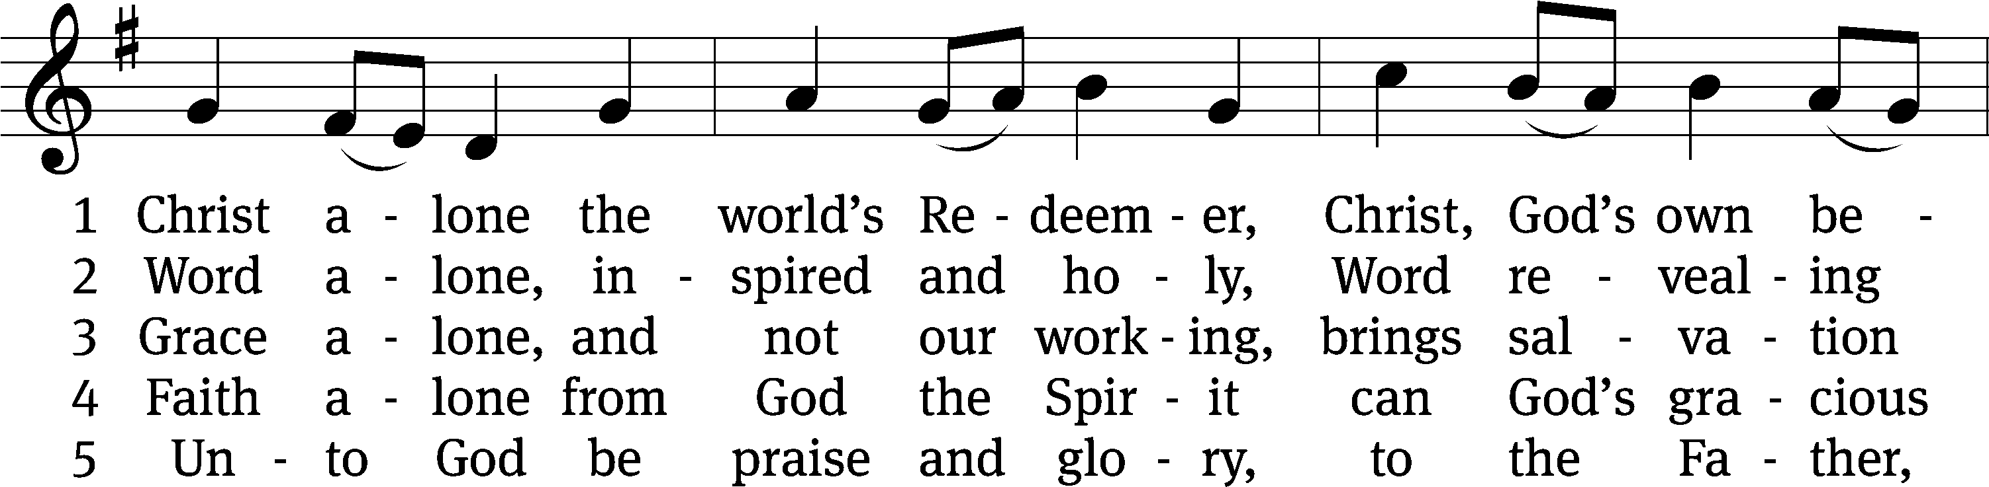
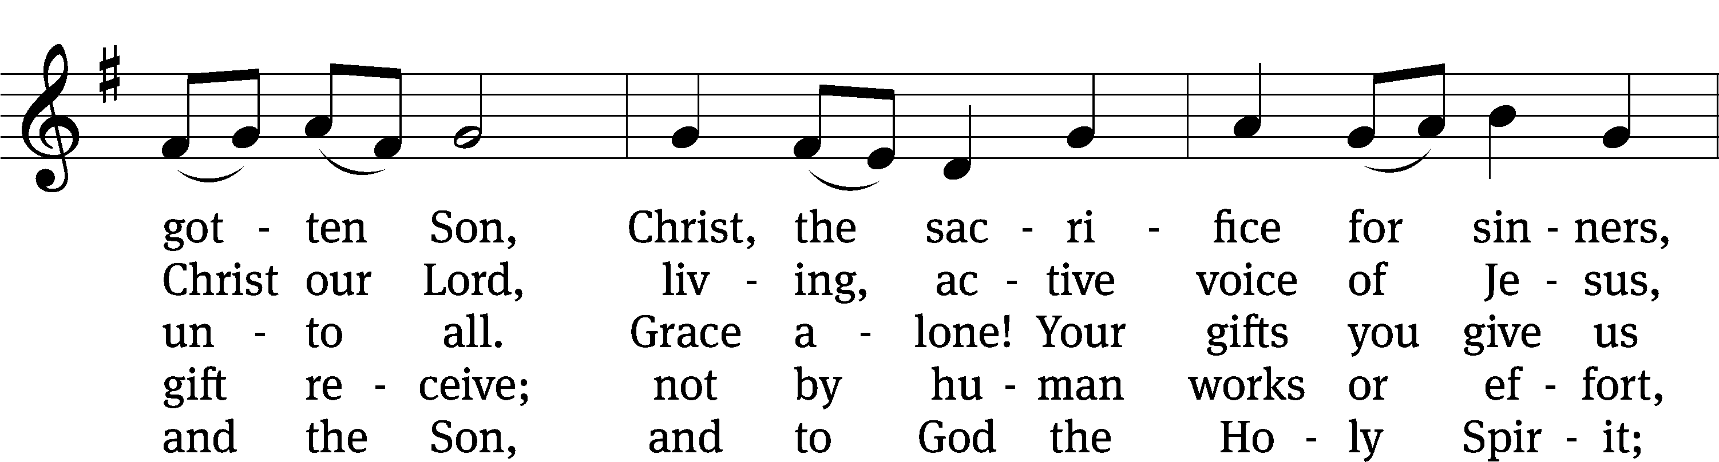
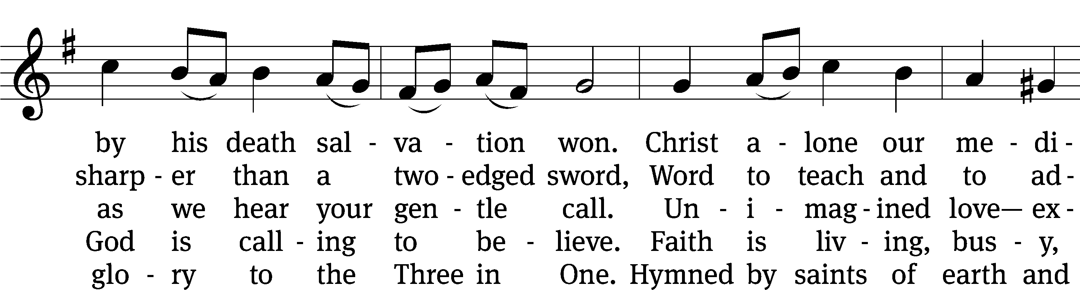
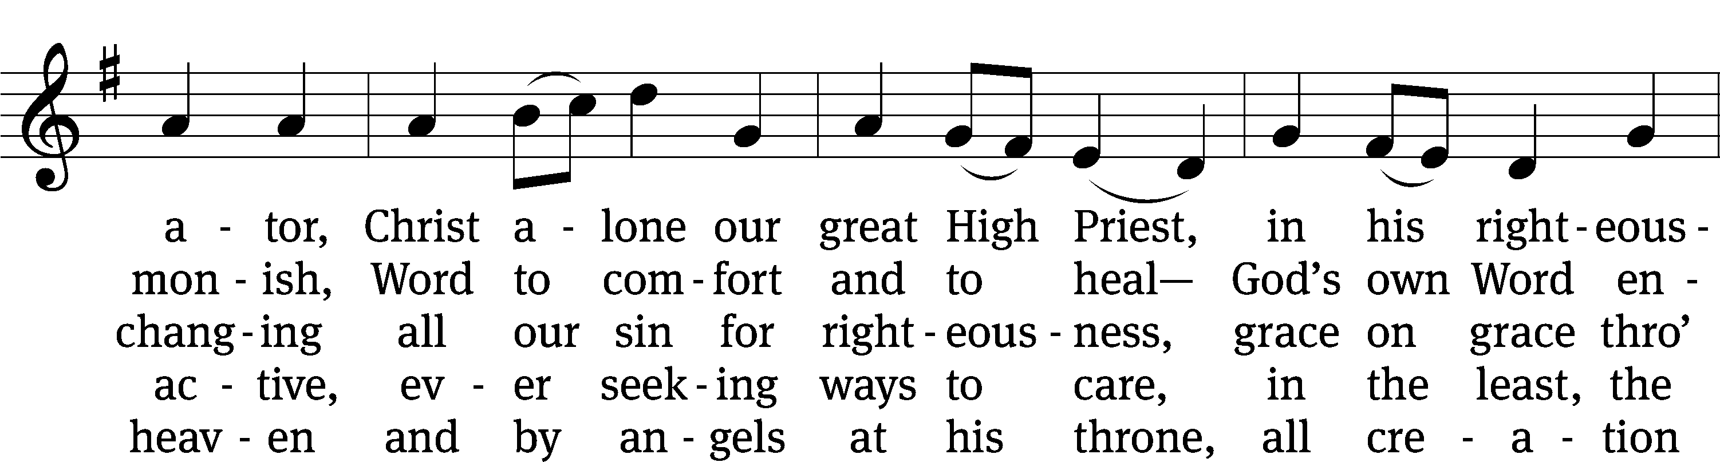
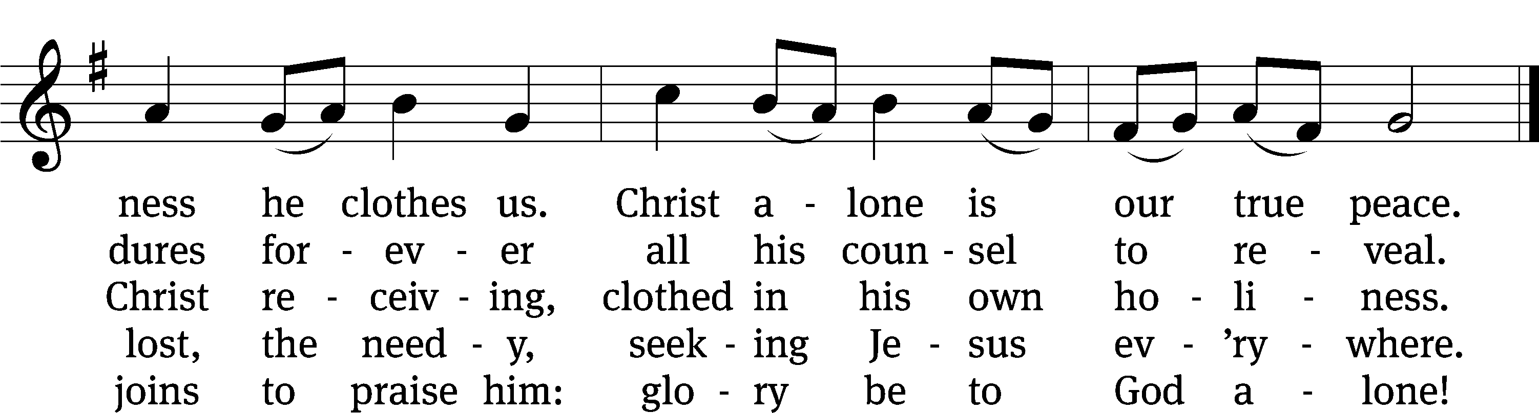
Text: Steven P. Mueller, b. 1964
Tune: Oude en Nieuwe Hollantse . . . Contradanseu, Amsterdam, c. 1710
Text: © 2017 Steven P. Mueller. Used by permission: OneLicense no. 727703
Tune: Public domain

PLEASE STAND, IF YOU ARE ABLE

invocation

M: The grace of our Lord (+) Jesus Christ and the love of God and the fellowship of the Holy Spirit be with you.
C: And also with you.

CONFESSION OF SINS
M: God invites us to come into his presence and worship him with humble and penitent hearts. Therefore, let us acknowledge our sinfulness and ask him to forgive us.
C: Holy and merciful Father, I confess that I am by nature sinful, and that I have disobeyed you in my thoughts, words, and actions. I have done what is evil and failed to do what is good. For this I deserve your punishment both now and in eternity. But I am truly sorry for my sins, and trusting in my Savior Jesus Christ, I pray: Lord, have mercy on me, a sinner.
M: God, our heavenly Father, has been merciful to us and has given his only Son to be the atoning sacrifice for our sins. Therefore, as a called servant of Christ and by his authority, I forgive you all your sins in the name of the Father and of the Son (+) and of the Holy Spirit.
C: Amen.

PRAYER AND PRAISE
LORD, HAVE MERCY
M: For all that we need in life and for the wisdom to use all your gifts with gratitude and joy, hear our prayer, O Lord.

M: For the steadfast assurance that nothing can separate us from your love and for the courage to stand firm against the assaults of Satan and every evil, hear our prayer, O Christ.

M: For the well-being of your holy Church in all the world and for those who offer here their worship and praise, hear our prayer, O Lord.

M: Merciful God, maker and preserver of life, uphold us by your power and keep us in your tender care:

M: The works of the Lord are great and glorious; his name is worthy of praise

Prayer of the day

M: Let us pray.

Eternal God and Father, help us to remember Jesus, who obeyed your will and bore the cross for our salvation, that through his anguish, pain, and death we may receive the forgiveness of sins, victory over the grave, and finally inherit eternal life; through your Son, Jesus Christ our Lord, who lives and reigns with you and the Holy Spirit, one God, now and forever.

PLEASE BE SEATED

The Word

first lesson Isaiah 43:1-7
43 But now this is what the Lord says,
the Lord who created you, O Jacob,
the Lord who formed you, O Israel.
Do not be afraid, because I have redeemed you.
I have called you by name. You are mine.
² When you cross through the waters, I will be with you.
When you cross the rivers, they will not sweep you away.
When you walk through fire, you will not be burned,
and the flame will not set you on fire.
³ Because I am the Lord your God,
the Holy One of Israel, your Savior,
I gave Egypt as your ransom,
Cush and Seba in exchange for you.
⁴ Because you are precious and honored in my eyes,
and I myself love you,
I will give people in exchange for you,
and peoples in exchange for your life.
⁵ Do not be afraid, because I am with you.
From the east I will bring your offspring,
and from the west I will gather you.
⁶ I will say to the north, “Give them back!”
and to the south, “Do not hold them.”
Bring my sons from far away
and my daughters from the end of the earth—
⁷ everyone who is called by my name,
everyone I created for my glory,
everyone I formed,
yes, everyone I have made.

121A I Lift Up My Eyes to the Mountains Psalm 121A
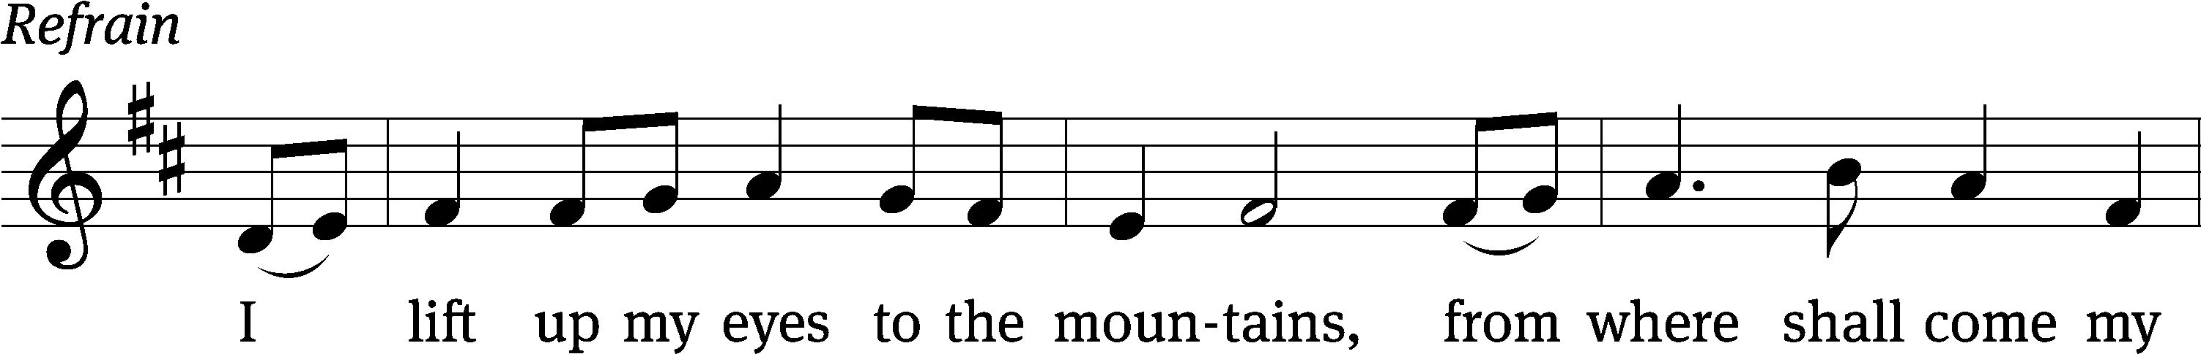
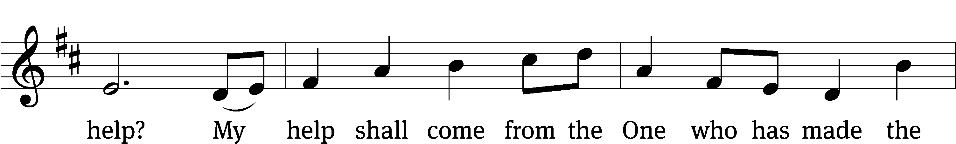
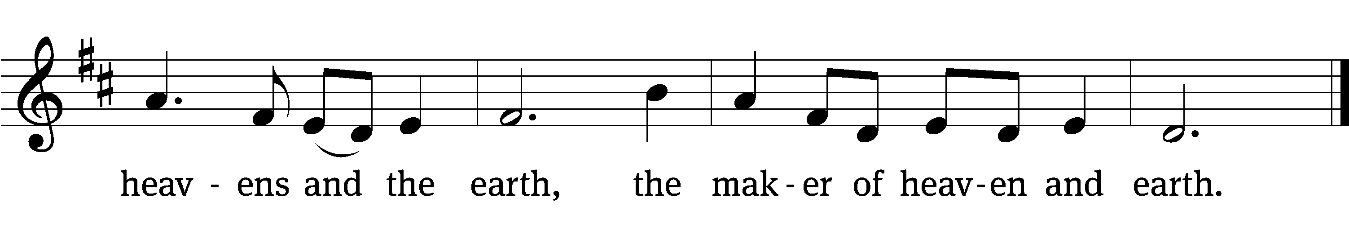

I lift up my eyes to the / mountains—
where does my help / come from?
My help comes / from the Lord,
the maker of / heaven and earth.
He will not let your / foot slip—
he who watches over you will not / slumber;
indeed, he who watches over / Israel
will neither / slumber nor sleep. Refrain

The Lord watches / over you—
the Lord is your shade / at your right hand.
The Lord will keep you / from all harm—
he will watch / over your life;
the Lord will watch over your coming and / going
both now and for- / evermore.
Glory be to the Father and / to the Son
and to the Holy / Spirit,
as it was in the be- / ginning,
is now, and will be forever. / Amen. Refrain
Tune: Marty Haugen
Tune: © 2000 GIA Publications, Inc. Used by permission: OneLicense no. 727703
Setting: © 2021 Northwestern Publishing House. Used by permission: OneLicense no. 727703

second lesson Hebrews 5:5-10
⁵ In the same way, Christ did not take the glory of becoming a high priest on himself, but God said to him:
You are my Son.
Today I have begotten you.
⁶ He also said the same thing in another place:
You are a priest forever, like Melchizedek.
⁷ In the days of his flesh, he offered prayers and pleas with loud cries and tears to the one who was able to save him from death, and he was heard because of his reverence. ⁸ Although he was the Son, he learned obedience from the things he suffered. ⁹ After he was brought to his goal, he became the source of eternal salvation for everyone who obeys him, ¹⁰ because he was designated by God as a high priest, like Melchizedek.

PLEASE STAND, IF YOU ARE ABLE

VERSE OF THE DAY Mark 10:45
For even the Son of Man did not come to be served, but to serve, and to give His life as a ransom for many.

GOSPEL John 12:20-33
²⁰ Now there were some Greeks among those who went up to worship at the Festival. ²¹ They came to Philip, who was from Bethsaida in Galilee, and asked him, “Sir, we want to see Jesus.” ²² Philip went to tell Andrew. Andrew came with Philip and told Jesus. ²³ Jesus answered them, “The time has come for the Son of Man to be glorified. ²⁴ Amen, Amen, I tell you: Unless a kernel of wheat falls to the ground and dies, it continues to be one kernel. But if it dies, it produces much grain. ²⁵ Anyone who loves his life destroys it. And the one who hates his life in this world will hold on to it for eternal life. ²⁶ If anyone serves me, let him follow me. And where I am, there my servant will be also. If anyone serves me, the Father will honor him. ²⁷ “Now my soul is troubled. And what shall I say? ‘Father, save me from this hour’? No, this is the reason I came to this hour. ²⁸ Father, glorify your name!” A voice came from heaven: “I have glorified my name, and I will glorify it again.” ²⁹ The crowd standing there heard it and said it thundered. Others said an angel talked to him. ³⁰ Jesus answered, “This voice was not for my sake but for yours. ³¹ “Now is the judgment of this world. Now the ruler of this world will be thrown out. ³² And I, when I am lifted up from the earth, will draw all people to myself.” ³³ He said this to indicate what kind of death he was going to die.
M: This is the Gospel of the Lord.

PLEASE BE SEATED

756 Shepherd of Tender Youth CW 756
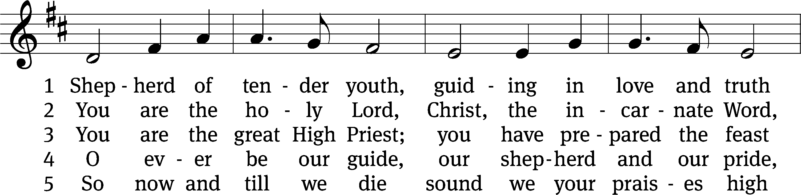
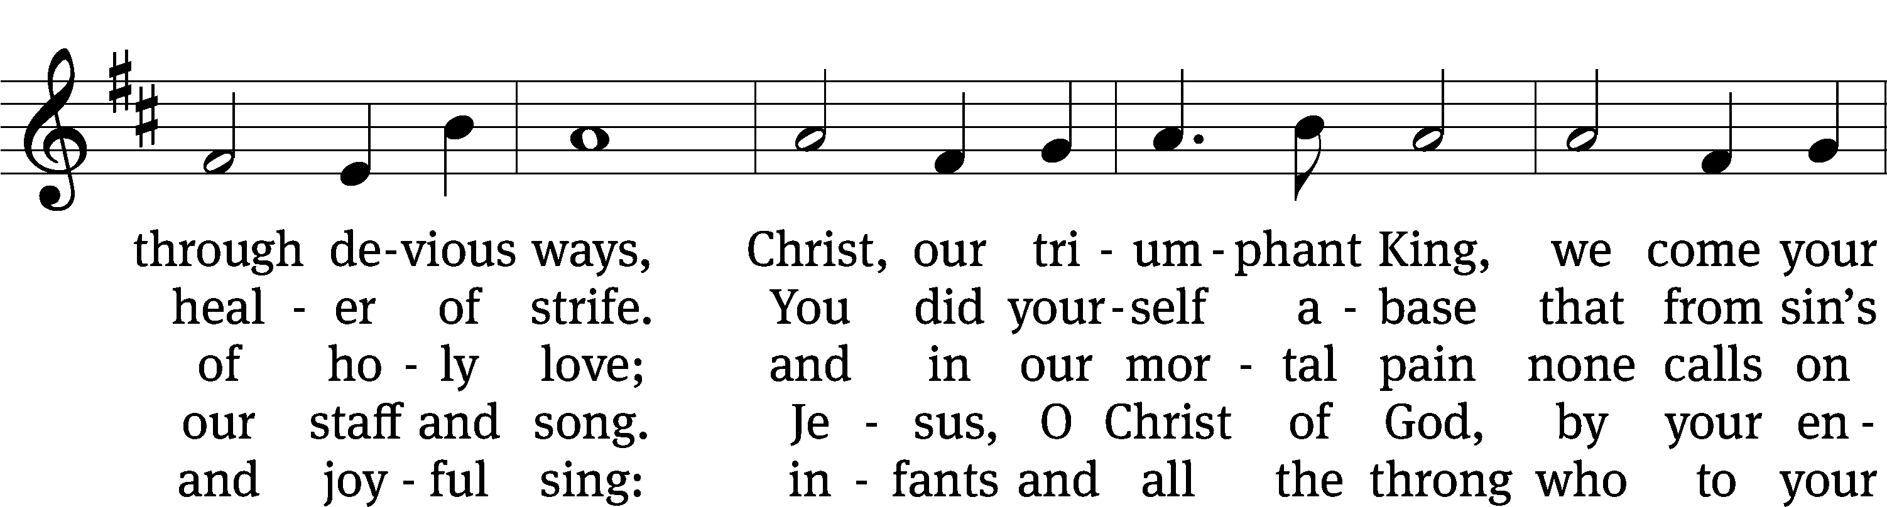
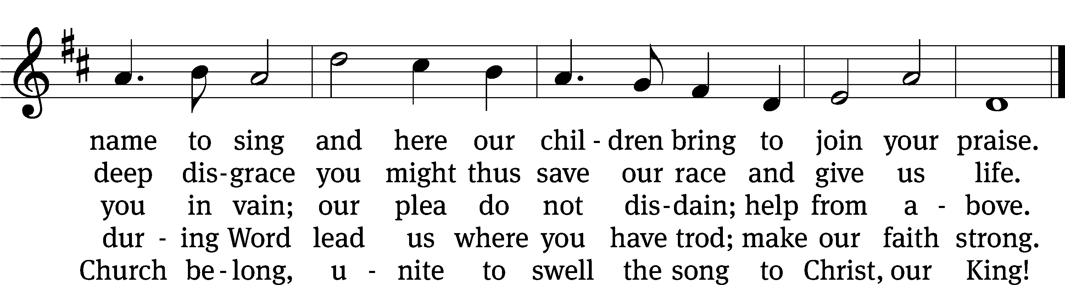
Text: tr. Henry M. Dexter, 1821–1890, alt.; attr. Clement of Alexandria, c. 170–c. 220
Tune: Lowell Mason, 1792–1872
Text and tune: Public domain

Sermon Hebrews 5:5-10

“Jesus, a Priest Then and Now”

please stand, if you are able

nicene creed

We believe in one God, the Father, the Almighty, maker of heaven and earth, of all that is, seen and unseen.
We believe in one Lord, Jesus Christ, the only Son of God, eternally begotten of the Father, God from God, Light from Light, true God from true God, begotten, not made, of one being with the Father. Through him all things were made. For us and for our salvation, he came down from heaven, was incarnate of the Holy Spirit and the virgin Mary, and became truly human. For our sake he was crucified under Pontius Pilate. He suffered death and was buried. On the third day he rose again in accordance with the Scriptures. He ascended into heaven and is seated at the right hand of the Father. He will come again in glory to judge the living and the dead, and his kingdom will have no end.
We believe in the Holy Spirit, the Lord, the giver of life, who proceeds from the Father and the Son, who in unity with the Father and the Son is worshiped and glorified, who has spoken through the prophets. We believe in one holy Christian and apostolic Church. We acknowledge one baptism for the forgiveness of sins. We look for the resurrection of the dead and the life of the world to come. Amen.

Bell Choir (8:30 a.m.) “God of Grace and God of Glory”

prayer of the church

lord’s prayer
C: Our Father, who art in heaven,
hallowed be thy name,
thy kingdom come,
thy will be done
on earth as it is in heaven.
Give us this day our daily bread;
and forgive us our trespasses,
as we forgive those
who trespass against us;
and lead us not into temptation,
but deliver us from evil.
For thine is the kingdom
and the power and the glory
forever and ever. Amen.

The Sacrament of Holy Communion
Trinity Lutheran Church follows the historic Christian practice of close communion. We ask that only members of Trinity or one of our sister congregations partake of the sacrament. If you are not a member, please see the note about Holy Communion in the beginning of the Worship Folder.

M: The Lord be with you.

M: Lift up your hearts.

M: Let us give thanks to the Lord our God.

M: Praise to the God and Father of our Lord Jesus Christ! In love he has blessed us with every spiritual blessing. He sends the Holy Spirit to testify that we are his children and to strengthen us when we are weak. Now have come the salvation and the power and the kingdom of our God and the authority of his Christ. To him who sits on the throne and to the Lamb be praise and thanks and honor and glory for ever and ever:

Holy, Holy, Holy

Words of institution
M: Our Lord Jesus Christ, on the night he was betrayed, took bread; and when he had given thanks, he broke it and gave it to his disciples, saying: “Take and eat. This is my ✙ body, which is given for you. Do this in remembrance of me.”
Then he took the cup, gave thanks, and gave it to them, saying, “Drink from it all of you; this is my ✙ blood of the new covenant, which is poured out for you for the forgiveness of sins. Do this, whenever you drink it, in remembrance of me.”
M: The peace of the Lord be with you always.

O CHRIST, LAMB OF GOD

661 Draw Near and Take the Body of Your Lord CW 661
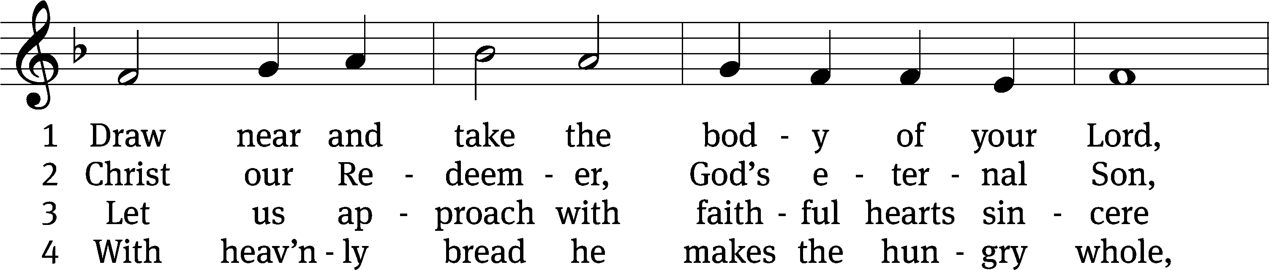
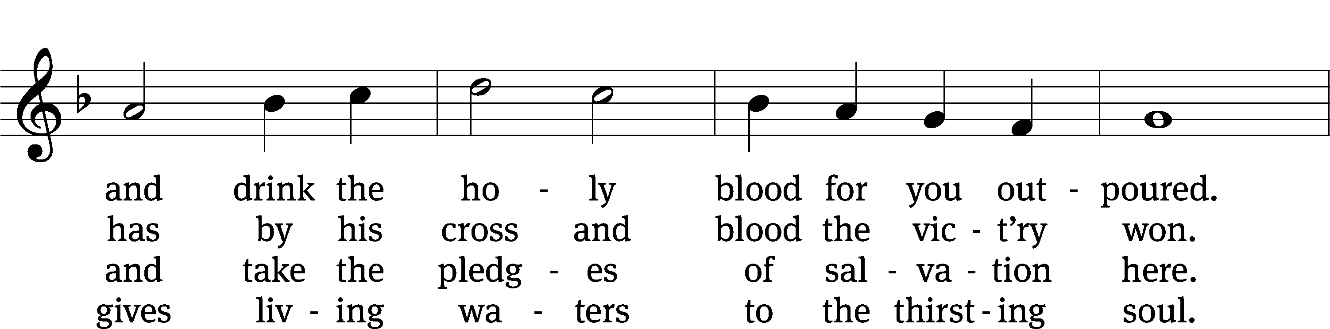
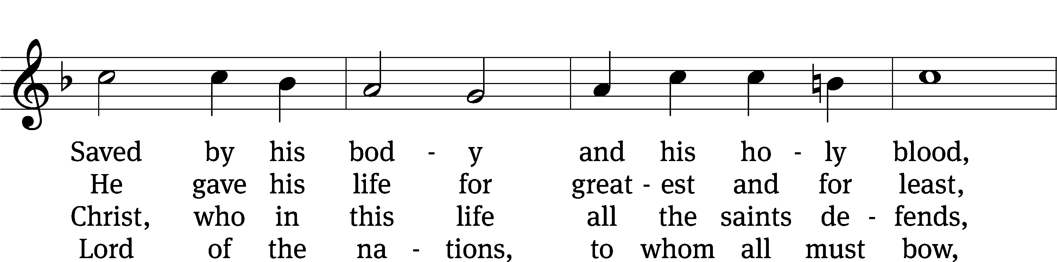
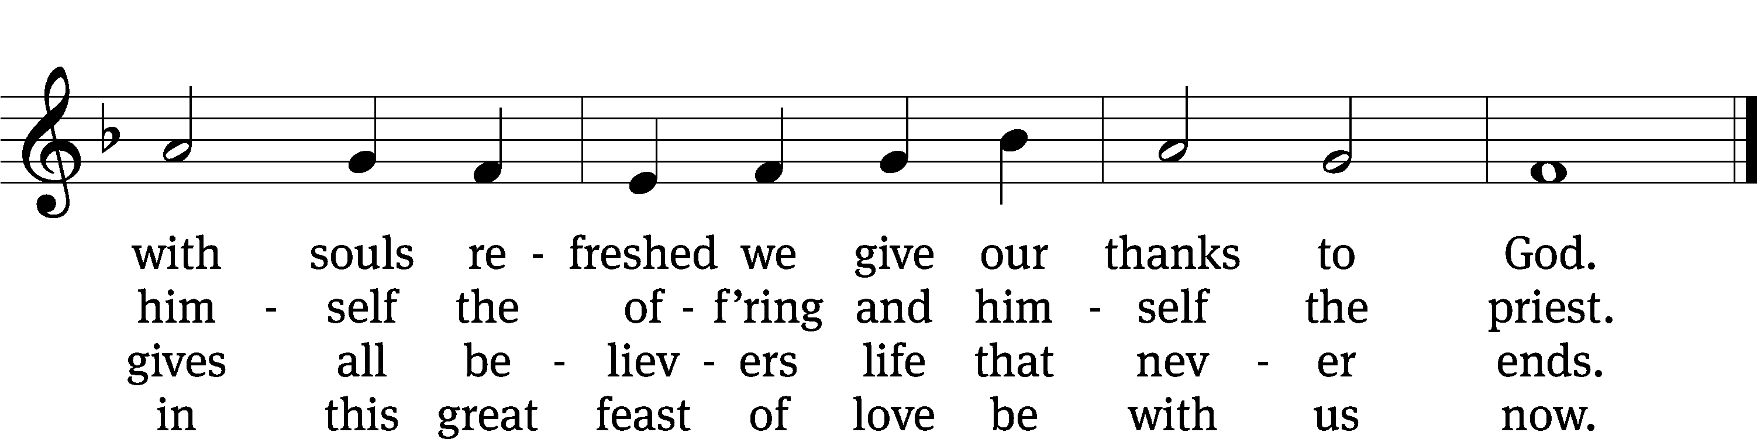
Text: tr. John Mason Neale, 1818–1866, alt.; Latin, 7th cent., abr.
Tune: Trente quatre Pseaumes de David, Geneva, 1551, ed. Louis Bourgeois
Text and tune: Public domain

668 Jesus Comes Today with Healing CW 668
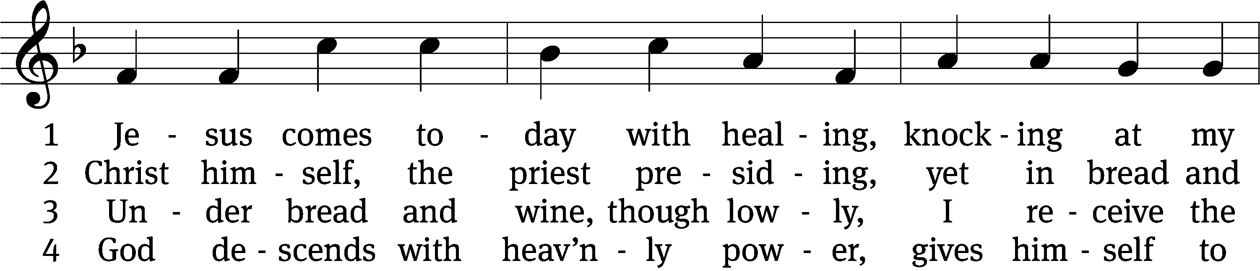
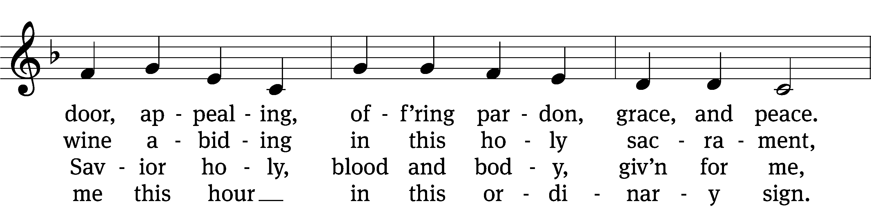
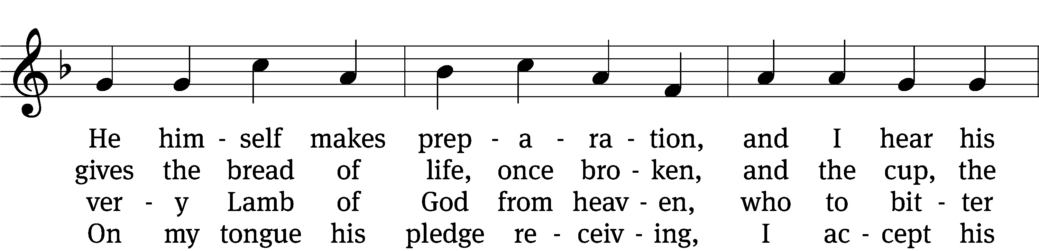
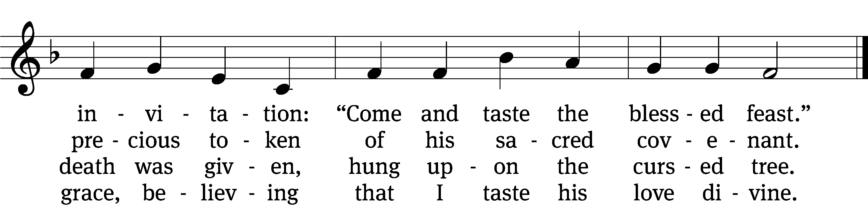

5 Let me praise God’s boundless favor,
whose own feast of love I savor,
bidden by his gracious call.
Wedding garments he provides me,
with a robe of white he hides me,
fits me for the royal hall.

(Continued)

6 Now have I found consolation,
comfort in my tribulation,
balm to heal the troubled soul.
God, my shield from ev’ry terror,
cleanses me from sin and error,
makes my wounded spirit whole.
Text: tr. David W. Rogner, b. 1960; Heinrich Puchta, 1808–1858
Tune: adapt. Johann Balthasar König, 1691–1758; Johann Löhner, 1645–1705
Text: © 2003 David W. Rogner. Used by permission: OneLicense no. 727703
Tune: Public domain

PLEASE STAND, IF YOU ARE ABLE

M: Hear the prayer of your people, O Lord, that the lips which have praised you here may glorify you in the world, that the eyes which have seen the coming of your Son may long for his coming again, and that all who have received in his true body and blood the pledge of your forgiveness may be restored to live a new and holy life, through Jesus Christ, our Lord, who lives and reigns with you and the Holy Spirit, one God, now and forever.

M: Brothers and sisters, go in peace. Live in harmony with one another.
Serve the Lord with gladness.
The Lord bless you and keep you.
The Lord make his face shine on you and be gracious to you.
The Lord look on you with favor and (+) give you peace.

PLEASE BE SEATED

581 Lord, ’Tis Not That I Did Choose You CW 581
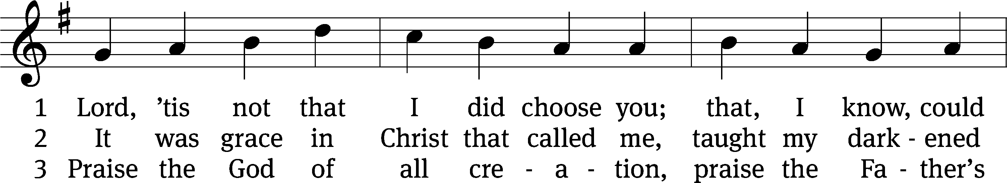
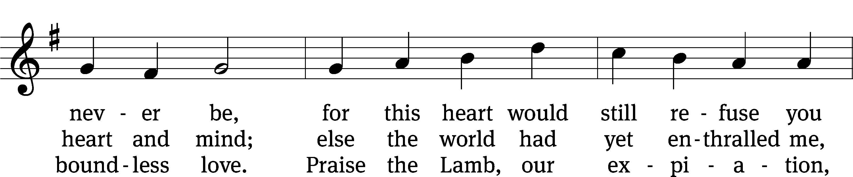
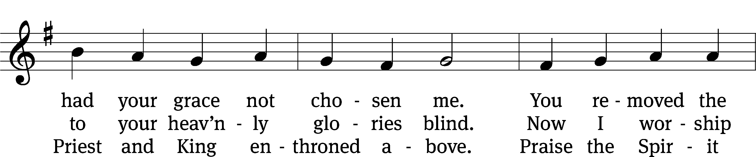
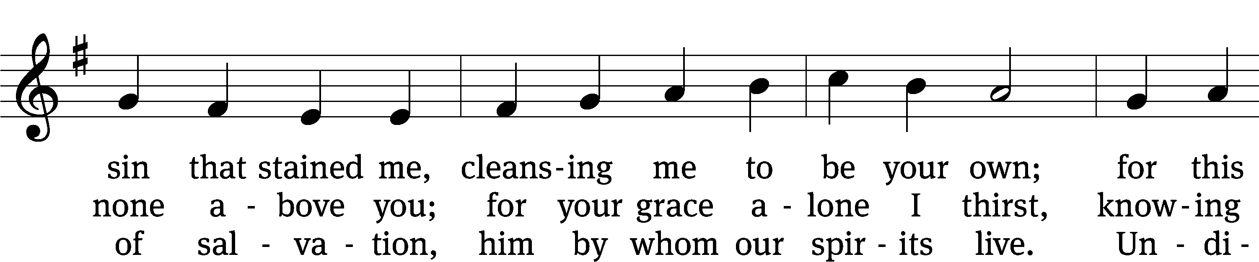
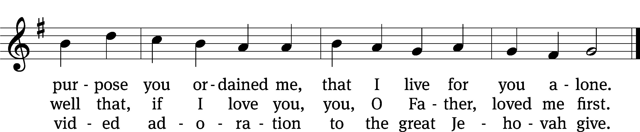
Text: Josiah Conder, 1789–1855, alt.
Tune: Erbaulicher Musicalischer Christen-Schatz, Basel, 1745
Text and tune: Public domain

Serving In Worship

Officiant Pastor Natsis
Organist Marcia Marion Ackling
Bell Choir Director Meg Nortley
Deacons (8:30) Duane Mason and Dave Stevenson
(11:00) Robert Niethammer and Gary Knowlton
Ushers (8:30) Dale Finkbeiner and Mark Finkbeiner
(11:00) Dave Boswell and Jake Vershum
Altar Guild Ann Latowski and Jean Fiegel
Videographer Jeff Neuburger

Copyright information
Service of Word and Sacrament: Christian Worship. © 1993 Northwestern Publishing House. All rights reserved. Reprinted under ONE LICENSE #A-727703 and CCLI #1151741/ CSPL126093
Words and Music: All rights reserved. Reprinted/Podcast/Streamed with permission under ONE LICENSE #A-727703 and CCLI #1151741/CSPL126093

