Midweek Lenten Service Four
“I Will Keep the Passover”

tRINITY EVANGELICAL LUTHERAN CHURCH | Saline, Michigan
March 23, 2022

WELCOME TO WORSHIP

Thank you for joining us in God’s house today! We cordially ask that our Guests sign one of the guestbooks located at either the front or back entryways.

THANK OFFERING: Members of Trinity give their offering as an expression of love and thankfulness to the Lord and to help support the Lord’s work in our community and around the world. Visitors need not feel obligated to participate in this offering which supports our ministry.

Restrooms are located at the back of the upper level (the annex), and in the basement (down the back stairs of the sanctuary or annex). Handicap access is available, please ask an usher for assistance.

Young Families / Toddler Bags – We are GLAD YOU BROUGHT YOUR CHILDREN to our worship service. Jesus said: “Let the little children come to me and do not hinder them, for the kingdom of God belongs to such as these.” We know that having little children in church can be a challenge, but DO NOT WORRY about it. Many of your fellow worshippers have been in your shoes and are just happy you brought your children with you. For your convenience, we have reserved the back rows of seating for parents with small children. These areas provide more flexibility for your family, as well as, easy access to move downstairs if necessary. A closed-circuit TV system allows families to continue participating in the service while downstairs. Pre-school toddler bags and children’s bulletins are available for their enjoyment. Ask an usher for one to use during the service and please return the toddler bag afterwards.

OPENING HYMN CW #394

394 Come to Calvary’s Holy Mountain CW 394
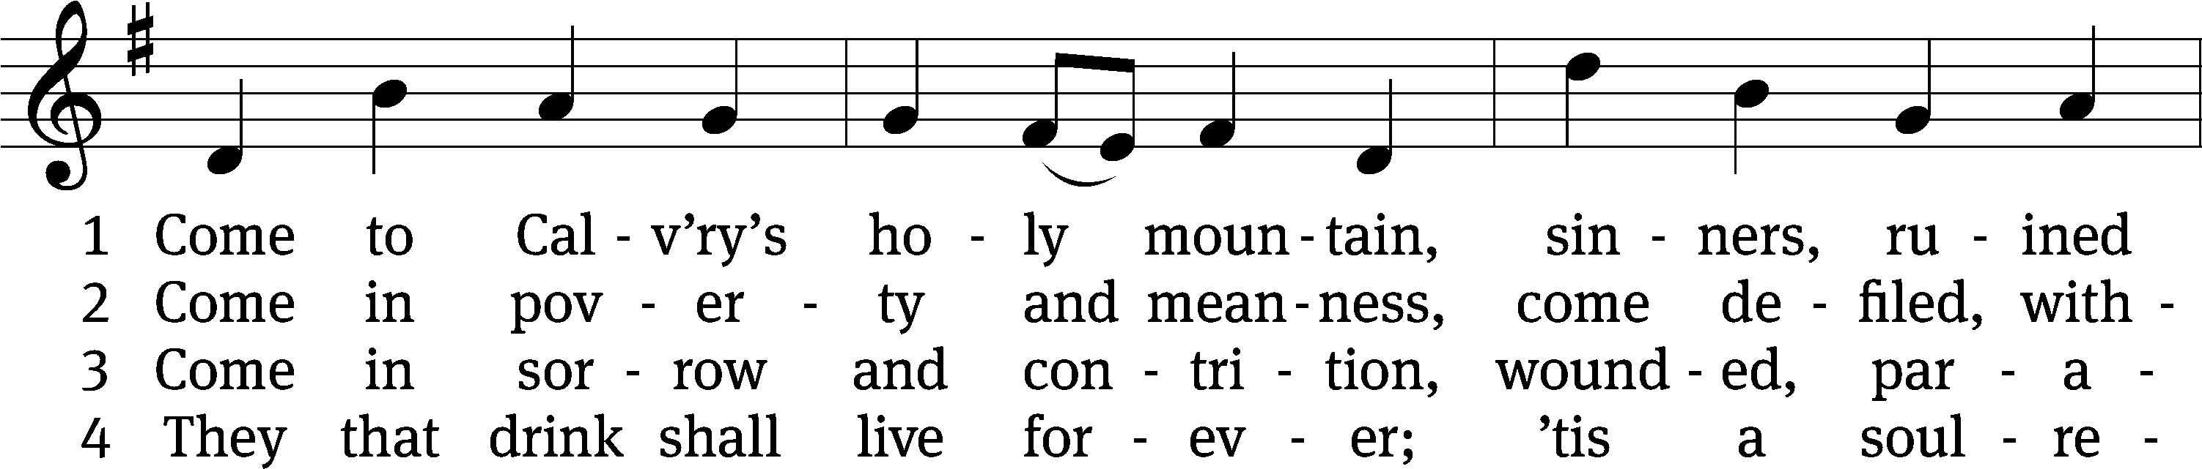
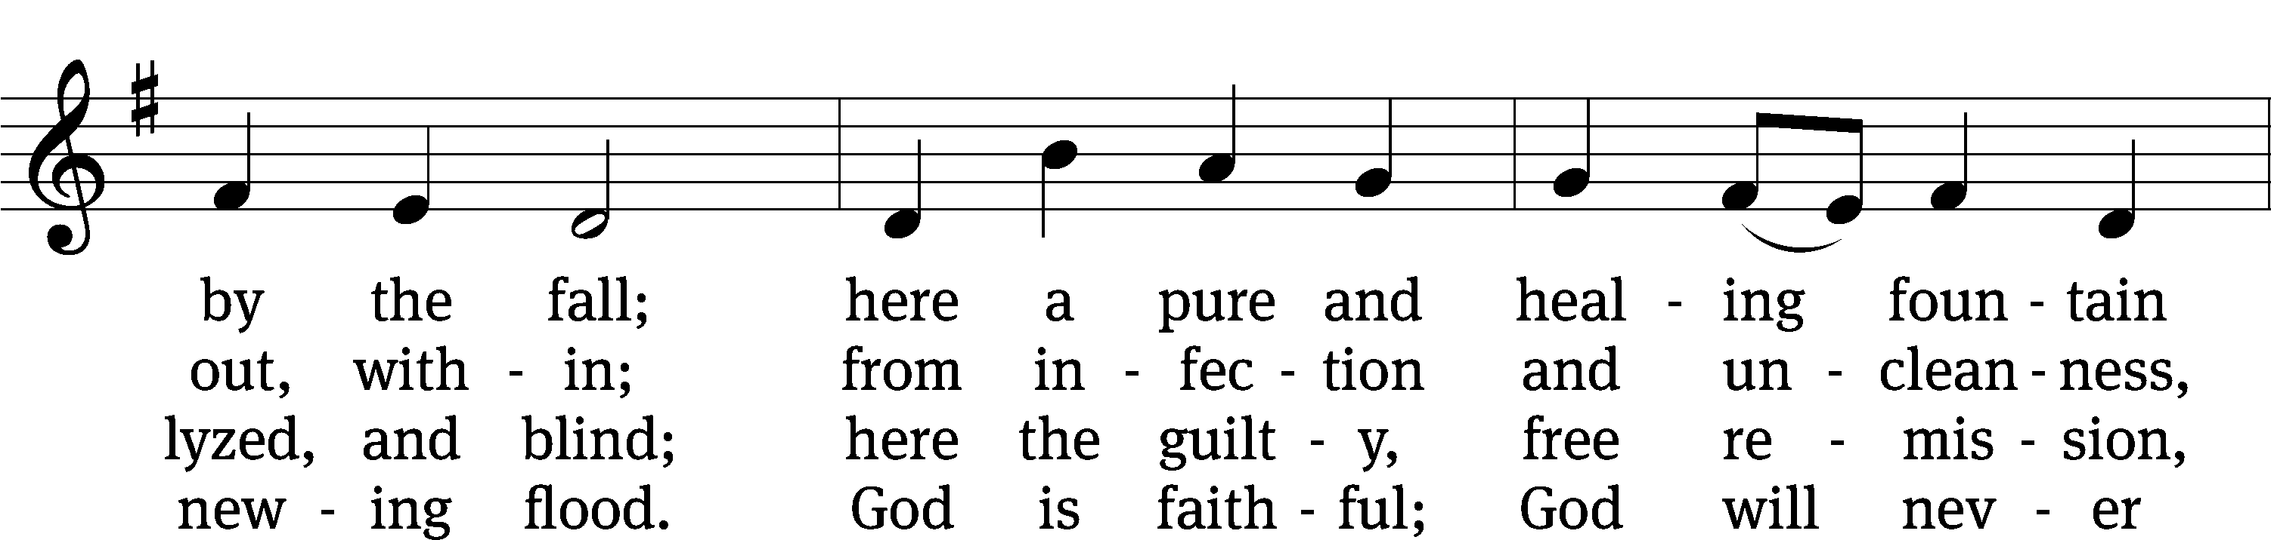
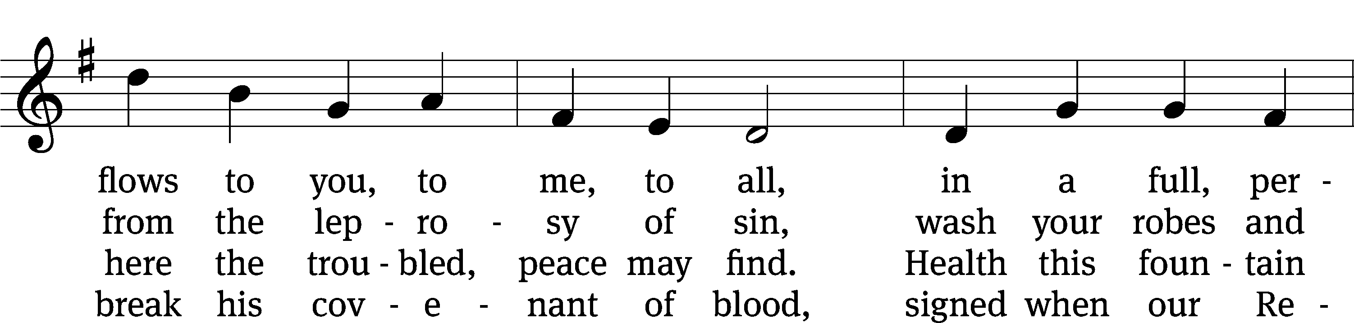
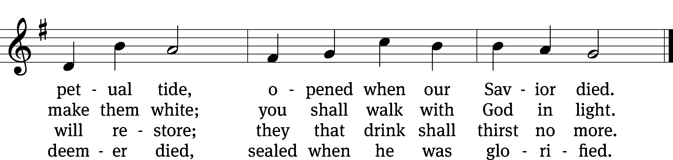
Text: James Montgomery, 1771–1854, alt.
Tune: Ludvig M. Lindeman, 1812–1887
Text and tune: Public domain

invocation

Please stand, if you are able

M: In the name of the Father and of the Son (+) and of the Holy Spirit.
C: Amen.

CONFESSION

M: Dear friends, let us approach God with a true heart and confess our sins, asking him in the name of our Lord Jesus Christ to forgive us.
C: Lord of life, I confess that I am by nature dead in sin.
For faithless worrying and selfish pride, for sins of habit and sins of choice,
For the evil I have done and the good I have failed to do,
You should cast me away from your presence forever.
O Lord, I am sorry for my sins. Forgive me, for Jesus’ sake.

ABSOLUTION
M: Christ has died. Christ is risen. Christ will come again. In his great mercy, God made us alive in Christ even when we were dead in our sins. Hear the word of Christ through his called servant:
I forgive you all your sins in the name of the Father and of the Son (+) and of the Holy Spirit.
C: Amen.

PRAYER
M: Lord God, you have brought us safely to this hour of evening prayer. We thank you for providing all that we need for body and life. Bless us who have gathered in your name. Forgive our sins. Speak to our hearts. Dispel our sorrows with the comfort of your Word, and receive our hymns of thanks and praise, through Jesus Christ, our living Savior, who reigns with you and the Holy Spirit, one God, now and forever.
C: Amen.
Please be seated

PSALM Psalm 22
22D LORD, Why Have You Forsaken Me Psalm 22D
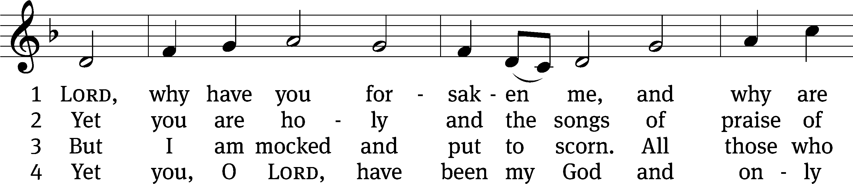
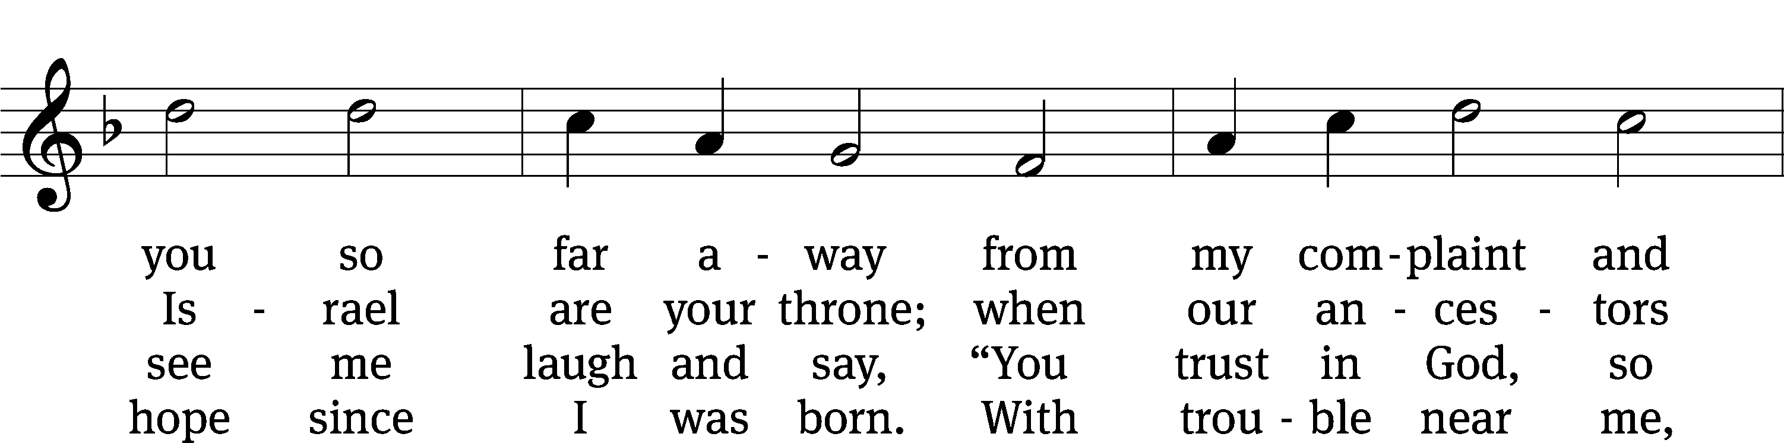
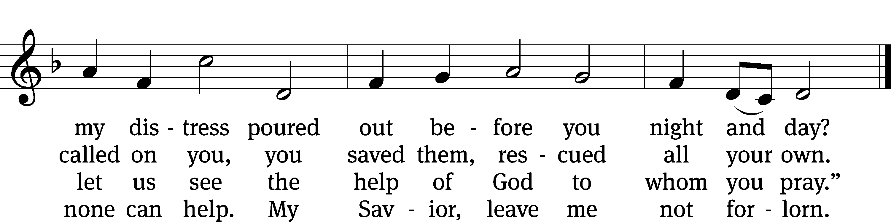
Text: Christopher L. Webber
Tune: Southern Harmony, 1835, ed. William Walker
Text: © 1968 Christopher L. Webber, admin. Church Publishing Inc. Used by permission: OneLicense no. 727703
Tune: Public domain

PSALM PRAYER

M: Lord God, grant us your Holy Spirit that we may hear and believe your Word. Cleanse our minds and renew our hearts that we may live for you here and hereafter; through Jesus Christ our Lord

C: Amen.

LESSON The Passion History – Part Three

SEASONAL RESPONSE: (All)

M: We join in responding:

C: All we like sheep have gone astray, and the Lord has laid on him the
iniquity of us all. By his wounds we are healed.

SERMON HYMN CWS #422
422 A Lamb Goes Uncomplaining Forth CW 422
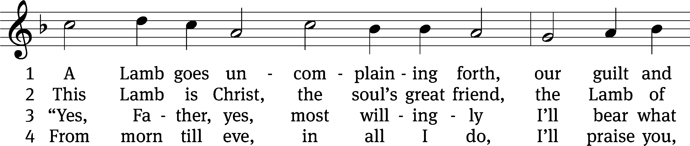
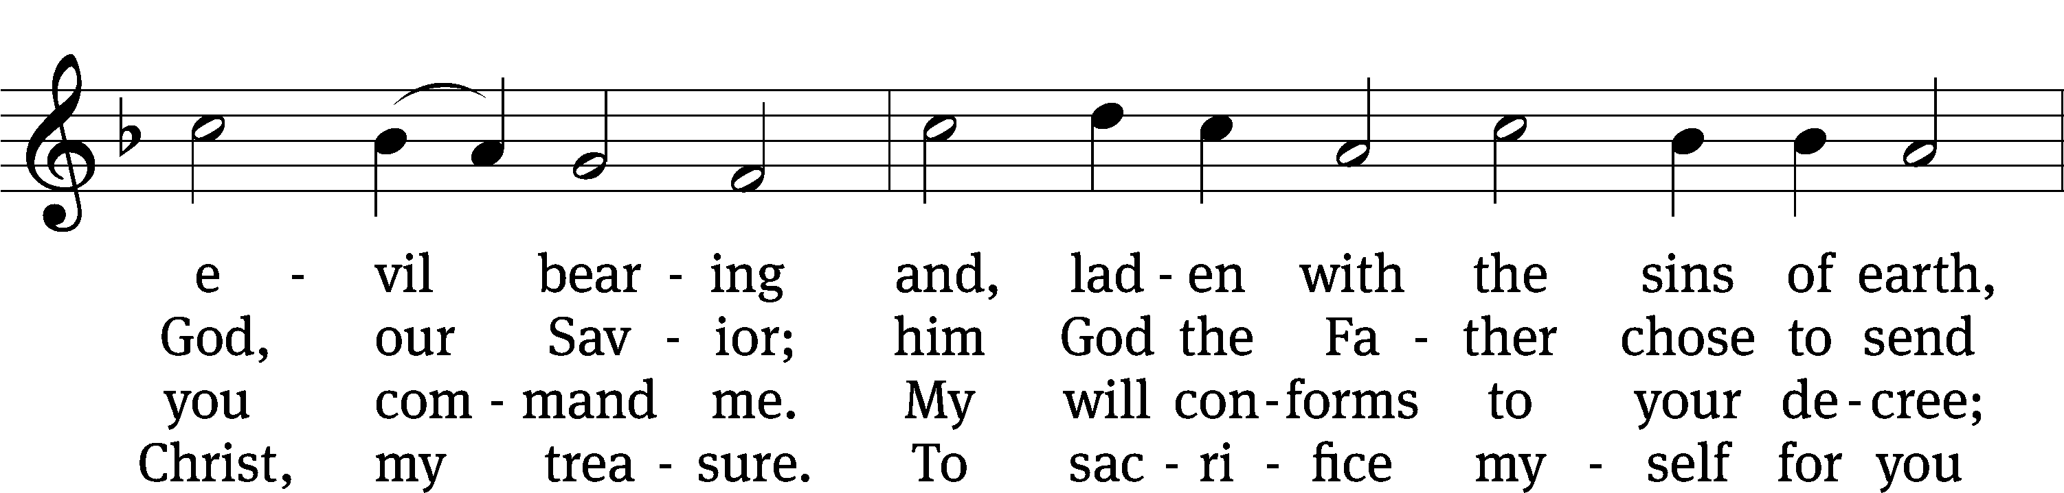
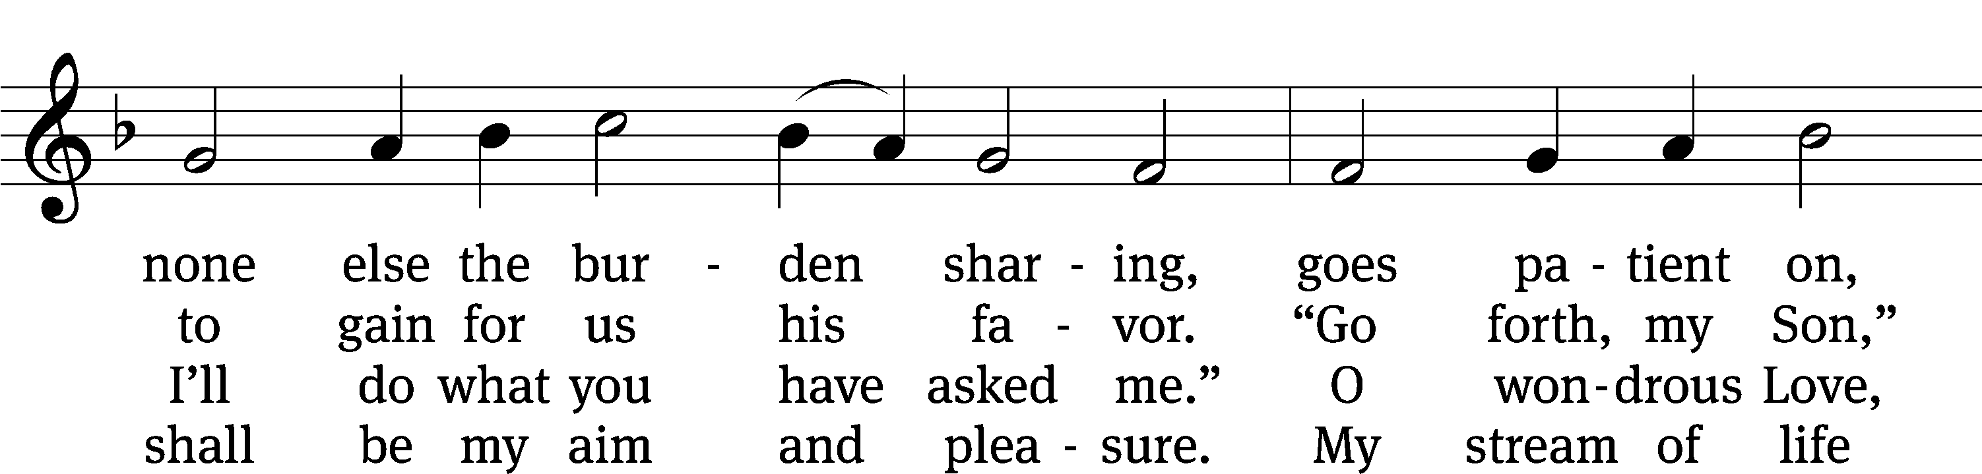
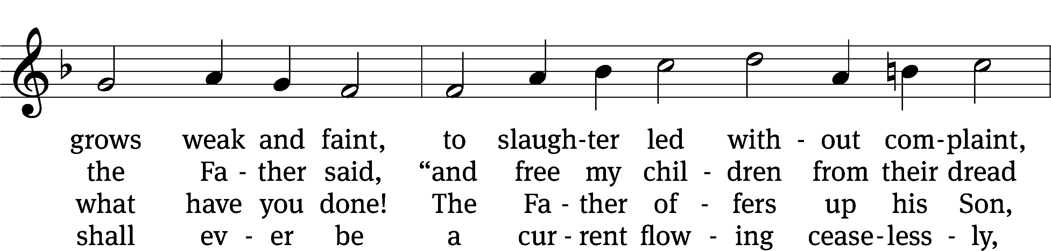
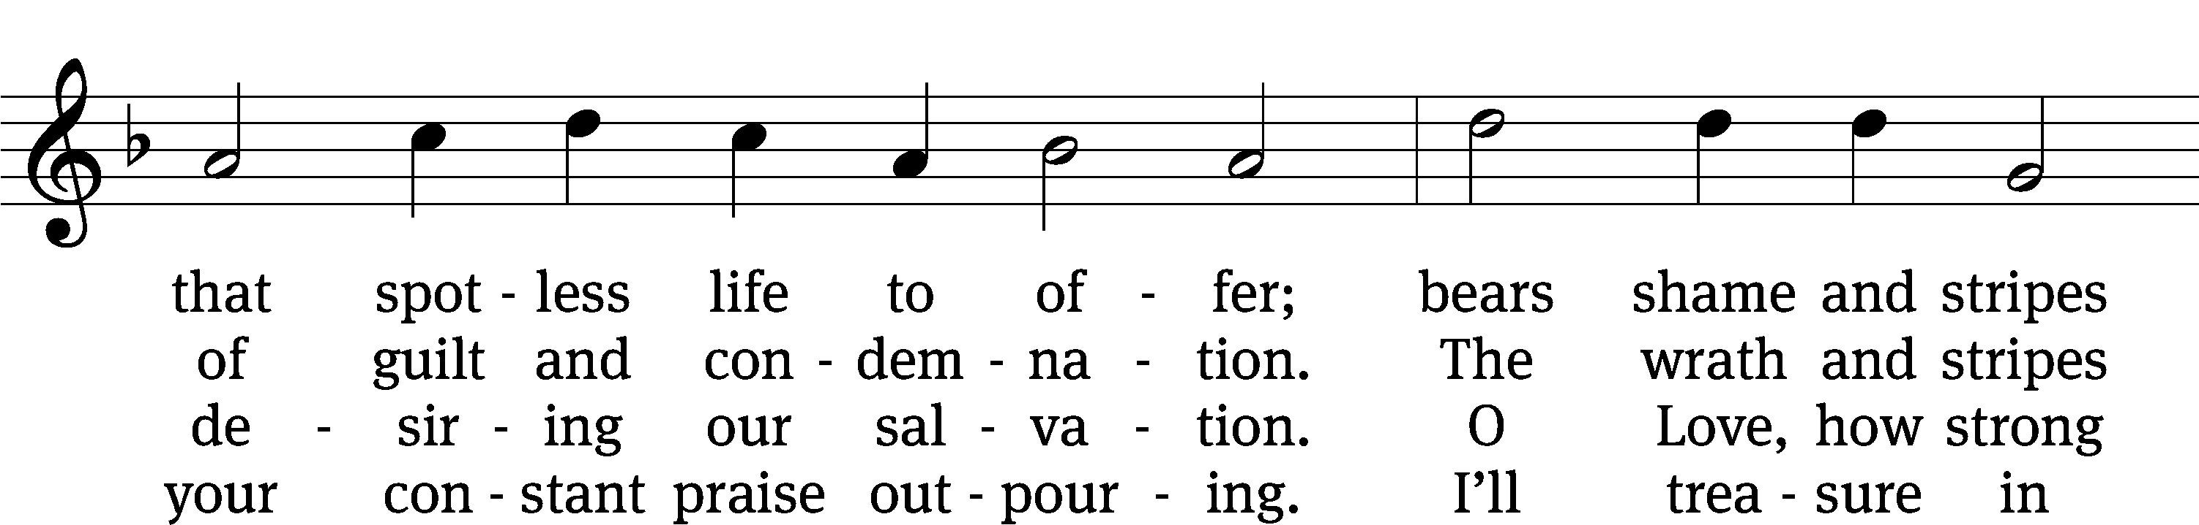
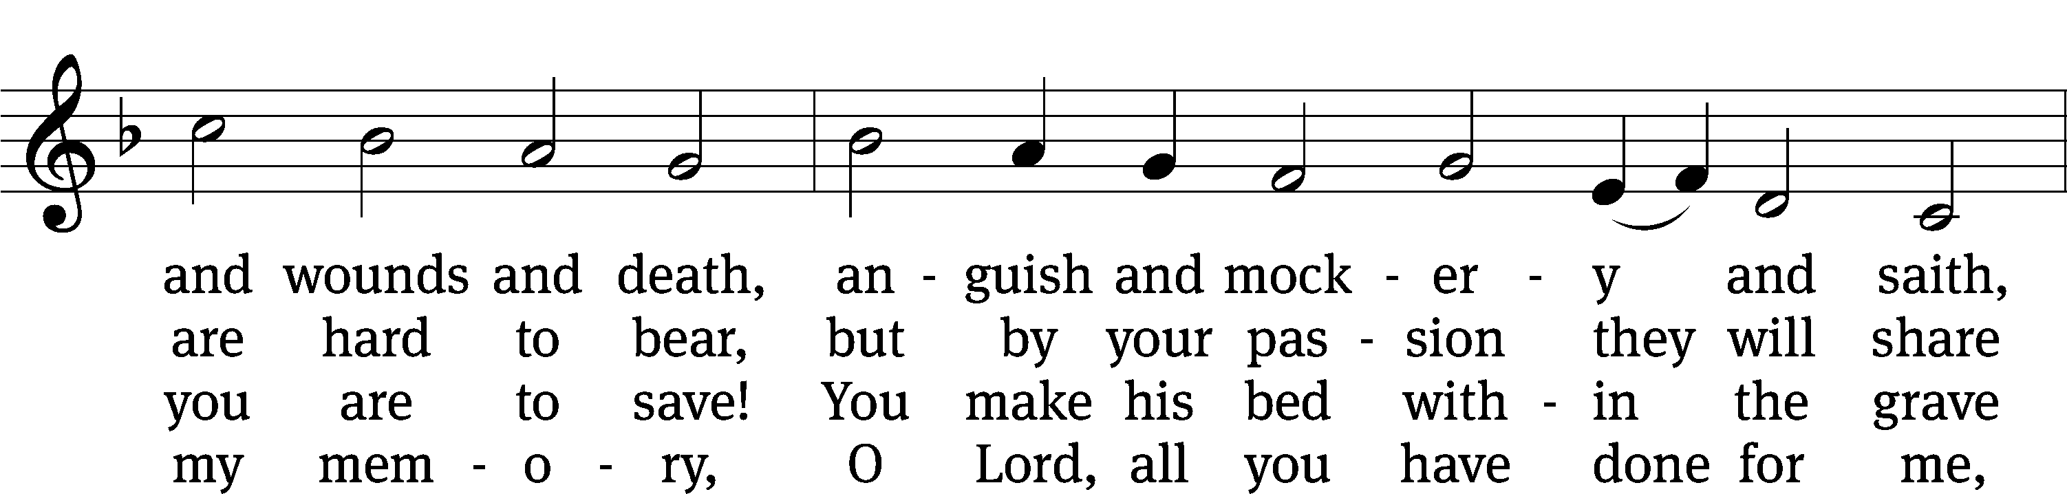
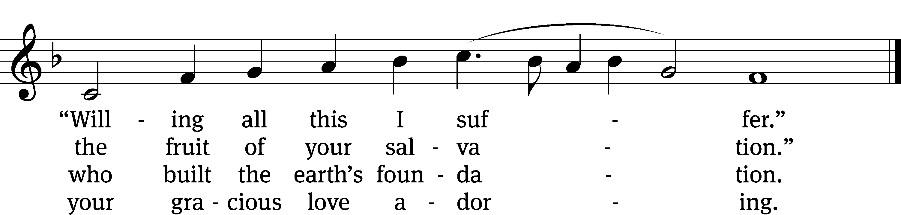
Text: tr. The Lutheran Hymnal, 1941, alt.; Paul Gerhardt, 1607–1676, abr.
Tune: Wolfgang Dachstein, c. 1487–1553
Text: © 1941 Concordia Publishing House. Used by permission: OneLicense no. 727703
Tune: Public domain

SERMON TEXT: Matthew 26:18
He said, “Go into the city to a certain man and tell him the Teacher says, ‘My time is near. I will observe the Passover with my disciples at your house.’”

Please stand, if you are able

APOSTLES’ CREED

I believe in God, the Father almighty,
maker of heaven and earth.
I believe in Jesus Christ, his only Son, our Lord,
who was conceived by the Holy Spirit,
born of the virgin Mary,
suffered under Pontius Pilate,
was crucified, died, and was buried.
He descended into hell.
The third day he rose again from the dead.
He ascended into heaven
and is seated at the right hand of God the Father almighty.
From there he will come to judge the living and the dead.
I believe in the Holy Spirit,
the holy Christian Church,
the communion of saints,
the forgiveness of sins,
the resurrection of the body,
and the life everlasting. Amen.

Please be seated

CHOIR “If I Had Been in Jerusalem”

If I had been in Jerusalem on that day, on that day,
Would I have left my Savior’s side, or would I stay, would I stay?
If I had been in Jerusalem, if I had spent all that time with him,
If I had been his trusted friend, what could have torn me away?

If I had witnessed his miracles and believed, and believed,
Would I have stayed by my Savior’s side or would I leave, would I leave?
If I had seen all that he could do, if I had known what he would go through,
If I was one of his chosen few, what could have torn me away?

He healed the eyes that were blind from birth;
He made them see somehow, somehow.
He healed the eyes that were blind from birth;
Why can’t that see the truth now?

If I had been in Jerusalem, would I be, would I be
Willing to give my life for him, Like he did for me?

Please stand, if you are able

PRAYER OF THE CHURCH

THE LORD’S PRAYER

C: Our Father, who art in heaven, hallowed be thy name, thy kingdom come, thy will be done on earth as it is in heaven. Give us this day our daily bread; and forgive us our trespasses, as we forgive those who trespass against us; and lead us not into temptation, but deliver us from evil. For thine is the kingdom and the power and the glory forever and ever. Amen.

M: The Lord bless you and keep you.
The Lord make his face shine on you and be gracious to you.
The Lord look on you with favor and (+) give you peace.
C: Amen.

Please be seated

CLOSING HYMN #784
784 Now the Light Has Gone Away CW 784
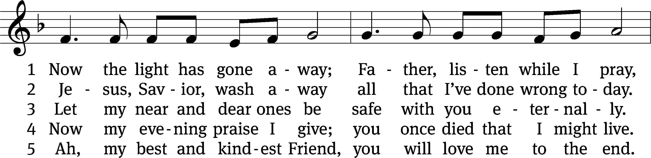
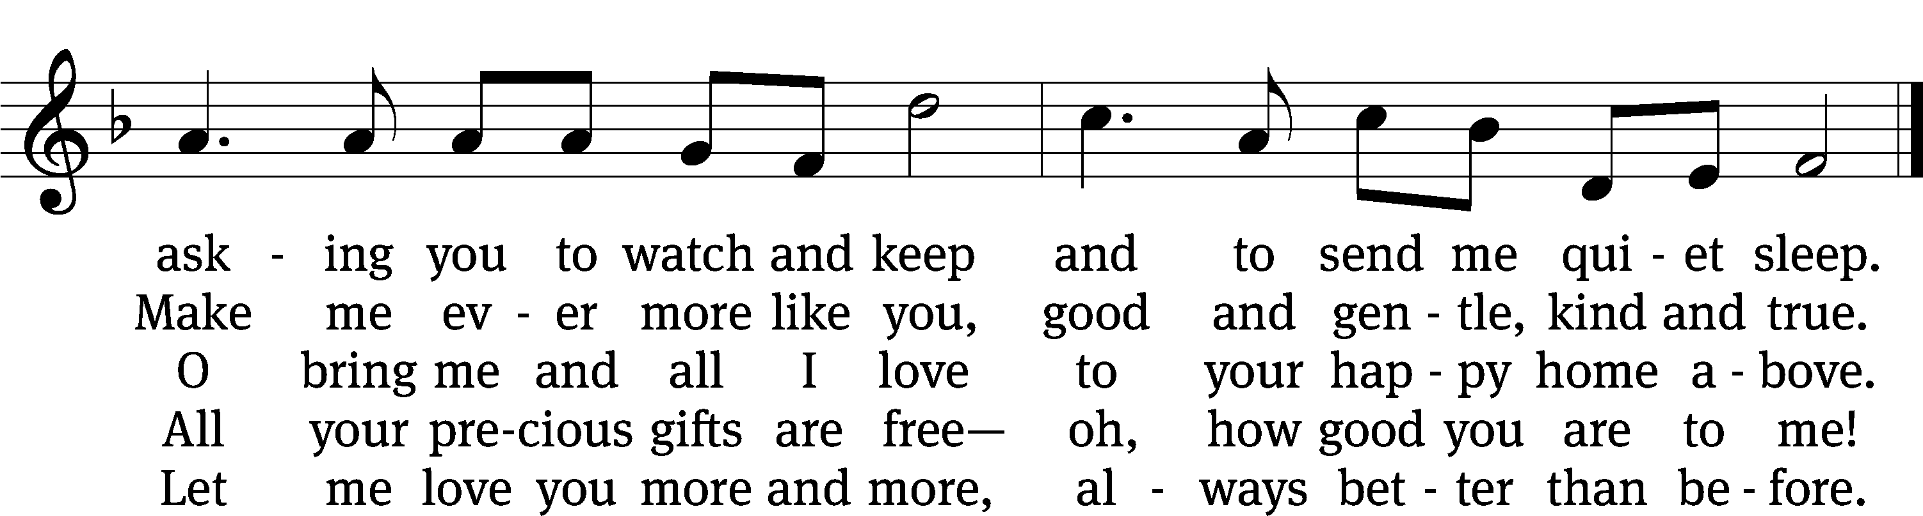
Text: Frances R. Havergal, 1836–1879, alt.
Tune: Liederbuch für Kleinkinder-Schulen, Kaiserswerth, 1842
Text and tune: Public domain

Serving In Worship
Officiant Pastor Kurt Uhlenbrauck (St. Jacob, Grass Lake)
Organist Emily Wheeler
Accompanist Sarah Hanke
Choir Director Cynthia Natsis
Deacon Dave Stevenson
Altar Guild Judy Lindemann and Connie Marion
Videographer Jake Vershum

Copyright information
Words and Music: All rights reserved. Reprinted with permission under ONE LICENSE #A-727703 and
CCLI #1151741/CSPL126093

