EASTER SUNDAY
THE RESURRECTION OF OUR LORD

tRINITY EVANGELICAL LUTHERAN CHURCH | Saline, Michigan
March 31, 2024

WELCOME TO WORSHIP
Thank you for joining us in God’s house today! We cordially ask that our Guests sign one of the guestbooks located at either the front or back entryways, or fill out a “Let’s Get Acquainted” card located in the hymnal pew rack and place it in the collection plate.

THANK OFFERING: Members of Trinity give their offering as an expression of love and thankfulness to the Lord and to help support the Lord’s work in our community and around the world. Visitors need not feel obligated to participate in this offering which supports our ministry.

Restrooms are located at the back of the upper level (the annex), and in the basement (down the back stairs of the sanctuary or annex). Handicap access is available, please ask an usher for assistance.

Young Families / Toddler Bags – For your convenience, we have reserved the back rows of seating for parents with small children. These areas provide more flexibility for your family, as well as, easy access to move downstairs if necessary. A closed-circuit TV system allows families to continue participating in the service while downstairs. Pre-school toddler bags are available for their enjoyment. Ask an usher for one to use during the service and please return it afterwards.

Choir “Gaelic Alleluia”
Joy dawned again on Easter Day. The sun shone out with fair array, when to their longing eyes restored th’apostles saw their risen Lord. Alle, alleluia!
O Jesus King of gentleness, do thou thyself our hearts possess that we may give thee all our days, that willing tribute of our praise. Alle, alleluia!
O Lord of all, with us abide in this our joyful Eastertide; from ev’ry weapon death can wield thine own redeemed forever shield. Alle, alleluia!
O son and daughters of the King, whom heav’nly hosts in glory sing. Today the grave has lost its sting! Alleluia! Alleluia!
Alleluia! Alleluia! Alleluia!

Words of Welcome

438 Jesus Christ Is Risen Today CW 438
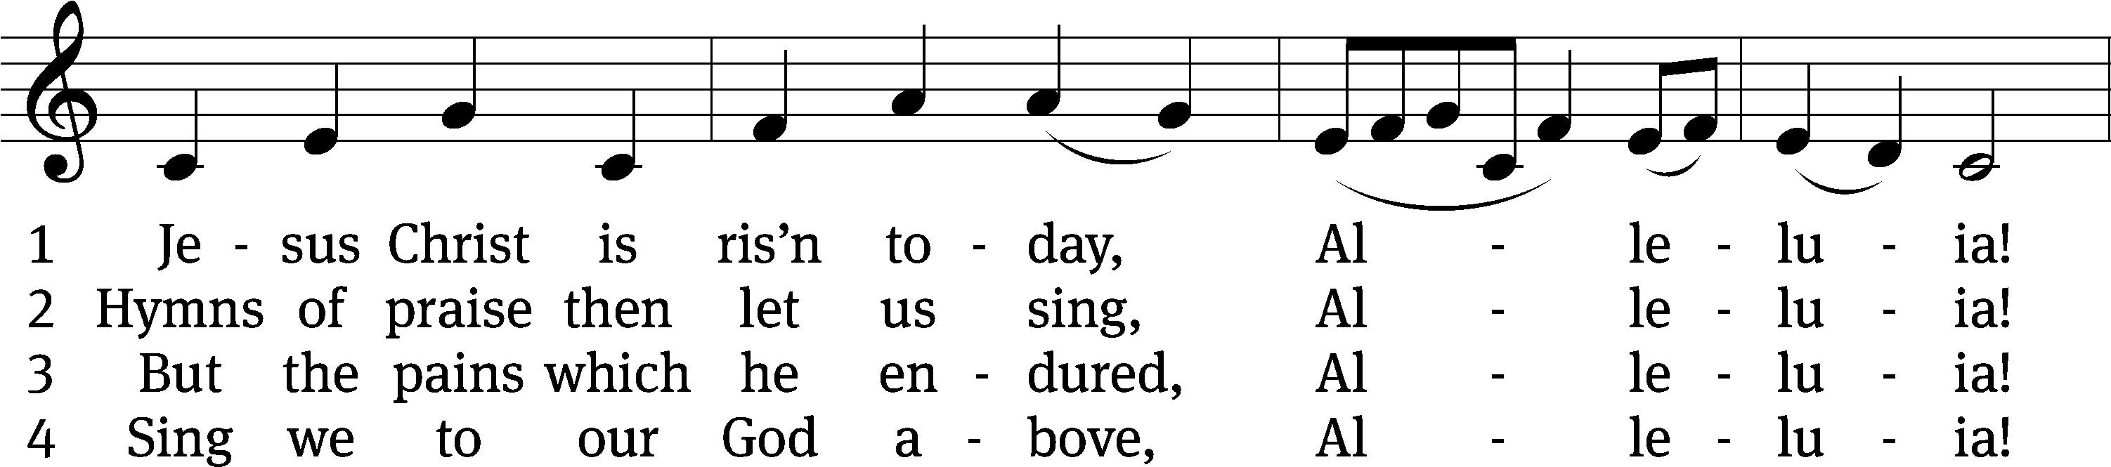
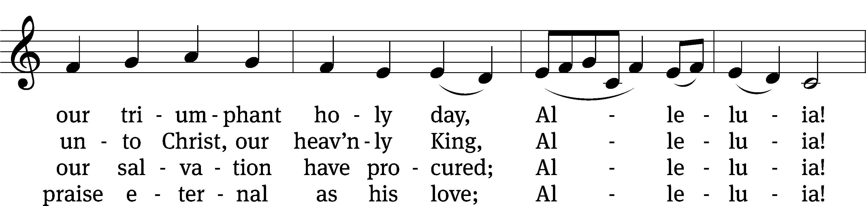
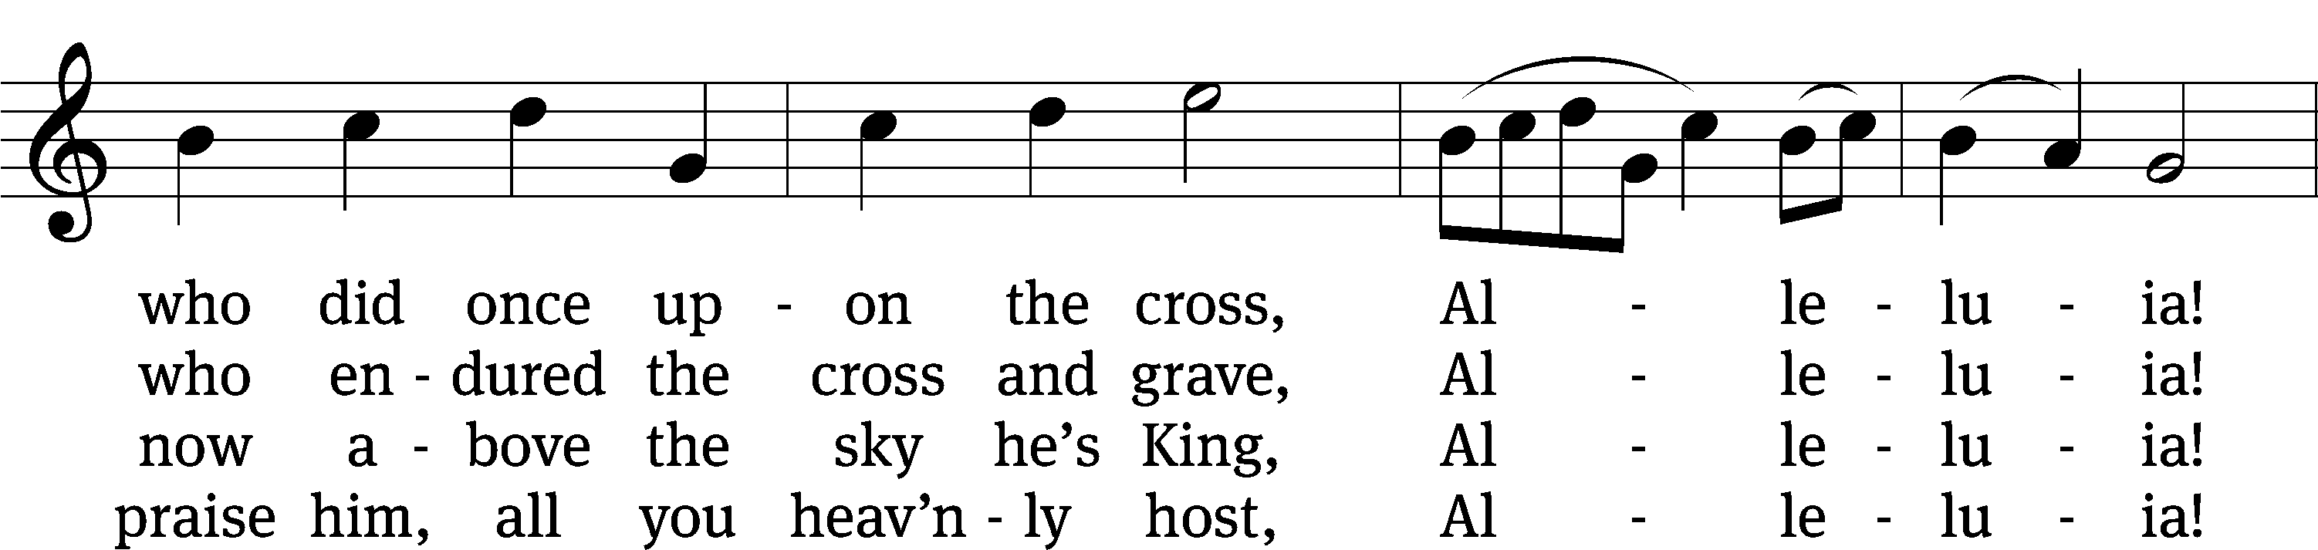
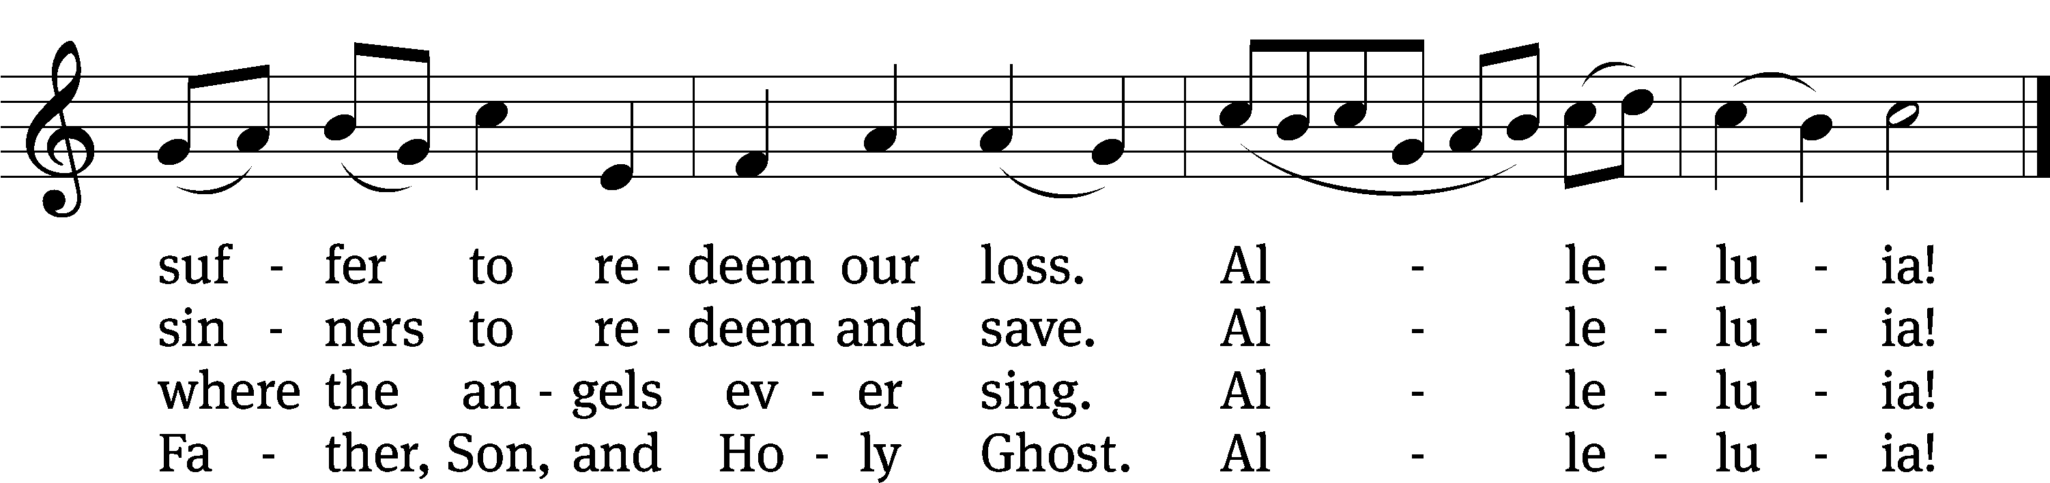

Text (sts. 1–3): tr. Lyra Davidica, 1708, alt.; (sts. 1–3): Latin, 14th cent.; (st. 4): Charles Wesley, 1707–1788
Tune: Lyra Davidica, London, 1708
Text and tune: Public domain

Opening Liturgy

PLEASE STAND IF YOU ARE ABLE

M: He is risen!
C: He is risen indeed!

M: The grace of our Lord Jesus Christ and the love of God and the fellowship of the Holy Spirit be with you.
C: And also with you.

M: God invites us to come into his presence and worship him with humble and penitent hearts. Therefore, let us acknowledge our sinfulness and ask him to forgive us.
C: Holy and merciful Father, I confess that I am by nature sinful, and that I have disobeyed you in my thoughts, words, and actions. I have done what is evil and failed to do what is good. For this I deserve your punishment both now and in eternity. But I am truly sorry for my sins, and trusting in my Savior Jesus Christ, I pray: Lord, have mercy on me, a sinner.

M: God, our heavenly Father, has been merciful to us and has given his only Son to be the atoning sacrifice for our sins. Therefore, as a called servant of Christ and by his authority, I forgive you all your sins in the name of the Father and of the Son (+) and of the Holy Spirit.
C: Amen.

Prayer of the Day
M: Let us pray.

Almighty God, through your only-begotten Son, Jesus Christ, you overcame death and opened to us the gate of everlasting life. We humbly pray that we may live before you in righteousness and purity forever; through your Son, Jesus Christ our Lord, who lives and reigns with you and the Holy Spirit, one God, now and forever.

Amen.

938 This Is the Feast CW 938
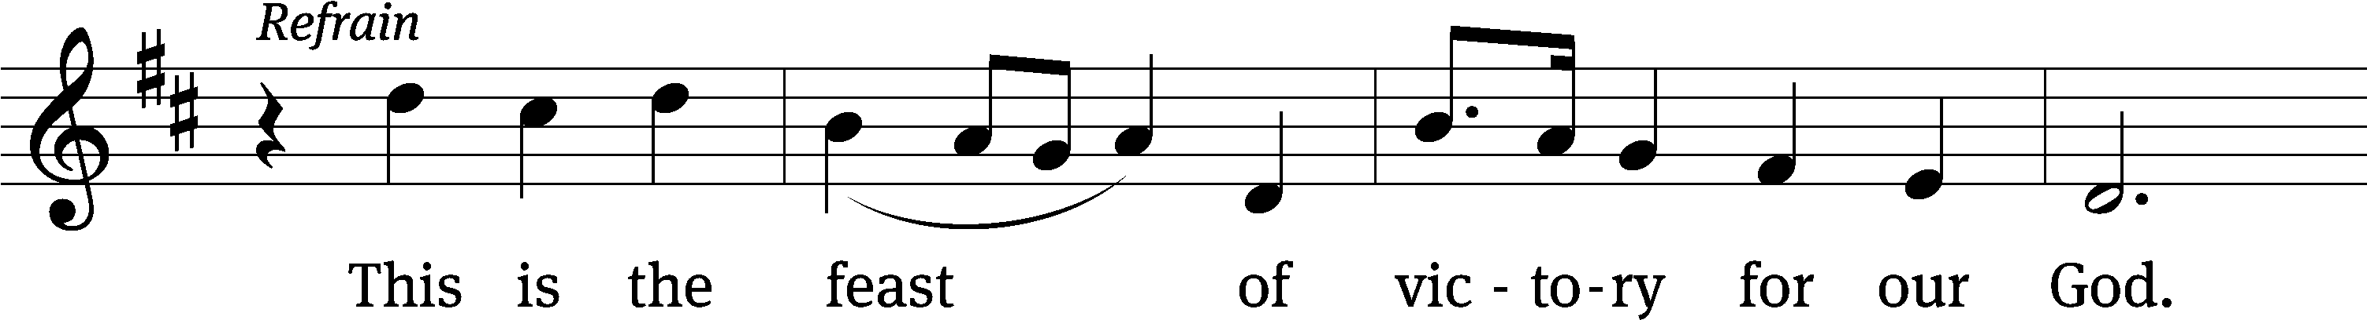
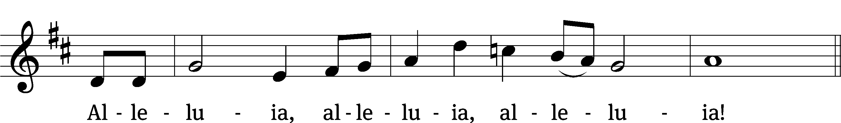

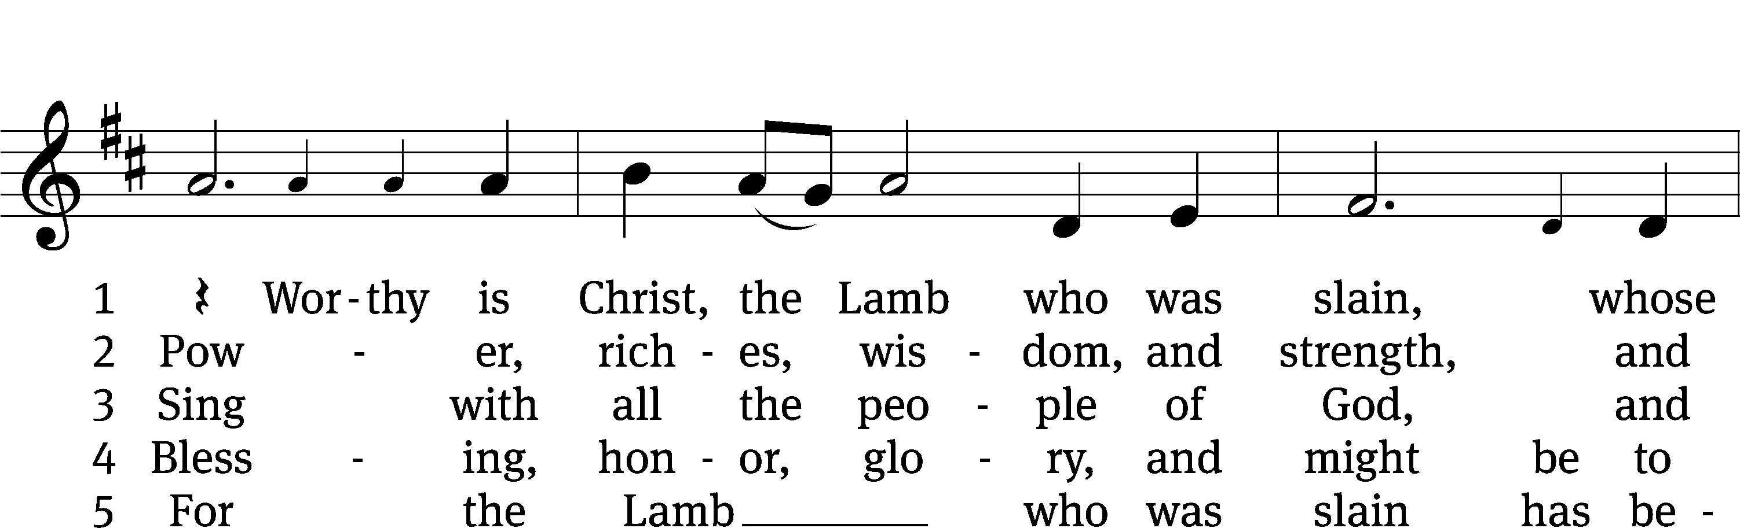
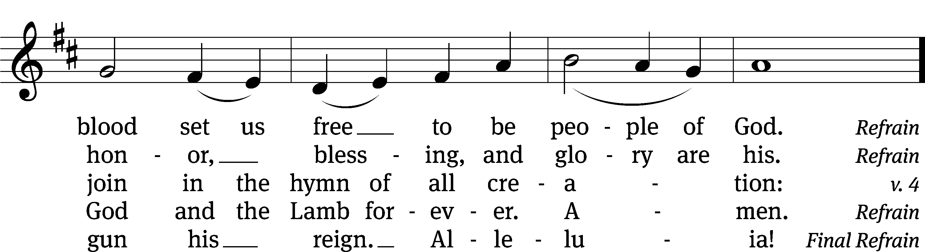
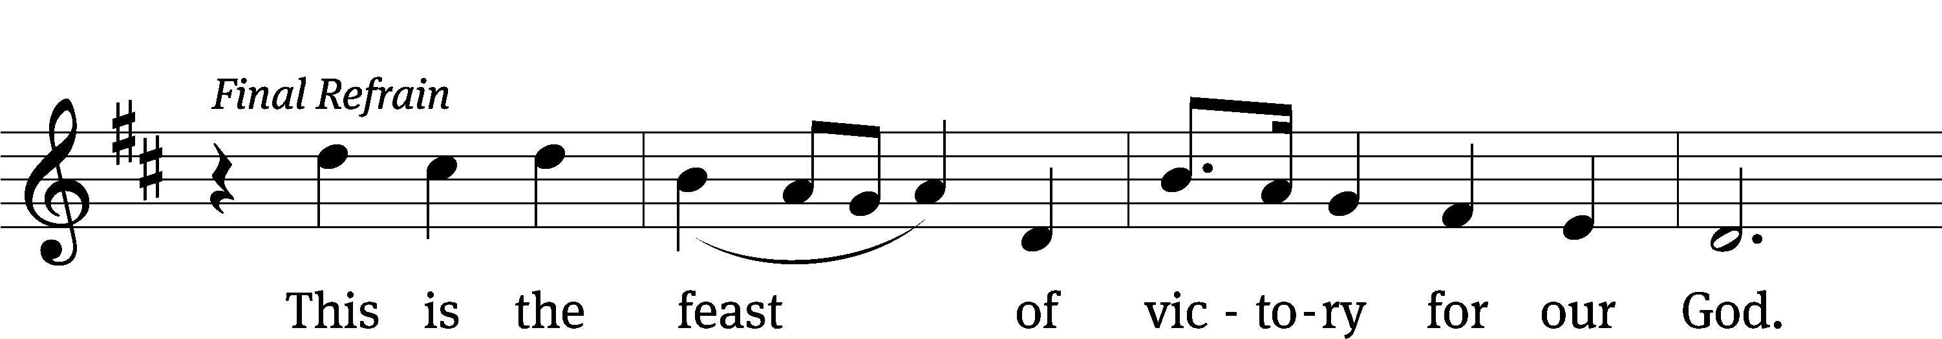
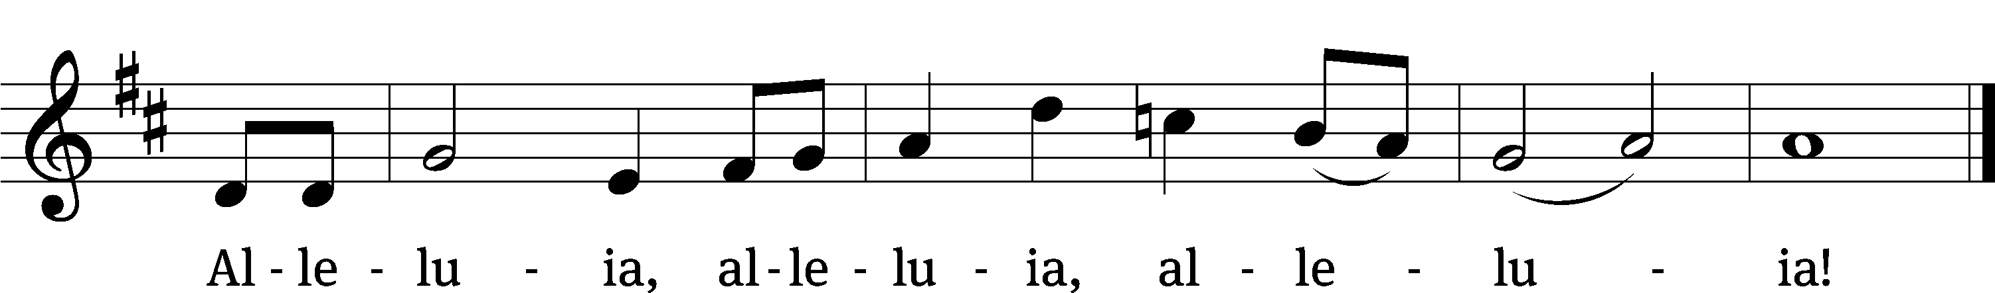

Text: Richard W. Hillert, 1923–2010; John W. Arthur, 1922–1980
Tune: Richard W. Hillert, 1923–2010
Text: © 1978 Lutheran Book of Worship, admin. Augsburg Fortress. Used by permission: OneLicense no. 727703
Tune: © 1975, 1988 Richard W. Hillert. Used by permission: OneLicense no. 727703

PLEASE BE SEATED

The First Lesson for Easter Compiled from the Gospels

SENIOR CHOIR and Congregation “Alleluia! Jesus is Risen”
(Congregation joins on vs. 4-5)

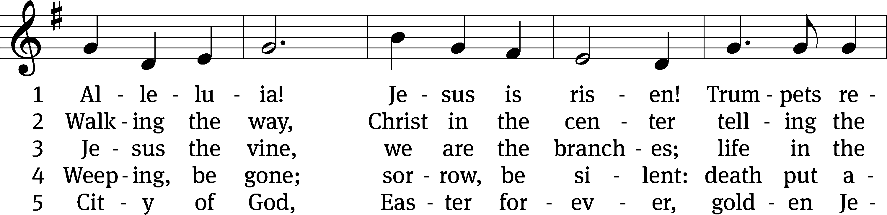
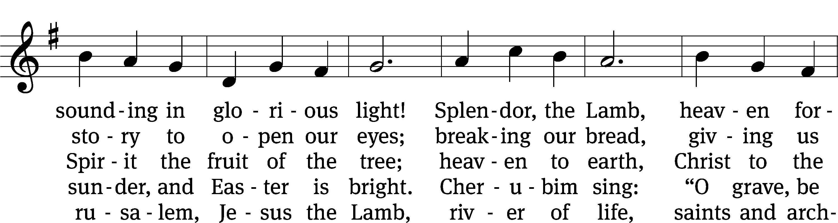
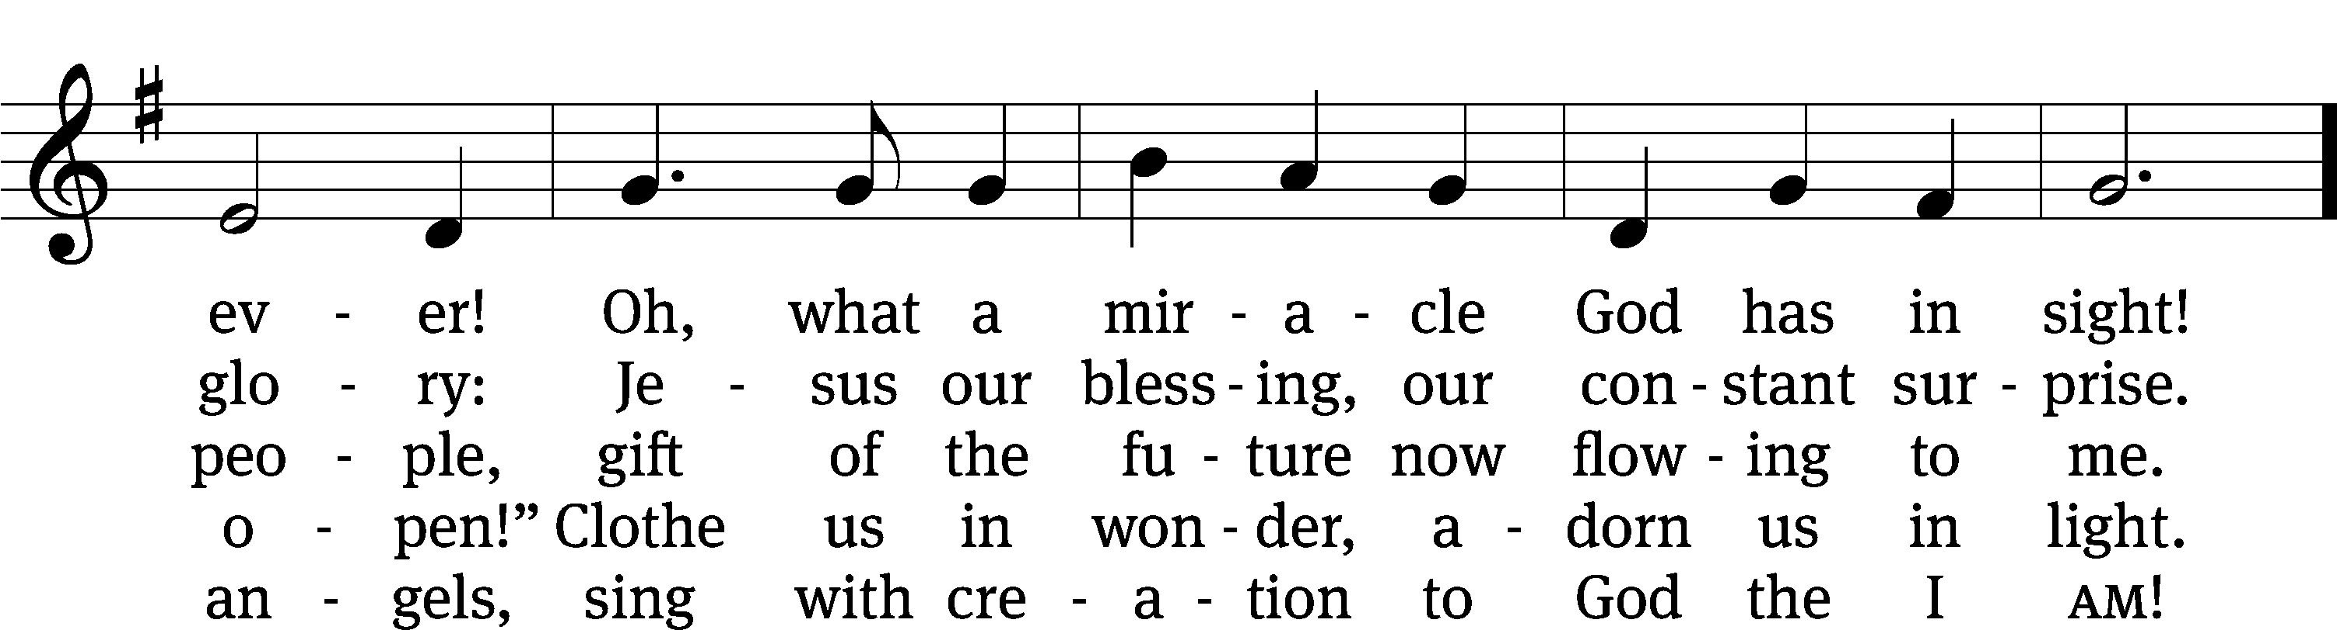
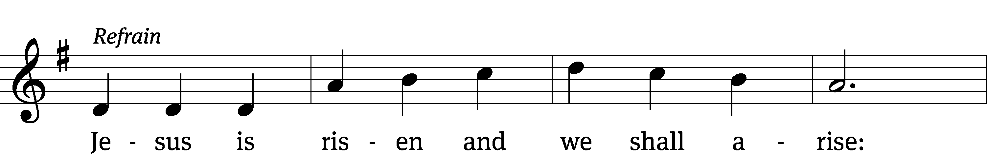
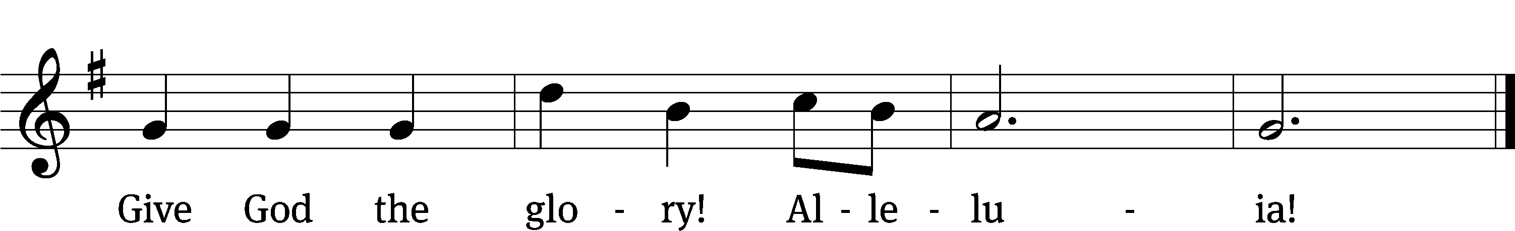

Text: Herbert F. Brokering, 1926–2009
Tune: David N. Johnson, 1922–1987
Text: © 1995 Augsburg Fortress. Used by permission: OneLicense no. 727703
Tune: © 1968 Augsburg Publishing House, admin. Augsburg Fortress. Used by permission: OneLicense no. 727703

The Second Lesson for Easter Compiled from the Gospels
455 Alleluia! Jesus Lives CW 455
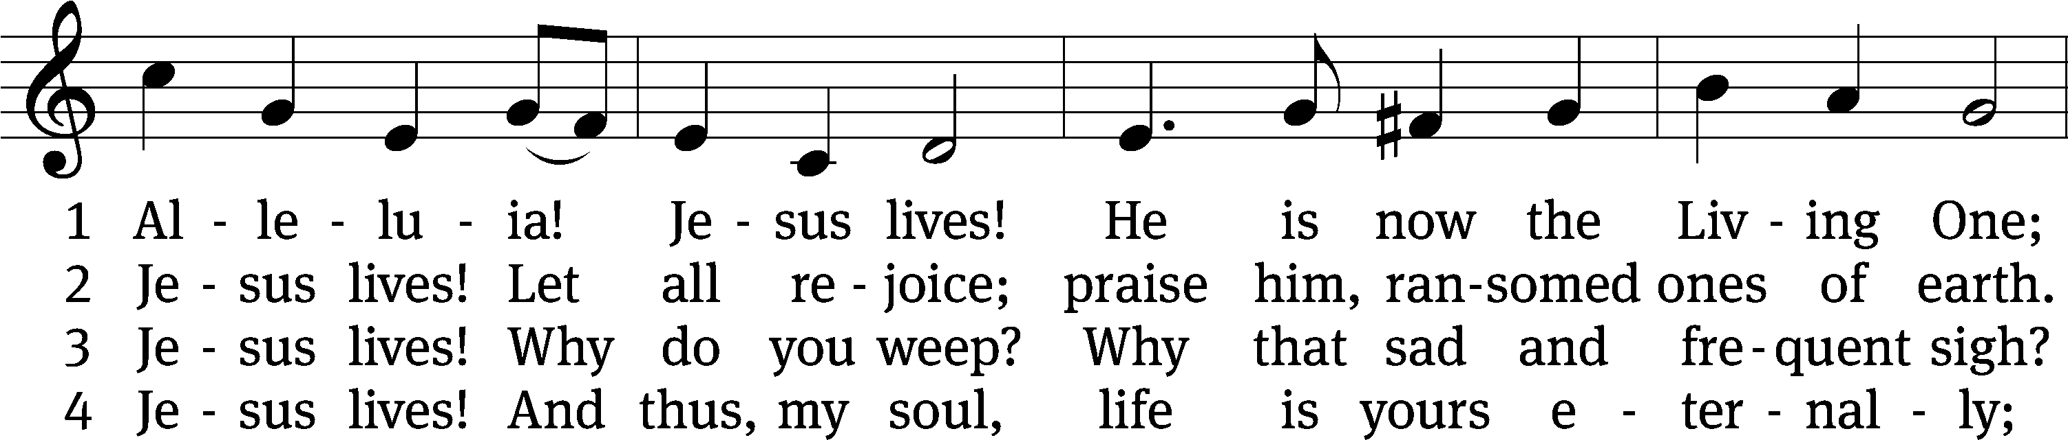
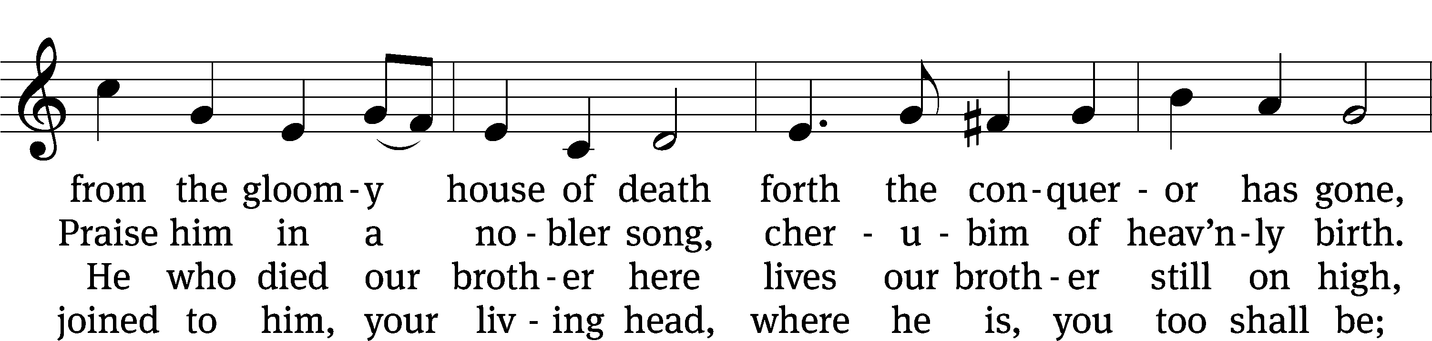
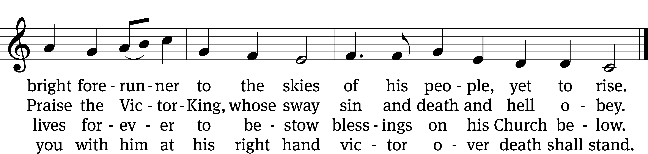
Text: tr. Jane L. Borthwick, 1813–1897, alt.; Karl B. Garve, 1763–1841, abr.
Tune: Ludvig M. Lindeman, 1812–1887
Text and tune: Public domain

The Third Lesson for Easter Compiled from the Gospels

444 Jesus Lives! The Victory’s Won! CW 444 sts. 1, 3, 5
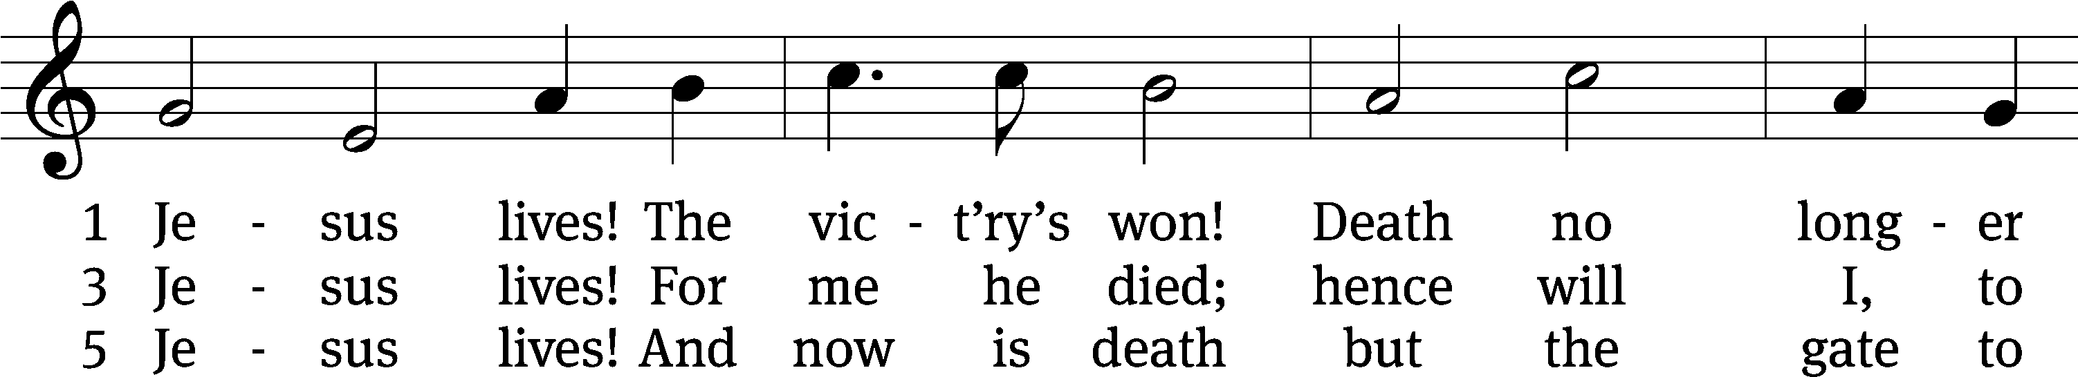
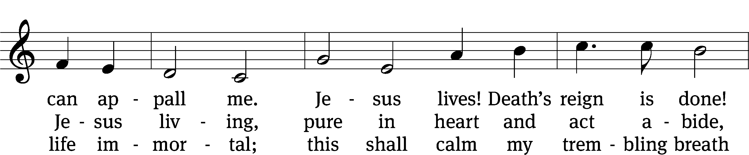
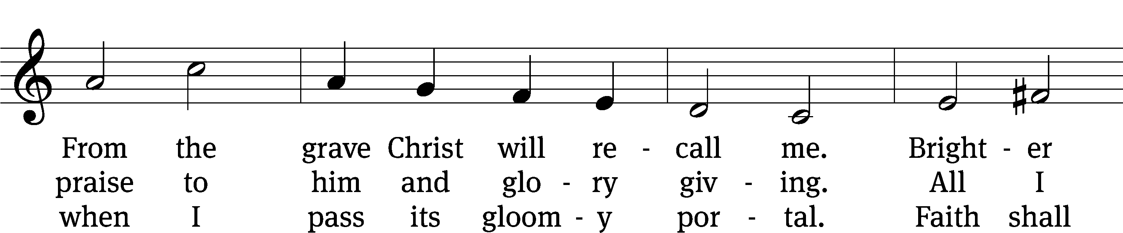
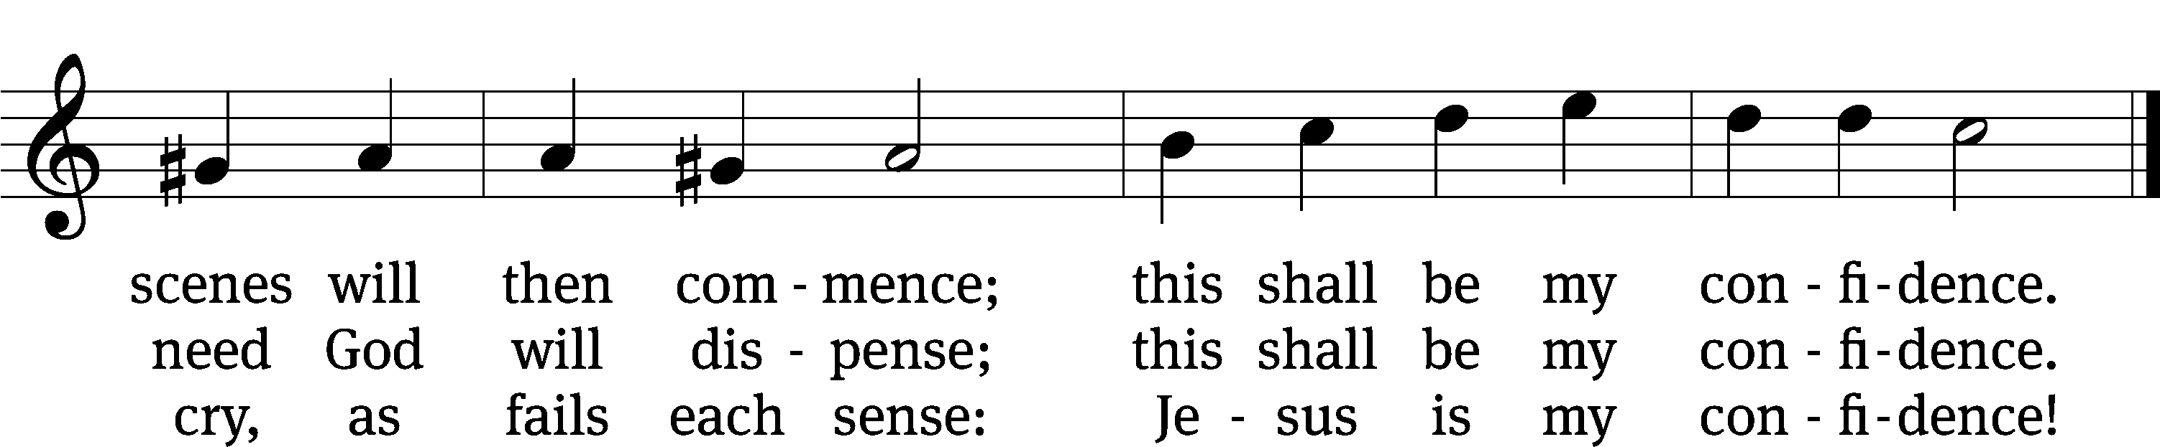
Text: tr. Frances E. Cox, 1812–1897, alt.; Christian F. Gellert, 1715–1769, abr.
Tune: Johann Crüger, 1598–1662
Text and tune: Public domain

The Fourth Lesson for Easter Compiled from the Gospels

452 The Strife Is O’er, the Battle Done CW 452
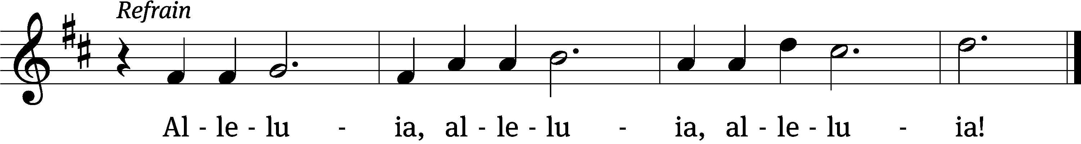
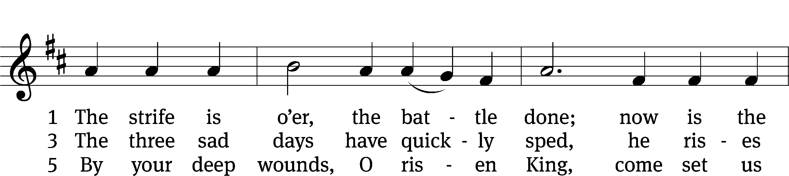
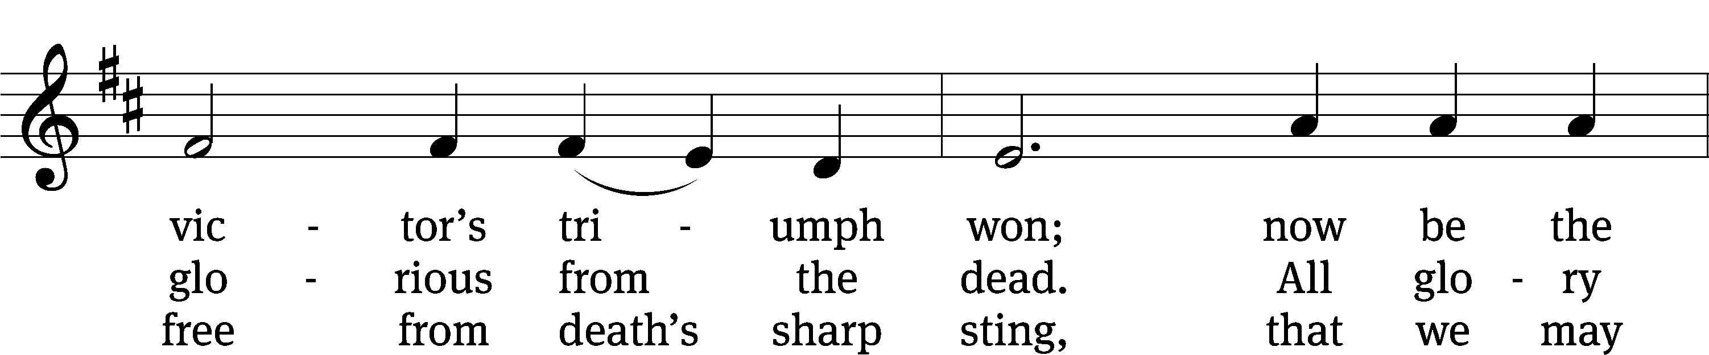
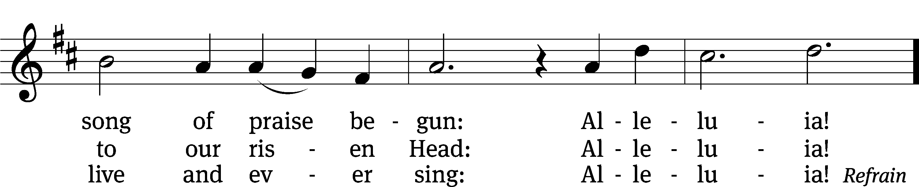
Text: tr. Francis Pott, 1832–1909, alt.; Symphonia Sirenum Selectarum, Köln, 1695
Tune: Giovanni P. da Palestrina, c. 1525–1594, adapt.
Text and tune: Public domain

The Fifth Lesson for Easter Compiled from the Gospels

441 I Know That My Redeemer Lives CW 441
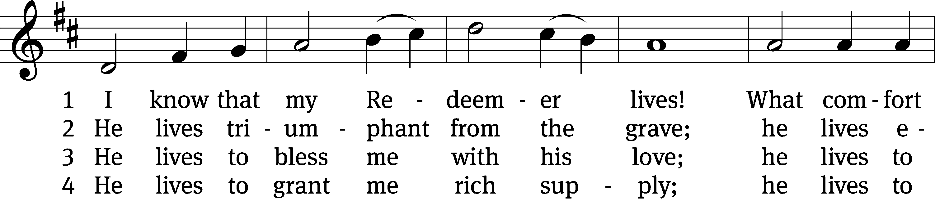
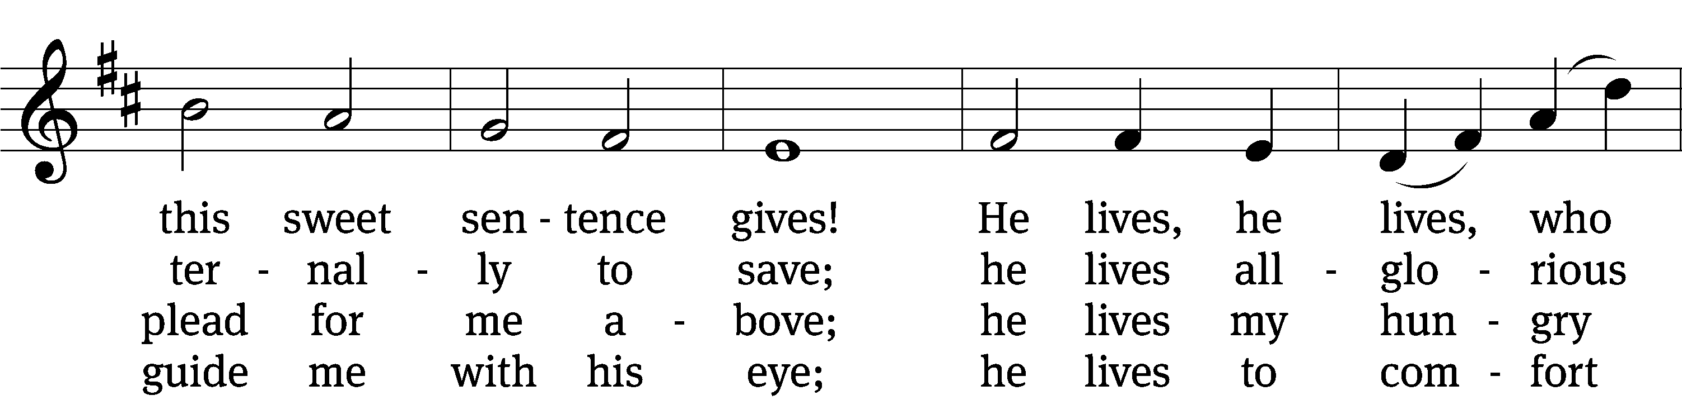
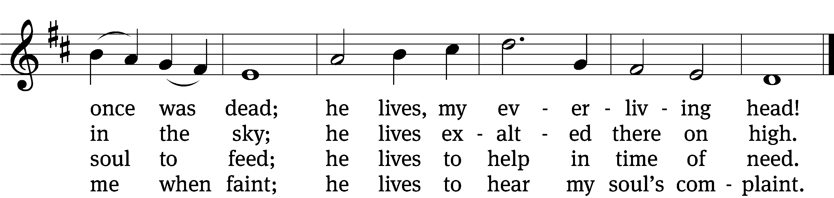

5 He lives to silence all my fears;
he lives to wipe away my tears;
he lives to calm my troubled heart;
he lives all blessings to impart.

6 He lives, my kind, wise, heav’nly friend;
he lives and loves me to the end;
he lives, and while he lives, I’ll sing;
he lives, my Prophet, Priest, and King.

7 He lives and grants me daily breath;
he lives, and I shall conquer death;
he lives my mansion to prepare;
he lives to bring me safely there.

8 He lives, all glory to his name!
He lives, my Jesus, still the same.
Oh, the sweet joy this sentence gives:
I know that my Redeemer lives!
Text: Samuel Medley, 1739–1799, abr.
Tune: attr. John C. Hatton, 1710–1793
Text and tune: Public domain

Sermon Job 19:23-27

“My Redeemer, Your Brother, Our Vindicator!”

PLEASE STAND, IF YOU ARE ABLE
Nicene Creed
We believe in one God, the Father, the Almighty,
maker of heaven and earth,
of all that is,
seen and unseen.
We believe in one Lord, Jesus Christ, the only Son of God,
eternally begotten of the Father,
God from God, Light from Light, true God from true God,
begotten, not made,
of one being with the Father.
Through him all things were made.
For us and for our salvation, he came down from heaven,
was incarnate of the Holy Spirit and the Virgin Mary,
and became truly human.
For our sake he was crucified under Pontius Pilate.
He suffered death and was buried.
On the third day he rose again in accordance with the Scriptures.
He ascended into heaven
and is seated at the right hand of the Father.
He will come again in glory to judge the living and the dead,
and his kingdom will have no end.
We believe in the Holy Spirit,
the Lord, the giver of life,
who proceeds from the Father and the Son,
who in unity with the Father and the Son
is worshiped and glorified,
who has spoken through the prophets.
We believe in one holy Christian and apostolic Church.
We acknowledge one baptism for the forgiveness of sins.
We look for the resurrection of the dead
and the life of the world to come. Amen.

PLEASE BE SEATED

Offertory

PLEASE STAND IF YOU ARE ABLE

Easter Prayer

O Lord God, our strength, our song, and our salvation, you fulfilled your promises by the resurrection of your Son, Jesus Christ, from the dead.
Thanks be to God! You give us the victory through our Lord Jesus Christ.
In your compassion you sent Christ, the Good Shepherd, who laid down his life to rescue the lost.
Drive out all doubt and gloom that we may delight in your glorious triumph.
Lift our eyes heavenward to see him who lives to make intercession for the saints, and grant us confidence in the greatness of his power. Keep before us the vision of your redeemed people standing before your throne and singing the song of victory:
Worthy is the Lamb who was slain to receive wisdom and power and honor and glory and praise.
Make us instruments of your peace as we bring the good news of hope and new life to those around us. Guide us in the use of all that you have entrusted to us: our time, our talents, and our treasures.
Risen Lord, live in us that we may live for you.
Merciful Lord Jesus, grant healing to the sick, and strengthen the faith of the suffering and the dying. Assure them of your abiding presence, and comfort them with the hope of eternal life.
Hear us, Lord, as we bring you our private petitions.
Silent prayer.
Gracious Father, you have restored to us the joy of your salvation. With happy hearts, we come before you and say:
Alleluia! Thanks be to God! Amen.

The Lord’s Prayer

Our Father, who art in heaven, hallowed be thy name, thy kingdom come, thy will be done on earth as it is in heaven. Give us this day our daily bread; and forgive us our trespasses, as we forgive those who trespass against us; and lead us not into temptation, but deliver us from evil. For thine is the kingdom and the power and the glory forever and ever. Amen.

WORDS OF INSTITUTION
Our Lord Jesus Christ, on the night he was betrayed, took bread; and when he had given thanks, he broke it and gave it to his disciples, saying, “Take and eat; this is my body, which is given for you. Do this in remembrance of me.”

Then he took the cup, gave thanks, and gave it to them, saying, “Drink from it, all of you; this is my blood of the new covenant, which is poured out for you for the forgiveness of sins. Do this, whenever you drink it, in remembrance of me.”

The peace of the Lord be with you always.
Amen.

PLEASE BE SEATED
440 Christ Jesus Lay in Death’s Strong Bands CW 440
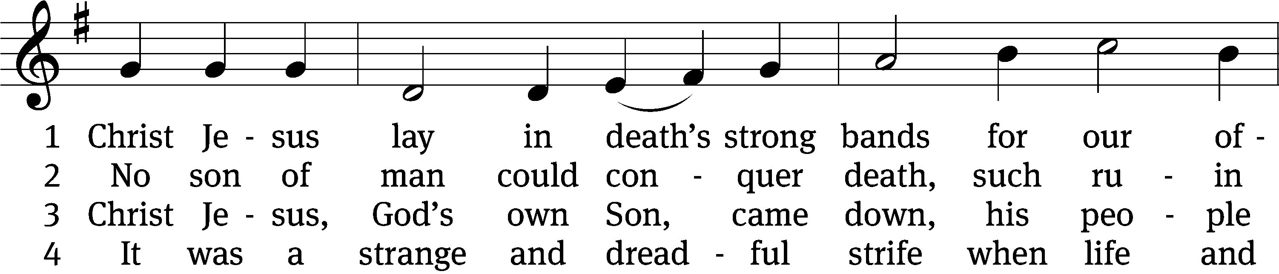
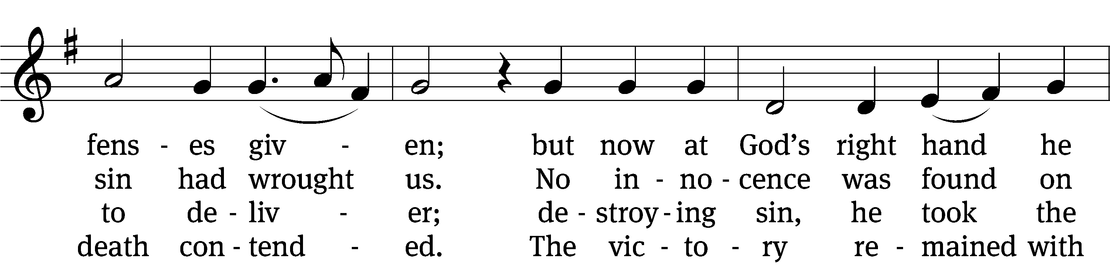
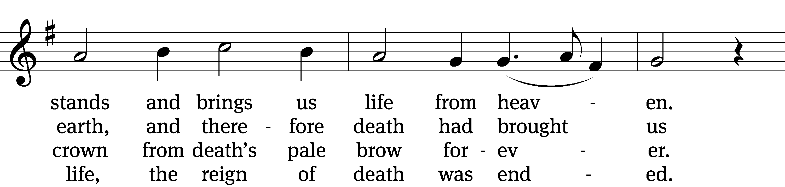
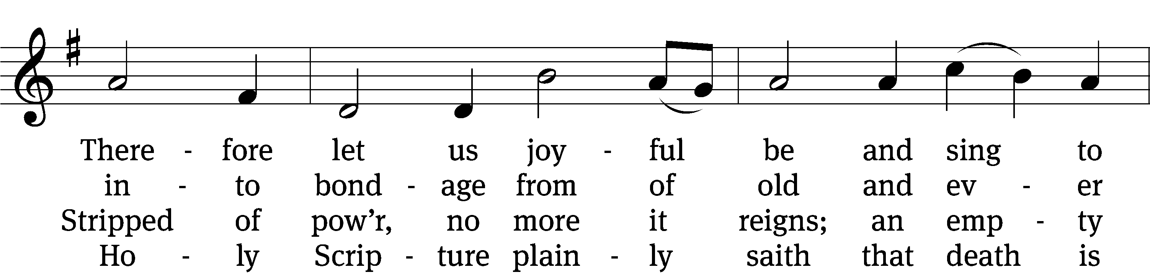
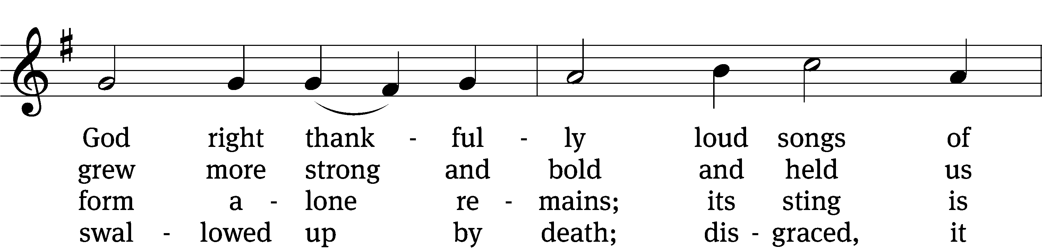
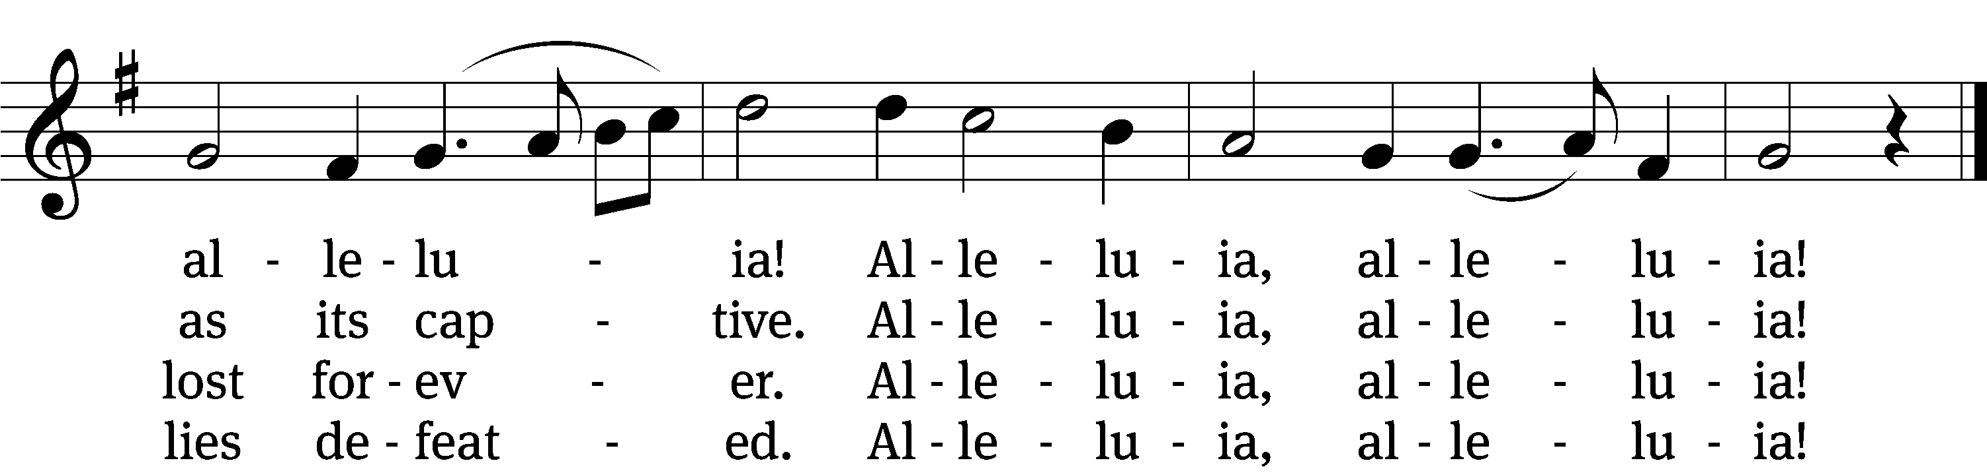

5 Here the true Paschal Lamb we see,
whom God so freely gave us;
he died on the accursèd tree—
so strong his love—to save us.
See, his blood now marks our door;
faith points to it; death passes o’er,
and Satan cannot harm us.
Alleluia, alleluia!

6 So let us keep the festival
to which the Lord invites us;
Christ is himself the joy of all,
the sun that warms and lights us.
Now his grace to us imparts
eternal sunshine to our hearts;
the night of sin is ended.
Alleluia, alleluia!

7 Then let us feast this Easter Day
on Christ, the bread of heaven;
the Word of grace has purged away
the old and evil leaven.
Christ alone our souls will feed;
he is our meat and drink indeed;
faith lives upon no other!
Alleluia, alleluia!
Text: tr. Richard Massie, 1800–1887, alt.; Martin Luther, 1483–1546
Tune: Kermit G. Moldenhauer, b. 1949
Text: Public domain
Tune: © 2005 Kermit G. Moldenhauer, admin. Northwestern Publishing House. Used by permission: OneLicense no. 727703

466 Christ Has Arisen, Alleluia CW 466
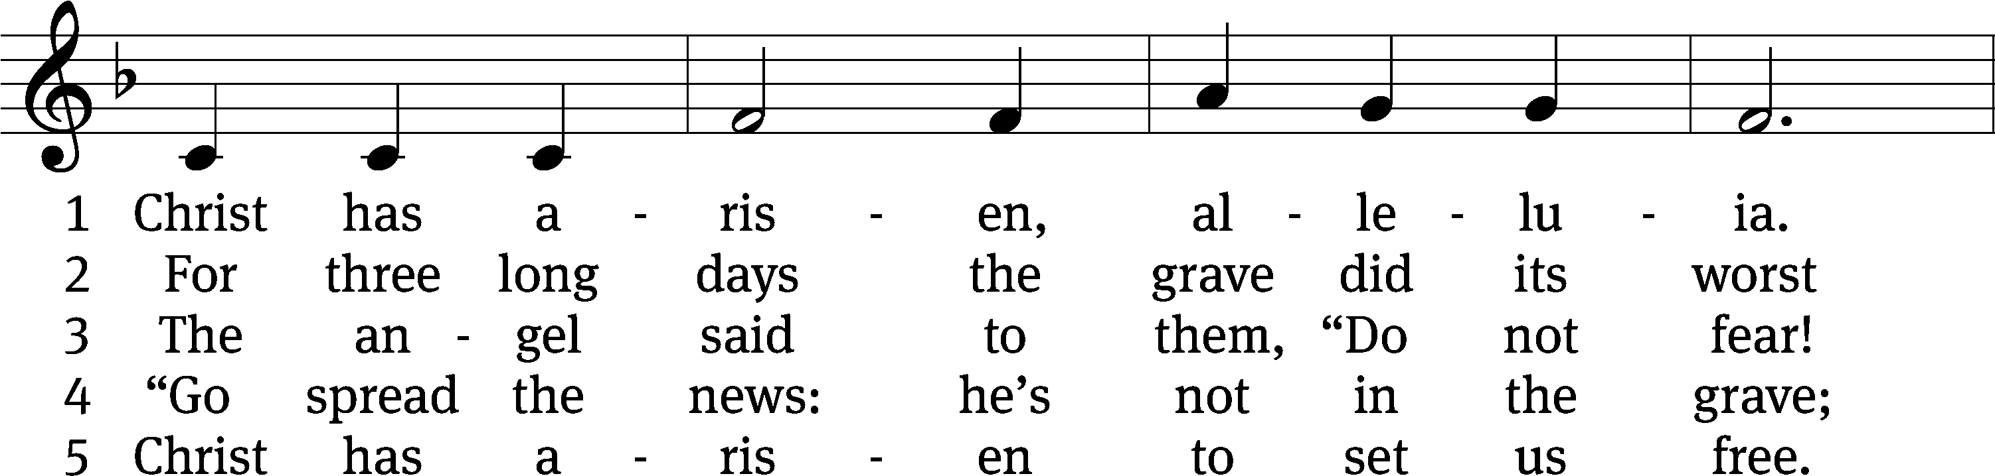
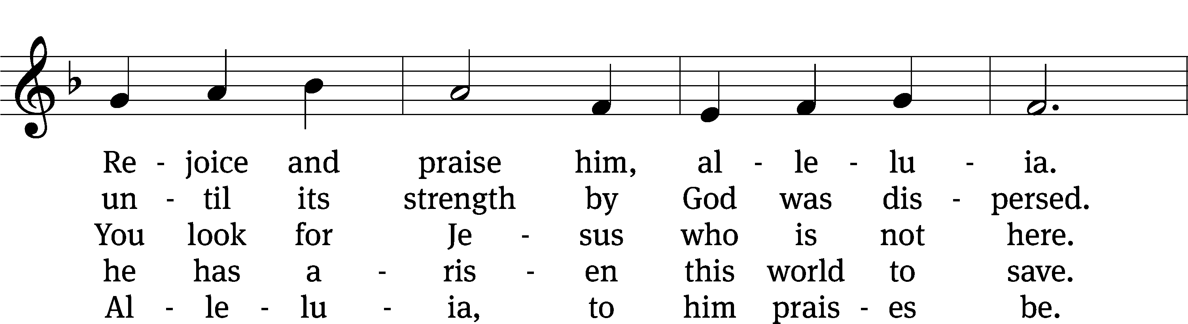
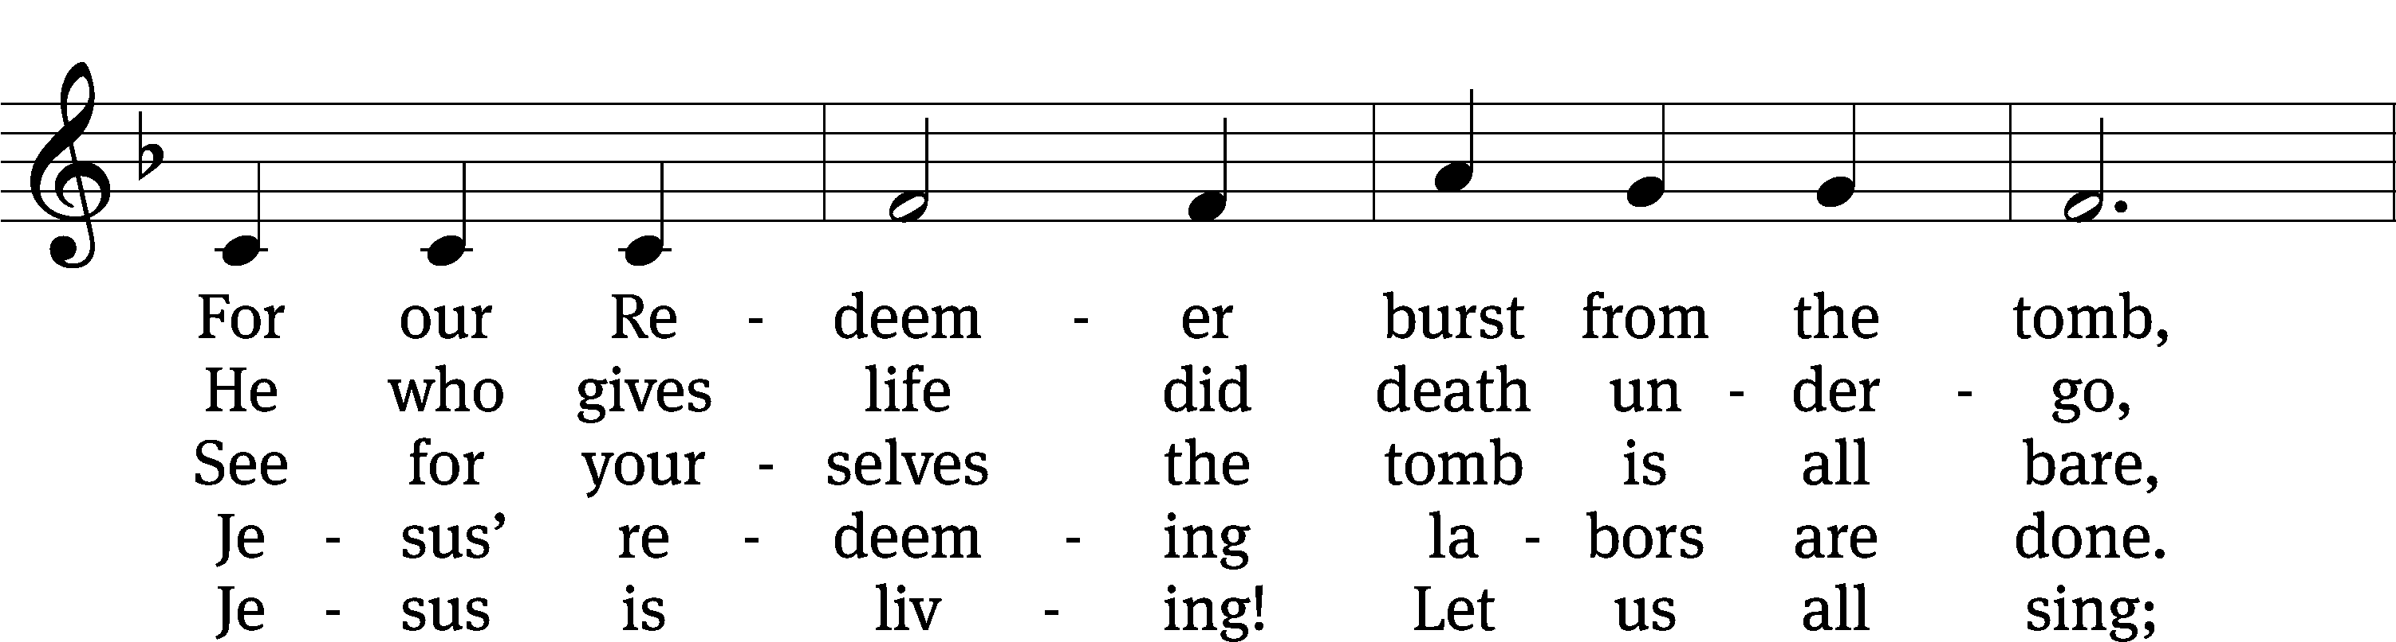
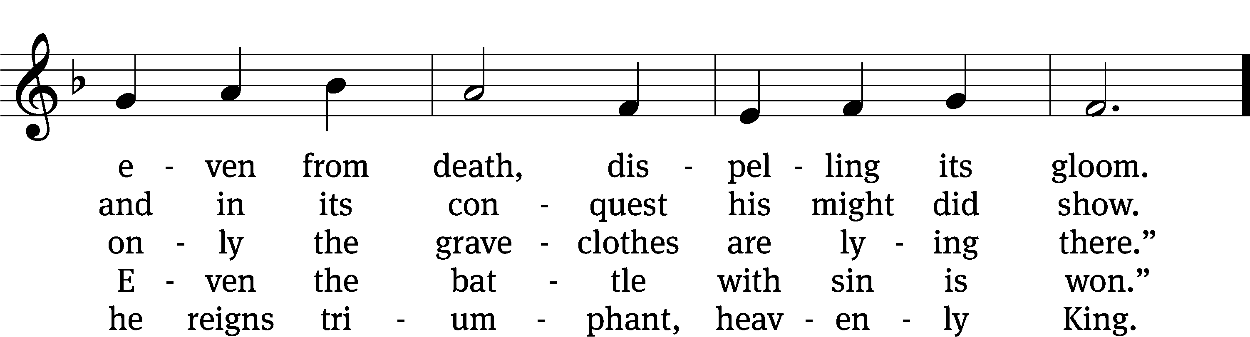
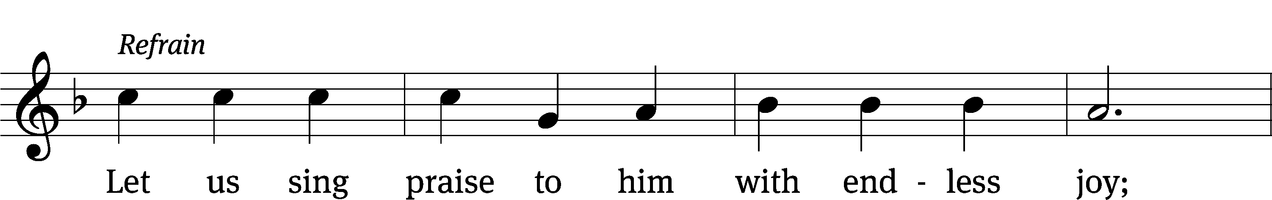
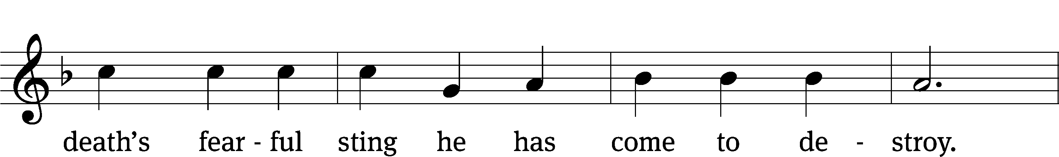
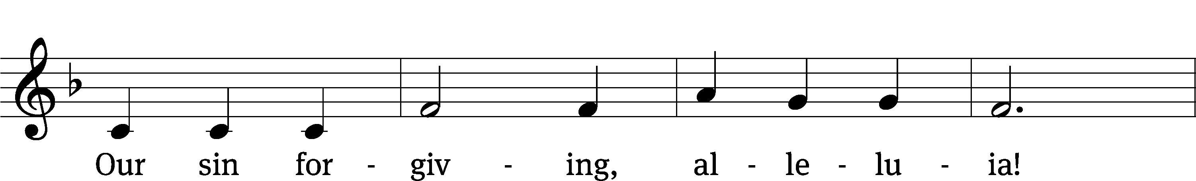
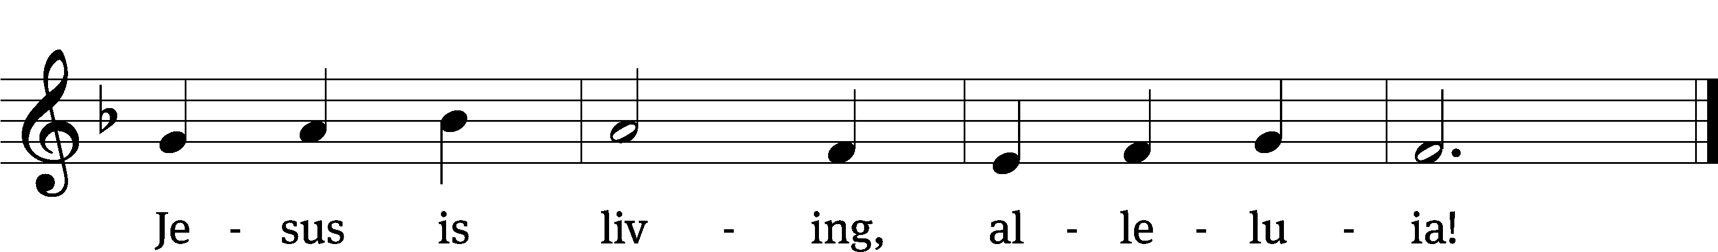
Text: tr. Howard S. Olson, 1922–2010; Bernard Kyamanywa, b. 1938
Tune: Tanzanian
Text: © 1968 Makumira University College, admin. Augsburg Fortress. Used by permission: OneLicense no. 727703
Text: © 1977 Howard S. Olson, admin. Augsburg Fortress (Translation). Used by permission: OneLicense no. 727703
Tune: Public domain

PLEASE STAND, IF YOU ARE ABLE

Closing Responses

Give thanks to the Lord, for he is good;
his mercy endures forever.

Whenever we eat this bread and drink this cup,
we proclaim the Lord’s death until he comes.

We give thanks, almighty God, that you have refreshed us with this saving gift. We pray that through it you will strengthen our faith in you and increase our love for one another. We ask this in the name of Jesus Christ our Lord, who lives and reigns with you and the Holy Spirit, one God, now and forever.
Amen.

Blessing
The Lord bless you and keep you.
The Lord make his face shine on you and be gracious to you.
The Lord look on you with favor and T give you peace.
Amen.
451 See, What a Morning (after stanza 3 repeat last 3 lines) CW 451
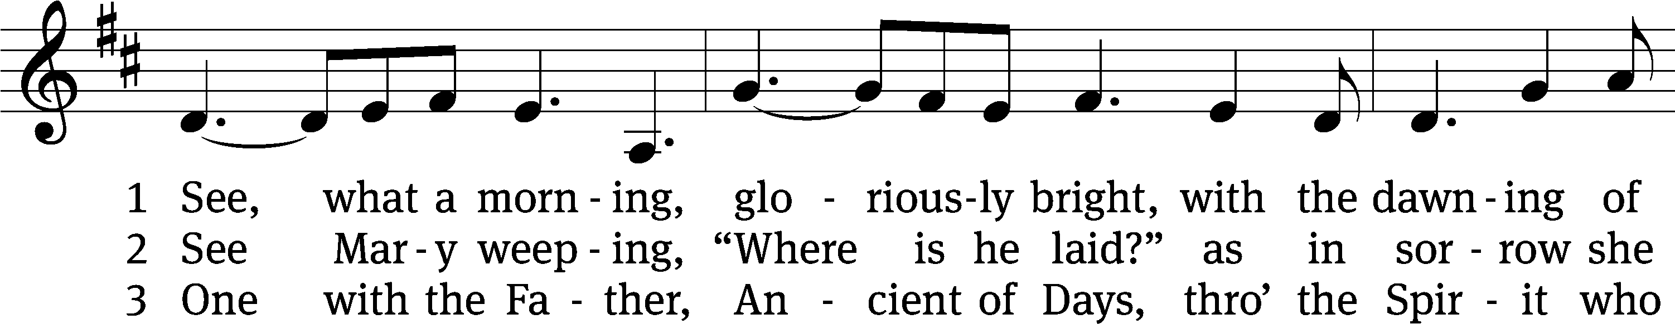
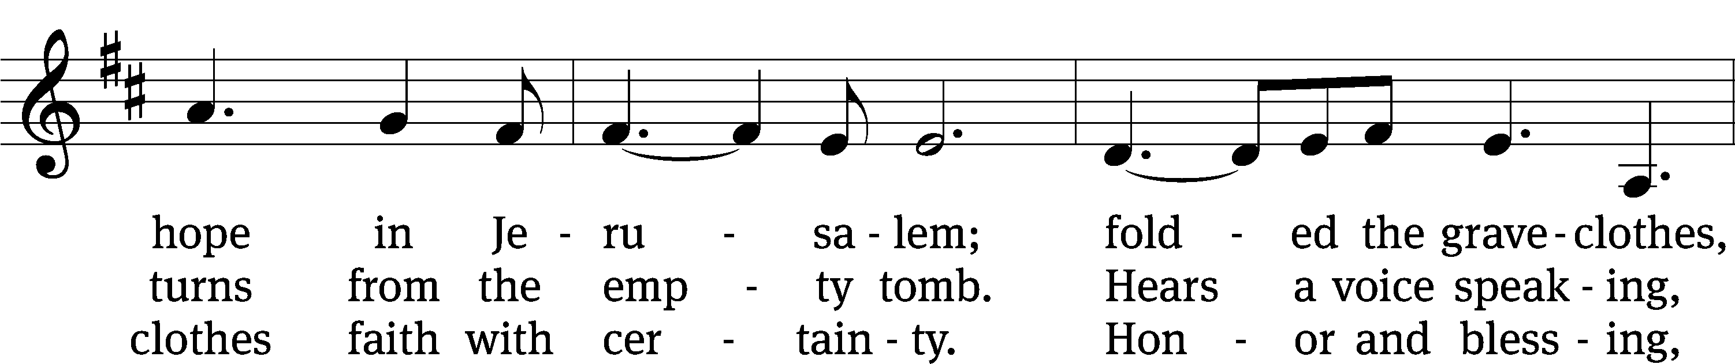
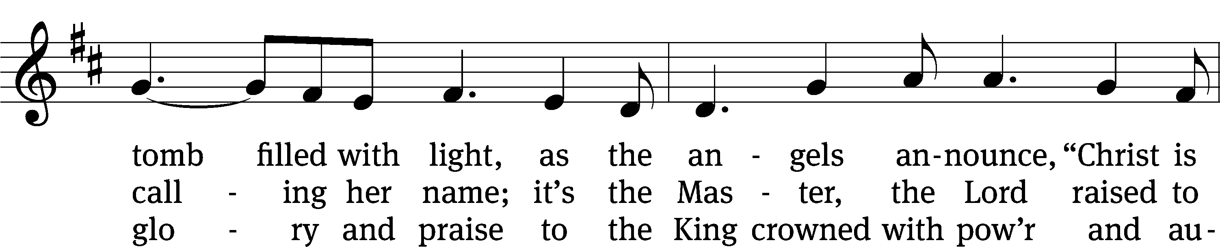
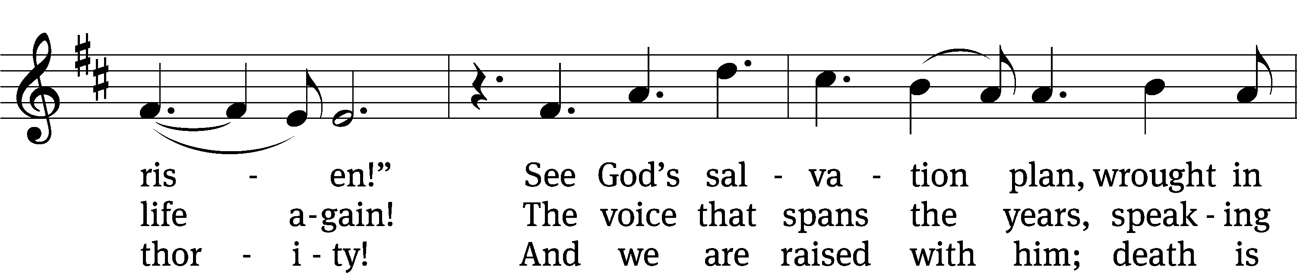
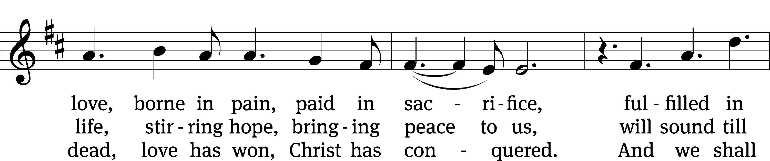
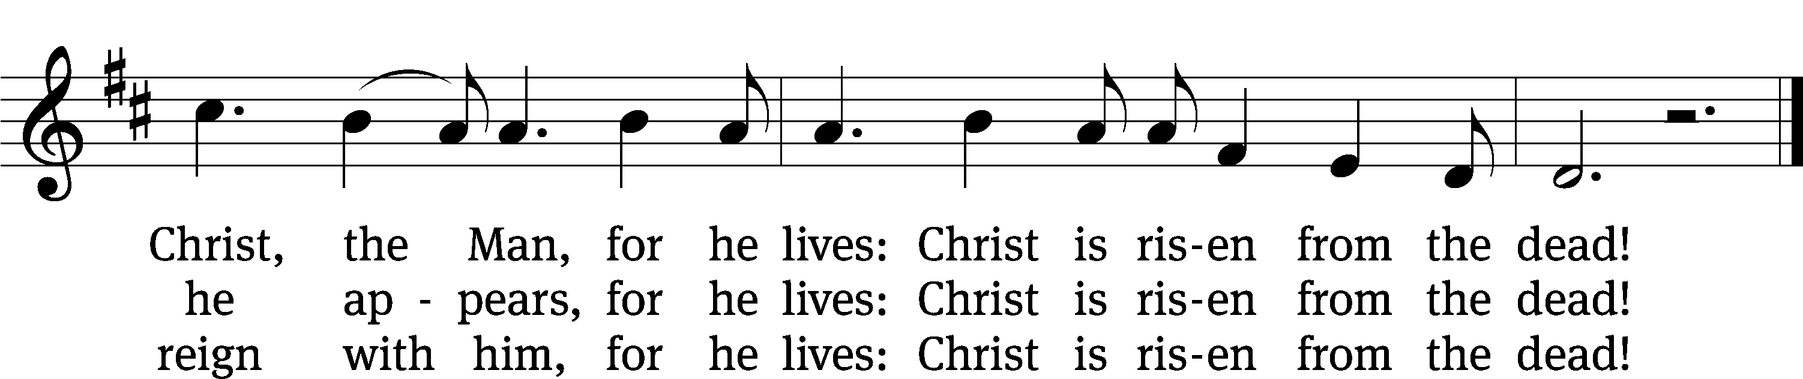
Text: Stuart Townend, b. 1963; Keith Getty, b. 1974
Tune: Stuart Townend, b. 1963; Keith Getty, b. 1974
Text and tune: © 2003 Thankyou Music (PRS), admin. CapitolCMGPublishing,com. Used by permission: OneLicense no. 727703

Serving In Worship
Officiant Pastor Pappenfuss
Organist Sarah Hanke
Choir Director Cynthia Natsis
Accompanist Sarah Hanke
Accompanist Laura Sala
Trumpeter Tom Amerman
Trumpeter Ken Kirkpatrick
Trumpeter Megan Marion
Trombone and Timpani Jeremy Hanke
Deacons (6:30) Duane Mason and Dave Stevenson
Deacons (9:30) Gary Knowlton and Robert Niethammer
Ushers (6:30) Dale Finkbeiner and Mark Finkbeiner
Ushers (9:30) Dave Boswell and Jake Vershum
Altar Guild Jean Fiegel and Ann Latowski
Videographer Jake Vershum

Copyright information

Music and Liturgy reprinted under One License #A-727703 and CCLI #1151741
Music and liturgy reprinted under OneLicense.net A-717558 & CCLI 11355138

Music and liturgy reprinted under OneLicense.net A-717558 & CCLI 11355138

Music and liturgy reprinted under OneLicense.net A-717558 & CCLI 11355138

tlcsaline.church

