THE SIXTH SUNDAY IN LENT
PALM SUNDAY

TRINITY EVANGELICAL LUTHERAN CHURCH | Saline, Michigan
WELCOME TO WORSHIP April 2, 2023
Thank you for joining us in God’s house today! We cordially ask that our Guests sign one of the guestbooks located at either the front or back entryways, or fill out a “Let’s Get Acquainted” card located in the hymnal pew rack and place it in the collection plate.

Thank Offering: Members of Trinity give their offering as an expression of love and thankfulness to the Lord and to help support the Lord’s work in our community and around the world. Visitors need not feel obligated to participate in this offering .

Restrooms are located at the back of the upper level (the annex), and in the basement (down the back stairs of the sanctuary or annex). Handicap access is available, please ask an usher for assistance.

Young Families / Toddler Bags – We are GLAD YOU BROUGHT YOUR CHILDREN to our worship service. Jesus said: “Let the little children come to me and do not hinder them, for the kingdom of God belongs to such as these.” We know that having little children in church can be a challenge, but DO NOT WORRY about it. Many of your fellow worshippers have been in your shoes and are just happy you brought your children with you. For your convenience, we have reserved the back rows of seating for parents with small children. These areas provide more flexibility for your family, as well as, easy access to move downstairs if necessary. A closed-circuit TV system allows families to continue participating in the service while downstairs. Pre-school toddler bags and children’s bulletins are available for their enjoyment. Ask an usher for one to use during the service and please return the toddler bag afterwards.

Holy Communion – In His Word, God makes it clear that the Lord’s Supper is to be shared by people of a common proclamation of faith (1 Corinthians 11:26; 1 Corinthians 10:16-17). Without judging anyone’s hearts, we invite those who share in our confession by their membership in our congregation or another congregation of the Wisconsin Evangelical Lutheran Synod (WELS) or the Evangelical Lutheran Synod (ELS) and who are properly prepared (1 Corinthians 11;27-29) to receive the Sacrament. Page 295 in Christian Worship provides a guide for preparation.
Guests, we would love to have you join us in communion fellowship in the future, and for that to be possible, we ask that you speak with one of the pastors so that we may speak with you on how that would be possible. We thank you for respecting the way we celebrate the Lord’s Supper in our congregations.

the SERVICE – setting one - WITH HOLY COMMUNION CW, page 154

Processional (Sunday School, Choir, Bell Choir) “Hosanna to the Son of David”

Sing and shout to the Son of David, bring unto the King a jubilant song.
Raise your voices, sing hosanna. Sing unto the King a jubilant song.
Sing hosanna, blessed is the One who comes in the name of the Lord.
Sing hosanna, blessed is the One who comes.
Sing and shout to the Son of David, bring unto the King a jubilant song.
Raise your voices, sing hosanna. Sing unto the King a jubilant song.
Sing hosanna!

Words of Welcome
411 Ride On, Ride On in Majesty CW 411
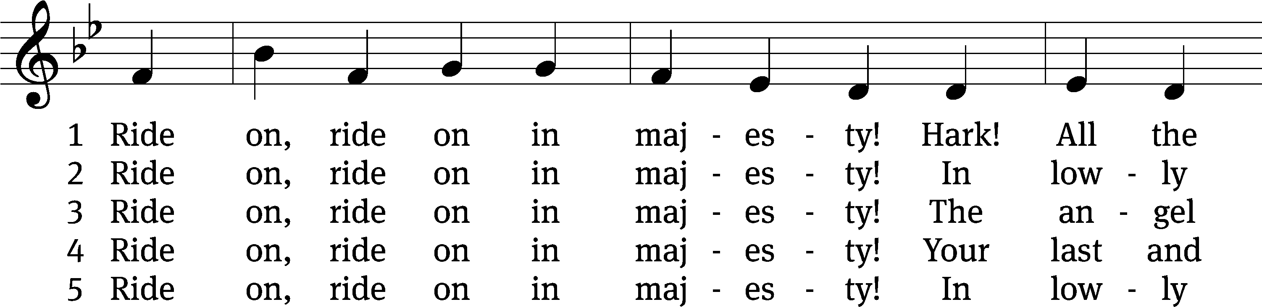
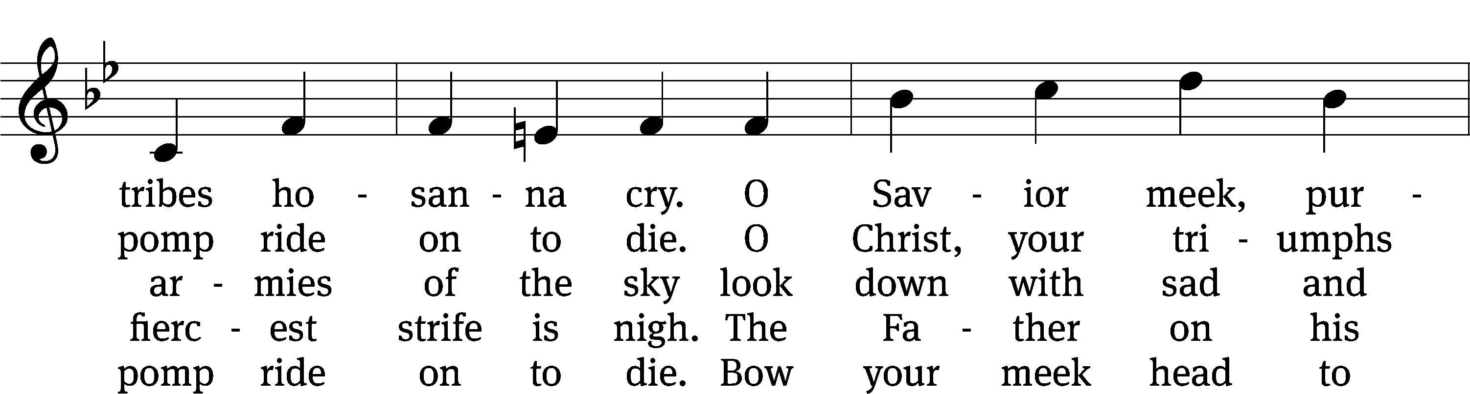
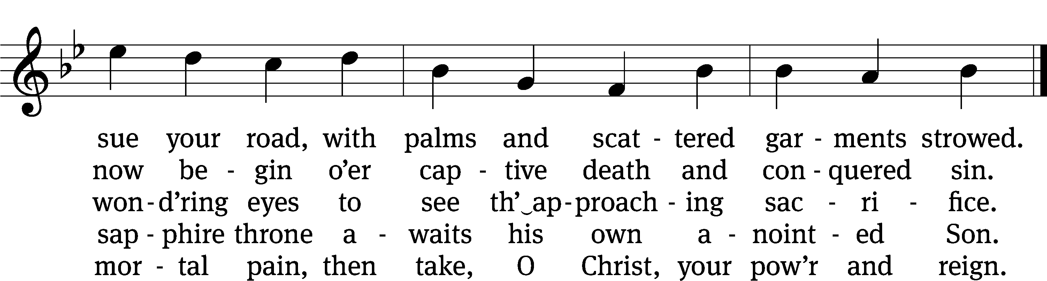
Text: Henry H. Milman, 1791–1868, alt.
Tune: Musicalisch Hand-Buch der Geistlichen Melodien, Hamburg, 1690, alt.
Text and tune: Public domain

Please stand, if you are able
Invocation
In the name of the Father and of the Son and of the Holy Spirit.
Amen.
Confession
If we claim to be without sin, we deceive ourselves and the truth is not in us.
If we confess our sins, God is faithful and just
and will forgive us our sins
and purify us from all unrighteousness.

Let us confess our sins to the Lord.
Holy God, gracious Father,
I am sinful by nature
and have sinned against you in my thoughts, words, and actions.
I have not loved you with my whole heart;
I have not loved others as I should.
I deserve your punishment both now and forever.
But Jesus, my Savior, paid for my sins
with his innocent suffering and death.
Trusting in him, I pray: God, have mercy on me, a sinner.

Our gracious Father in heaven has been merciful to us. He sent his only Son, Jesus Christ, who gave his life as the atoning sacrifice for the sins of the whole world. Therefore, as a called servant of Christ and by his authority, I forgive you all your sins in the name of the Father and of the Son and of the Holy Spirit.
Amen.

Lord, Have Mercy

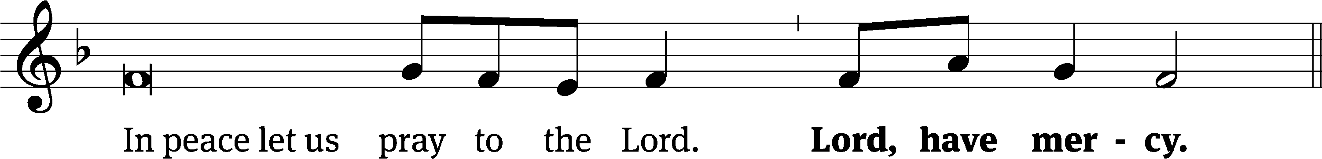
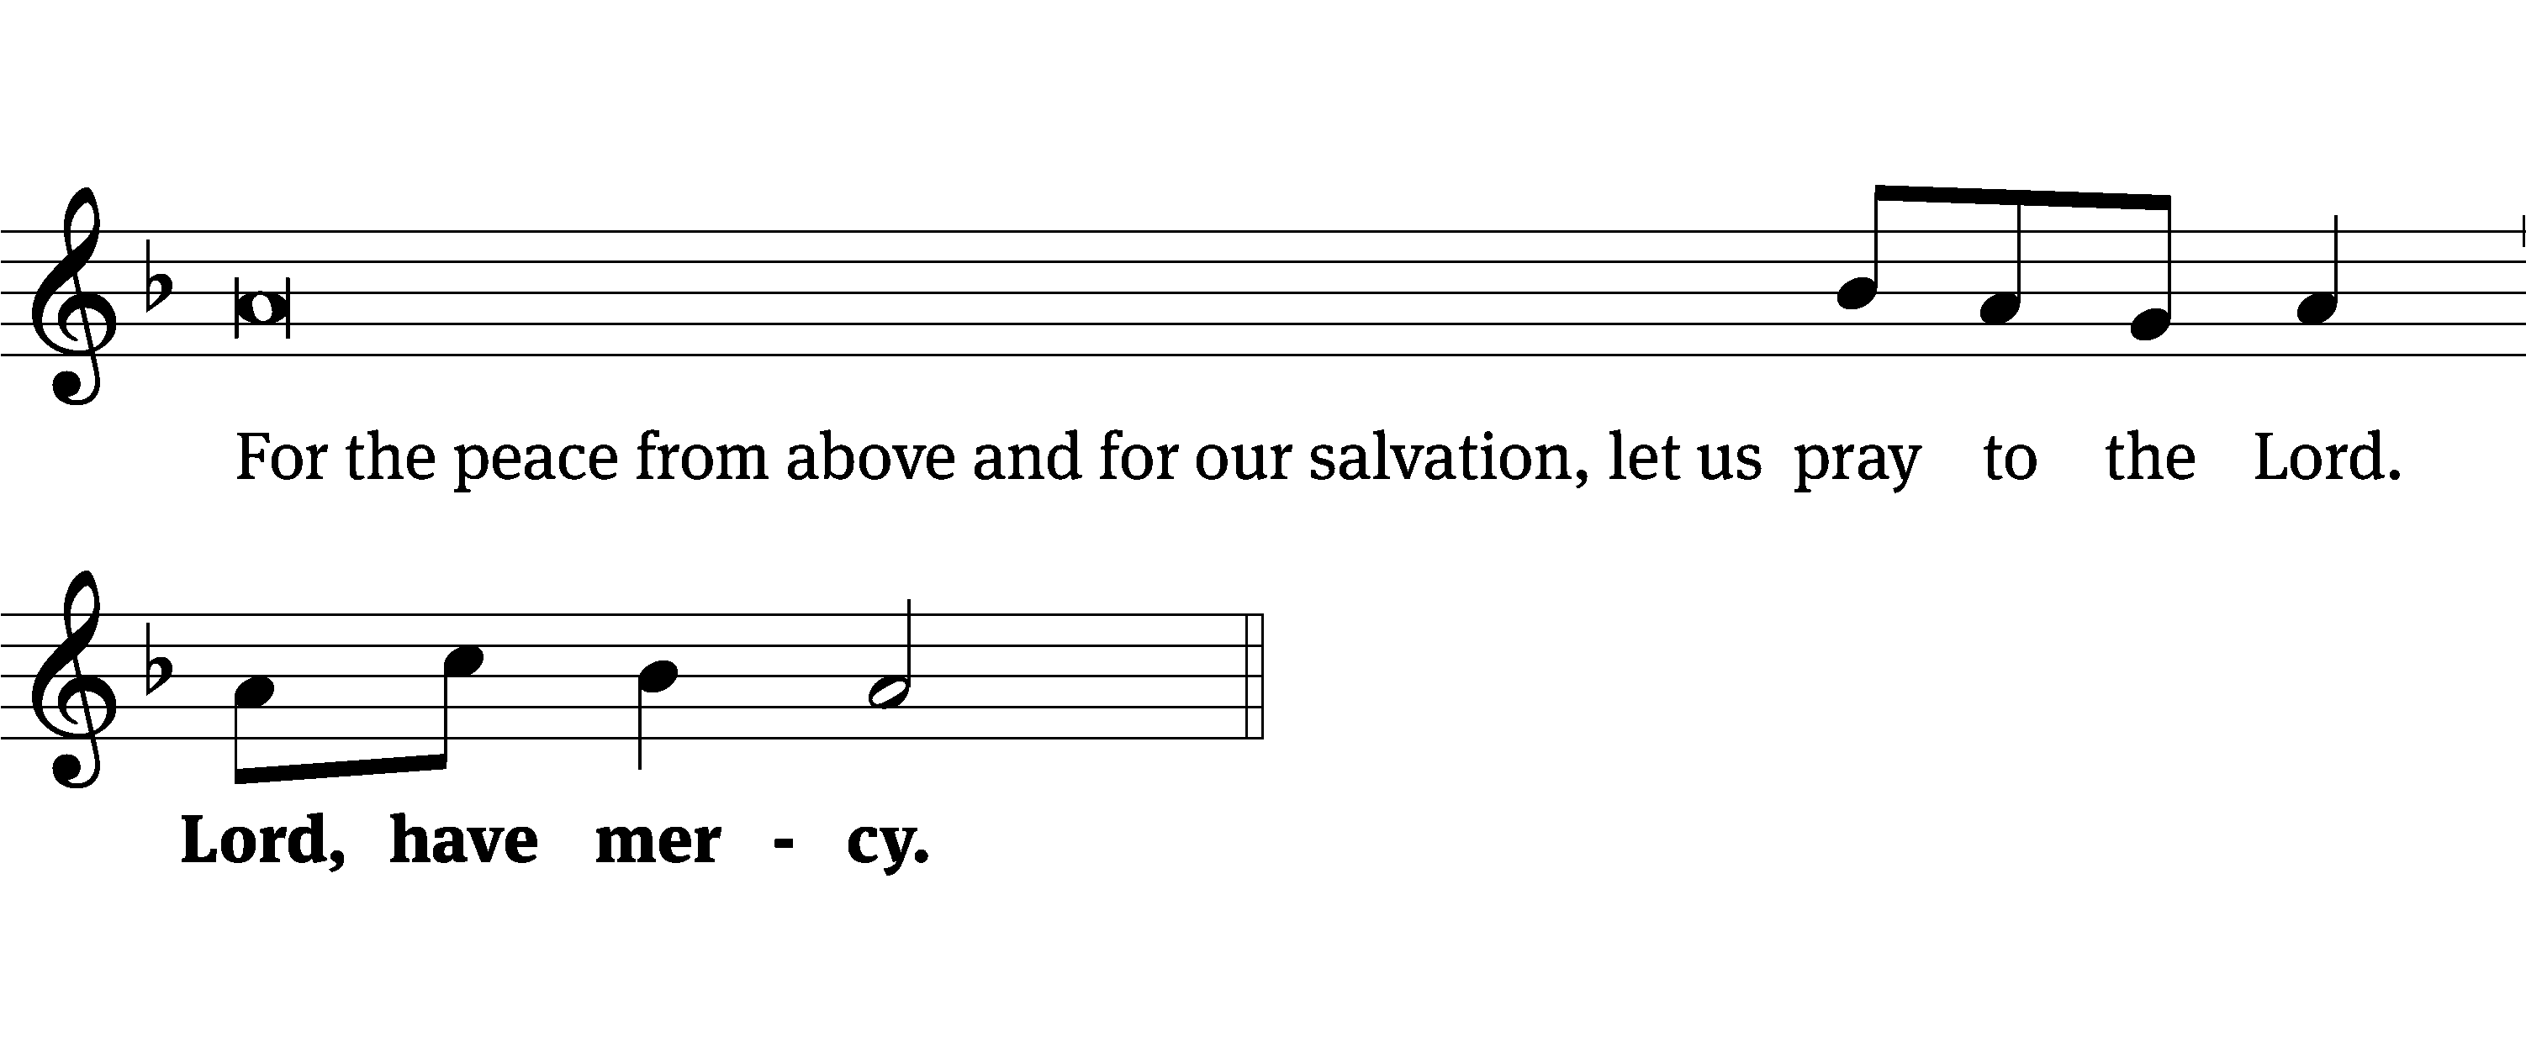
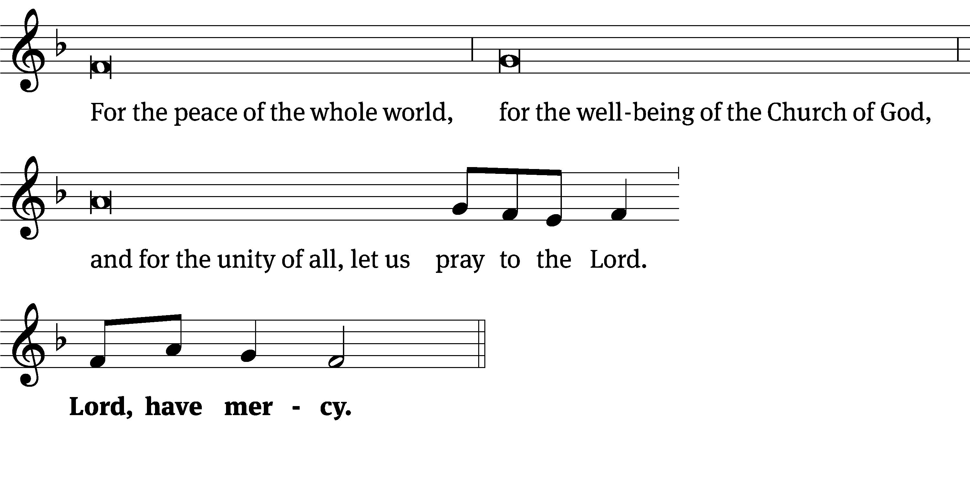
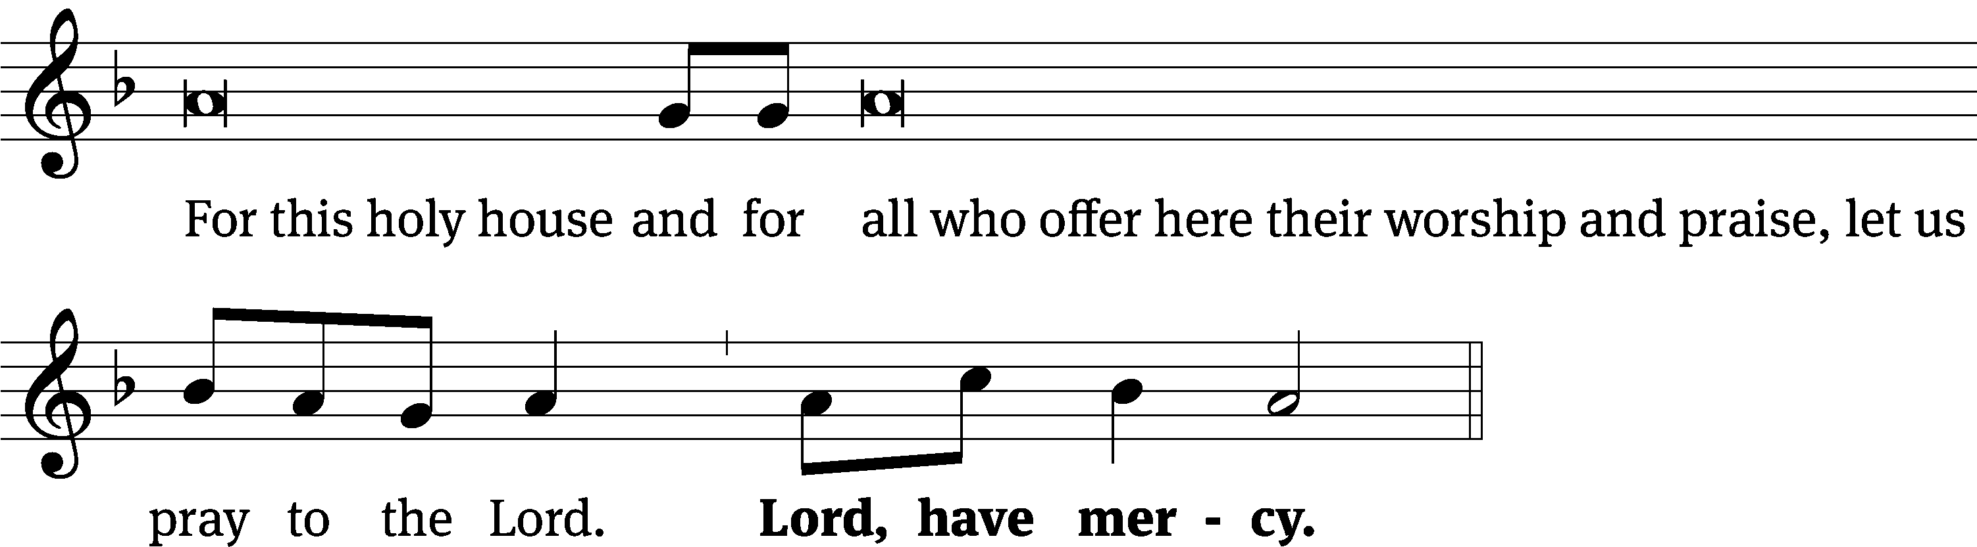
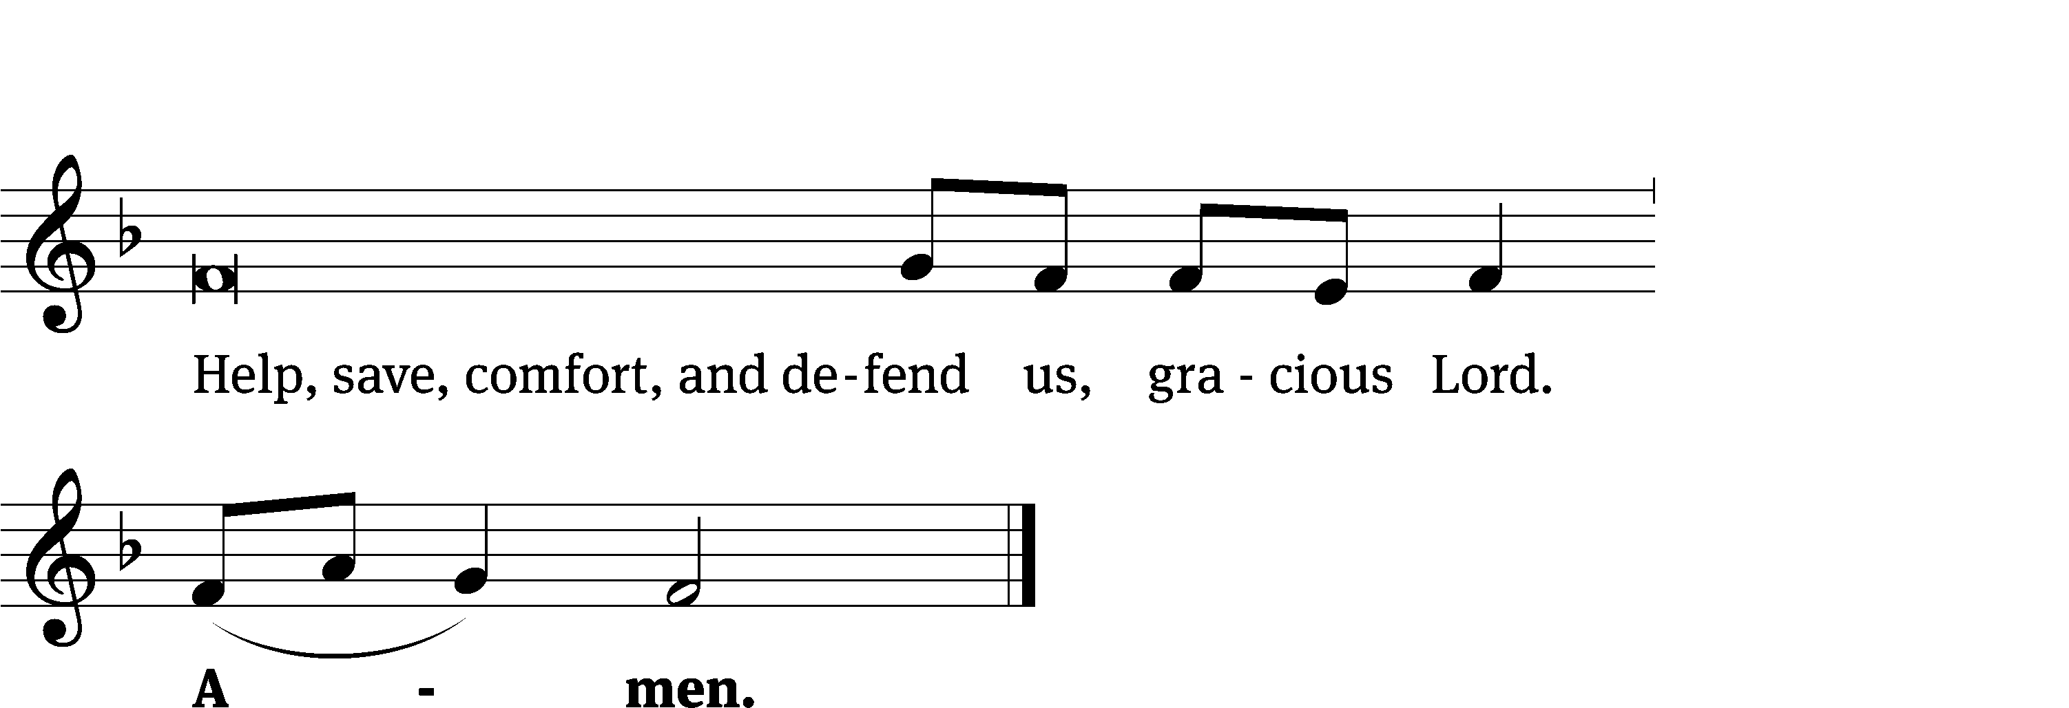
Glory Be to God on High CW 157
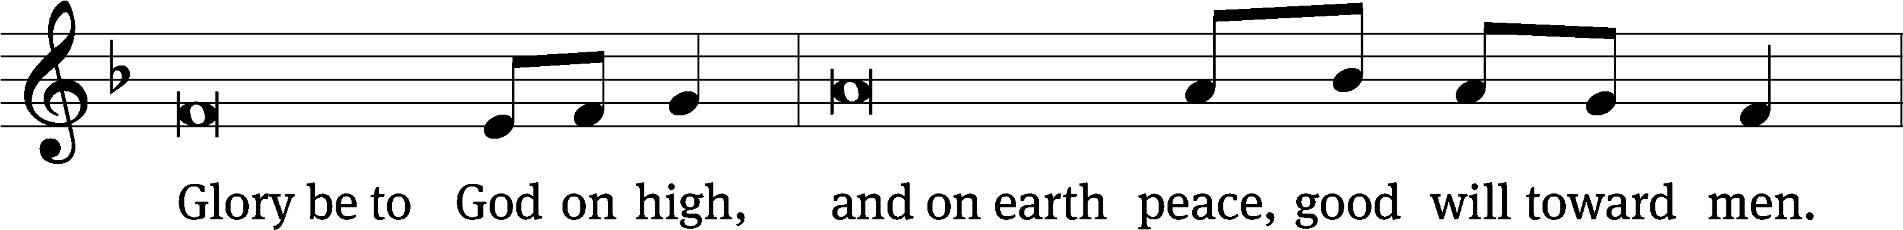
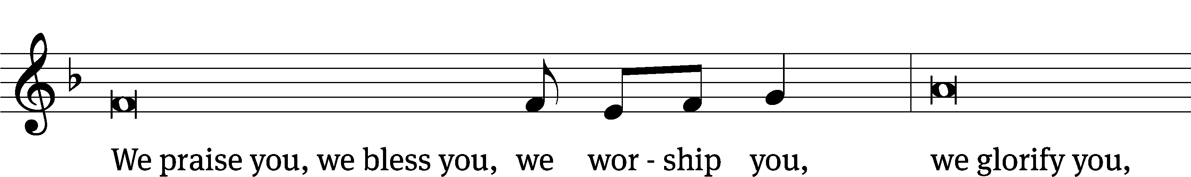
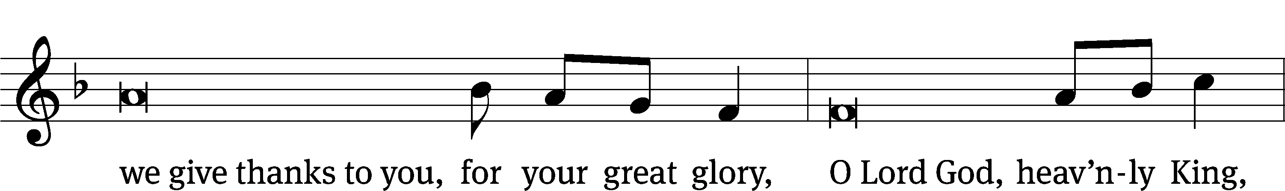
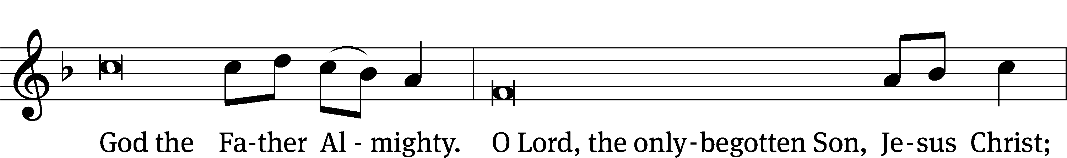
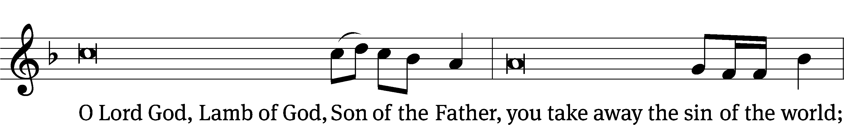
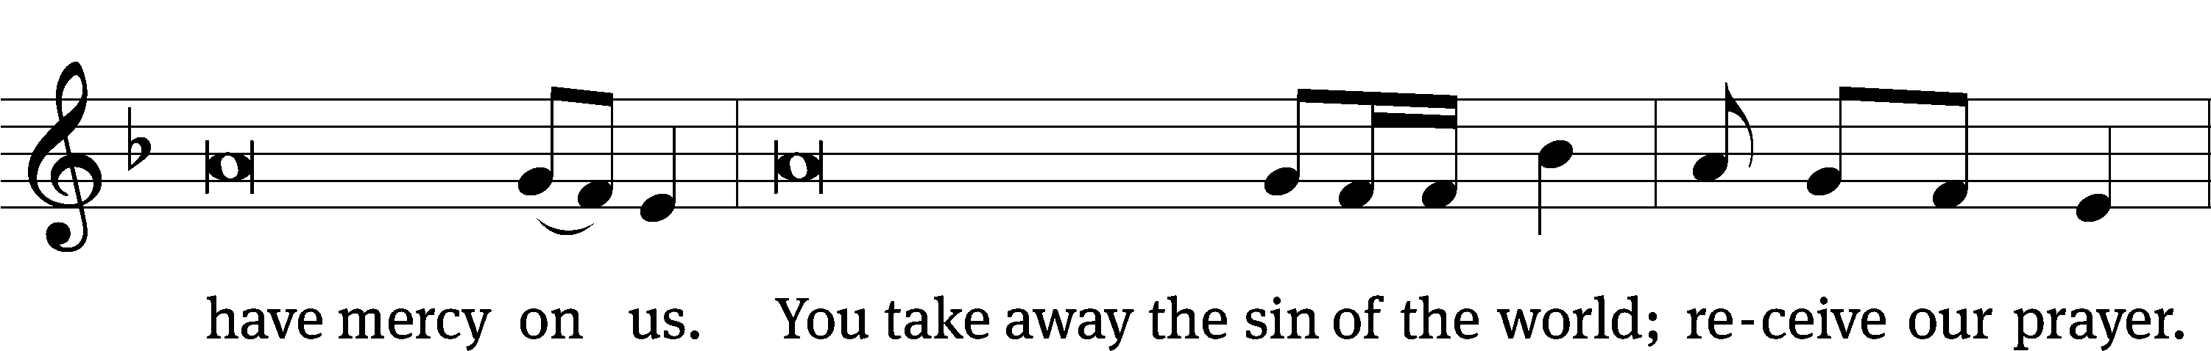
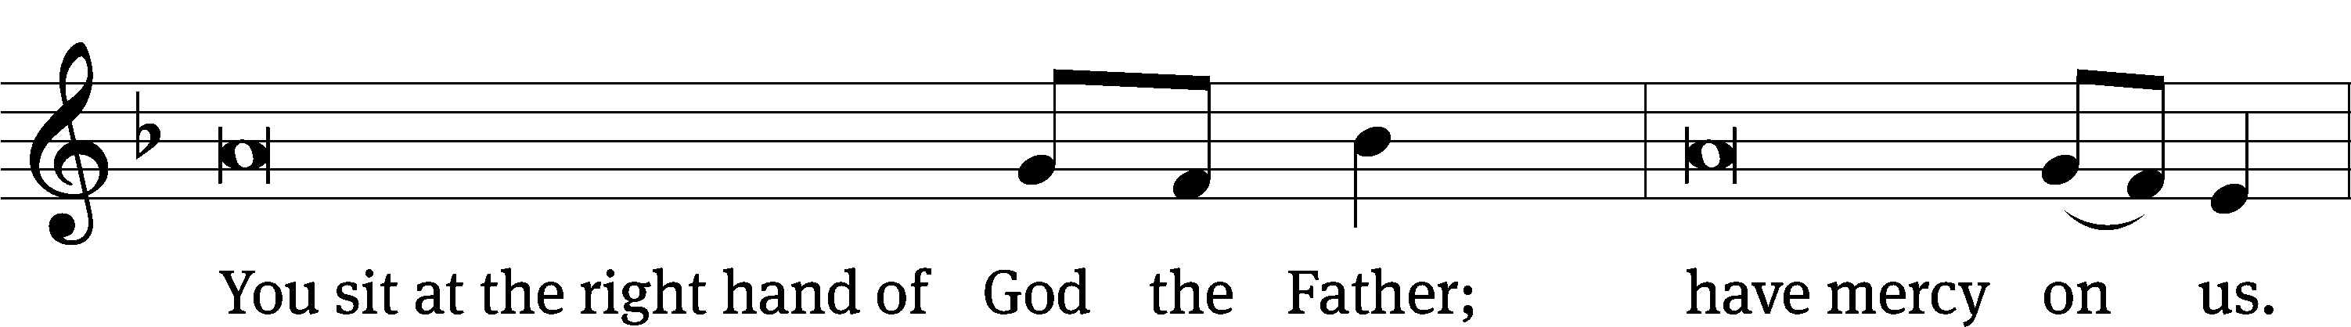
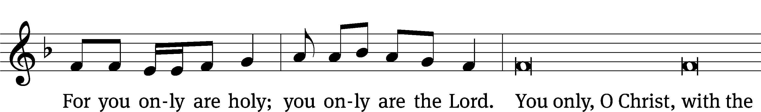
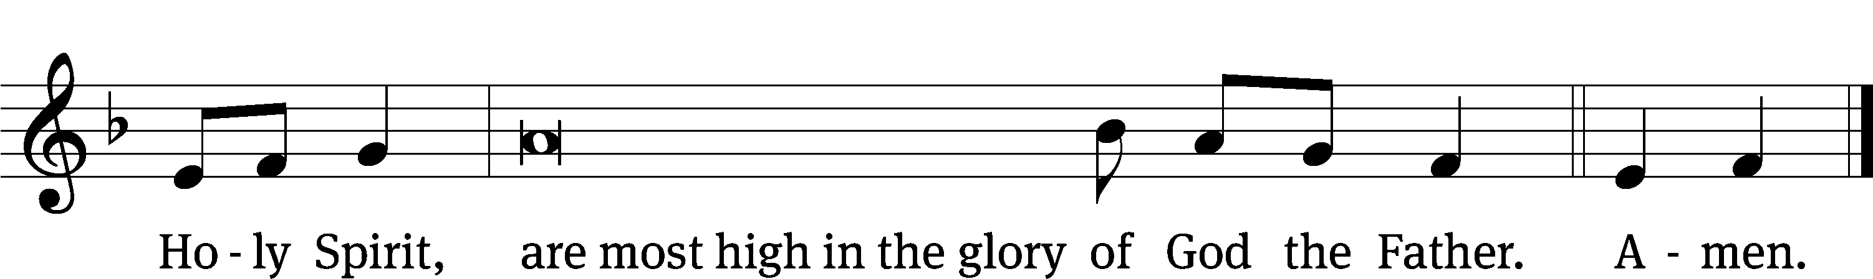

The Lord be with you.
And also with you.
Prayer of the Day
Let us pray.

We praise you, O God, for the great acts of love by which you have redeemed us through your Son, Jesus Christ. As he was acclaimed by those who scattered their garments and branches of palms in his path, so may we always hail him as our King and follow him with perfect confidence; who lives and reigns with you and the Holy Spirit, one God, now and forever.

Amen.

Please be seated

First Reading Zechariah 9:9-10

⁹ Rejoice greatly, Daughter of Zion!
Shout, Daughter of Jerusalem!
Look! Your King is coming to you.
He is righteous and brings salvation.
He is humble and is riding on a donkey,
on a colt, the foal of a donkey.
¹⁰ I will cut off the chariot from Ephraim
and the horse from Jerusalem.
The battle bow will be taken away,
and he will proclaim peace to the nations.
His kingdom will extend from sea to sea,
from the River to the ends of the earth.

The Word of the Lord.
Thanks be to God.

24B Welcome the King Psalm 24B
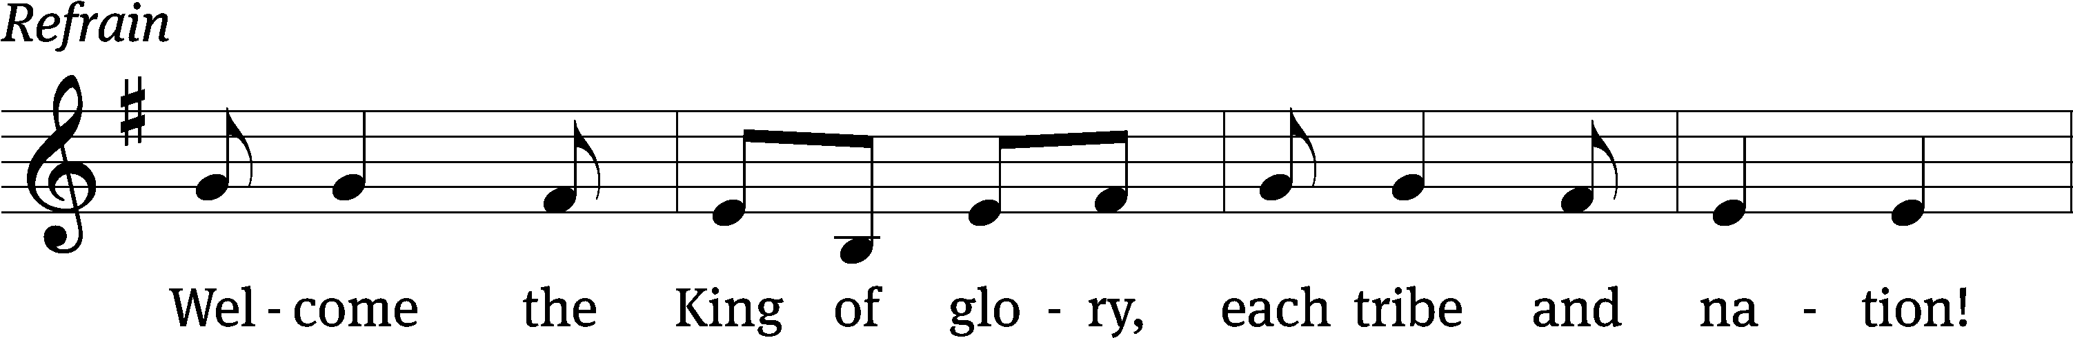
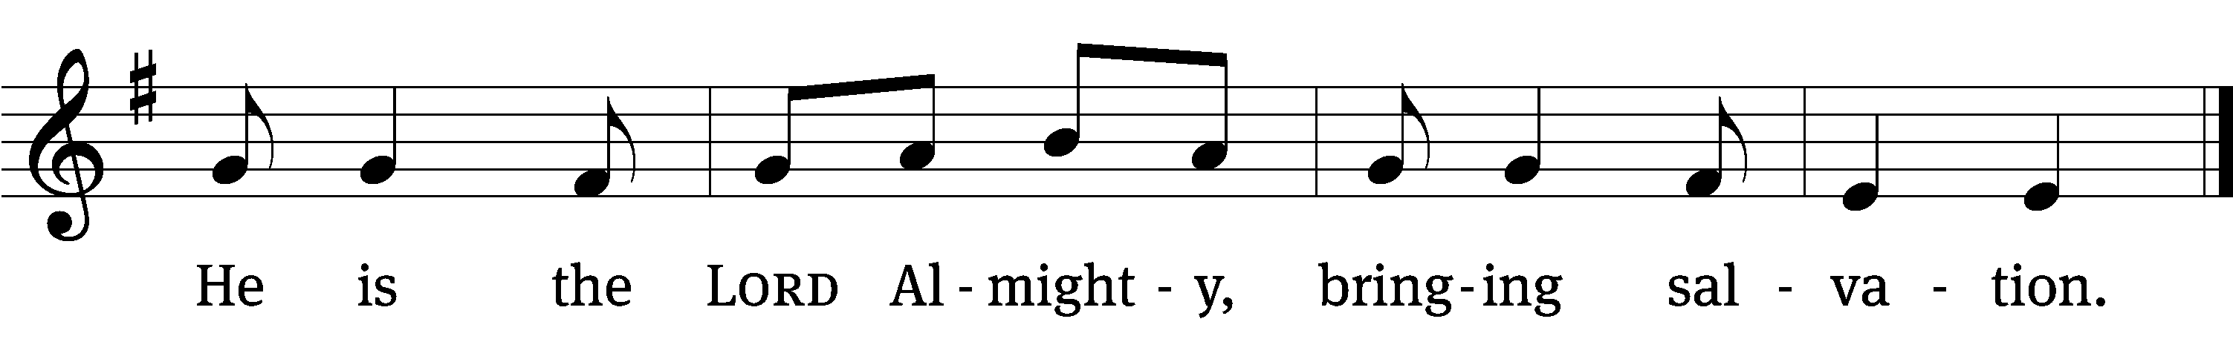
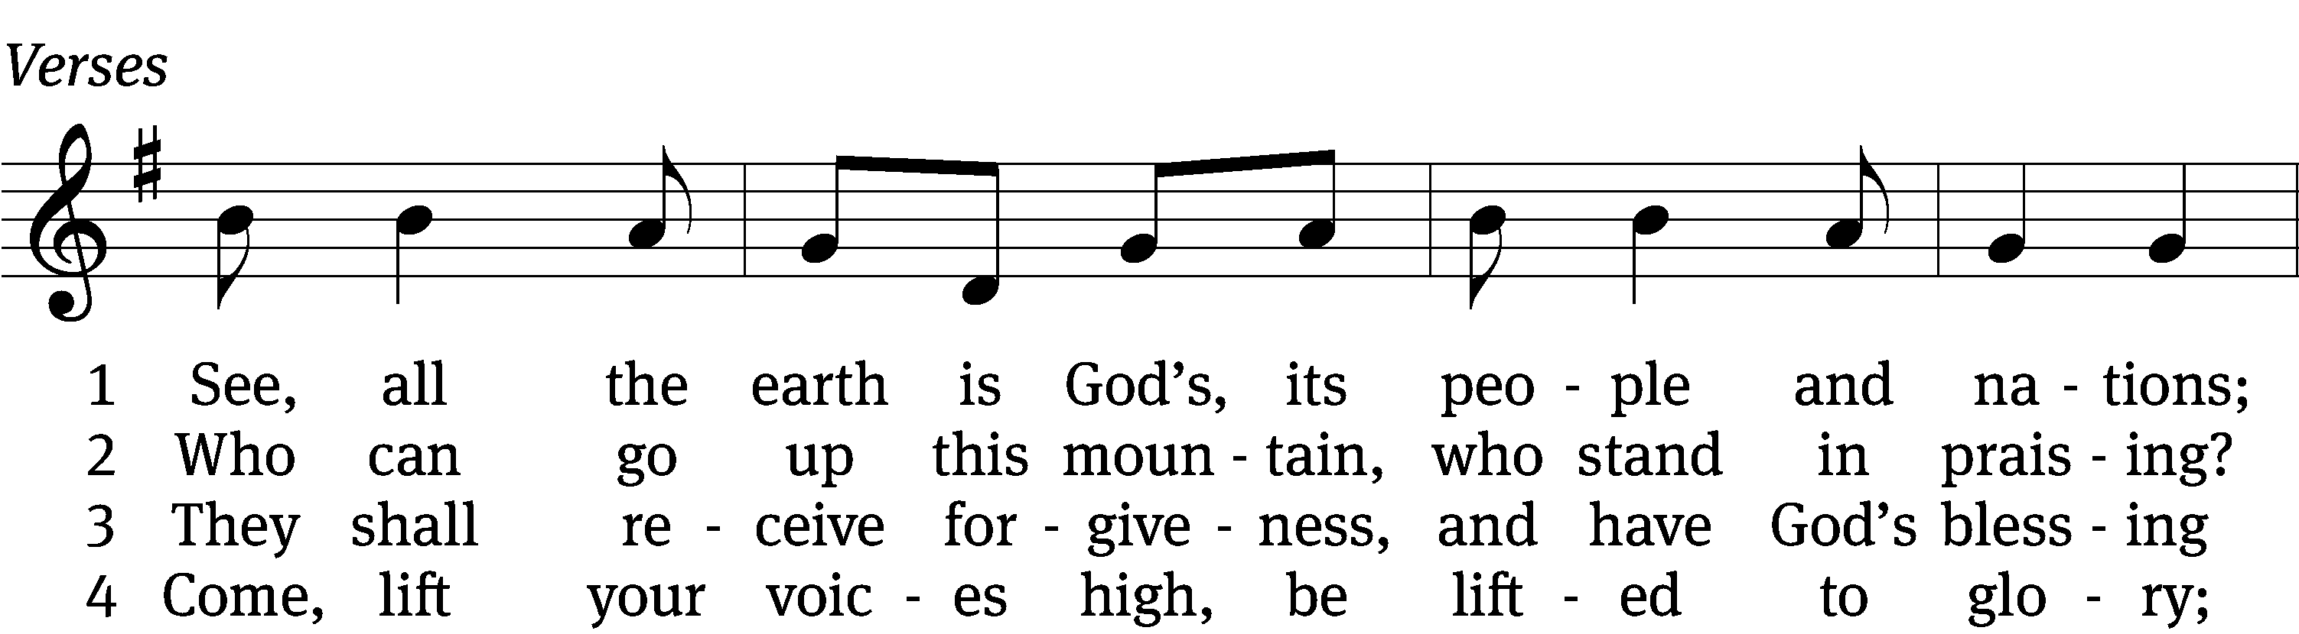
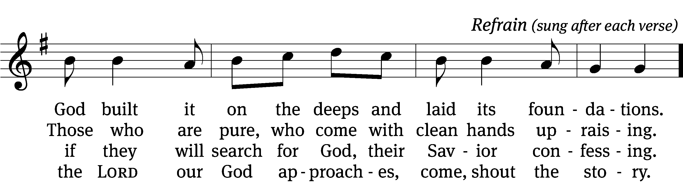

5 Who is this glorious one, for whom we are waiting?
We wait the mighty LORD, our God celebrating. (Refrain)

6 Come, lift your heads with joy; come, lift up your tower;
the King of glory comes in full might and power. (Refrain)

7 Who is this King of glory of whom we’re singing?
Our God, this LORD of hosts, the vict’ry is bringing. (Refrain)
Text (sts. 1–7): Arlo D. Duba; (Ref): Northwestern Publishing House
Tune: Israeli
Text (sts. 1–7): © 1986 Arlo D. Duba; (Ref): © 2021 Northwestern Publishing House. Used by permission: OneLicense no. 727703
Tune: Public domain

Second Reading Philippians 2:5-11
⁵ Indeed, let this attitude be in you, which was also in Christ Jesus. ⁶ Though he was by nature God, he did not consider equality with God as a prize to be displayed, ⁷ but he emptied himself by taking the nature of a servant. When he was born in human likeness, and his appearance was like that of any other man, ⁸ he humbled himself and became obedient to the point of death—even death on a cross. ⁹ Therefore God also highly exalted him and gave him the name that is above every name, ¹⁰ so that at the name of Jesus every knee will bow, in heaven and on earth and under the earth, ¹¹ and every tongue will confess that Jesus Christ is Lord, to the glory of God the Father.

The Word of the Lord.
Thanks be to God.

Please stand, if you are able

Gospel Acclamation John 12:23
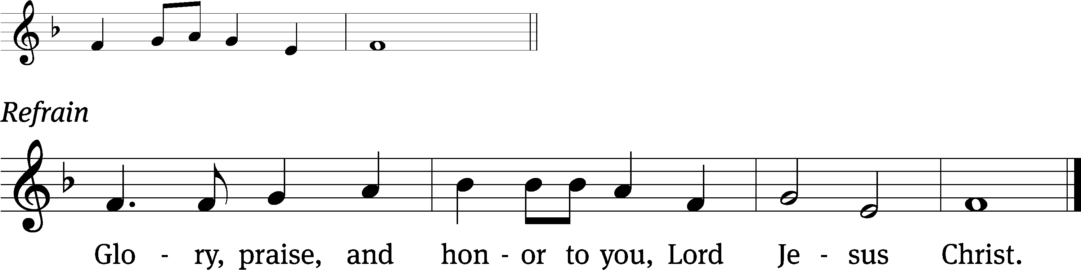
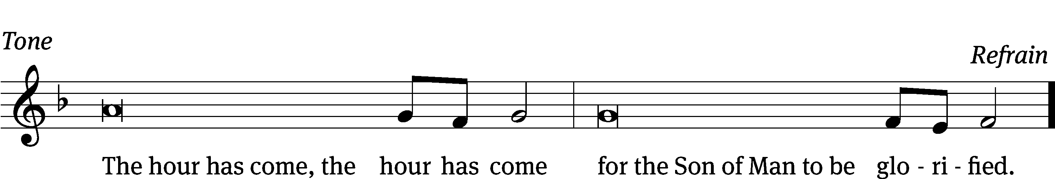
Tune: © 2021 Northwestern Publishing House. Used by permission: OneLicense no. 727703

Gospel Matthew 21:1-11
¹ As they approached Jerusalem and came to Bethphage on the Mount of Olives, Jesus sent two disciples, ² telling them, “Go to the village ahead of you. Immediately you will find a donkey tied there along with her colt. Untie them and bring them to me. ³ If anyone says anything to you, you are to say, ‘The Lord needs them,’ and he will send them at once.”
⁴ This took place to fulfill what was spoken through the prophet:
⁵ Tell the daughter of Zion: Look, your King comes to you, humble, and riding on a donkey, on a colt, the foal of a donkey.
⁶ The disciples went and did just as Jesus commanded them. ⁷ They brought the donkey and the colt, laid their outer clothing on them, and he sat on it. ⁸ A very large crowd spread their outer clothing on the road. Others were cutting branches from the trees and spreading them out on the road. ⁹ The crowds who went in front of him and those who followed kept shouting,
Hosanna to the Son of David!
Blessed is he who comes in the name of the Lord!^{[c]}
Hosanna in the highest!
¹⁰ When he entered Jerusalem, the whole city was stirred up, asking, “Who is this?” ¹¹ And the crowds were saying, “This is Jesus, the prophet from Nazareth in Galilee.”

The Gospel of the Lord.
Praise be to you, O Christ!

Please be seated

413 Hosanna, Loud Hosanna CW 413
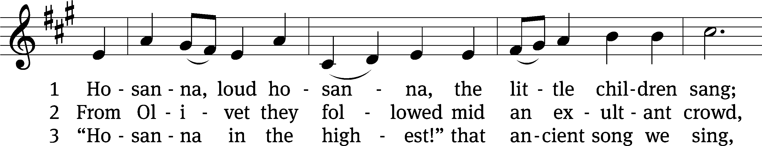
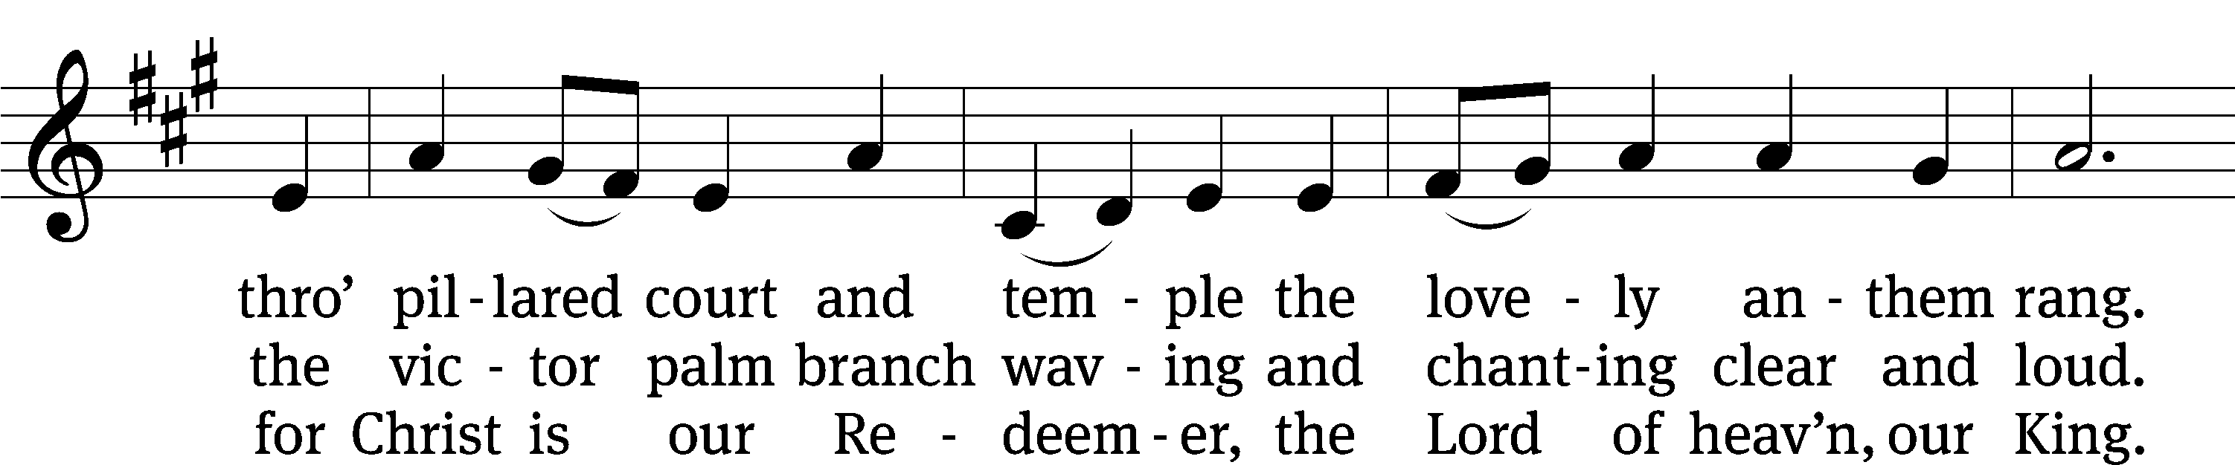
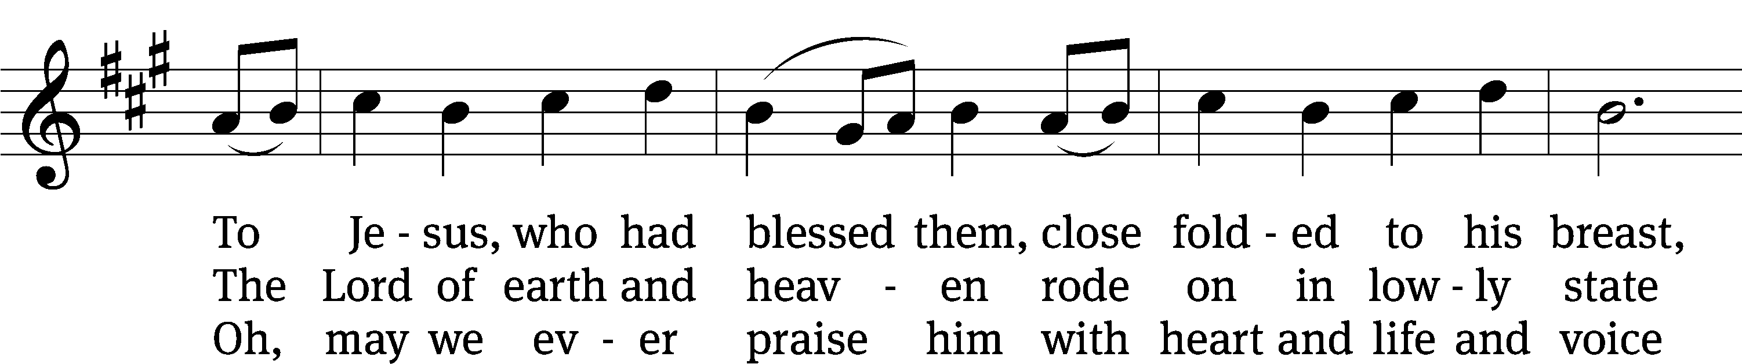
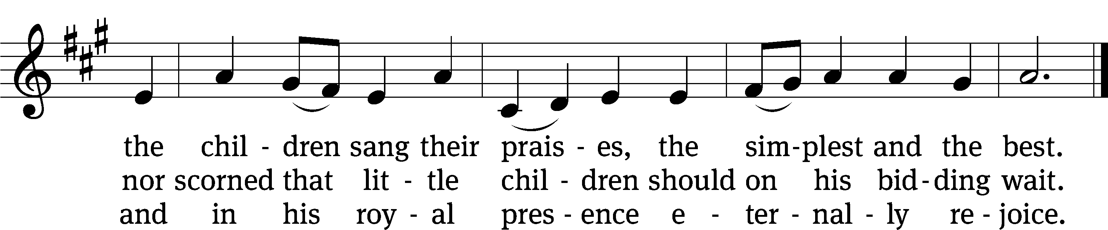
Text: Jeannette Threlfall, 1821–1880, alt.
Tune: Gesang-Buch Herzogl. Hofkapelle, Württemberg, 1784
Text and tune: Public domain

SERMON Matthew 21:1-11
“His Final Steps Led to a Donkey”

Please stand, if you are able
Nicene Creed
We believe in one God, the Father, the Almighty,
maker of heaven and earth,
of all that is,
seen and unseen.
We believe in one Lord, Jesus Christ, the only Son of God,
eternally begotten of the Father,
God from God, Light from Light, true God from true God,
begotten, not made,
of one being with the Father.
Through him all things were made.
For us and for our salvation, he came down from heaven,
was incarnate of the Holy Spirit and the Virgin Mary,
and became truly human.
For our sake he was crucified under Pontius Pilate.
He suffered death and was buried.
On the third day he rose again in accordance with the Scriptures.
He ascended into heaven
and is seated at the right hand of the Father.
He will come again in glory to judge the living and the dead,
and his kingdom will have no end.
We believe in the Holy Spirit,
the Lord, the giver of life,
who proceeds from the Father and the Son,
who in unity with the Father and the Son
is worshiped and glorified,
who has spoken through the prophets.
We believe in one holy Christian and apostolic Church.
We acknowledge one baptism for the forgiveness of sins.
We look for the resurrection of the dead
and the life of the world to come. Amen.
Prayer of the Church

The Sacrament
Preface CW 165
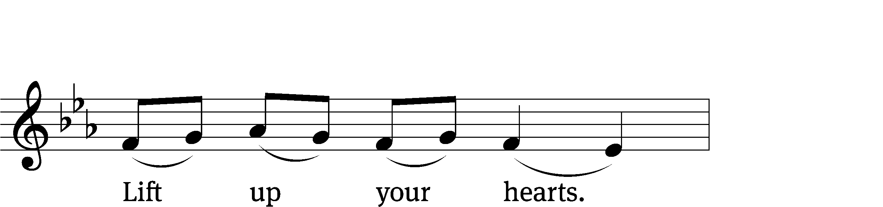
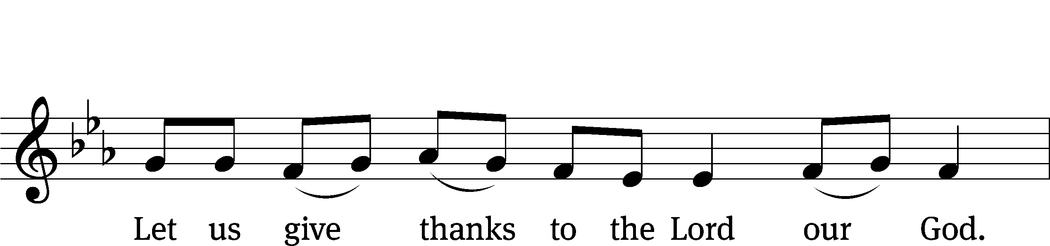
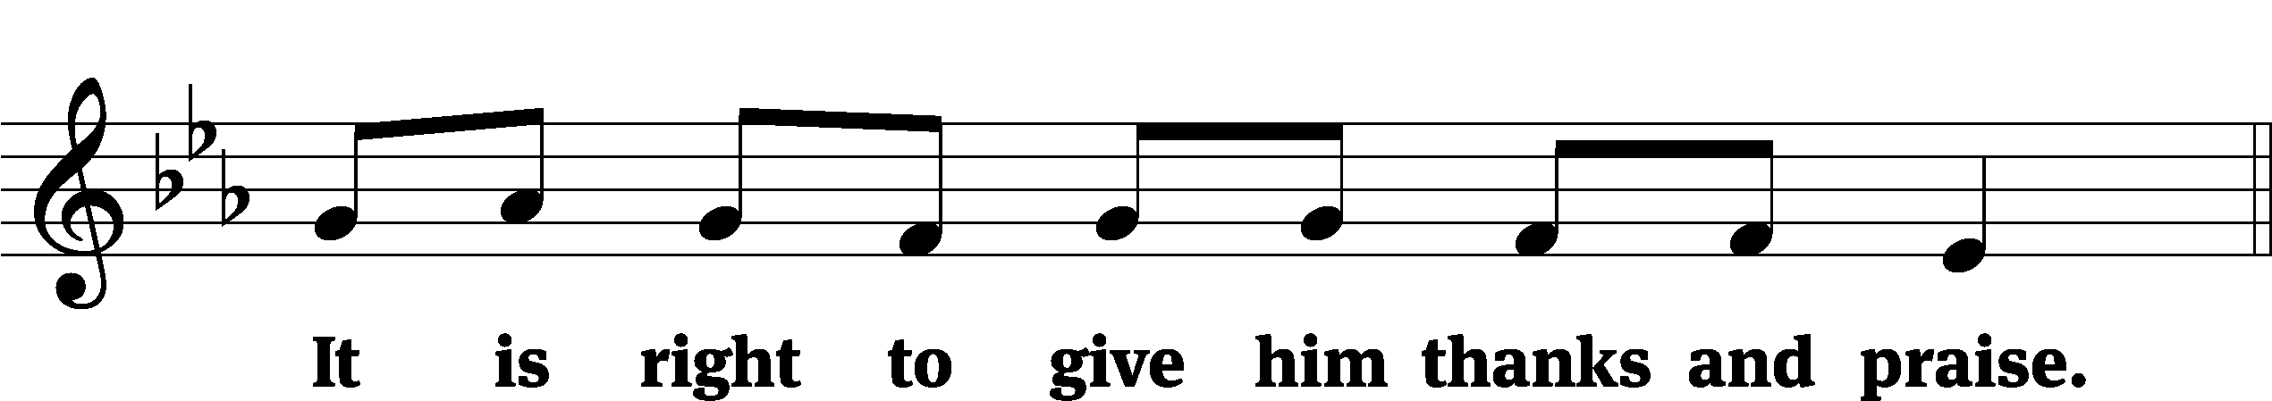

It is truly good and right that we should at all times and in all places give you thanks, O Lord, holy Father, almighty and everlasting God, through Jesus Christ our Lord, who promised that wherever two or three come together in his name, there he is with them to shepherd his flock until he comes again in glory. Therefore, with all the saints on earth and hosts of heaven, we praise your holy name and join their glorious song:
Holy, Holy, Holy CW 167
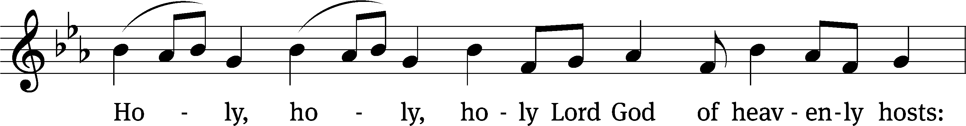
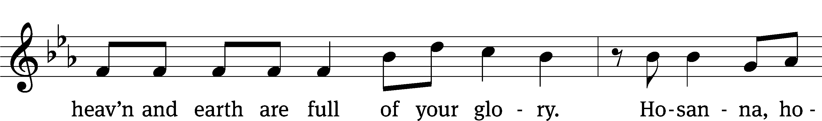
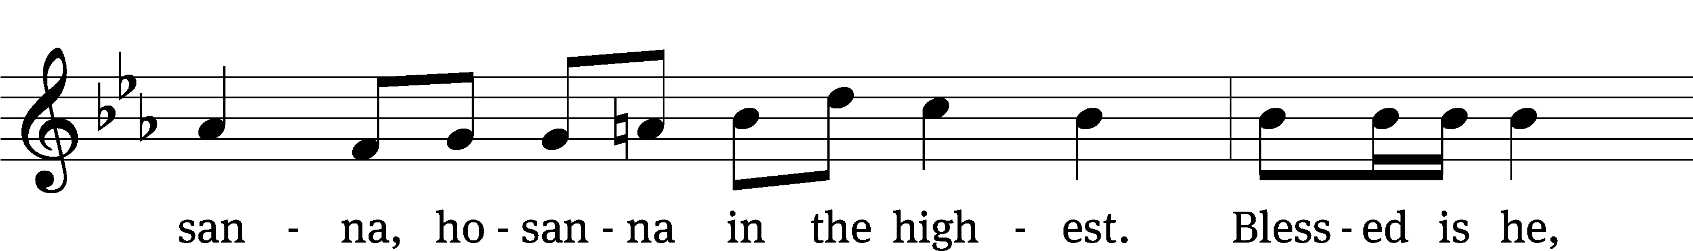
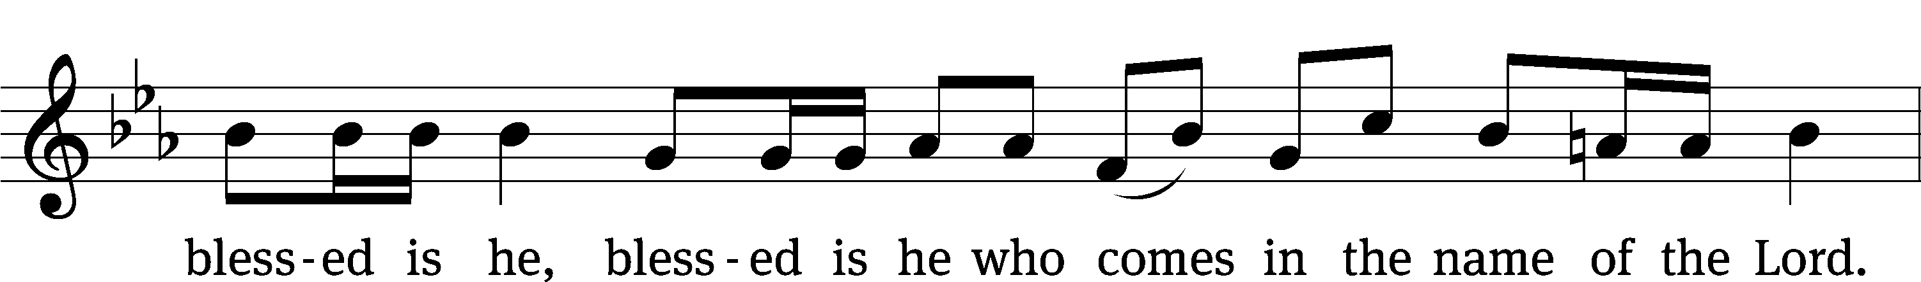
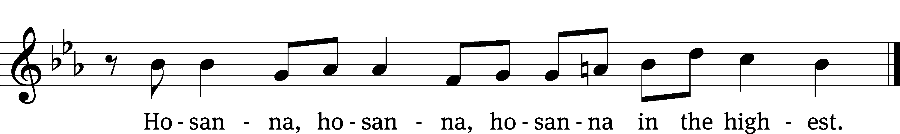

Prayer of Thanksgiving
We give thanks to you, O God, through your dear Son, Jesus Christ, whom you sent to be our Savior, our Redeemer, and the messenger of your grace. Through him you made all things; in him you are well pleased. He is the incarnate Word, conceived by the Holy Spirit and born of the Virgin Mary. To fulfill your promises, he stretched out his hands on the cross and released from eternal death all who believe in you.

As we remember Jesus’ death and resurrection, we thank you that you have gathered us together to receive your Son’s body and blood. Send us your Spirit, unite us as one, and strengthen our faith so that we may praise you in your Son, Jesus Christ. Through him, we glorify and honor you, O God our Father, with the Holy Spirit, one God, now and forever.
Amen.

Lord’s Prayer
Our Father, who art in heaven, hallowed be thy name, thy kingdom come, thy will be done on earth as it is in heaven. Give us this day our daily bread; and forgive us our trespasses, as we forgive those who trespass against us; and lead us not into temptation, but deliver us from evil. For thine is the kingdom and the power and the glory forever and ever. Amen.

Words of Institution
Our Lord Jesus Christ, on the night he was betrayed, took bread; and when he had given thanks, he broke it and gave it to his disciples, saying, “Take and eat; this is my body, which is given for you. Do this in remembrance of me.”
Then he took the cup, gave thanks, and gave it to them, saying, “Drink from it, all of you; this is my blood of the new covenant, which is poured out for you for the forgiveness of sins. Do this, whenever you drink it, in remembrance of me.”

The peace of the Lord be with you always.
Amen.
O Christ, Lamb of God CW 169
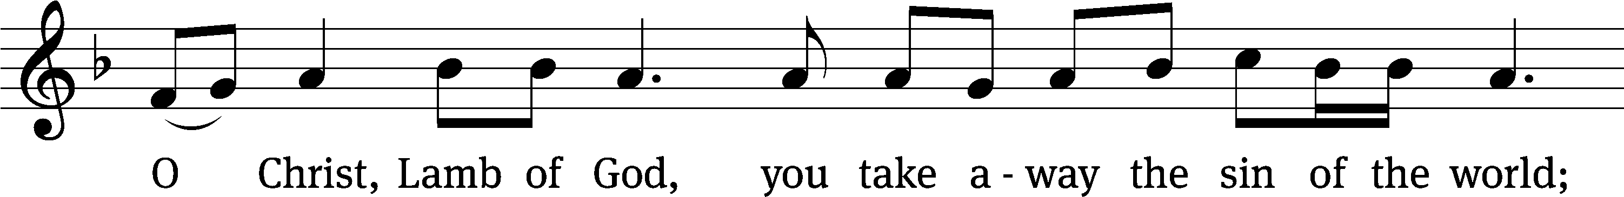
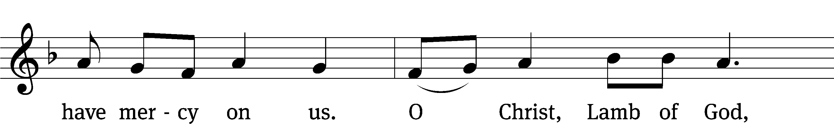
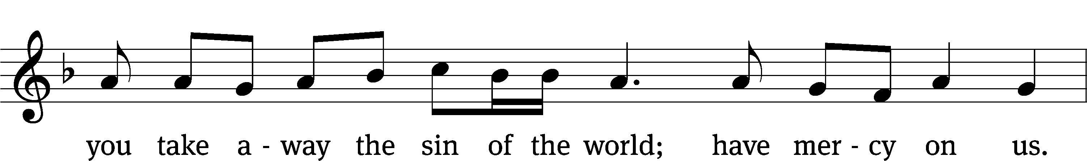
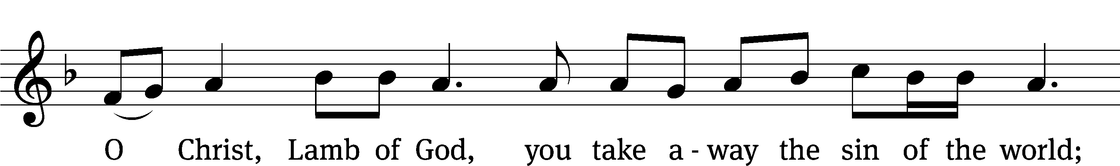
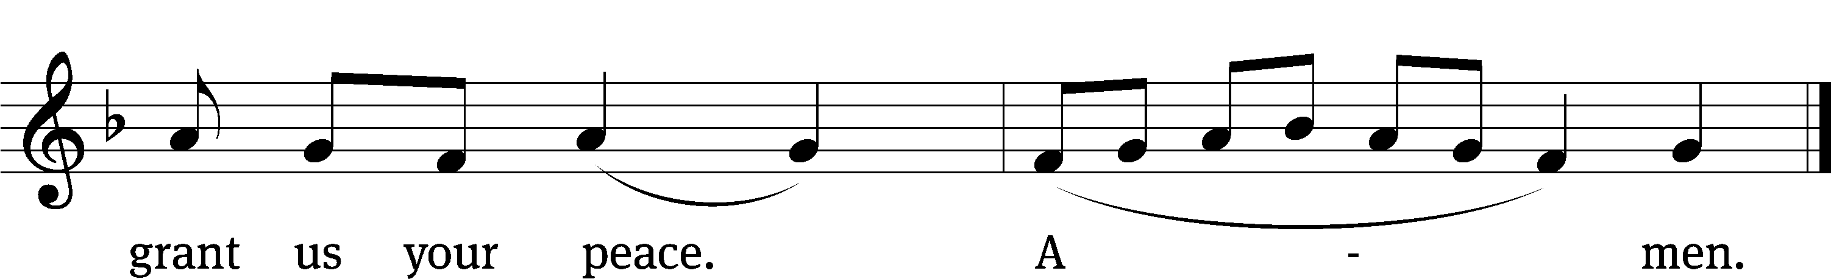
Please be seated
412 All Glory, Laud, and Honor CW 412
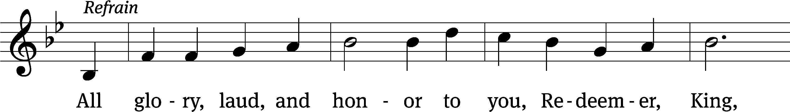
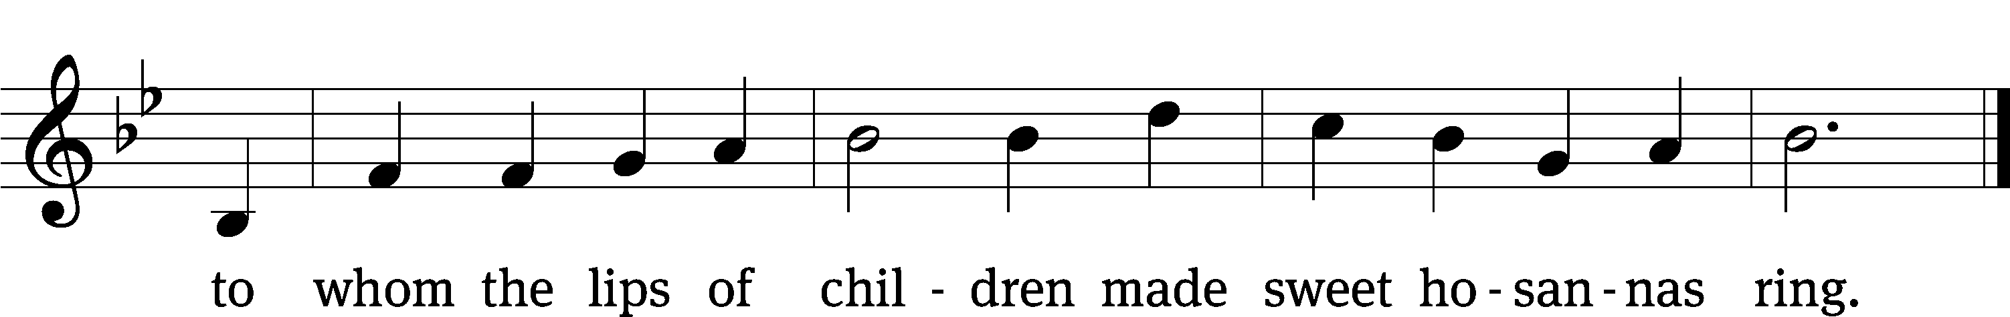
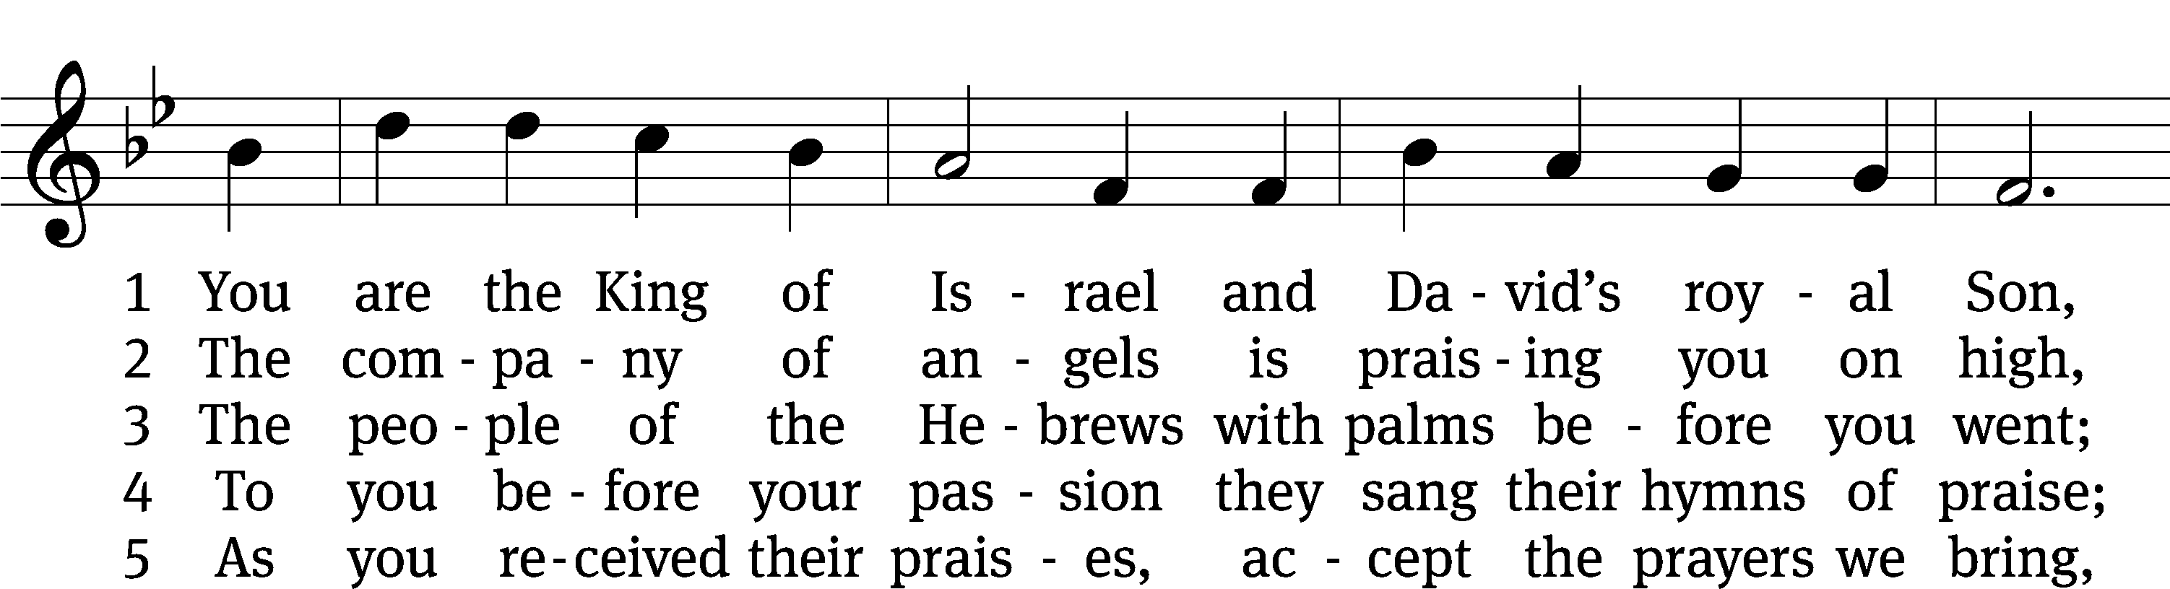
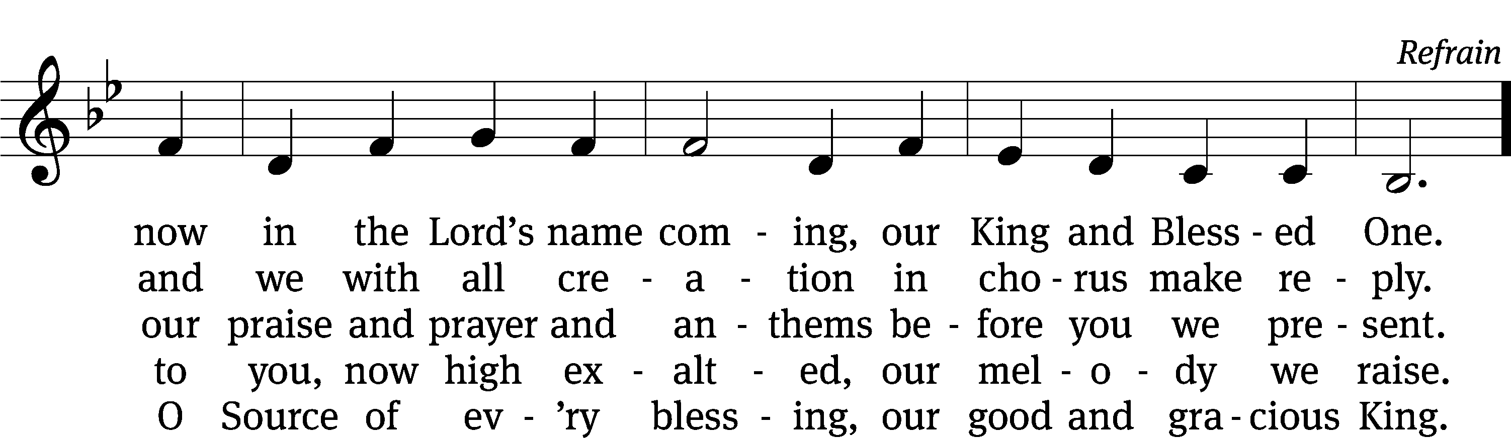
Text: tr. John Mason Neale, 1818–1866, alt.; Theodulph of Orleans, c. 762–821
Tune: Melchior Teschner, 1584–1635, alt.
Text and tune: Public domain

660 Here, O My Lord, I See You Face to Face CW 660
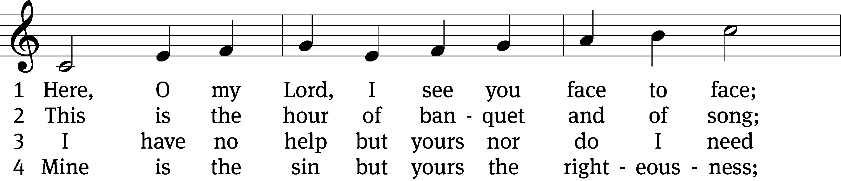
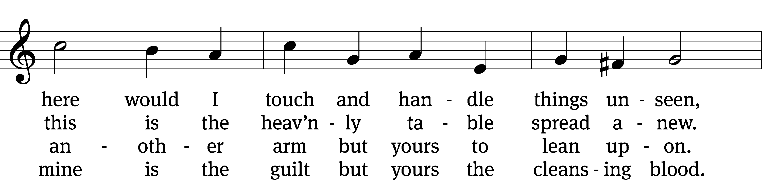
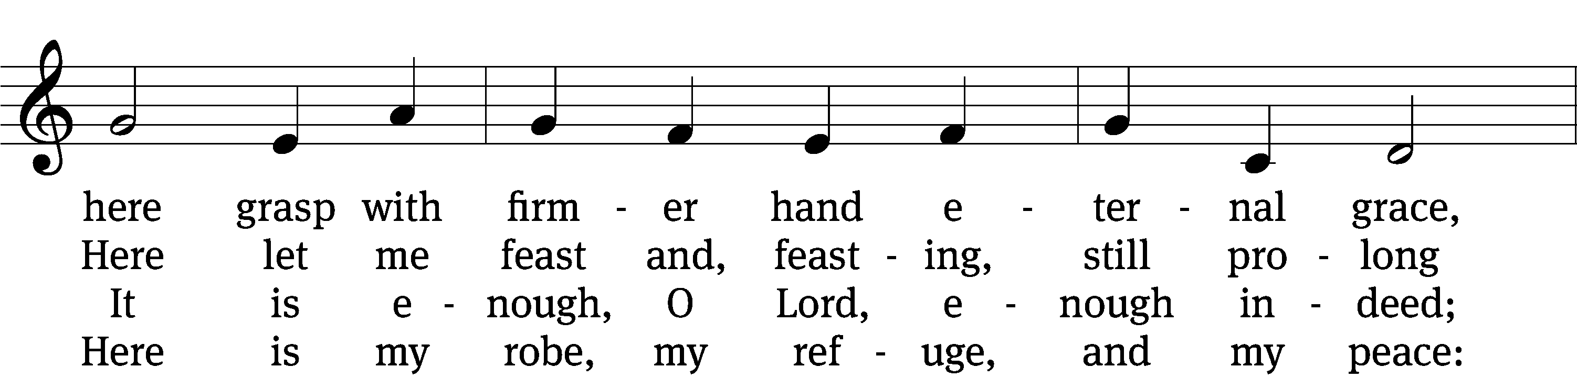
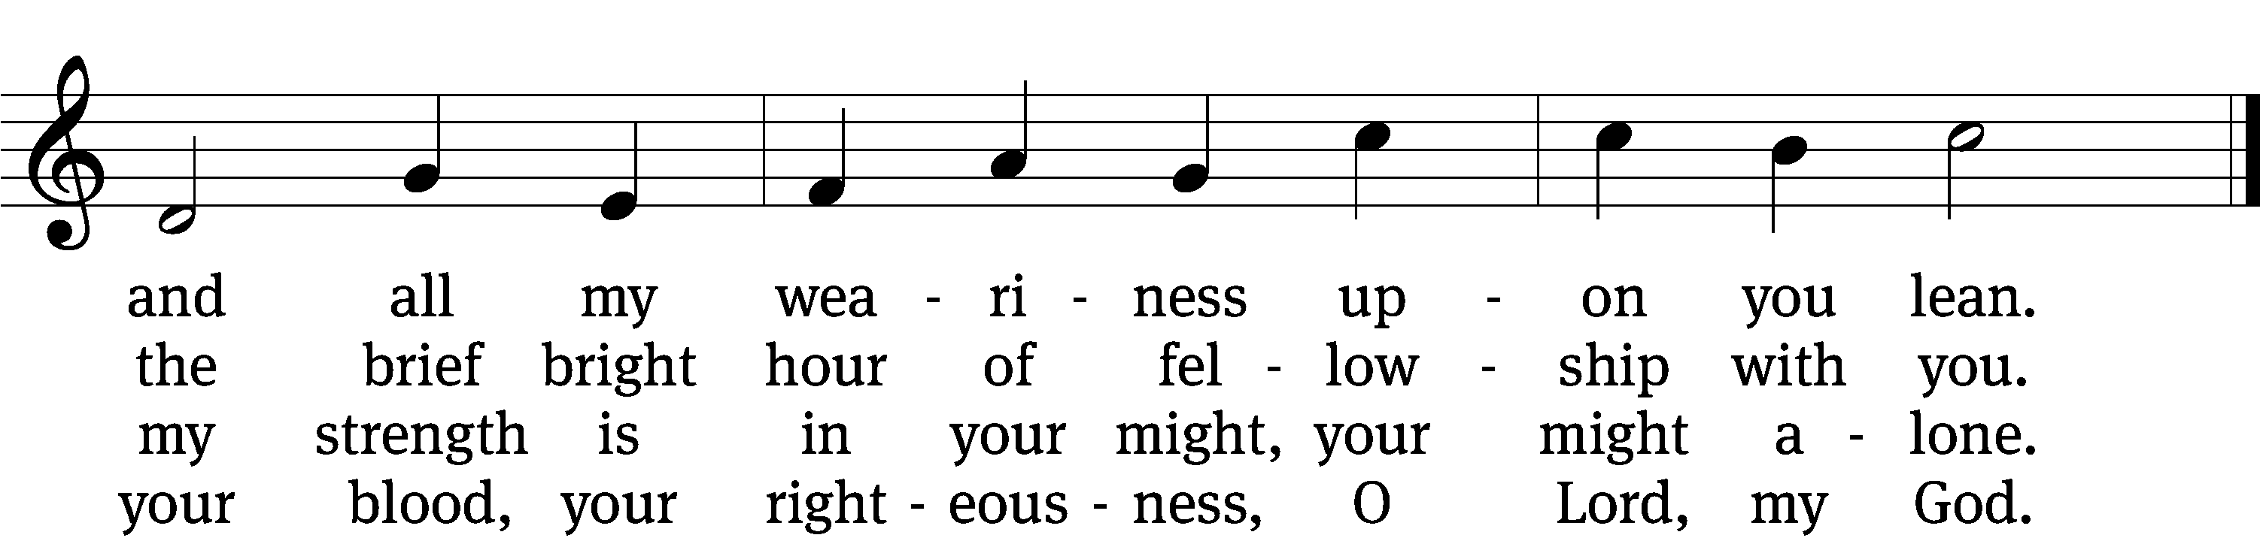

5 Too soon we rise; the vessels disappear;
the feast, though not the love, is past and gone.
The bread and wine remove, but you are here,
nearer than ever, still my shield and sun.

6 Feast after feast thus comes and passes by,
yet, passing, points to that glad feast above,
giving sweet foretaste of the festal joy,
the Lamb’s great marriage feast of bliss and love.
Text: Horatius Bonar, 1808–1889, abr., alt.
Tune: Henry Lawes, 1595–1662
Text and tune: Public domain

Please stand, if you are able

Give thanks to the Lord, for he is good;
his mercy endures forever.

Whenever we eat this bread and drink this cup,
we proclaim the Lord’s death until he comes.

We give thanks, almighty God, that you have refreshed us with this saving gift. We pray that through it you will strengthen our faith in you and increase our love for one another. We ask this in the name of Jesus Christ our Lord, who lives and reigns with you and the Holy Spirit, one God, now and forever.
Amen.

Blessing
The Lord bless you and keep you.
The Lord make his face shine on you and be gracious to you.
The Lord look on you with favor and give you peace.
Amen.

Please be seated

414 No Tramp of Soldiers’ Marching Feet CW 414
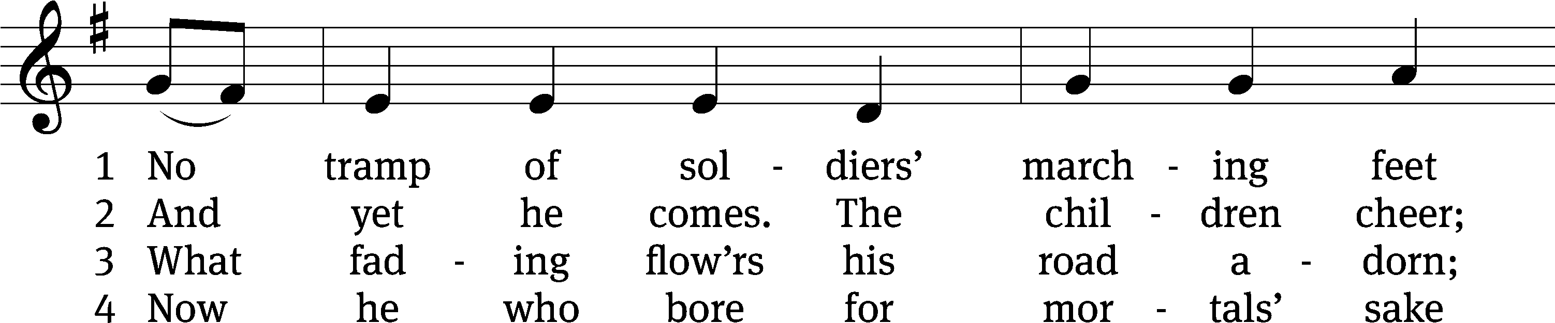
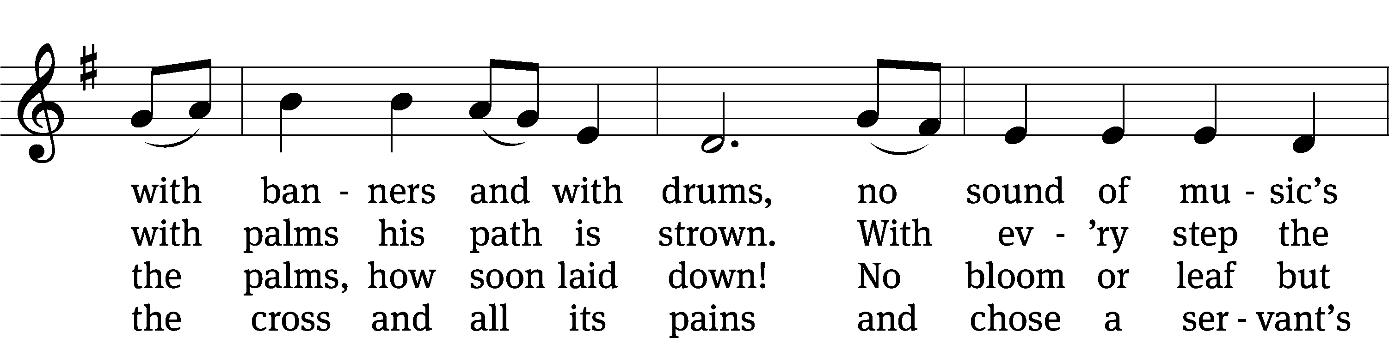
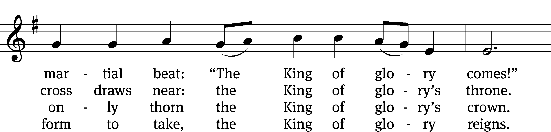
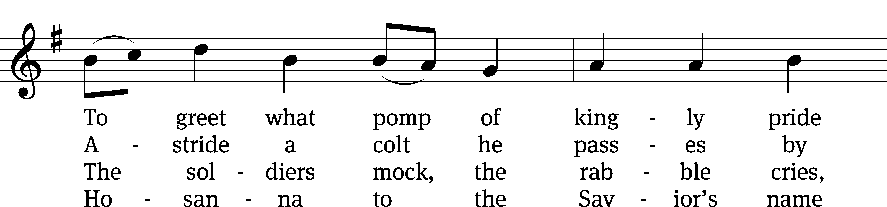
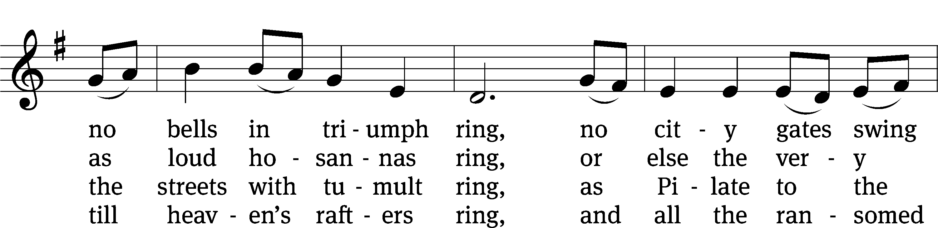
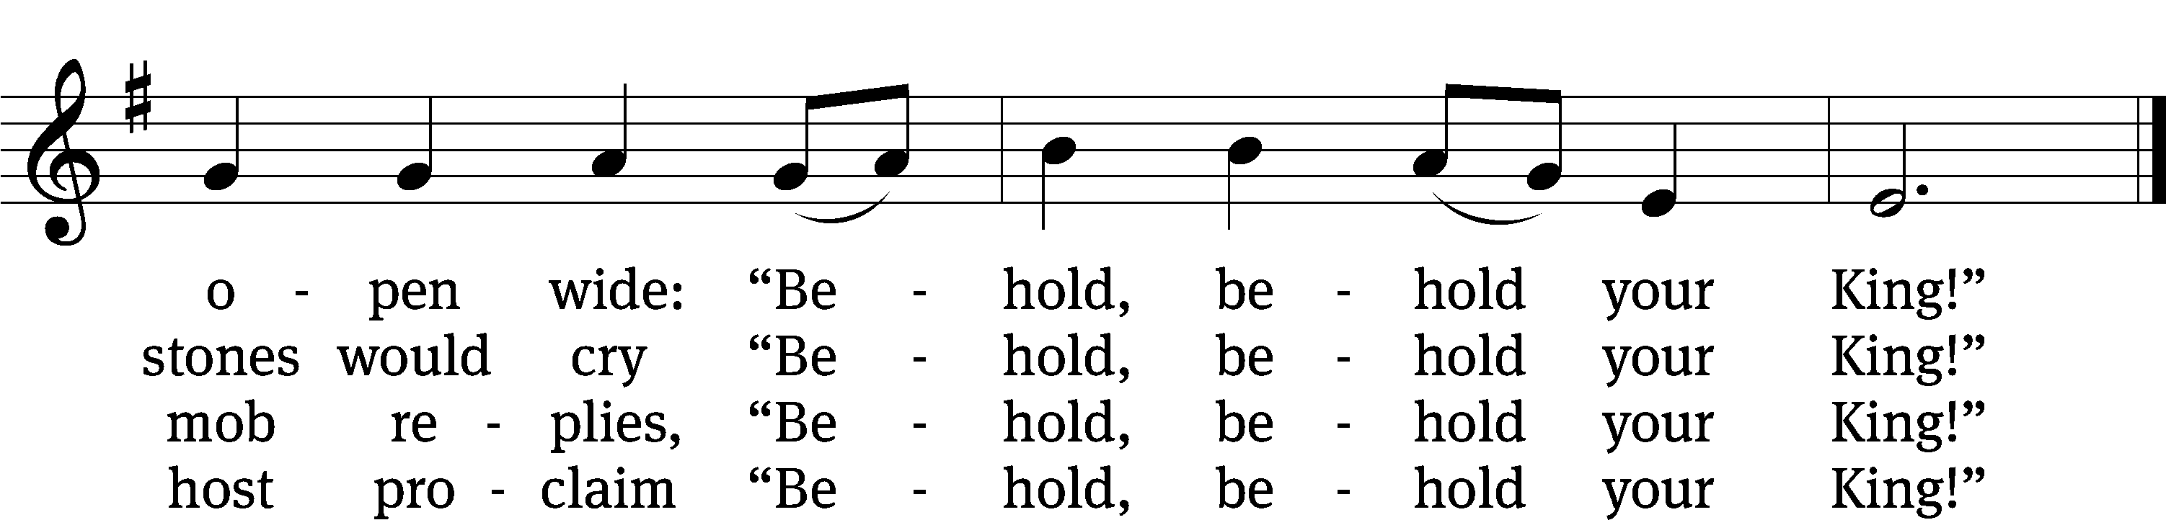
Text: Timothy Dudley-Smith, b. 1926
Tune: English; adapt. Ralph Vaughan Williams, 1872–1958
Text: © 1984 Hope Publishing Co. Used by permission: OneLicense no. 727703
Tune: Public domain
Acknowledgments
Setting One from Christian Worship
Software distributed in partnership with Northwestern Publishing House.
Created by Christian Worship: Service Builder © 2022 Concordia Publishing House.
Serving in Worship
Officiant Pastor William Natsis
Organist and Sunday School Music Director Marcia Marion Ackling
Choir Director Cynthia Natsis
Bell Choir Director Meg Nortley
Accompanist Tom Amerman
Deacons (8:30) Dave Stevenson and Jim Tice
Deacons (11:00) Steve Hoeft and Jeff Neuburger
Ushers (8:30) Dale Finkbeiner and Mark Finkbeiner
Ushers (11:00) Al Whitley
Altar Guild Jean Fiegel and Ann Latowski
Videographer Cindy Dresch

