The THIRD sunday
OF EASTER

TRINITY EVANGELICAL LUTHERAN CHURCH | Saline, Michigan
WELCOME TO WORSHIP April 23, 2023
Thank you for joining us in God’s house today! We cordially ask that our Guests sign one of the guestbooks located at either the front or back entryways, or fill out a “Let’s Get Acquainted” card located in the hymnal pew rack and place it in the collection plate.

THANK OFFERING: Members of Trinity give their offering as an expression of love and thankfulness to the Lord and to help support the Lord’s work in our community and around the world. Visitors need not feel obligated to participate in this offering which supports our ministry.

Restrooms are located at the back of the upper level (the annex), and in the basement (down the back stairs of the sanctuary or annex). Handicap access is available, please ask an usher for assistance.

Young Families / Toddler Bags – We are GLAD YOU BROUGHT YOUR CHILDREN to our worship service. Jesus said: “Let the little children come to me and do not hinder them, for the kingdom of God belongs to such as these.” We know that having little children in church can be a challenge, but DO NOT WORRY about it. Many of your fellow worshippers have been in your shoes and are just happy you brought your children with you. For your convenience, we have reserved the back rows of seating for parents with small children. These areas provide more flexibility for your family, as well as, easy access to move downstairs if necessary. A closed-circuit TV system allows families to continue participating in the service while downstairs. Pre-school toddler bags and children’s bulletins are available for their enjoyment. Ask an usher for one to use during the service and please return the toddler bag afterwards.

the SERVICE – setting one - WITHOUT HOLY COMMUNION CW, page 154

442 Christ the Lord Is Risen Today; Alleluia CW 442
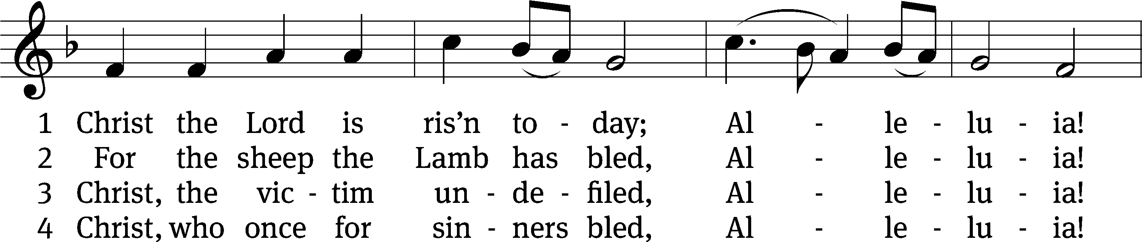
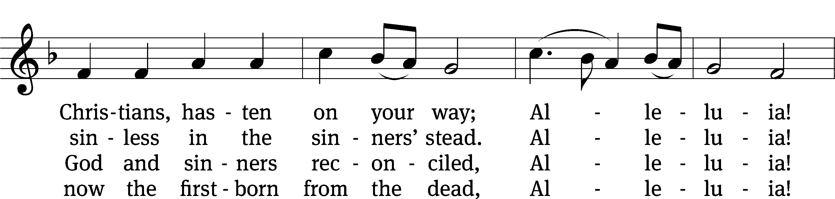
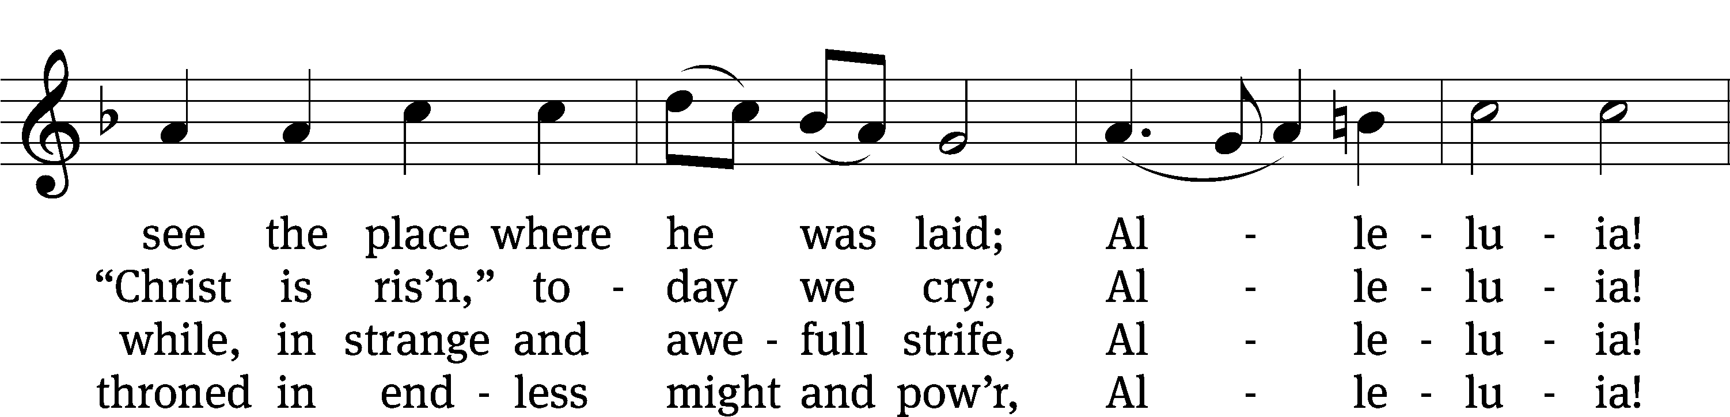
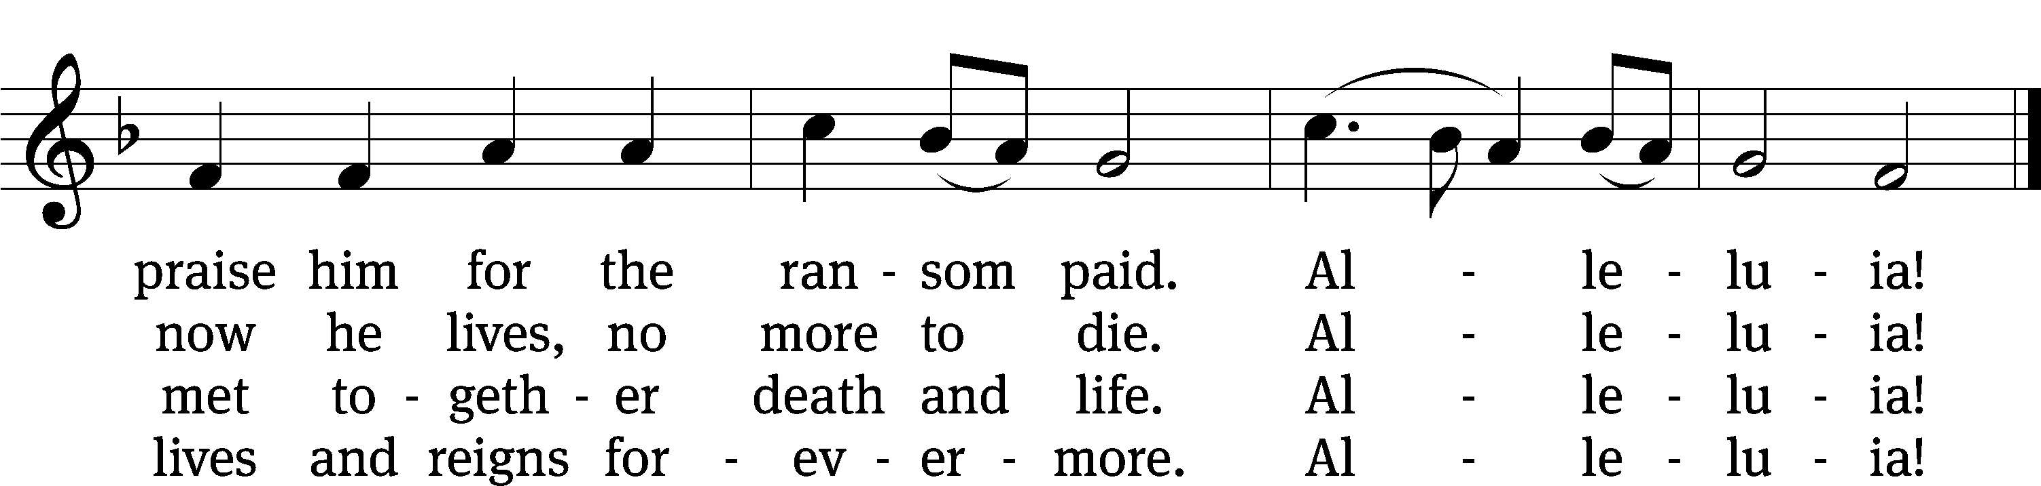
Text: tr. Jane E. Leeson, 1807–1882, alt.; Latin, 11th cent., attr. Wipo of Burgundy, d. c. 1050, abr.
Tune: Robert Williams, c. 1781–1821
Text and tune: Public domain

Please stand, if you are able
Invocation
In the name of the Father and of the Son and of the Holy Spirit.
Amen.
Confession
If we claim to be without sin, we deceive ourselves and the truth is not in us.
If we confess our sins, God is faithful and just
and will forgive us our sins
and purify us from all unrighteousness.

Let us confess our sins to the Lord.
Holy God, gracious Father,
I am sinful by nature
and have sinned against you in my thoughts, words, and actions.
I have not loved you with my whole heart;
I have not loved others as I should.
I deserve your punishment both now and forever.
But Jesus, my Savior, paid for my sins
with his innocent suffering and death.
Trusting in him, I pray: God, have mercy on me, a sinner.

Our gracious Father in heaven has been merciful to us. He sent his only Son, Jesus Christ, who gave his life as the atoning sacrifice for the sins of the whole world. Therefore, as a called servant of Christ and by his authority, I forgive you all your sins in the name of the Father and of the Son and of the Holy Spirit.
Amen.

Lord, Have Mercy
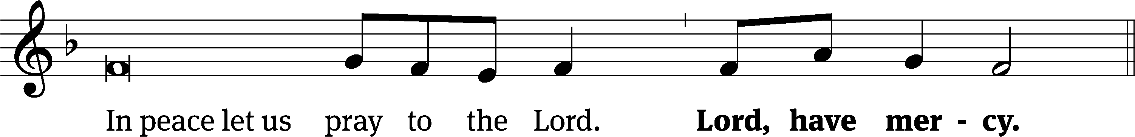
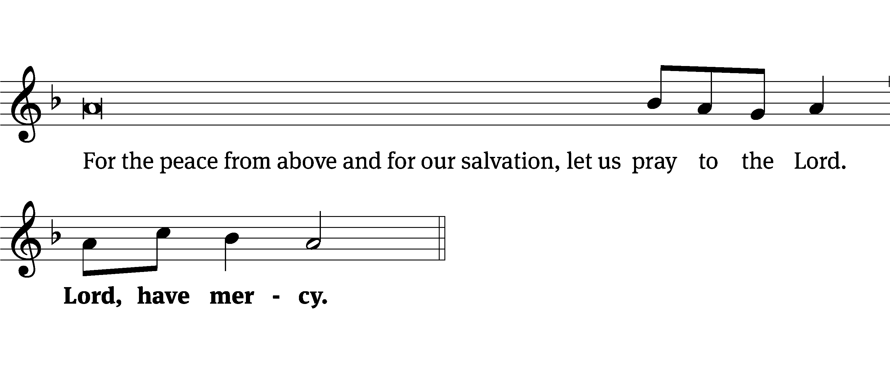
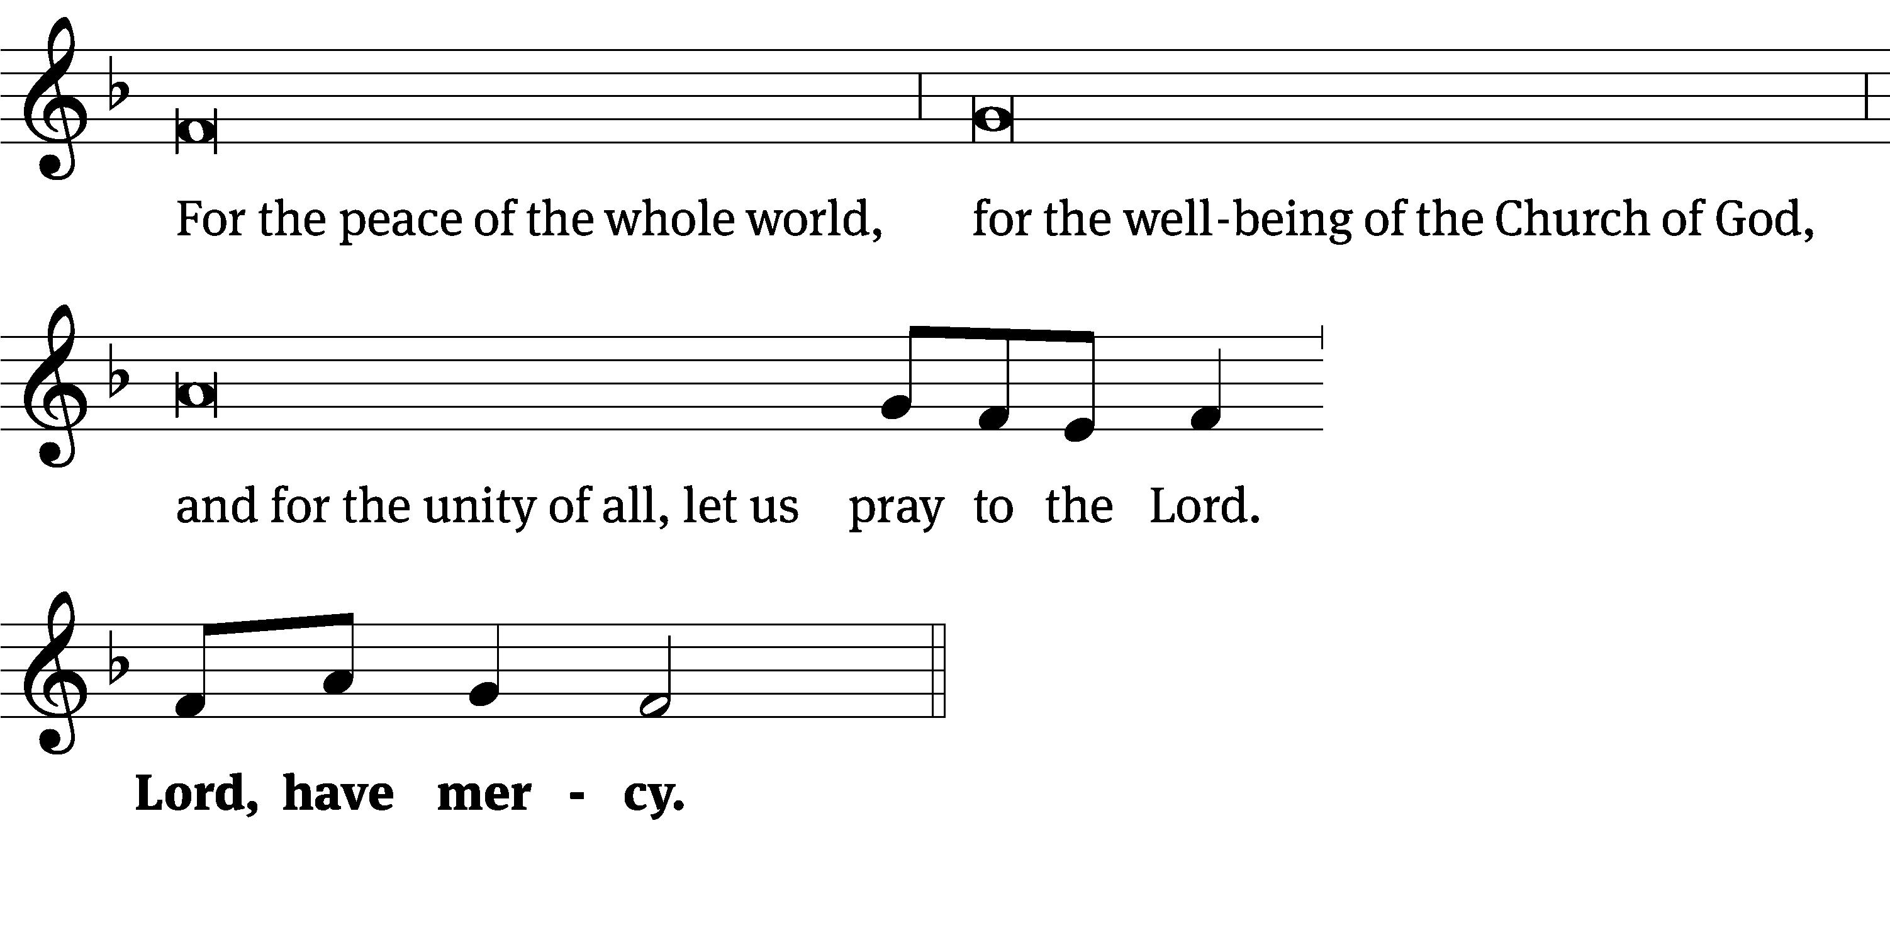
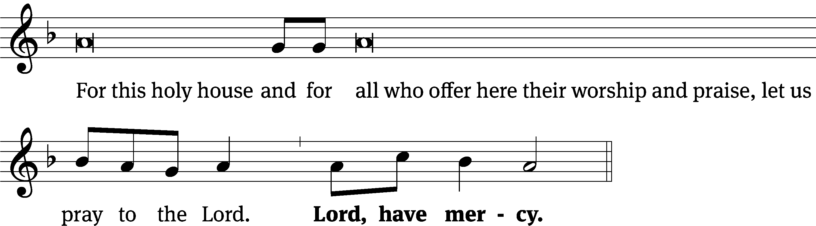
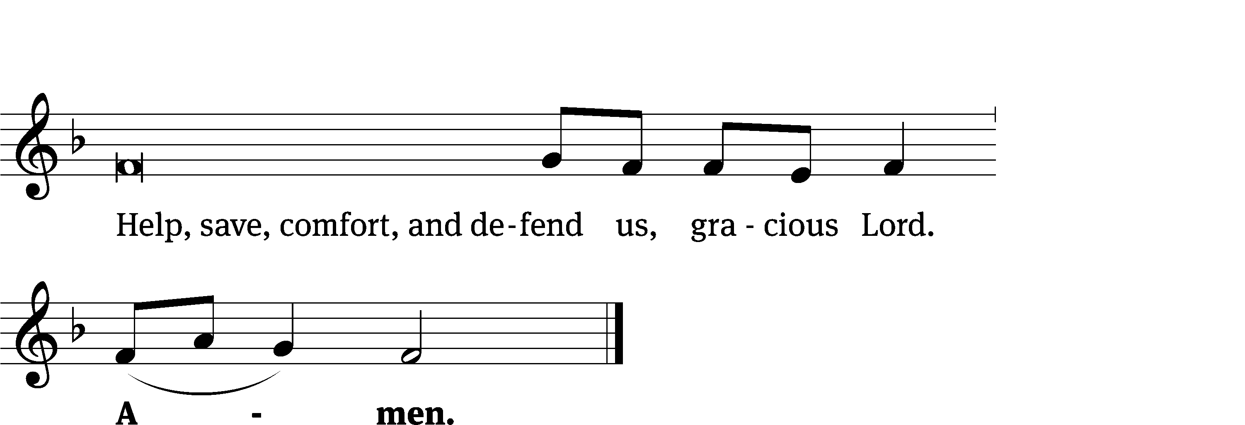
Tune: Kevin Becker
Tune: © 2021 Northwestern Publishing House. Used by permission: OneLicense no. 727703

Glory Be to God CW 157
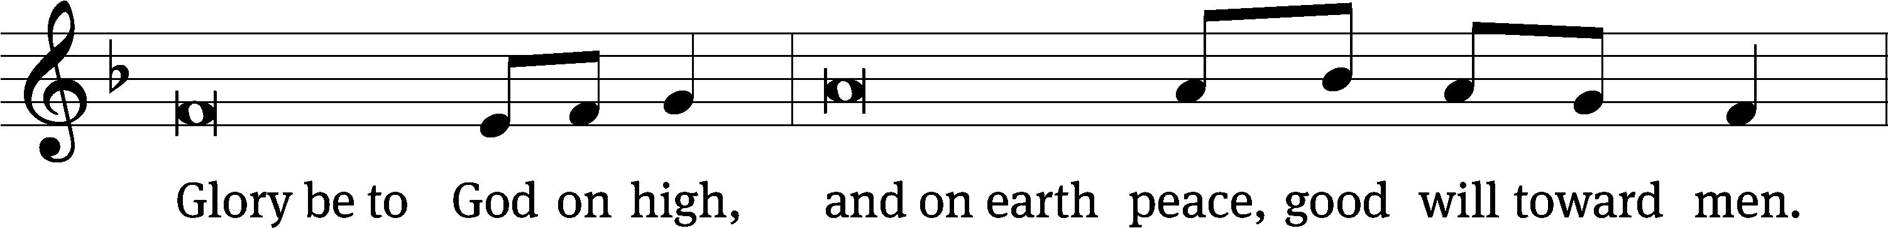
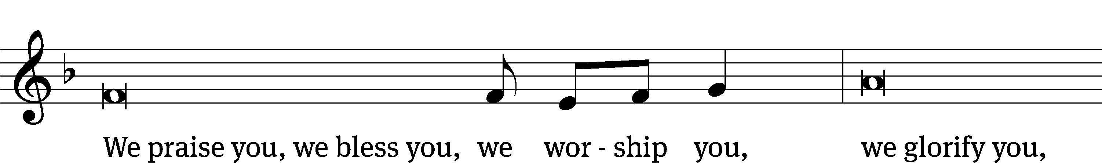
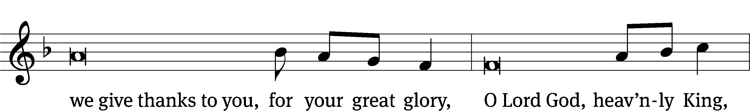
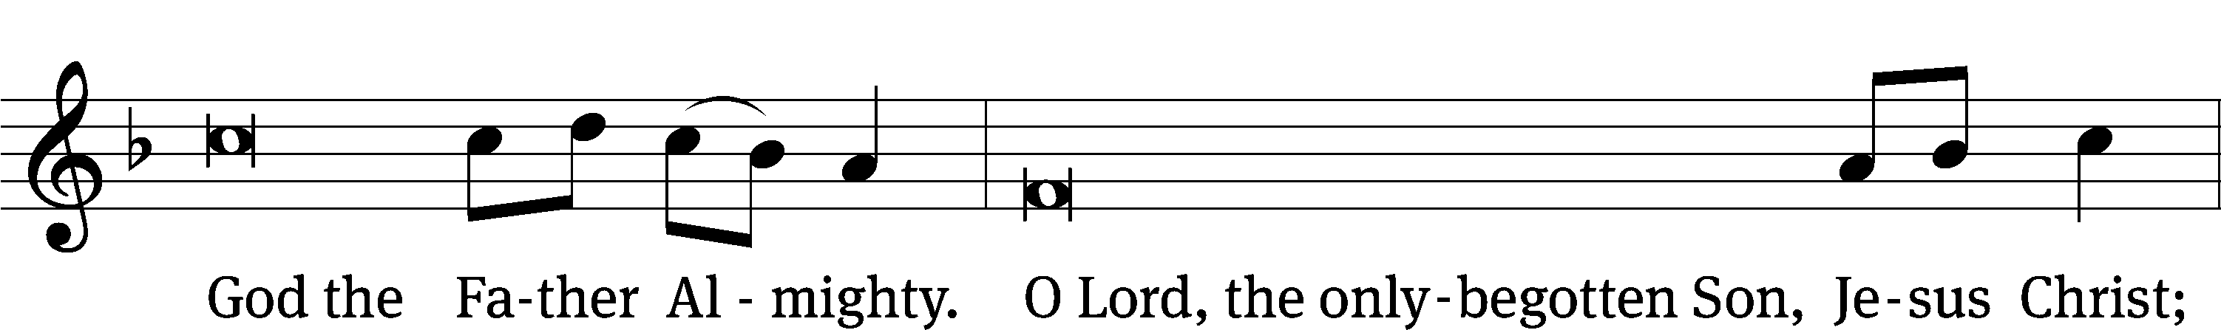
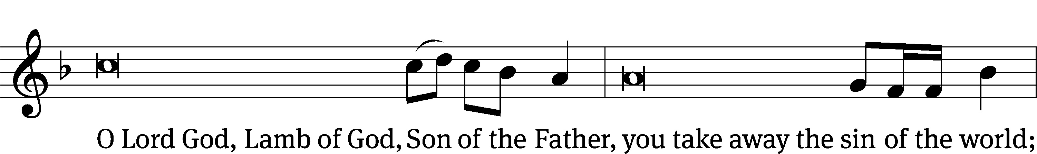
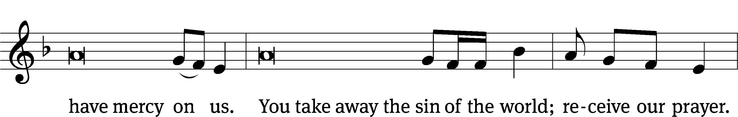
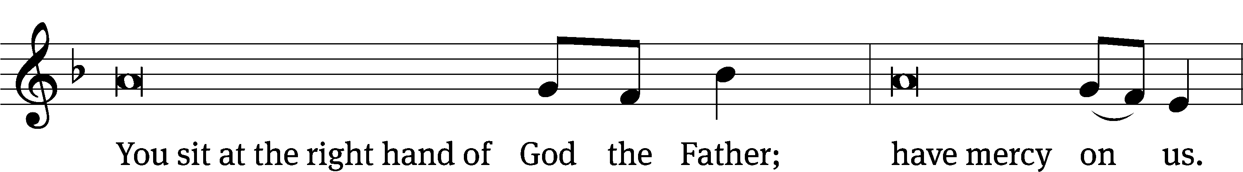
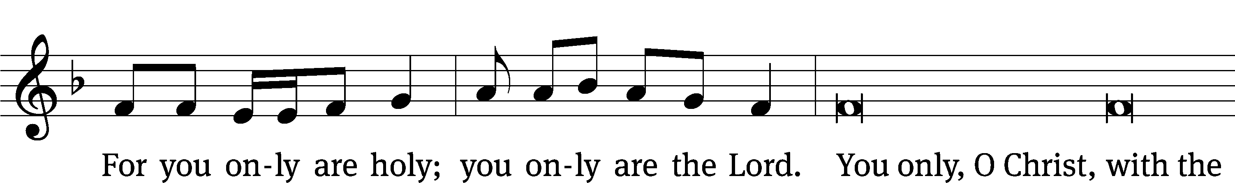
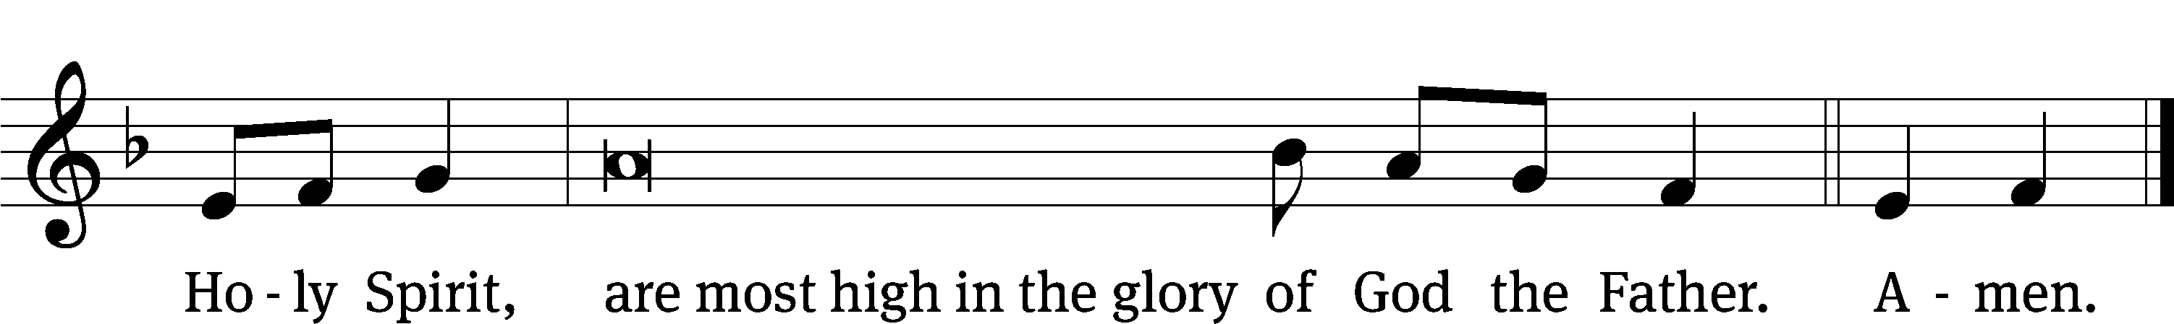

Tune: © 2021 Northwestern Publishing House. Used by permission: OneLicense no. 727703

The Lord be with you.
And also with you.
Prayer of the Day
Let us pray.

O God, by the humiliation of your Son, you lifted up this fallen world from the despair of death. By his resurrection to life, grant your faithful people gladness of heart and the hope of eternal joys; through your Son, Jesus Christ our Lord, who lives and reigns with you and the Holy Spirit, one God, now and forever.
Amen.

Please be seated

First Reading Acts 2:14A, 32-41

¹⁴ Then Peter stood up with the Eleven, raised his voice, and spoke loudly and clearly to them:
³² “This Jesus is the one God has raised up. We are all witnesses of that. ³³ So, after he was exalted to the right hand of God and after he received the promised Holy Spirit from the Father, he poured out what you are now seeing and hearing.
³⁴ “For David did not ascend into heaven, and yet he says:
The Lord said to my Lord,
‘Sit at my right hand,
³⁵ until I make your enemies
a footstool under your feet.’^{[k]}
³⁶ “Therefore let all the house of Israel know for certain that God has made this Jesus, whom you crucified, both Lord and Christ.”
³⁷ Now when the people heard this, they were cut to the heart and said to Peter and the other apostles, “Gentlemen, brothers, what should we do?”
³⁸ Peter answered them, “Repent and be baptized, every one of you, in the name of Jesus Christ for the forgiveness of your^{[l]} sins, and you will receive the gift of the Holy Spirit. ³⁹ For the promise is for you and for your children and for all who are far away, as many as the Lord our God will call.”
⁴⁰ He testified solemnly with many other words and was appealing to them, saying, “Save yourselves from this crooked generation.”
⁴¹ Those who^{[m]} accepted his message were baptized, and that day about three thousand people were added.

The Word of the Lord.
Thanks be to God.

116B I Will Walk in the Presence of the Lord Psalm 116B
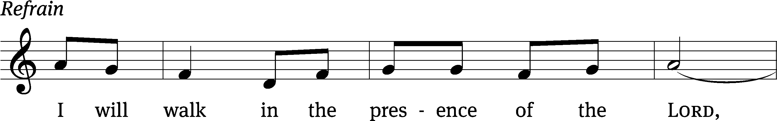
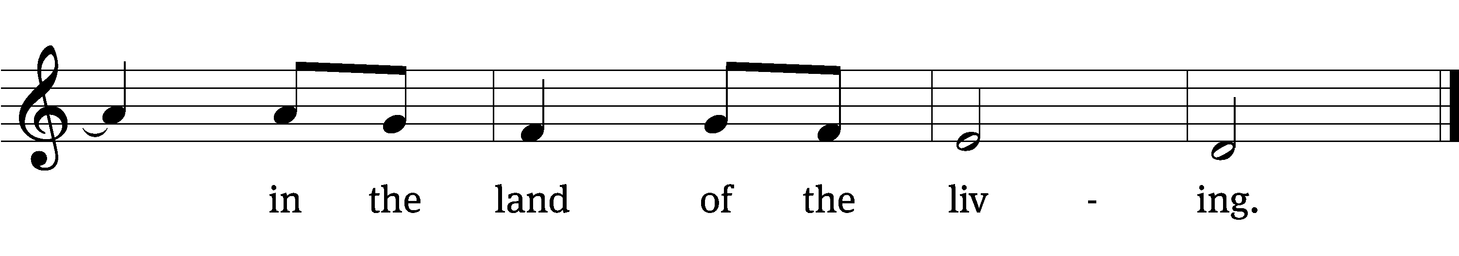
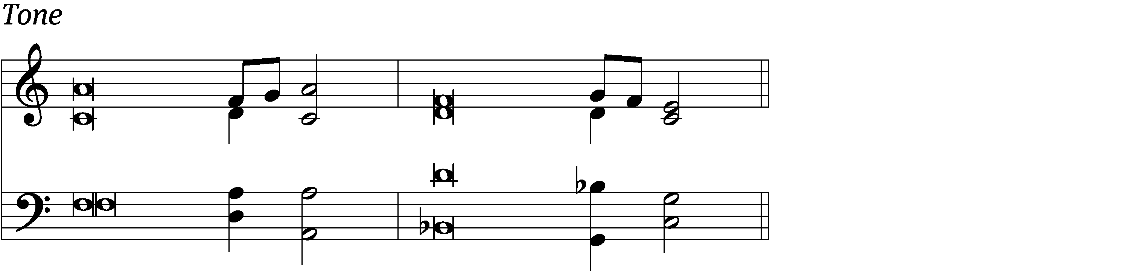

I love the Lord, for he / heard my voice;
he heard my cry for / mercy.
Because he turned his / ear to me,
I will call on him as long / as I live.
The Lord is gracious and / righteous;
when I was brought low, he / saved me. Refrain

What shall I return / to the Lord
for all his good- / ness to me?
I will lift up the cup of sal- / vation
and call on the name / of the Lord.
Precious in the sight / of the Lord
is the death of his faithful / servants.
Glory be to the Father and / to the Son
and to the Holy / Spirit,
as it was in the be- / ginning,
is now, and will be forever. / Amen. Refrain
Tune: Richard T. Proulx
Text: © 1963, 1993 The Grail, GIA Publications, Inc., agent (refrain). Used by permission: OneLicense no. 727703
Tune: © 1975 GIA Publications, Inc. Used by permission: OneLicense no. 727703
Setting: © 1993 Kermit G. Moldenhauer, admin. Northwestern Publishing House. Used by permission: OneLicense no. 727703

Second Reading 1 Peter 1:17-21

¹⁷ If you call on the Father who judges impartially, according to the work of each person, conduct yourselves during the time of your pilgrimage in reverence, ¹⁸ because you know that you were redeemed from your empty way of life handed down to you from your forefathers, not with things that pass away, such as silver or gold, ¹⁹ but with the precious blood of Christ, like a lamb without blemish or spot. ²⁰ He was chosen before the foundation of the world but revealed in these last times for your sake. ²¹ Through him you are believers in God, who raised him from the dead and gave him glory, so that your faith and hope are in God.

The Word of the Lord.
Thanks be to God.

Please stand, if you are able
Gospel Acclamation Luke 24:32
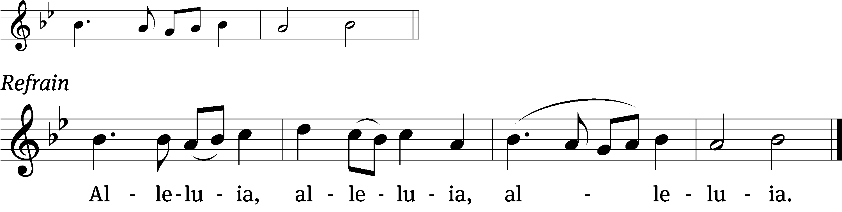
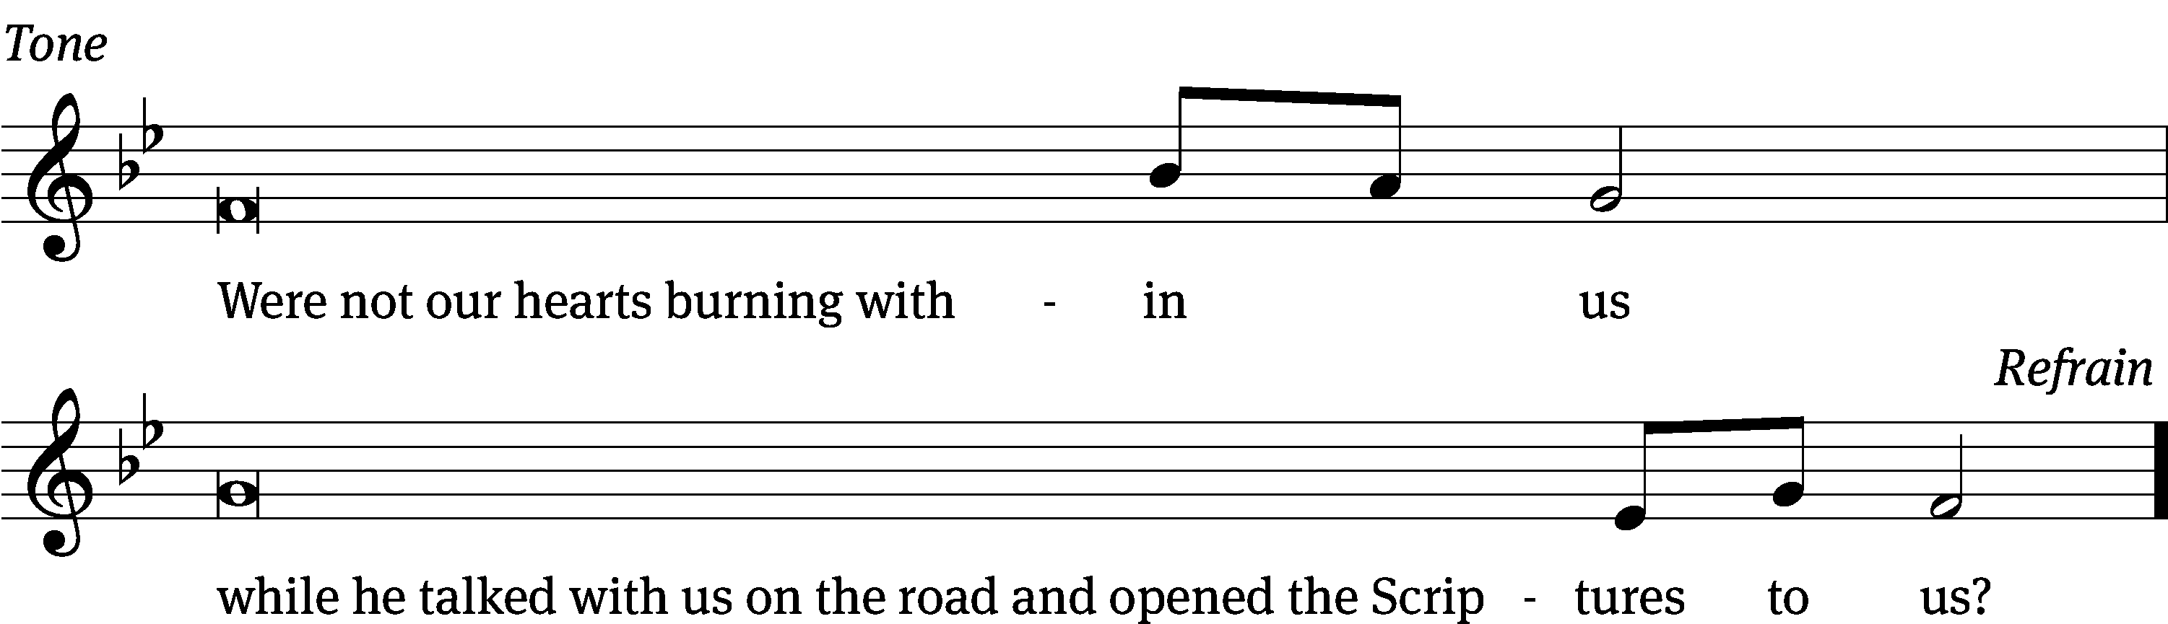
Tune: © 2021 Northwestern Publishing House. Used by permission: OneLicense no. 727703

Gospel Luke 24:13-35
¹³ Now, on that same day, two of them were going to a village named Emmaus, about seven miles^{[a]} from Jerusalem. ¹⁴ They were talking with each other about all of these things that had happened. ¹⁵ While they were talking and discussing this, Jesus himself approached and began to walk along with them. ¹⁶ But their eyes were kept from recognizing him. ¹⁷ He said to them, “What are you talking about as you walk along?” Saddened, they stopped.
¹⁸ One of them, named Cleopas, answered him, “Are you the only visitor in Jerusalem who does not know the things that have happened there in these days?”
¹⁹ “What things?” he asked them.
They replied, “The things concerning Jesus of Nazareth, a man who was a prophet, mighty in deed and word before God and all the people. ²⁰ The chief priests and our rulers handed him over to be condemned to death. And they crucified him. ²¹ But we were hoping that he was going to redeem Israel. Not only that, but besides all this, it is now the third day since these things happened. ²² Also some women of our group amazed us. They were at the tomb early in the morning. ²³ When they did not find his body, they came back saying that they had even seen a vision of angels, who said that he was alive. ²⁴ Some of those who were with us went to the tomb. They found it just as the women had said, but they did not see him.”
²⁵ He said to them, “How foolish you are and slow of heart to believe all that the prophets have spoken! ²⁶ Did not the Christ have to suffer these things and to enter his glory?” ²⁷ Then beginning with Moses and all the prophets, he explained to them what was said in all the Scriptures concerning himself.
²⁸ As they approached the village where they were going, he acted as if he were going to travel farther. ²⁹ But they urged him strongly, saying, “Stay with us, since it is almost evening, and the day is almost over.”
So he went in to stay with them. ³⁰ When he reclined at the table with them, he took the bread, blessed it, broke it, and began giving it to them. ³¹ Suddenly their eyes were opened, and they recognized him. Then he vanished from their sight. ³² They said to each other, “Were not our hearts burning within us while he was speaking to us along the road and while he was explaining the Scriptures to us?” ³³ They got up that very hour and returned to Jerusalem. They found the Eleven and those who were with them assembled together. ³⁴ They were saying, “The Lord really has been raised! He has appeared to Simon.” ³⁵ They themselves described what had happened along the road, and how they recognized him when he broke the bread.
The Gospel of the Lord.
Praise be to you, O Christ!

Please be seated

980 Who Are You Who Walk in Sorrow CW 980
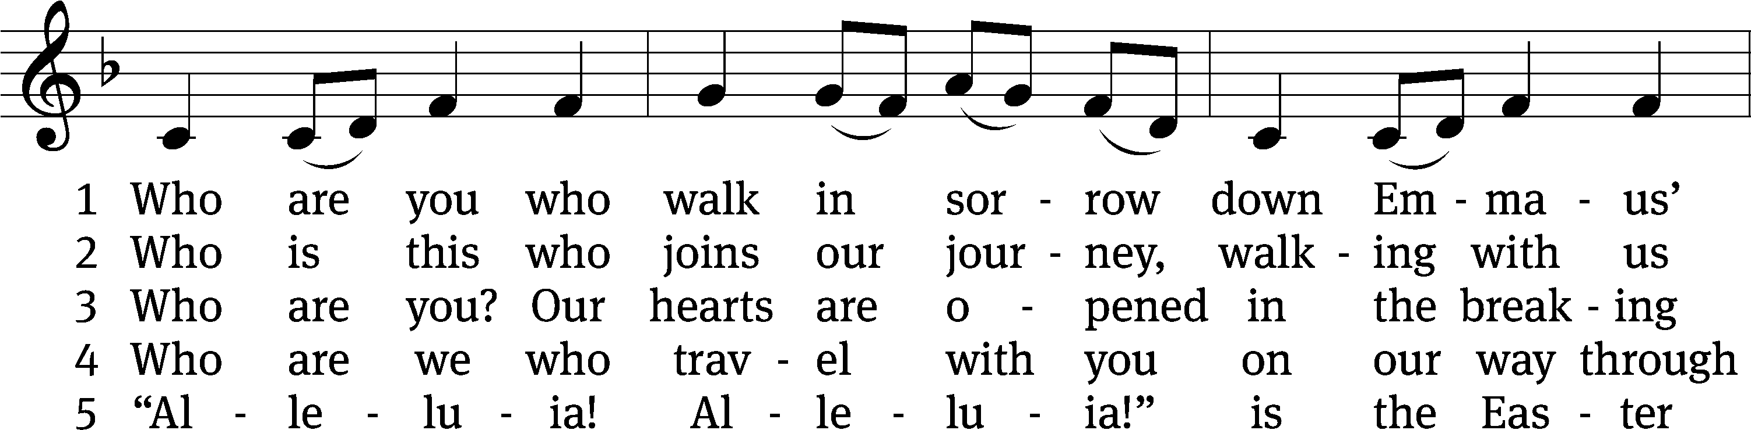
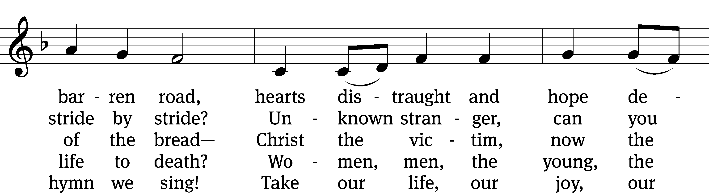
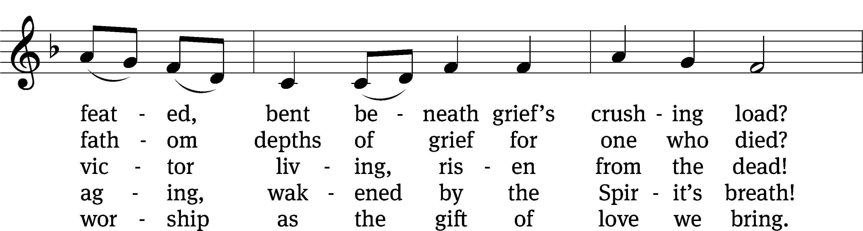
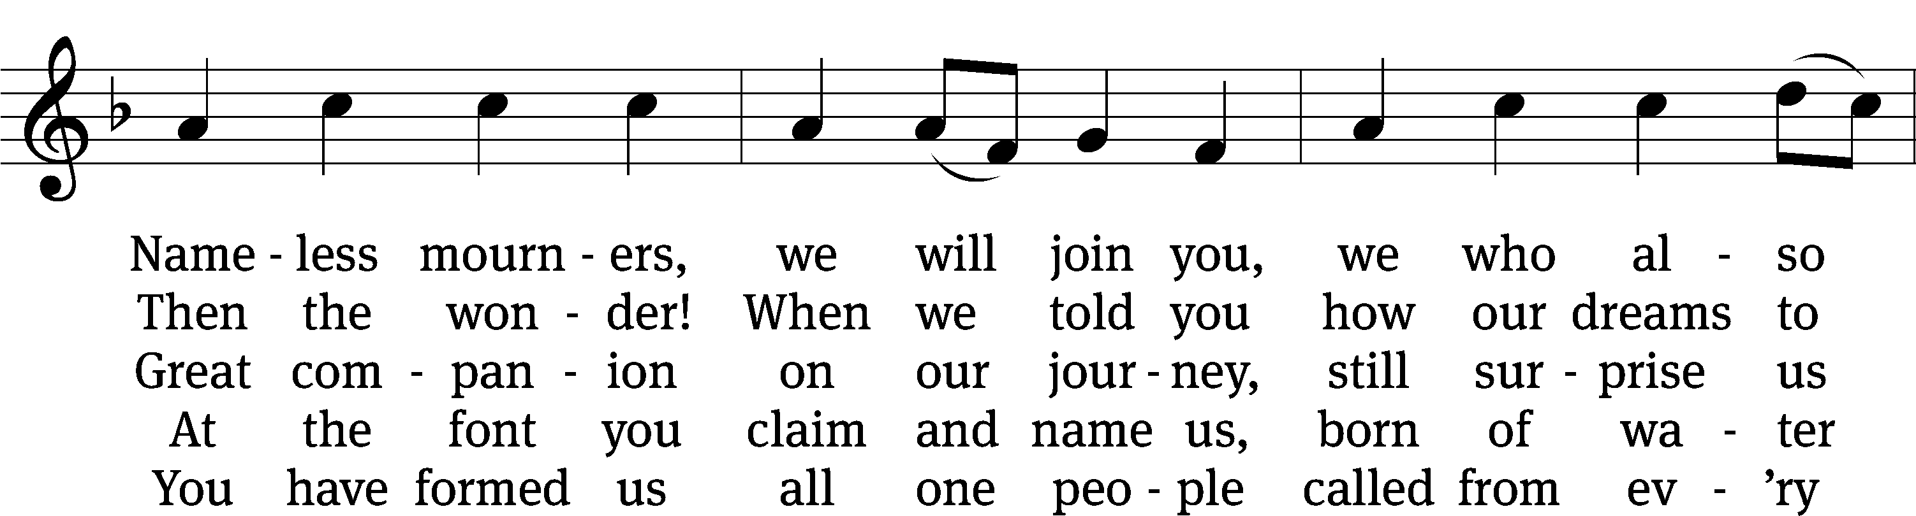
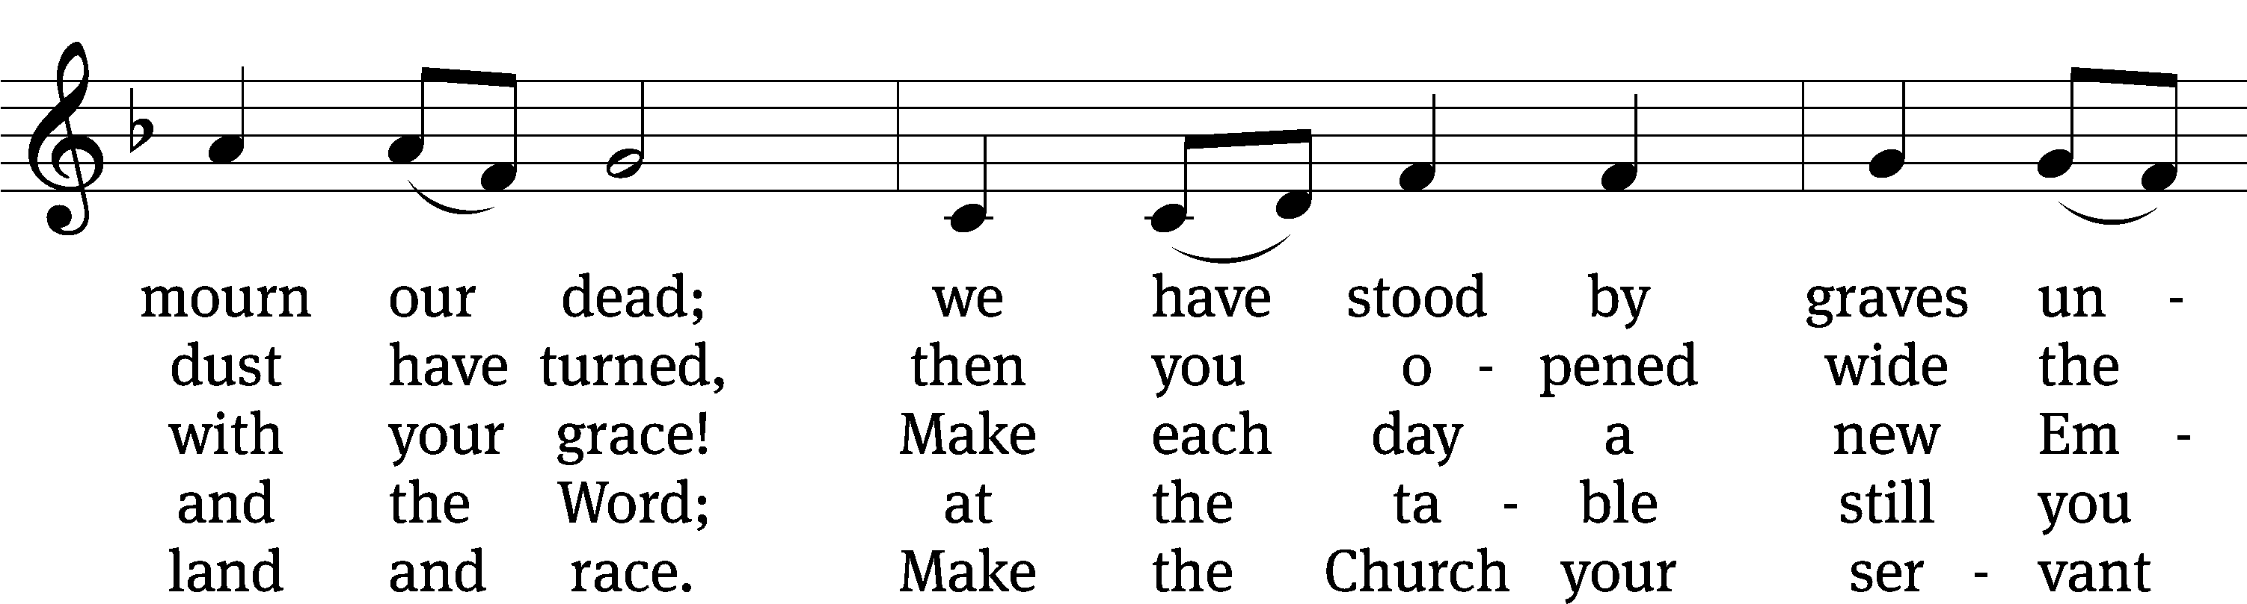
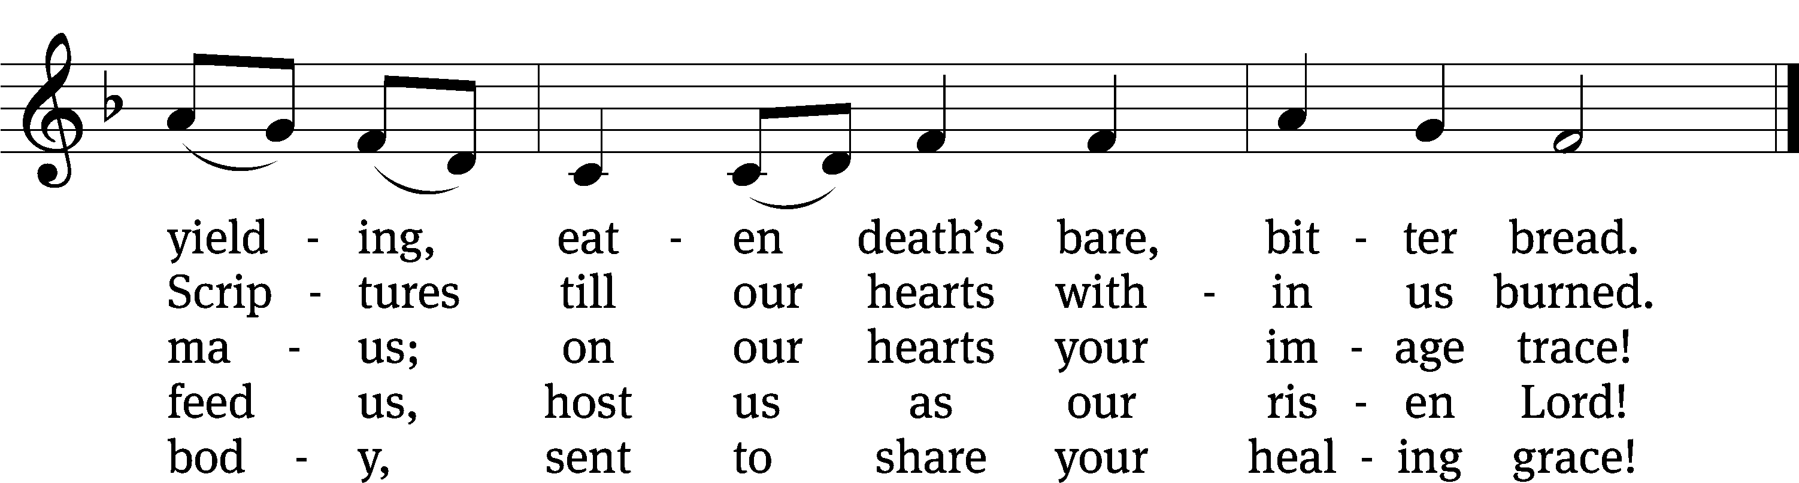
Text: Herman G. Stuempfle, Jr., 1923–2007
Tune: Columbian Harmony, Cincinatti, 1825, ed. William Moore
Text: © 2000 National Association of Pastoral Musicians. Used by permission: OneLicense no. 727703
Tune: Public domain

Sermon Luke 24:13-35
“What a Difference a Day Can Make”

Please stand, if you are able

Apostles’ Creed
I believe in God, the Father Almighty,
maker of heaven and earth.

I believe in Jesus Christ, his only Son, our Lord,
who was conceived by the Holy Spirit,
born of the Virgin Mary,
suffered under Pontius Pilate,
was crucified, died, and was buried.
He descended into hell.
The third day he rose again from the dead.
He ascended into heaven
and is seated at the right hand of God the Father Almighty.
From there he will come to judge the living and the dead.

I believe in the Holy Spirit,
the holy Christian Church,
the communion of saints,
the forgiveness of sins,
the resurrection of the body,
and the life everlasting. Amen.

Prayer of the Church

Please be seated

464 I Am Content! My Jesus Lives Again CW 464
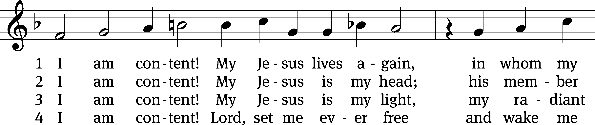
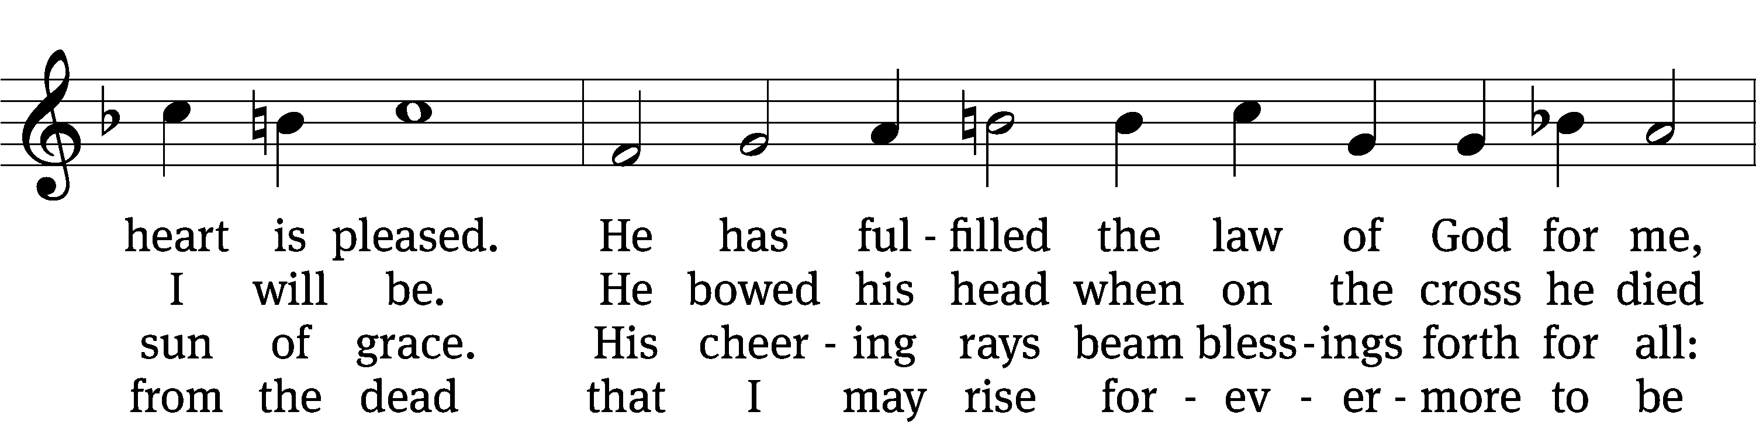
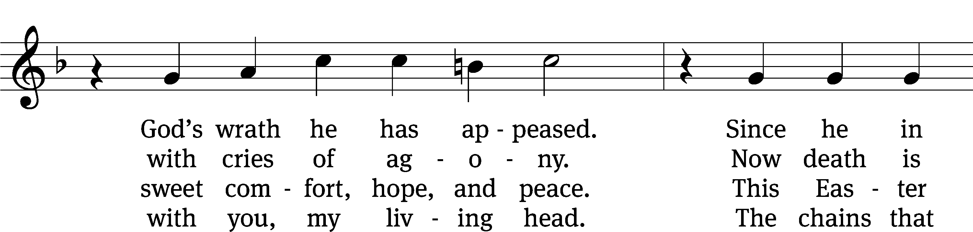
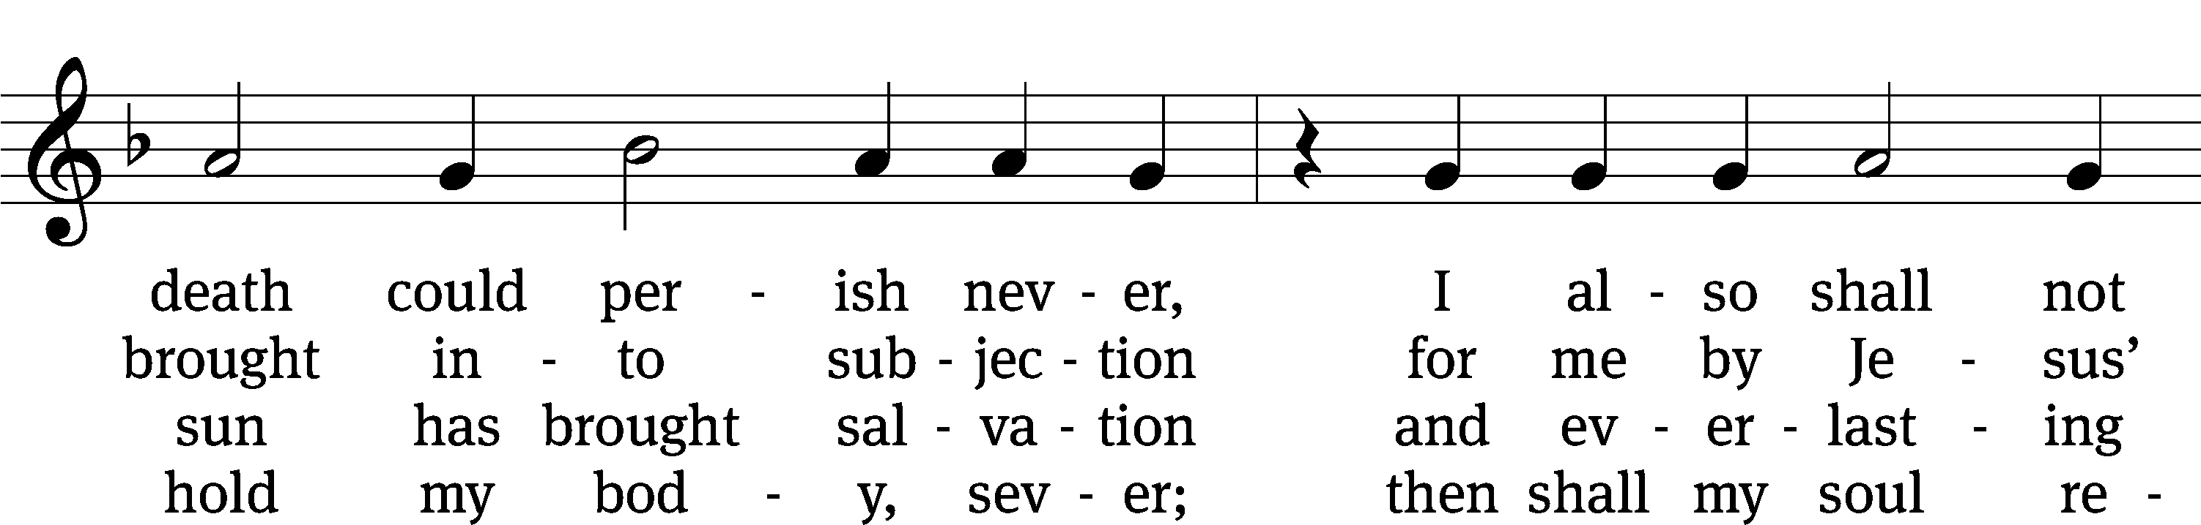
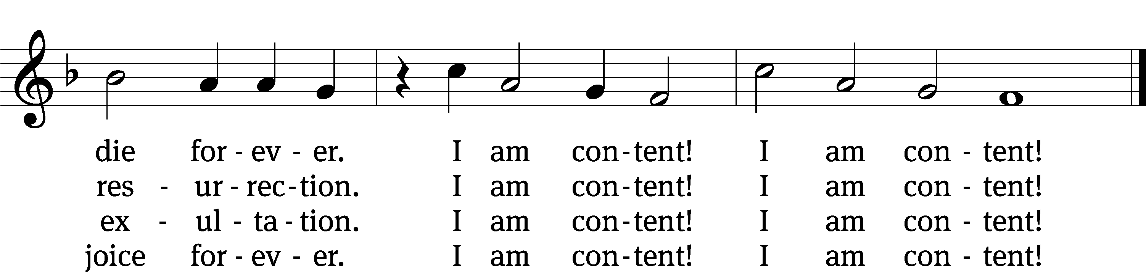
Text: tr. August Crull, 1845–1923, alt.; attr. Johann J. Möller, 1660–1733, abr
Tune: Johann R. Ahle, 1625–1673
Text and tune: Public domain

Please stand, if you are able
Prayer
Blessed Lord, you have given us your Holy Scriptures for our learning. May we so hear them, read, learn, and take them to heart that, being strengthened and comforted by your holy Word, we may cling to the blessed hope of everlasting life; through Jesus Christ our Lord, who lives and reigns with you and the Holy Spirit, one God, now and forever.
Amen.
Lord’s Prayer
Our Father, who art in heaven, hallowed be thy name, thy kingdom come, thy will be done on earth as it is in heaven. Give us this day our daily bread; and forgive us our trespasses, as we forgive those who trespass against us; and lead us not into temptation, but deliver us from evil. For thine is the kingdom and the power and the glory forever and ever. Amen.

Blessing
The Lord bless you and keep you.
The Lord make his face shine on you and be gracious to you.
The Lord look on you with favor and give you peace.
Amen.

Please be seated

470 Like the Golden Sun Ascending CW 470
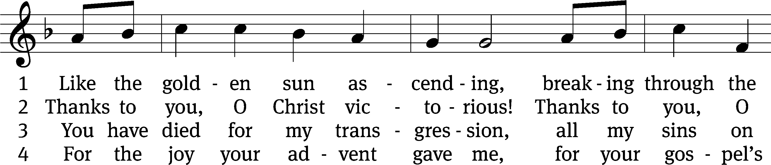
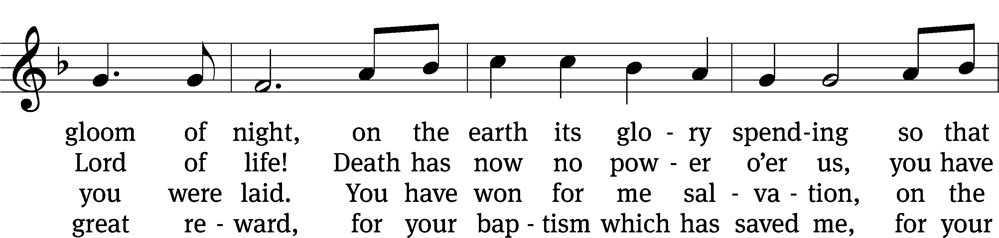
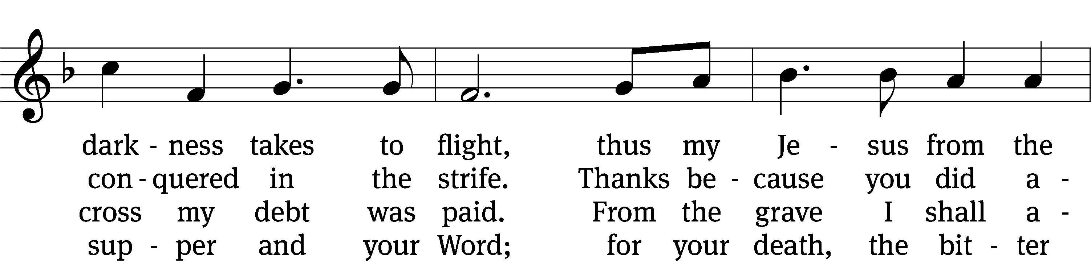
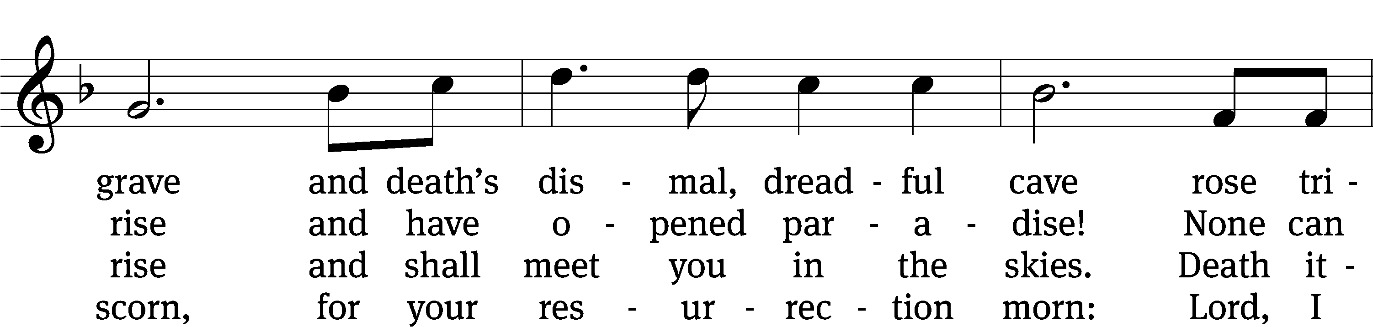
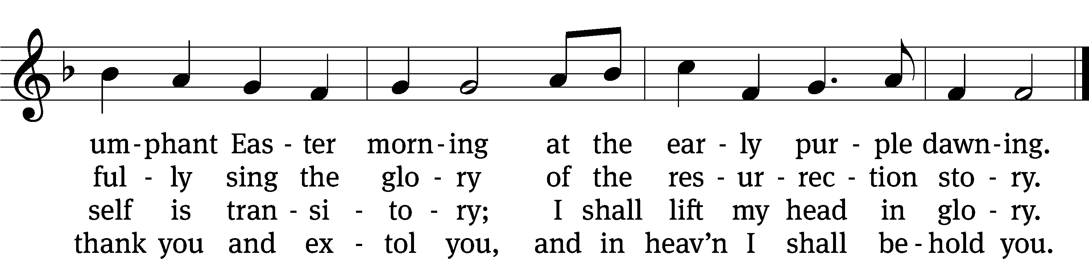
Text: tr. George A. T. Rygh, 1860–1942, alt.; Thomas H. Kingo, 1634–1703, abr.
Tune: Johann Schop, c. 1590–1667
Text and tune: Public domain

Acknowledgments
Setting One from Christian Worship
Software distributed in partnership with Northwestern Publishing House.
Created by Christian Worship: Service Builder © 2022 Concordia Publishing House.

Serving in Worship
Officiant Pastor Natsis
Organist Ann Hoeft
Deacons (8:30) Dave Stevenson and Jim Tice
(11:00) Steve Hoeft and Jeff Neuburger
Ushers (8:30) Dale Finkbeiner and Mark Finkbeiner
(11:00) Al Whitley
Altar Guild Jean Fiegel and Ann Latowski
Videographer Jake Vershum

