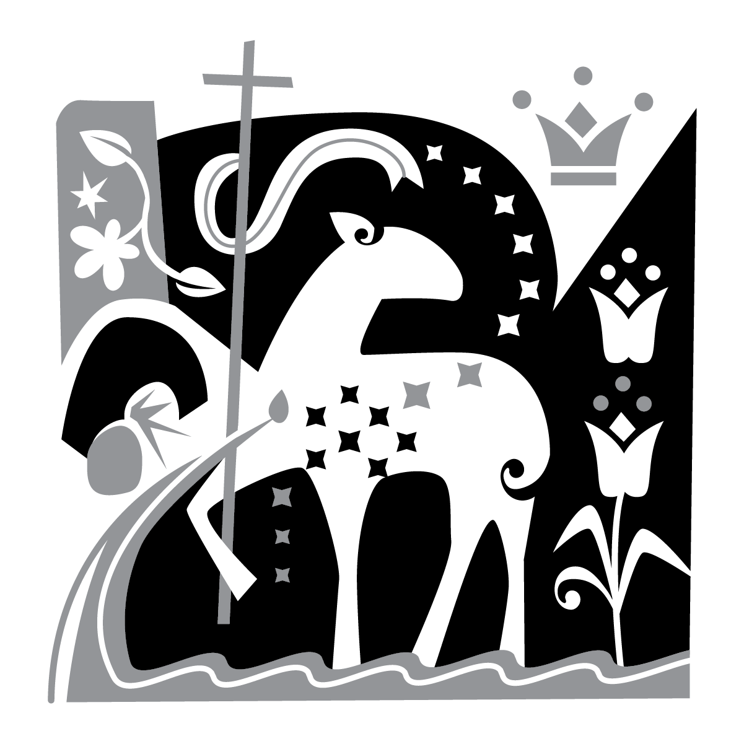
THE FIFTH SUNDAY
OF EASTER

TRINITY EVANGELICAL LUTHERAN CHURCH | Saline, Michigan
WELCOME TO WORSHIP May 7, 2023
Thank you for joining us in God’s house today! We cordially ask that our Guests sign one of the guestbooks located at either the front or back entryways, or fill out a “Let’s Get Acquainted” card located in the hymnal pew rack and place it in the collection plate.

Thank Offering: Members of Trinity give their offering as an expression of love and thankfulness to the Lord and to help support the Lord’s work in our community and around the world. Visitors need not feel obligated to participate in this offering .

Restrooms are located at the back of the upper level (the annex), and in the basement (down the back stairs of the sanctuary or annex). Handicap access is available, please ask an usher for assistance.

Young Families / Toddler Bags – We are GLAD YOU BROUGHT YOUR CHILDREN to our worship service. Jesus said: “Let the little children come to me and do not hinder them, for the kingdom of God belongs to such as these.” We know that having little children in church can be a challenge, but DO NOT WORRY about it. Many of your fellow worshippers have been in your shoes and are just happy you brought your children with you. For your convenience, we have reserved the back rows of seating for parents with small children. These areas provide more flexibility for your family, as well as, easy access to move downstairs if necessary. A closed-circuit TV system allows families to continue participating in the service while downstairs. Pre-school toddler bags and children’s bulletins are available for their enjoyment. Ask an usher for one to use during the service and please return the toddler bag afterwards.

Holy Communion – In His Word, God makes it clear that the Lord’s Supper is to be shared by people of a common proclamation of faith (1 Corinthians 11:26; 1 Corinthians 10:16-17). Without judging anyone’s hearts, we invite those who share in our confession by their membership in our congregation or another congregation of the Wisconsin Evangelical Lutheran Synod (WELS) or the Evangelical Lutheran Synod (ELS) and who are properly prepared (1 Corinthians 11;27-29) to receive the Sacrament. Page 295 in Christian Worship provides a guide for preparation.
Guests, we would love to have you join us in communion fellowship in the future, and for that to be possible, we ask that you speak with one of the pastors so that we may speak with you on how that would be possible. We thank you for respecting the way we celebrate the Lord’s Supper in our congregations.

the SERVICE – setting one - WITH HOLY COMMUNION CW, page 154
521 Christ the Eternal Lord CW 521
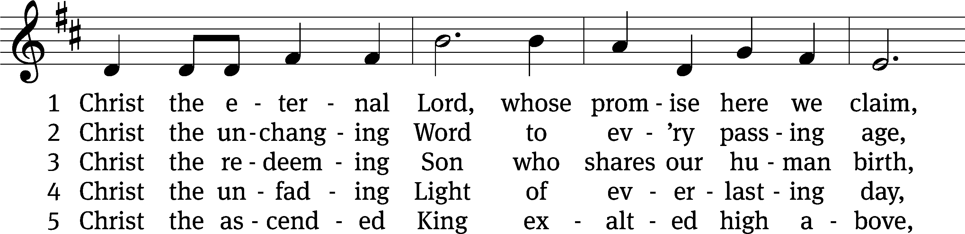
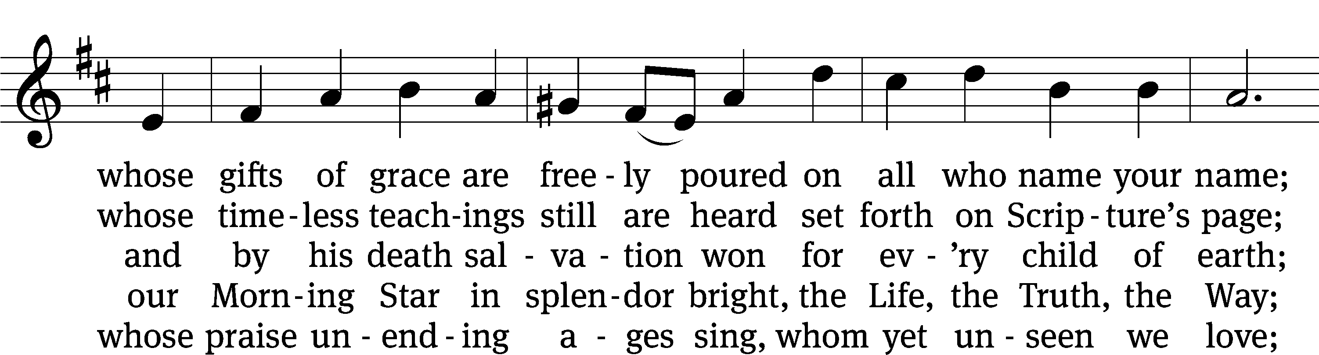
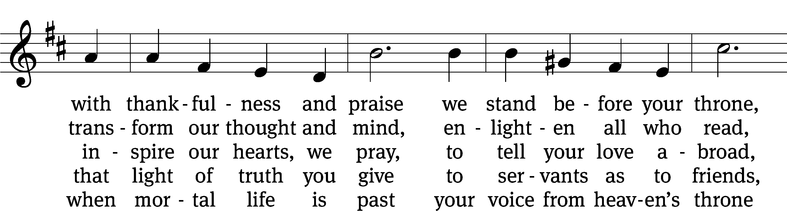
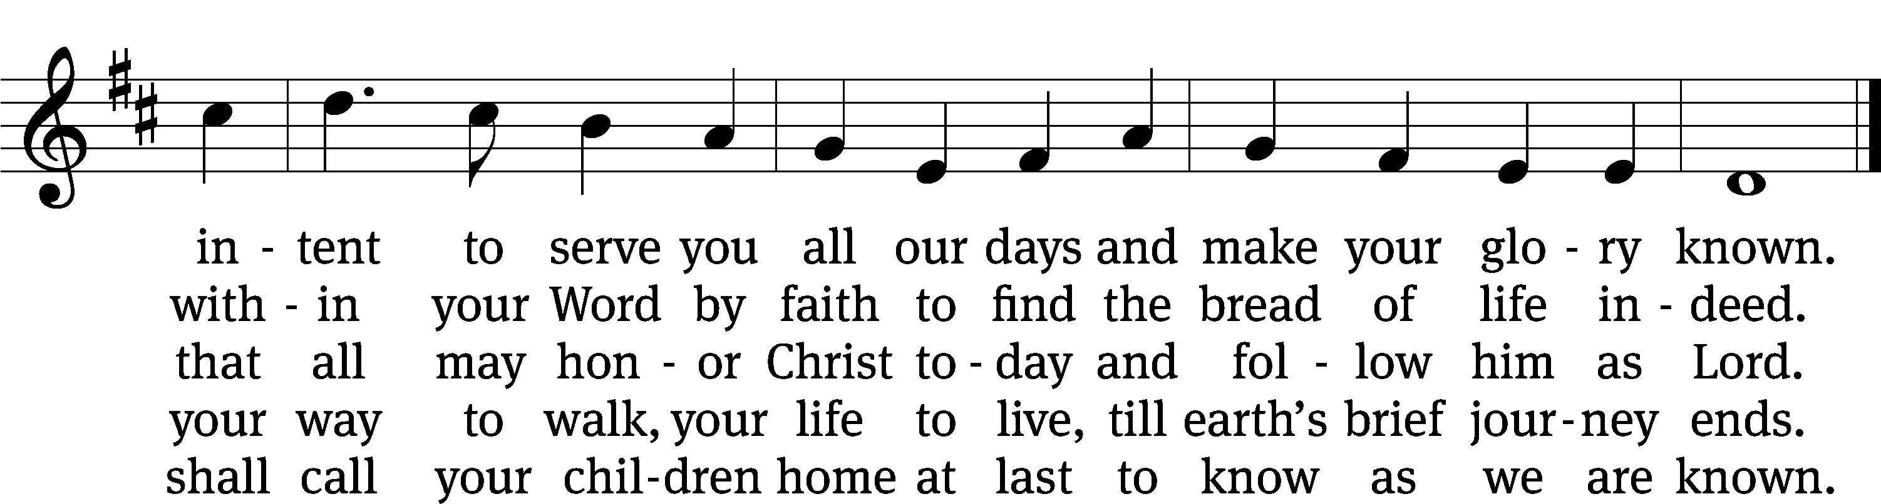
Text: Timothy Dudley-Smith, b. 1926
Tune: George J. Elvey, 1816–1893
Text: © 1999 Hope Publishing Co. Used by permission: OneLicense no. 727703
Tune: Public domain

Please stand, if you are able
Invocation
In the name of the Father and of the Son and of the Holy Spirit.
Amen.
Confession
If we claim to be without sin, we deceive ourselves and the truth is not in us.
If we confess our sins, God is faithful and just
and will forgive us our sins
and purify us from all unrighteousness.

Let us confess our sins to the Lord.
Holy God, gracious Father,
I am sinful by nature
and have sinned against you in my thoughts, words, and actions.
I have not loved you with my whole heart;
I have not loved others as I should.
I deserve your punishment both now and forever.
But Jesus, my Savior, paid for my sins
with his innocent suffering and death.
Trusting in him, I pray: God, have mercy on me, a sinner.

Our gracious Father in heaven has been merciful to us. He sent his only Son, Jesus Christ, who gave his life as the atoning sacrifice for the sins of the whole world. Therefore, as a called servant of Christ and by his authority, I forgive you all your sins in the name of the Father and of the Son and of the Holy Spirit.
Amen.

Lord, Have Mercy

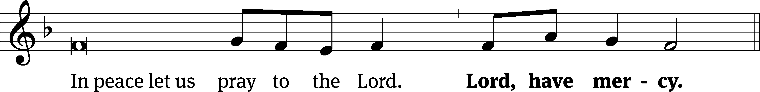
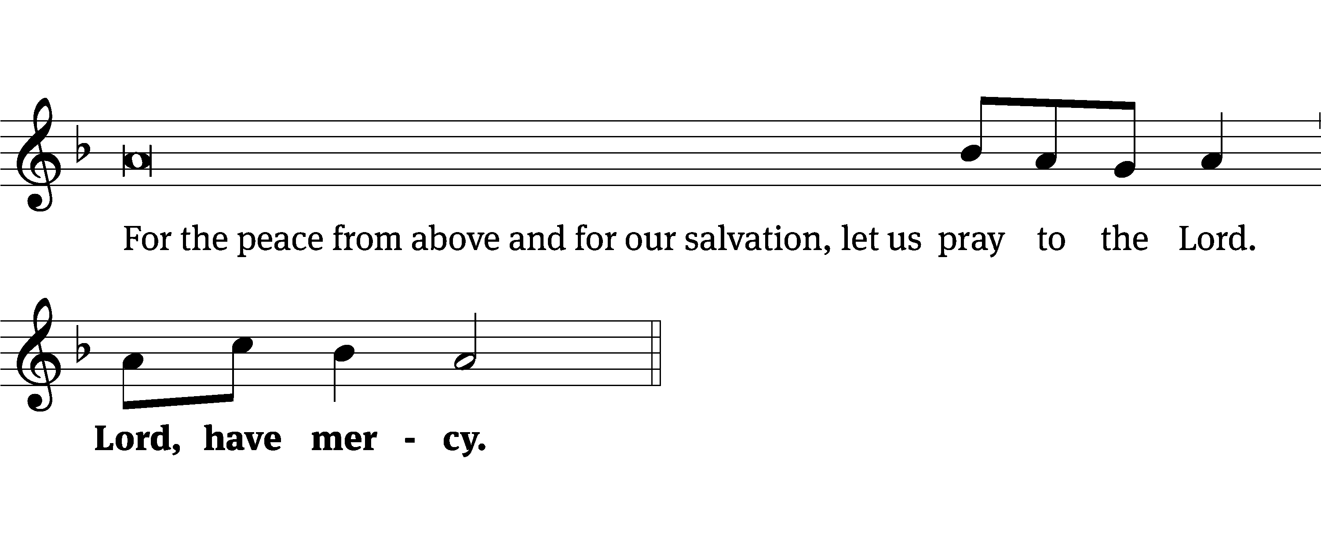
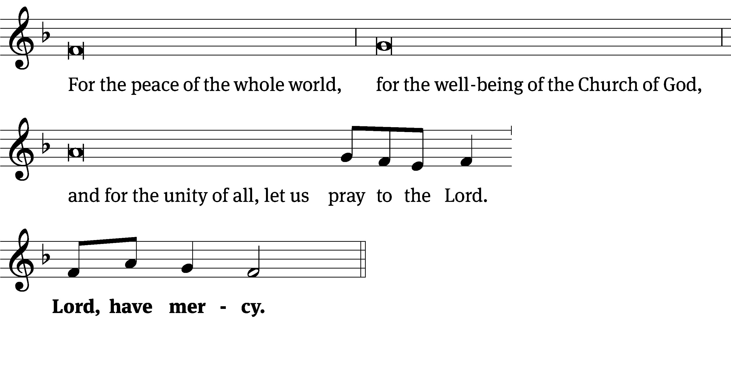
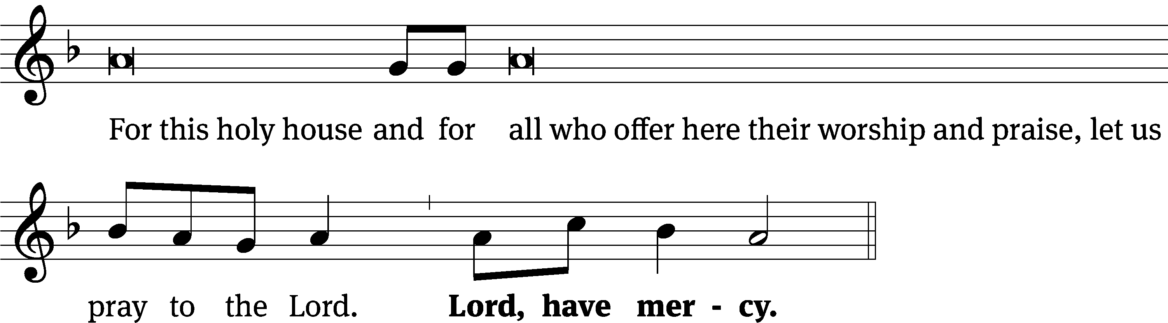
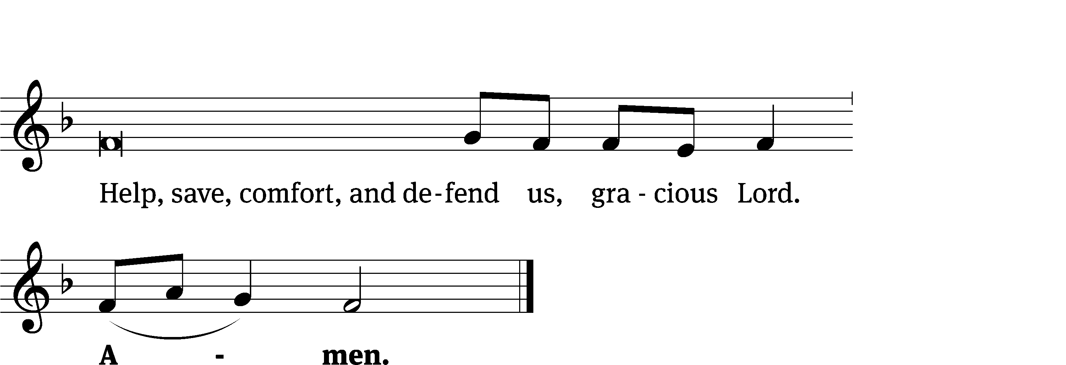
Glory Be to God on High CW 157
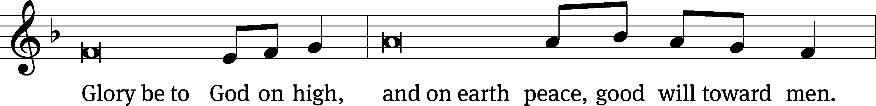
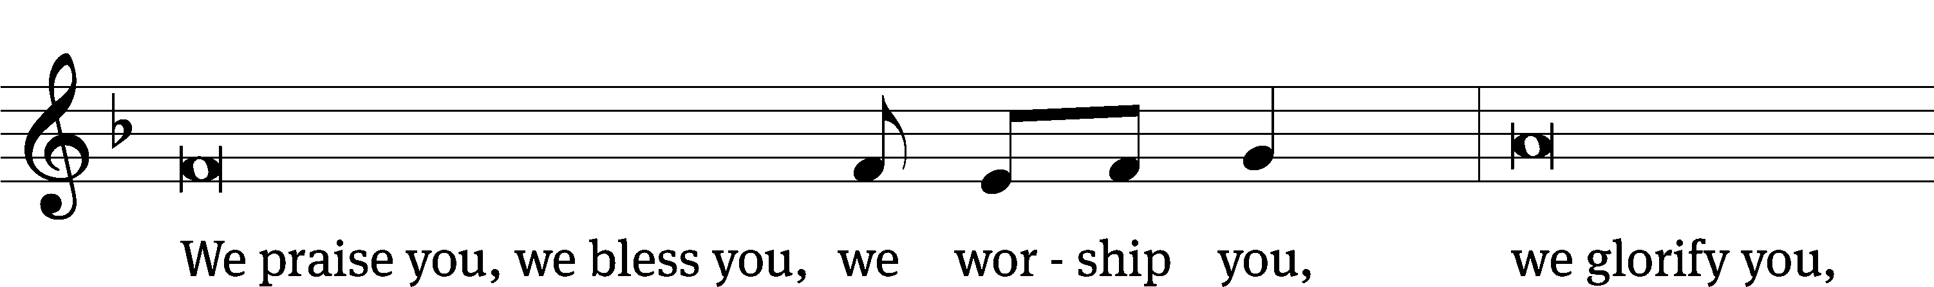
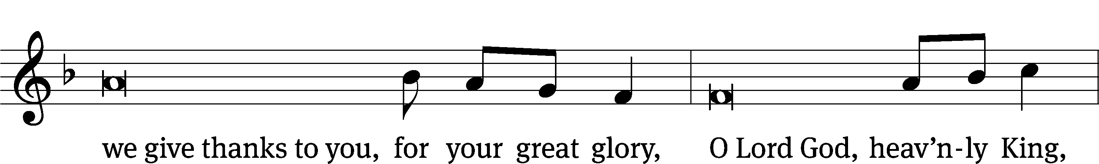
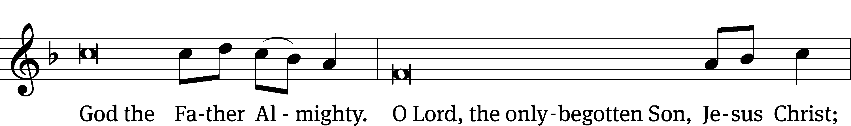
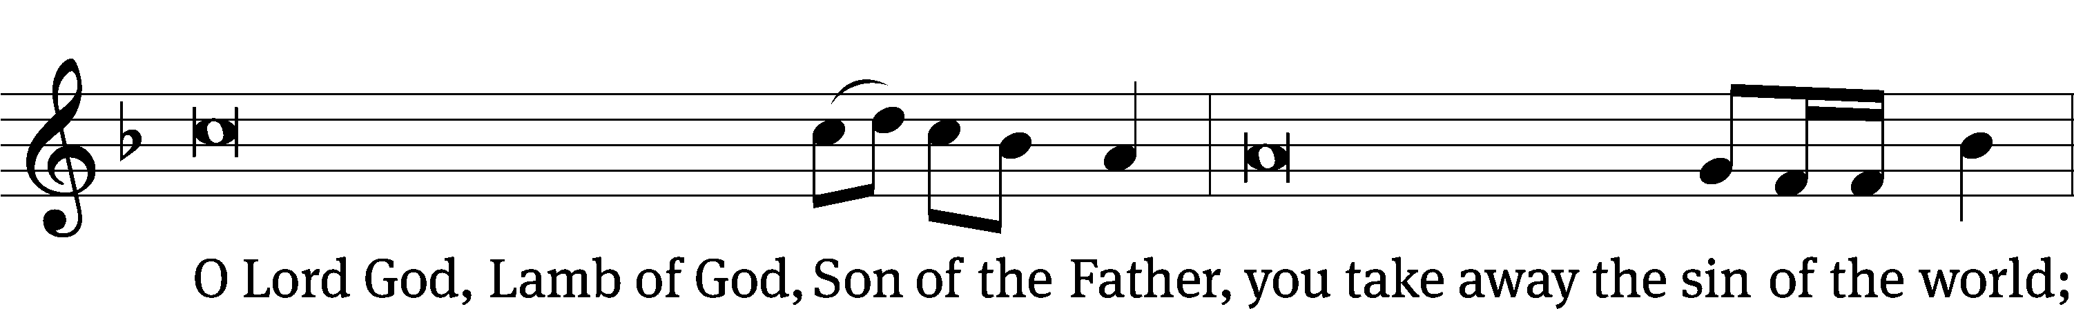
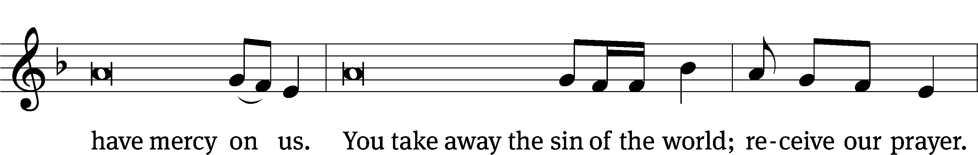
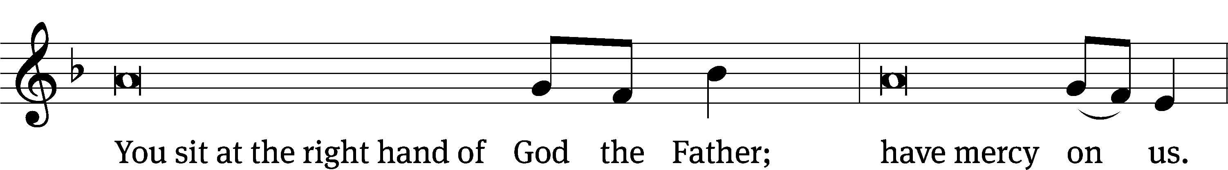
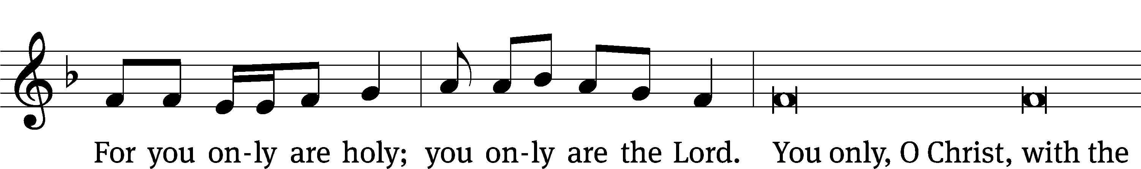
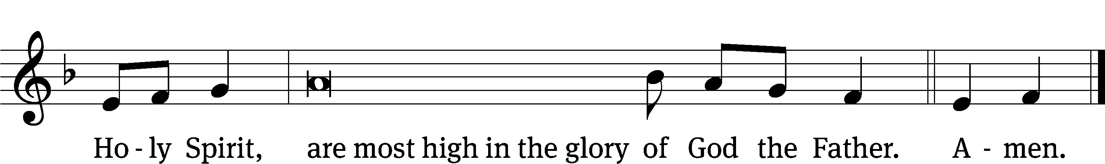

The Lord be with you.
And also with you.
Prayer of the Day
Let us pray.

O God, you form the minds of your faithful people into a single will. Make us love what you command and desire what you promise, that among the many changes of this world, our hearts may ever yearn for the lasting joys of heaven; through your Son, Jesus Christ our Lord, who lives and reigns with you and the Holy Spirit, one God, now and forever.
Amen.

Please be seated

First Reading Acts 4:8-12

⁸ Then Peter, filled with the Holy Spirit, said to them, “Rulers of the people and elders of Israel, ⁹ if we are being questioned today for a kind act that was done for the lame man, as to how this man has been healed, ¹⁰ let it be known to all of you and to all the people of Israel that it was by the name of Jesus Christ the Nazarene, whom you crucified, whom God raised from the dead! By him this man stands before you healed. ¹¹ This Jesus is the stone that was rejected by you builders, which has become the cornerstone.
¹² “There is salvation in no one else, for there is no other name under heaven given to people by which we must be saved.”

The Word of the Lord.
Thanks be to God.

118B Irish Alleluia Psalm 118B
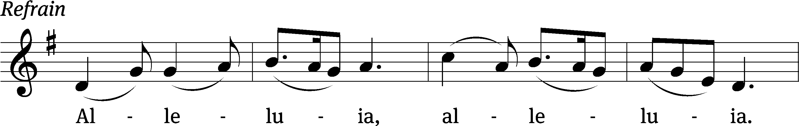
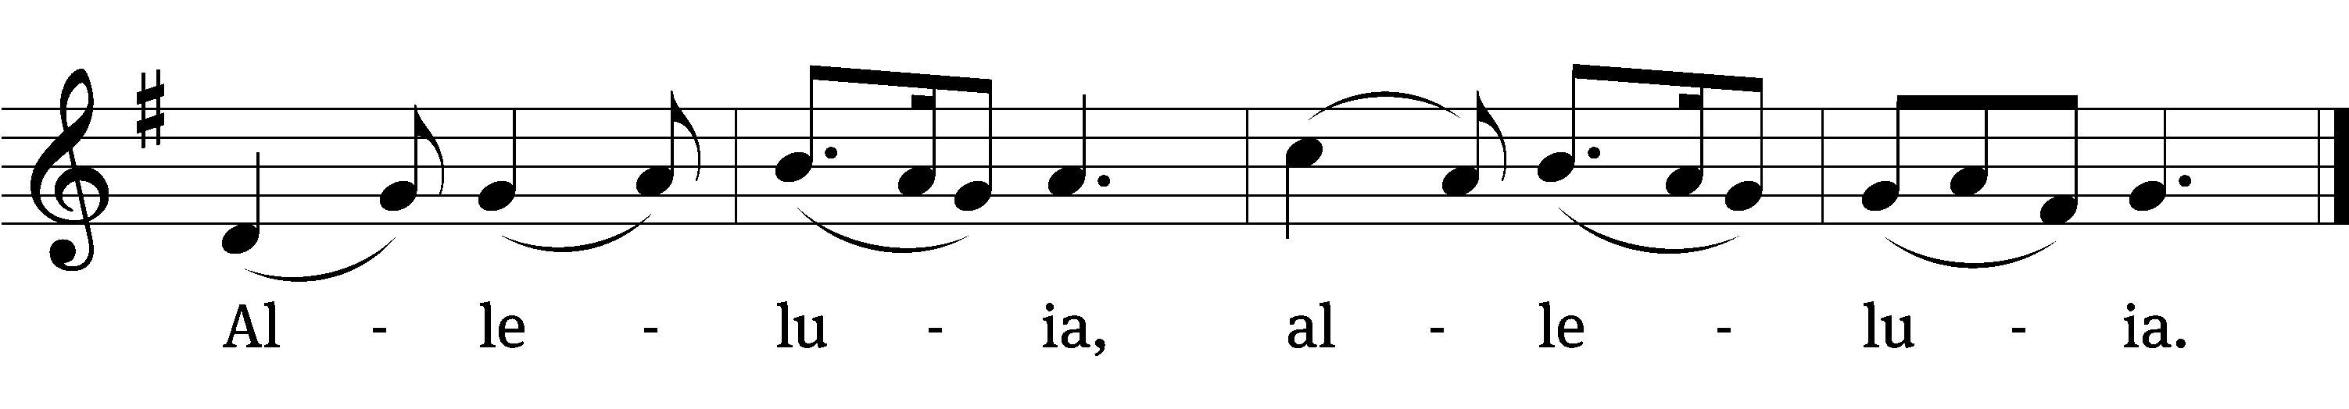
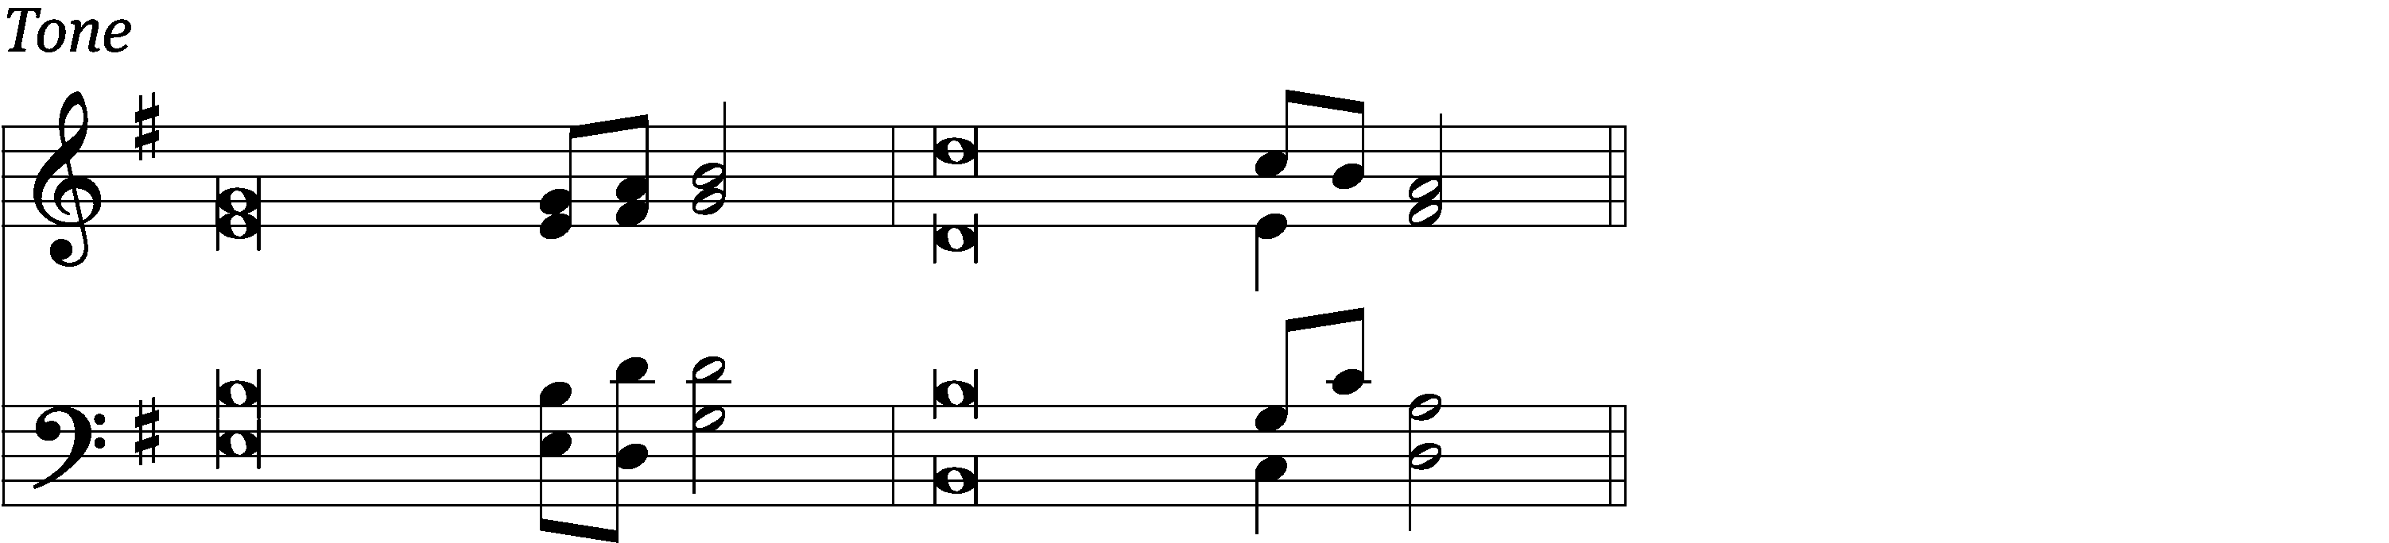

The Lord is my strength and / my defense;
he has become my sal- / vation.
The Lord’s right hand is / lifted high;
the Lord’s right hand has done / mighty things!
I will not / die but live,
and will proclaim what the / Lord has done. Refrain

I will give you thanks, for you / answered me;
you have become my sal- / vation.
The stone the builders re- / jected
has become the / cornerstone;
the Lord has / done this,
and it is marvelous / in our eyes.
Glory be to the Father and / to the Son
and to the Holy / Spirit,
as it was in the be- / ginning,
is now, and will be forever. / Amen. Refrain
Tune: Fintan O’Carroll
Setting: Fintan O’Carroll
Music: © 1985 GIA Publications, Inc. Used by permission: OneLicense no. 727703

Second Reading 1 Peter 2:4-10
⁴ As you come to him, the Living Stone, rejected by men but chosen by God and precious, ⁵ you also, like living stones, are being built as a spiritual house to be a holy priesthood, in order to bring spiritual sacrifices that are acceptable to God through Jesus Christ. ⁶ For it says in Scripture:
See, I lay a stone in Zion,
a chosen and precious cornerstone,
and the one who believes in him will certainly not be put to shame.
⁷ Therefore, for you who believe, this is an honor. But for those who do not believe:
The stone which the builders rejected has become the cornerstone,
⁸ and,
a stone over which they stumble
and a rock over which they fall.
Because they continue to disobey the word, they stumble over it. And that is the consequence appointed for them.
⁹ But you are a chosen people, a royal priesthood, a holy nation, the people who are God’s own possession, so that you may proclaim the praises of him who called you out of darkness into his marvelous light. ¹⁰ At one time you were not a people, but now you are the people of God. At one time you were not shown mercy, but now you have been shown mercy.

The Word of the Lord.
Thanks be to God.

Please stand, if you are able

Gospel Acclamation John 14:6
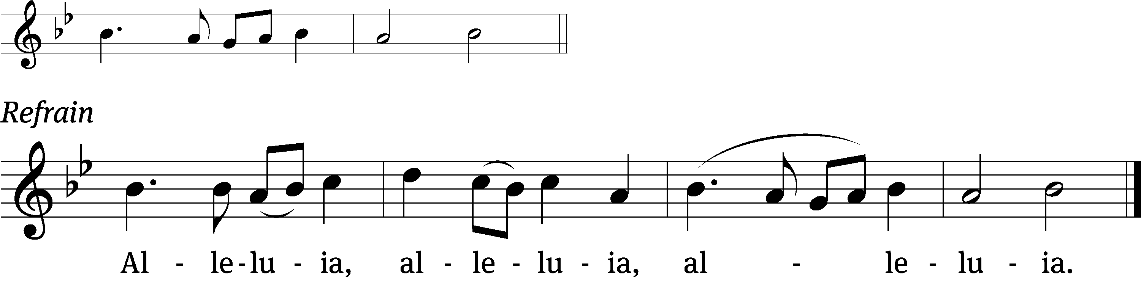
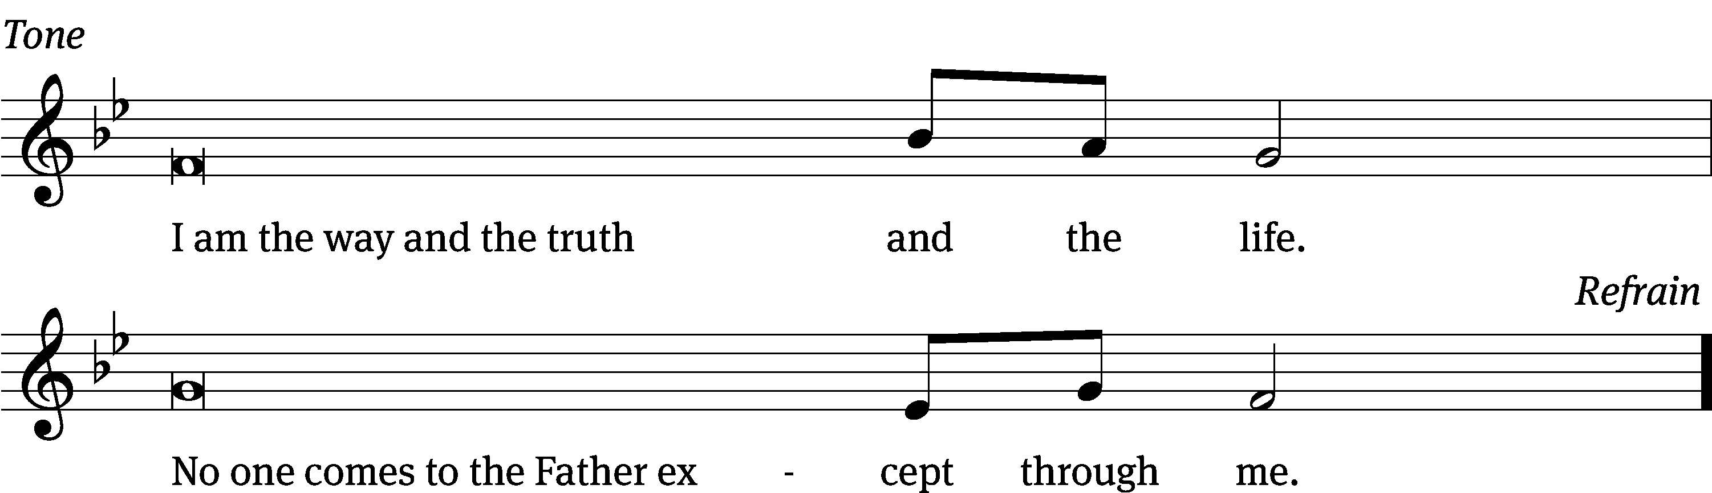
Tune: © 2021 Northwestern Publishing House. Used by permission: OneLicense no. 727703
Gospel John 14:1-11
“Do not let your heart be troubled. Believe in God; believe also in me. ² In my Father’s house are many mansions. If it were not so, I would have told you. I am going to prepare a place for you. ³ And if I go and prepare a place for you, I will come again and take you to be with me, so that you may also be where I am. ⁴ You know where I am going, and you know the way.”
⁵ “Lord, we don’t know where you are going,” Thomas replied, “so how can we know the way?”
⁶ Jesus said to him, “I am the Way and the Truth and the Life. No one comes to the Father, except through me. ⁷ If you know me, you would also know my Father. From now on you do know him and have seen him.”
⁸ “Lord,” said Philip, “show us the Father, and that is enough for us.”
⁹ “Have I been with you so long,” Jesus answered, “and you still do not know me, Philip? The one who has seen me has seen the Father. How can you say, ‘Show us the Father’? ¹⁰ Don’t you believe that I am in the Father and the Father is in me? The words that I am telling you I am not speaking on my own, but the Father who remains in me is doing his works. ¹¹ Believe me that I am in the Father, and the Father is in me. Or else believe because of the works themselves.
The Gospel of the Lord.
Praise be to you, O Christ!

Please be seated

702 Come, Follow Me, the Savior Spake CW 702
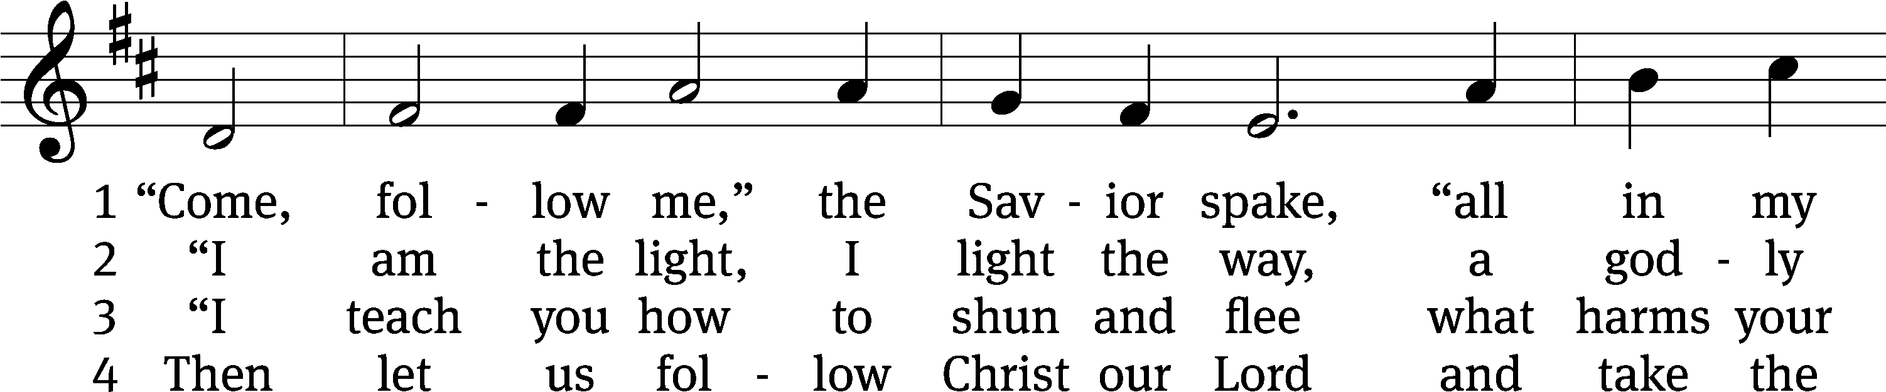
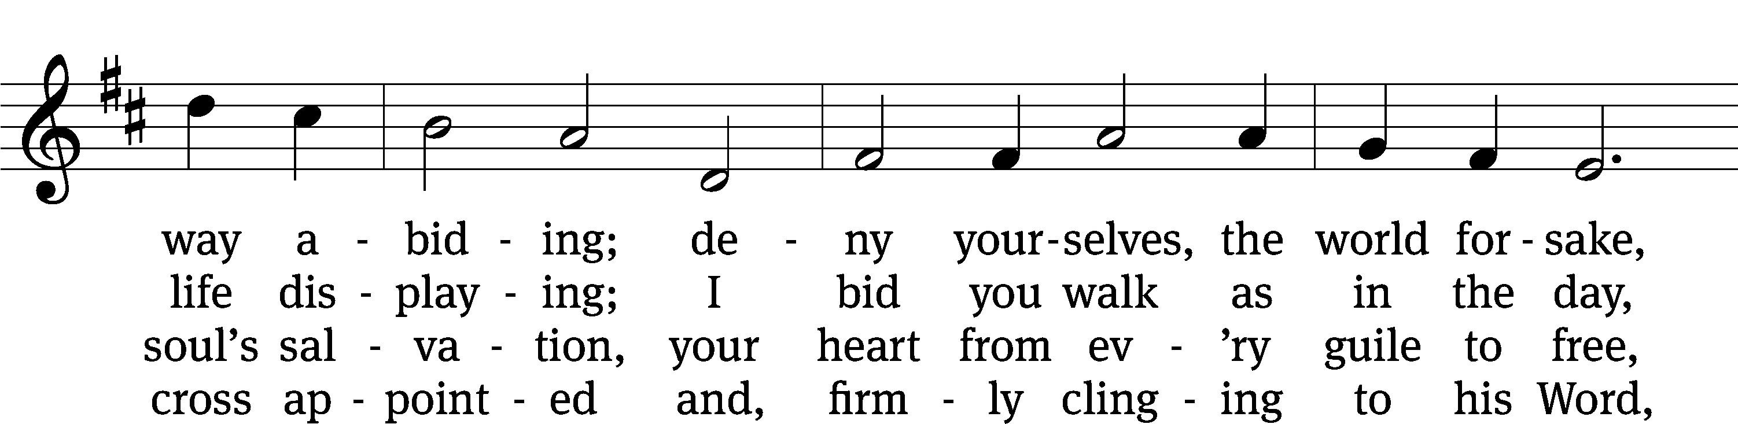
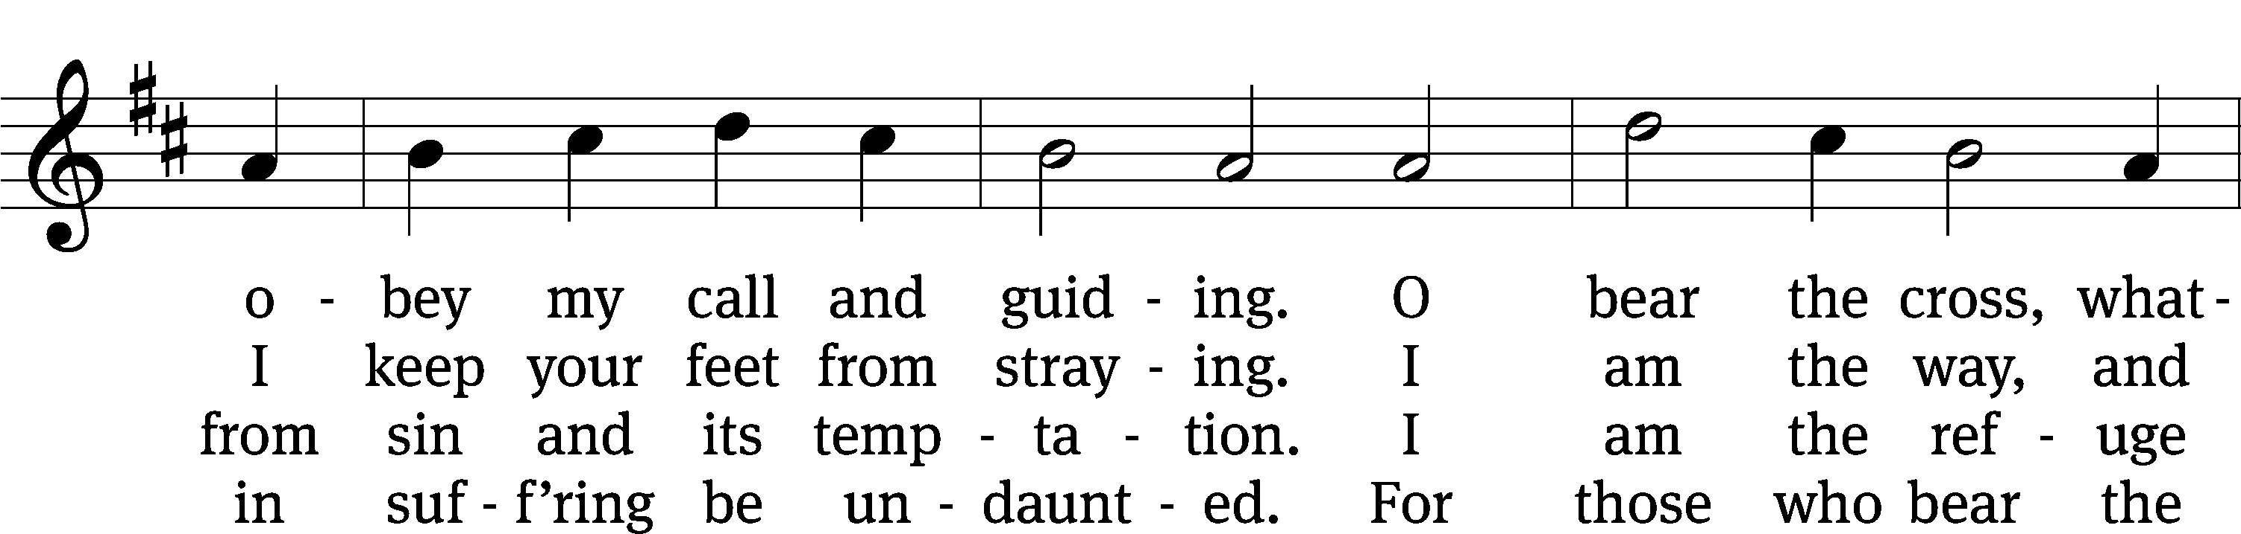
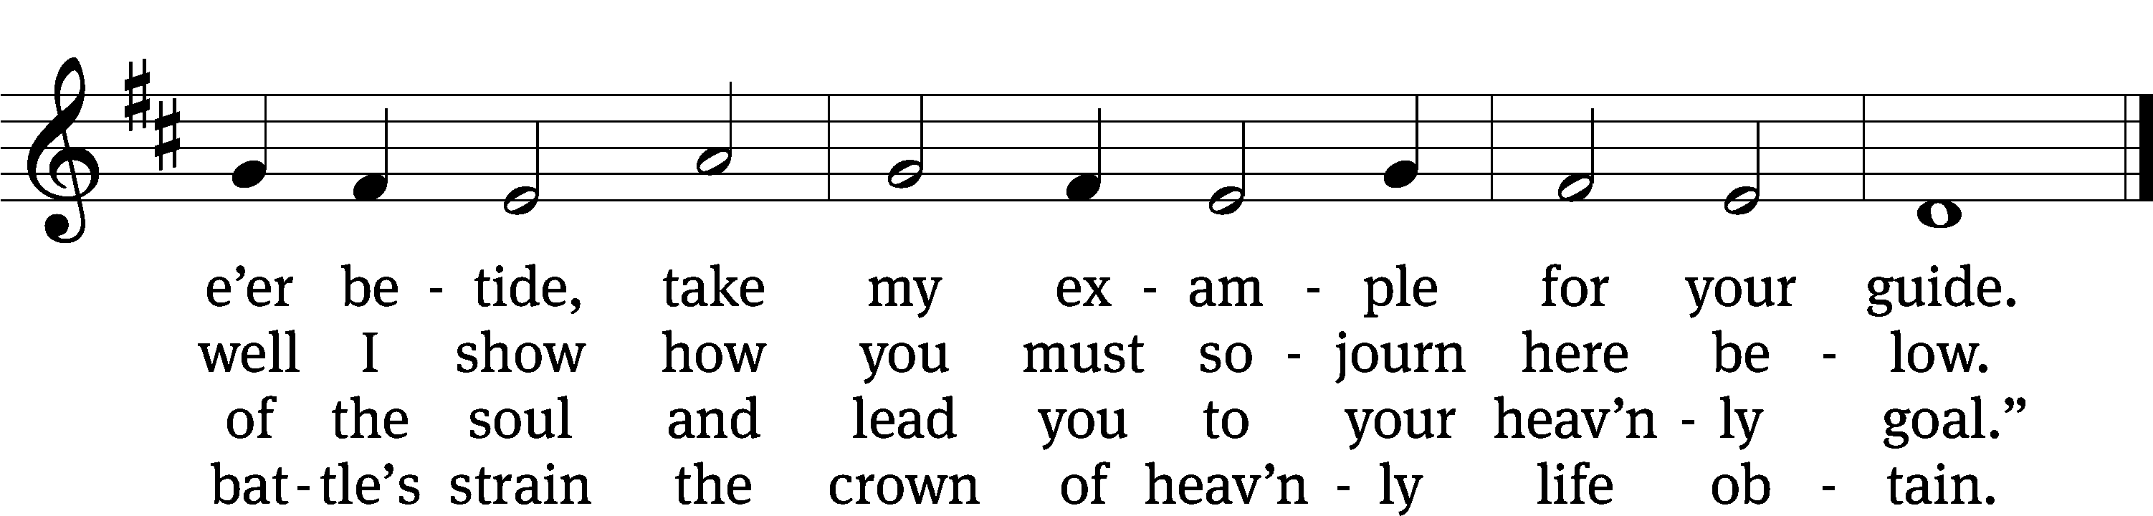
Text: tr. Charles W. Schaeffer, 1813–1896, alt.; (sts. 1–2, 4): Johann Scheffler, 1624–1677, abr.; (st. 3): Geistliche Lieder und Lobgesänge, 1695
Tune: Bartholomäus Gesius, c. 1555–1613, adapt.
Text and tune: Public domain

SERMON John 14:1-6
“Going Home”

Please stand, if you are able
Nicene Creed
We believe in one God, the Father, the Almighty,
maker of heaven and earth,
of all that is,
seen and unseen.
We believe in one Lord, Jesus Christ, the only Son of God,
eternally begotten of the Father,
God from God, Light from Light, true God from true God,
begotten, not made,
of one being with the Father.
Through him all things were made.
For us and for our salvation, he came down from heaven,
was incarnate of the Holy Spirit and the Virgin Mary,
and became truly human.
For our sake he was crucified under Pontius Pilate.
He suffered death and was buried.
On the third day he rose again in accordance with the Scriptures.
He ascended into heaven
and is seated at the right hand of the Father.
He will come again in glory to judge the living and the dead,
and his kingdom will have no end.
We believe in the Holy Spirit,
the Lord, the giver of life,
who proceeds from the Father and the Son,
who in unity with the Father and the Son
is worshiped and glorified,
who has spoken through the prophets.
We believe in one holy Christian and apostolic Church.
We acknowledge one baptism for the forgiveness of sins.
We look for the resurrection of the dead
and the life of the world to come. Amen.
Prayer of the Church

The Sacrament
Preface CW 165
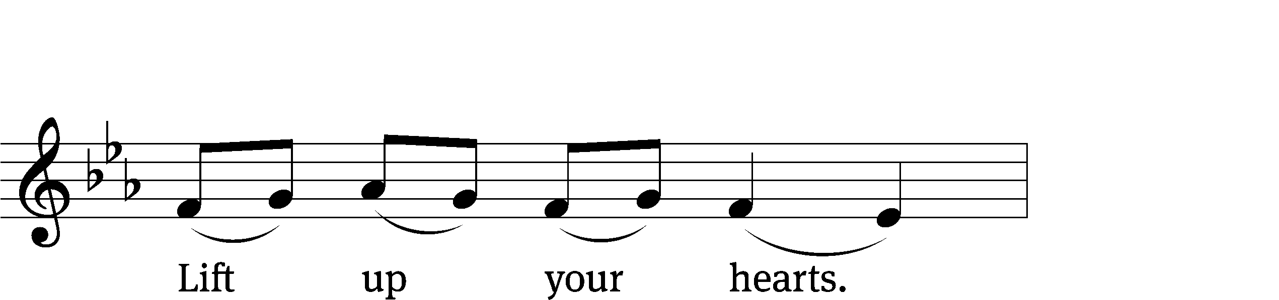
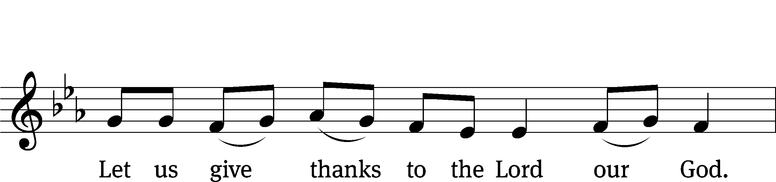
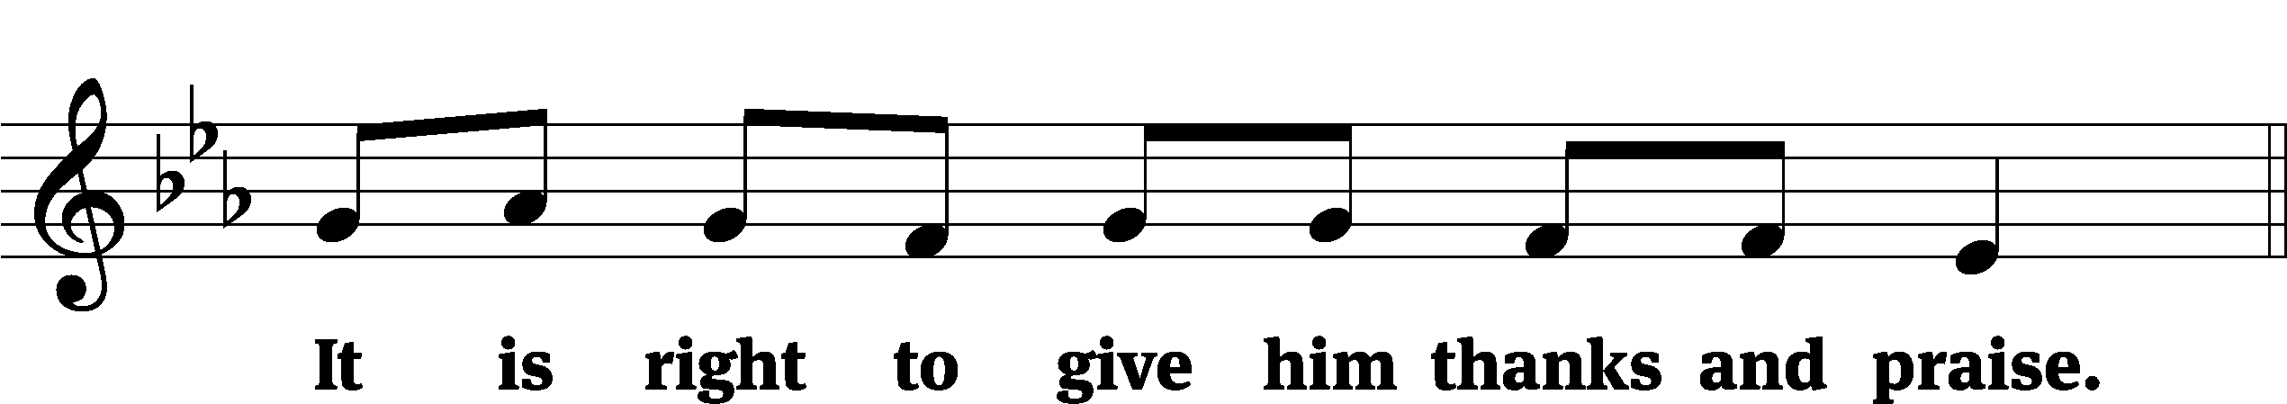

It is truly good and right that we should at all times and in all places give you thanks, O Lord, holy Father, almighty and everlasting God, through Jesus Christ our Lord, who by his willing sacrifice on the cross took away the sins of the world and by his glorious resurrection restored everlasting life. Therefore, with all the saints on earth and hosts of heaven, we praise your holy name and join their glorious song:
Holy, Holy, Holy CW 167
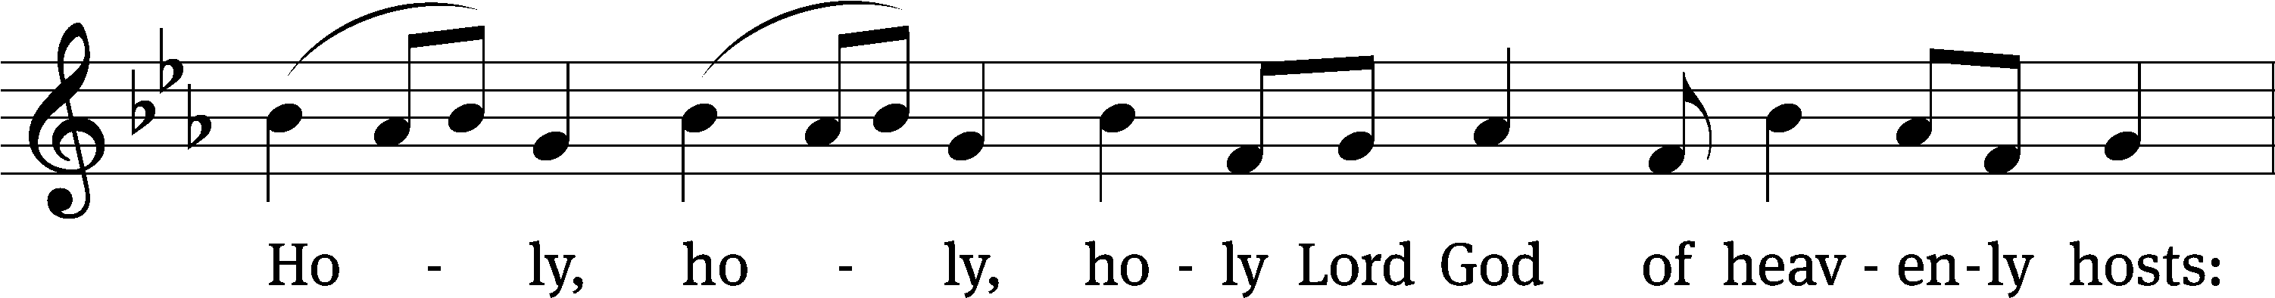
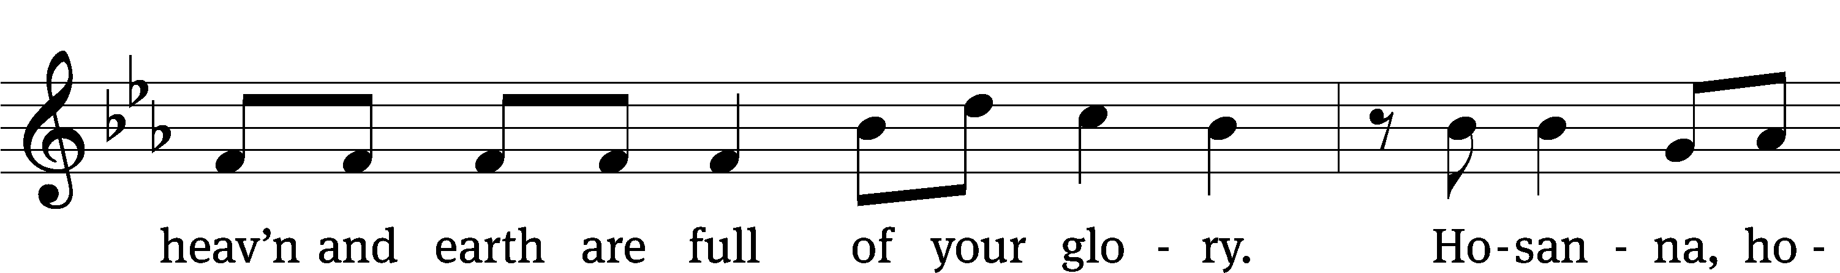
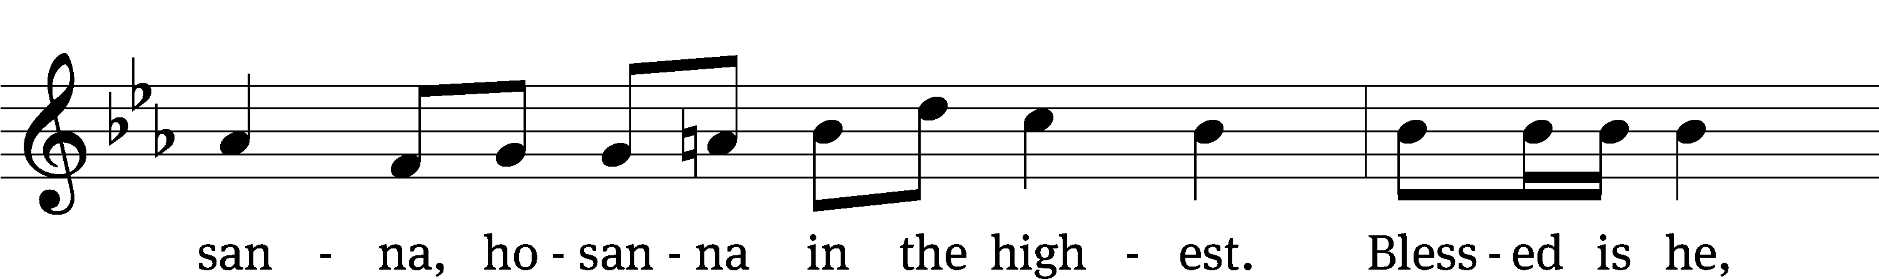
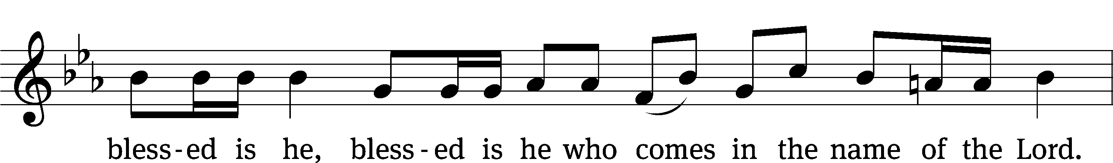
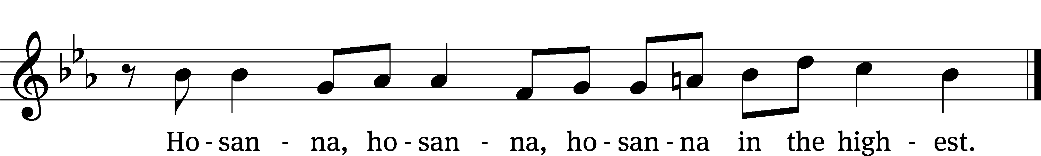

Prayer of Thanksgiving
We give thanks to you, O God, through your dear Son, Jesus Christ, whom you sent to be our Savior, our Redeemer, and the messenger of your grace. Through him you made all things; in him you are well pleased. He is the incarnate Word, conceived by the Holy Spirit and born of the Virgin Mary. To fulfill your promises, he stretched out his hands on the cross and released from eternal death all who believe in you.

As we remember Jesus’ death and resurrection, we thank you that you have gathered us together to receive your Son’s body and blood. Send us your Spirit, unite us as one, and strengthen our faith so that we may praise you in your Son, Jesus Christ. Through him, we glorify and honor you, O God our Father, with the Holy Spirit, one God, now and forever.
Amen.

Lord’s Prayer
Our Father, who art in heaven, hallowed be thy name, thy kingdom come, thy will be done on earth as it is in heaven. Give us this day our daily bread; and forgive us our trespasses, as we forgive those who trespass against us; and lead us not into temptation, but deliver us from evil. For thine is the kingdom and the power and the glory forever and ever. Amen.

Words of Institution
Our Lord Jesus Christ, on the night he was betrayed, took bread; and when he had given thanks, he broke it and gave it to his disciples, saying, “Take and eat; this is my body, which is given for you. Do this in remembrance of me.”
Then he took the cup, gave thanks, and gave it to them, saying, “Drink from it, all of you; this is my blood of the new covenant, which is poured out for you for the forgiveness of sins. Do this, whenever you drink it, in remembrance of me.”

The peace of the Lord be with you always.
Amen.
O Christ, Lamb of God CW 169
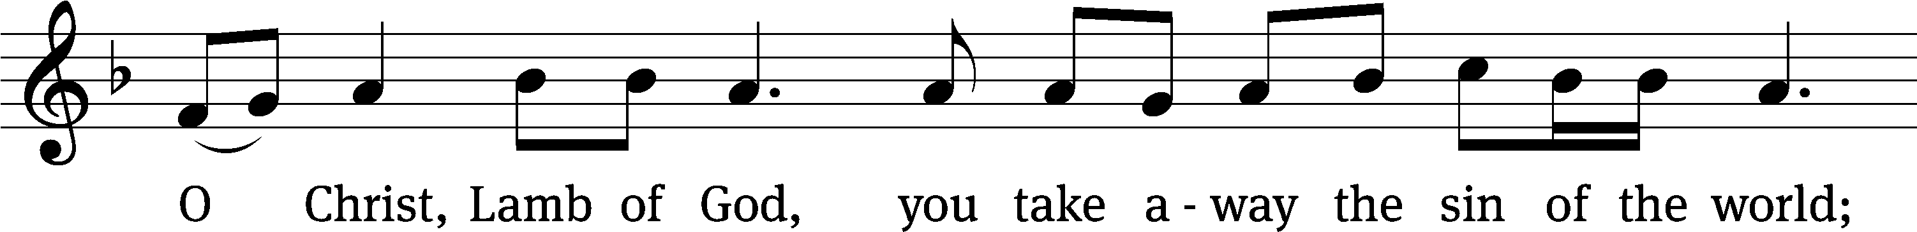
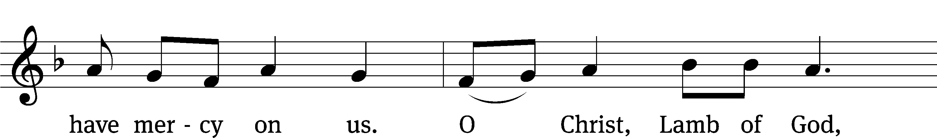
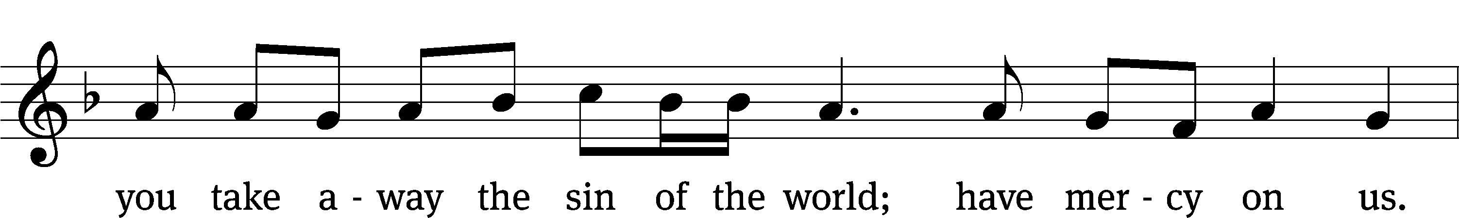
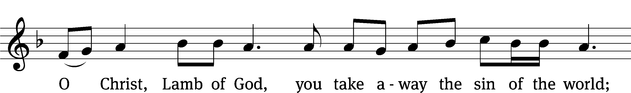
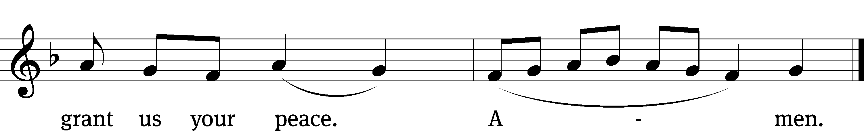
Please be seated
675 At the Lamb’s High Feast We Sing CW 675
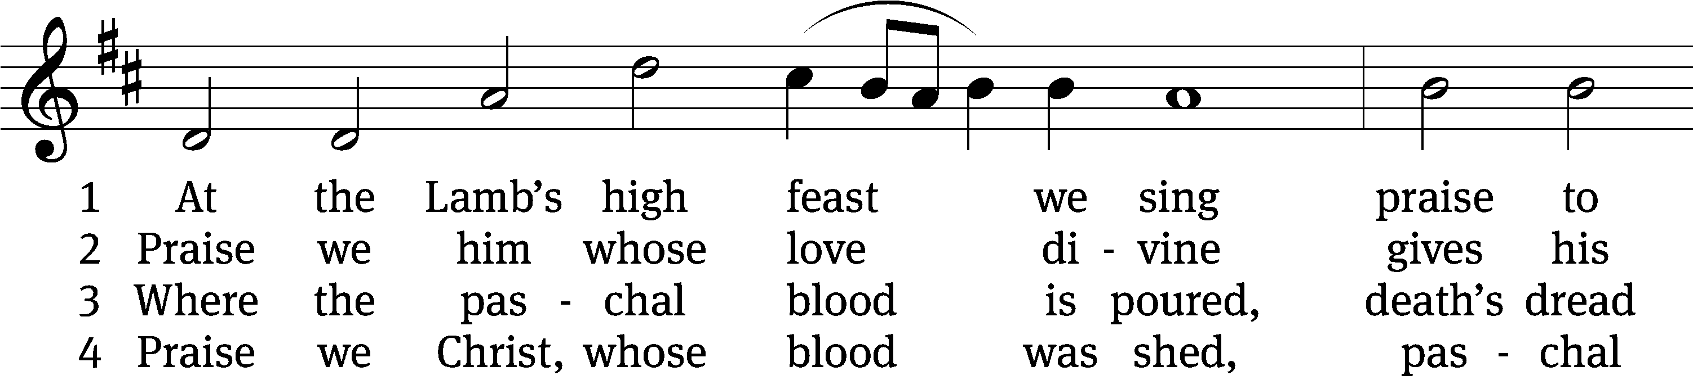
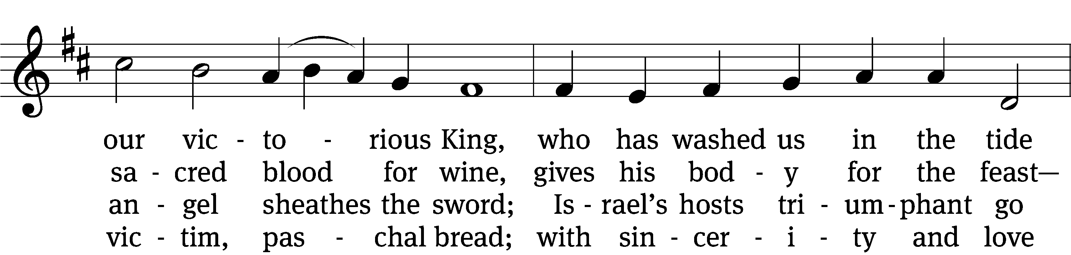
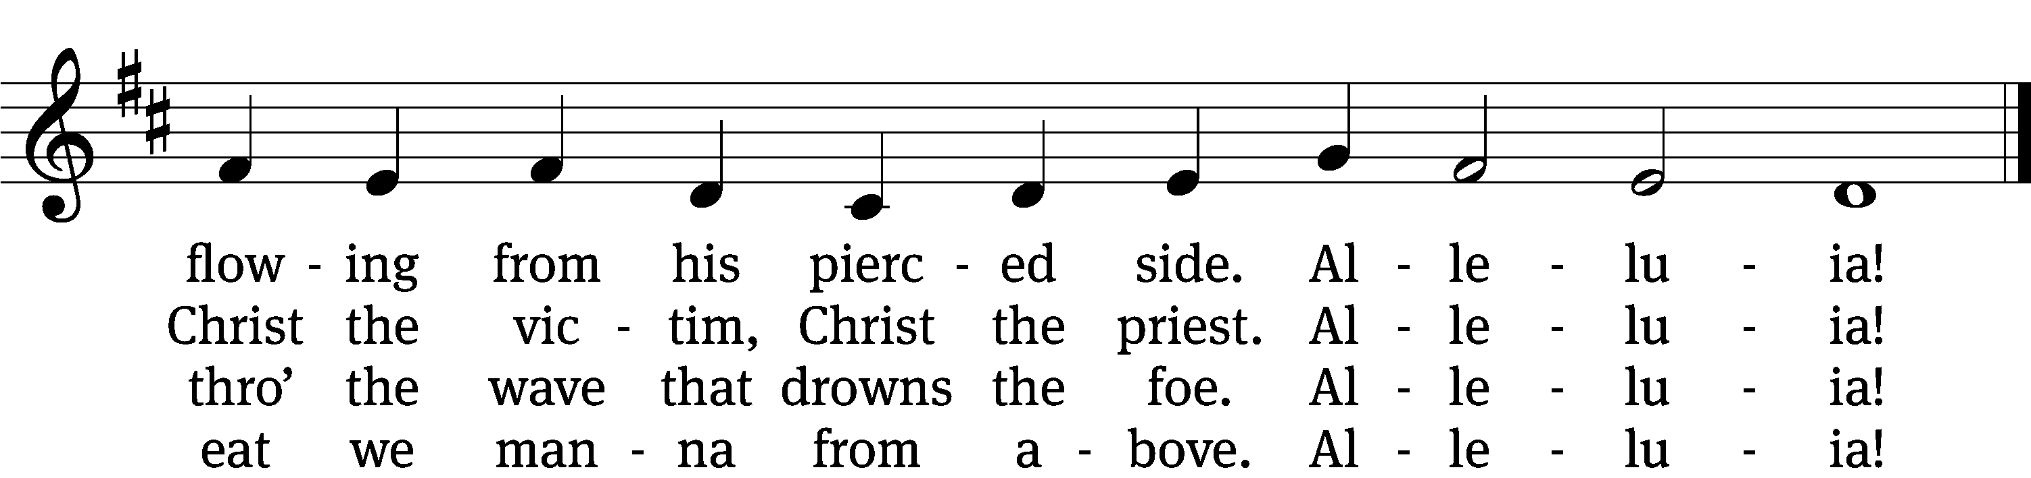

5 Mighty Victim from the sky,
hell’s fierce pow’rs beneath you lie.
You have conquered in the fight,
you have brought us life and light.
Alleluia!

6 Now no more can death appall,
now no more the grave enthrall;
you have opened paradise,
and your saints in you shall rise.
Alleluia!

7 Easter triumph, Easter joy!
This alone can sin destroy;
from sin’s pow’r, Lord, set us free,
newborn souls in you to be.
Alleluia!
8 Father, who the crown shall give,
Savior, by whose death we live,
Spirit, guide through all our days,
Three in One, your name we praise.
Alleluia!
Text: tr. Robert Campbell, 1814–1868, alt.; Latin, c. 4th–10th cent., alt. 17th cent.
Tune: Kirchengeseng, Ivancice, 1566
Text and tune: Public domain
514 You Are the Way; through You Alone CW 514
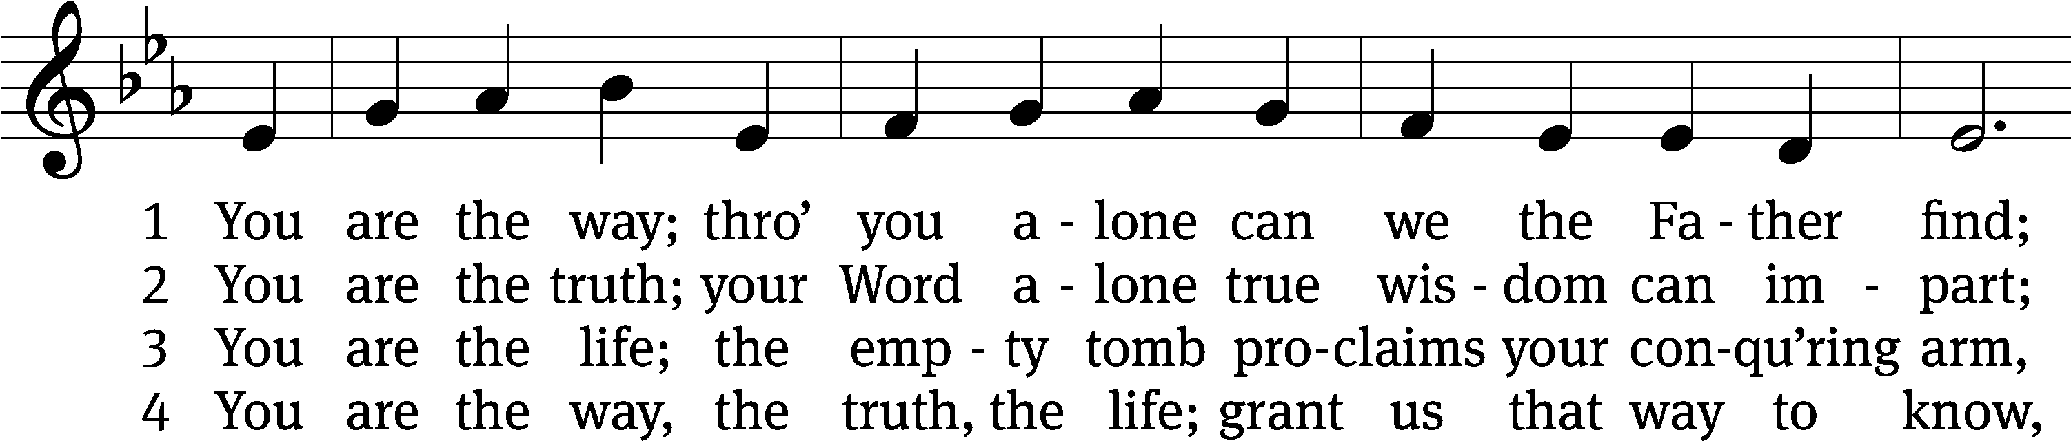
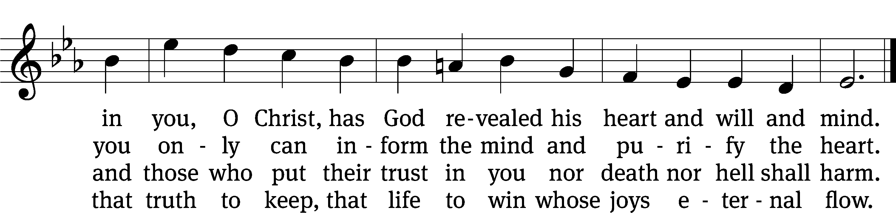
Text: George W. Doane, 1799–1859, alt.
Tune: The CL Psalmes of David, Edinburgh, 1615
Text and tune: Public domain

Please stand, if you are able

Give thanks to the Lord, for he is good;
his mercy endures forever.

Whenever we eat this bread and drink this cup,
we proclaim the Lord’s death until he comes.

We give thanks, almighty God, that you have refreshed us with this saving gift. We pray that through it you will strengthen our faith in you and increase our love for one another. We ask this in the name of Jesus Christ our Lord, who lives and reigns with you and the Holy Spirit, one God, now and forever.
Amen.
Blessing
The Lord bless you and keep you.
The Lord make his face shine on you and be gracious to you.
The Lord look on you with favor and give you peace.
Amen.

Please be seated
853 I’m But a Stranger Here CW 853
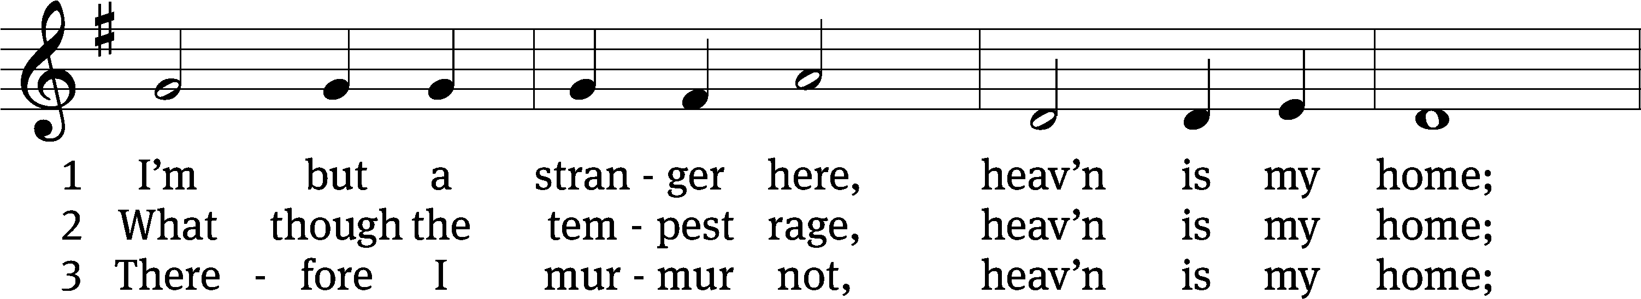
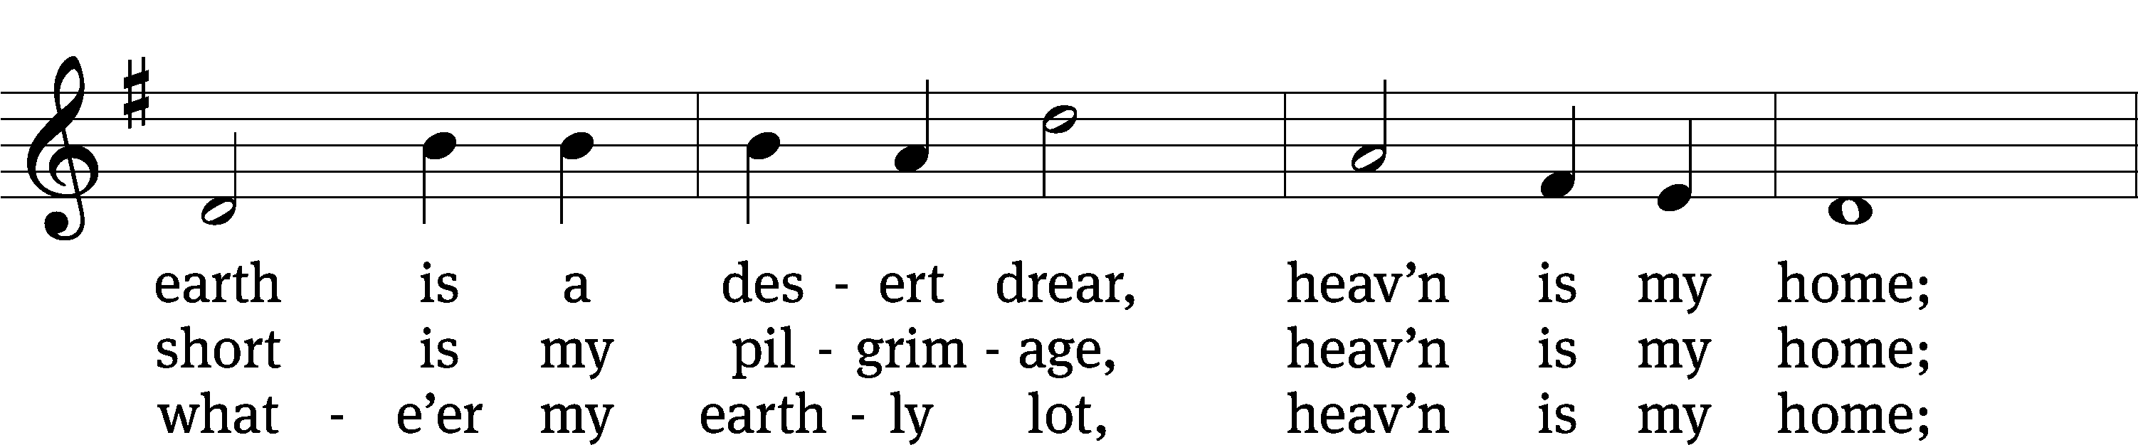
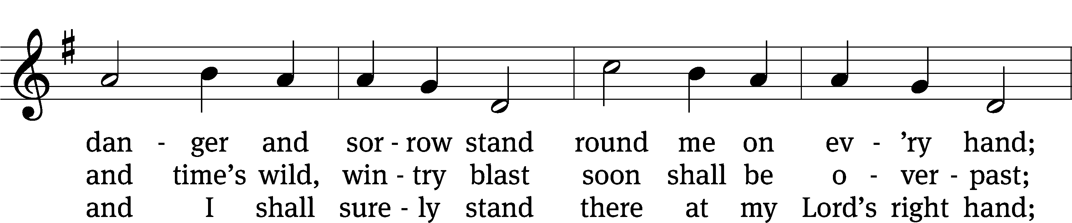
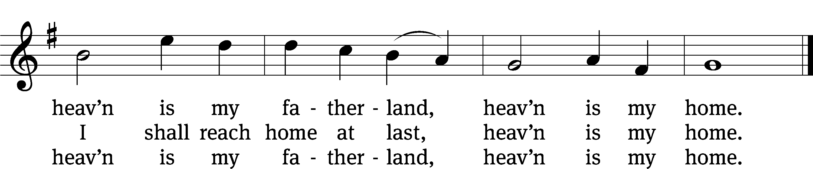
Text: Thomas R. Taylor, 1807–1835, abr.
Tune: Arthur S. Sullivan, 1842–1900
Text and tune: Public domain

Acknowledgments
Setting One from Christian Worship
Software distributed in partnership with Northwestern Publishing House.
Created by Christian Worship: Service Builder © 2022 Concordia Publishing House.
Serving in Worship
Officiant Pastor William Natsis
Organist Sarah Hanke
Deacons (8:30) Duane Mason and Dave Stevenson
Deacons (11:00) Jeff Neuburger and Robert Niethammer
Ushers (8:30) Tim Phelps
Ushers (11:00) Ron Zahn
Altar Guild Sandy Kirkpatrick and Barb Neuburger
Videographer Cindy Dresch

