THIRD SUNDAY AFTER PENTECOST

TRINITY EVANGELICAL LUTHERAN CHURCH | Saline, Michigan
WELCOME TO WORSHIP June 23/26, 2022
Thank you for joining us in God’s house today! We cordially ask that our Guests sign one of the guestbooks located at either the front or back entryways, or fill out a “Let’s Get Acquainted” card located in the hymnal pew rack and place it in the collection plate.

THANK OFFERING: Members of Trinity give their offering as an expression of love and thankfulness to the Lord and to help support the Lord’s work in our community and around the world. Visitors need not feel obligated to participate in this offering which supports our ministry.

Restrooms are located at the back of the upper level (the annex), and in the basement (down the back stairs of the sanctuary or annex). Handicap access is available, please ask an usher for assistance.

Young Families / Toddler Bags – We are GLAD YOU BROUGHT YOUR CHILDREN to our worship service. Jesus said: “Let the little children come to me and do not hinder them, for the kingdom of God belongs to such as these.” We know that having little children in church can be a challenge, but DO NOT WORRY about it. Many of your fellow worshippers have been in your shoes and are just happy you brought your children with you. For your convenience, we have reserved the back rows of seating for parents with small children. These areas provide more flexibility for your family, as well as, easy access to move downstairs if necessary. A closed-circuit TV system allows families to continue participating in the service while downstairs. Pre-school toddler bags and children’s bulletins are available for their enjoyment. Ask an usher for one to use during the service and please return the toddler bag afterwards.

the SERVICE – setting one - WITHOUT HOLY COMMUNION CW, page 154

896 Dear Lord, to Your True Servants Give CW 896
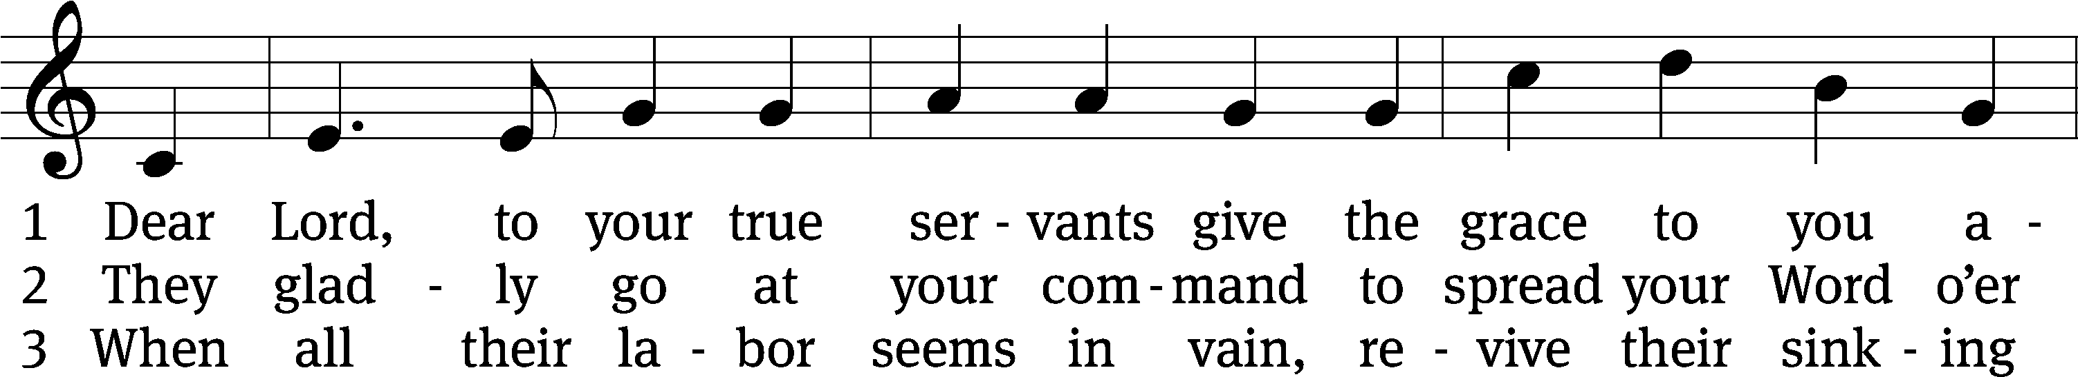
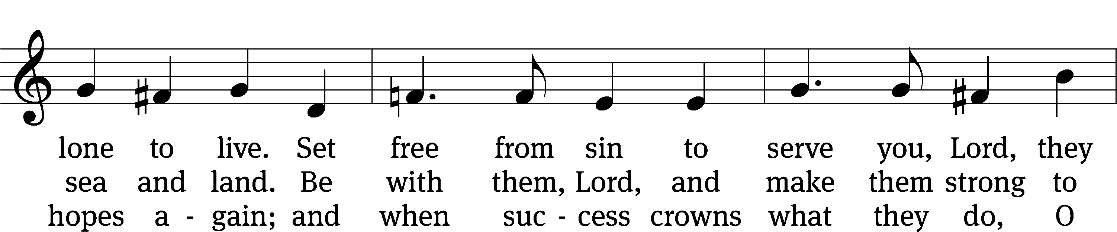
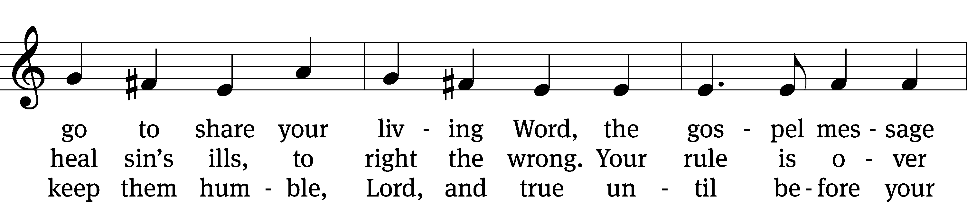
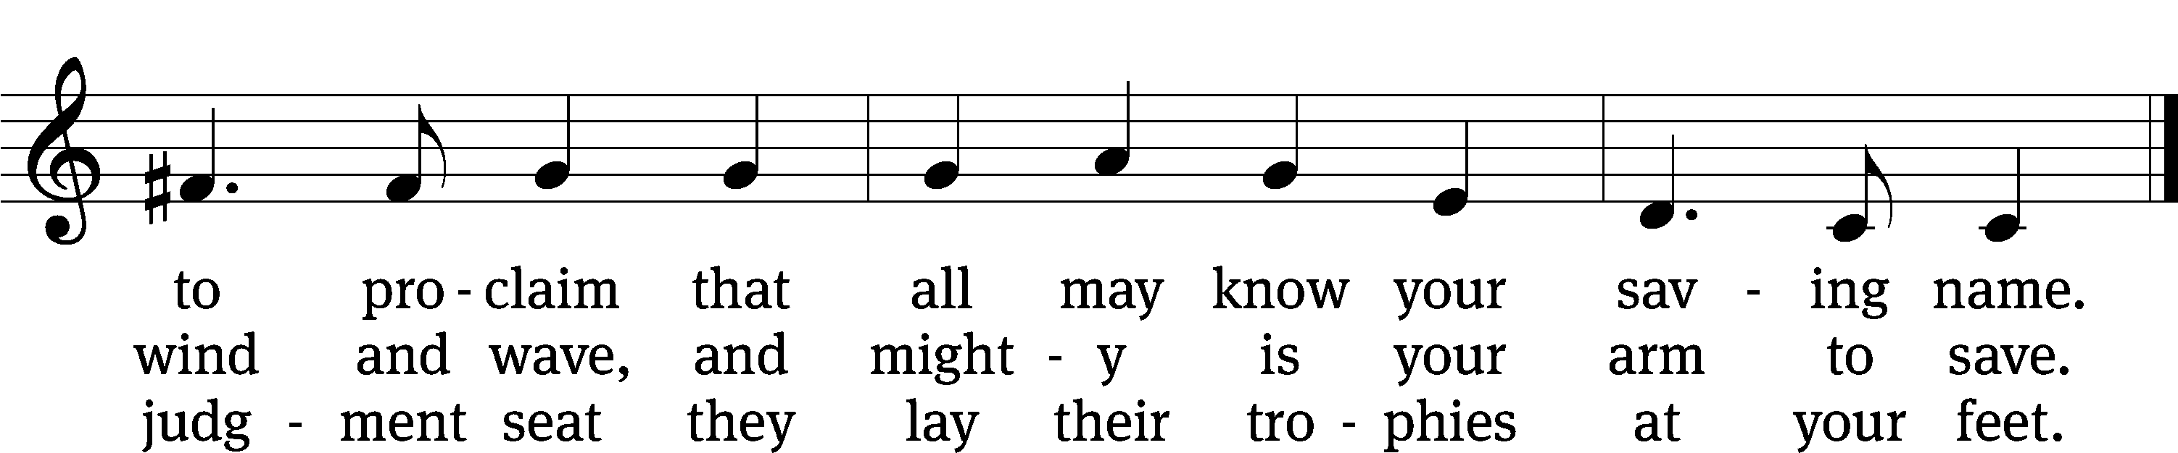
Text: W. Gustave Polack, 1890–1950, alt.
Tune: John B. Dykes, 1823–1876
Text: © 1941 Concordia Publishing House. Used by permission: OneLicense no. 727703
Tune: Public domain

Please stand, if you are able
Invocation
In the name of the Father and of the Son and of the Holy Spirit.
Amen.
Confession
If we claim to be without sin, we deceive ourselves and the truth is not in us.
If we confess our sins, God is faithful and just
and will forgive us our sins
and purify us from all unrighteousness.

Let us confess our sins to the Lord.
Holy God, gracious Father,
I am sinful by nature
and have sinned against you in my thoughts, words, and actions.
I have not loved you with my whole heart;
I have not loved others as I should.
I deserve your punishment both now and forever.
But Jesus, my Savior, paid for my sins
with his innocent suffering and death.
Trusting in him, I pray: God, have mercy on me, a sinner.

Our gracious Father in heaven has been merciful to us. He sent his only Son, Jesus Christ, who gave his life as the atoning sacrifice for the sins of the whole world. Therefore, as a called servant of Christ and by his authority, I forgive you all your sins in the name of the Father and of the the Son and of the Holy Spirit.
Amen.

Lord, Have Mercy

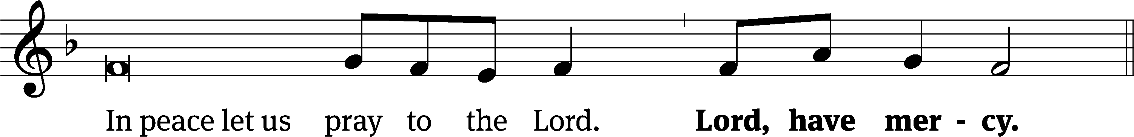
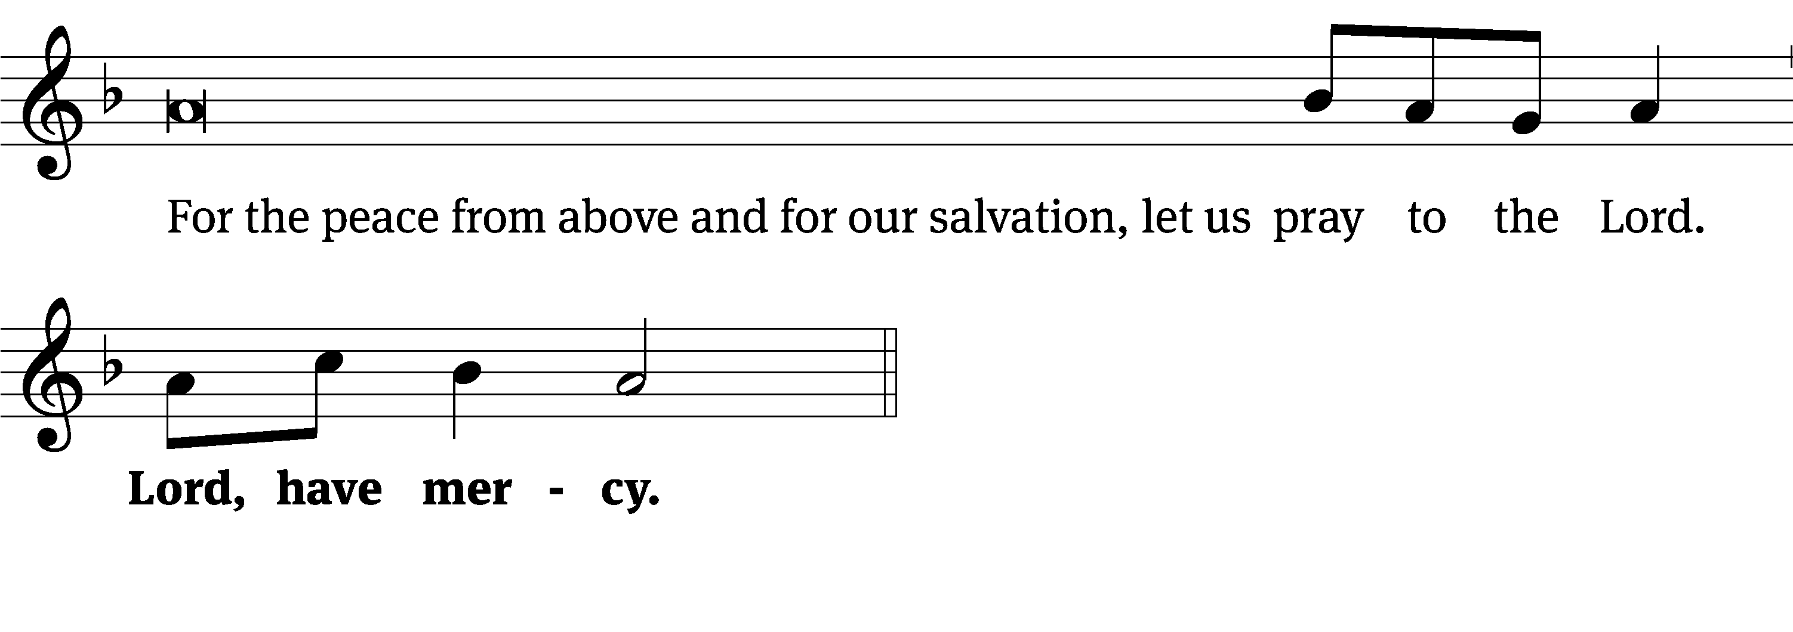
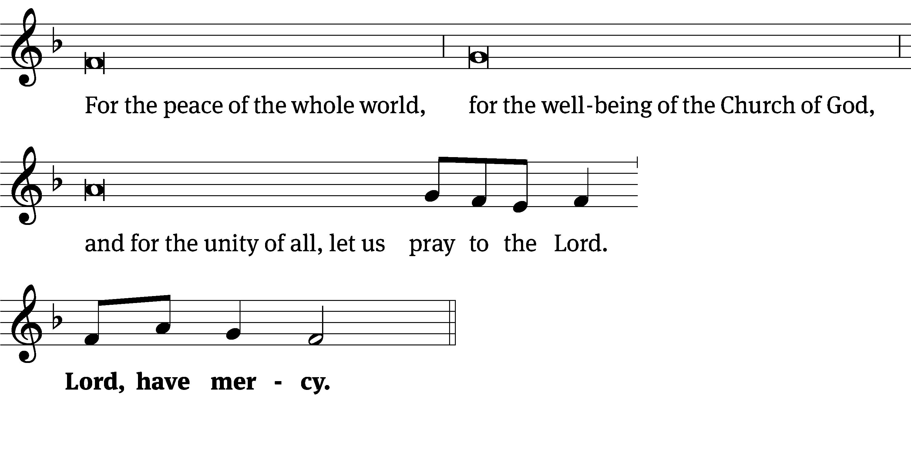
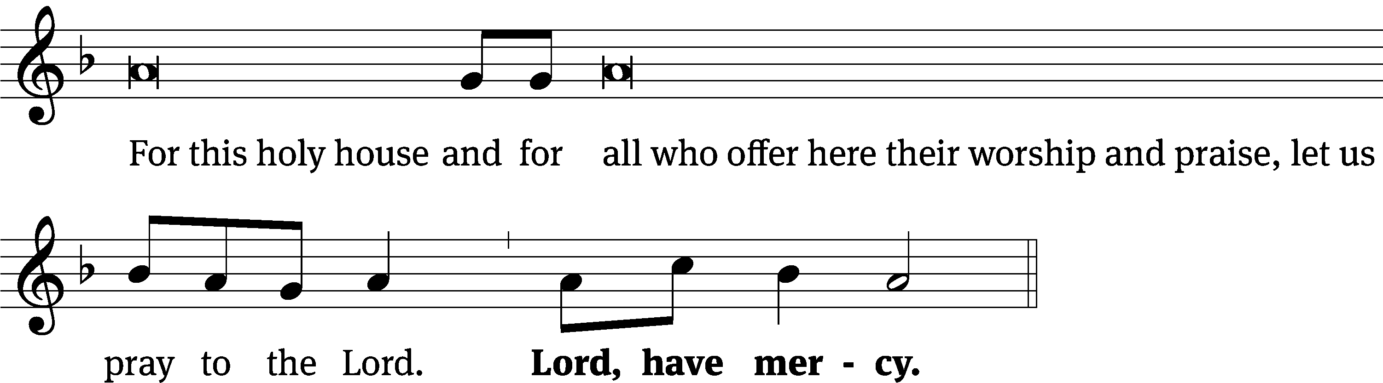
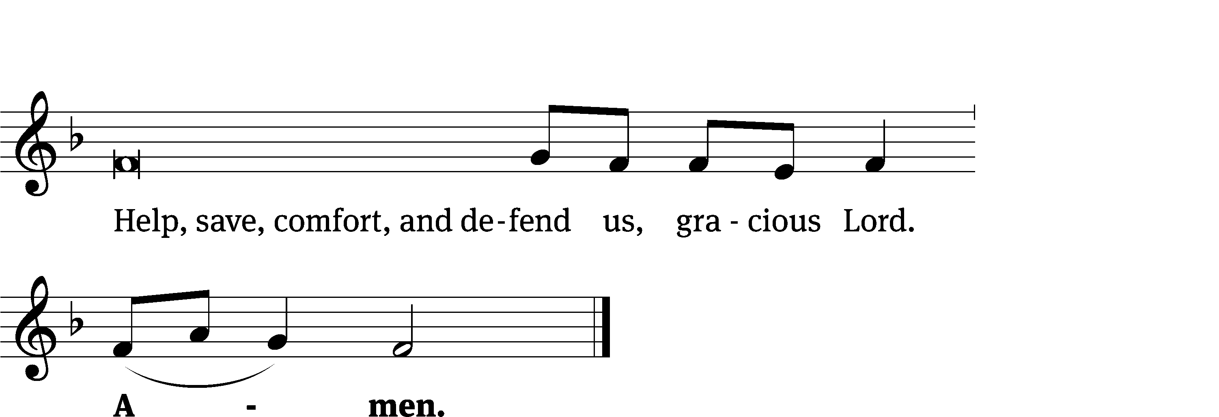

Glory Be to God CW 157
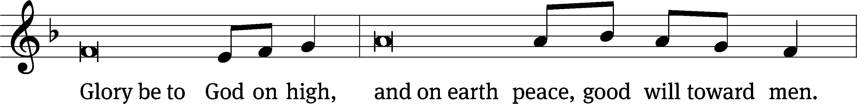
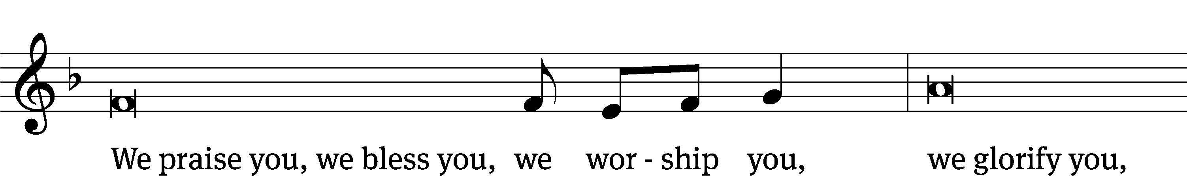
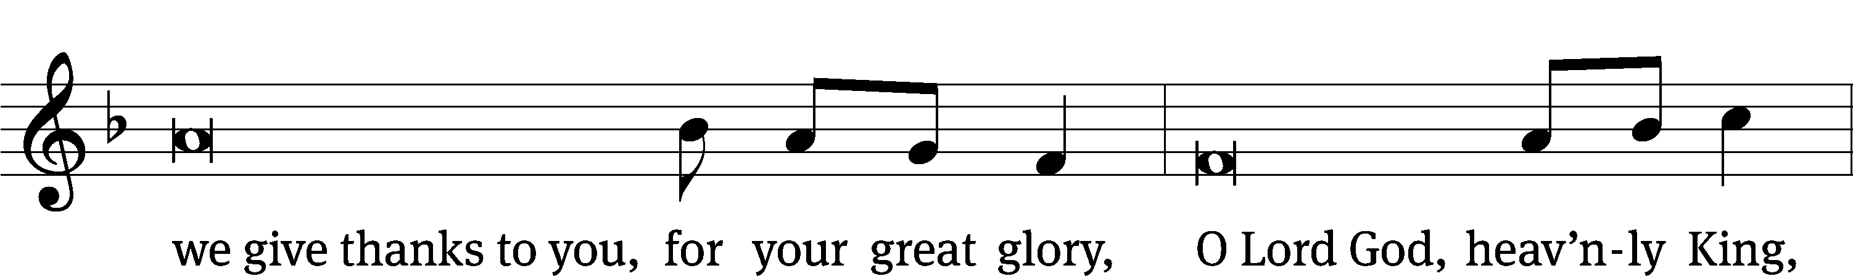
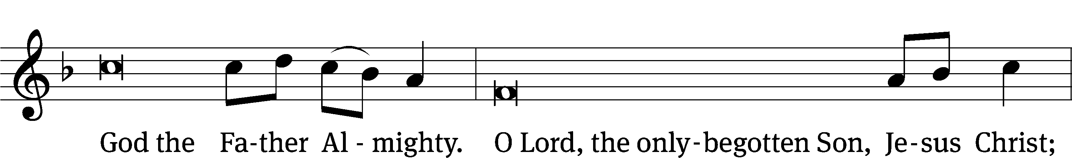
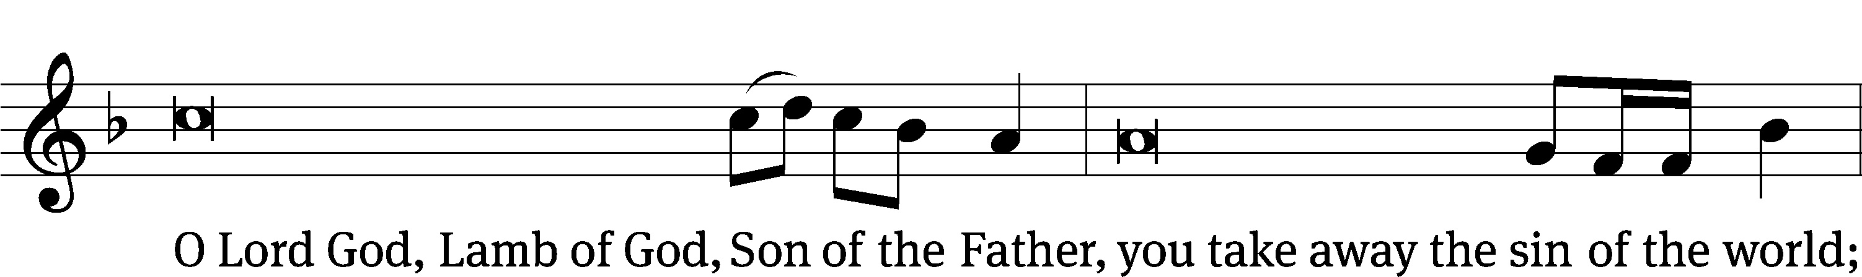
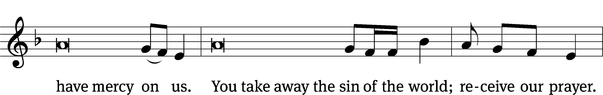
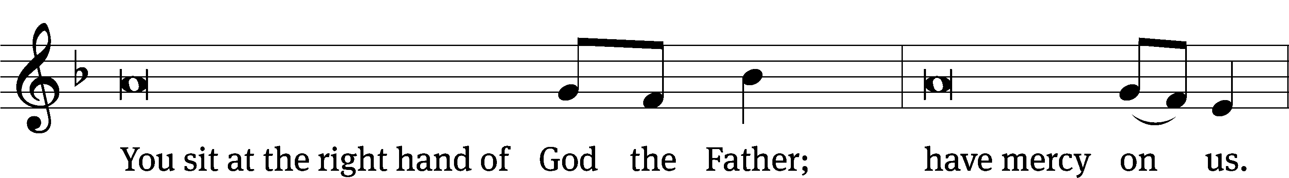
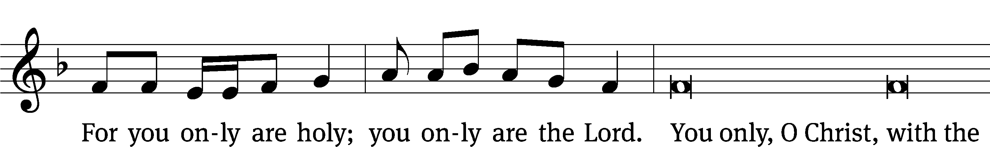
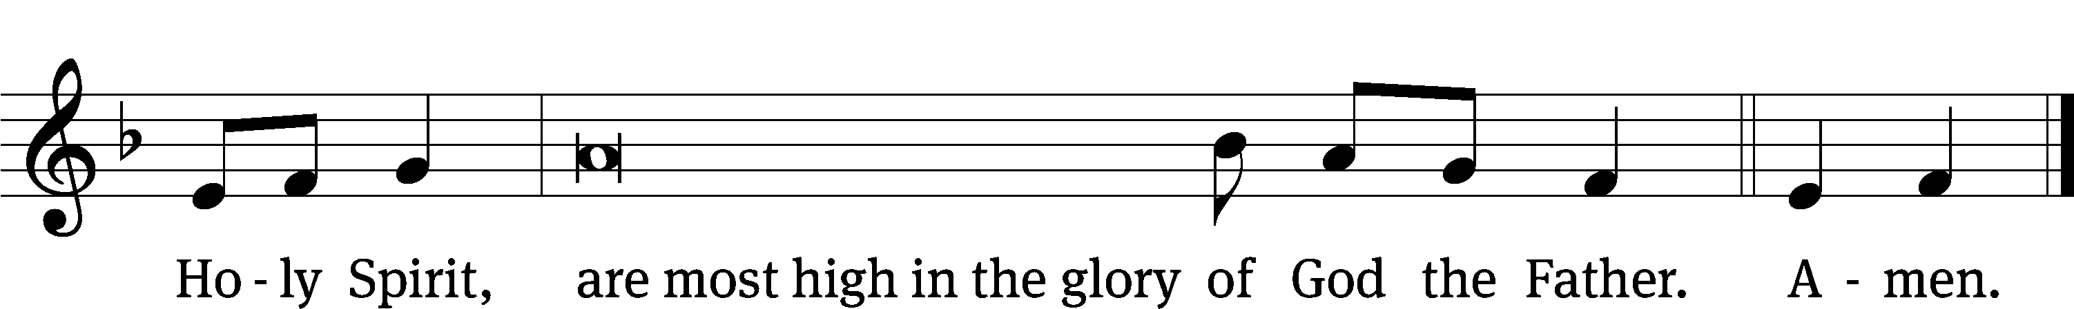

Tune: © 2021 Northwestern Publishing House. Used by permission: OneLicense no. 727703

The Lord be with you.
And also with you.
Prayer of the Day
Let us pray.

O God, you have prepared joys beyond understanding for those who love you. Pour into our hearts such love for you that, loving you above all things, we may obtain your promises, which exceed all that we can desire; through your Son, Jesus Christ our Lord, who lives and reigns with you and the Holy Spirit, one God, now and forever.
Amen.

Please be seated

First Reading 1 Kings 19:19-21
¹⁹ So Elijah went from there and found Elisha son of Shaphat. Elisha was doing the plowing with twelve teams of oxen in front of him, and he himself was driving the twelfth team. Elijah crossed over to him and threw his cloak over him. ²⁰ Then Elisha left the oxen and ran after Elijah. He said, “Let me kiss my father and my mother good-bye! Then I will follow you.”
Then Elijah said, “Go back! For what have I done to you?”
²¹ So Elisha turned back from following him. Then he took the team of oxen and slaughtered them. Using the equipment from the oxen as fuel, he cooked the meat and gave it to the people, and they ate. Then he got up, followed Elijah, and served him.

The Word of the Lord.
Thanks be to God.

Psalm of the Day
62D I’ll Not Be Shaken Psalm 62D
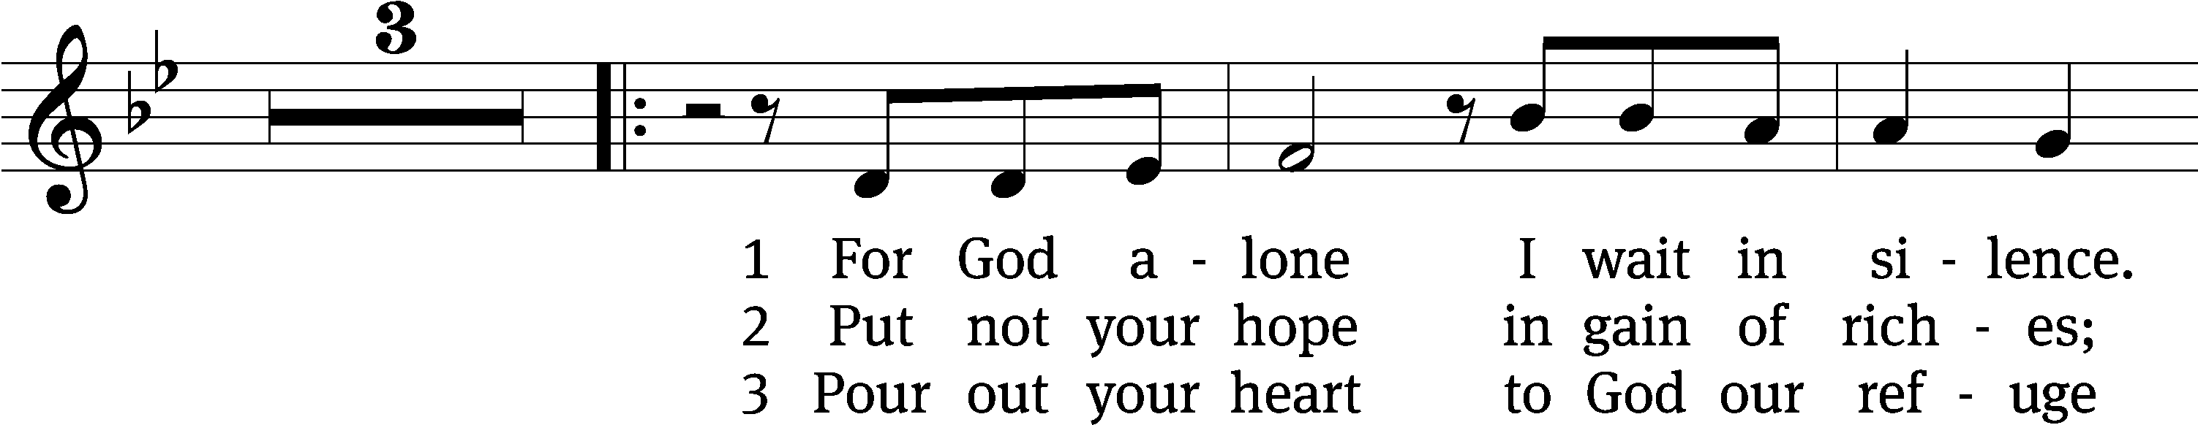
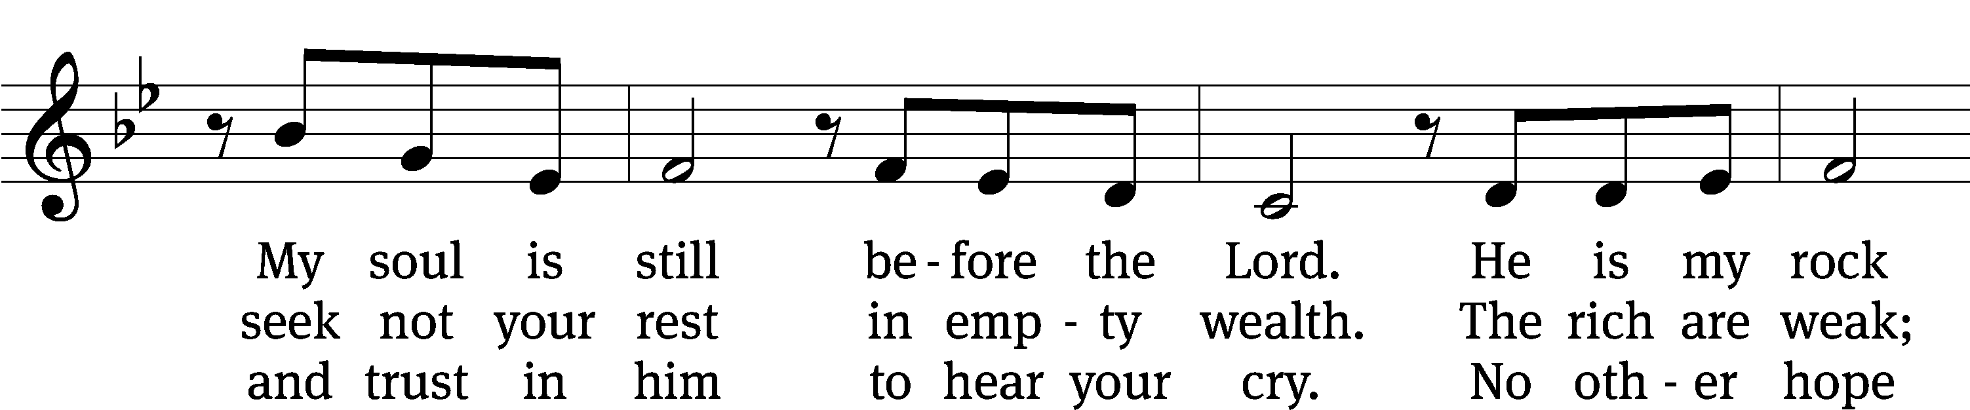
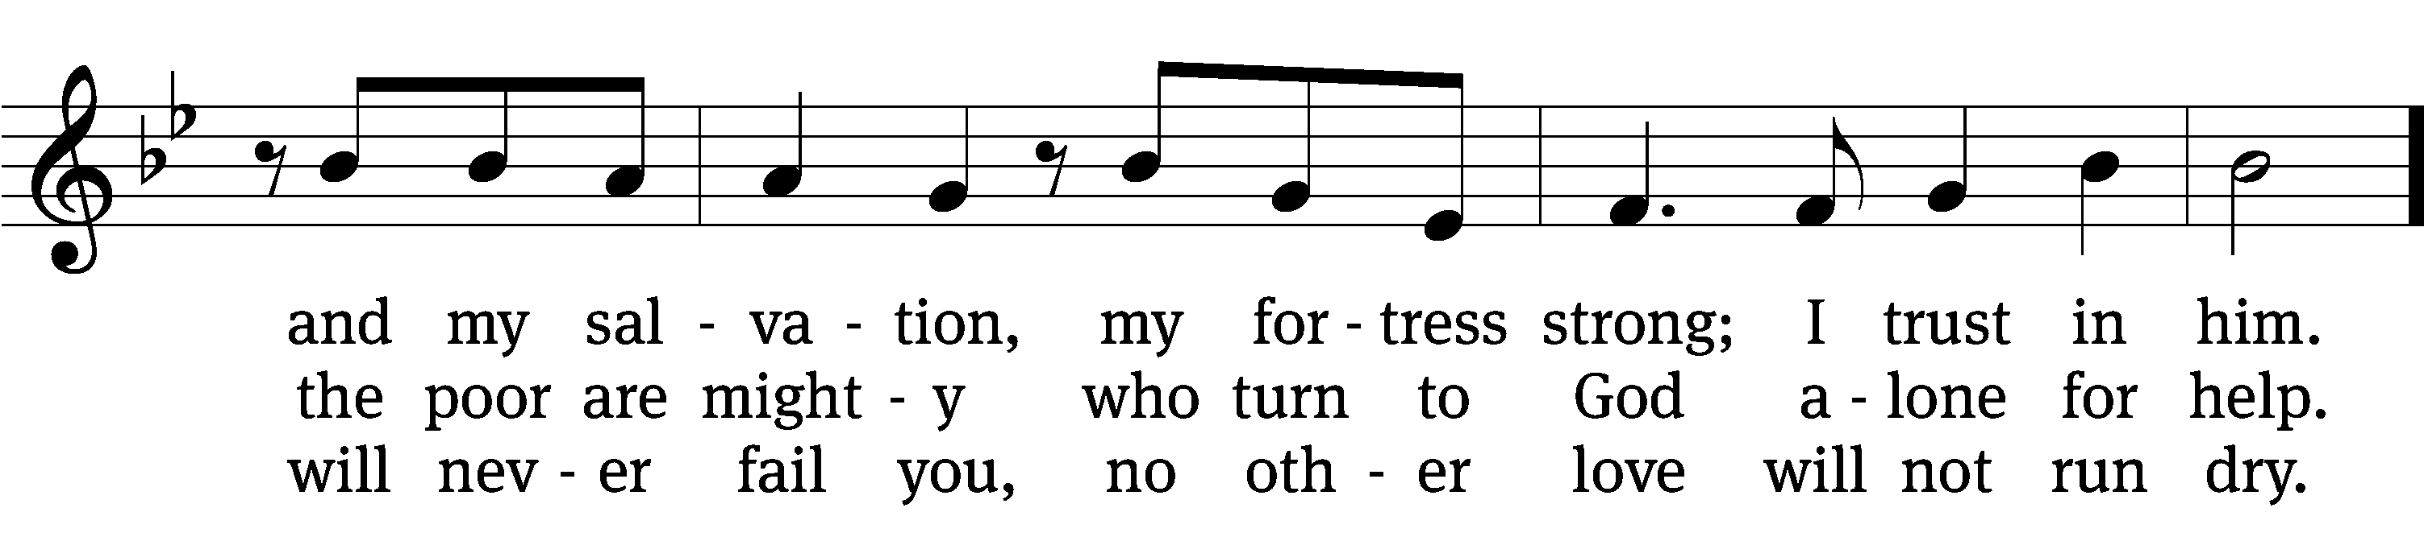
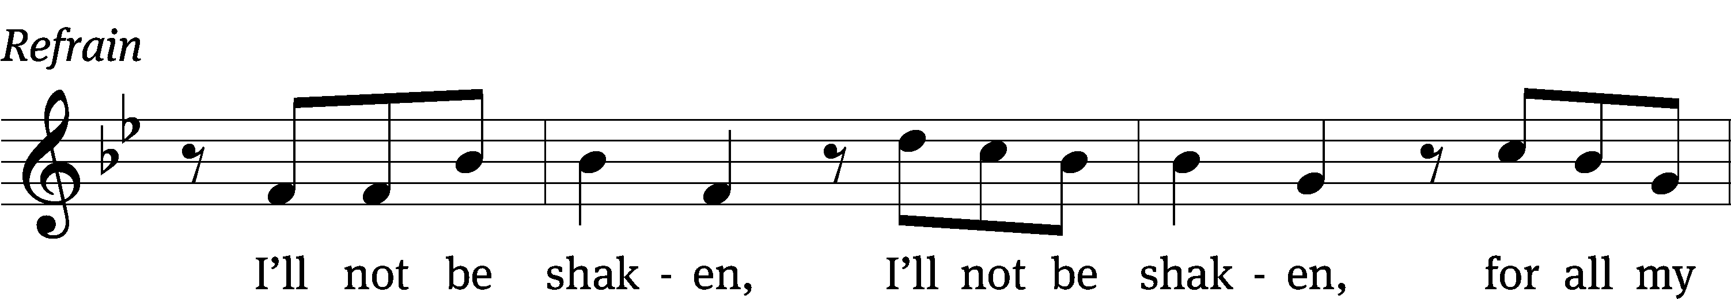
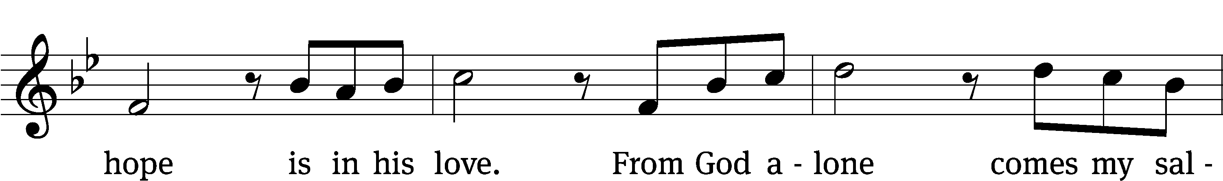
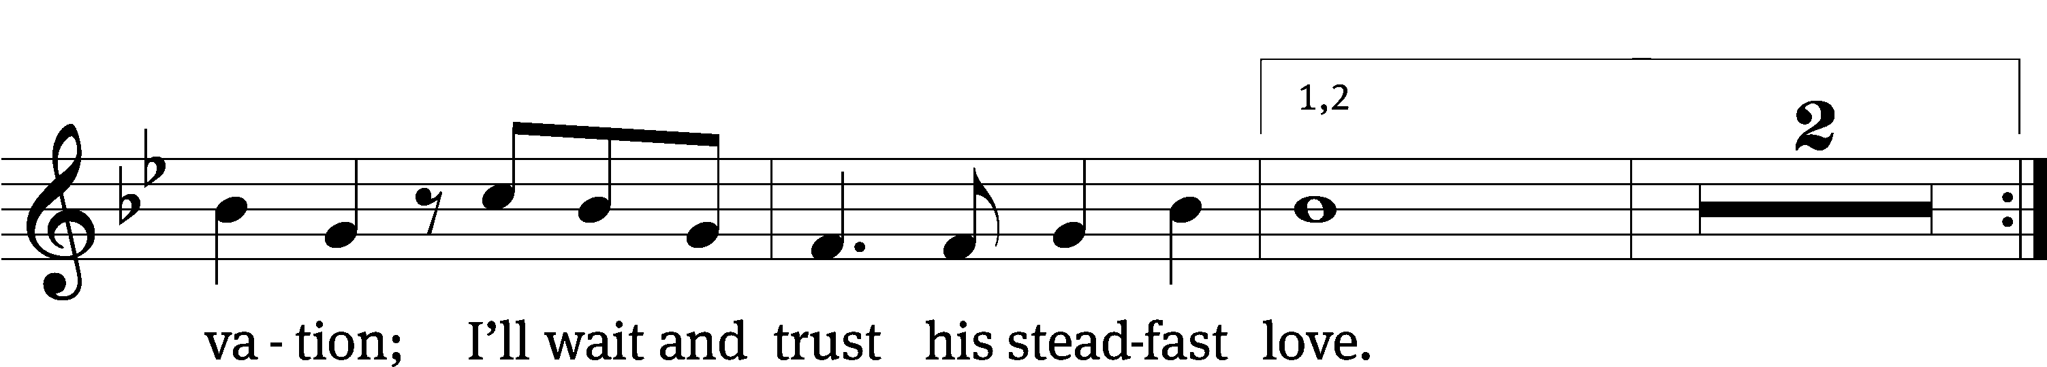
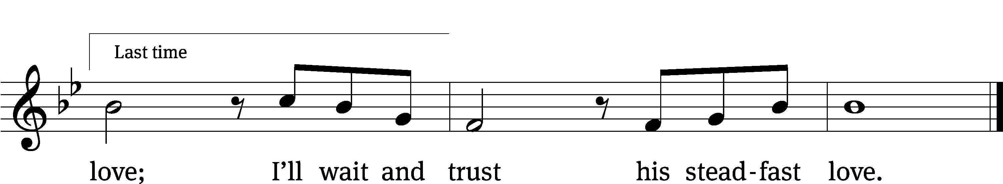
Text: Wendell Kimbrough
Tune: Wendell Kimbrough
Text and tune: © 2015 Wendell Kimbrough. Used by permission: OneLicense no. 727703

Second Reading 2 Corinthians 11:21b-30
²¹ However bold anyone might be (I am speaking in a foolish way), I am going to be bold too. ²² Are they Hebrews? So am I. Are they Israelites? So am I. Are they Abraham’s seed? So am I. ²³ Are they ministers of Christ? (I am speaking in a crazy way.) I am even more. I’ve done more hard work, been in prisons more often, been whipped far more, and I’ve been close to death many times. ²⁴ Five times I received from the Jews the forty lashes minus one. ²⁵ Three times I was beaten with rods. One time I was stoned. Three times I was shipwrecked. I have spent a night and a day on the open sea. ²⁶ I have often been on journeys, in danger from rivers, in danger from robbers, in danger from my own people, in danger from Gentiles, in danger in the city, in danger in the wilderness, in danger on the sea, in danger among false brothers. ²⁷ I have worked hard and struggled. I’ve spent many sleepless nights. I’ve been hungry and thirsty. I’ve gone without food many times. I’ve been cold and lacked clothing.
²⁸ Besides those external matters, there is the daily pressure on me of my concern for all the churches. ²⁹ Who is weak without my being weak? Who falls into sin without my being distressed?
³⁰ If it is necessary that I boast, I will boast of the things that show my weakness.

The Word of the Lord.
Thanks be to God.

Please stand, if you are able

Gospel Acclamation Mark 8:34
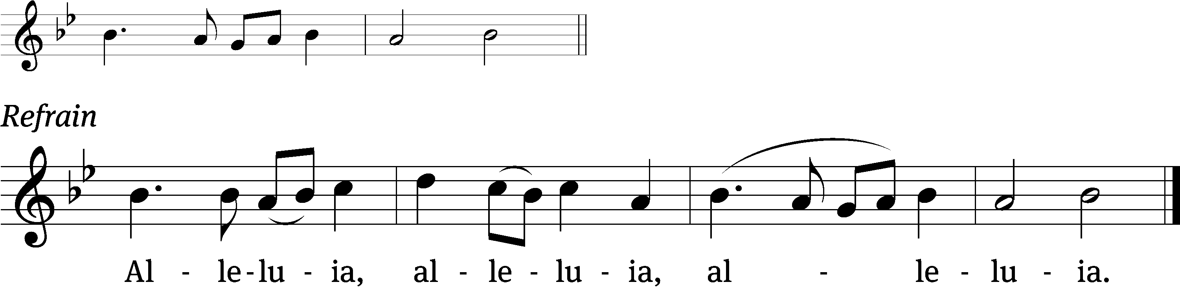
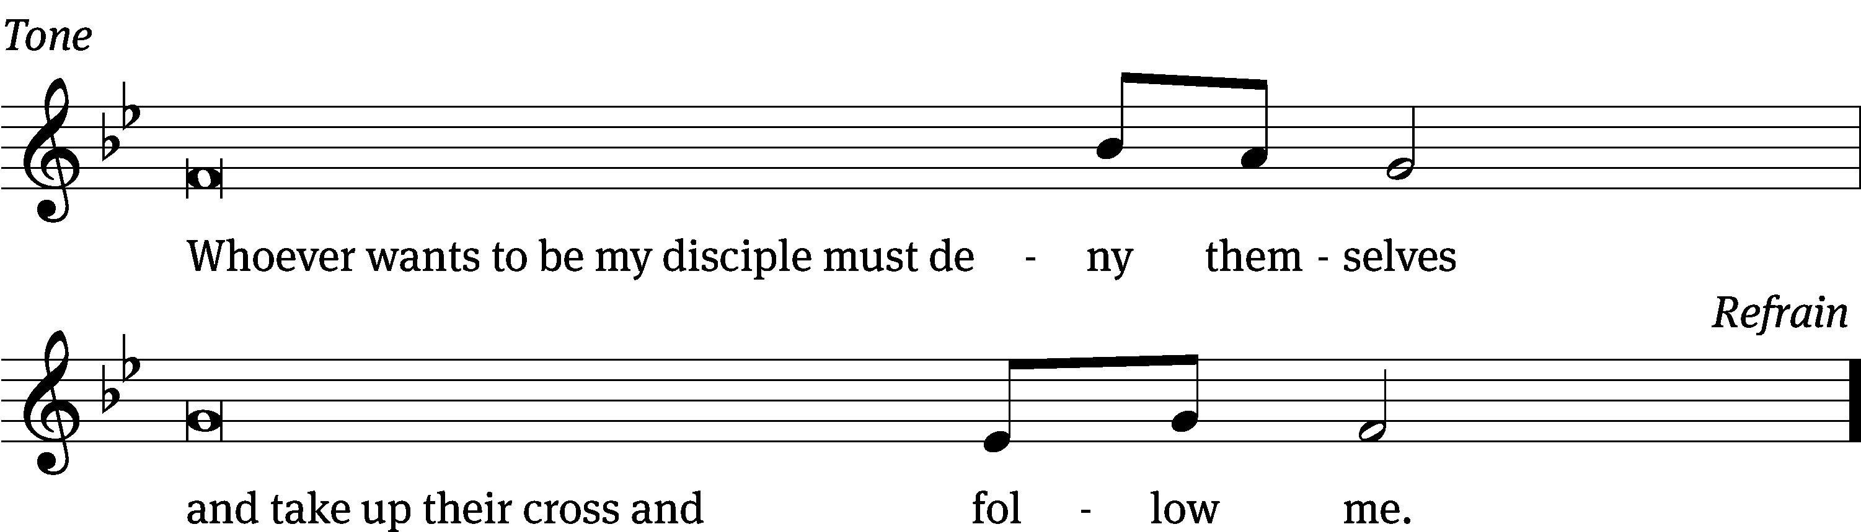
Tune: © 2021 Northwestern Publishing House. Used by permission: OneLicense no. 727703

Gospel Luke 9:51-62
⁵¹ When the days were approaching for him to be taken up, Jesus was determined to go to Jerusalem. ⁵² He sent messengers ahead of him. They went and entered a Samaritan village to make preparations for him. ⁵³ But the people did not welcome him, because he was determined to go to Jerusalem. ⁵⁴ When his disciples James and John saw this, they said, “Lord, do you want us to call down fire from heaven to consume them?”
⁵⁵ But he turned and rebuked them. “You don’t know what kind of spirit is influencing you. ⁵⁶ For the Son of Man did not come to destroy people’s souls, but to save them.” Then they went to another village.
⁵⁷ As they went on the way, a man said to him, “I will follow you wherever you go.”
⁵⁸ Jesus said to him, “Foxes have holes, and birds of the air have nests, but the Son of Man has no place to lay his head.”
⁵⁹ He said to another man, “Follow me!”
But he said, “Lord, first let me go and bury my father.”
⁶⁰ Jesus told him, “Let the dead bury their own dead, but you go and proclaim the kingdom of God.”
⁶¹ Another man also said, “I will follow you, Lord, but first let me say good-bye to those at my home.”
⁶² Jesus told him, “No one who puts his hand to the plow and looks back is fit for the kingdom of God.”
The Gospel of the Lord.
Praise be to you, O Christ!

Please be seated

576 Amazing Grace CW 576
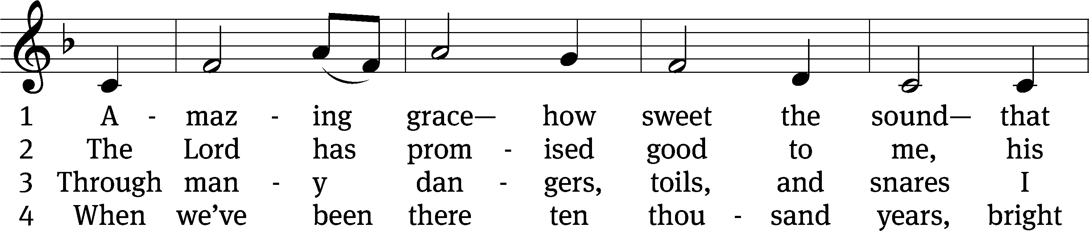
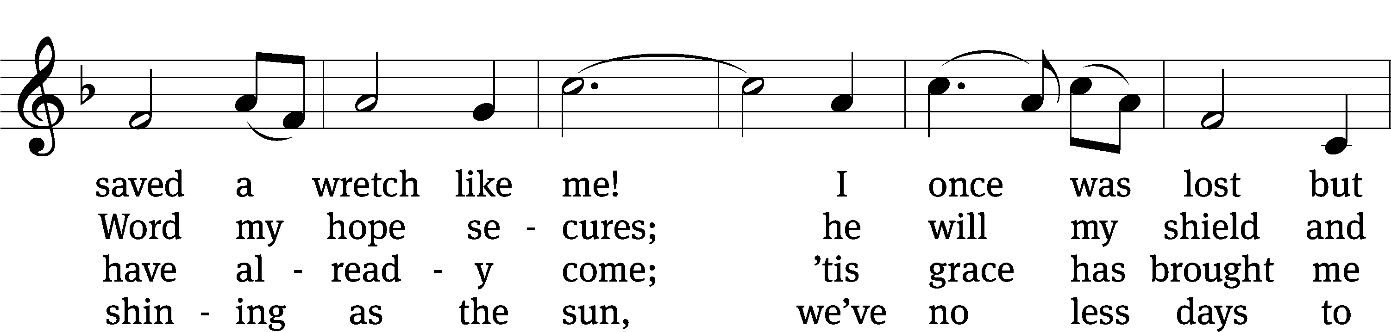
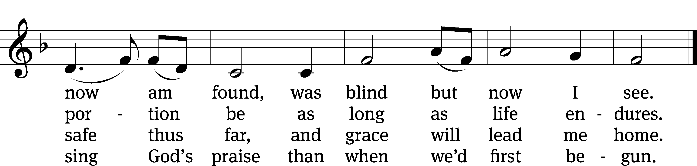
Text (sts. 1–3): John Newton, 1725–1807, alt.; (st. 4): A Collection of Sacred Ballads, Richmond, 1790
Tune: Columbian Harmony, Cincinnati, 1829, ed. Benjamin Shaw; ed. Charles H. Spilman
Text and tune: Public domain
Sermon Luke 9:51-62
“Where Is Jesus Taking Those Who Follow Him?”

Please stand, if you are able
Apostles’ Creed
I believe in God, the Father Almighty,
maker of heaven and earth.

I believe in Jesus Christ, his only Son, our Lord,
who was conceived by the Holy Spirit,
born of the Virgin Mary,
suffered under Pontius Pilate,
was crucified, died, and was buried.
He descended into hell.
The third day he rose again from the dead.
He ascended into heaven
and is seated at the right hand of God the Father Almighty.
From there he will come to judge the living and the dead.

I believe in the Holy Spirit,
the holy Christian Church,
the communion of saints,
the forgiveness of sins,
the resurrection of the body,
and the life everlasting. Amen.

Prayer of the Church

853 I’m But a Stranger Here CW 853
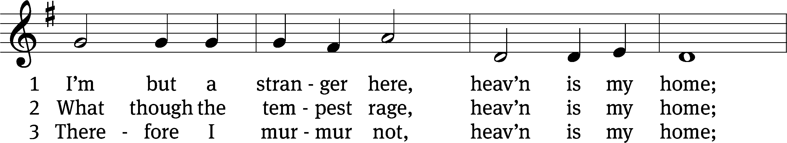
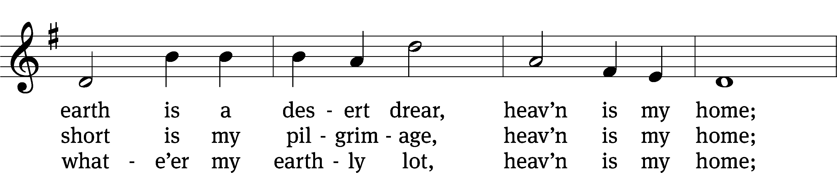
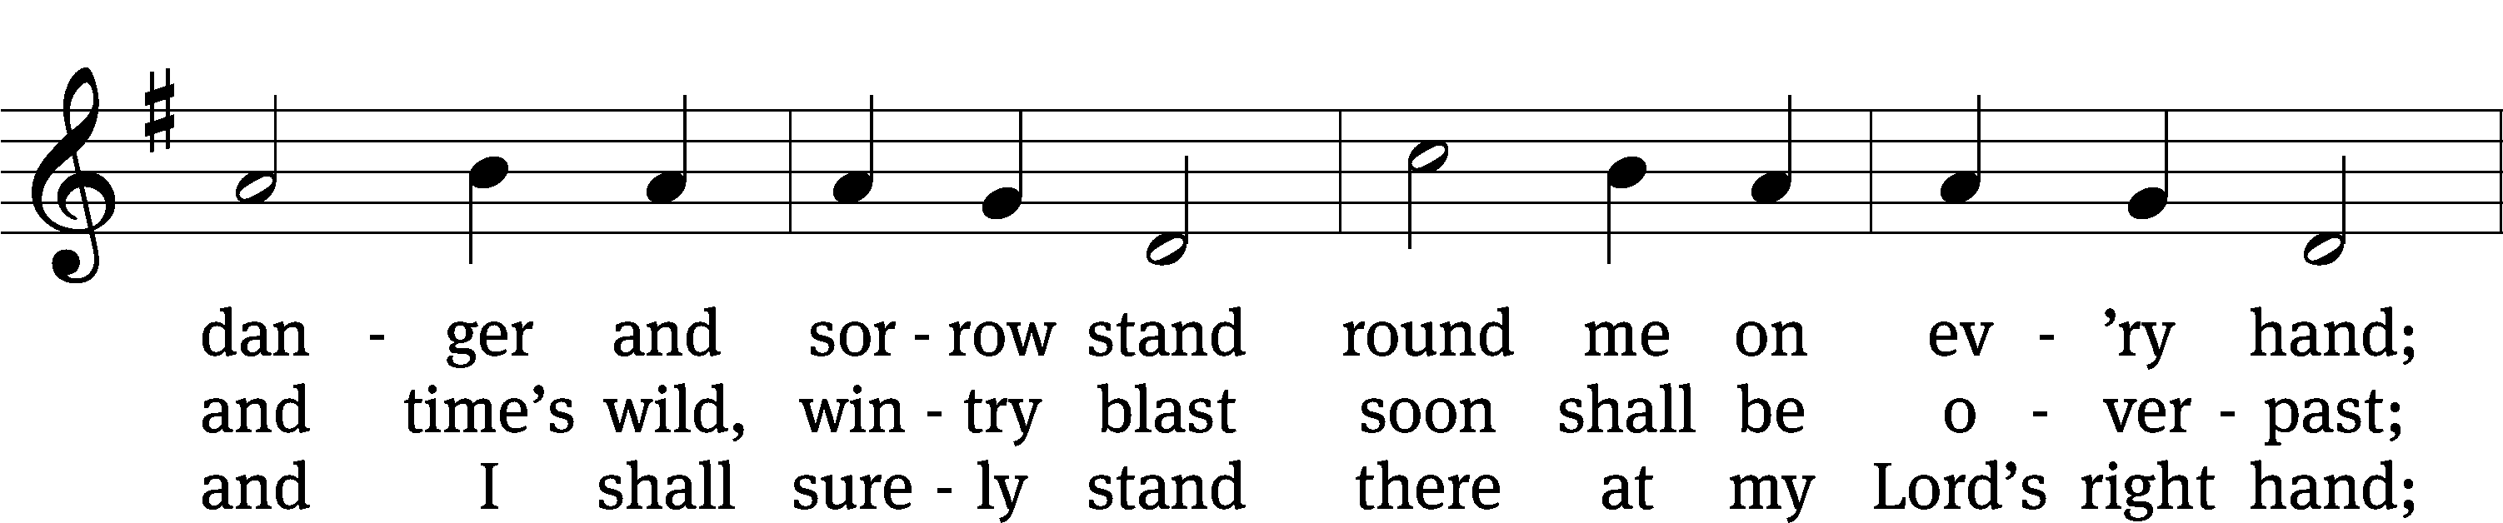
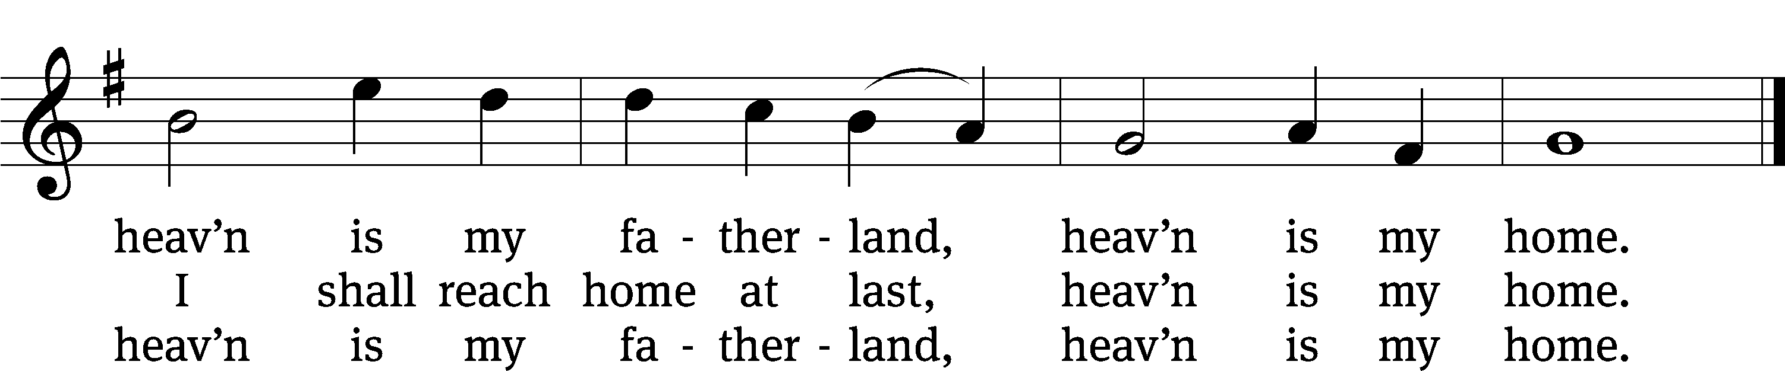
Text: Thomas R. Taylor, 1807–1835, abr.
Tune: Arthur S. Sullivan, 1842–1900
Text and tune: Public domain

Prayer
Blessed Lord, you have given us your Holy Scriptures for our learning. May we so hear them, read, learn, and take them to heart that, being strengthened and comforted by your holy Word,
we may cling to the blessed hope of everlasting life; through Jesus Christ our Lord, who lives and reigns with you and the Holy Spirit, one God, now and forever.
Amen.
Lord’s Prayer
Our Father, who art in heaven, hallowed be thy name, thy kingdom come, thy will be done on earth as it is in heaven. Give us this day our daily bread; and forgive us our trespasses, as we forgive those who trespass against us; and lead us not into temptation, but deliver us from evil. For thine is the kingdom and the power and the glory forever and ever. Amen.

Blessing
The Lord bless you and keep you.
The Lord make his face shine on you and be gracious to you.
The Lord look on you with favor and give you peace.
Amen.

Please be seated

695 Take My Life and Let It Be CW 695
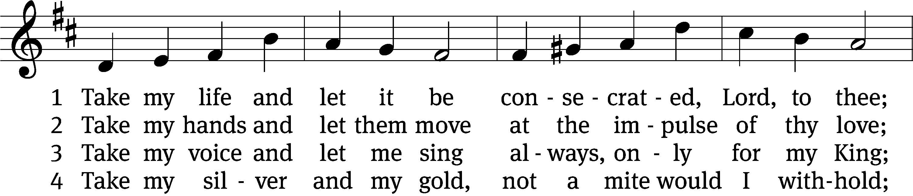
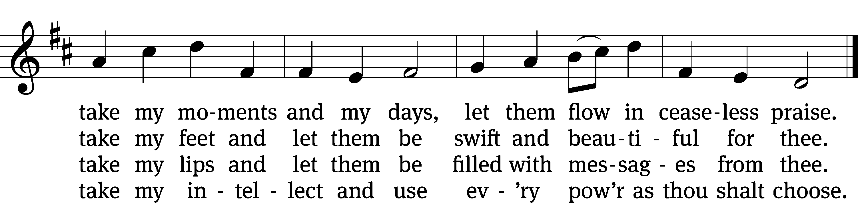

5 Take my will and make it thine,
it shall be no longer mine;
take my heart, it is thine own,
it shall be thy royal throne.

6 Take my love, my Lord, I pour
at thy feet its treasure store;
take myself, and I will be
ever, only, all for thee.
Text: Frances R. Havergal, 1836–1879
Tune: William H. Havergal, 1793–1870
Text and tune: Public domain

Acknowledgments
Setting One from Christian Worship
Software distributed in partnership with Northwestern Publishing House.
Created by Christian Worship: Service Builder © 2022 Concordia Publishing House.

Serving in Worship
Officiant Pastor Natsis
Organist and Accompanist Emily Wheeler
Deacons (Thursday) Dave Frey and Jim Tice
(Sunday) Jeff Neuburger and Ed Wheeler
Ushers (Thursday) Bob Newman and Henry Schneider
(Sunday) Ed Sala and Al Whitley
Altar Guild Esther Gross and Diane Stevenson
Videographer Cindy Dresch

