THE FIFTH SUNDAY
AFTER PENTECOST
TRINITY EVANGELICAL LUTHERAN CHURCH | Saline, Michigan
WELCOME TO WORSHIP June 29/July/2, 2023
Thank you for joining us in God’s house today! We cordially ask that our Guests sign one of the guestbooks located at either the front or back entryways, or fill out a “Let’s Get Acquainted” card located in the hymnal pew rack and place it in the collection plate.

Thank Offering: Members of Trinity give their offering as an expression of love and thankfulness to the Lord and to help support the Lord’s work in our community and around the world. Visitors need not feel obligated to participate in this offering .

Restrooms are located at the back of the upper level (the annex), and in the basement (down the back stairs of the sanctuary or annex). Handicap access is available, please ask an usher for assistance.

Young Families / Toddler Bags – We are GLAD YOU BROUGHT YOUR CHILDREN to our worship service. Jesus said: “Let the little children come to me and do not hinder them, for the kingdom of God belongs to such as these.” We know that having little children in church can be a challenge, but DO NOT WORRY about it. Many of your fellow worshippers have been in your shoes and are just happy you brought your children with you. For your convenience, we have reserved the back rows of seating for parents with small children. These areas provide more flexibility for your family, as well as, easy access to move downstairs if necessary. A closed-circuit TV system allows families to continue participating in the service while downstairs. Pre-school toddler bags and children’s bulletins are available for their enjoyment. Ask an usher for one to use during the service and please return the toddler bag afterwards.

Holy Communion – In His Word, God makes it clear that the Lord’s Supper is to be shared by people of a common proclamation of faith (1 Corinthians 11:26; 1 Corinthians 10:16-17). Without judging anyone’s hearts, we invite those who share in our confession by their membership in our congregation or another congregation of the Wisconsin Evangelical Lutheran Synod (WELS) or the Evangelical Lutheran Synod (ELS) and who are properly prepared (1 Corinthians 11;27-29) to receive the Sacrament. Page 295 in Christian Worship provides a guide for preparation.
Guests, we would love to have you join us in communion fellowship in the future, and for that to be possible, we ask that you speak with one of the pastors so that we may speak with you on how that would be possible. We thank you for respecting the way we celebrate the Lord’s Supper in our congregations.

the SERVICE – setting one - WITH HOLY COMMUNION CW, page 154
711 Jesus Calls Us o’er the Tumult CW 711
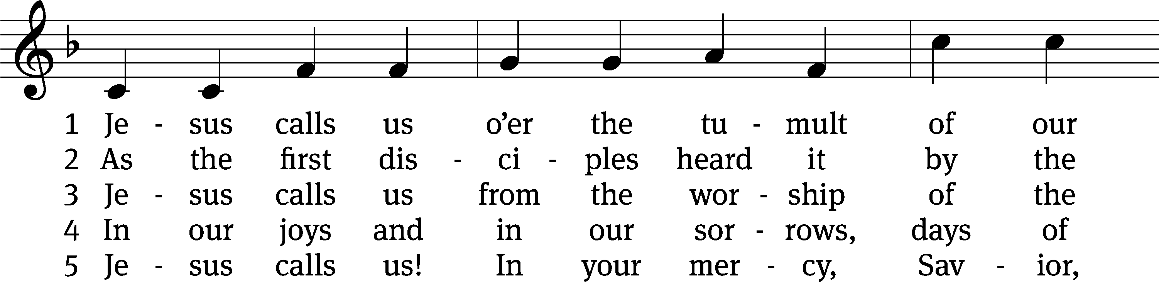
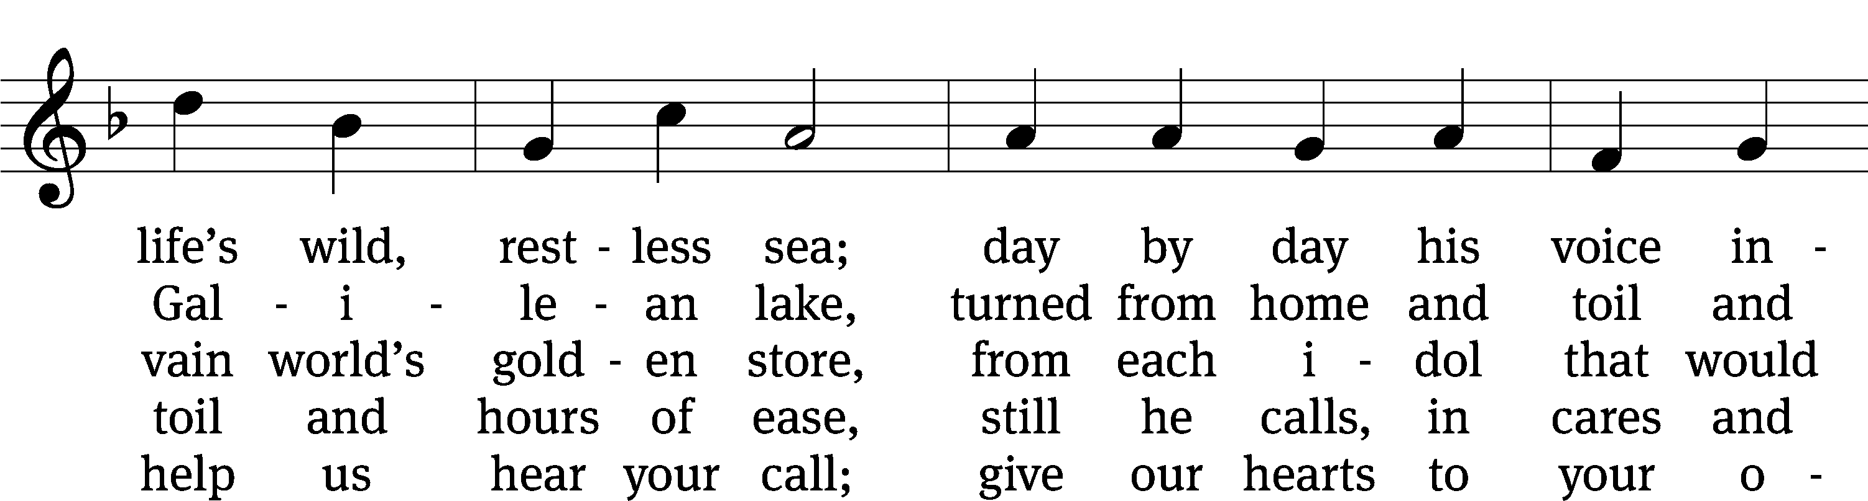
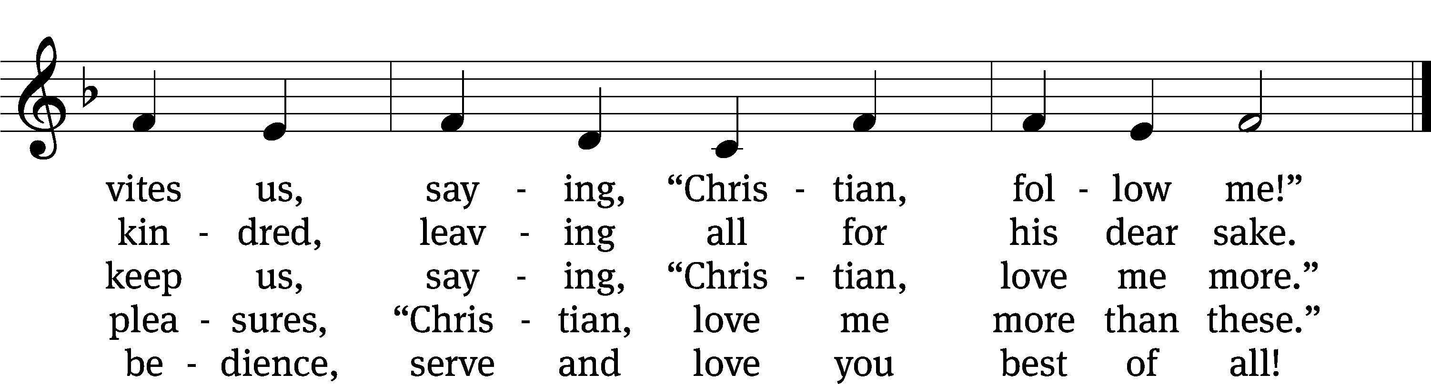
Text: Cecil F. Alexander, 1818–1895, alt.
Text and tune: Public domain

Please stand, if you are able

Invocation
In the name of the Father and of the Son and of the Holy Spirit.
Amen.
Confession
If we claim to be without sin, we deceive ourselves and the truth is not in us.
If we confess our sins, God is faithful and just
and will forgive us our sins
and purify us from all unrighteousness.

Let us confess our sins to the Lord.
Holy God, gracious Father,
I am sinful by nature
and have sinned against you in my thoughts, words, and actions.
I have not loved you with my whole heart;
I have not loved others as I should.
I deserve your punishment both now and forever.
But Jesus, my Savior, paid for my sins
with his innocent suffering and death.
Trusting in him, I pray: God, have mercy on me, a sinner.

Our gracious Father in heaven has been merciful to us. He sent his only Son, Jesus Christ, who gave his life as the atoning sacrifice for the sins of the whole world. Therefore, as a called servant of Christ and by his authority, I forgive you all your sins in the name of the Father and of the Son and of the Holy Spirit.
Amen.

Lord, Have Mercy

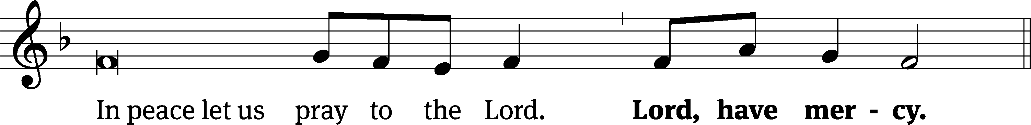
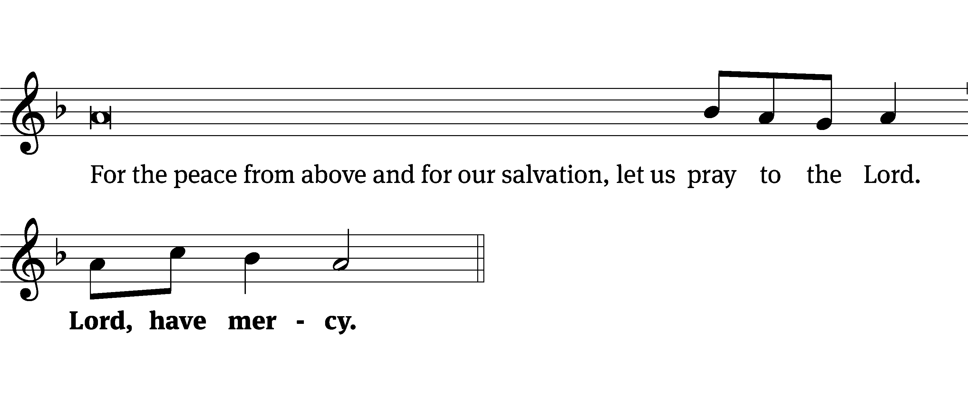
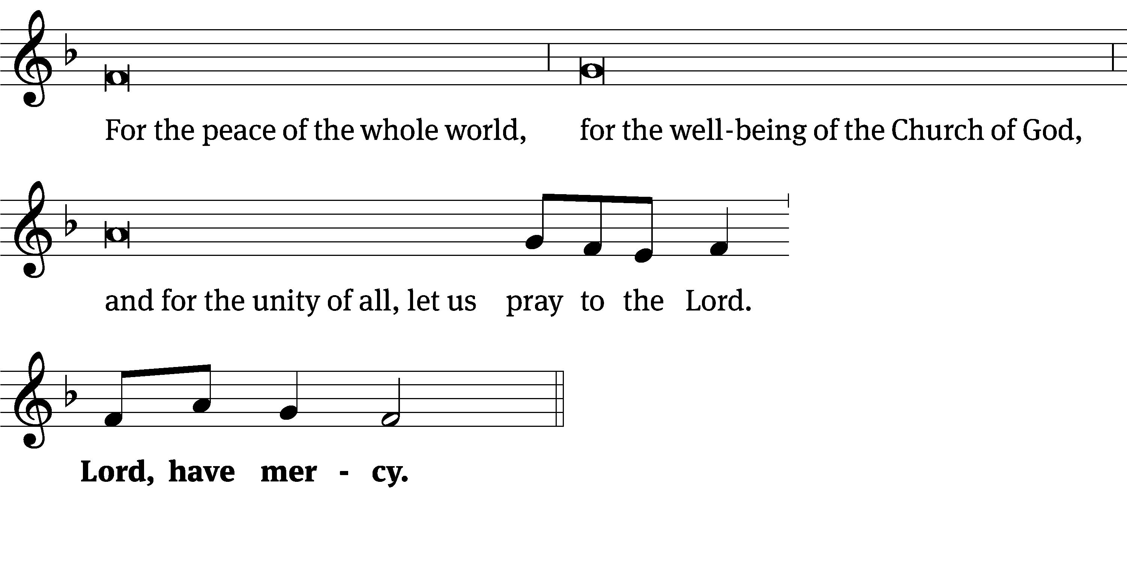
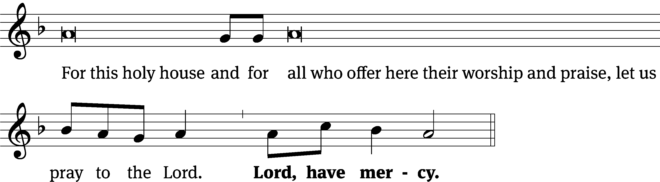
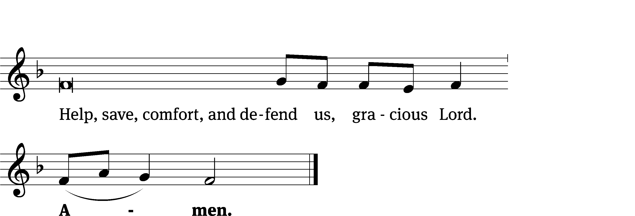
Glory Be to God on High CW 157
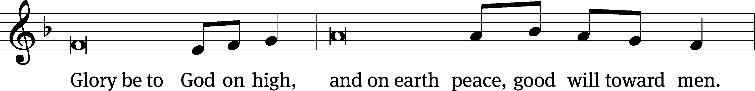
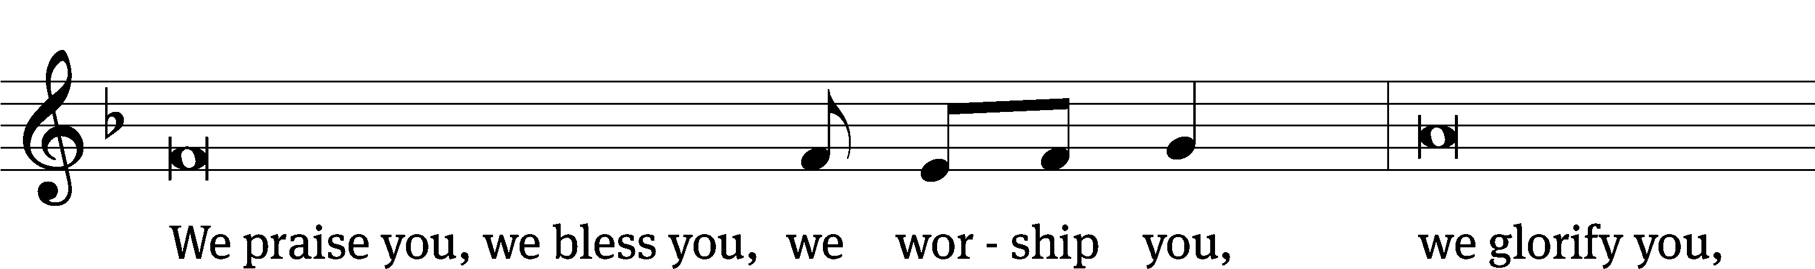
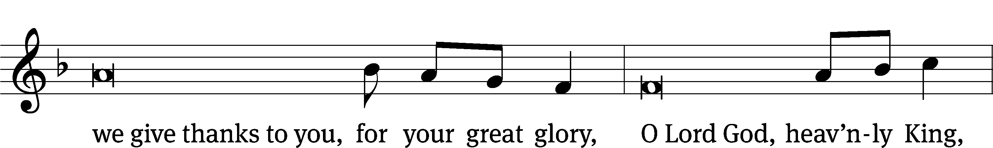
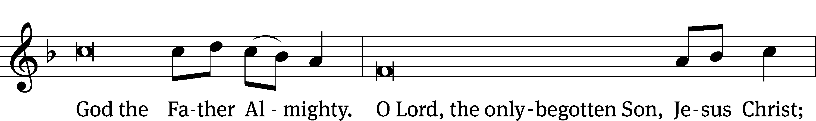
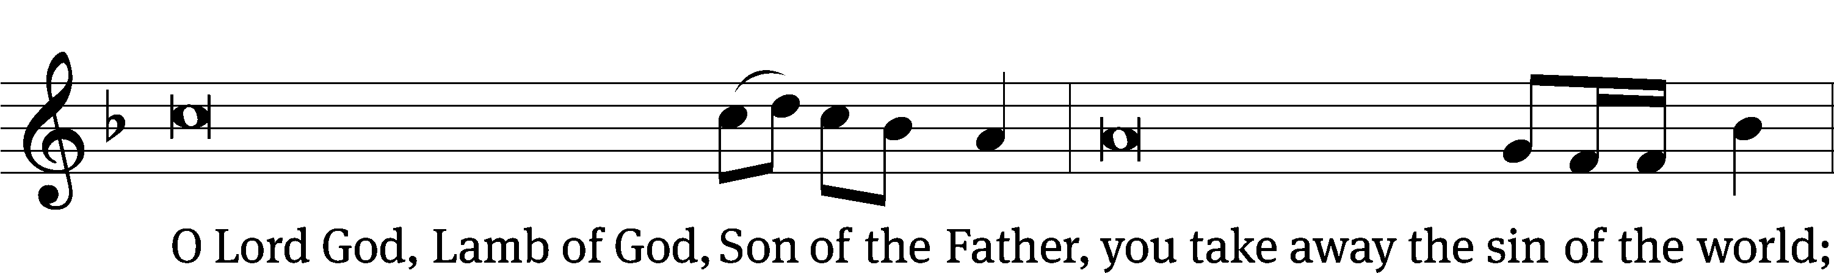
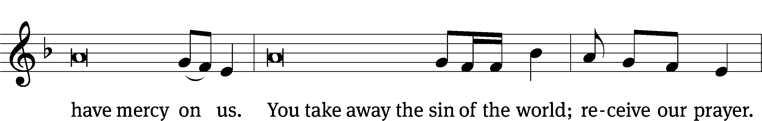
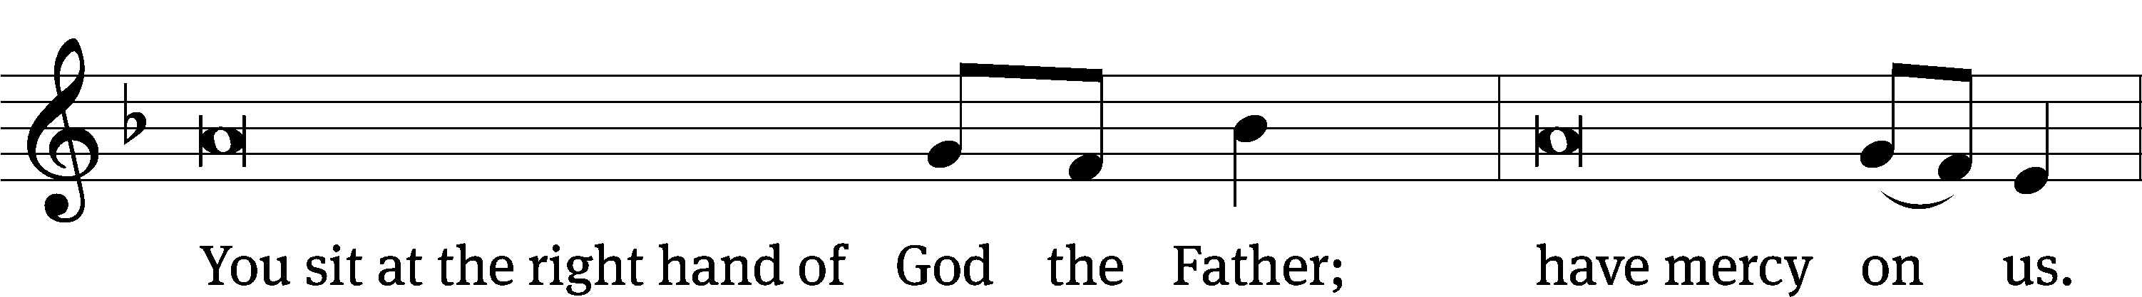
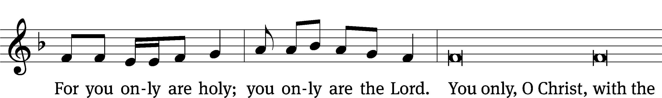
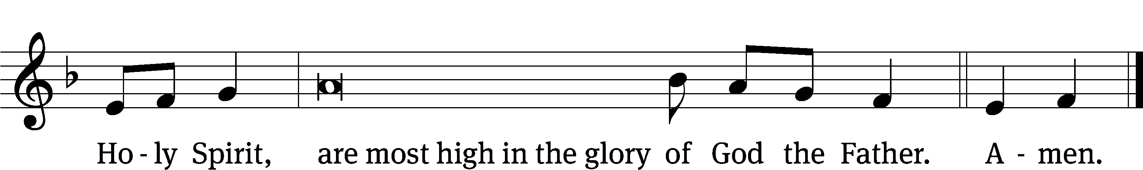

The Lord be with you.
And also with you.

Prayer of the Day
Let us pray.

God of all power and might, you are the giver of all that is good. Help us love you with all our heart, strengthen us in true faith, provide us with all we need, and keep us safe in your care; through your Son, Jesus Christ our Lord, who lives and reigns with you and the Holy Spirit, one God, now and forever.
Amen.

Please be seated

First Reading Exodus 32:15-29
¹⁵ Moses turned and went down the mountain, with the two tablets of the Testimony in his hand—tablets that were written on both sides, written on one side and on the other. ¹⁶ The tablets were the work of God, and the writing was the writing of God, engraved on the tablets.
¹⁷ When Joshua heard the noise of the people as they shouted, he said to Moses, “There is the noise of war in the camp.”
¹⁸ Moses said, “It is not the sound of people who shout for victory; neither is it the sound of people who cry because of defeat. But I do hear the sound of people who are celebrating.”
¹⁹ As soon as Moses came near the camp, he saw the calf and the dancing, and Moses’ anger burned. So he threw the tablets out of his hands and broke them at the foot of the mountain. ²⁰ He took the calf that they had made, burned it with fire, ground it to powder, and scattered it on the water. Then he made the people of Israel drink it.
²¹ Moses said to Aaron, “What did these people do to you, that you have brought such a great sin on them?”
²² Aaron said, “Do not let the anger of my lord burn. You know these people. They are set on evil, ²³ so they said to me, ‘Make a god for us, who will go ahead of us, because this Moses, the man who brought us up out of the land of Egypt, we do not know what has become of him.’ ²⁴ So I said to them, ‘Whoever has any gold, pull it off.’ So they gave it to me. I threw it into the fire and out came this calf.”
²⁵ When Moses saw that the people were out of control (for Aaron had let them get so out of control that they were disgraced among their enemies), ²⁶ Moses stood in the gate of the camp and said, “Whoever is on the Lord’s side, come to me!”
All the descendants of Levi gathered themselves together to Moses. ²⁷ He said to them, “This is what the Lord, the God of Israel, says, ‘Every man is to strap his sword on his thigh and go back and forth throughout the camp, from one gate of the camp to the other, and every man is to kill his brother, and every man his friend, and every man his neighbor.’” ²⁸ The Levites did what Moses said, and that day about three thousand men from among the people fell. ²⁹ Moses said, “Begin your service of the Lord today.^{[a]} Yes, because every man among you took a stand against his son and against his brother, the Lord is bestowing a blessing on you today.”

The Word of the Lord.
Thanks be to God.

27C The LORD Is My Light and My Salvation Psalm 27C
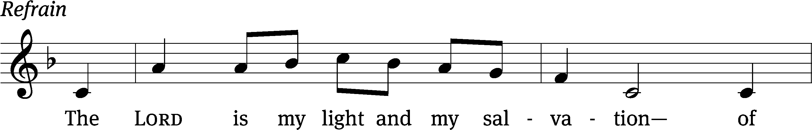
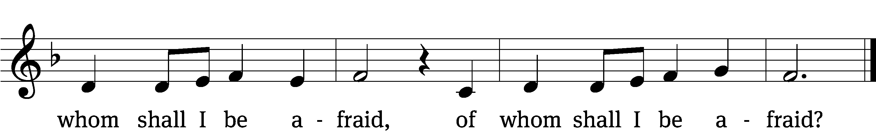

Hear my voice when I / call, Lord;
be merciful to me and / answer me.
Do not hide your / face from me,
do not turn your servant away in anger; you have been my / helper.
Do not reject me or for- / sake me,
God my / Savior. Refrain

Though my father and mother for- / sake me,
the Lord will re- / ceive me.
I remain confi- / dent of this:
I will see the goodness of the Lord in the land of the / living.
Wait / for the Lord;
be strong and take heart and wait / for the Lord.
Glory be to the Father and / to the Son
and to the Holy / Spirit,
as it was in the be- / ginning,
is now, and will be forever. / Amen. Refrain
Tune: David Haas
Tune: © 1983 GIA Publications, Inc. Used by permission: OneLicense no. 727703
Setting: © 1993 Kermit G. Moldenhauer, admin. Northwestern Publishing House. Used by permission: OneLicense no. 727703

Second Reading 1 Timothy 6:11-16
¹¹ But you, O man of God, flee from these things and pursue righteousness, godliness, faith, love, perseverance, and gentleness. ¹² Fight the good fight of faith. Take hold of eternal life, to which you were called and about which you made your good confession in the presence of many witnesses. ¹³ I charge you in the presence of God, who gives life to all things, and of Christ Jesus, who made a good confession as a witness before Pontius Pilate, ¹⁴ that you keep this command without spot and without fault, until the appearing of our Lord Jesus Christ, ¹⁵ which he will make known at the proper time—the blessed and only ruler, the King of kings and Lord of lords, ¹⁶ who alone has immortality, who lives in unapproachable light, whom no one has seen or is able to see. To him be honor and power forever! Amen.

The Word of the Lord.
Thanks be to God.

Please stand, if you are able

Gospel Acclamation Mark 8:34
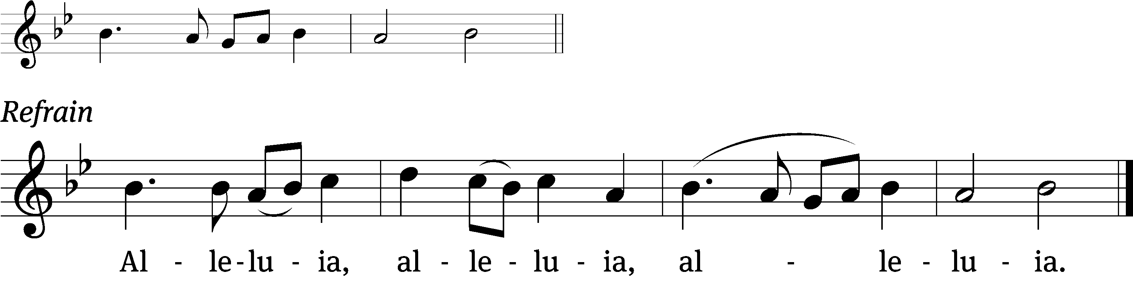
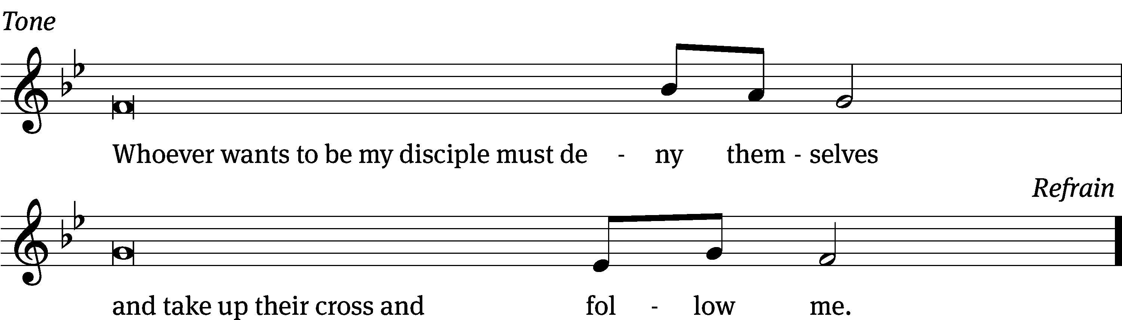
Tune: © 2021 Northwestern Publishing House. Used by permission: OneLicense no. 727703

Gospel Matthew 10:34-42
³⁴ “Do not think that I came to bring peace to the earth. I did not come to bring peace, but a sword. ³⁵ For I came to turn a man against his father, a daughter against her mother, and a daughter-in-law against her mother-in-law. ³⁶ A man’s enemies will be the members of his own household.
³⁷ “Whoever loves father or mother more than me is not worthy of me, and whoever loves son or daughter more than me is not worthy of me. ³⁸ Whoever does not take up his cross and follow me is not worthy of me. ³⁹ Whoever finds his life will lose it, and whoever loses his life for my sake will find it.
⁴⁰ “Whoever receives you receives me, and whoever receives me receives him who sent me. ⁴¹ Whoever receives a prophet because he is a prophet will receive a prophet’s reward. Whoever receives a righteous man because he is a righteous man will receive a righteous man’s reward. ⁴² Whoever gives one of these little ones even a cup of cold water to drink because he is my disciple—Amen I tell you—he will never lose his reward.”

The Gospel of the Lord.
Praise be to you, O Christ!

Please be seated

702 Come, Follow Me, the Savior Spake CW 702
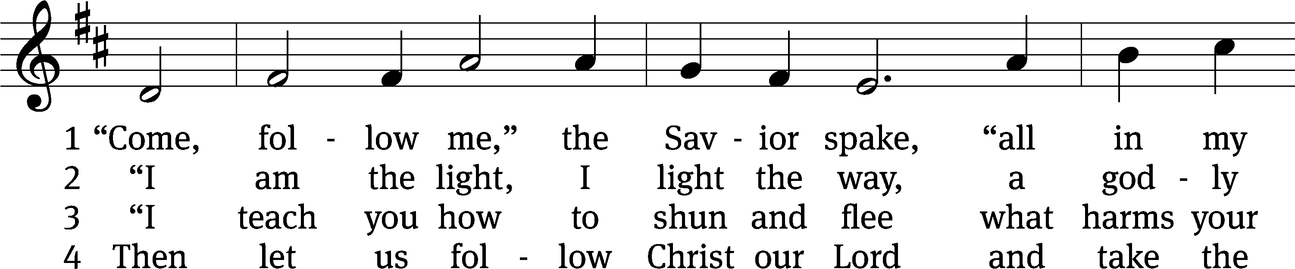
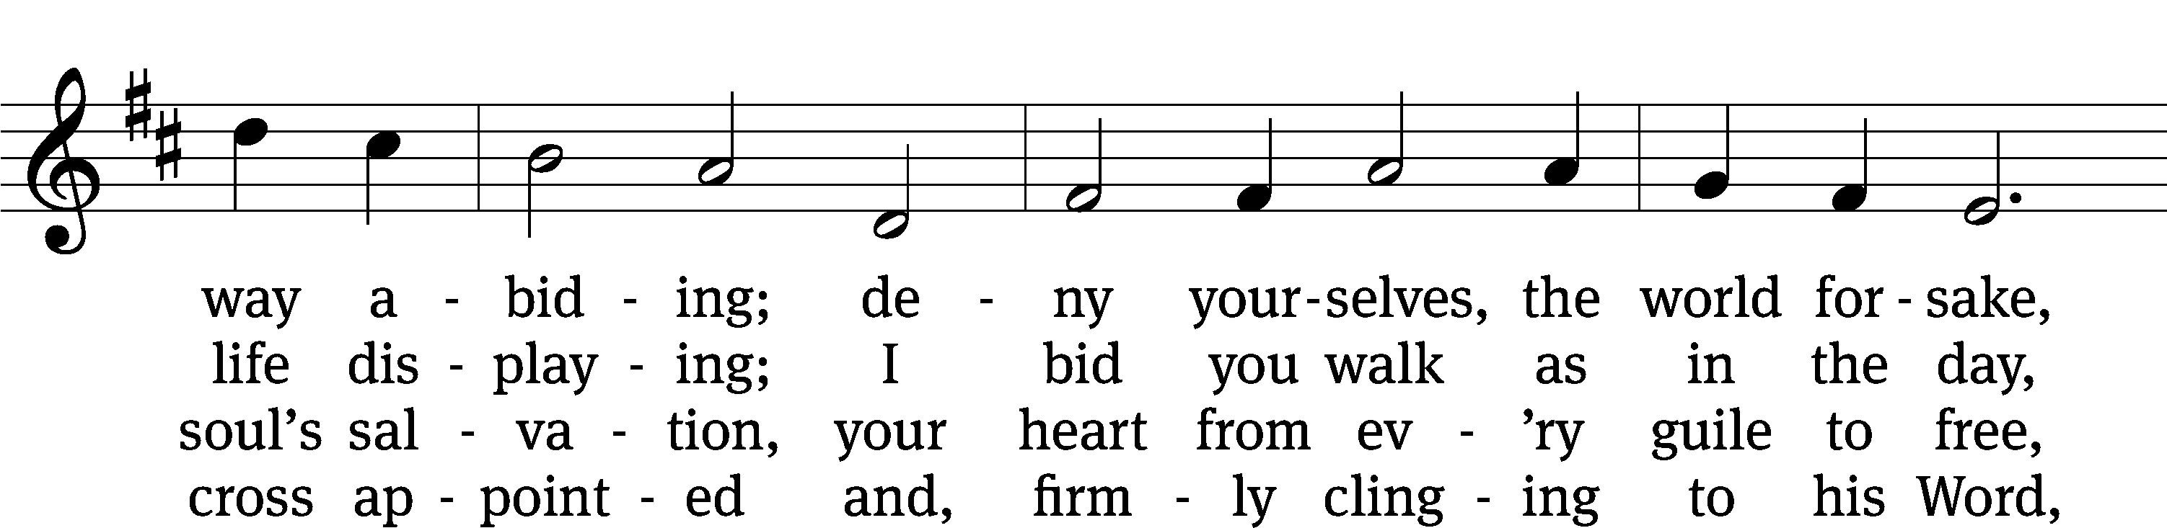
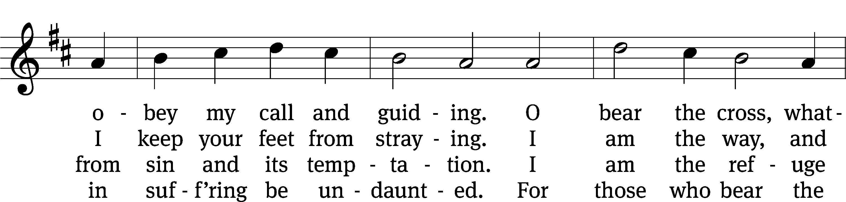
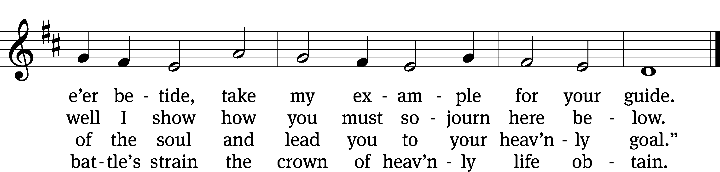
Text: tr. Charles W. Schaeffer, 1813–1896, alt.; (sts. 1–2, 4): Johann Scheffler, 1624–1677, abr.; (st. 3): Geistliche Lieder und Lobgesänge, 1695
Tune: Bartholomäus Gesius, c. 1555–1613, adapt.
Text and tune: Public domain

SERMON John 8:12
“Jesus Says, “I AM the Light of the World”

¹² When Jesus spoke to them again, he said, “I am the Light of the World. Whoever follows me will never walk in darkness, but will have the light of life.”

Please stand, if you are able

nicene creed
We believe in one God, the Father, the Almighty, maker of heaven and earth, of all that is, seen and unseen.
We believe in one Lord, Jesus Christ, the only Son of God, eternally begotten of the Father, God from God, Light from Light, true God from true God, begotten, not made, of one being with the Father. Through him all things were made. For us and for our salvation, he came down from heaven, was incarnate of the Holy Spirit and the virgin Mary, and became truly human. For our sake he was crucified under Pontius Pilate. He suffered death and was buried. On the third day he rose again in accordance with the Scriptures. He ascended into heaven and is seated at the right hand of the Father. He will come again in glory to judge the living and the dead, and his kingdom will have no end.
We believe in the Holy Spirit, the Lord, the giver of life, who proceeds from the Father and the Son, who in unity with the Father and the Son is worshiped and glorified, who has spoken through the prophets. We believe in one holy Christian and apostolic Church. We acknowledge one baptism for the forgiveness of sins. We look for the resurrection of the dead and the life of the world to come. Amen.

Prayer of the Church

The Sacrament
Preface CW 165
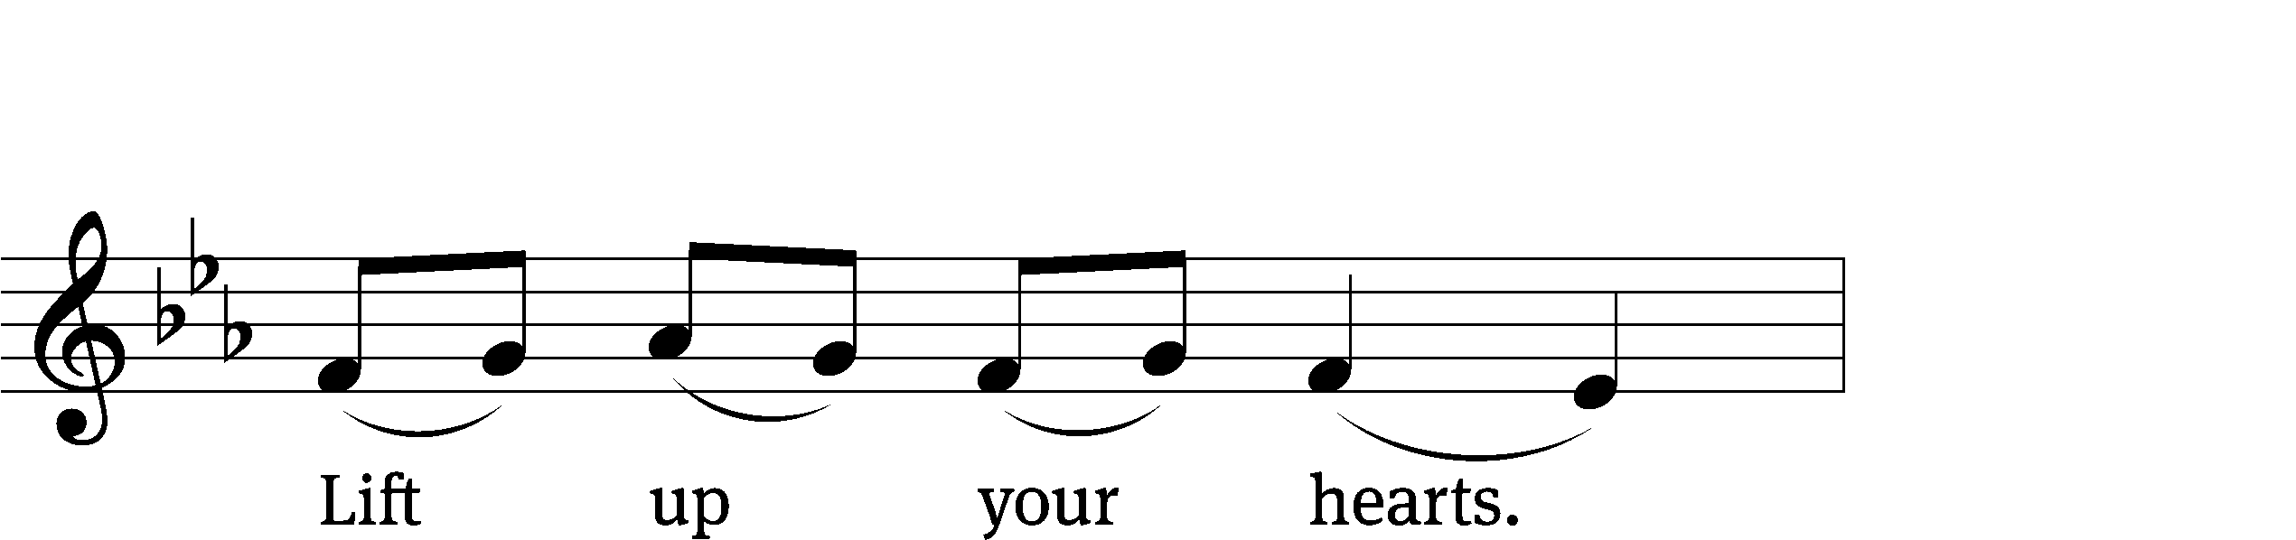
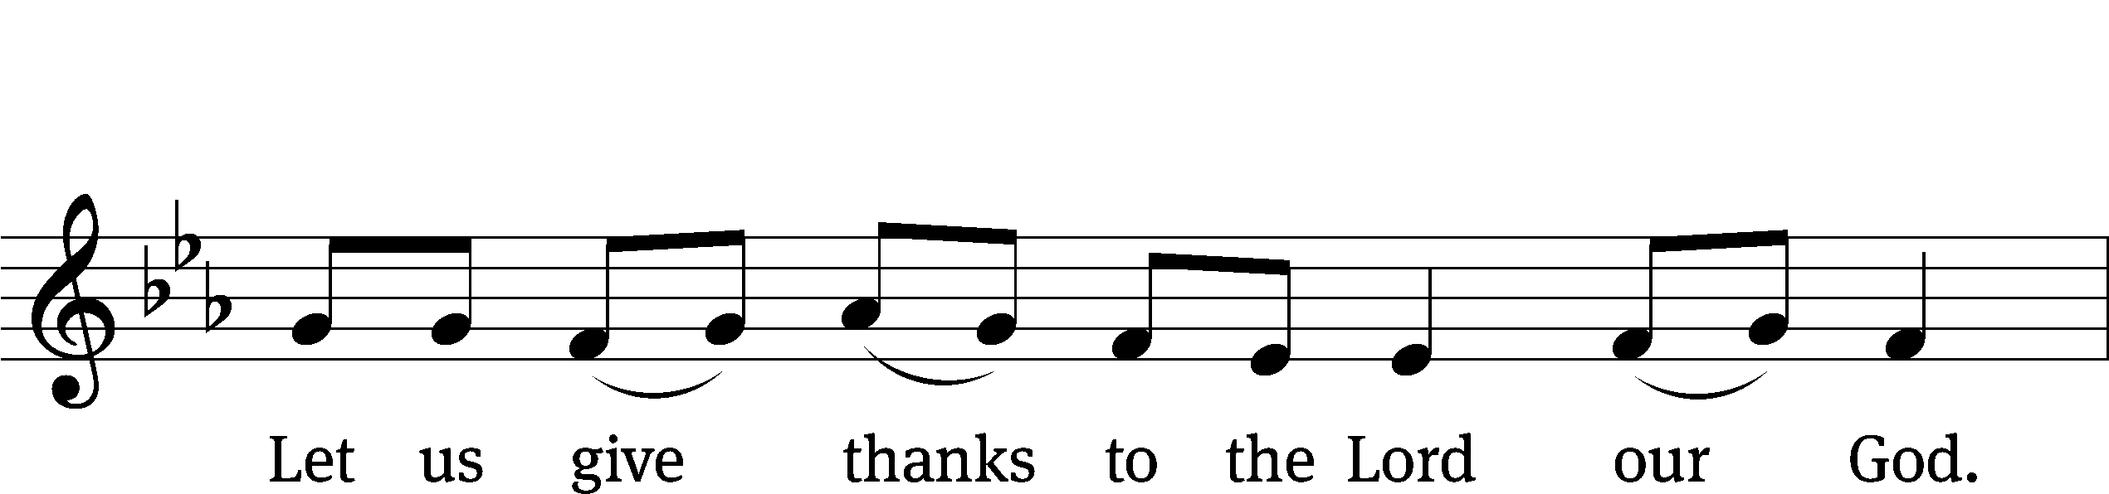
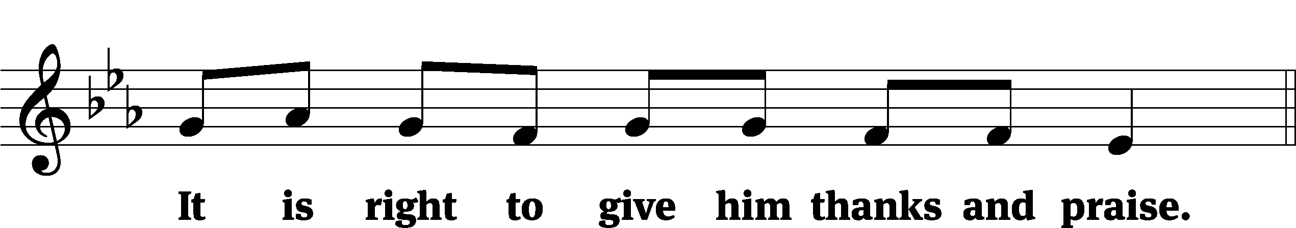

It is truly good and right that we should at all times and in all places give you thanks, O Lord, holy Father, almighty and everlasting God, through Jesus Christ our Lord, who by his willing sacrifice on the cross took away the sins of the world and by his glorious resurrection restored everlasting life. Therefore, with all the saints on earth and hosts of heaven, we praise your holy name and join their glorious song:

Holy, Holy, Holy CW 167
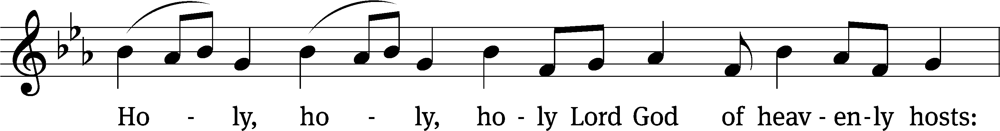
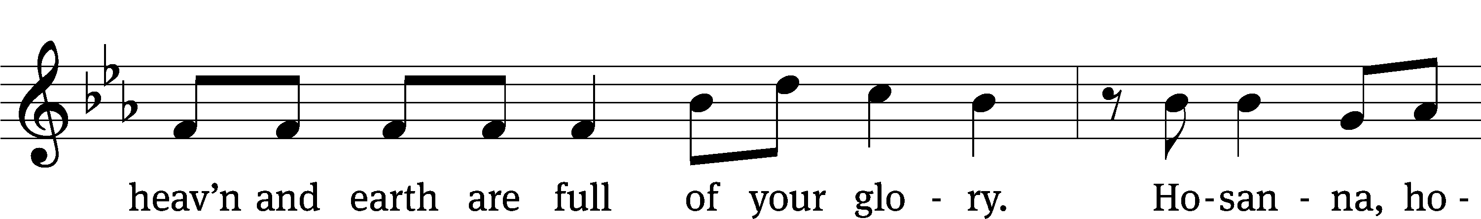
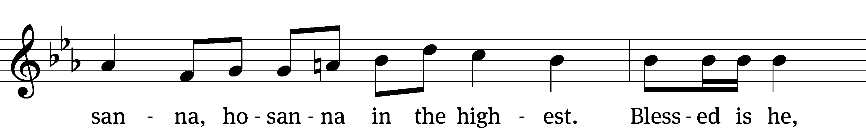
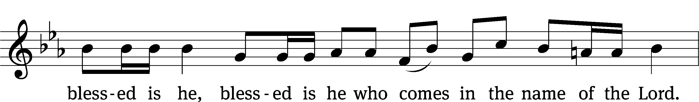
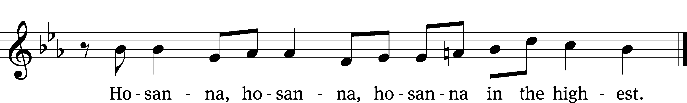

Prayer of Thanksgiving
We give thanks to you, O God, through your dear Son, Jesus Christ, whom you sent to be our Savior, our Redeemer, and the messenger of your grace. Through him you made all things; in him you are well pleased. He is the incarnate Word, conceived by the Holy Spirit and born of the Virgin Mary. To fulfill your promises, he stretched out his hands on the cross and released from eternal death all who believe in you.

As we remember Jesus’ death and resurrection, we thank you that you have gathered us together to receive your Son’s body and blood. Send us your Spirit, unite us as one, and strengthen our faith so that we may praise you in your Son, Jesus Christ. Through him, we glorify and honor you, O God our Father, with the Holy Spirit, one God, now and forever.
Amen.

Lord’s Prayer
Our Father, who art in heaven, hallowed be thy name, thy kingdom come, thy will be done on earth as it is in heaven. Give us this day our daily bread; and forgive us our trespasses, as we forgive those who trespass against us; and lead us not into temptation, but deliver us from evil. For thine is the kingdom and the power and the glory forever and ever. Amen.

Words of Institution
Our Lord Jesus Christ, on the night he was betrayed, took bread; and when he had given thanks, he broke it and gave it to his disciples, saying, “Take and eat; this is my body, which is given for you. Do this in remembrance of me.”
Then he took the cup, gave thanks, and gave it to them, saying, “Drink from it, all of you; this is my blood of the new covenant, which is poured out for you for the forgiveness of sins. Do this, whenever you drink it, in remembrance of me.”

The peace of the Lord be with you always.
Amen.
O Christ, Lamb of God CW 169
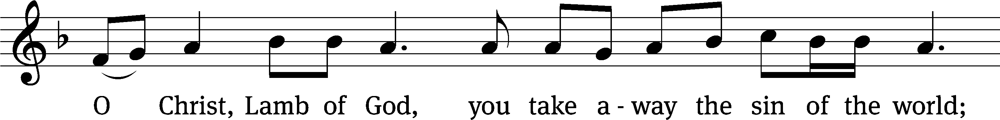
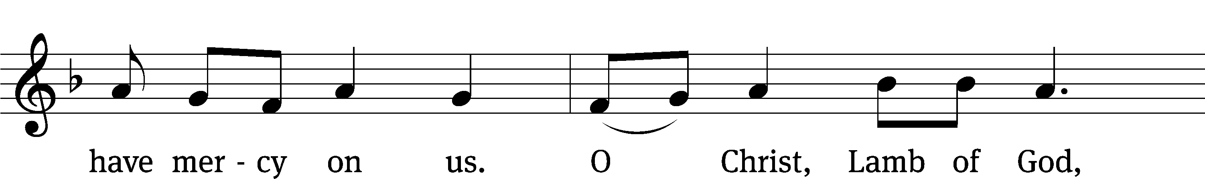
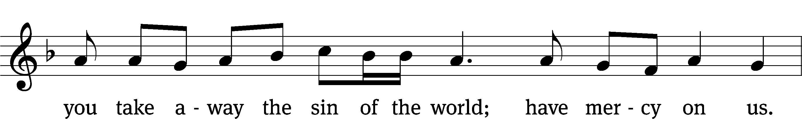
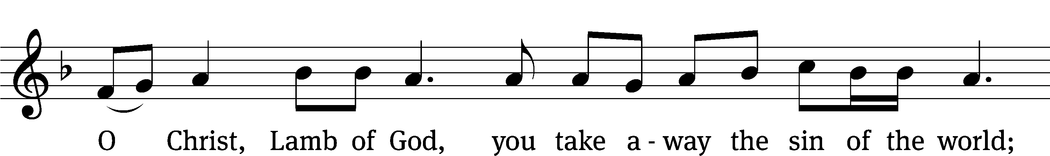
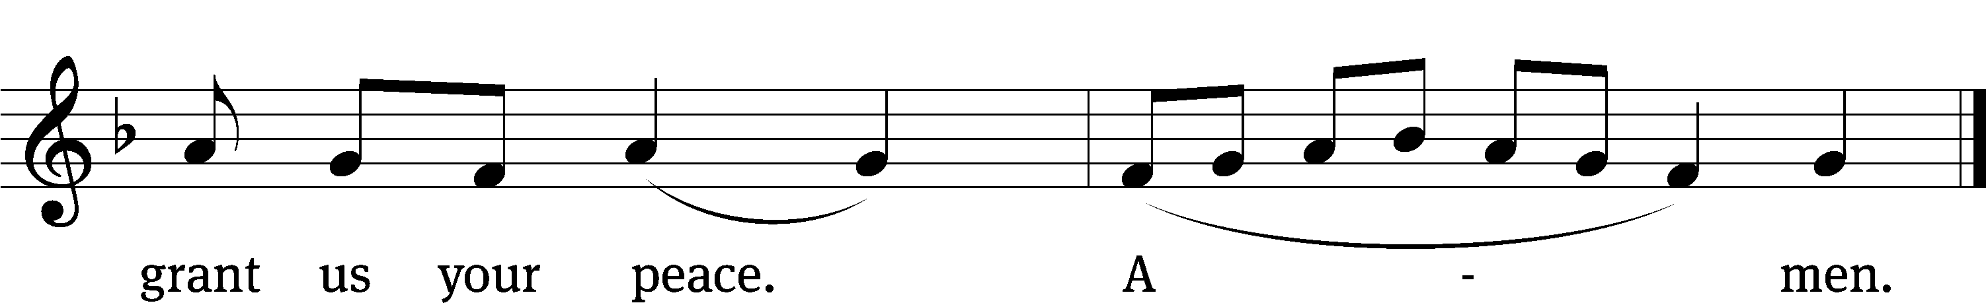
Please be seated

659 Jesus Christ, Our Blessed Savior CW 659
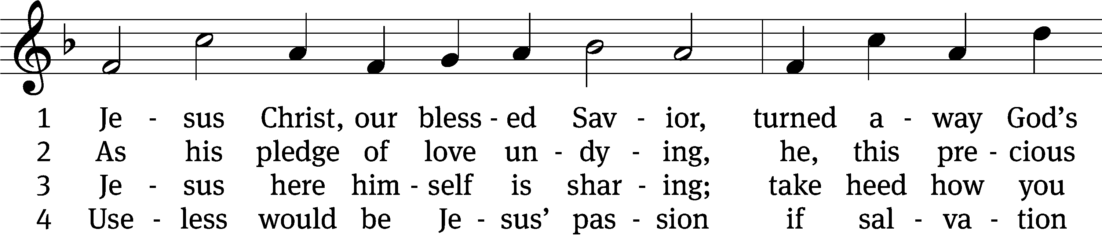
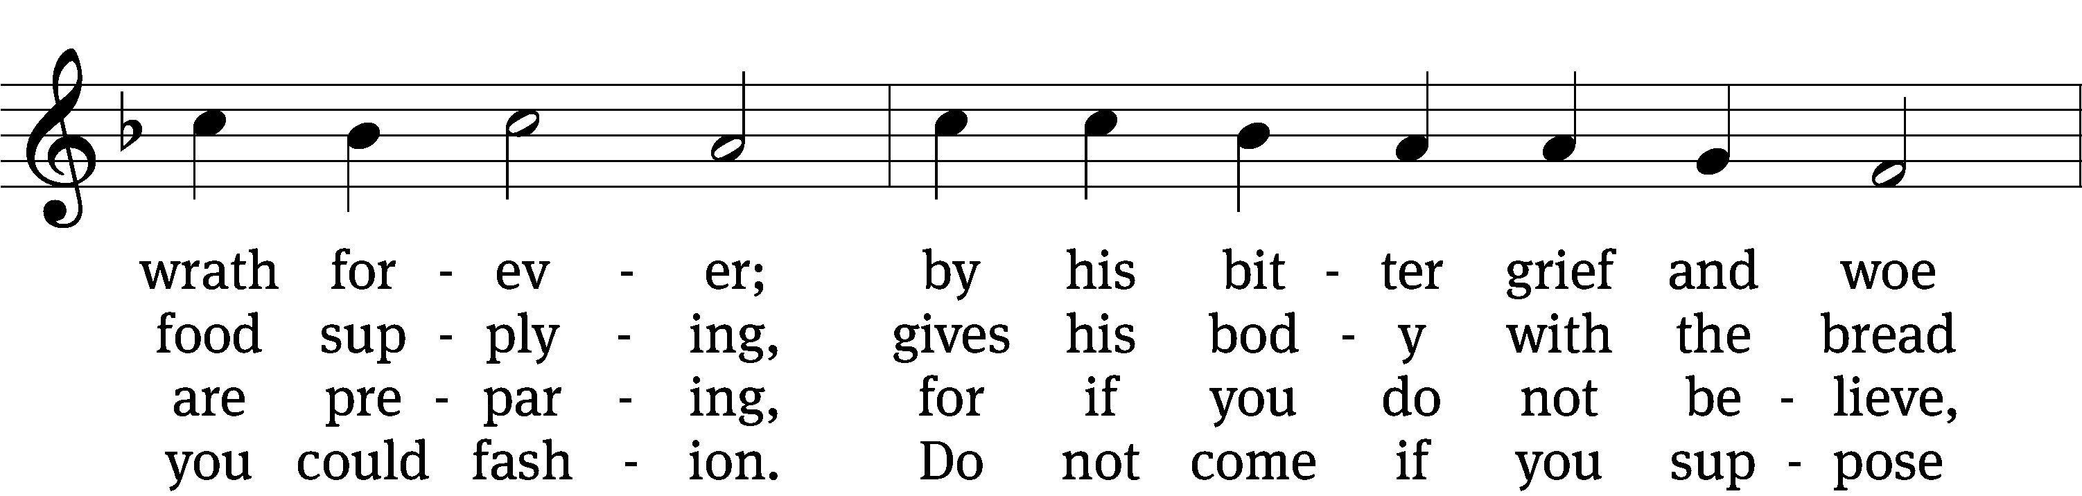
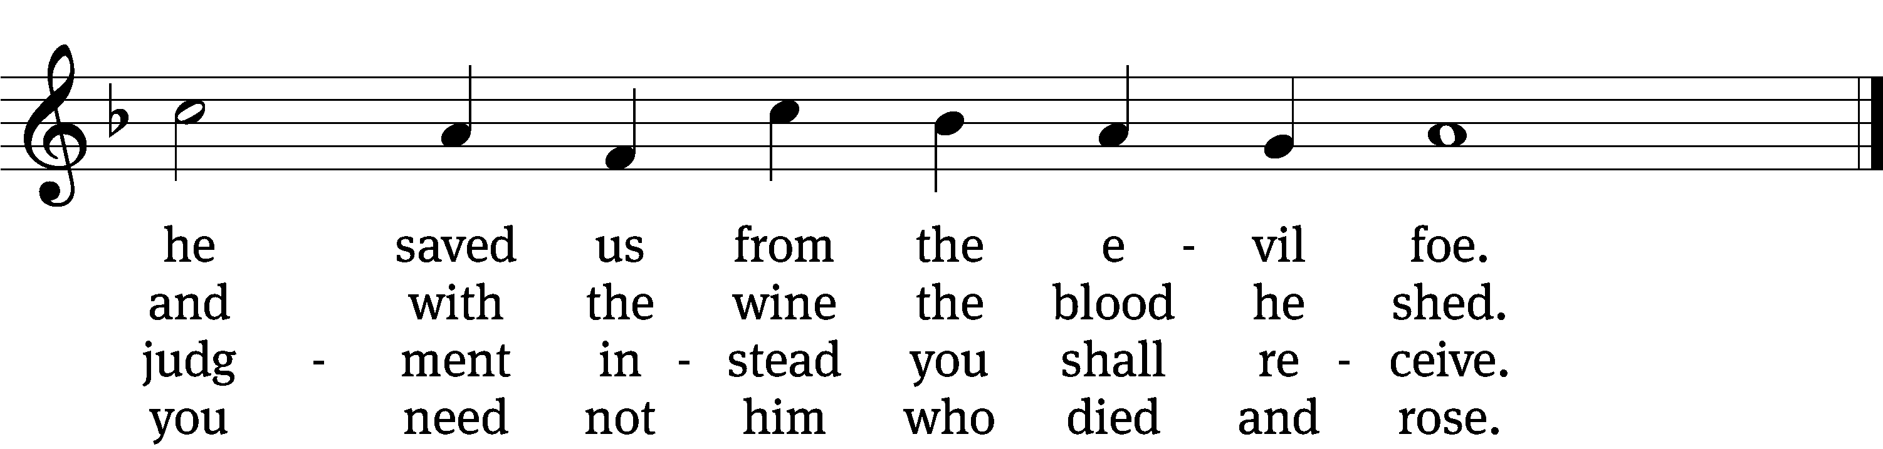

5 Christ says, “Come, all you that labor,
and receive my grace and favor;
those who feel no pain or ill
need no physician’s help or skill.”

6 Then hold fast with faith unshaken
that this food is to be taken
by the souls who are distressed,
by hearts that long for peace and rest.

7 Praise the Father, who from heaven
unto us such food has given
and, to mend what we have done,
gave into death his only Son.

8 If your heart this truth professes
and your mouth your sin confesses,
surely you will be his guest
and at his banquet ever blest.
Text: tr. The Lutheran Hymnal, 1941; German version, Martin Luther, 1483–1546, abr.; John Hus, c. 1369–1415
Tune: Geistliche Lieder auffs new gebessert, Wittenberg, 1533, ed. Joseph Klug, alt.
Text and tune: Public domain

774 God Bless Our Native Land CW 774
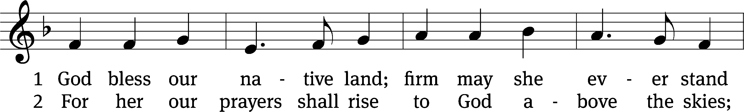
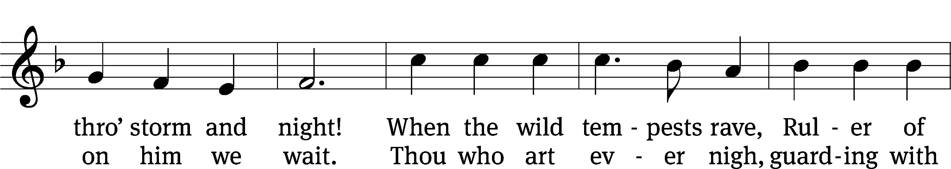
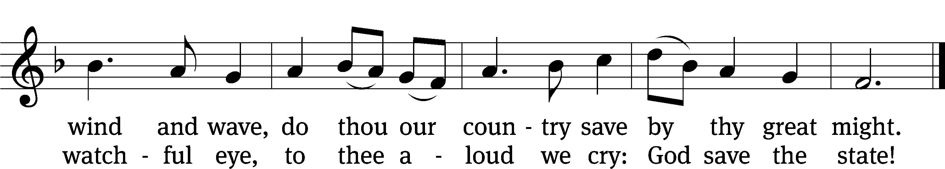
Text (st. 1): Charles T. Brooks, 1813–1883, st. 1, alt.; (st. 2): John S. Dwight, 1813–1893
Tune: Thesaurus Musicus, London, c. 1740
Text and tune: Public domain

Please stand, if you are able

Give thanks to the Lord, for he is good;
his mercy endures forever.

Whenever we eat this bread and drink this cup,
we proclaim the Lord’s death until he comes.

We give thanks, almighty God, that you have refreshed us with this saving gift. We pray that through it you will strengthen our faith in you and increase our love for one another. We ask this in the name of Jesus Christ our Lord, who lives and reigns with you and the Holy Spirit, one God, now and forever.
Amen.
Blessing
The Lord bless you and keep you.
The Lord make his face shine on you and be gracious to you.
The Lord look on you with favor and give you peace.
Amen.

Please be seated
510 In Christ Alone CW 510
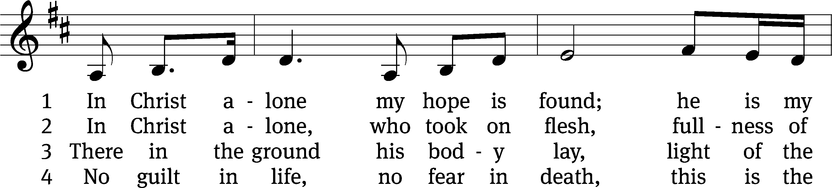
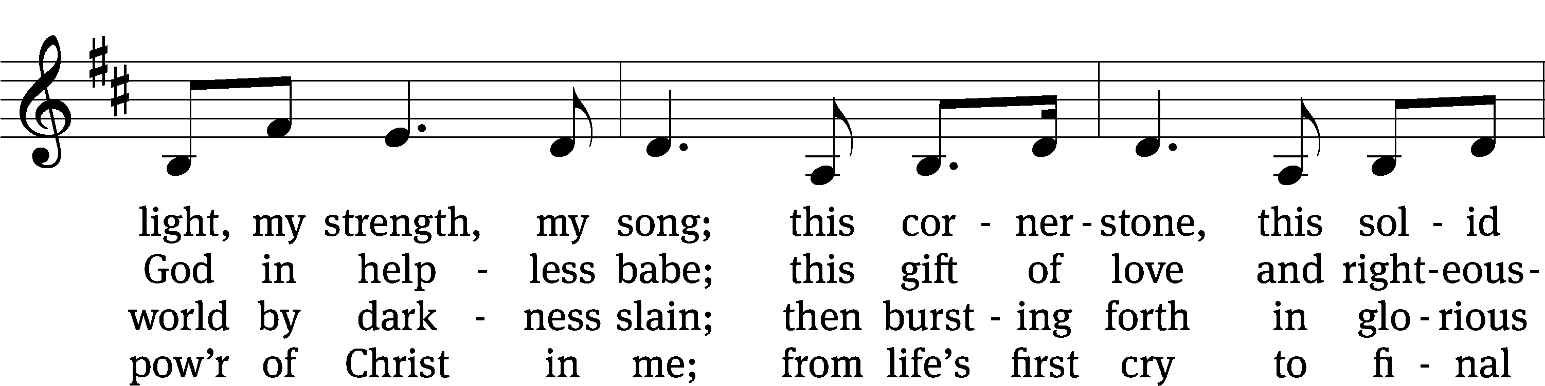
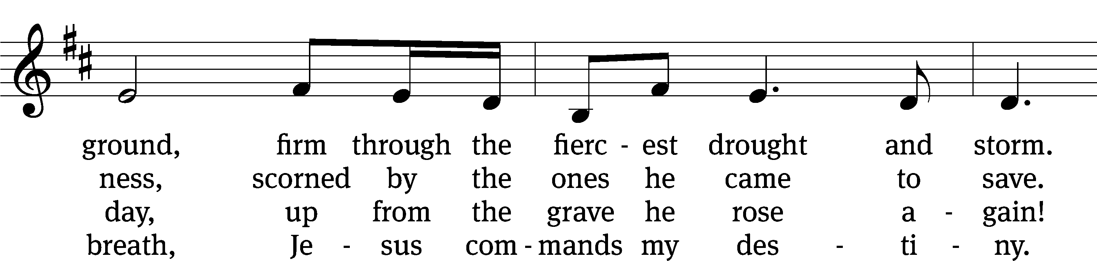
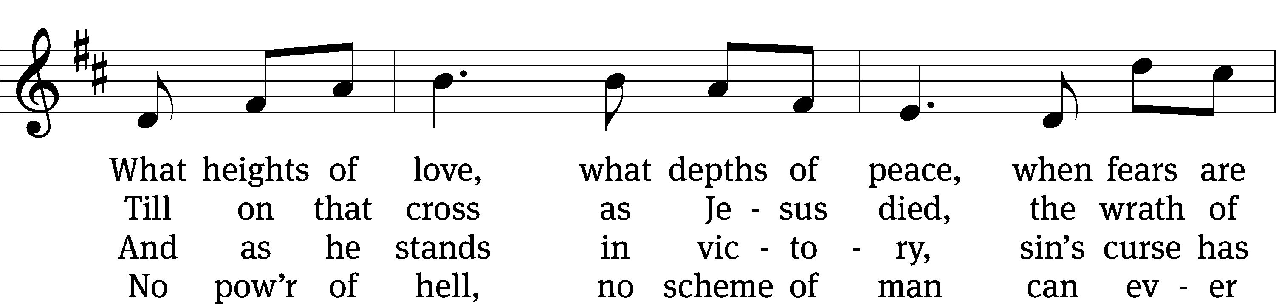
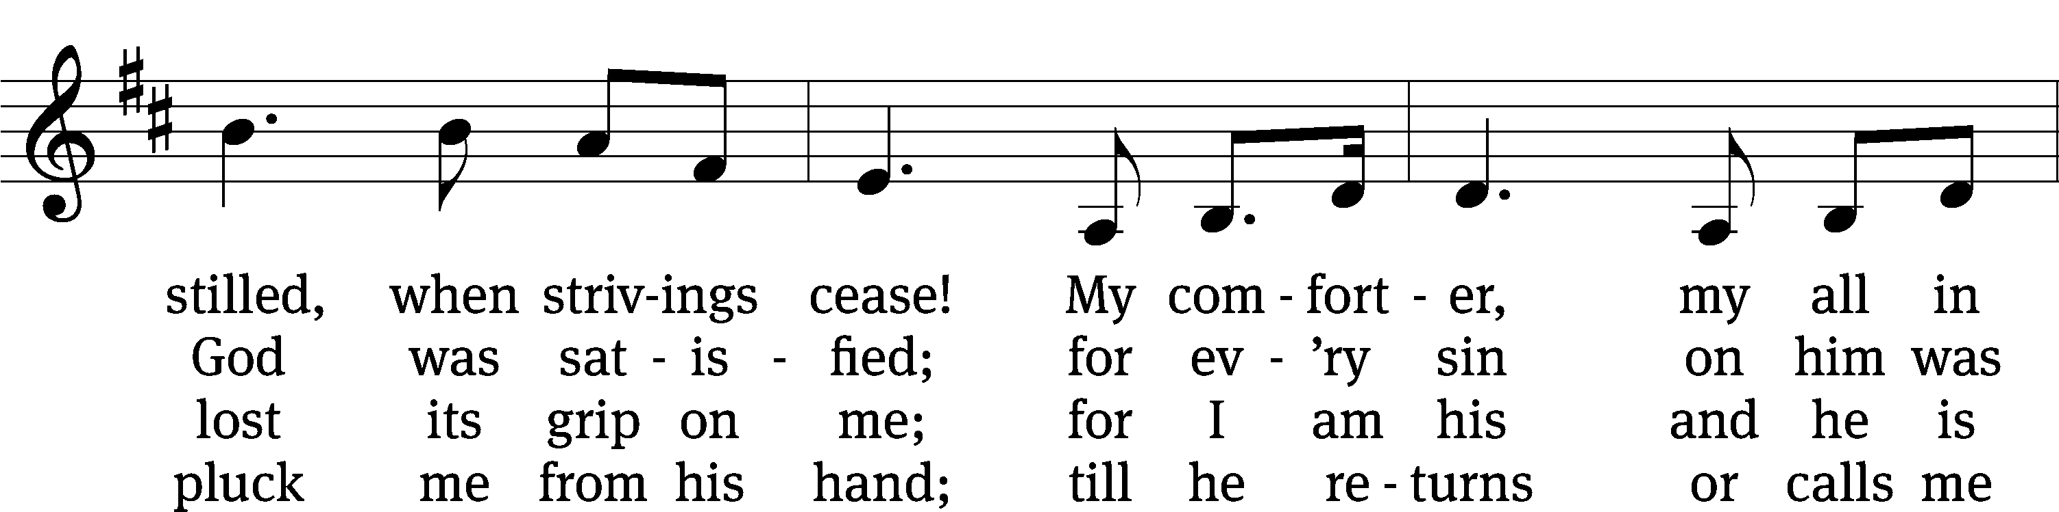
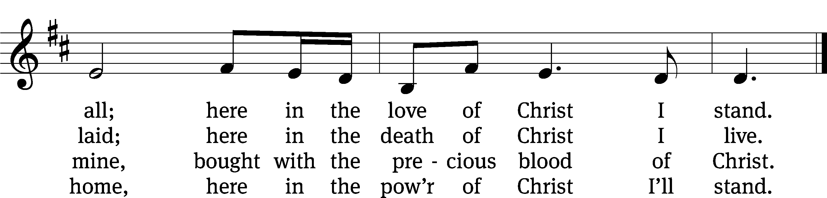
Text: Stuart Townend, b. 1963; Keith Getty, b. 1974
Tune: Stuart Townend, b. 1963; Keith Getty, b. 1974
Text and tune: © 2002 Thankyou Music, admin. CapitolCMGPublishing,com. Used by permission: OneLicense no. 727703

Acknowledgments
Setting One from Christian Worship
Software distributed in partnership with Northwestern Publishing House.
Created by Christian Worship: Service Builder © 2022 Concordia Publishing House.

Serving in Worship
Officiant Pastor William Natsis
Organist Sarah Hanke
Deacons (Thursday) Steve Hoeft and Jim Tice
Deacons (Sunday) Jeff Neuburger and Dave Stevenson
Ushers (Thursday) Dale Finkbeiner and Mark Finkbeiner
Ushers (Sunday) Al Whitley
Altar Guild Esther Gross and Diane Stevenson
Videographer Cindy Dresch

