THE FOURTH SUNDAY
AFTER PENTECOST

TRINITY EVANGELICAL LUTHERAN CHURCH | Saline, Michigan
WELCOME TO WORSHIP June 30/July 3, 2022
Thank you for joining us in God’s house today! We cordially ask that our Guests sign one of the guestbooks located at either the front or back entryways, or fill out a “Let’s Get Acquainted” card located in the hymnal pew rack and place it in the collection plate.

THANK OFFERING: Members of Trinity give their offering as an expression of love and thankfulness to the Lord and to help support the Lord’s work in our community and around the world. Visitors need not feel obligated to participate in this offering which supports our ministry.

Restrooms are located at the back of the upper level (the annex), and in the basement (down the back stairs of the sanctuary or annex). Handicap access is available, please ask an usher for assistance.

Young Families / Toddler Bags – We are GLAD YOU BROUGHT YOUR CHILDREN to our worship service. Jesus said: “Let the little children come to me and do not hinder them, for the kingdom of God belongs to such as these.” We know that having little children in church can be a challenge, but DO NOT WORRY about it. Many of your fellow worshippers have been in your shoes and are just happy you brought your children with you. For your convenience, we have reserved the back rows of seating for parents with small children. These areas provide more flexibility for your family, as well as, easy access to move downstairs if necessary. A closed-circuit TV system allows families to continue participating in the service while downstairs. Pre-school toddler bags and children’s bulletins are available for their enjoyment. Ask an usher for one to use during the service and please return the toddler bag afterwards.

celebration of holy communion:
In His Word, God makes it clear that the Lord’s Supper is to be shared by people of a common proclamation of faith (1 Corinthians 11:26; 1 Corinthians 10:16-17). Without judging anyone’s hearts, we invite those who share in our confession by their membership in our congregation or another congregation of the Wisconsin Evangelical Lutheran Synod (WELS) or the Evangelical Lutheran Synod (ELS) and who are properly prepared (1 Corinthians 11;27-29) to receive the Sacrament. Page 295 in Christian Worship provides a guide for preparation.
Guests, we would love to have you join us in communion fellowship in the future, and for that to be possible, we ask that you speak with one of the pastors so that we may speak with you on how that would be possible. We thank you for respecting the way we celebrate the Lord’s Supper in our congregations.
the SERVICE – setting one - WITH HOLY COMMUNION CW, page 154

775 Before You, Lord, We Bow CW 775
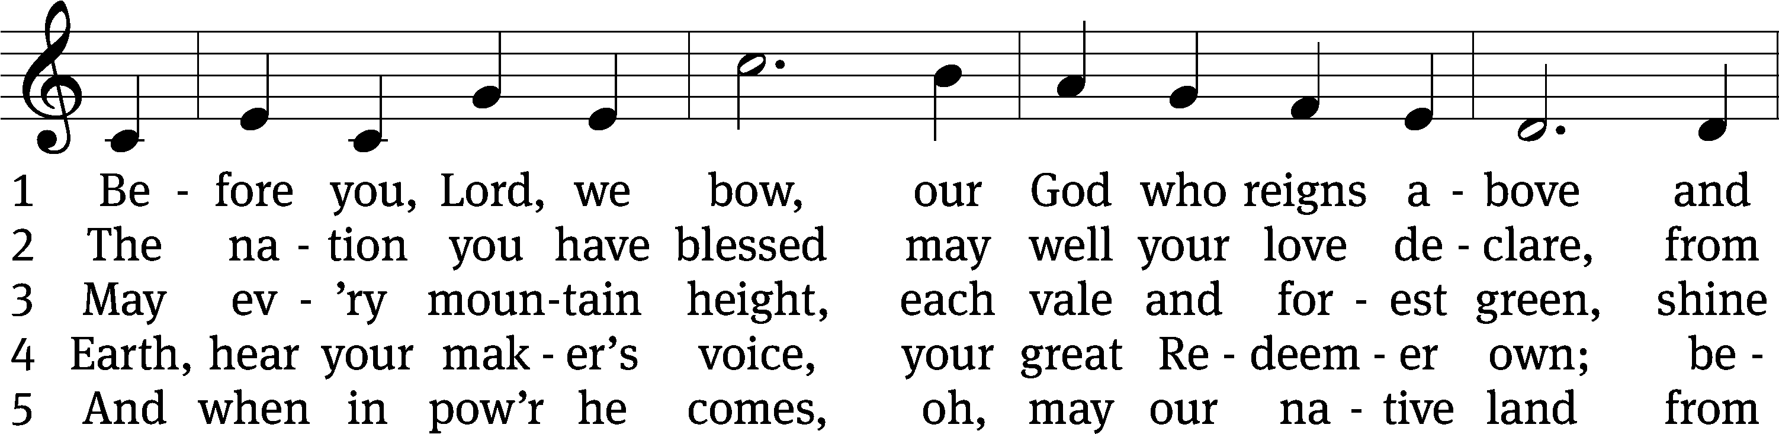
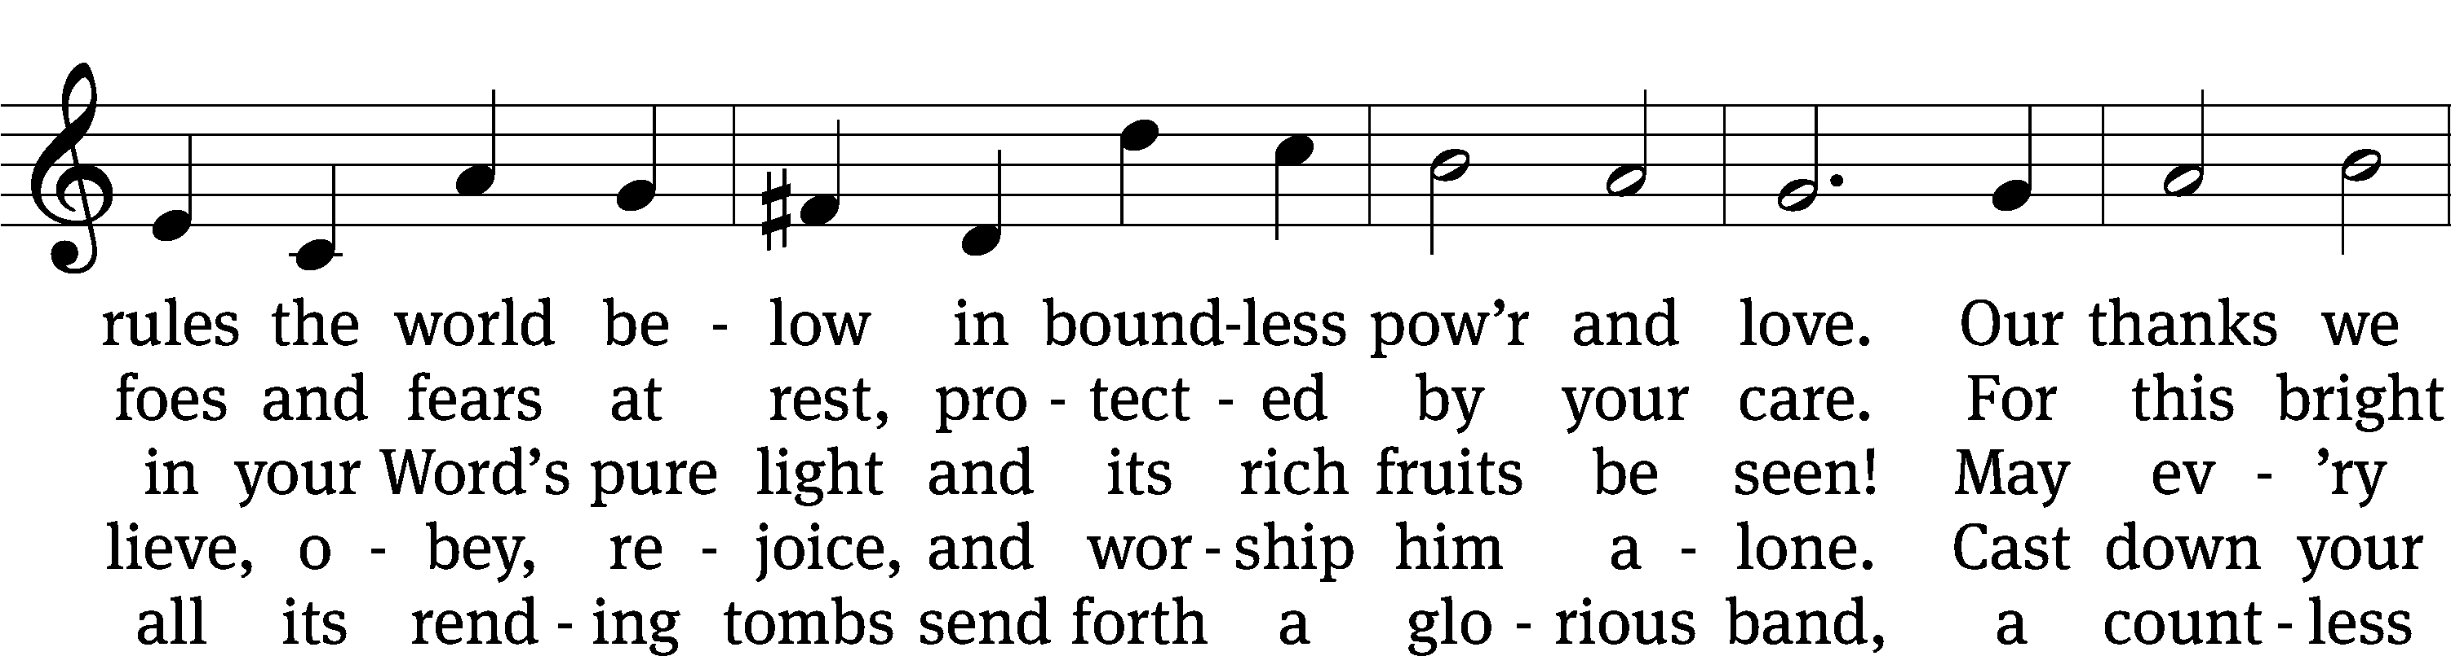
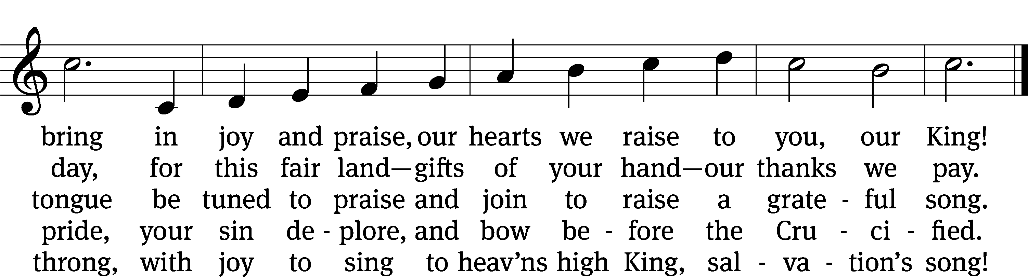
Text: Francis Scott Key, 1779–1843, alt.
Tune: John Darwall, 1731–1789
Text and tune: Public domain

Please stand, if you are able
Invocation
In the name of the Father and of the Son and of the Holy Spirit.
Amen.
Confession
If we claim to be without sin, we deceive ourselves and the truth is not in us.
If we confess our sins, God is faithful and just
and will forgive us our sins
and purify us from all unrighteousness.

Let us confess our sins to the Lord.
Holy God, gracious Father,
I am sinful by nature
and have sinned against you in my thoughts, words, and actions.
I have not loved you with my whole heart;
I have not loved others as I should.
I deserve your punishment both now and forever.
But Jesus, my Savior, paid for my sins
with his innocent suffering and death.
Trusting in him, I pray: God, have mercy on me, a sinner.

Our gracious Father in heaven has been merciful to us. He sent his only Son, Jesus Christ, who gave his life as the atoning sacrifice for the sins of the whole world. Therefore, as a called servant of Christ and by his authority, I forgive you all your sins in the name of the Father and of the Son and of the Holy Spirit.
Amen.

Lord, Have Mercy

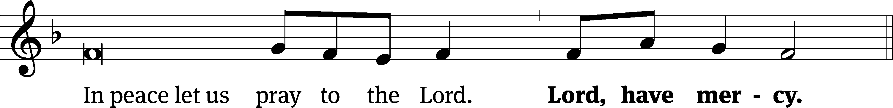
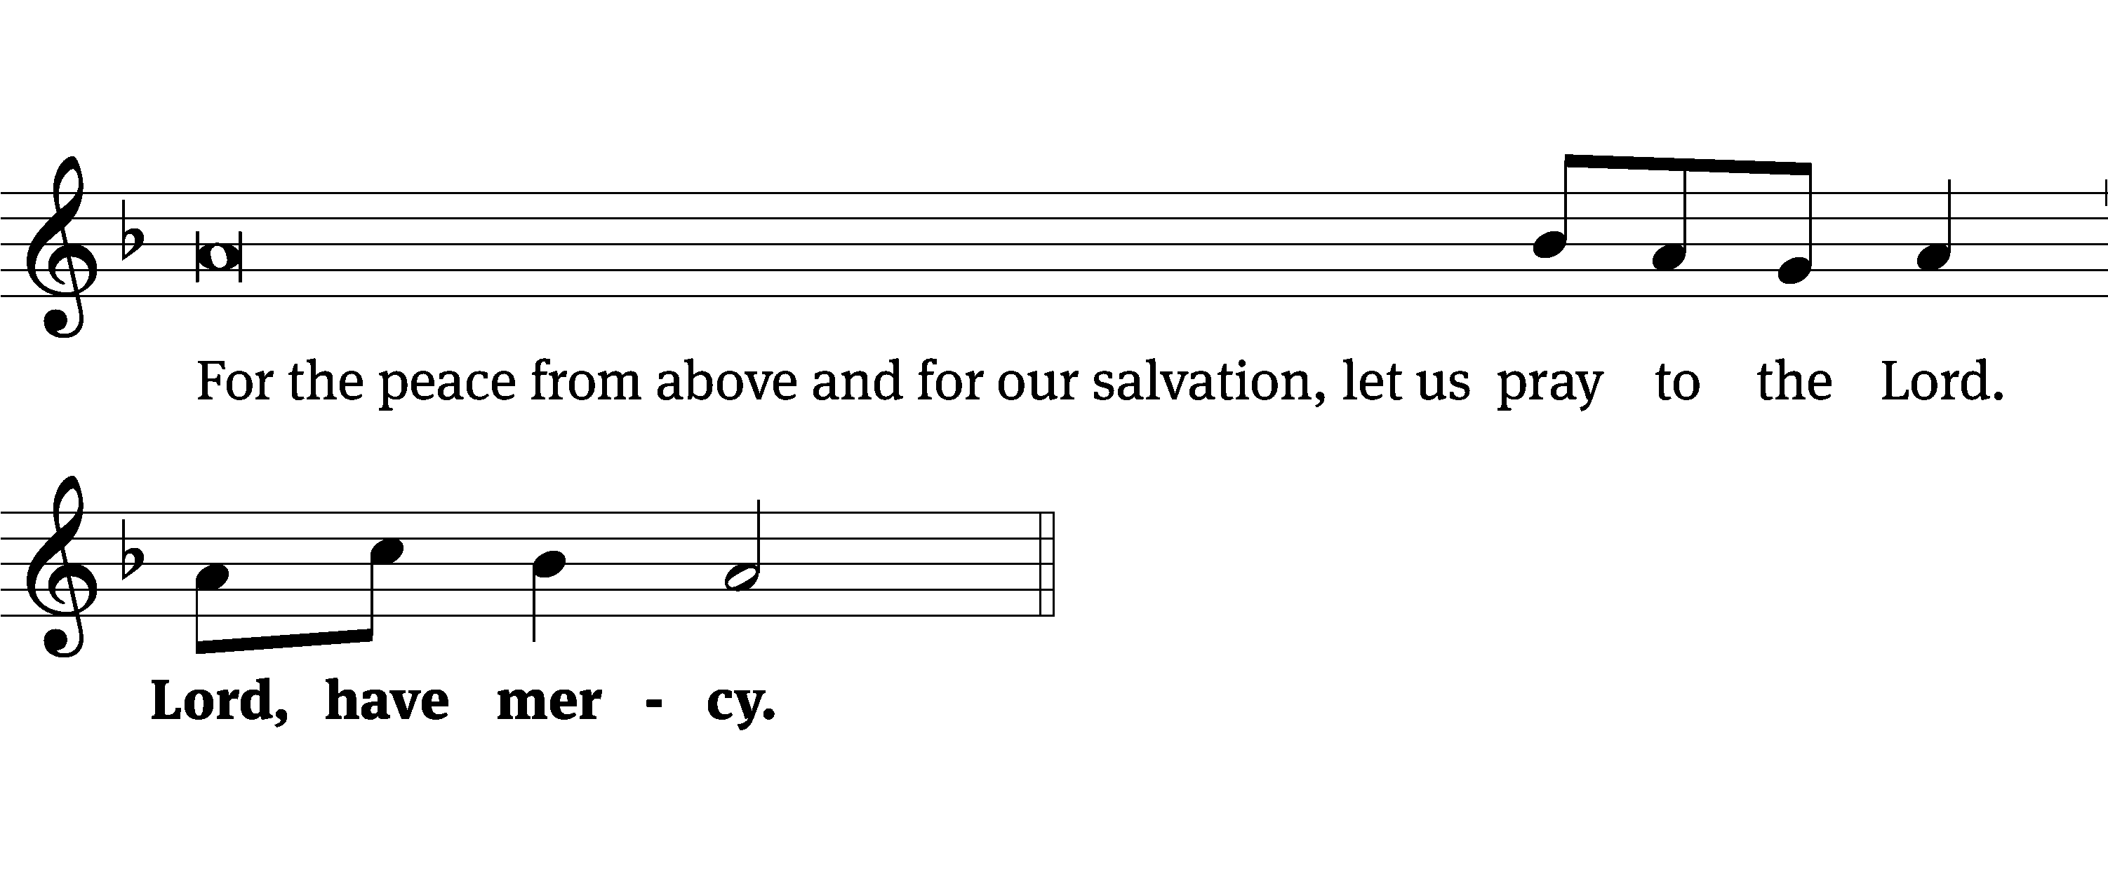
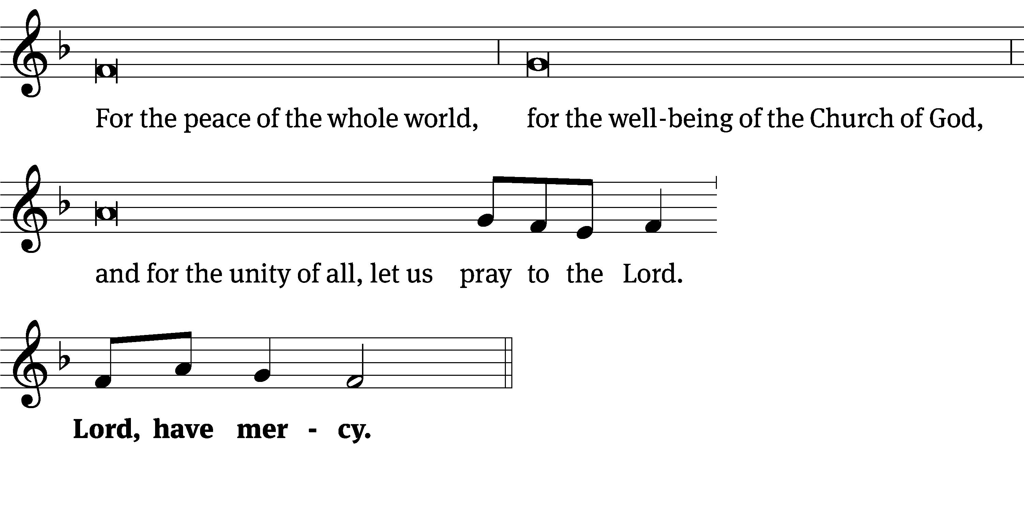
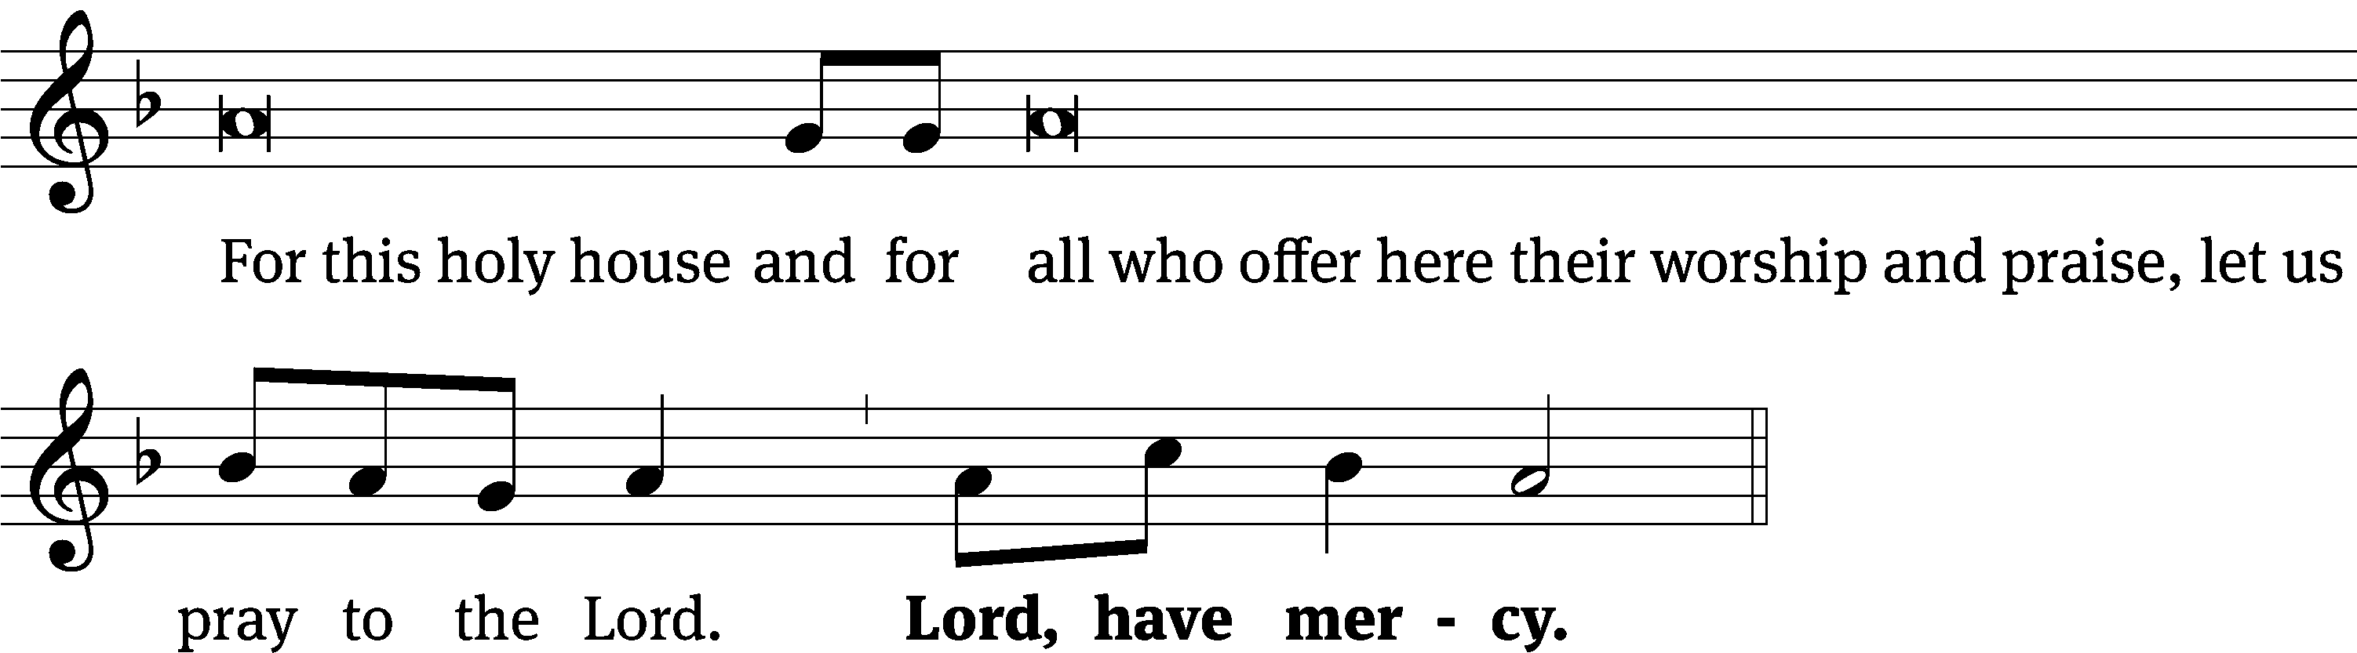
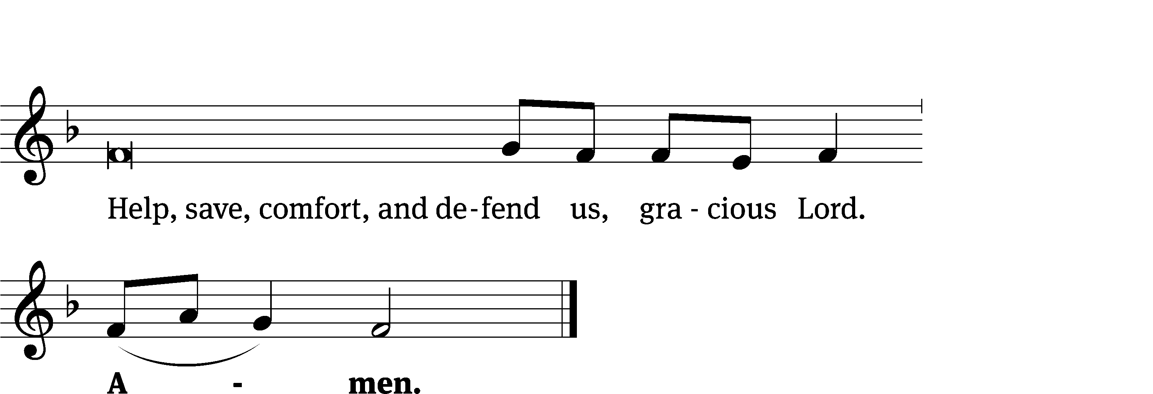
Tune: Kevin Becker
Tune: © 2021 Northwestern Publishing House. Used by permission: OneLicense no. 727703

Glory Be to God CW 157
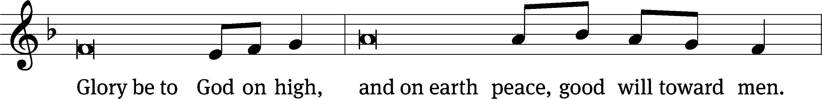
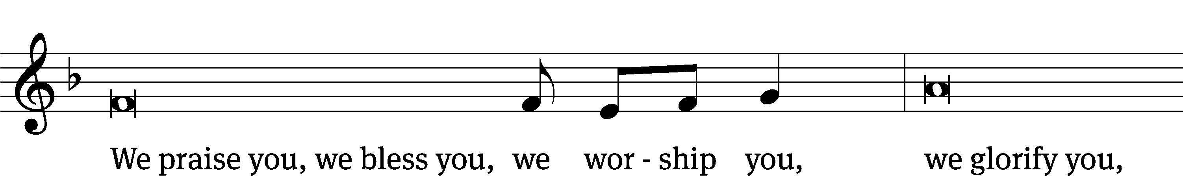
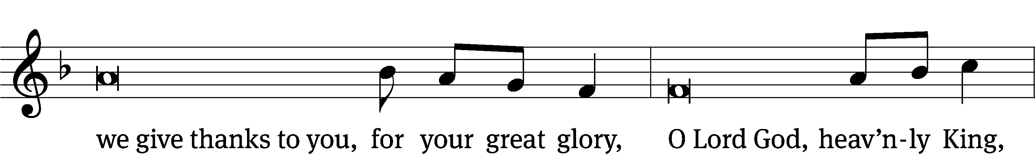
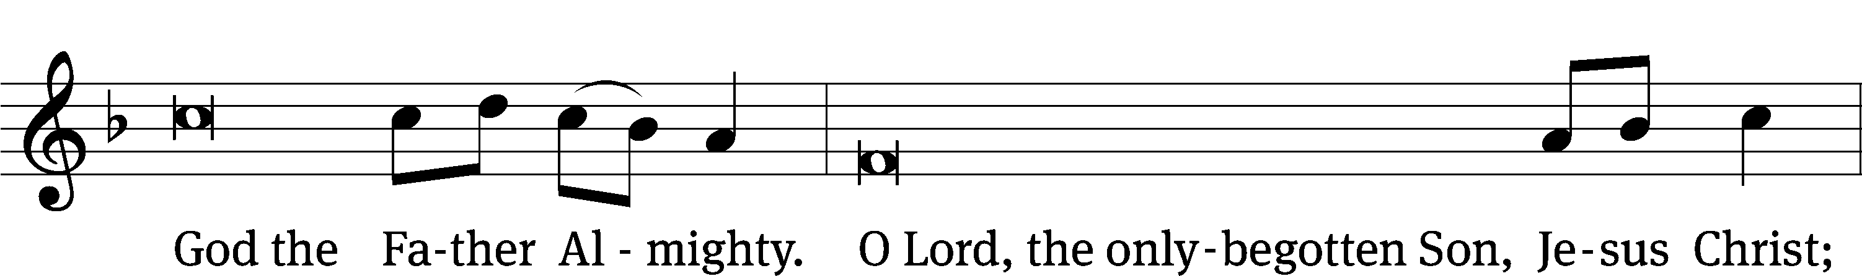
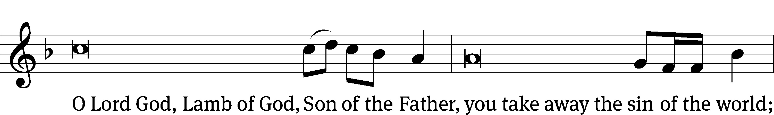
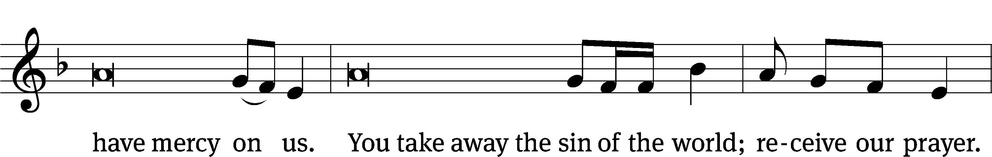
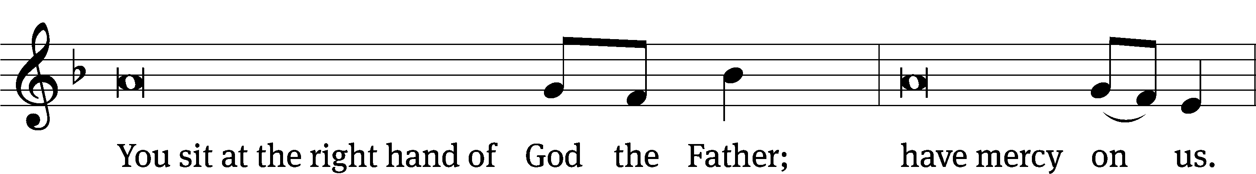
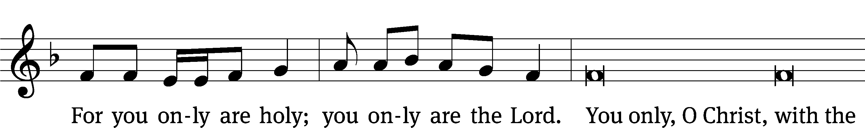
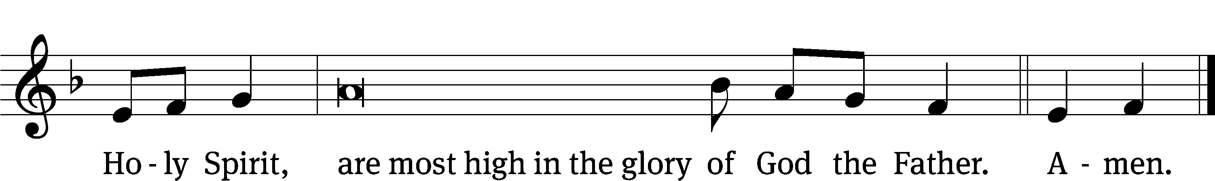

The Lord be with you.
And also with you.
Prayer of the Day
Let us pray.

Almighty God, you have built your church on the foundation of the apostles and prophets with Christ Jesus himself as the cornerstone. Continue to send your messengers to preserve your people in true peace, that, by the preaching of your Word, your church may be kept free from all harm and danger; through your Son, Jesus Christ our Lord, who lives and reigns with you and the Holy Spirit, one God, now and forever.
Amen.

Please be seated

First Reading Ezekiel 2:9-3:11
⁹ Then I looked, and I saw a hand stretched out toward me, and in it there was a rolled-up scroll. ¹⁰ He unrolled it in front of me, and there was writing on both sides. Written on it was: Laments, Groaning, and Woe.
3 Then he said to me, “Son of man, eat what you have received. Eat this scroll, and then go, speak to the house of Israel.” ² I opened my mouth, and he fed me the scroll.
³ Then he said to me, “Son of man, feed your stomach and fill your belly with this scroll that I am giving you.” I ate, and in my mouth it was sweet like honey.
⁴ He then said to me, “Son of man, go now to the house of Israel and speak my words to them. ⁵ For you are not being sent to a people who have incomprehensible speech or a difficult language, but you are being sent to the house of Israel. ⁶ Nor are you being sent to many peoples who have incomprehensible speech and difficult languages, whose words you cannot understand. Certainly, if I were to send you to such people, they would listen to you. ⁷ But the house of Israel will not be willing to listen to you because they are not willing to listen to me, because the whole house of Israel is hard-headed and hard-hearted. ⁸ Look, I have made your face just as hard as their faces and your forehead just as hard as their foreheads. ⁹ I have made your forehead like the hardest stone, harder than flint. Do not fear them, and do not be intimidated by their looks, for they are a rebellious house.”
¹⁰ Then he said to me, “Son of man, receive into your heart all my words that I will speak to you, and hear them with your ears. ¹¹ Go now to the exiles, to your own people.^{[a]} You shall speak to them and say to them, ‘This is what the Lord God says,’ whether they listen or they do not.”

The Word of the Lord.
Thanks be to God.

Psalm 67D Let the People Praise You, O God Psalm 67D
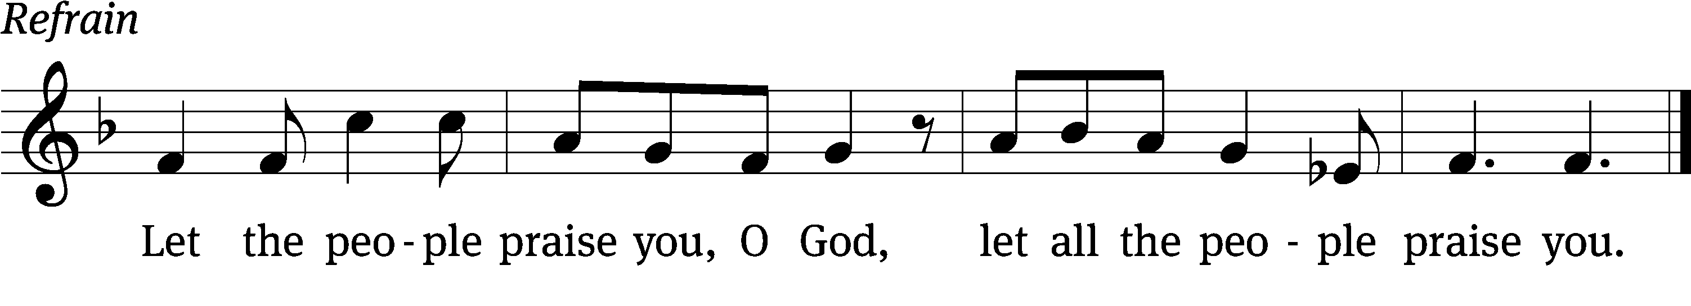

May God be gracious to us and / bless us
and make his face / shine on us—
so that your ways may be / known on earth,
your salvation among all / nations.
May the peoples / praise you, God;
may all the peoples / praise you.
May the nations be glad and / sing for joy,
for you rule the peoples with equity and guide the nations / of the earth. Refrain

The land yields its / harvest;
God, our God, / blesses us.
May God / bless us still,
so that all the ends of the earth will / fear him.
Glory be to the Father and / to the Son
and to the Holy / Spirit,
as it was in the be- / ginning,
is now, and will be forever. / Amen. Refrain
Tune: Dale Wood
Text: © 1976 Massey H. Shepherd, Jr., admin. Augsburg Fortress. Used by permission: License no. 130003540
Tune: © 1978 Augsburg Fortress, admin. Augsburg Publishing House. Used by permission: OneLicense no. 727703
Setting: © 1993 Northwestern Publishing House, admin. Kermit G. Moldenhauer. Used by permission: OneLicense no. 727703

Second Reading 1 Peter 5:1-4
¹ Therefore, as a fellow elder and a witness of the sufferings of Christ, and as one who also shares in the glory that is about to be revealed, I appeal to the elders among you: ² Shepherd God’s flock that is among you, serving as overseers, not grudgingly but willingly, as God desires, not because you are greedy for money but because you are eager to do it. ³ Do not lord it over those entrusted to your care, but be examples for the flock. ⁴ And when the Chief Shepherd appears, you will receive an unfading crown of glory.

The Word of the Lord.
Thanks be to God.

Please stand, if you are able

Gospel Acclamation Isaiah 52:7
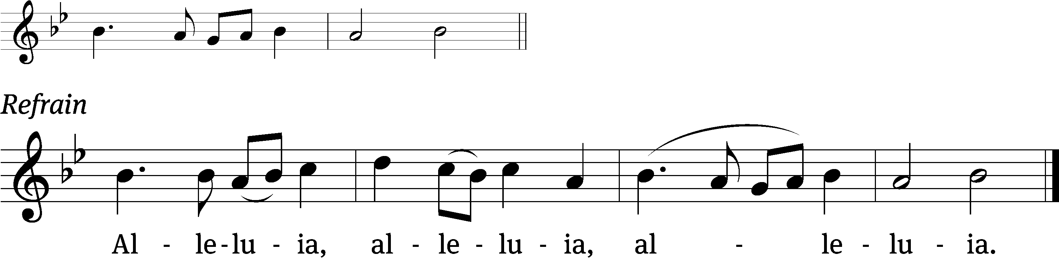
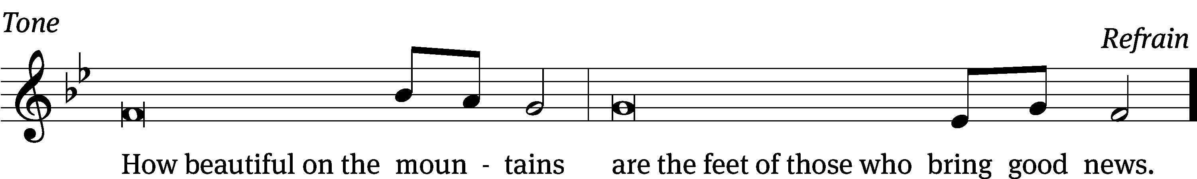
Tune: © 2021 Northwestern Publishing House. Used by permission: OneLicense no. 727703

Gospel Luke 10:1-12, 16-20
¹ After this, the Lord appointed seventy-two^{[a]} others and sent them out two by two ahead of him^{[b]} to every town and place where he was about to go.
² He told them, “The harvest is plentiful, but the workers are few. So ask the Lord of the harvest to send out workers into his harvest field. ³ Go your way. Look, I am sending you out as lambs among wolves. ⁴ Do not carry a money bag or traveler’s bag or sandals. Do not greet anyone along the way. ⁵ Whenever you enter a house, first say, ‘Peace be to this house.’ ⁶ And if a peaceful person is there, your peace will rest on him, but if not, it will return to you. ⁷ Remain in that same house, eating and drinking what they give you, because the worker is worthy of his pay. Do not keep moving from house to house. ⁸ Whenever you enter a town and they welcome you, eat what is set before you. ⁹ Heal the sick who are in the town and tell them, ‘The kingdom of God has come near you.’
¹⁰ “But whenever you enter a town and they do not welcome you, go out into its streets and say, ¹¹ ‘Even the dust from your town that clings to our feet, we wipe off against you. Nevertheless know this: The kingdom of God has come near.’ ¹² I tell you, it will be more bearable for Sodom on that day than for that town.
¹⁶ Whoever listens to you listens to me. Whoever rejects you rejects me. And whoever rejects me rejects the one who sent me.”
¹⁷ The seventy-two returned with joy, saying, “Lord, even the demons submit to us in your name!”
¹⁸ He told them, “I was watching Satan fall like lightning from heaven. ¹⁹ Look, I have given you authority to trample on snakes and scorpions and over all the power of the enemy. And nothing will ever harm you. ²⁰ Nevertheless, do not rejoice that the spirits submit to you, but rejoice that your names have been written in heaven.”

The Gospel of the Lord.
Praise be to you, O Christ!
Please be seated

767 Lord of Glory, You Have Bought Us CW 767
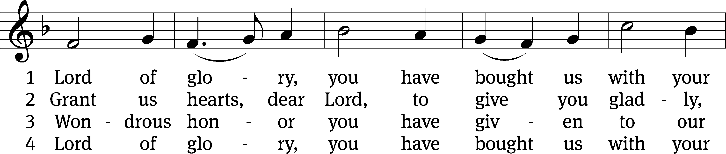
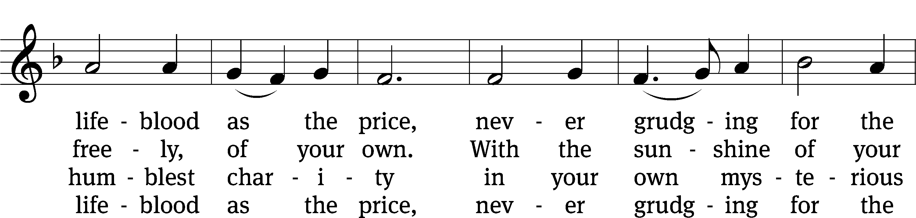
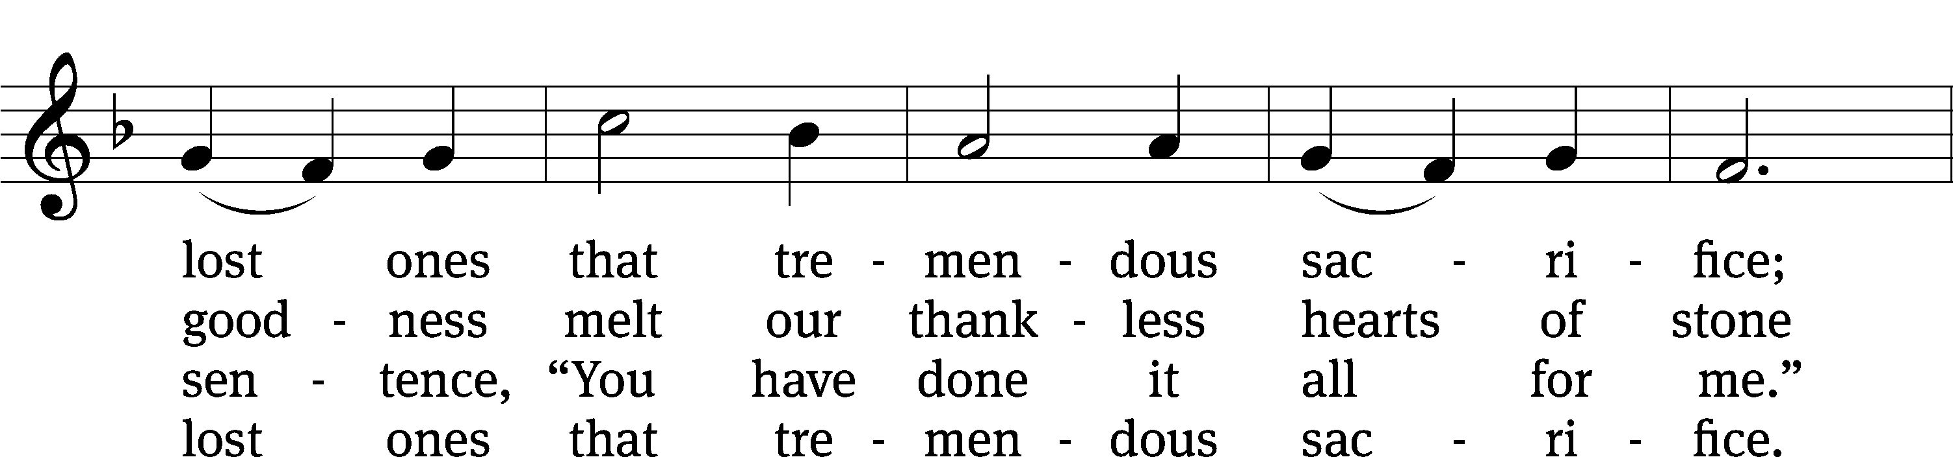
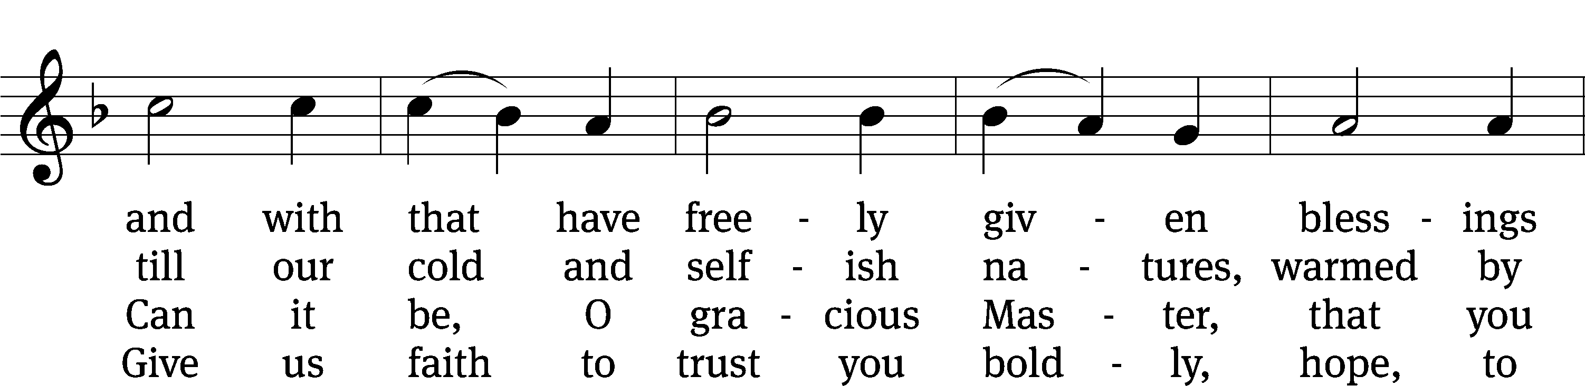
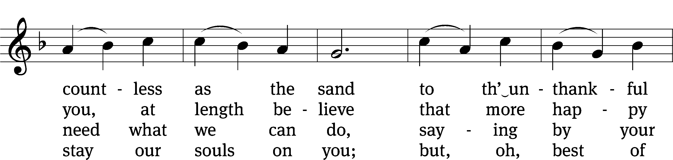
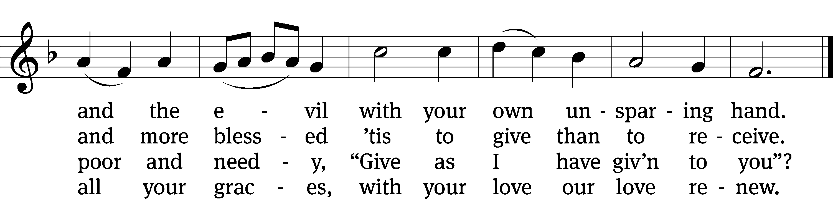
SERMON Galatians 5:1
“The High Cost of Freedom”

Please stand, if you are able
Nicene Creed
We believe in one God, the Father, the Almighty,
maker of heaven and earth,
of all that is,
seen and unseen.
We believe in one Lord, Jesus Christ, the only Son of God,
eternally begotten of the Father,
God from God, Light from Light, true God from true God,
begotten, not made,
of one being with the Father.
Through him all things were made.
For us and for our salvation, he came down from heaven,
was incarnate of the Holy Spirit and the Virgin Mary,
and became truly human.
For our sake he was crucified under Pontius Pilate.
He suffered death and was buried.
On the third day he rose again in accordance with the Scriptures.
He ascended into heaven
and is seated at the right hand of the Father.
He will come again in glory to judge the living and the dead,
and his kingdom will have no end.
We believe in the Holy Spirit,
the Lord, the giver of life,
who proceeds from the Father and the Son,
who in unity with the Father and the Son
is worshiped and glorified,
who has spoken through the prophets.
We believe in one holy Christian and apostolic Church.
We acknowledge one baptism for the forgiveness of sins.
We look for the resurrection of the dead
and the life of the world to come. Amen.
Offertory
Prayer of the Church

The Sacrament
Preface CW 165
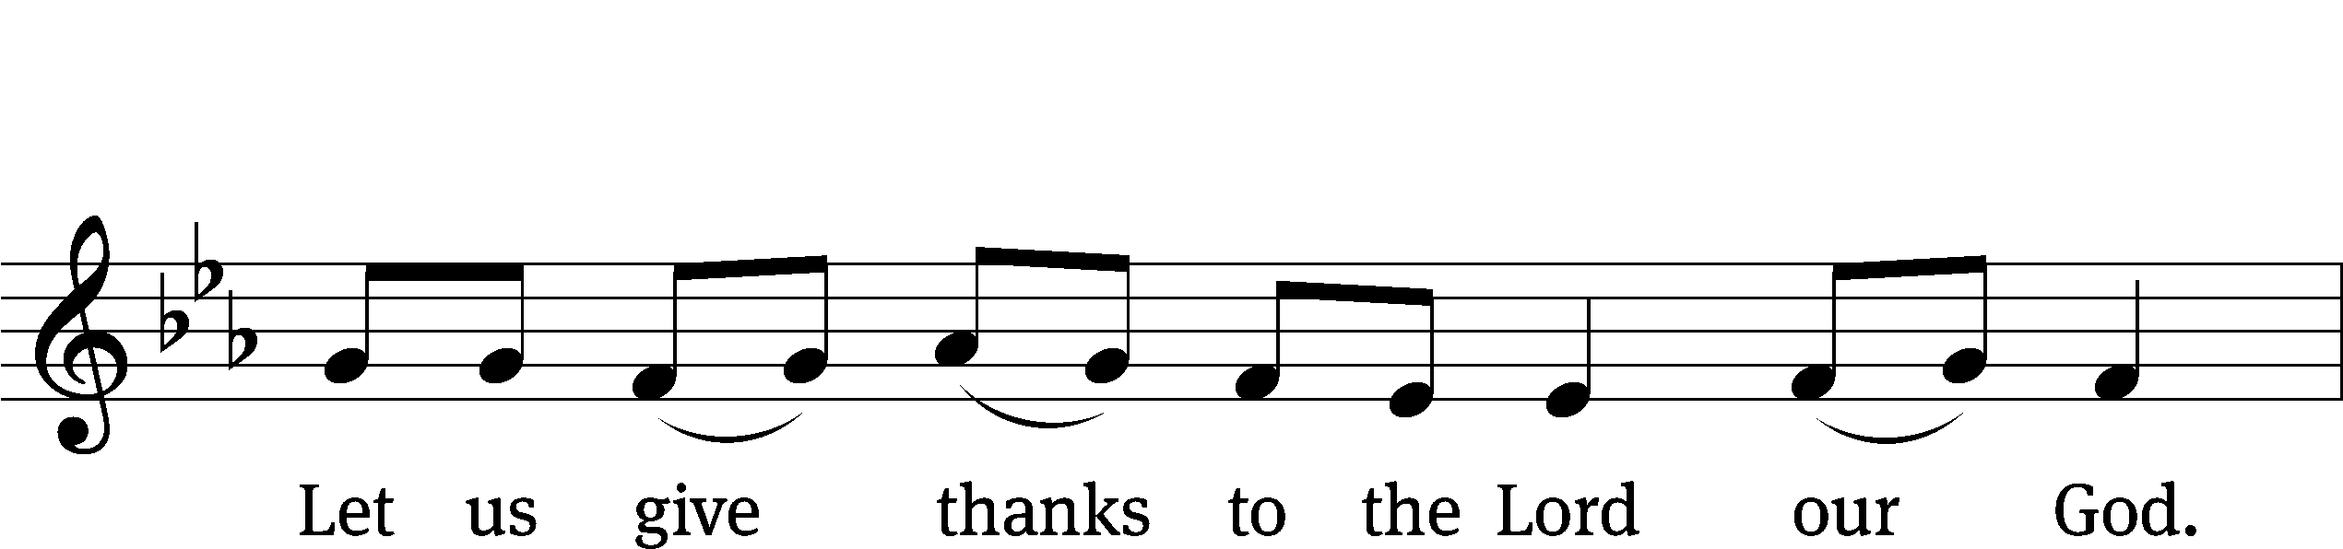
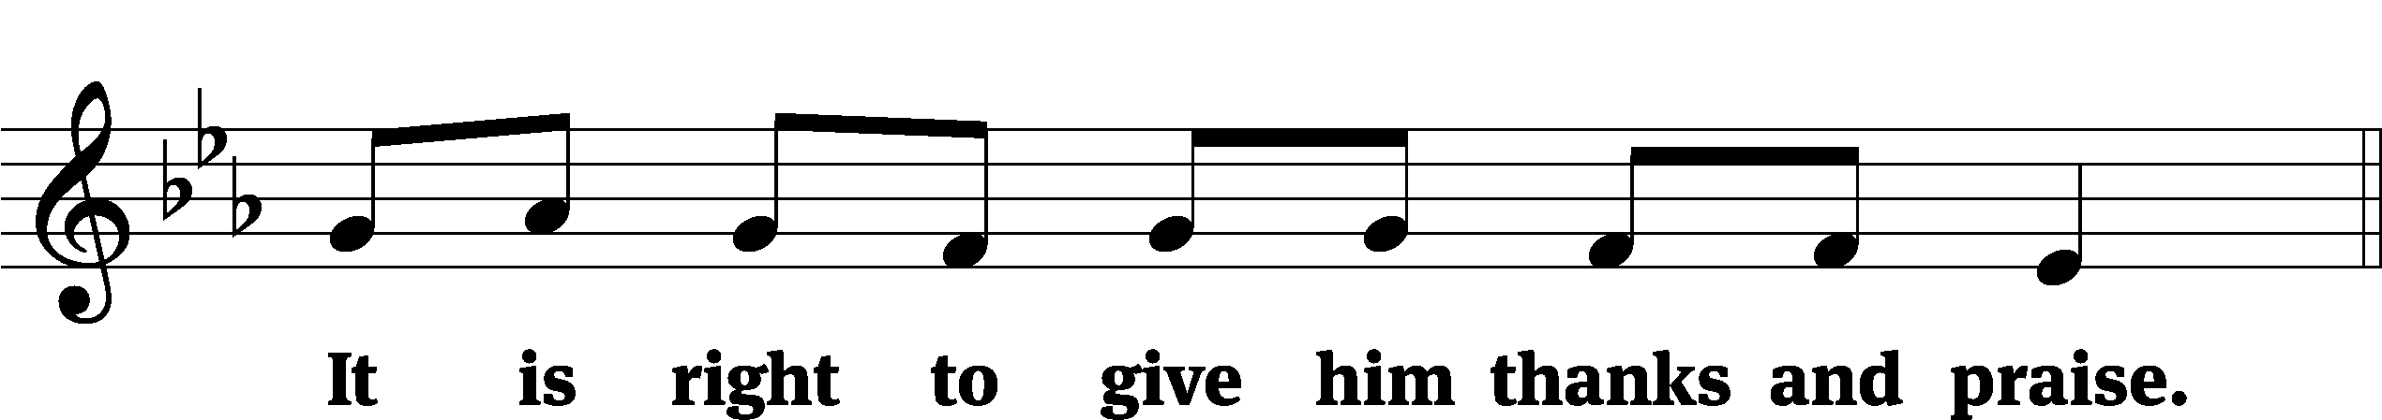

It is truly good and right that we should at all times and in all places give you thanks, O Lord, holy Father, almighty and everlasting God, through Jesus Christ our Lord, who promised that wherever two or three come together in his name, there he is with them to shepherd his flock until he comes again in glory. Therefore, with all the saints on earth and hosts of heaven, we praise your holy name and join their glorious song:

Holy, Holy, Holy CW 167
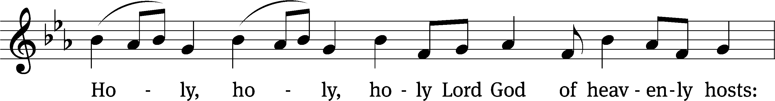
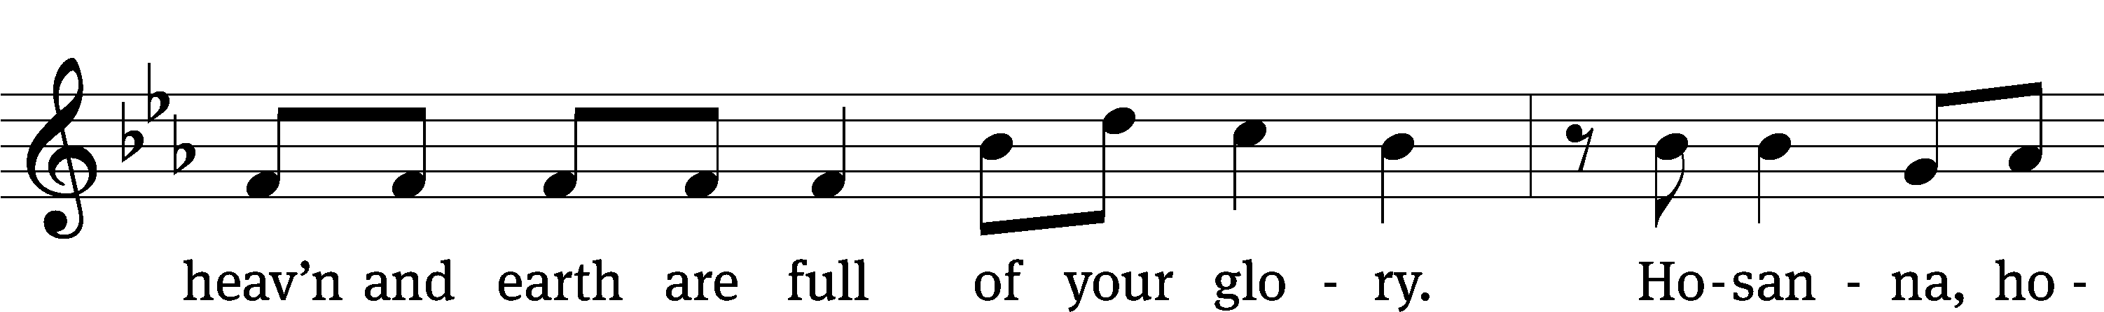
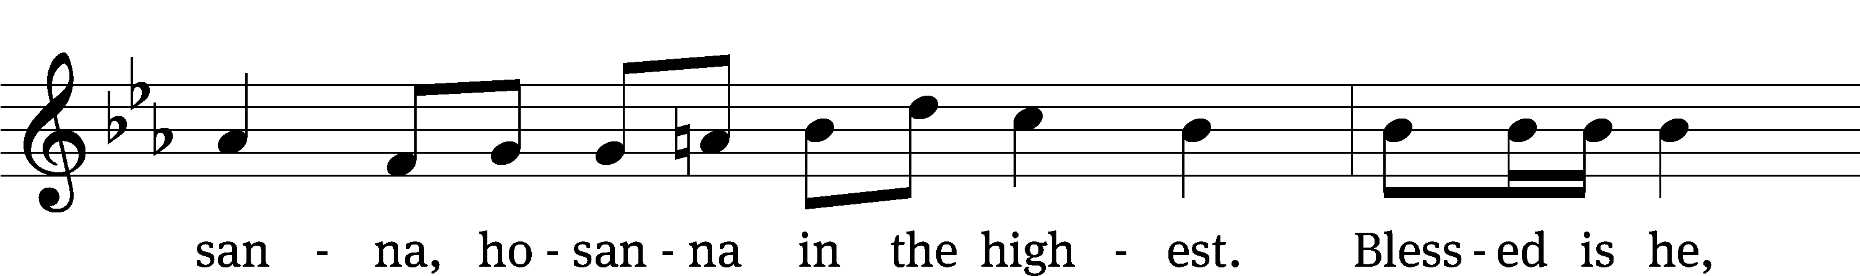
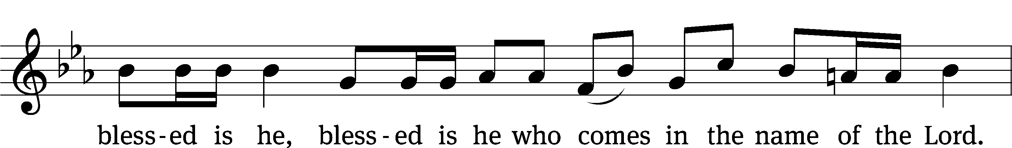
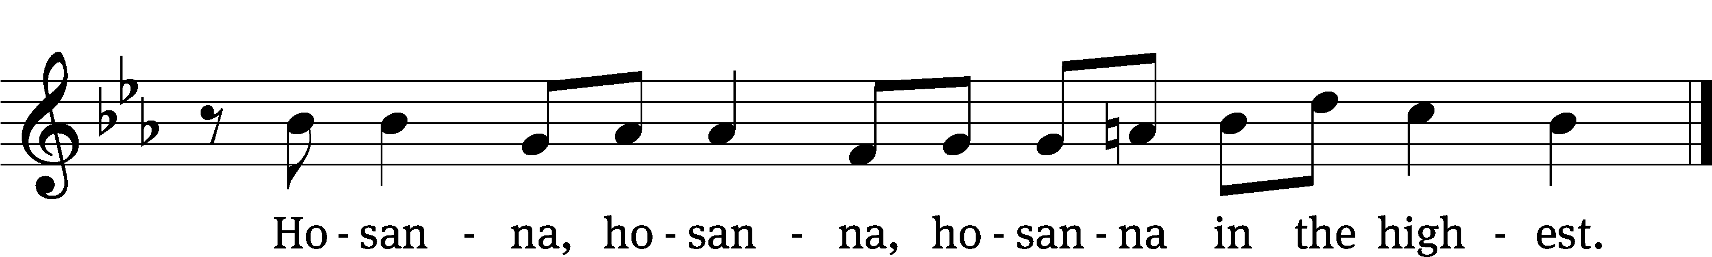

Prayer of Thanksgiving
We give thanks to you, O God, through your dear Son, Jesus Christ, whom you sent to be our Savior, our Redeemer, and the messenger of your grace. Through him you made all things; in him you are well pleased. He is the incarnate Word, conceived by the Holy Spirit and born of the Virgin Mary. To fulfill your promises, he stretched out his hands on the cross and released from eternal death all who believe in you.

As we remember Jesus’ death and resurrection, we thank you that you have gathered us together to receive your Son’s body and blood. Send us your Spirit, unite us as one, and strengthen our faith so that we may praise you in your Son, Jesus Christ. Through him, we glorify and honor you, O God our Father, with the Holy Spirit, one God, now and forever.
Amen.

Lord’s Prayer
Our Father, who art in heaven, hallowed be thy name, thy kingdom come, thy will be done on earth as it is in heaven. Give us this day our daily bread; and forgive us our trespasses, as we forgive those who trespass against us; and lead us not into temptation, but deliver us from evil. For thine is the kingdom and the power and the glory forever and ever. Amen.

Words of Institution
Our Lord Jesus Christ, on the night he was betrayed, took bread; and when he had given thanks, he broke it and gave it to his disciples, saying, “Take and eat; this is my body, which is given for you. Do this in remembrance of me.”
Then he took the cup, gave thanks, and gave it to them, saying, “Drink from it, all of you; this is my blood of the new covenant, which is poured out for you for the forgiveness of sins. Do this, whenever you drink it, in remembrance of me.”

The peace of the Lord be with you always.
Amen.

O Christ, Lamb of God CW 169
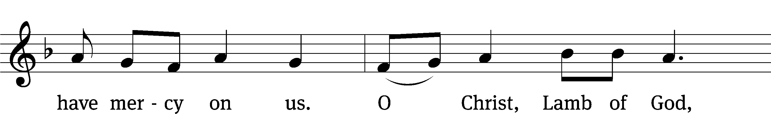
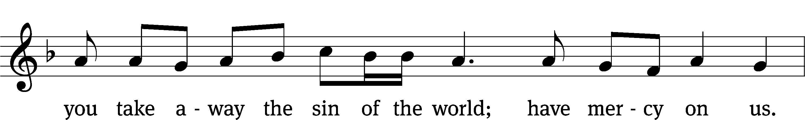
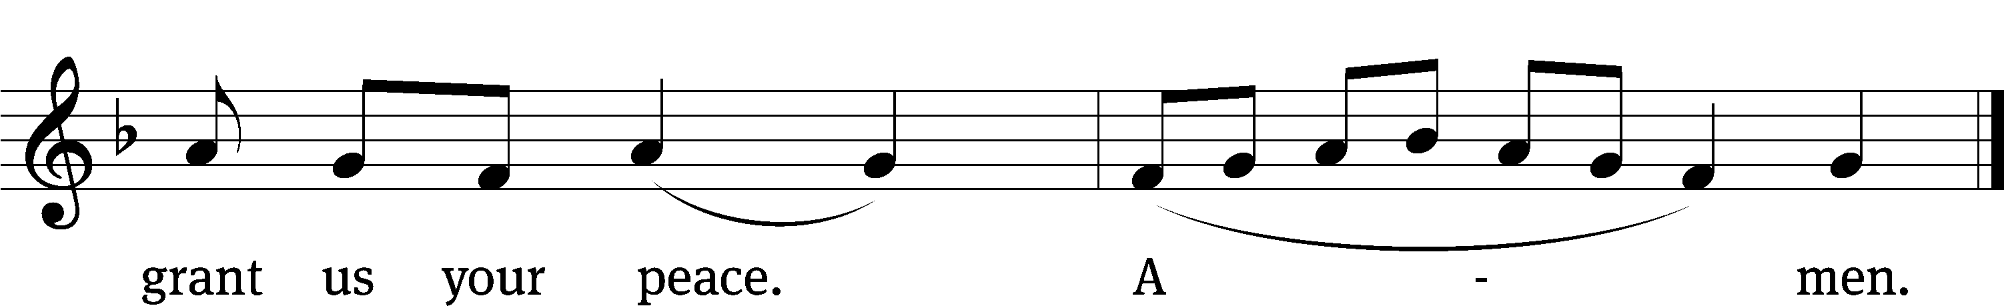

Please be seated

659 Jesus Christ, Our Blessed Savior CW 659
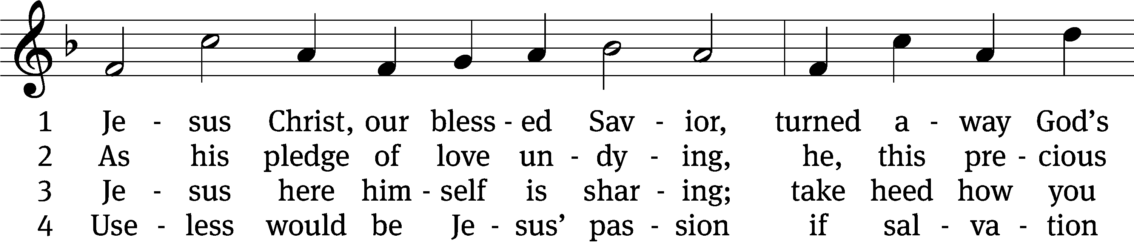
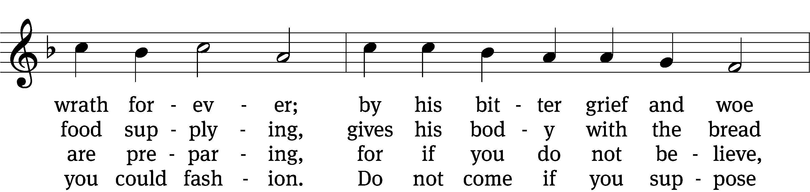
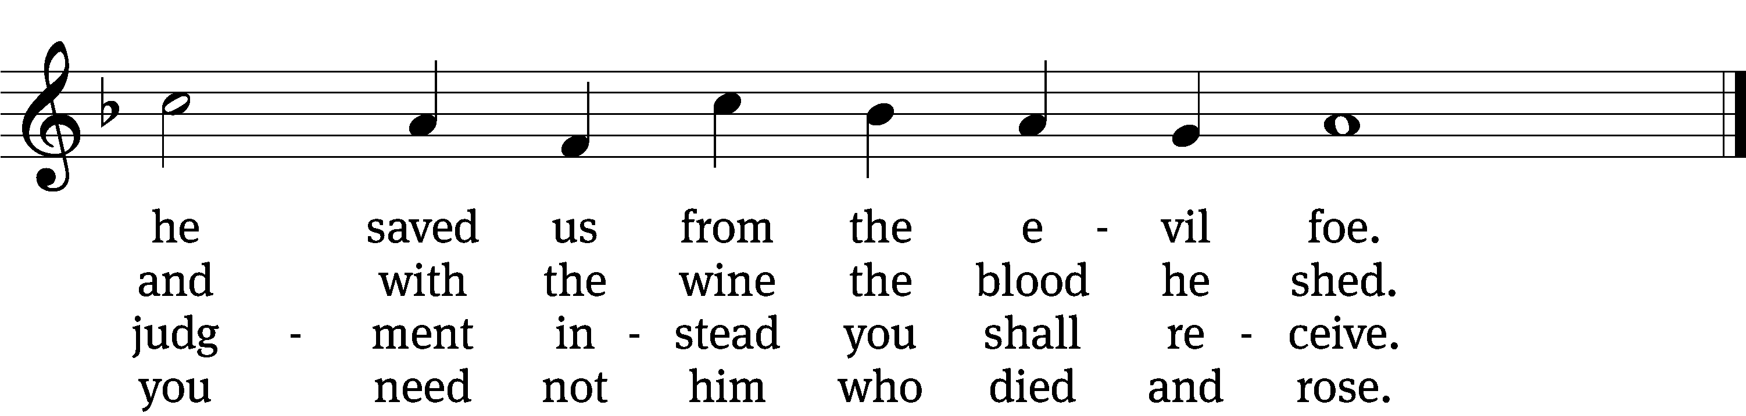

5 Christ says, “Come, all you that labor,
and receive my grace and favor;
those who feel no pain or ill
need no physician’s help or skill.”

6 Then hold fast with faith unshaken
that this food is to be taken
by the souls who are distressed,
by hearts that long for peace and rest.

7 Praise the Father, who from heaven
unto us such food has given
and, to mend what we have done,
gave into death his only Son.

8 If your heart this truth professes
and your mouth your sin confesses,
surely you will be his guest
and at his banquet ever blest.
Please stand, if you are able

Give thanks to the Lord, for he is good;
his mercy endures forever.
Whenever we eat this bread and drink this cup,
we proclaim the Lord’s death until he comes.

We give thanks, almighty God, that you have refreshed us with this saving gift. We pray that through it you will strengthen our faith in you and increase our love for one another. We ask this in the name of Jesus Christ our Lord, who lives and reigns with you and the Holy Spirit, one God, now and forever.
Amen.

Blessing
The Lord bless you and keep you.
The Lord make his face shine on you and be gracious to you.
The Lord look on you with favor and give you peace.
Amen.

Please be seated
774 God Bless Our Native Land CW 774
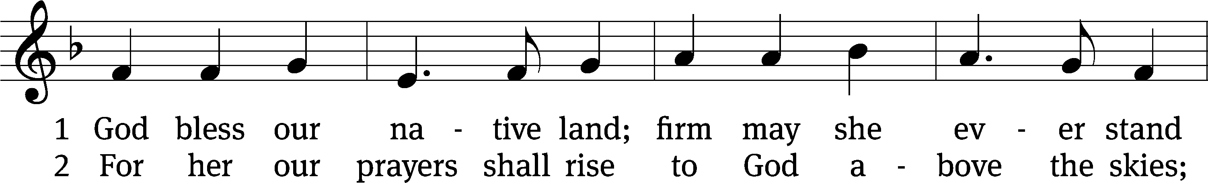
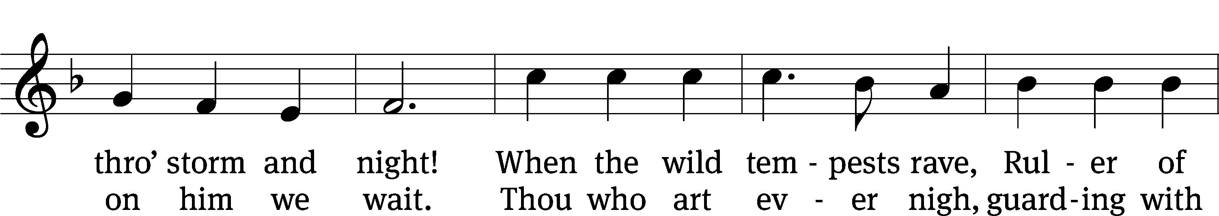
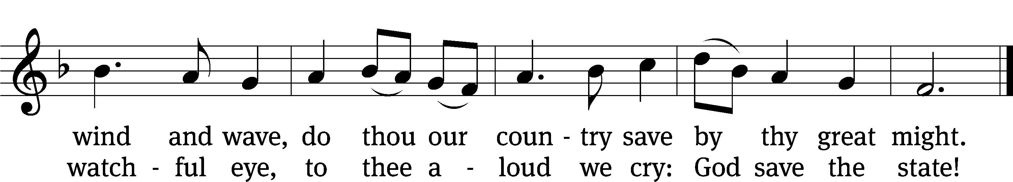
Text (st. 1): Charles T. Brooks, 1813–1883, st. 1, alt.; (st. 2): John S. Dwight, 1813–1893
Tune: Thesaurus Musicus, London, c. 1740
Text and tune: Public domain
Acknowledgments
Setting One from Christian Worship
Software distributed in partnership with Northwestern Publishing House.
Created by Christian Worship: Service Builder © 2022 Concordia Publishing House.

Serving in Worship
Officiant Pastor Natsis
Organist Ann Hoeft
Deacons (Thursday) Steve Hoeft and Jim Tice
(Sunday) Jeff Neuburger and Dave Stevenson
Ushers (Thursday) Dale Finkbeiner and Mark Finkbeiner
(Sunday) Ed Sala and Al Whitley
Altar Guild Esther Gross and Diane Stevenson
Videographer Jake Vershum

