THE sixth SUNDAY
after pentecost
tRINITY EVANGELICAL LUTHERAN CHURCH | Saline, Michigan
July 6/9, 2023

WELCOME TO WORSHIP

Thank you for joining us in God’s house today! We cordially ask that our Guests with us this morning sign one of the guestbooks located at either the front or back entryways.

THANK OFFERING: Members of Trinity give their offering as an expression of love and thankfulness to the Lord and to help support the Lord’s work in our community and around the world. Visitors need not feel obligated to participate in this offering which supports our ministry.

Restrooms are located at the back of the upper level (the annex), and in the basement (down the back stairs of the sanctuary or annex). Handicap access is available, please ask an usher for assistance.

Young Families / Toddler Bags – We are GLAD YOU BROUGHT YOUR CHILDREN to our worship service. Jesus said: “Let the little children come to me and do not hinder them, for the kingdom of God belongs to such as these.” We know that having little children in church can be a challenge, but DO NOT WORRY about it. Many of your fellow worshippers have been in your shoes and are just happy you brought your children with you. For your convenience, we have reserved the back rows of seating for parents with small children. These areas provide more flexibility for your family, as well as, easy access to move downstairs if necessary. A closed-circuit TV system allows families to continue participating in the service while downstairs. Pre-school toddler bags and children’s bulletins are available for their enjoyment. Ask an usher for one to use during the service and please return the toddler bag afterwards.

SERVICE of the word
578 Chief of Sinners Though I Be CW 578
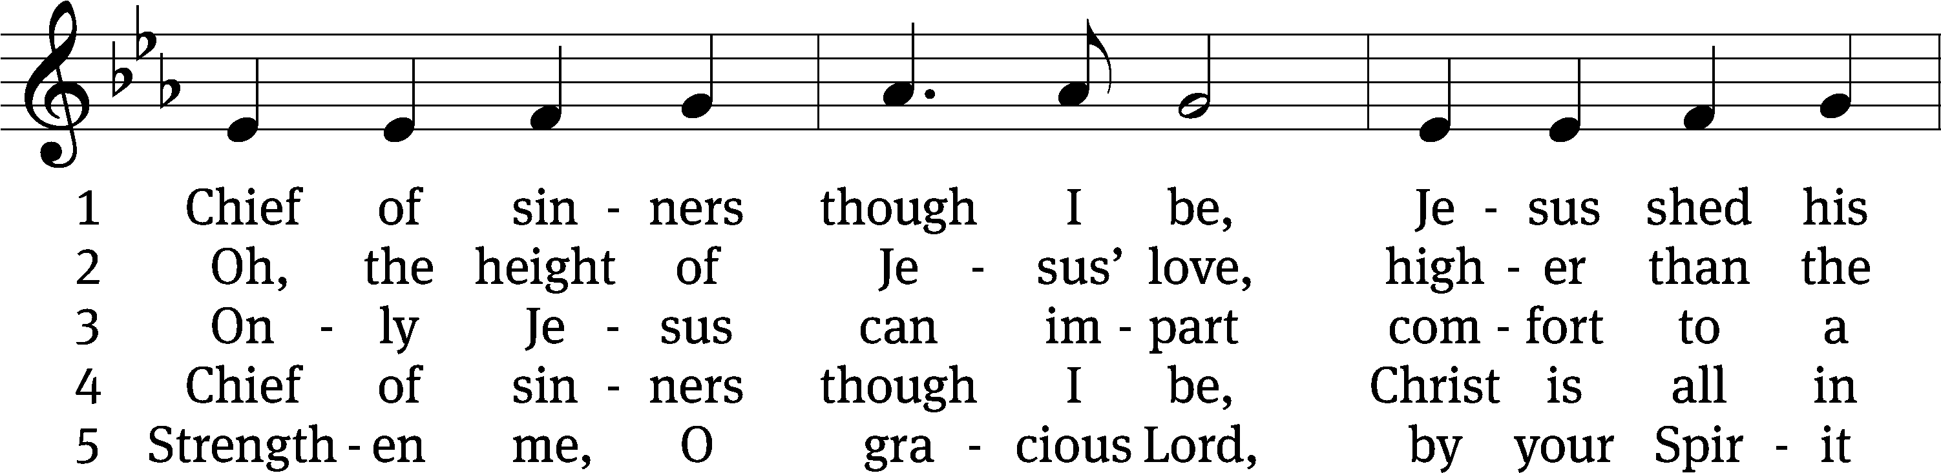
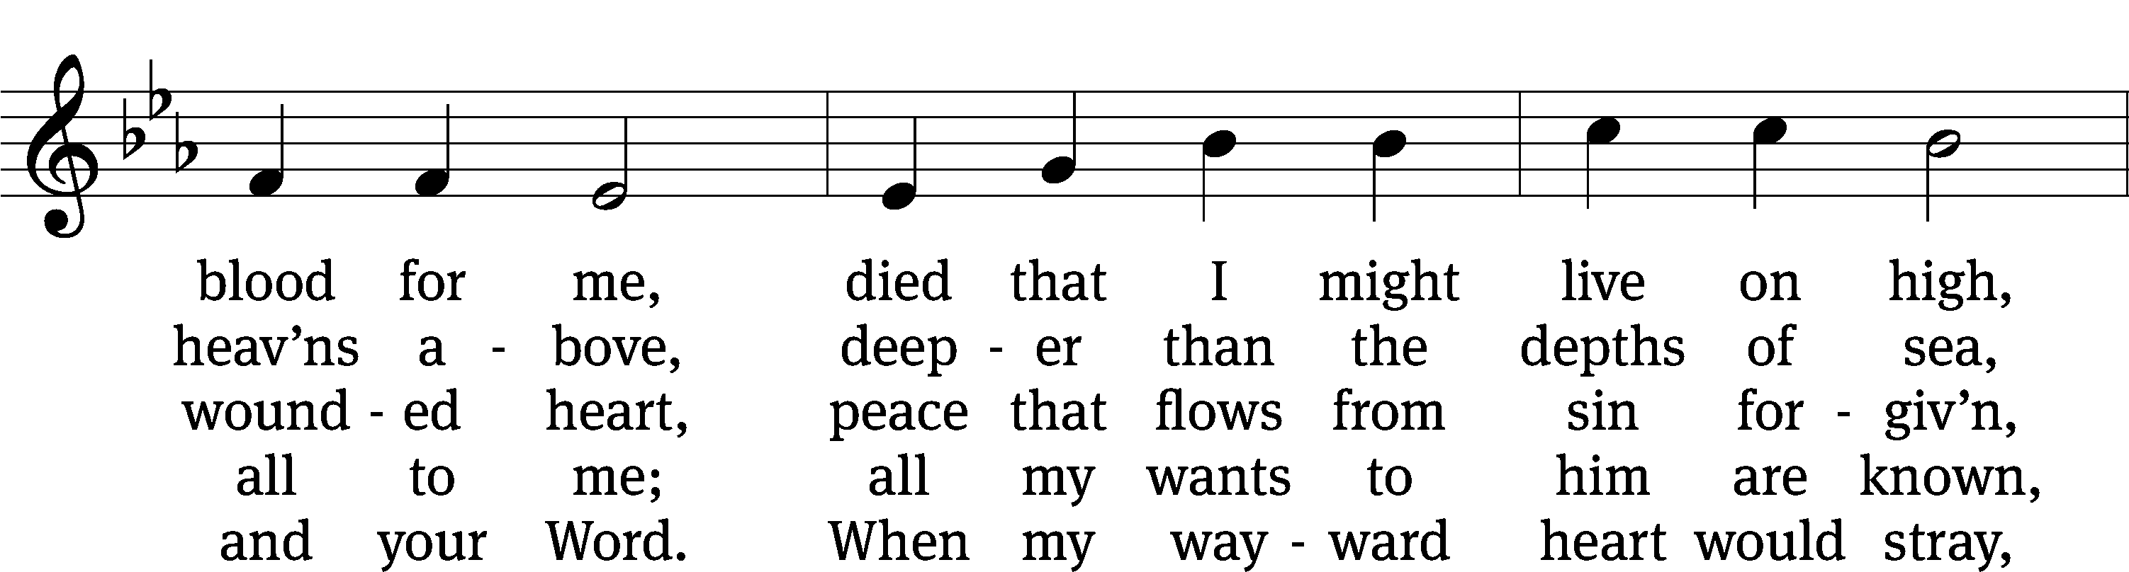
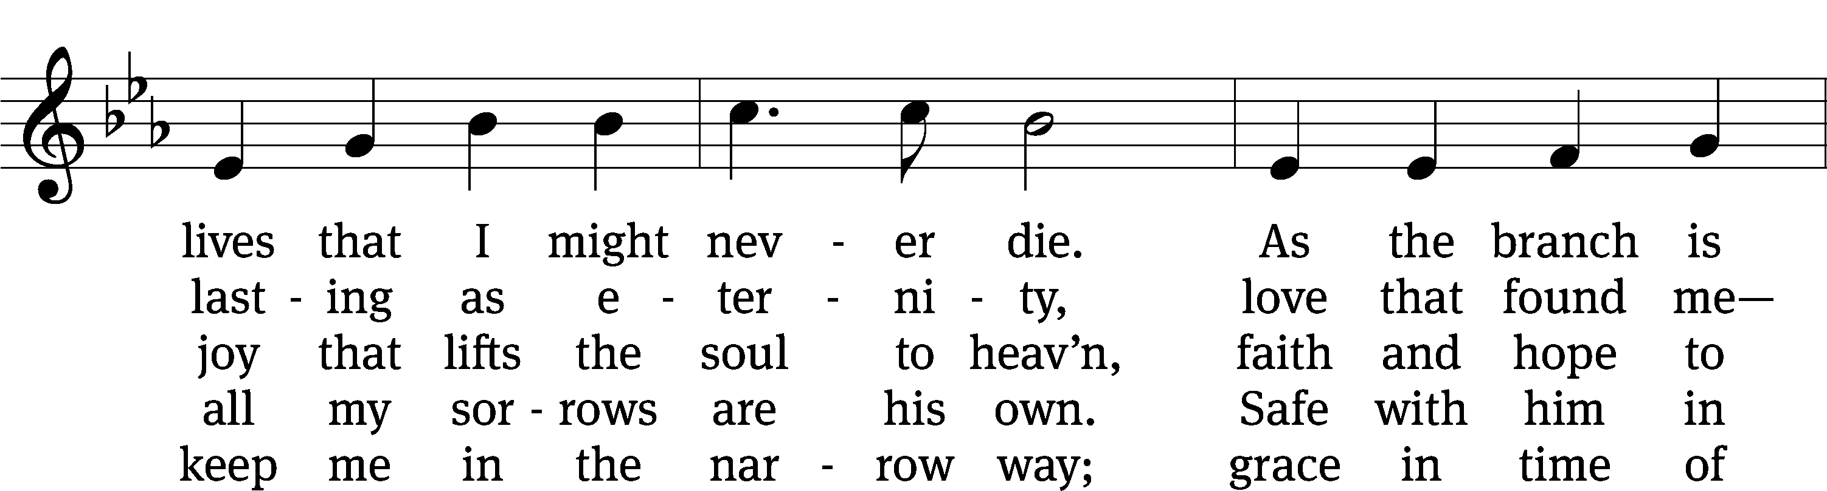
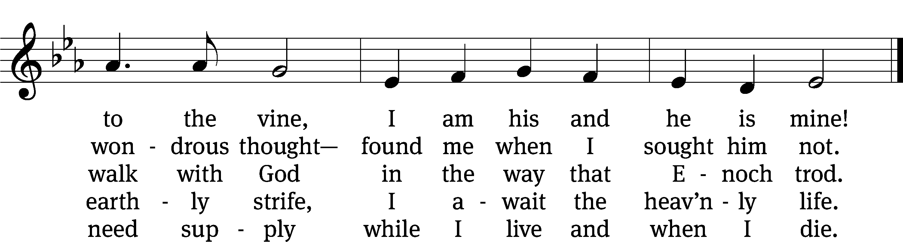
Text: William McComb, 1793–1873, alt.
Tune: Richard Redhead, 1820–1901
Text and tune: Public domain

PLEASE STAND, IF YOU ARE ABLE

invocation
M: The grace of our Lord (+) Jesus Christ and the love of God and the fellowship of the Holy Spirit be with you.
C: And also with you.
CONFESSION OF SINS
M: We have come into the presence of God, who created us to love and serve him as his dear children. But we have disobeyed him and deserve only his wrath and punishment. Therefore, let us confess our sins to him and plead for his mercy.

C: Merciful Father in heaven, I am altogether sinful from birth. In countless ways I have sinned against you and do not deserve to be called your child. But trusting in Jesus, my Savior, I pray: Have mercy on me according to your unfailing love. Cleanse me from my sin, and take away my guilt.

M: God, our heavenly Father, has forgiven all your sins. By the perfect life and innocent death of our Lord Jesus Christ, he has removed your guilt forever. You are his own dear child. May God give you strength to live according to his will.

C: Amen.
PRAYER AND PRAISE

M: In the peace of forgiveness, let us praise the Lord.

OH, TASTE AND SEE

PRAYER OF THE DAY

Let us pray.

Gracious God, our heavenly Father, your mercy attends us all our days. Be our strength and support amid the wearisome changes of this world, and at life’s end, grant us your promised rest and the full joys of your salvation; through your Son, Jesus Christ our Lord, who lives and reigns with you and the Holy Spirit, one God, now and forever.

PLEASE BE SEATED

The Word

the FIRST LESSON Exodus 33:12-23
¹² Moses said to the Lord, “Look, you yourself have been telling me, ‘Lead this people up,’ but you have not let me know whom you will send with me. Yet you have said, ‘I know you by name, and you have also found favor in my sight.’ ¹³ So now if I have found favor in your sight, please show me your ways, so that I may know you, so that I may find favor in your sight. Consider that this nation is your people.”
¹⁴ The Lord said, “My Presence will go with you, and I will give you rest.”
¹⁵ Moses said to him, “If your Presence is not going to go with me, do not send us up from here. ¹⁶ After all, how would people know that I have found favor in your sight, I and your people? Isn’t it in this way: that you go with us, so that we are distinguished, I and your people, from all the people who are on the face of the earth?”
¹⁷ The Lord said to Moses, “I will also do this thing that you have said, for you have found favor in my sight, and I know you by name.”
¹⁸ Then Moses said, “Please show me your glory.”
¹⁹ The Lord said, “I will make all my goodness pass in front of you, and I will proclaim the name of the Lord in your presence. I will be gracious to whom I will be gracious, and I will show mercy to whom I will show mercy.” ²⁰ He said, “You cannot see my face, for no human may see me and live.”
²¹ The Lord also said, “Look, there is a place next to me, where you shall stand on the rock. ²² It will happen that, while my glory passes by, I will put you in a crevice in the rock. I will cover you with my hand until I have passed by. ²³ Then I will take away my hand, and you will see my back. But my face will not be seen.”
62D I’ll Not Be Shaken Psalm 62D
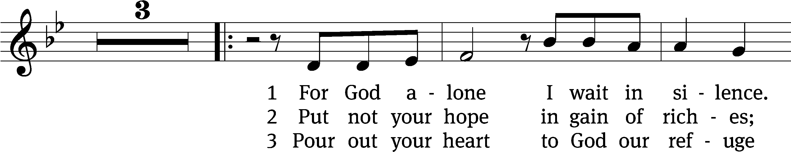
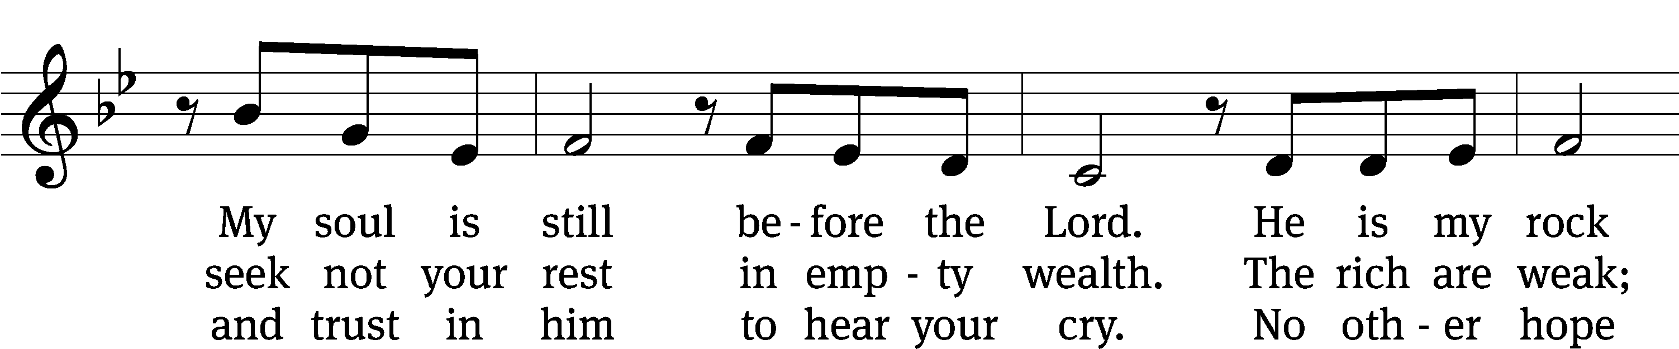
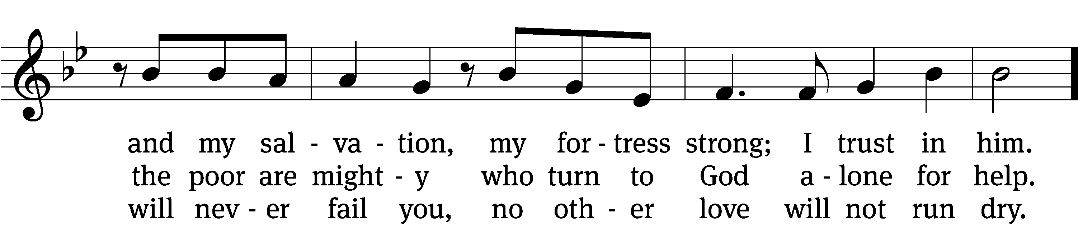
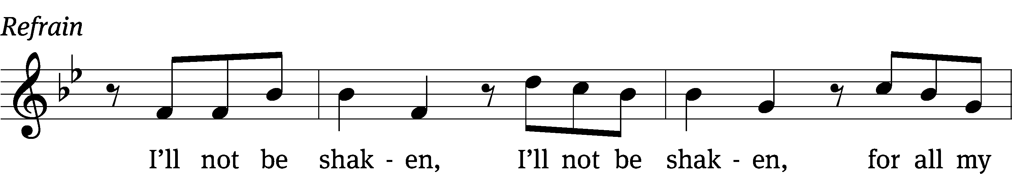
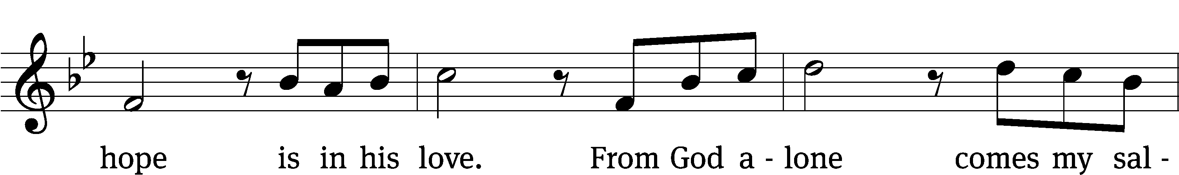
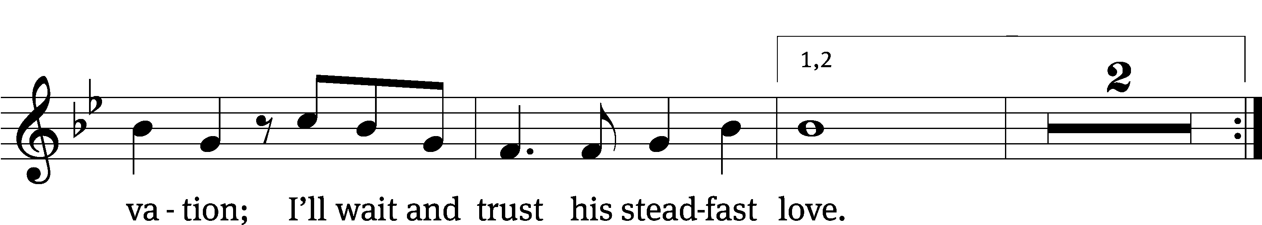
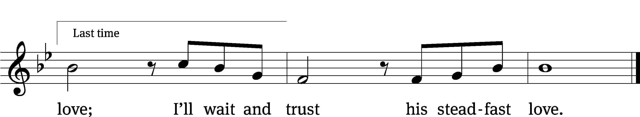
Text: Wendell Kimbrough
Tune: Wendell Kimbrough
Text and tune: © 2015 Wendell Kimbrough. Used by permission: OneLicense no. 727703

SECOND LESSON Romans 7:15-25a
¹⁵ For I do not understand what I am doing, because I do not keep doing what I want. Instead, I do what I hate. ¹⁶ And if I do what I do not want to do, I agree that the law is good. ¹⁷ But now it is no longer I who am doing it, but it is sin living in me. ¹⁸ Indeed, I know that good does not live in me, that is, in my sinful flesh. The desire to do good is present with me, but I am not able to carry it out. ¹⁹ So I fail to do the good I want to do. Instead, the evil I do not want to do, that is what I keep doing. ²⁰ Now if I do what I do not want to do, it is no longer I who am doing it, but it is sin living in me.
²¹ So I find this law at work: When I want to do good, evil is present with me. ²² I certainly delight in God’s law according to my inner self, ²³ but I see a different law at work in my members, waging war against the law of my mind and taking me captive to the law of sin, which is present in my members. ²⁴ What a miserable wretch I am! Who will rescue me from this body of death? ²⁵ I thank God through Jesus Christ our Lord!

please stand, if you are able

Verse of the day Matthew 11:28
Alleluia. Come to me, all you who are weary and burdened
And I will give you rest. Alleluia.

THE GOSPEL LESSON Matthew 11:25-30

M: The Gospel according to Matthew chapter 11, verses 25-30

²⁵ At that time, Jesus continued, “I praise you, Father, Lord of heaven and earth, that you have hidden these things from clever and learned people and have revealed them to little children. ²⁶ Yes, Father, because this was pleasing to you. ²⁷ Everything has been entrusted to me by my Father. No one knows the Son except the Father, and no one knows the Father except the Son and anyone to whom the Son wants to reveal him.
²⁸ “Come to me all you who are weary and burdened, and I will give you rest. ²⁹ Take my yoke upon you and learn from me, because I am gentle and humble in heart, and you will find rest for your souls. ³⁰ For my yoke is easy and my burden is light.”

M: This is the Gospel of the Lord.

PLEASE BE SEATED

892 By All Your Saints Still Striving CW 892 sts. 1, 15, 3
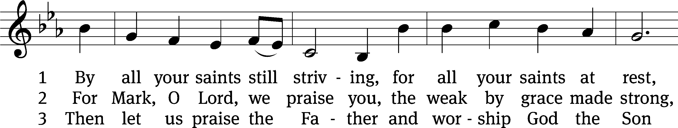
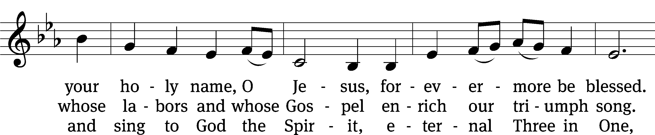
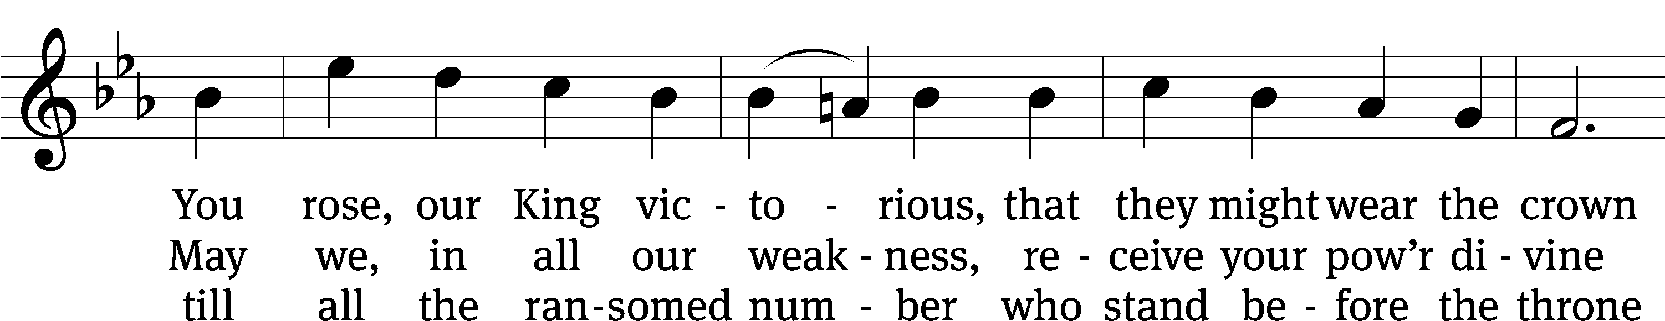
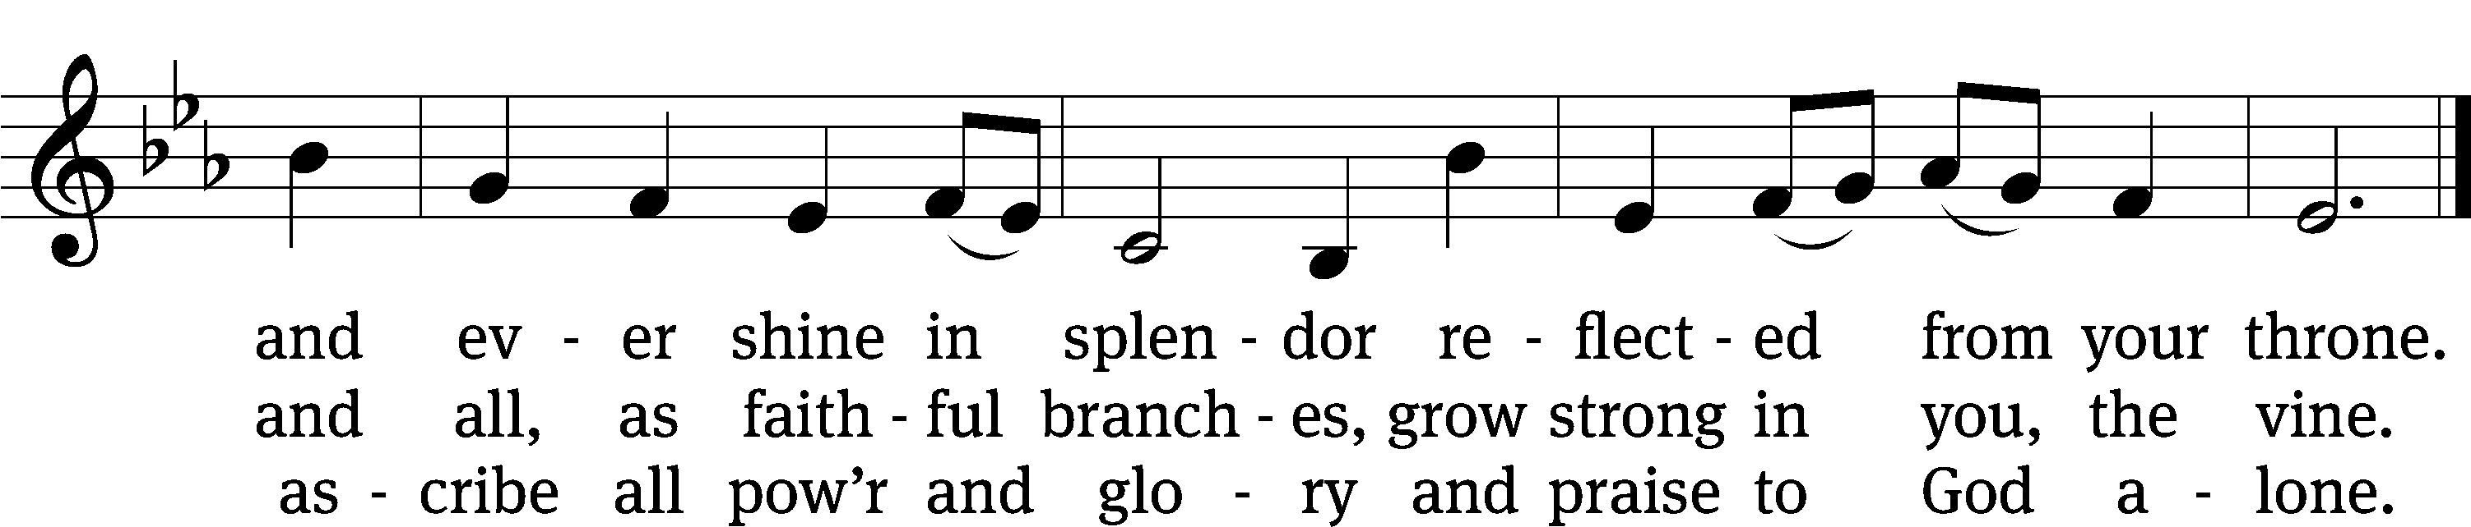
Text: Horatio Bolton Nelson, 1823–1913, alt.
Tune: Finnish
Text and tune: Public domain

SERMON John 15:1-5
“I AM the True Vine”

¹ “I am the true vine, and my Father is the gardener. ² Every branch in me that does not bear fruit, he is going to cut off. And he prunes every branch that does bear fruit, so that it will bear more fruit.
³ “You are already clean because of the word I have spoken to you. ⁴ Remain in me, and I am going to remain in you. A branch cannot bear fruit by itself; it must remain in the vine. Likewise, you cannot bear fruit unless you remain in me.

⁵ “I am the Vine; you are the branches. The one who remains in me and I in him is the one who bears much fruit, because without me you can do nothing.
PLEASE STAND, IF YOU ARE ABLE

THE APOSTLES’ CREED

I believe in God, the Father almighty,
maker of heaven and earth.
I believe in Jesus Christ, his only Son, our Lord,
who was conceived by the Holy Spirit,
born of the virgin Mary,
suffered under Pontius Pilate,
was crucified, died, and was buried.
He descended into hell.
The third day he rose again from the dead.
He ascended into heaven
and is seated at the right hand of God the Father almighty.
From there he will come to judge the living and the dead.
I believe in the Holy Spirit,
the holy Christian Church,
the communion of saints,
the forgiveness of sins,
the resurrection of the body,
and the life everlasting. Amen.

PRAYER OF THE CHURCH

THE LORD’S PRAYER

C: Our Father, who art in heaven, hallowed be thy name, thy kingdom come, thy will be done on earth as it is in heaven. Give us this day our daily bread; and forgive us our trespasses, as we forgive those who trespass against us; and lead us not into temptation, but deliver us from evil. For thine is the kingdom and the power and the glory forever and ever. Amen.

709 Christ the Vine CW 709
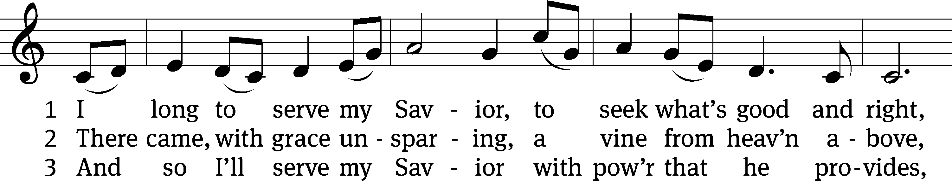
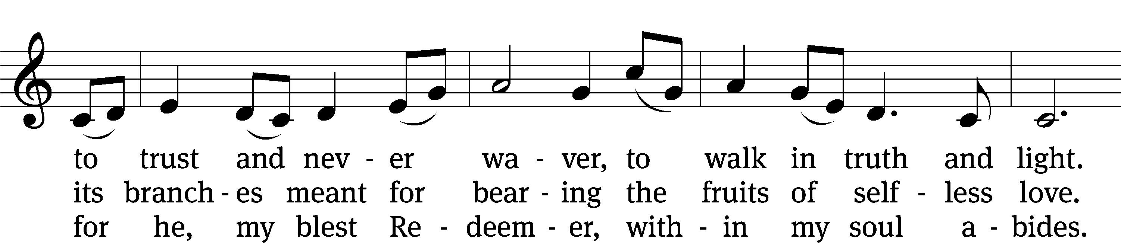
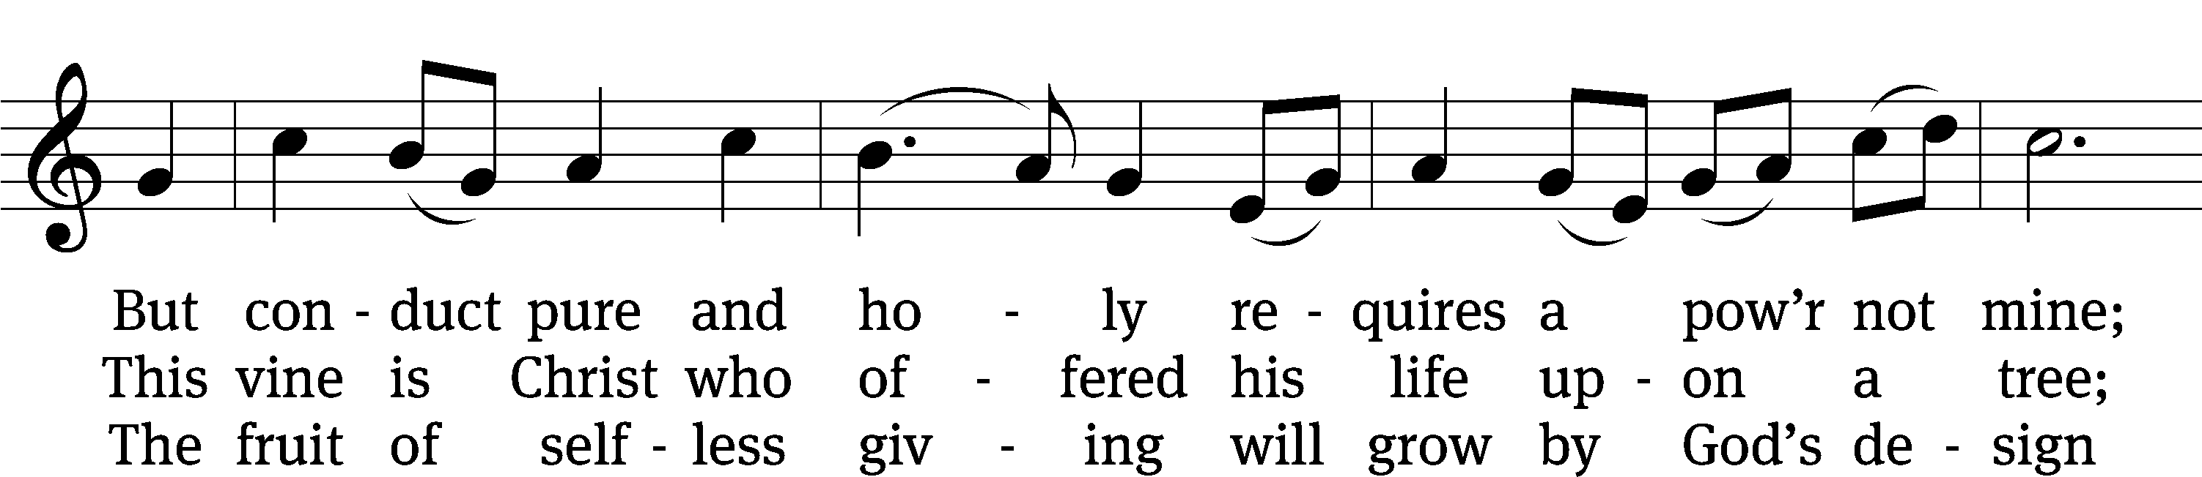
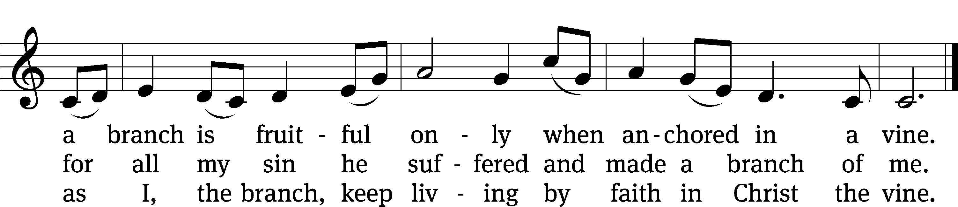
Text: Michael D. Schultz, b. 1963
Tune: Irish
Text: © 2021 Michael D. Schultz, admin. Northwestern Publishing House. Used by permission: OneLicense no. 727703
Tune: Public domain

PLEASE STAND, IF YOU ARE ABLE

CLOSING PRAYER
M: Almighty God, we thank you for teaching us the things you want us to believe and do. Help us by your Holy Spirit to keep your Word in pure hearts that we may be strengthened in faith, guided in holiness, and comforted in life and in death, through Jesus Christ, our Lord, who lives and reigns with you and the Holy Spirit, one God, now and forever.

M: Brothers and sisters, go in peace. Live in harmony with one another. Serve the Lord with gladness.
The Lord bless you and keep you.
The Lord make his face shine on you and be gracious to you.
The Lord look on you with favor and (+) give you peace.

PLEASE BE SEATED

528 Christ, the Word of God Incarnate CW 528 sts. 1, 3
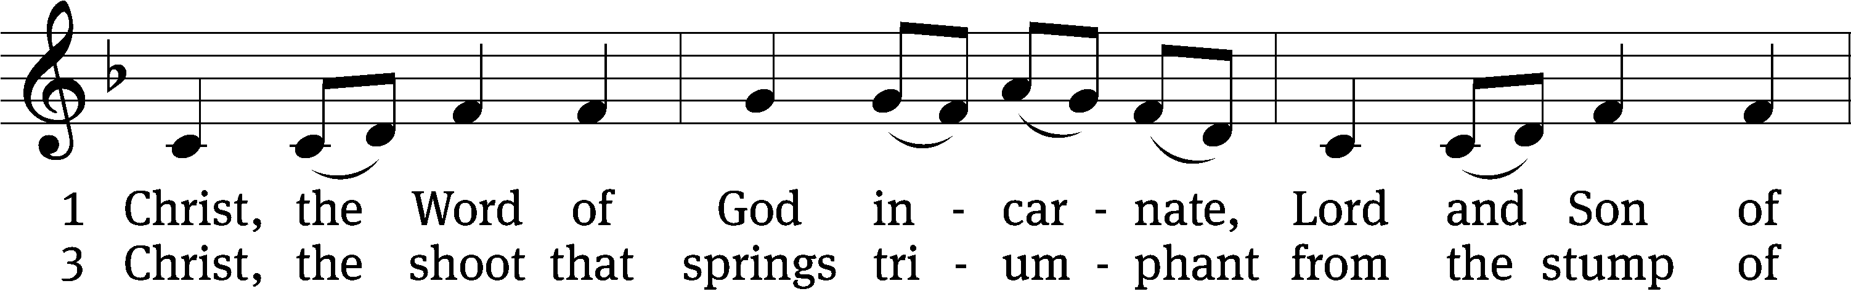
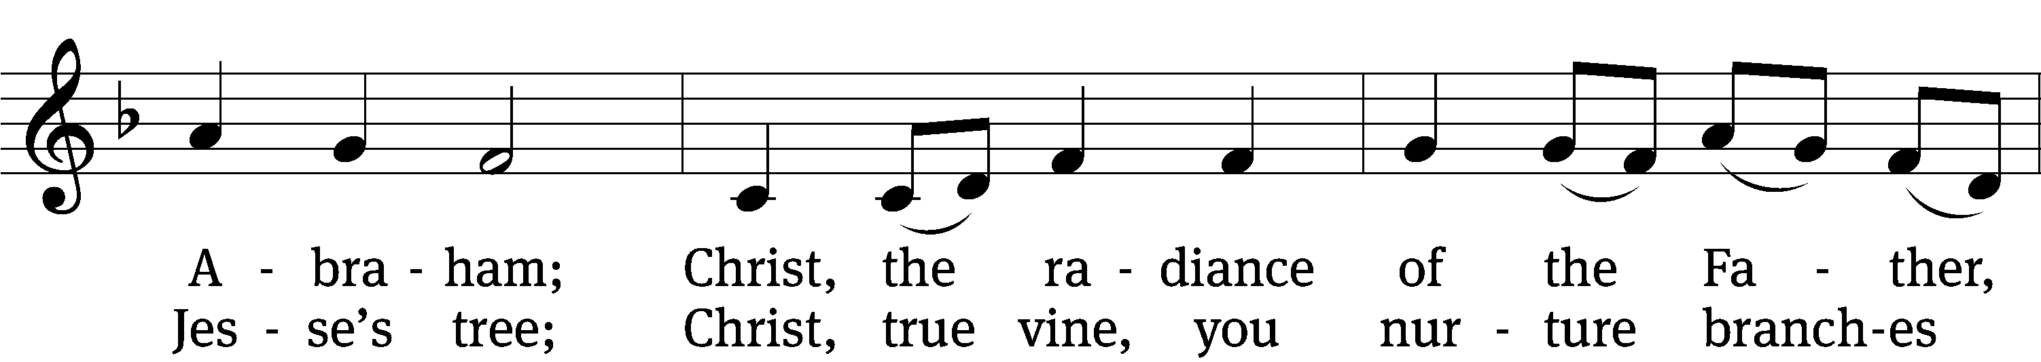
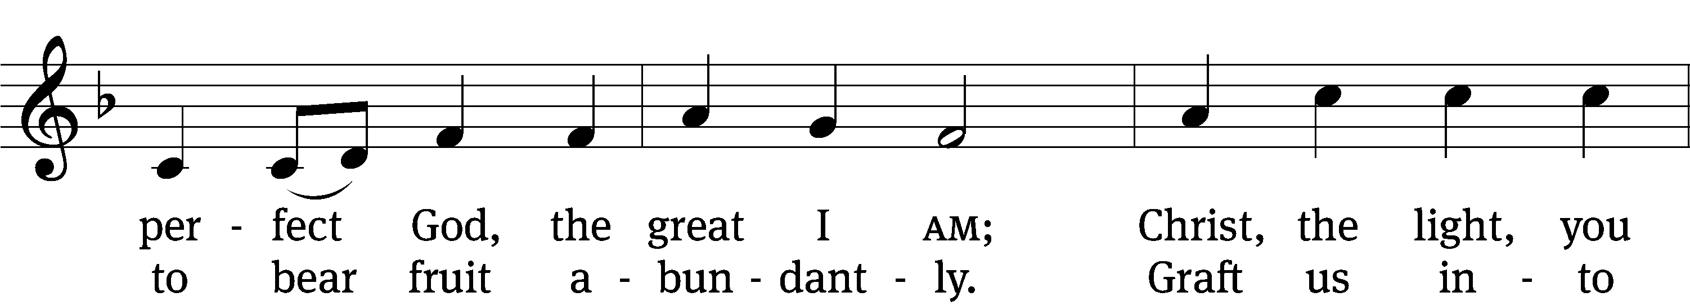
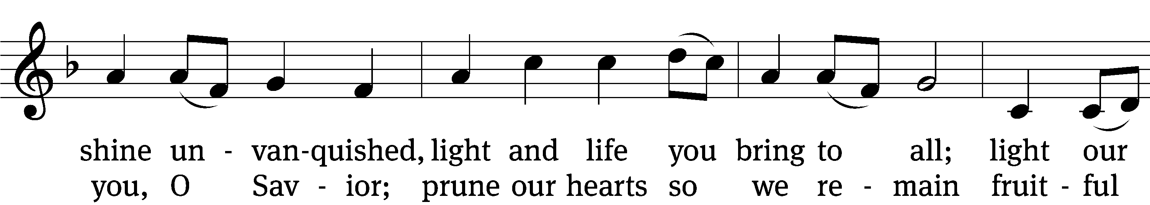
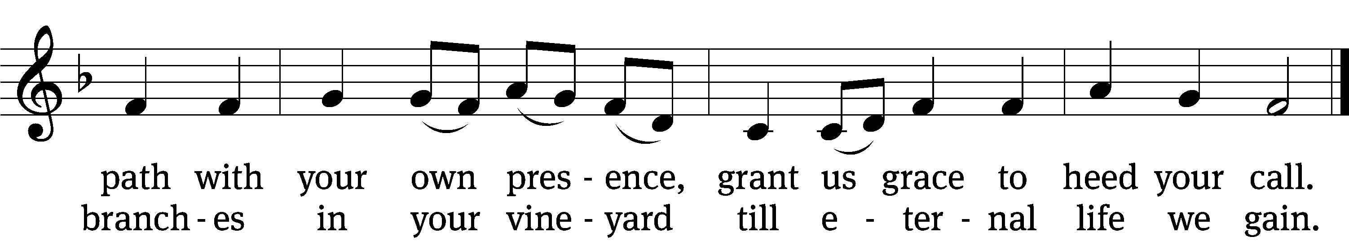
Text: Steven P. Mueller, b. 1964
Tune: Columbian Harmony, Cincinatti, 1825, ed. William Moore
Text: © 2001 Steven P. Mueller. Used by permission: OneLicense no. 727703
Tune: Public domain

Serving In Worship
Officiant Pastor Natsis
Organist Sarah Hanke
Deacons (Thursday) Steve Hoeft and Jim Tice
(Sunday) Jeff Neuburger and Dave Stevenson
Ushers (Thursday) Dale Finkbeiner and Mark Finkbeiner
(Sunday) Al Whitley
Altar Guild Esther Gross and Diane Stevenson
Videographer Ann Latowski

Copyright information
Service of the Word: Christian Worship. © 1993 Northwestern Publishing House. All rights reserved.
Reprinted with permission under ONE LICENSE #A-727703 and CCLI #1151741/CSPL126093

Words and Music: All rights reserved. Reprinted with permission under ONE LICENSE #A-727703 and
CCLI #1151741/CSPL126093
tlcsaline.church

