THE TENth SUNDAY
AFTER PENTECOST

tRINITY EVANGELICAL LUTHERAN CHURCH | Saline, Michigan
July 11/14, 2022

WELCOME TO WORSHIP

Thank you for joining us in God’s house today! We cordially ask that our Guests with us this morning sign one of the guestbooks located at either the front or back entryways.

THANK OFFERING: Members of Trinity give their offering as an expression of love and thankfulness to the Lord and to help support the Lord’s work in our community and around the world. Visitors need not feel obligated to participate in this offering which supports our ministry.

Restrooms are located at the back of the upper level (the annex), and in the basement (down the back stairs of the sanctuary or annex). Handicap access is available, please ask an usher for assistance.

Young Families / Toddler Bags – We are GLAD YOU BROUGHT YOUR CHILDREN to our worship service. Jesus said: “Let the little children come to me and do not hinder them, for the kingdom of God belongs to such as these.” We know that having little children in church can be a challenge, but DO NOT WORRY about it. Many of your fellow worshippers have been in your shoes and are just happy you brought your children with you. For your convenience, we have reserved the back rows of seating for parents with small children. These areas provide more flexibility for your family, as well as, easy access to move downstairs if necessary. A closed-circuit TV system allows families to continue participating in the service while downstairs. Pre-school toddler bags and children’s bulletins are available for their enjoyment. Ask an usher for one to use during the service and please return the toddler bag afterwards.

SERVICE of the word

876 Fight the Good Fight CW 876
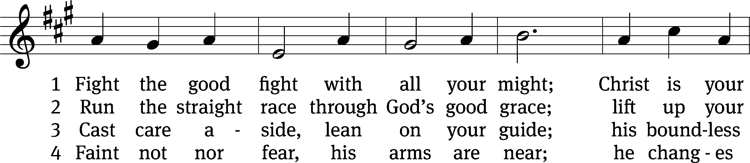
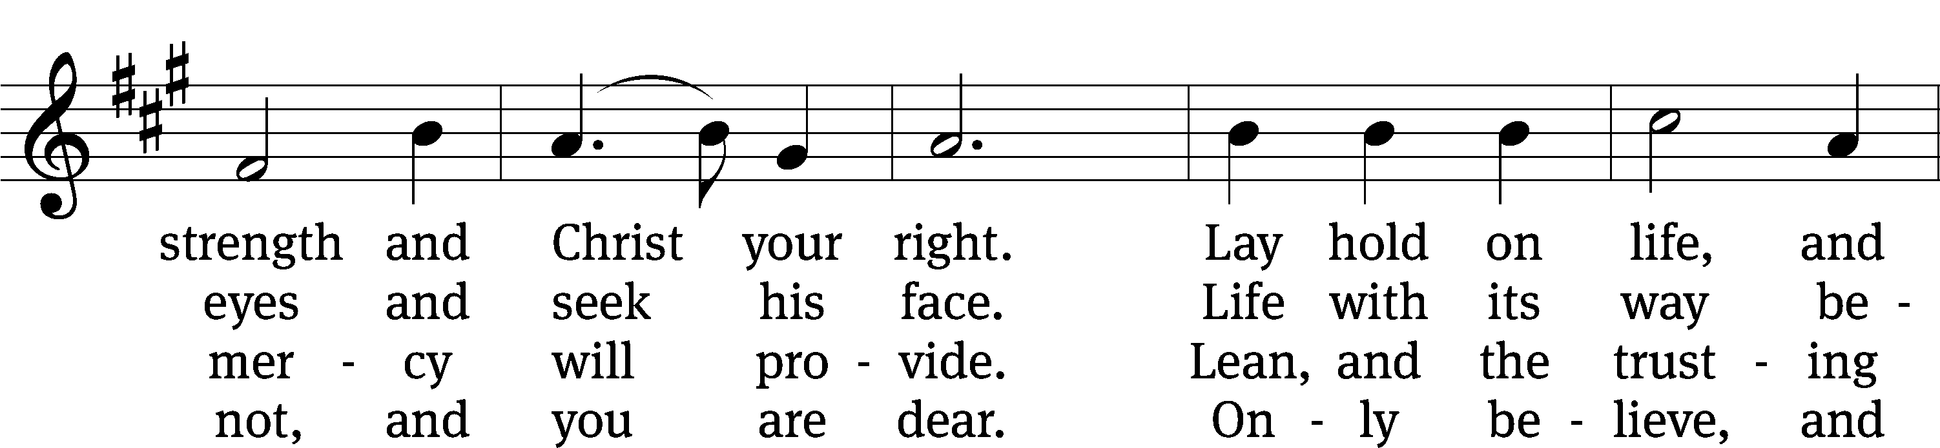
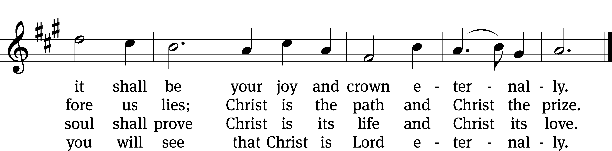
Text: John S. B. Monsell, 1811–1875, alt.
Tune: The Methodist Harmonist, New York, 1821
Text and tune: Public domain

PLEASE STAND, IF YOU ARE ABLE

invocation
M: The grace of our Lord (+) Jesus Christ and the love of God and the fellowship of the Holy Spirit be with you.
C: And also with you.
CONFESSION OF SINS
M: We have come into the presence of God, who created us to love and serve him as his dear children. But we have disobeyed him and deserve only his wrath and punishment. Therefore, let us confess our sins to him and plead for his mercy.

C: Merciful Father in heaven, I am altogether sinful from birth. In countless ways I have sinned against you and do not deserve to be called your child. But trusting in Jesus, my Savior, I pray: Have mercy on me according to your unfailing love. Cleanse me from my sin, and take away my guilt.
M: God, our heavenly Father, has forgiven all your sins. By the perfect life and innocent death of our Lord Jesus Christ, he has removed your guilt forever. You are his own dear child. May God give you strength to live according to his will.

C: Amen.
PRAYER AND PRAISE

M: In the peace of forgiveness, let us praise the Lord.

OH, TASTE AND SEE

PRAYER OF THE DAY

Let us pray.

Almighty and merciful God, it is only by your gift of grace that we come into your presence and offer true and faithful service. Grant that our worship on earth may always be pleasing to you, and in the life to come give us the fulfillment of what you have promised; through your Son, Jesus Christ our Lord, who lives and reigns with you and the Holy Spirit, one God, now and forever.

PLEASE BE SEATED

The Word

the FIRST LESSON jEREMIAH 23:23-29

²³ Am I a God who is only nearby, declares the Lord,
and not a God far away?
²⁴ Can anyone hide in secret places
so that I cannot see him? declares the Lord.
Do I not fill heaven and earth? declares the Lord.
²⁵ I have heard what the prophets who prophesy lies in my name have said. They say, “I have had a dream! I have had a dream!” ²⁶ How long will this be in the hearts of these lying prophets? These prophets proclaim the fantasies of their own hearts. ²⁷ They think they can make my people forget my name with the dreams each one tells his neighbor, the way their fathers forgot my name because of Baal. ²⁸ Let the prophet who has a dream tell his dream. But let the one who has my word speak my word faithfully.
What has chaff to do with grain? declares the Lord. ²⁹ Is not my word like a fire? declares the Lord, and like a hammer that breaks a rock in pieces?

Psalm 4C O God, Be Gracious Psalm 4C
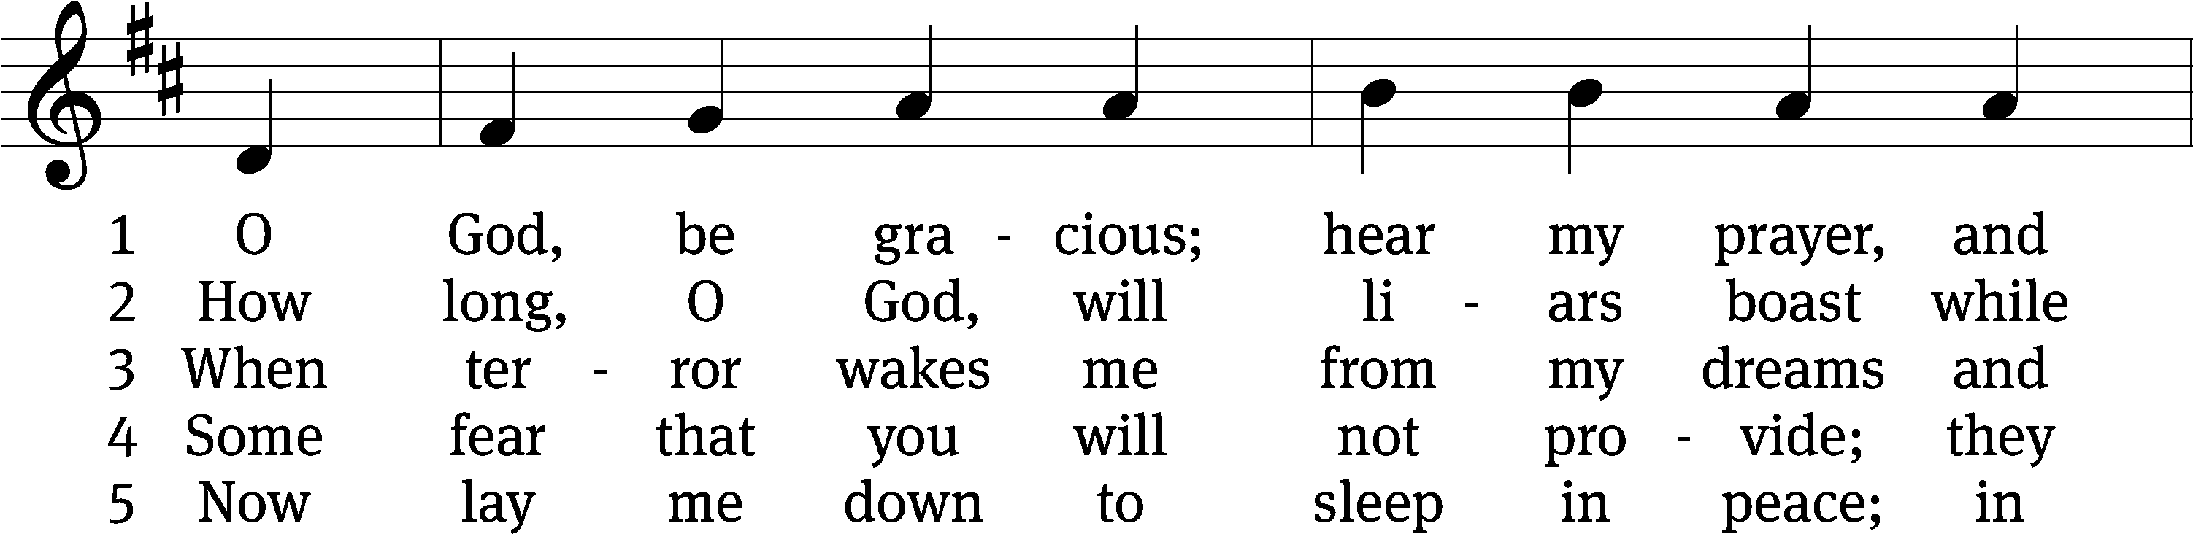
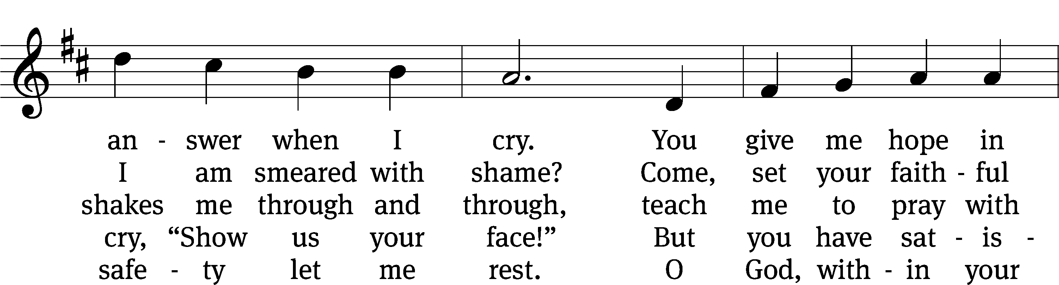
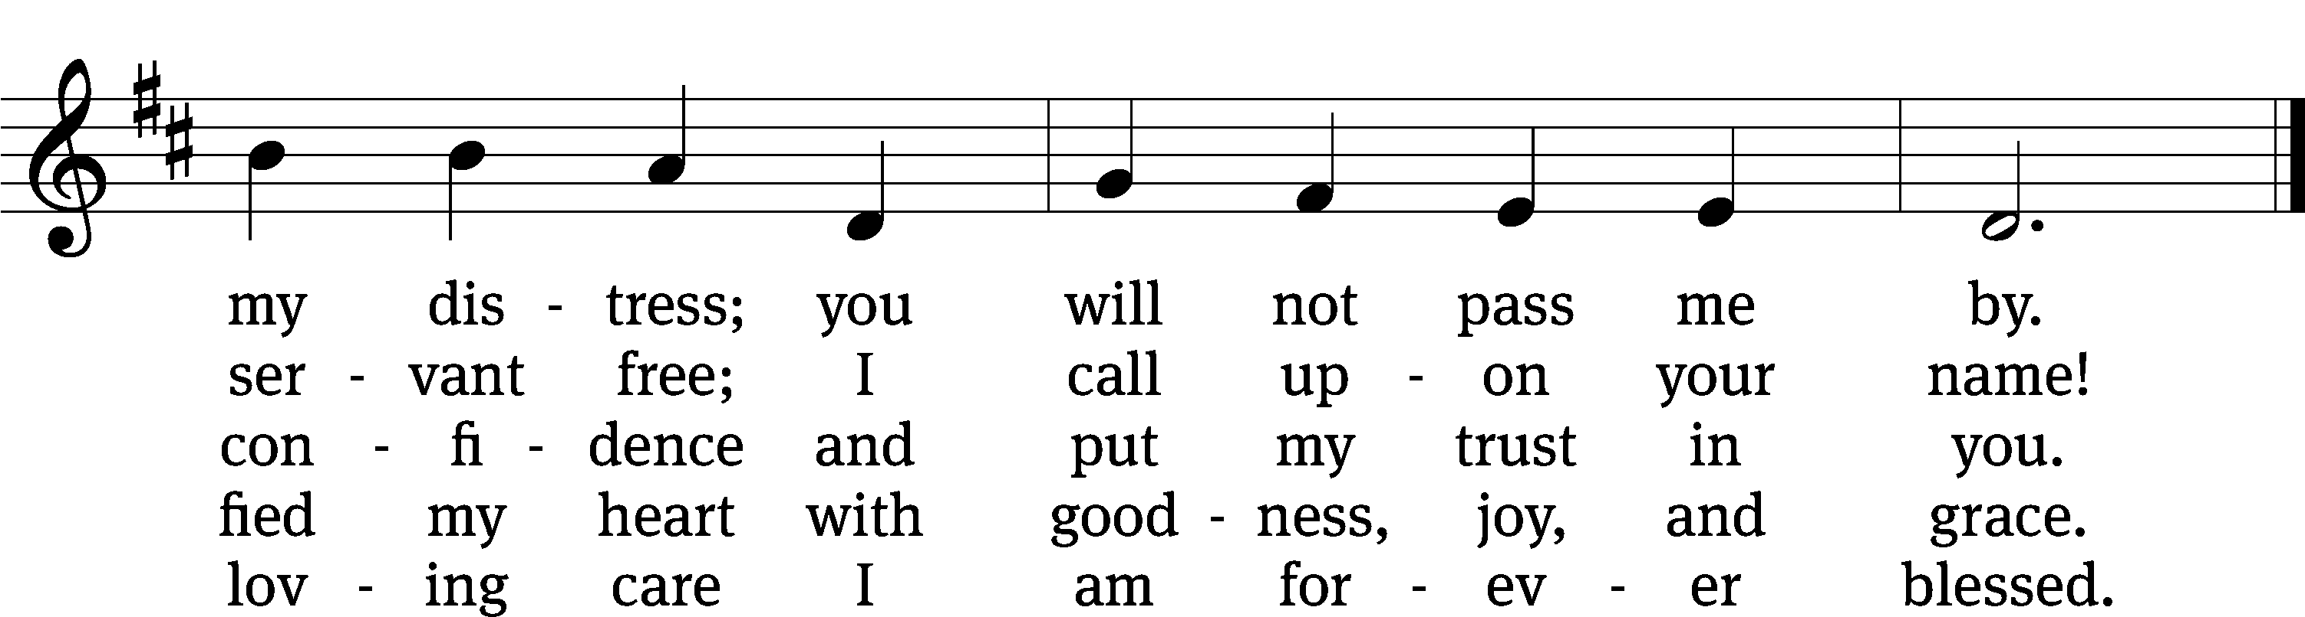
Text: David Gambrell
Tune: Thomas Tallis, alt.
Text: © 2011 David Gambrell, admin. Presbyterian Publishing Corp. Used by permission: OneLicense no. 727703
Tune: Public domain

THE SECOND LESSON HEBREWS 12:1-13
¹ Therefore, since we are surrounded by such a great cloud of witnesses, let us get rid of every burden and the sin that so easily ensnares us, and let us run with patient endurance the race that is laid out for us. ² Let us keep our eyes fixed on Jesus, who is the author of our faith and the one who brings it to its goal. In view of the joy set before him, he endured the cross, disregarding its shame, and has taken his seat at the right hand of God’s throne. ³ Carefully consider him who endured such hostility against himself from sinful people, so that you do not grow weary and lose heart.
⁴ You have not yet resisted to the point of shedding your blood in your fight against sin. ⁵ Have you also forgotten the encouragement that addresses you as sons?
My son, do not regard the Lord’s discipline lightly,
and do not become weary of his correction.
⁶ For the Lord disciplines the one whom he loves,
and he corrects every son he accepts.
⁷ Endure suffering as discipline. God is dealing with you as sons. Is there a son whose father does not discipline him? ⁸ If you are not disciplined (and all of us have received it), then you are illegitimate children and not sons. ⁹ In addition, we have earthly fathers who disciplined us, and we respected them. Should we not submit even more to the Father of the spirits and live? ¹⁰ They disciplined us for a little while, according to what seemed best to them, but God disciplines us for our good, so that we may have a share in his holiness. ¹¹ No discipline seems pleasant when it is happening, but painful, yet later it yields a peaceful harvest of righteousness for those who have been trained by it.
¹² Therefore strengthen your weak hands and feeble knees, ¹³ and make straight paths for your feet, so that what is lame may not be dislocated but rather healed.

PLEASE Stand, if you are able

Verse of the day

THE GOSPEL LESSON LUKE 12:49-53
M: The Gospel according to Luke chapter 12, verses 49-53

⁴⁹ “I came to throw fire on the earth, and how I wish it were already ignited. ⁵⁰ But I have a baptism to undergo, and how distressed I am until it is finished! ⁵¹ Do you think that I came to bring peace on the earth? No, I tell you, but rather division. ⁵² Yes, from now on there will be five divided in one household: three against two, and two against three. ⁵³ They will be divided: father against son, and son against father; mother against daughter, and daughter against mother; mother-in-law against her daughter-in-law, and daughter-in-law against her mother-in-law.”

M: This is the Gospel of the Lord.

PLEASE BE SEATED

868 By Faith CW 868 sts. 1–2, Ref, 3–4, Ref, 5, Ref
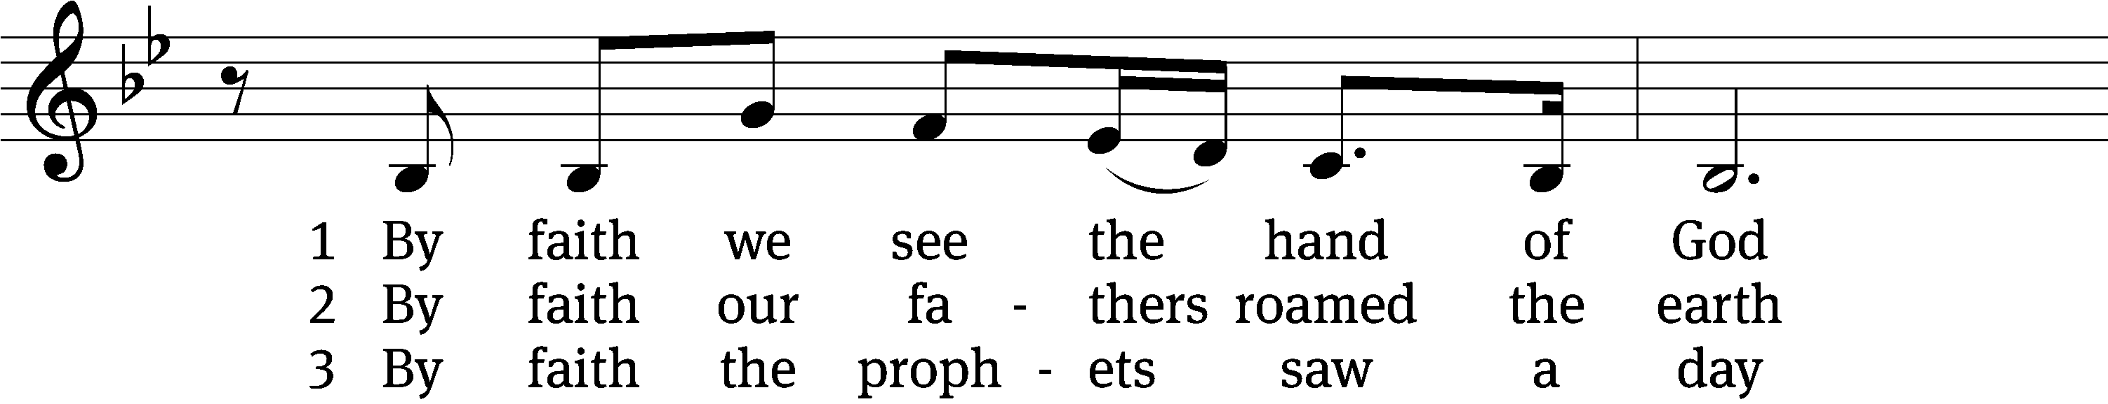
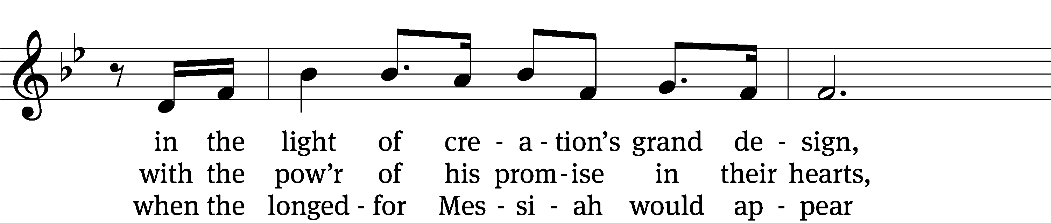
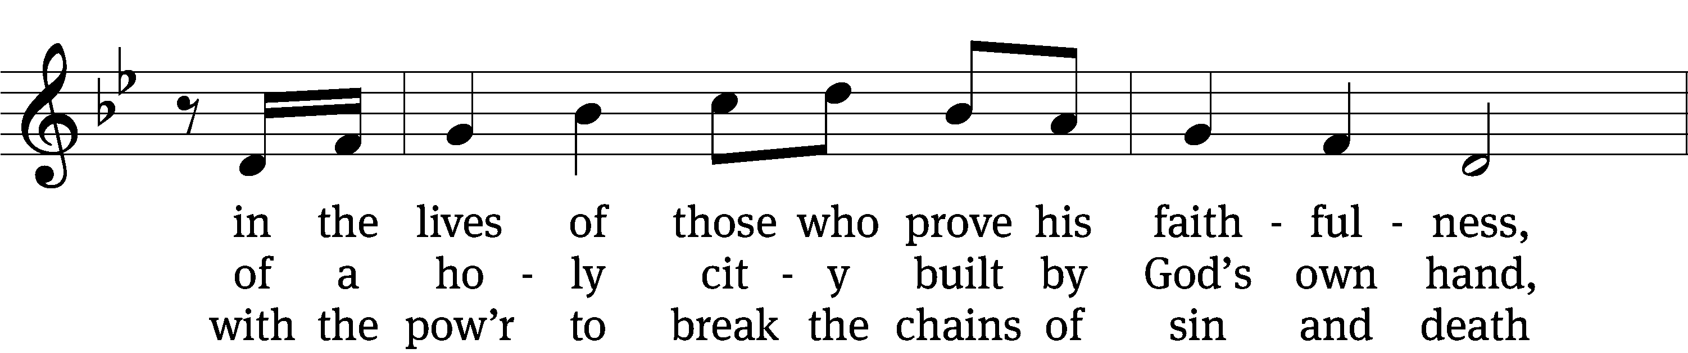
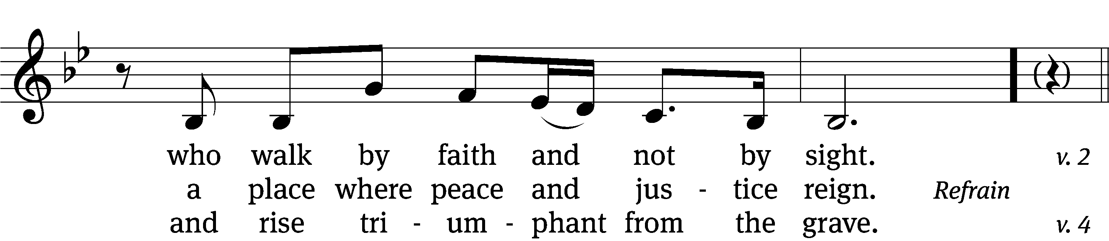
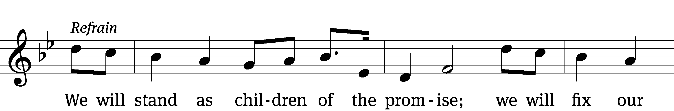
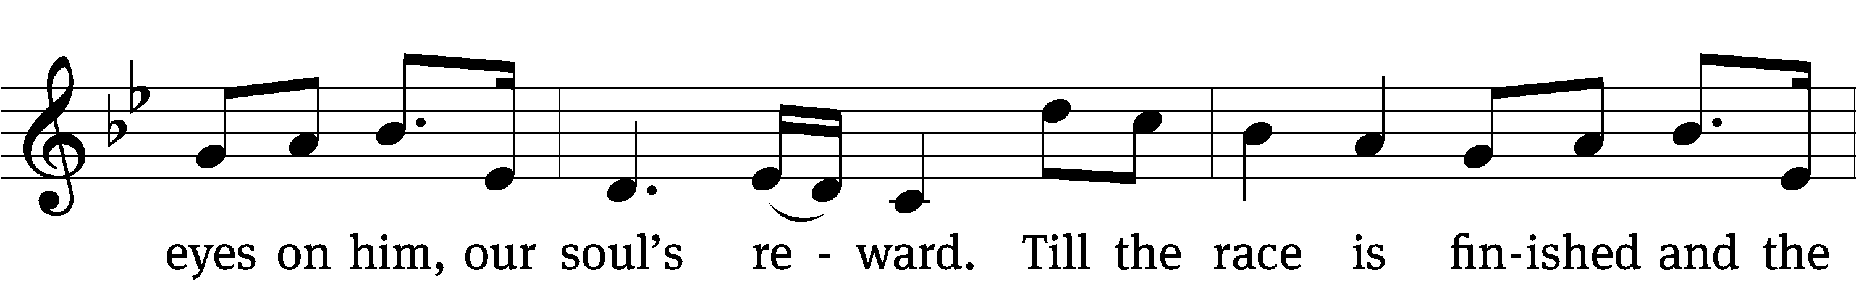
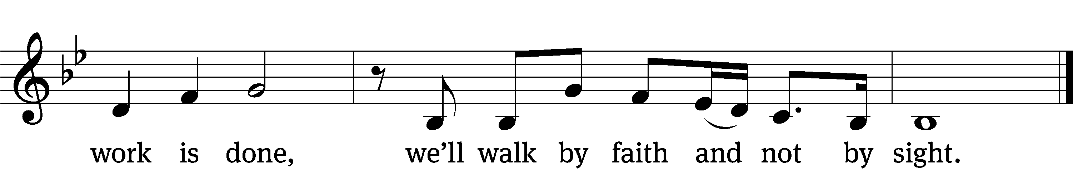

4 By faith the church was called to go
in the pow’r of the Spirit to the lost
to deliver captives and to preach good news
in ev’ry corner of the earth. (Refrain)

5 By faith this mountain shall be moved
and the pow’r of the gospel shall prevail,
for we know in Christ all things are possible
for all who call upon his name. (Refrain)
Text: Stuart Townend, b. 1963; Kristyn Getty, b. 1980; Keith Getty, b. 1974
Tune: arr. Ruth N. Coleman, b. 1953; Stuart Townend, b. 1963; Kristyn Getty, b. 1980; Keith Getty, b. 1974
Text: © 2009 Thankyou Music (PRS), admin. CapitolCMGPublishing,com; © Getty Music Publishing (ASCAP), admin. Music Services . Used by permission: OneLicense no. 727703
Tune: © 2009 Thankyou Music, admin. CapitolCMGPublishing,com. Used by permission: OneLicense no. 727703

SERMON TEXT AND THEME HEBREWS 12:1-13
“The Long Race of Faith”

PLEASE STAND, IF YOU ARE ABLE

THE APOSTLES’ CREED
I believe in God, the Father almighty,
maker of heaven and earth.
I believe in Jesus Christ, his only Son, our Lord,
who was conceived by the Holy Spirit,
born of the virgin Mary,
suffered under Pontius Pilate,
was crucified, died, and was buried.
He descended into hell.
The third day he rose again from the dead.
He ascended into heaven
and is seated at the right hand of God the Father almighty.
From there he will come to judge the living and the dead.
I believe in the Holy Spirit,
the holy Christian Church,
the communion of saints,
the forgiveness of sins,
the resurrection of the body,
and the life everlasting. Amen.
PRAYER OF THE CHURCH

THE LORD’S PRAYER

C: Our Father, who art in heaven, hallowed be thy name, thy kingdom come, thy will be done on earth as it is in heaven. Give us this day our daily bread; and forgive us our trespasses, as we forgive those who trespass against us; and lead us not into temptation, but deliver us from evil. For thine is the kingdom and the power and the glory forever and ever. Amen.

PLEASE BE SEATED

838 The Will of God Is Always Best CW 838
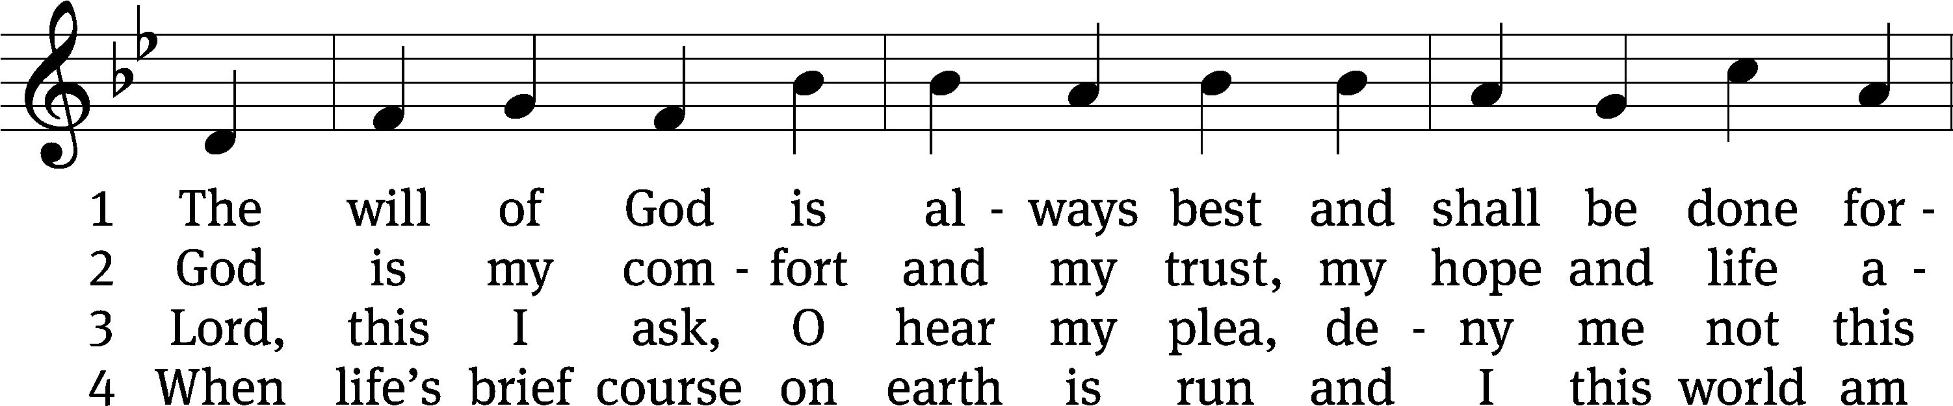
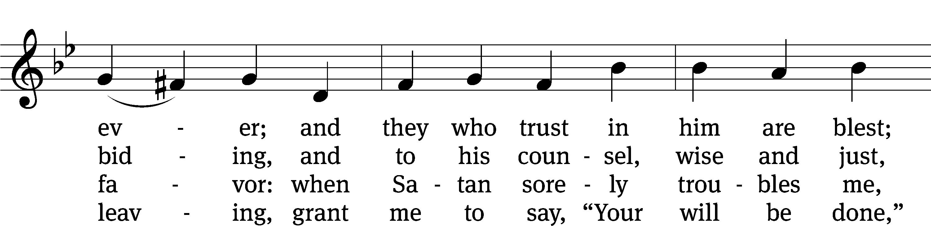
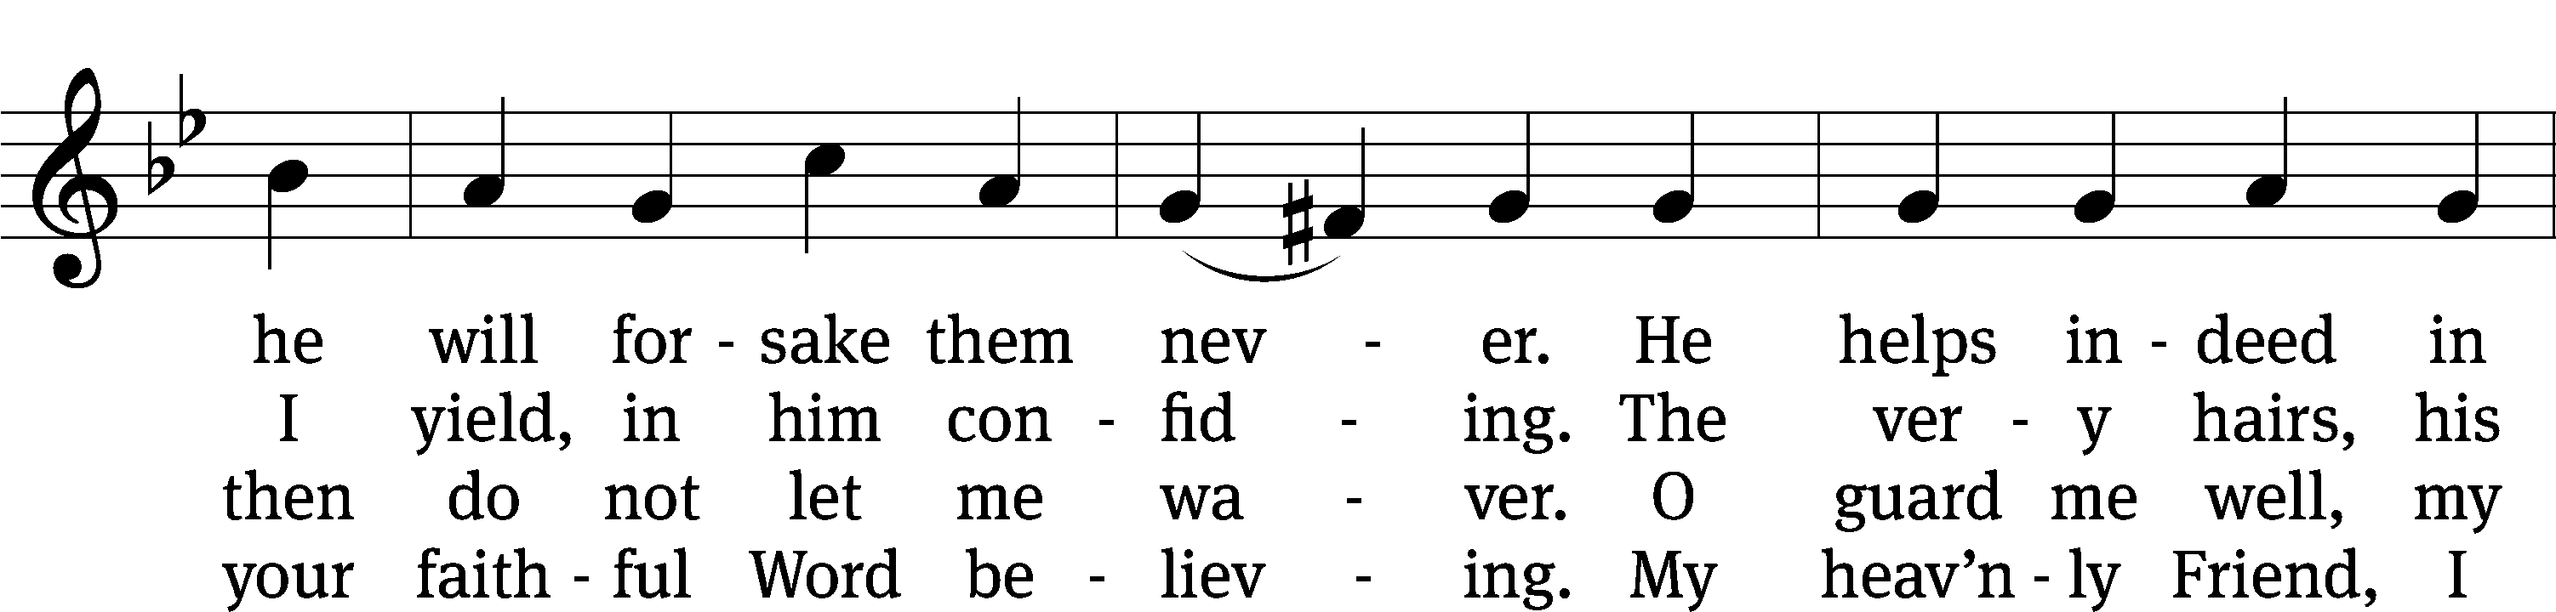
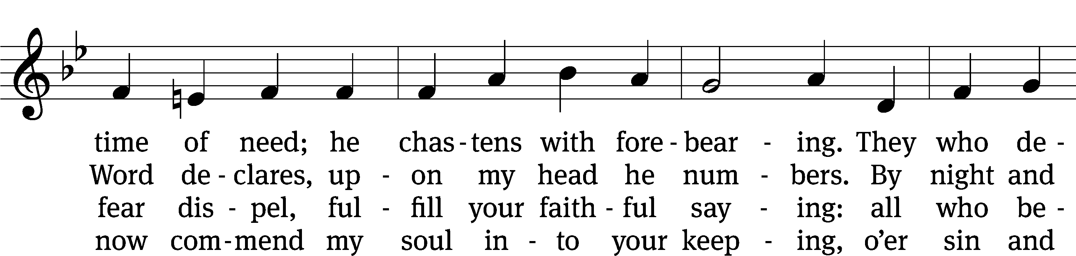
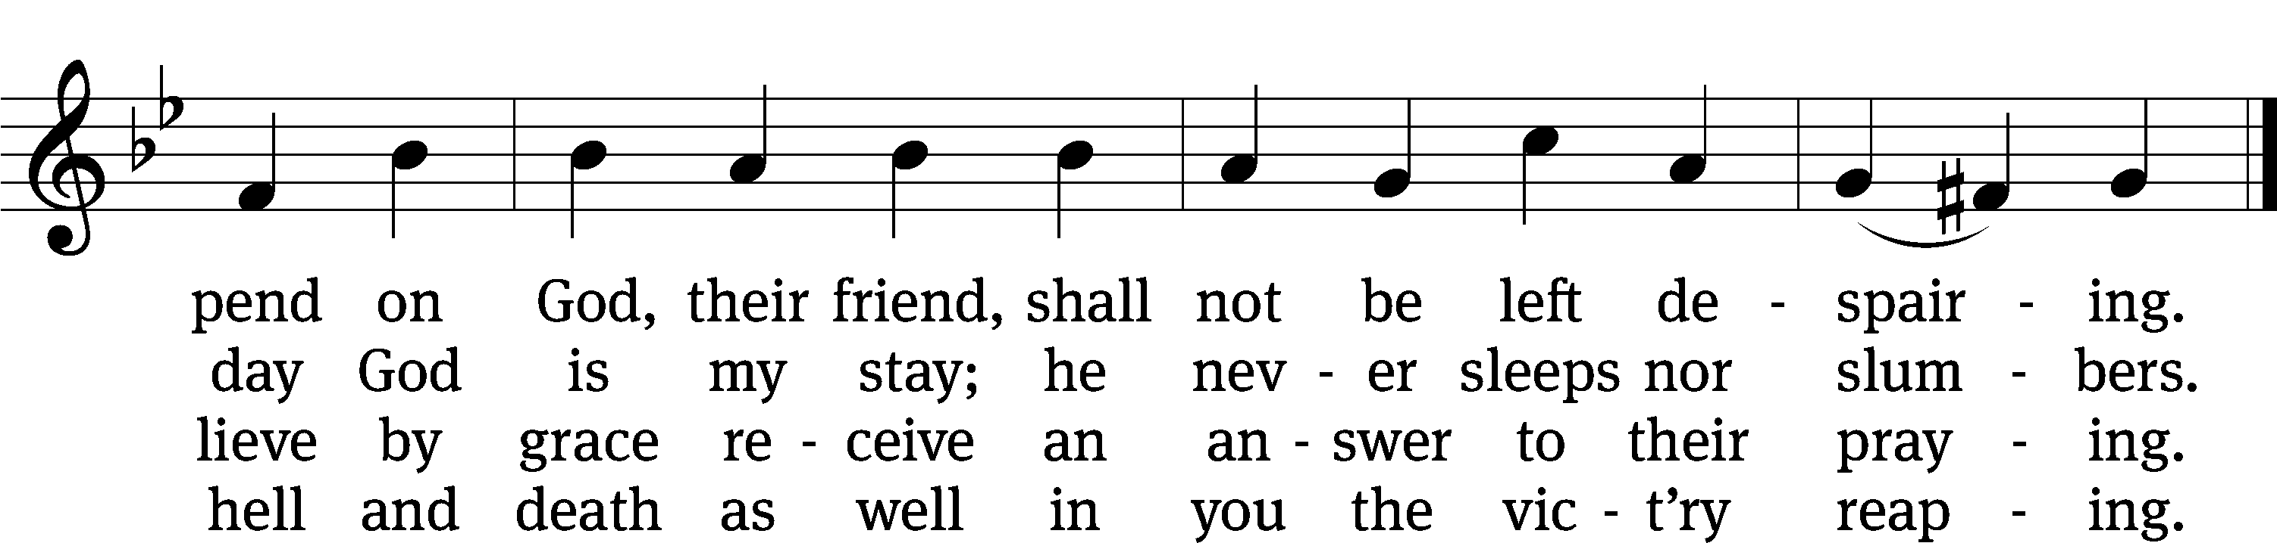
Text: tr. The Lutheran Hymnal, 1941, alt.; Albrecht von Preussen, 1490–1568
Tune: Claudin de Sermisy, c. 1490–1562
Text and tune: Public domain

PLEASE STAND, IF YOU ARE ABLE
CLOSING PRAYER
M: Almighty God, we thank you for teaching us the things you want us to believe and do. Help us by your Holy Spirit to keep your Word in pure hearts that we may be strengthened in faith, guided in holiness, and comforted in life and in death, through Jesus Christ, our Lord, who lives and reigns with you and the Holy Spirit, one God, now and forever.

M: Brothers and sisters, go in peace. Live in harmony with one another. Serve the Lord with gladness.
The Lord bless you and keep you.
The Lord make his face shine on you and be gracious to you.
The Lord look on you with favor and (+) give you peace.

PLEASE BE SEATED

923 Guide Me, O Thou Great Jehovah CW 923
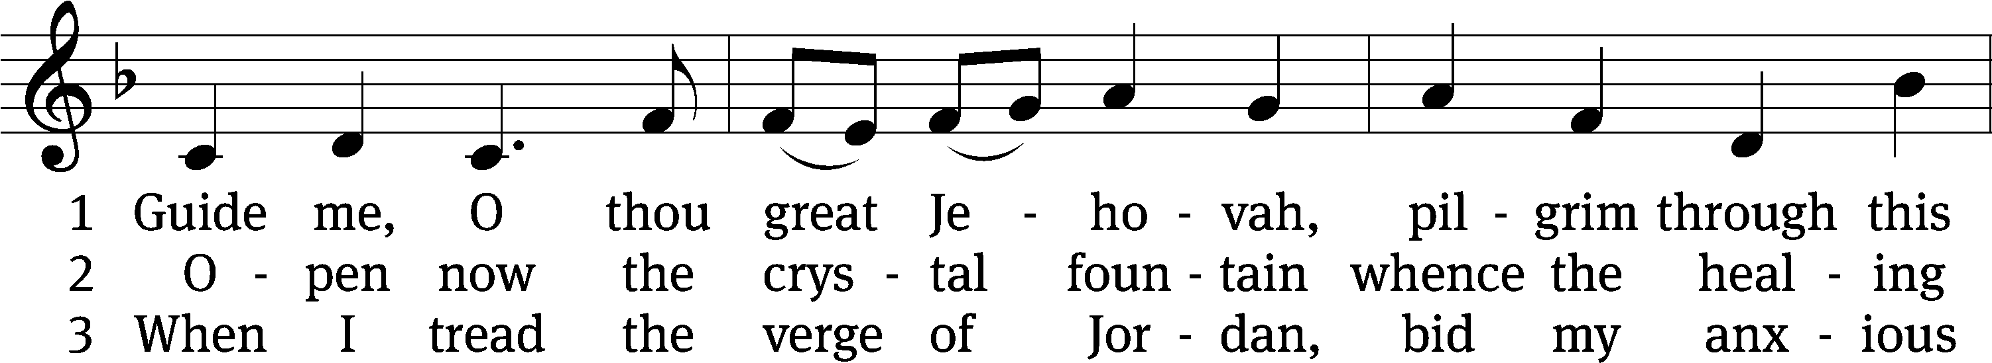
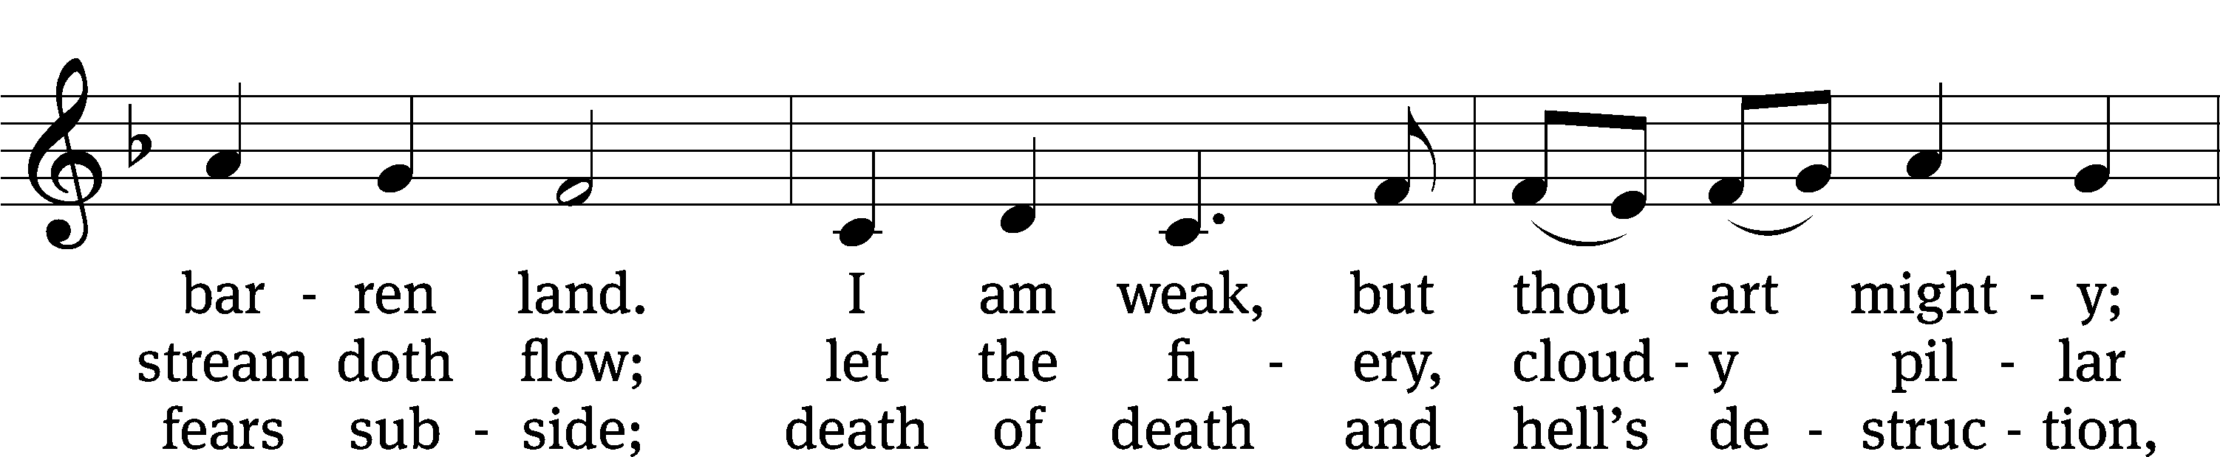
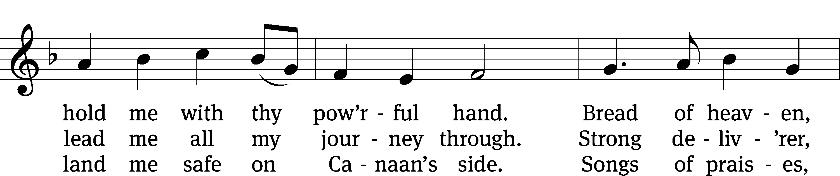
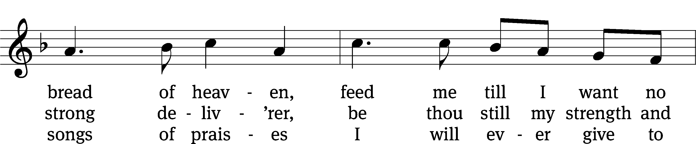
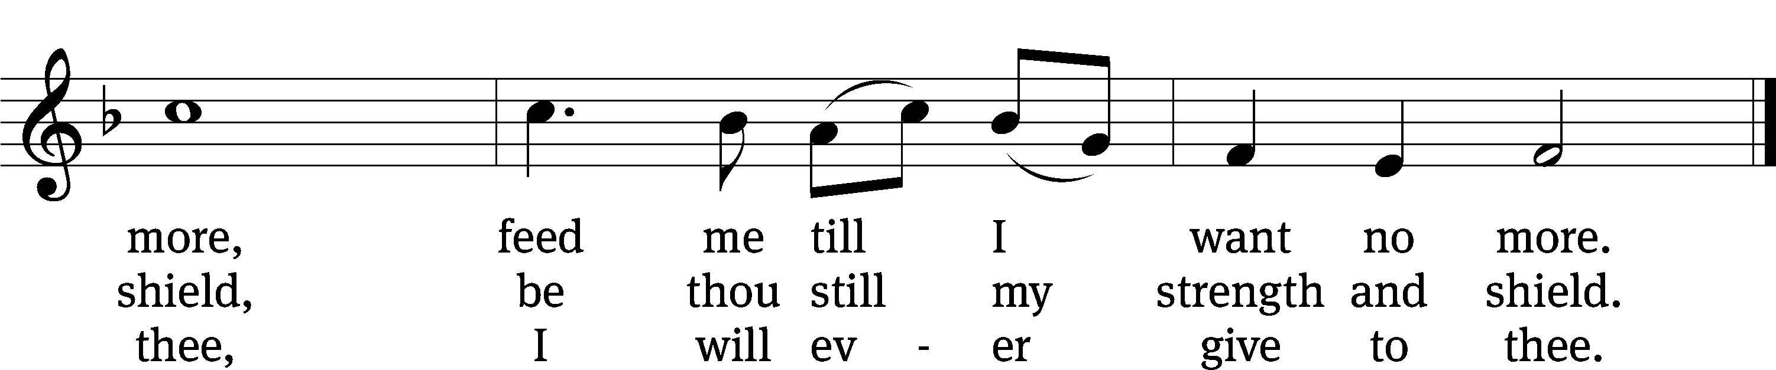
Text: William Williams, 1717–1791, abr.; (st. 1): tr. Peter Williams, 1722–1796, alt.; (sts. 2–3): tr. William Williams, 1717–1791
Tune: John Hughes, 1873–1932
Text and tune: Public domain

Serving In Worship
Officiant Pastor Natsis
Organist Sarah Hanke
Deacons (Thursday) Dave Frey and Steve Hoeft
(Sunday) Dave Stevenson and Ed Wheeler
Ushers (Thursday) Dale Radak
(Sunday) Ron Zahn
Altar Guild Marcia Marion Ackling and Scott Ackling
Videographer Rick Schneider

Copyright information
Service of the Word: Christian Worship. © 1993 Northwestern Publishing House. All rights reserved.
Reprinted with permission under ONE LICENSE #A-727703 and CCLI #1151741/CSPL126093

Words and Music: All rights reserved. Reprinted with permission under ONE LICENSE #A-727703 and
CCLI #1151741/CSPL126093

tlcsaline.church

