the TWELFth sunday
AFTER PENTECOST

TRINITY EVANGELICAL LUTHERAN CHURCH | Saline, Michigan
WELCOME TO WORSHIP August 25/28, 2022
Thank you for joining us in God’s house today! We cordially ask that our Guests sign one of the guestbooks located at either the front or back entryways, or fill out a “Let’s Get Acquainted” card located in the hymnal pew rack and place it in the collection plate.

THANK OFFERING: Members of Trinity give their offering as an expression of love and thankfulness to the Lord and to help support the Lord’s work in our community and around the world. Visitors need not feel obligated to participate in this offering which supports our ministry.

Restrooms are located at the back of the upper level (the annex), and in the basement (down the back stairs of the sanctuary or annex). Handicap access is available, please ask an usher for assistance.

Young Families / Toddler Bags – We are GLAD YOU BROUGHT YOUR CHILDREN to our worship service. Jesus said: “Let the little children come to me and do not hinder them, for the kingdom of God belongs to such as these.” We know that having little children in church can be a challenge, but DO NOT WORRY about it. Many of your fellow worshippers have been in your shoes and are just happy you brought your children with you. For your convenience, we have reserved the back rows of seating for parents with small children. These areas provide more flexibility for your family, as well as, easy access to move downstairs if necessary. A closed-circuit TV system allows families to continue participating in the service while downstairs. Pre-school toddler bags and children’s bulletins are available for their enjoyment. Ask an usher for one to use during the service and please return the toddler bag afterwards.

the SERVICE – setting one - WITHOUT HOLY COMMUNION CW, page 154

655 Before You, God, the Judge of All CW 655
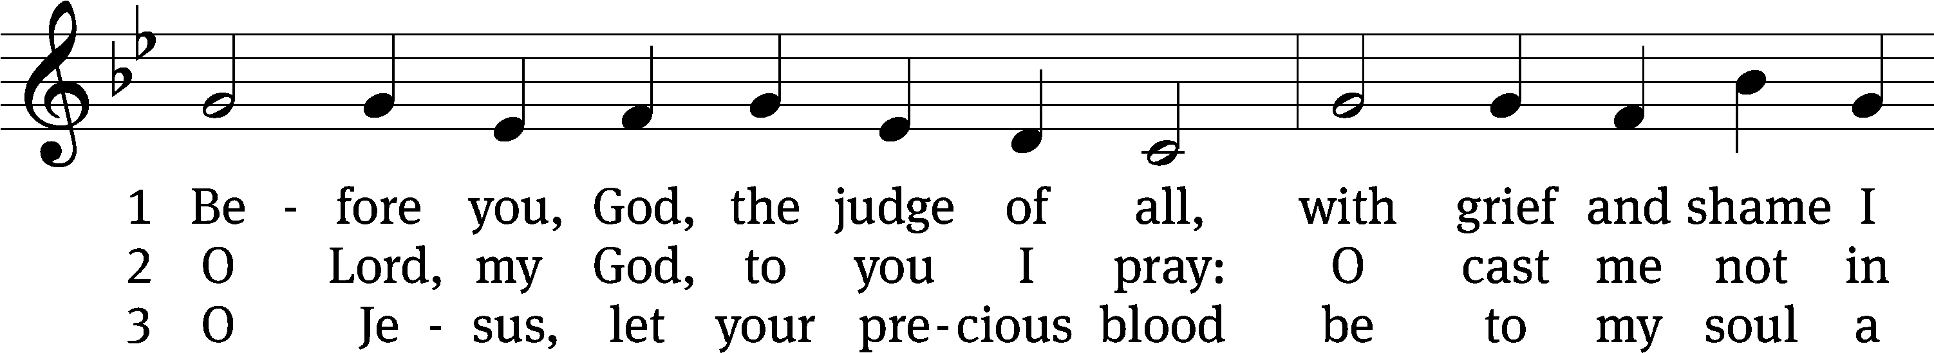
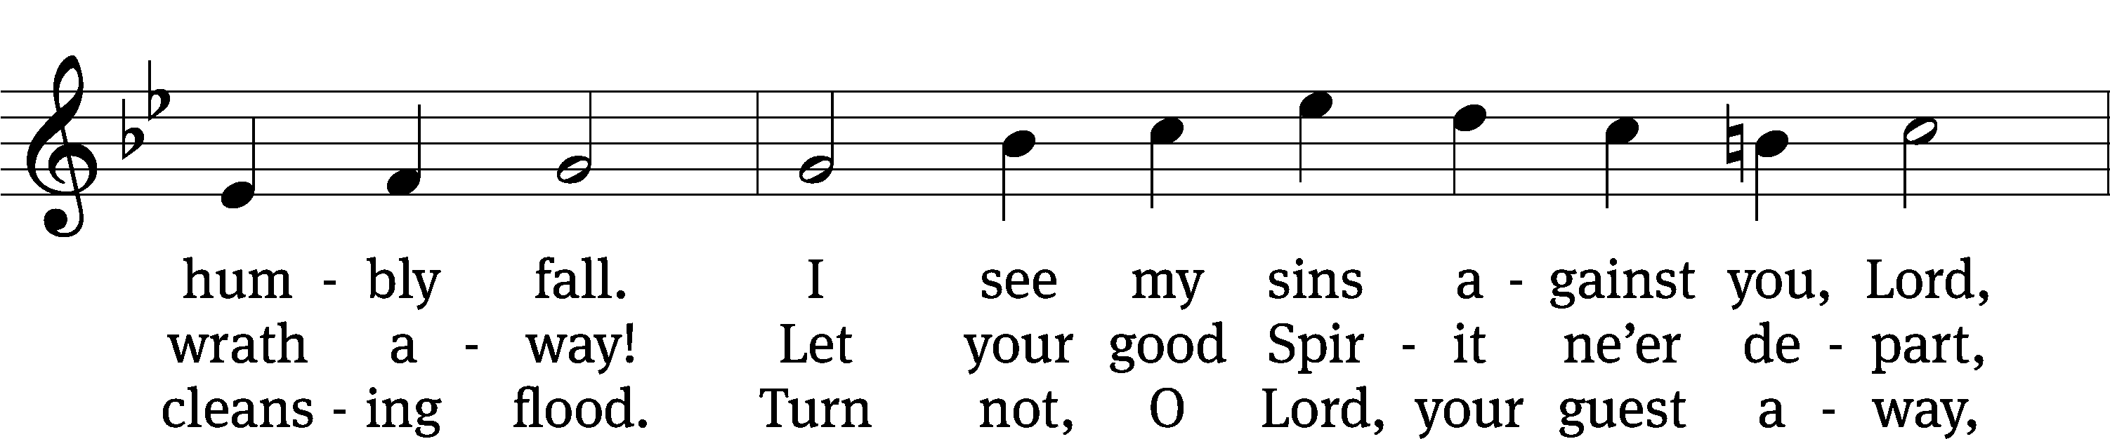
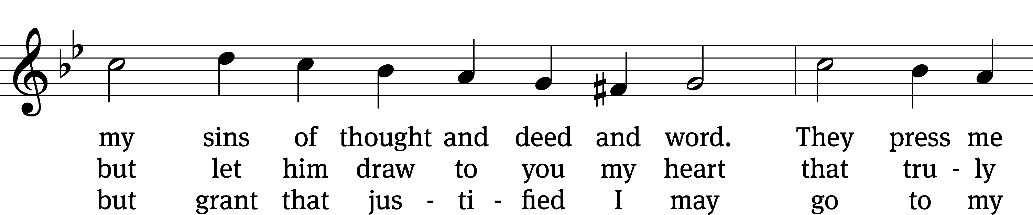
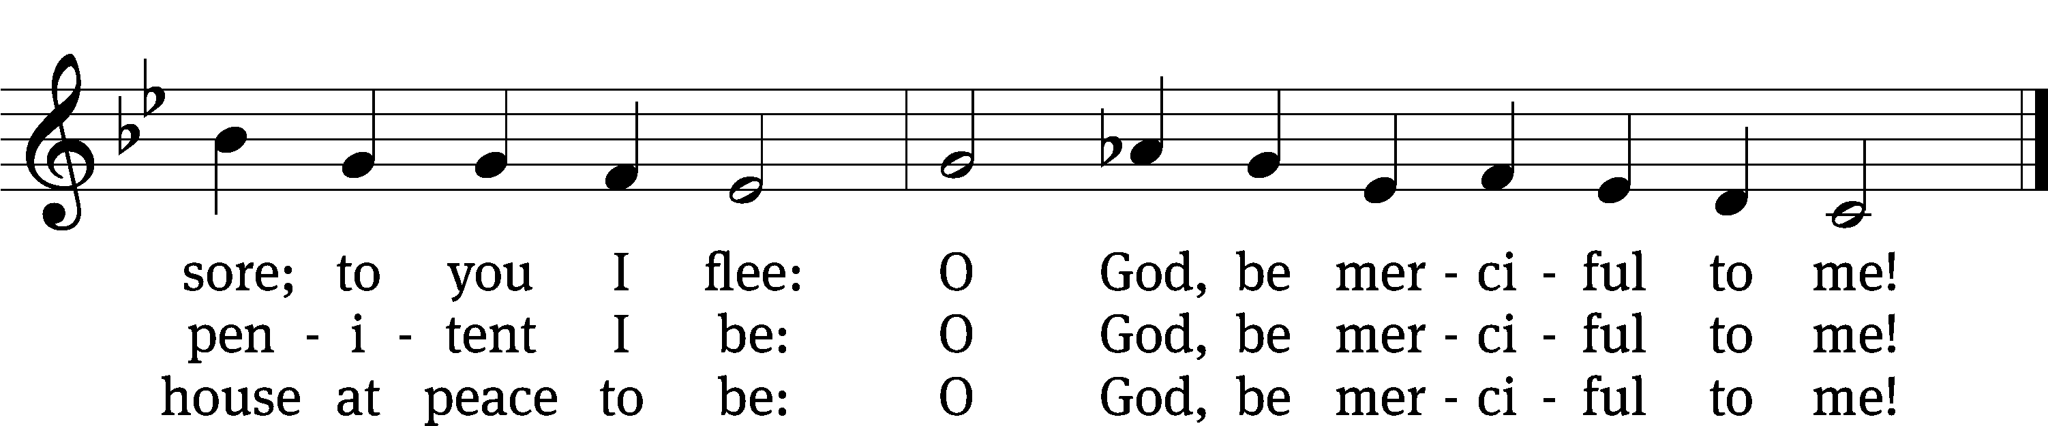
Text: tr. Carl Döving, 1867–1937, alt.; Magnus B. Landstad, 1802–1880, abr.
Tune: attr. Martin Luther, 1483–1546
Text and tune: Public domain

Please stand, if you are able
Invocation
In the name of the Father and of the Son and of the Holy Spirit.
Amen.
Confession
If we claim to be without sin, we deceive ourselves and the truth is not in us.
If we confess our sins, God is faithful and just
and will forgive us our sins
and purify us from all unrighteousness.

Let us confess our sins to the Lord.
Holy God, gracious Father,
I am sinful by nature
and have sinned against you in my thoughts, words, and actions.
I have not loved you with my whole heart;
I have not loved others as I should.
I deserve your punishment both now and forever.
But Jesus, my Savior, paid for my sins
with his innocent suffering and death.
Trusting in him, I pray: God, have mercy on me, a sinner.

Our gracious Father in heaven has been merciful to us. He sent his only Son, Jesus Christ, who gave his life as the atoning sacrifice for the sins of the whole world. Therefore, as a called servant of Christ and by his authority, I forgive you all your sins in the name of the Father and of the the Son and of the Holy Spirit.
Amen.

Lord, Have Mercy

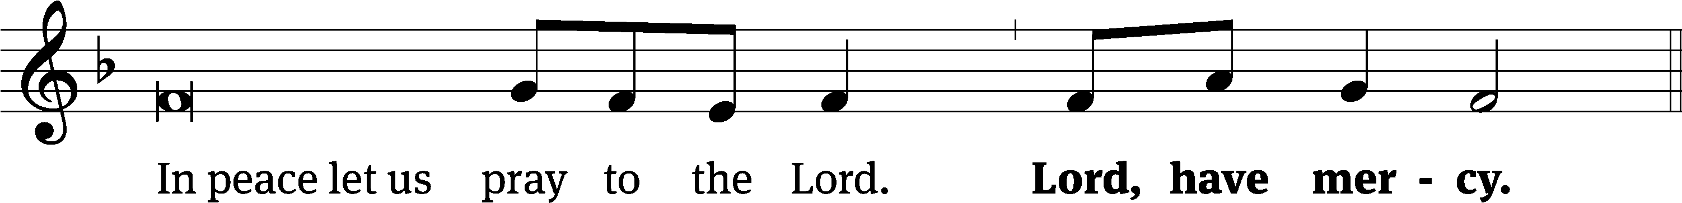
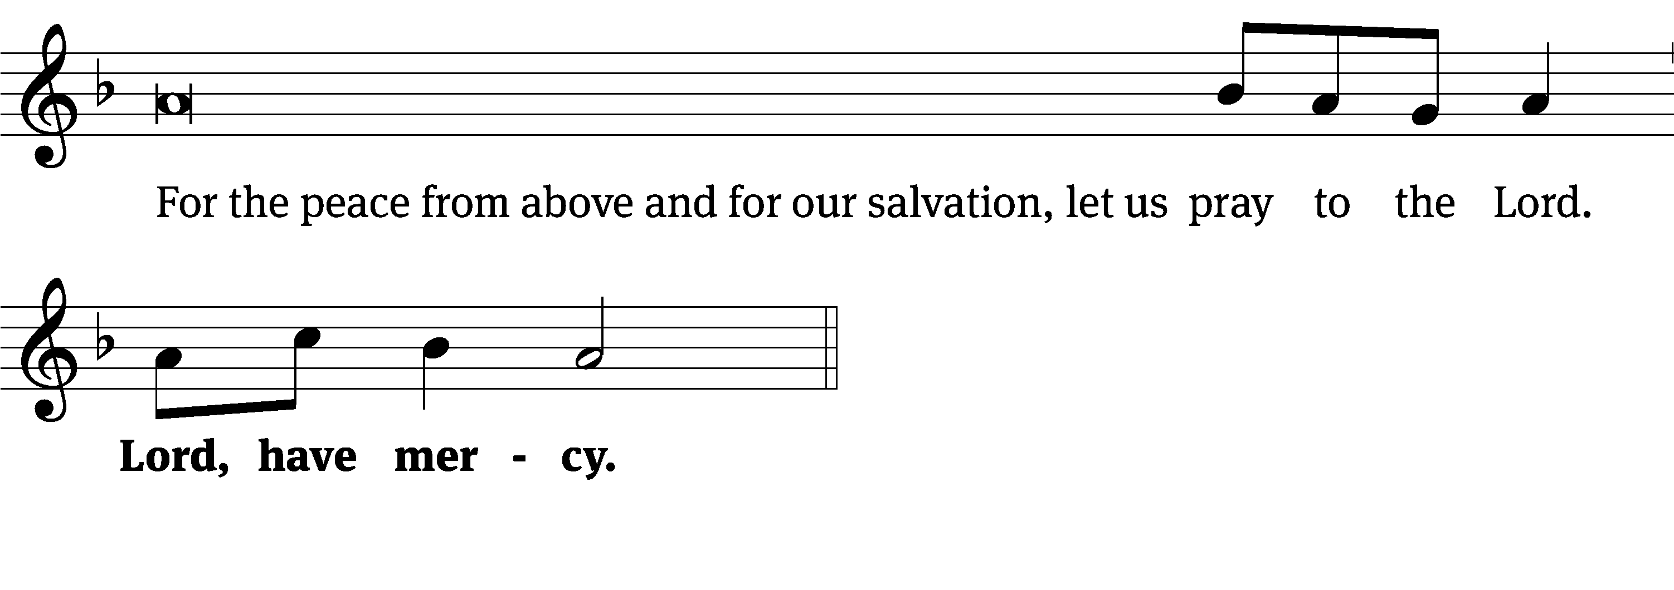
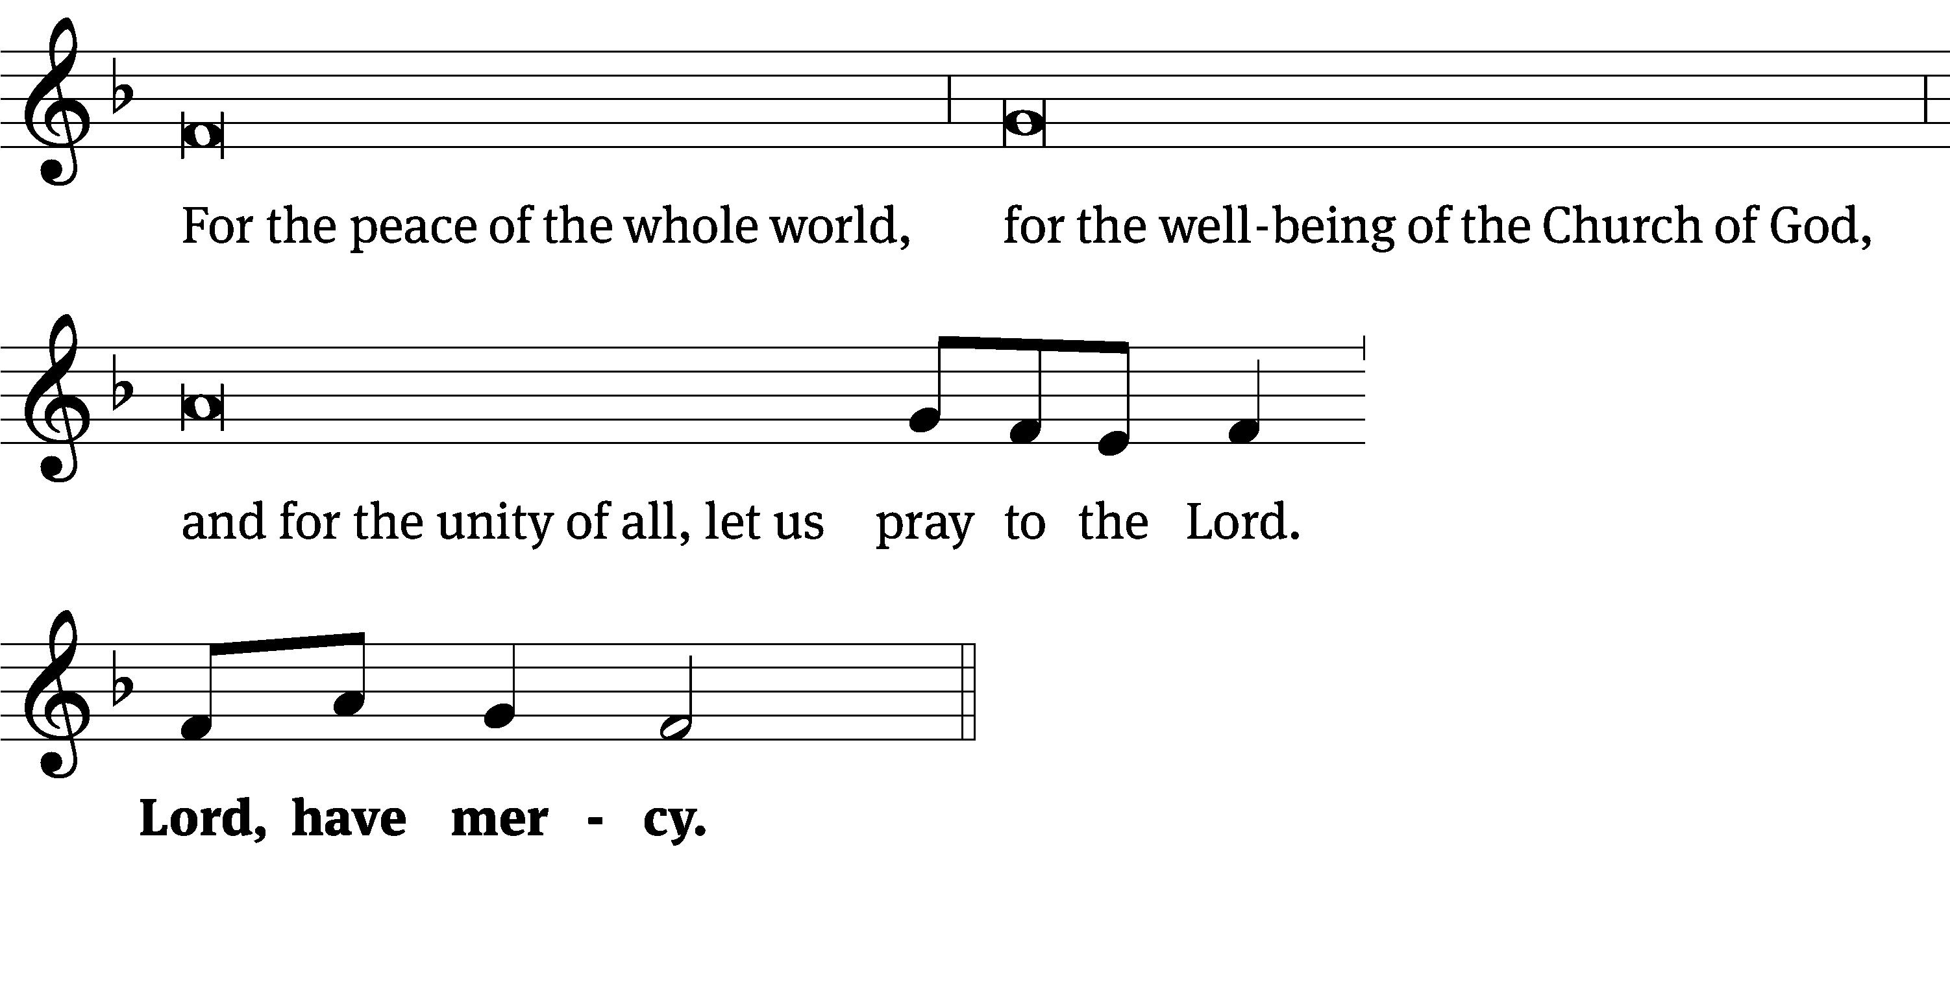
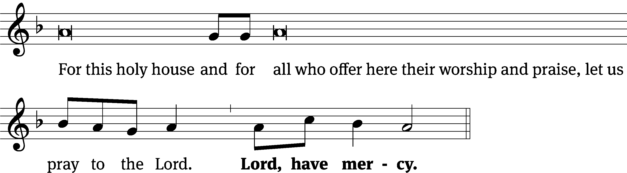
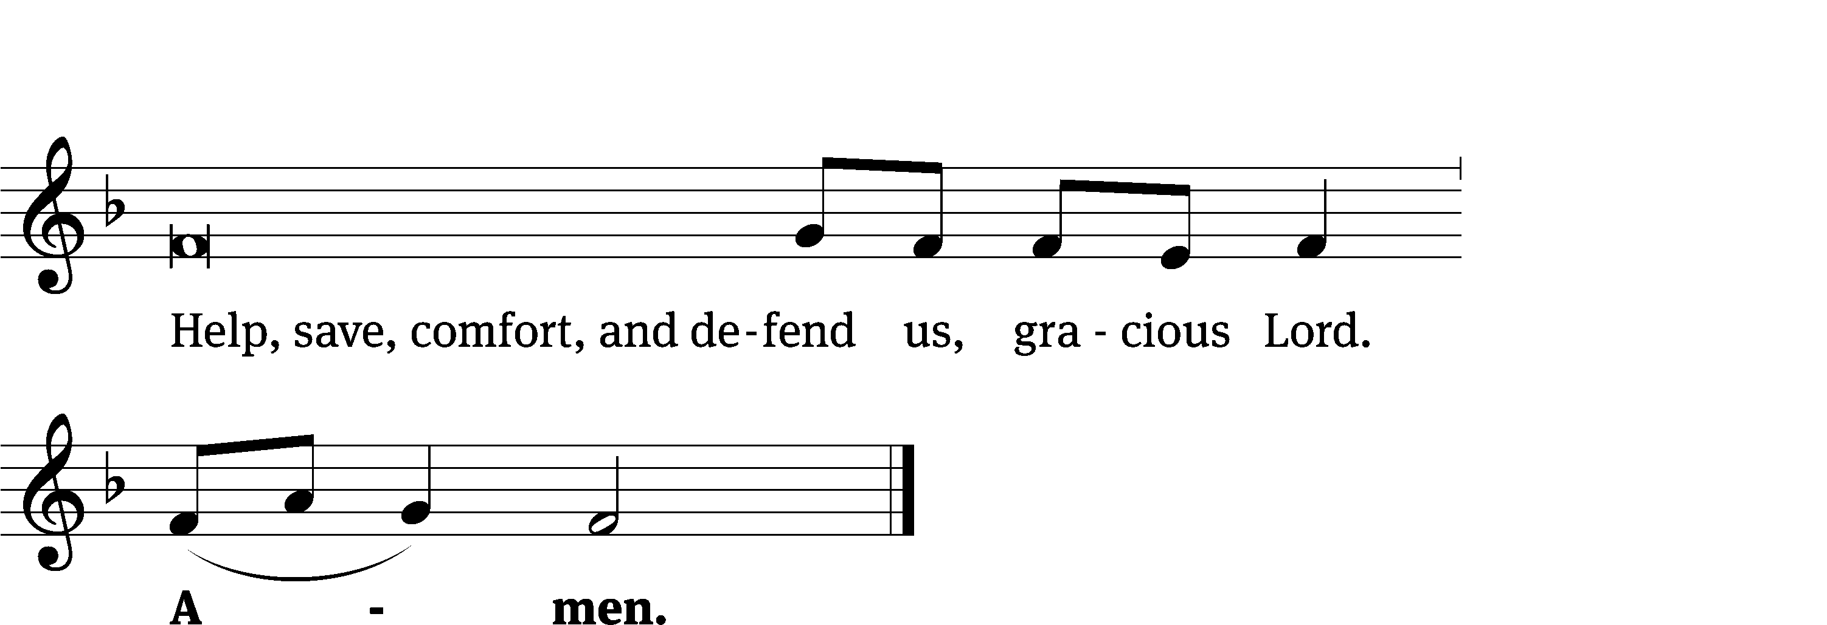
Glory Be to God CW 157
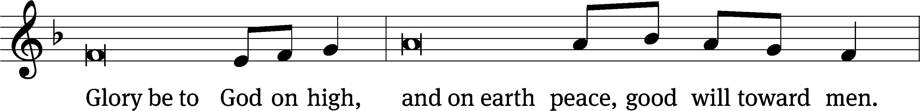
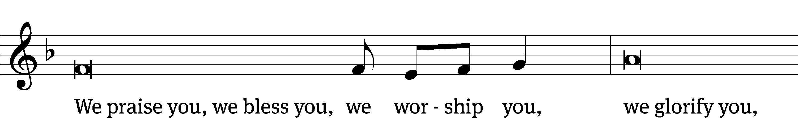
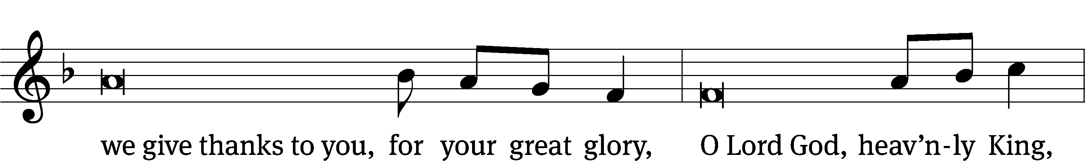
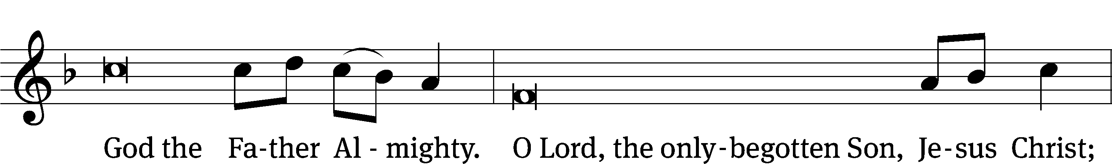
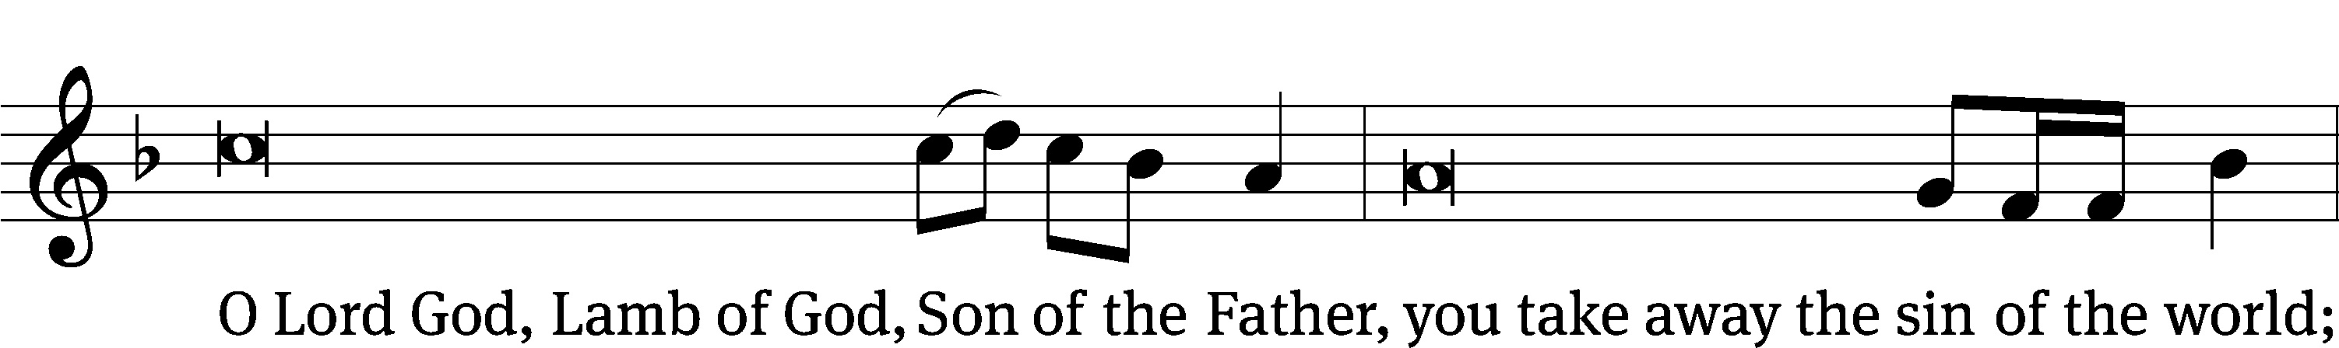
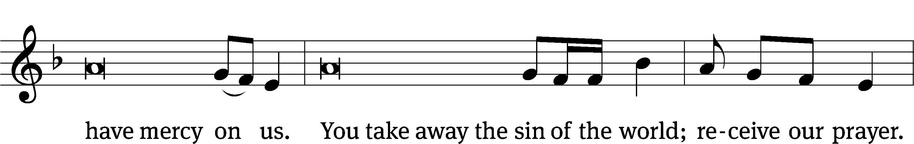
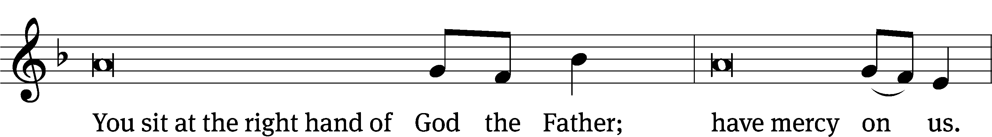
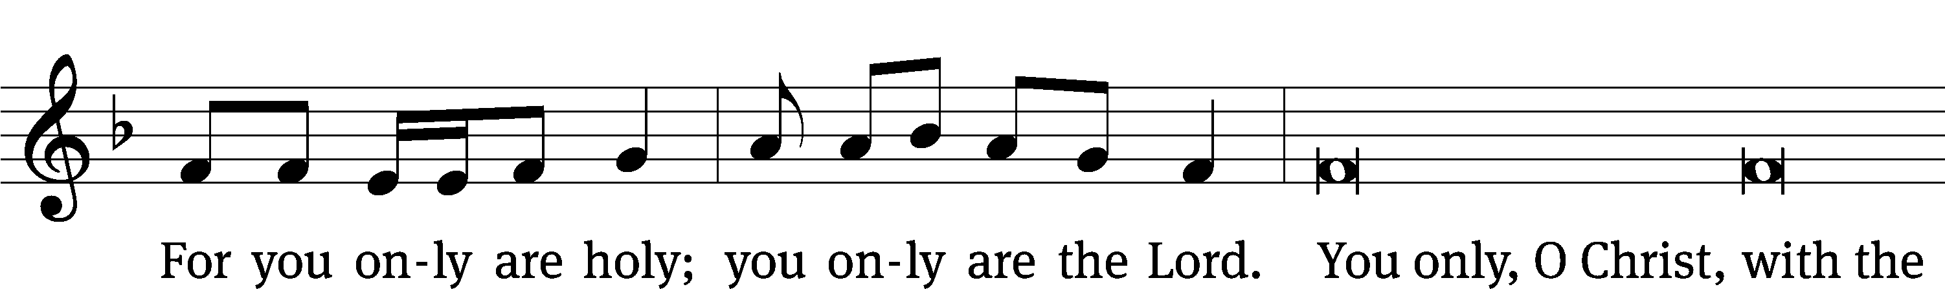
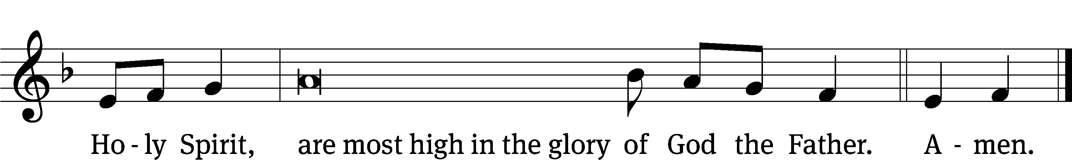

Tune: © 2021 Northwestern Publishing House. Used by permission: OneLicense no. 727703
The Lord be with you.
And also with you.
Prayer of the Day
Let us pray.

O Lord of grace and mercy, teach us by your Holy Spirit to follow the example of your Son in true humility, that we may withstand the temptations of the devil and with pure hearts and minds avoid ungodly pride; through your Son, Jesus Christ our Lord, who lives and reigns with you and the Holy Spirit, one God, now and forever.
Amen.

Please be seated

First Reading Proverbs 25:6-7

⁶ Do not honor yourself in a king’s presence.
Do not stand in a place reserved for great people,
⁷ because it is better to be told, “Come up here,”
than for you to be humiliated before a ruler
whom your eyes have seen.

The Word of the Lord.
Thanks be to God.

Psalm of the Day
112A Light Dawns in the Darkness Psalm 112A
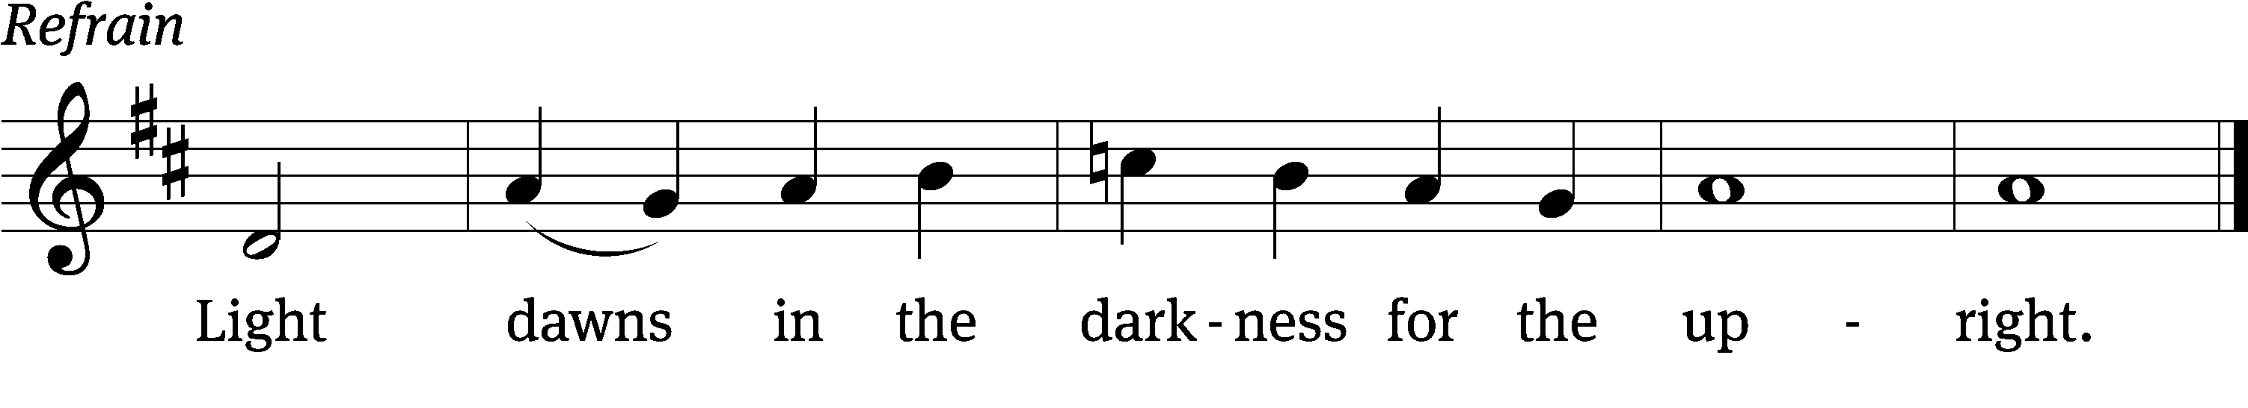
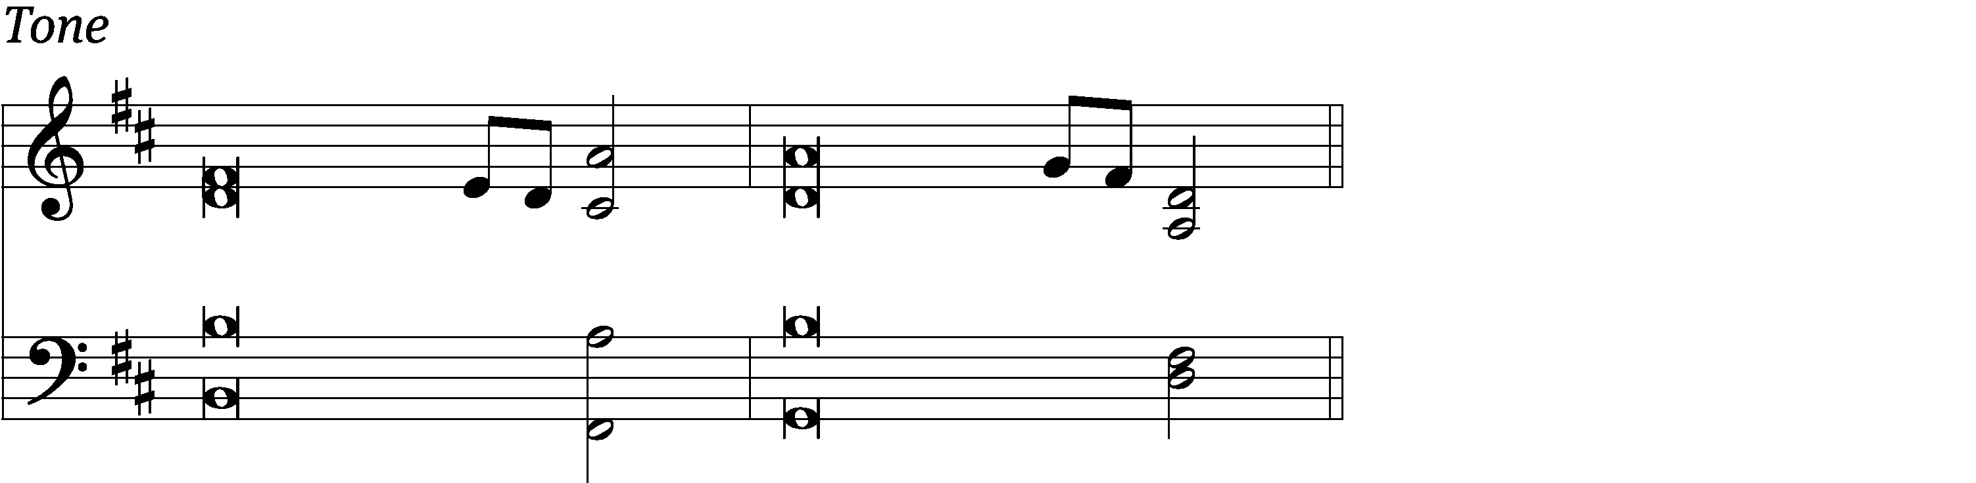

Blessed are those who / fear the Lord,
who find great delight in / his commands.
Wealth and riches are in their / houses,
and their righteousness endures for- / ever. Refrain

Surely the righteous will never be / shaken;
they will be remembered for- / ever.
Their hearts are secure, they will / have no fear;
in the end they will look in triumph / on their foes.
Glory be to the Father and / to the Son
and to the Holy / Spirit,
as it was in the be- / ginning,
is now, and will be forever. / Amen. Refrain
Text: The Holy Bible, English Standard Version
Text: © 2001 Crossway. Used by permission: OneLicense no. 727703
Music: © 2010 Kevin Hildebrand. Used by permission: OneLicense no. 727703

Second Reading James 2:1-13
¹ My brothers, have faith in our glorious Lord Jesus Christ without showing favoritism. ² For example, suppose a man enters your worship assembly wearing gold rings and fine clothing, and a poor man also enters wearing filthy clothing. ³ If you look with favor on the man wearing fine clothing and say, “Sit here in this good place,” but you tell the poor man, “Stand over there” or “Sit down here at my feet,” ⁴ have you not made a distinction among yourselves and become judges with evil opinions? ⁵ Listen, my dear brothers, has not God chosen those who are poor in the world to be rich in faith and to be heirs of the kingdom, which he promised to those who love him? ⁶ But you dishonored the poor man. Don’t the rich oppress you, and don’t they drag you into court? ⁷ Aren’t they the ones who blaspheme the noble name that was pronounced over you? ⁸ However, if you really fulfill the royal law according to the Scripture: “You shall love your neighbor as yourself,” you are doing well. ⁹ But if you show favoritism, you are committing a sin, since you are convicted by this law as transgressors.
¹⁰ In fact, whoever keeps the whole law but stumbles in one point has become guilty of breaking all of it. ¹¹ For the one who said, “Do not commit adultery,” also said, “Do not commit murder.” Now if you do not commit adultery, but you do commit murder, you have become a transgressor of the law. ¹² So speak and act as those who are going to be judged by the law of freedom. ¹³ For there will be judgment without mercy on the one who has not shown mercy. Mercy triumphs over judgment.

The Word of the Lord.
Thanks be to God.

Please stand, if you are able

Gospel Acclamation Luke 14:11
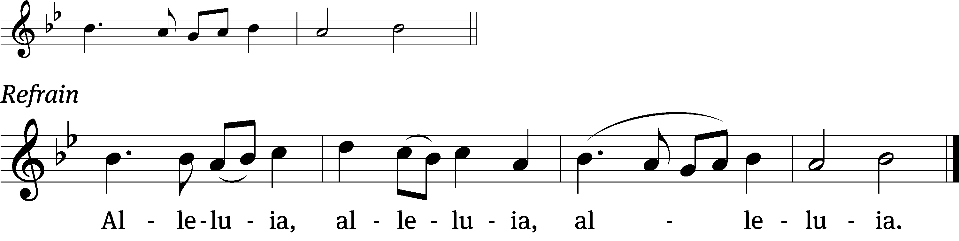
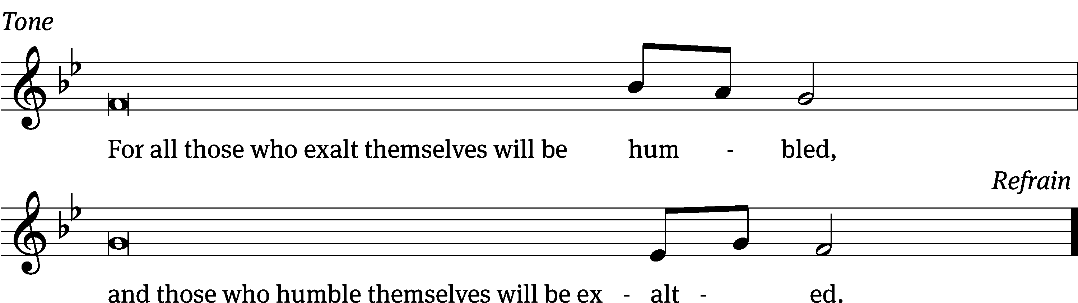
Tune: © 2021 Northwestern Publishing House. Used by permission: OneLicense no. 727703

Gospel Luke 14:1, 7-14
14 One Sabbath day, when Jesus went into the house of a leader of the Pharisees to eat bread, they were watching him closely.
⁷ When he noticed how they were selecting the places of honor, he told the invited guests a parable. ⁸ “When you are invited by someone to a wedding banquet, do not recline in the place of honor, or perhaps someone more distinguished than you may have been invited by him. ⁹ The one who invited both of you may come and tell you, ‘Give this man your place.’ Then you will begin, with shame, to take the lowest place.
¹⁰ “But when you are invited, go and recline in the lowest place, so that when the one who invited you comes, he will tell you, ‘Friend, move up to a higher place.’ Then you will have honor in the presence of all who are reclining at the table with you.
¹¹ “Yes, everyone who exalts himself will be humbled, and whoever humbles himself will be exalted.”
¹² He also said to the one who had invited him, “When you make a dinner or a supper, do not invite your friends, or your brothers, or your relatives, or rich neighbors, so that perhaps they may also return the favor and pay you back.
¹³ “But when you make a feast, invite the poor, the crippled, the lame, the blind, ¹⁴ and you will be blessed, because they cannot repay you. Certainly, you will be repaid in the resurrection of the righteous.”

The Gospel of the Lord.
Praise be to you, O Christ!

Please be seated

814 Just As I Am CW 814
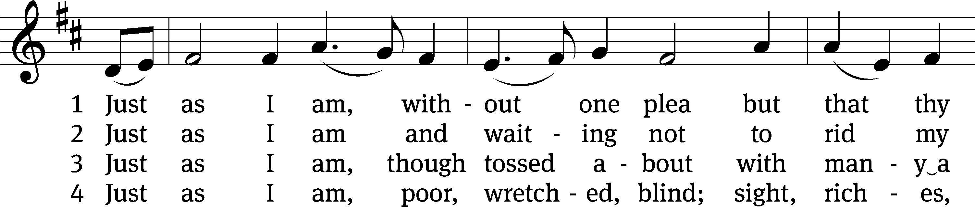
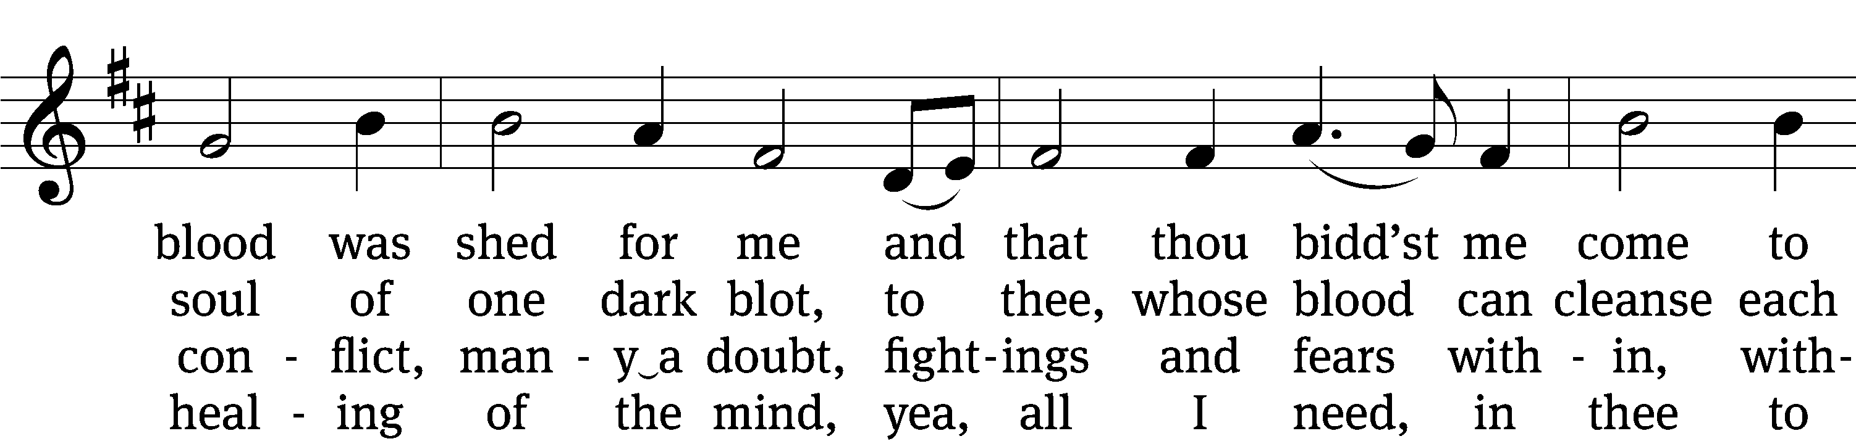
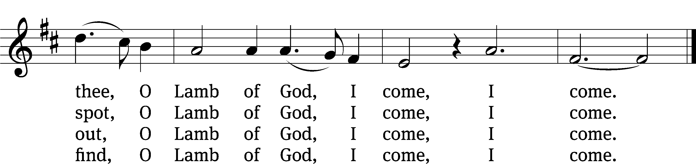

5 Just as I am, thou wilt receive,
wilt welcome, pardon, cleanse, relieve;
because thy promise I believe,
O Lamb of God, I come, I come.

6 Just as I am; thy love unknown
has broken ev’ry barrier down;
now to be thine, yea thine alone,
O Lamb of God, I come, I come.
Text: Charlotte Elliott, 1789–1871
Tune: William B. Bradbury, 1816–1868
Text and tune: Public domain

Sermon Luke 14:1, 7-14
“Humility vs. Humiliation”

Please stand, if you are able
Apostles’ Creed
I believe in God, the Father Almighty,
maker of heaven and earth.

I believe in Jesus Christ, his only Son, our Lord,
who was conceived by the Holy Spirit,
born of the Virgin Mary,
suffered under Pontius Pilate,
was crucified, died, and was buried.
He descended into hell.
The third day he rose again from the dead.
He ascended into heaven
and is seated at the right hand of God the Father Almighty.
From there he will come to judge the living and the dead.

I believe in the Holy Spirit,
the holy Christian Church,
the communion of saints,
the forgiveness of sins,
the resurrection of the body,
and the life everlasting. Amen.
Prayer of the Church
936 All Glory Be to God Alone CW 936
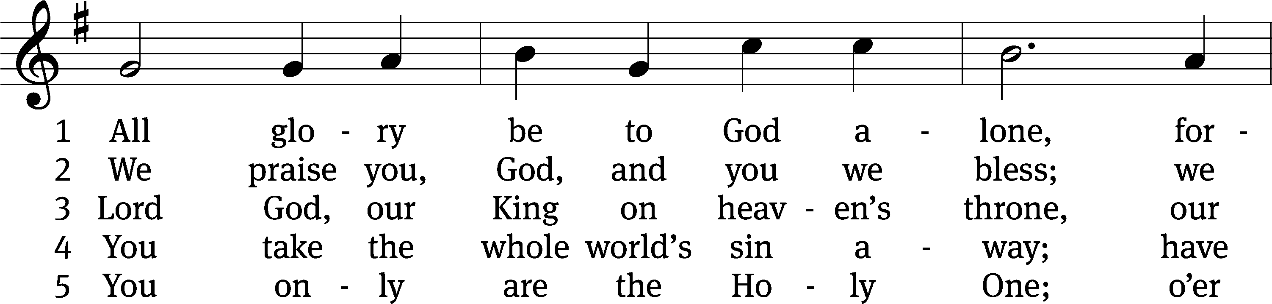
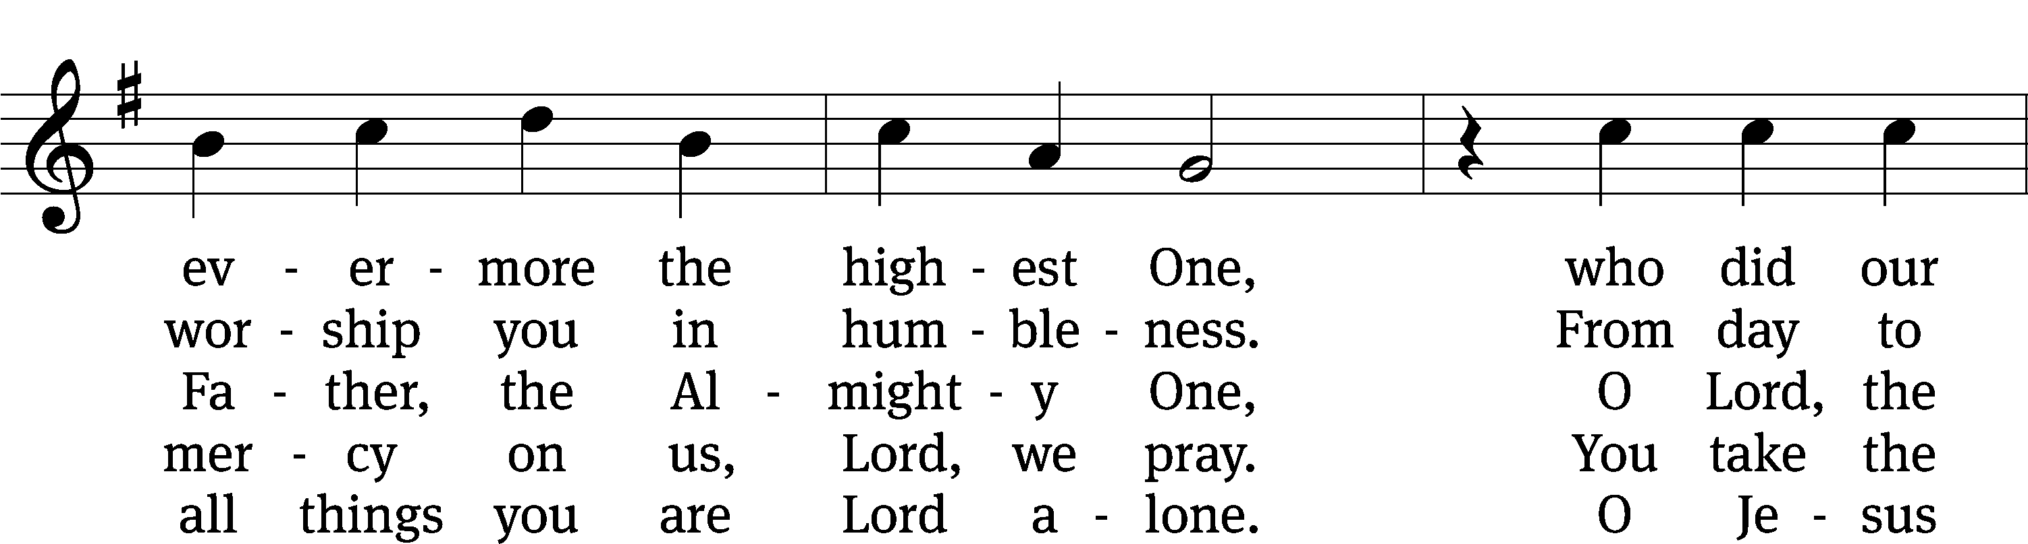
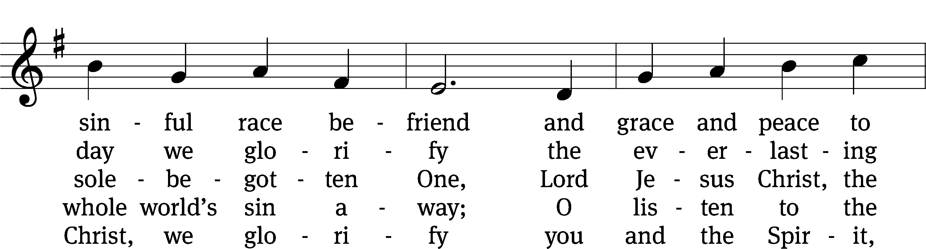
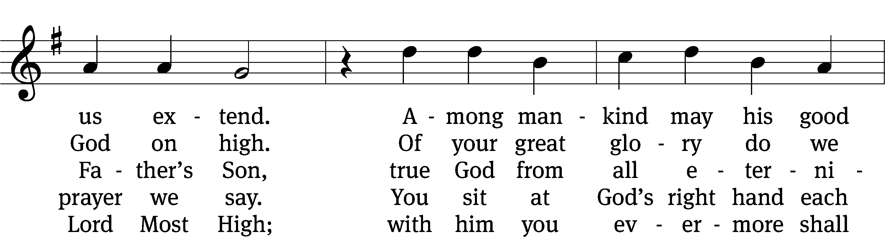
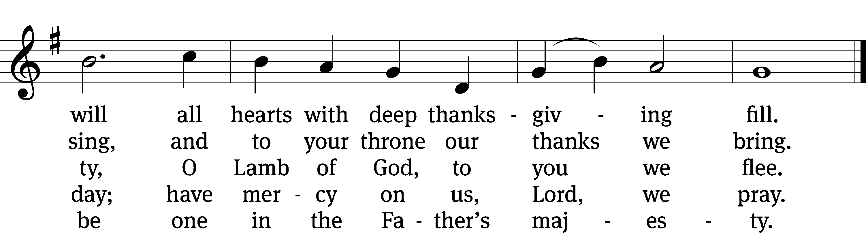
Text: tr. W. Gustave Polack, 1890–1950, alt.; Martin Luther, 1483–1546, abr.
Tune: Gesangbuch . . . Psalmen, Geistliche Lieder, Strassburg, 1541, alt.
Text: © 1941 Concordia Publishing House. Used by permission: OneLicense no. 727703
Tune: Public domain

Prayer

Blessed Lord, you have given us your Holy Scriptures for our learning. May we so hear them, read, learn, and take them to heart that, being strengthened and comforted by your holy Word,
we may cling to the blessed hope of everlasting life; through Jesus Christ our Lord, who lives and reigns with you and the Holy Spirit, one God, now and forever.
Amen.
Lord’s Prayer
Our Father, who art in heaven, hallowed be thy name, thy kingdom come, thy will be done on earth as it is in heaven. Give us this day our daily bread; and forgive us our trespasses, as we forgive those who trespass against us; and lead us not into temptation, but deliver us from evil. For thine is the kingdom and the power and the glory forever and ever. Amen.

Blessing
The Lord bless you and keep you.
The Lord make his face shine on you and be gracious to you.
The Lord look on you with favor and give you peace.
Amen.

Please be seated

881 Sing with All the Saints in Glory CW 881
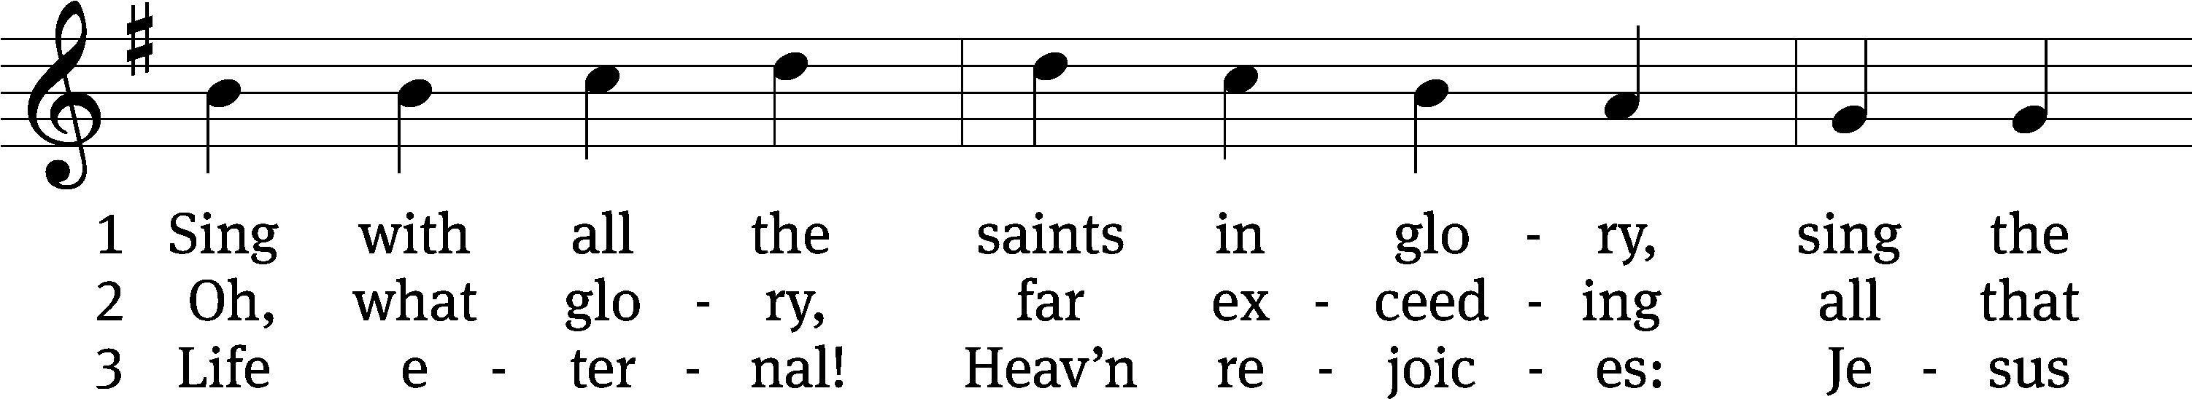
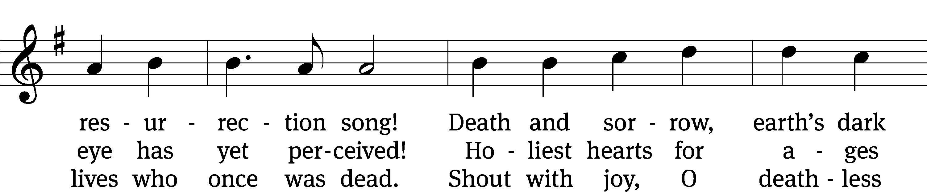
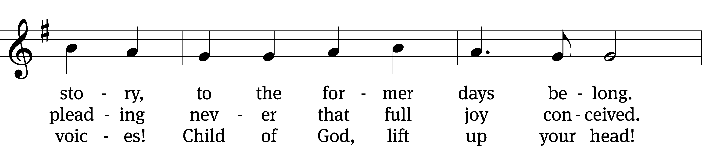
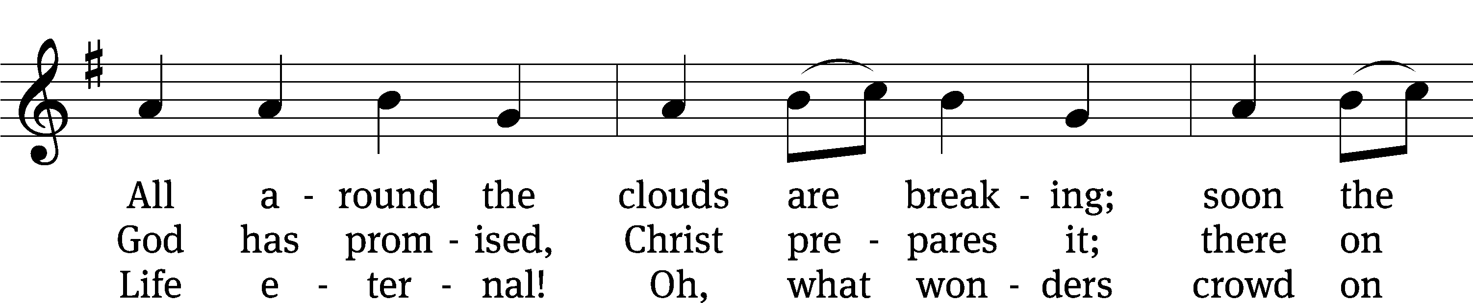
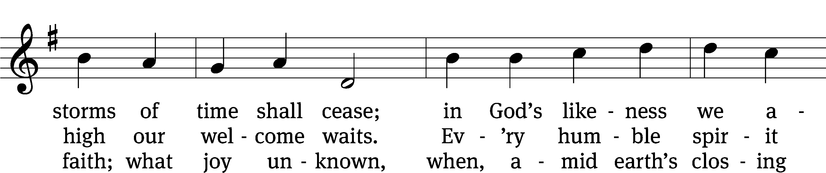
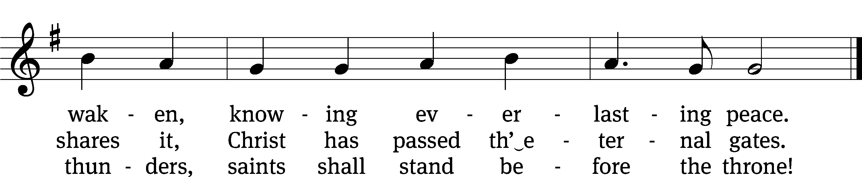
Text: William J. Irons, 1812–1883, alt.
Tune: Ludwig van Beethoven, 1770–1827
Text and tune: Public domain

Acknowledgments
Setting One from Christian Worship
Software distributed in partnership with Northwestern Publishing House.
Created by Christian Worship: Service Builder © 2022 Concordia Publishing House.

Serving in Worship
Officiant Pastor Natsis
Organist Marcia Marion Ackling
Deacons (Thursday) Dave Frey and Steve Hoeft
(Sunday) Dave Stevenson and Ed Wheeler
Ushers (Thursday) Dale Radak
(Sunday) Ron Zahn
Altar Guild Scott Ackling and Marcia Marion Ackling
Videographer Jake Vershum

