THE EIGHTEENTH SUNDAY
AFTER PENTECOST
TRINITY EVANGELICAL LUTHERAN CHURCH | Saline, Michigan
WELCOME TO WORSHIP October 1, 2023
Thank you for joining us in God’s house today! We cordially ask that our Guests sign one of the guestbooks located at either the front or back entryways, or fill out a “Let’s Get Acquainted” card located in the hymnal pew rack and place it in the collection plate.

Thank Offering: Members of Trinity give their offering as an expression of love and thankfulness to the Lord and to help support the Lord’s work in our community and around the world. Visitors need not feel obligated to participate in this offering .

Restrooms are located at the back of the upper level (the annex), and in the basement (down the back stairs of the sanctuary or annex). Handicap access is available, please ask an usher for assistance.

Young Families / Toddler Bags – We are GLAD YOU BROUGHT YOUR CHILDREN to our worship service. Jesus said: “Let the little children come to me and do not hinder them, for the kingdom of God belongs to such as these.” We know that having little children in church can be a challenge, but DO NOT WORRY about it. Many of your fellow worshippers have been in your shoes and are just happy you brought your children with you. For your convenience, we have reserved the back rows of seating for parents with small children. These areas provide more flexibility for your family, as well as, easy access to move downstairs if necessary. A closed-circuit TV system allows families to continue participating in the service while downstairs. Pre-school toddler bags and children’s bulletins are available for their enjoyment. Ask an usher for one to use during the service and please return the toddler bag afterwards.

Holy Communion – In His Word, God makes it clear that the Lord’s Supper is to be shared by people of a common proclamation of faith (1 Corinthians 11:26; 1 Corinthians 10:16-17). Without judging anyone’s hearts, we invite those who share in our confession by their membership in our congregation or another congregation of the Wisconsin Evangelical Lutheran Synod (WELS) or the Evangelical Lutheran Synod (ELS) and who are properly prepared (1 Corinthians 11;27-29) to receive the Sacrament. Page 295 in Christian Worship provides a guide for preparation.
Guests, we would love to have you join us in communion fellowship in the future, and for that to be possible, we ask that you speak with one of the pastors so that we may speak with you on how that would be possible. We thank you for respecting the way we celebrate the Lord’s Supper in our congregations.

the SERVICE – setting one - WITH HOLY COMMUNION CW, page 154
579 His Mercy Is More CW 579
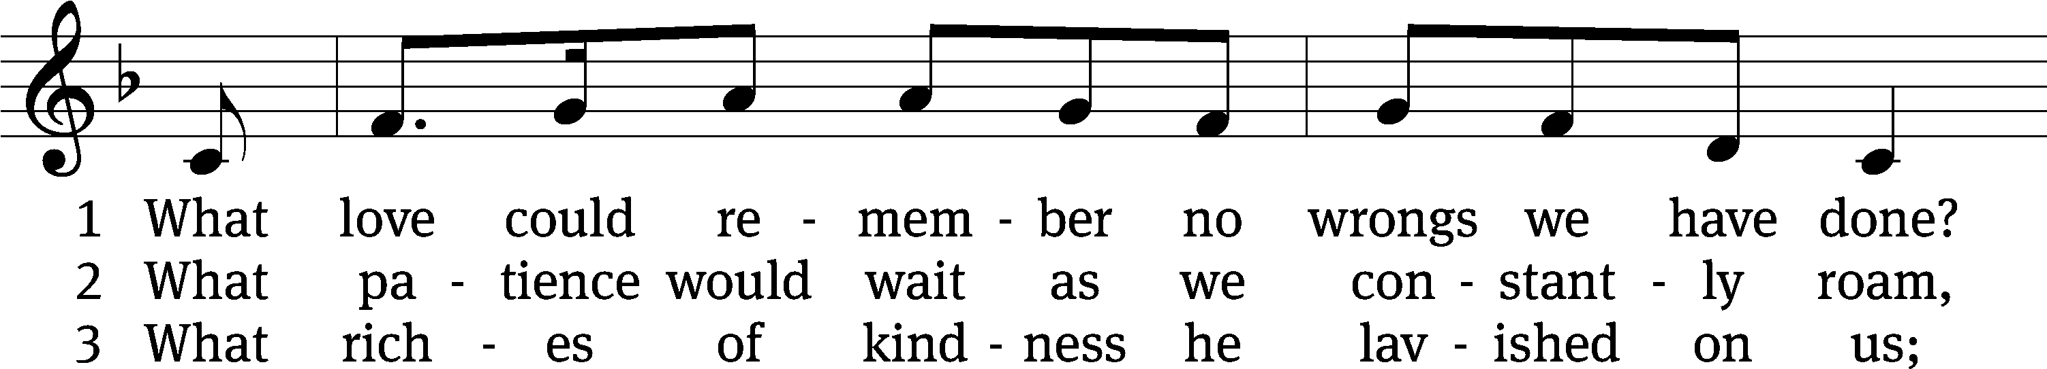
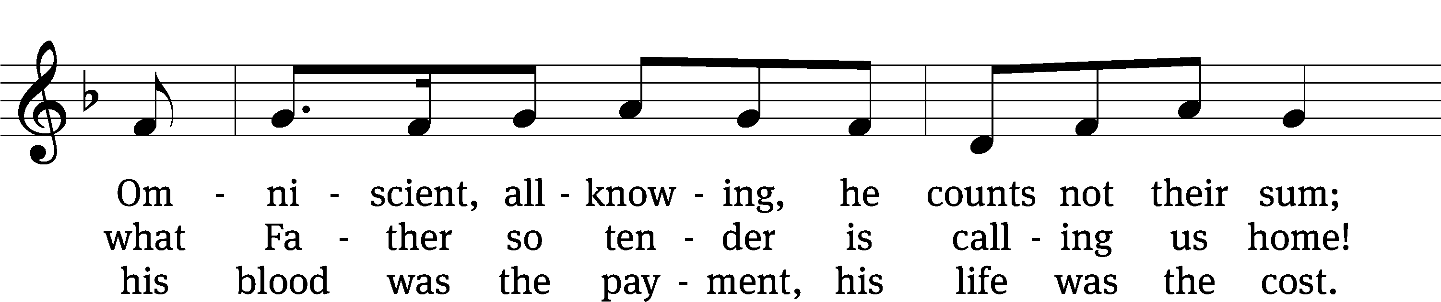
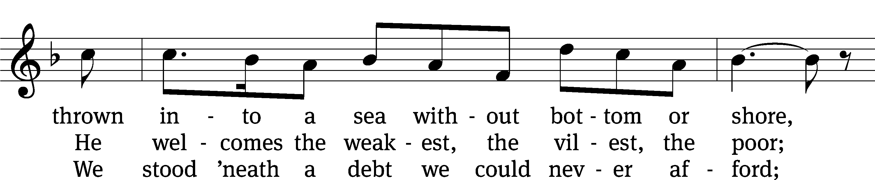
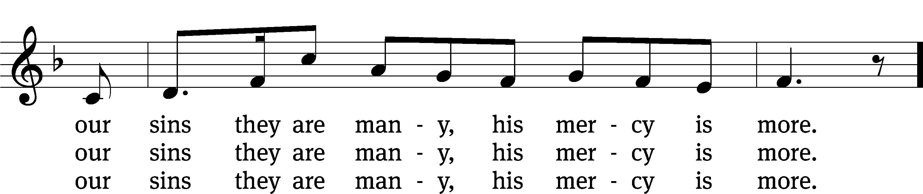
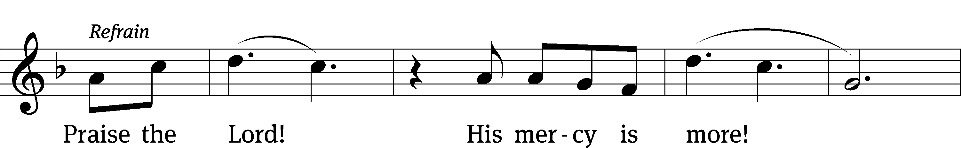
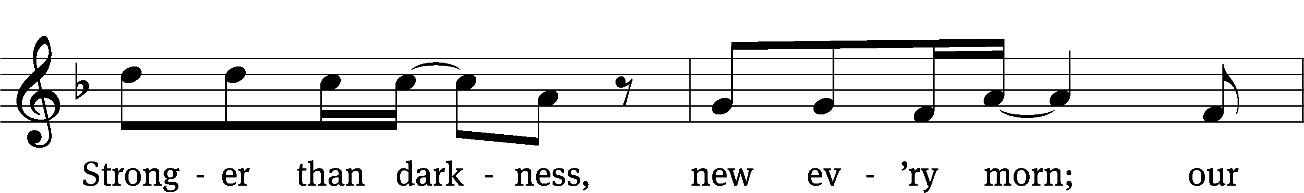
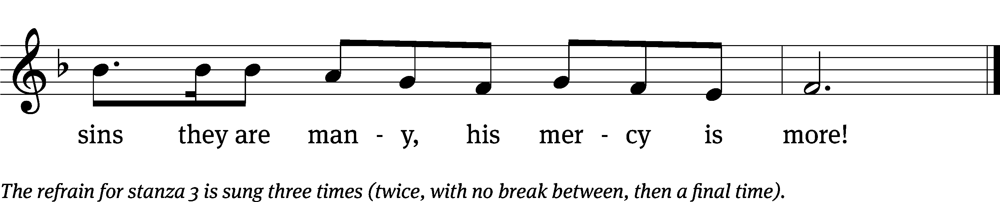
Text: Matt Papa, b. 1983; Matt Boswell, b. 1979
Tune: Matt Papa, b. 1983; Matt Boswell, b. 1979
Text and tune: © 2016 Getty Music Songs, Messenger Hymns, and Love Your Enemies Publishing, admin. MusicServices.org. Used by permission: OneLicense no. 727703
Please stand, if you are able
Invocation
In the name of the Father and of the Son and of the Holy Spirit.
Amen.
Confession
If we claim to be without sin, we deceive ourselves and the truth is not in us.
If we confess our sins, God is faithful and just
and will forgive us our sins
and purify us from all unrighteousness.

Let us confess our sins to the Lord.
Holy God, gracious Father,
I am sinful by nature
and have sinned against you in my thoughts, words, and actions.
I have not loved you with my whole heart;
I have not loved others as I should.
I deserve your punishment both now and forever.
But Jesus, my Savior, paid for my sins
with his innocent suffering and death.
Trusting in him, I pray: God, have mercy on me, a sinner.

Our gracious Father in heaven has been merciful to us. He sent his only Son, Jesus Christ, who gave his life as the atoning sacrifice for the sins of the whole world. Therefore, as a called servant of Christ and by his authority, I forgive you all your sins in the name of the Father and of the Son and of the Holy Spirit.
Amen.

Lord, Have Mercy

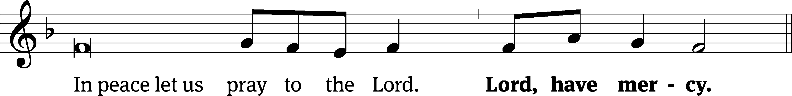
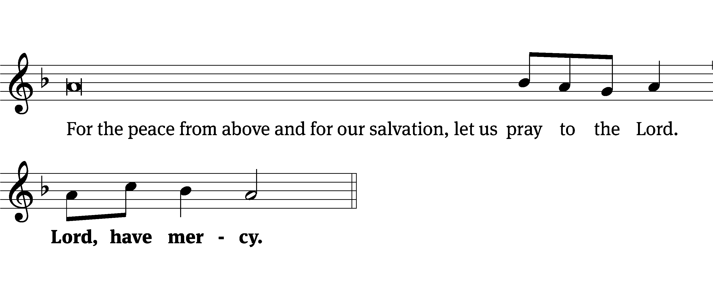
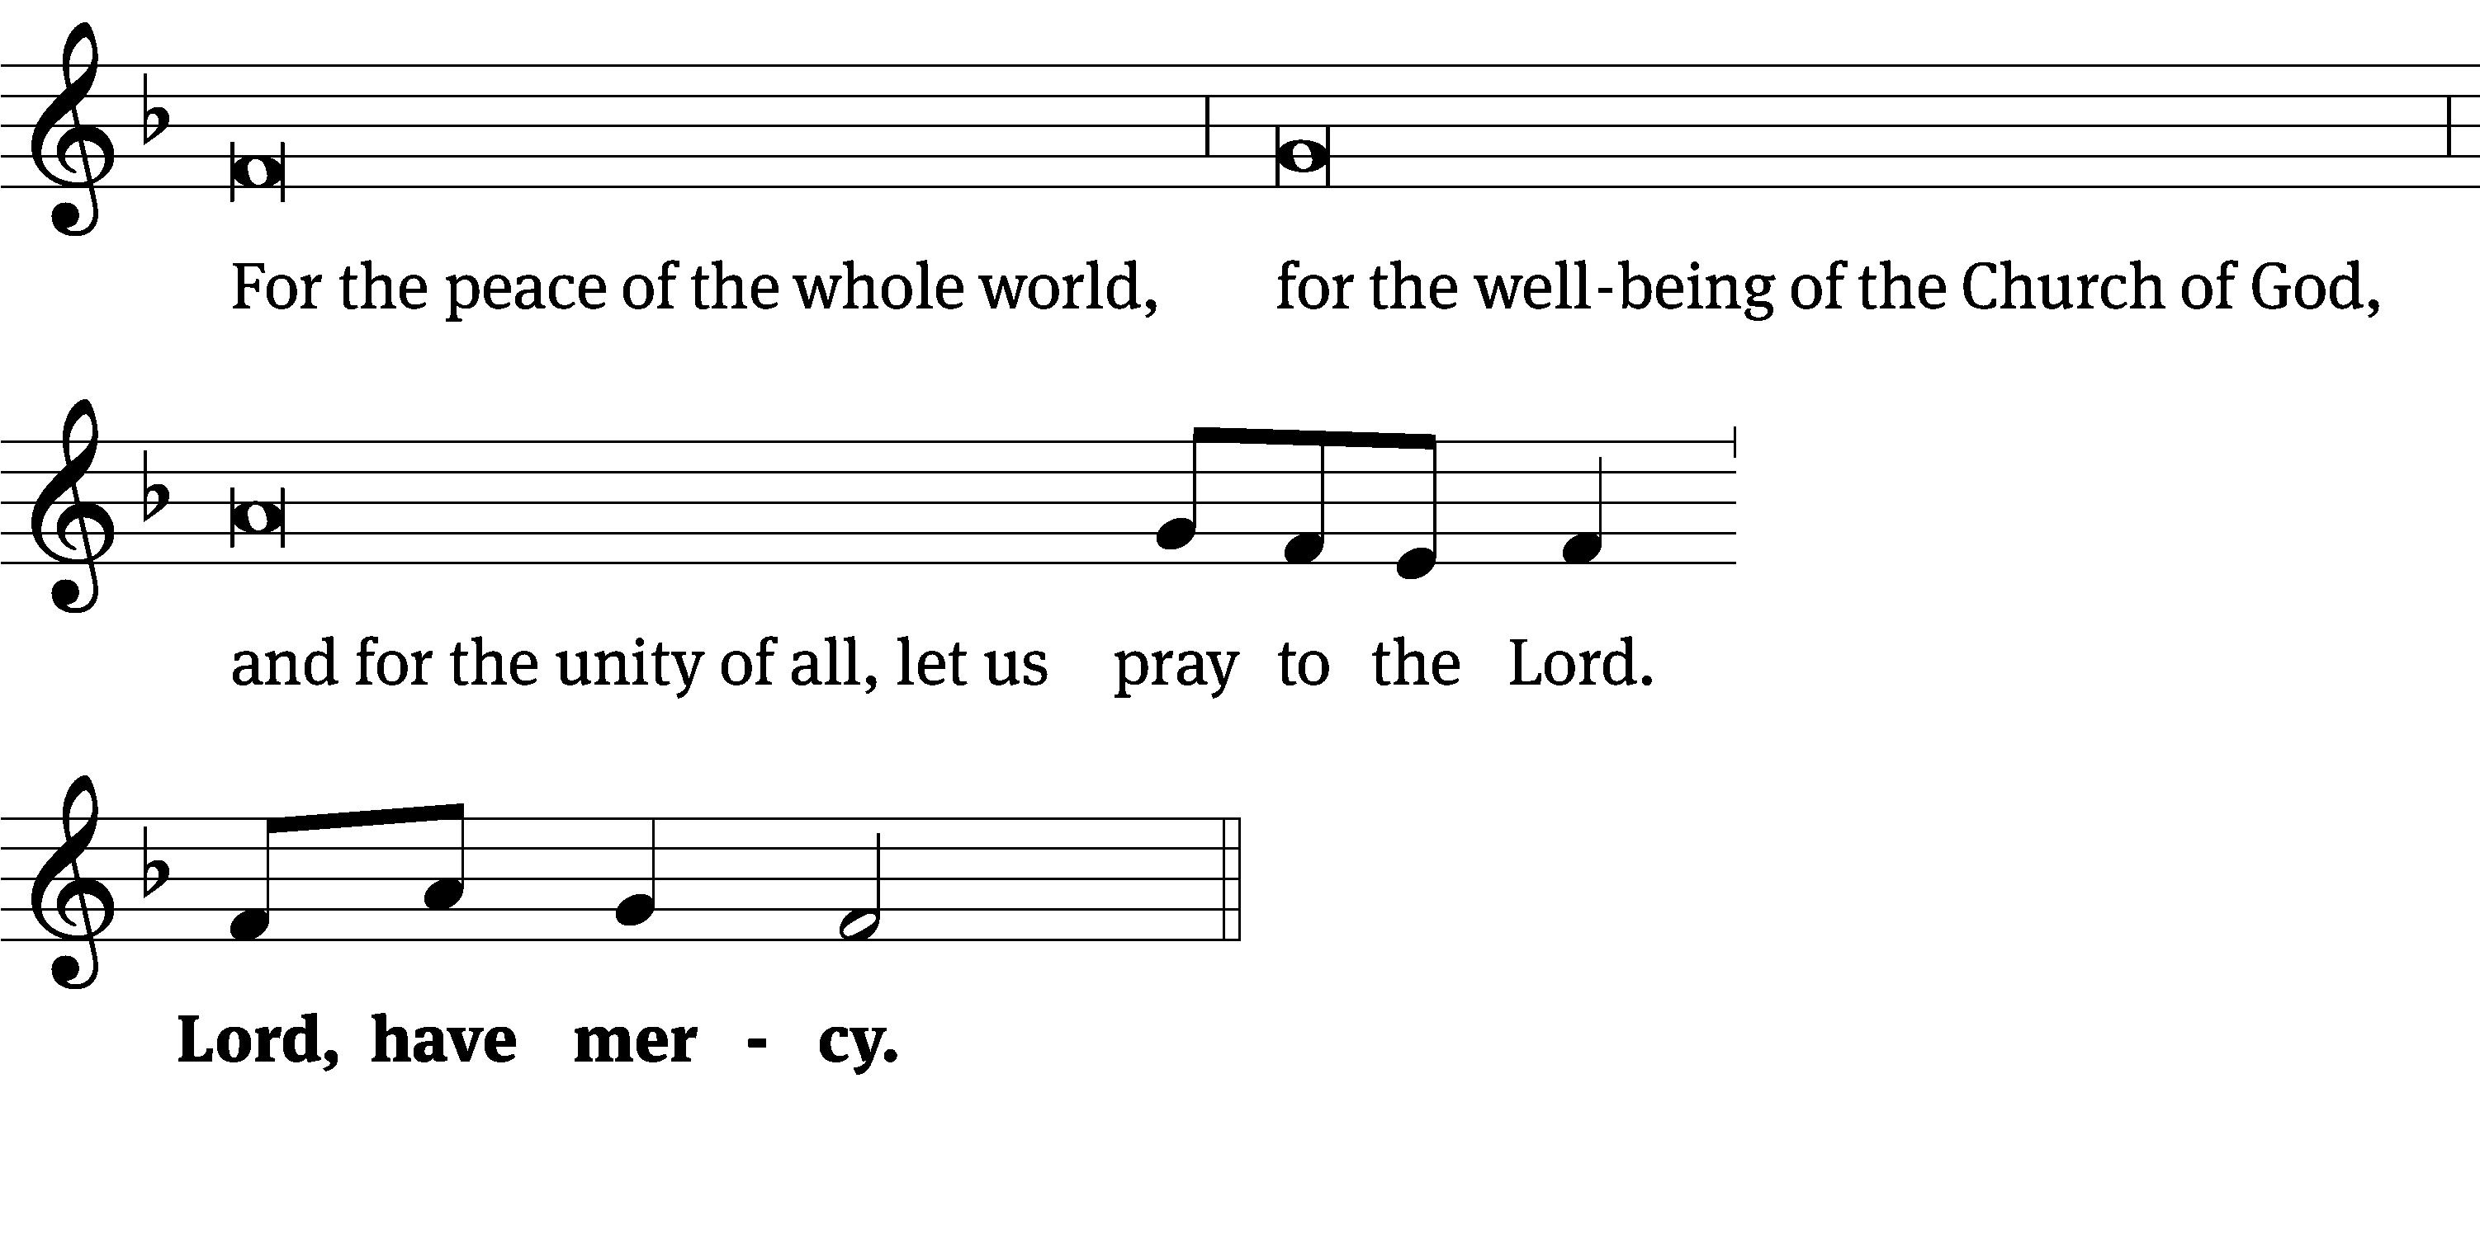
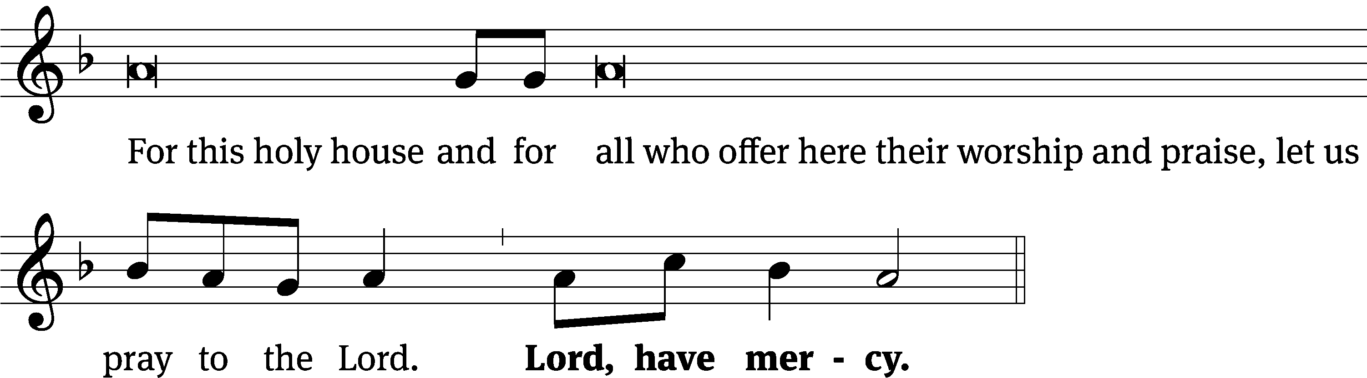
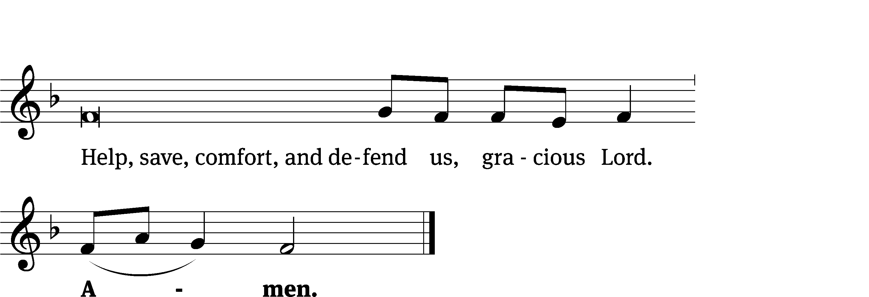
Glory Be to God on High CW 157
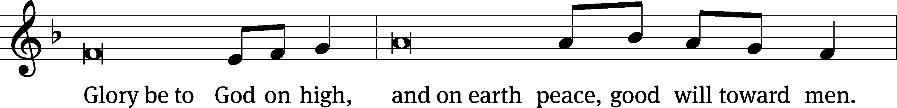
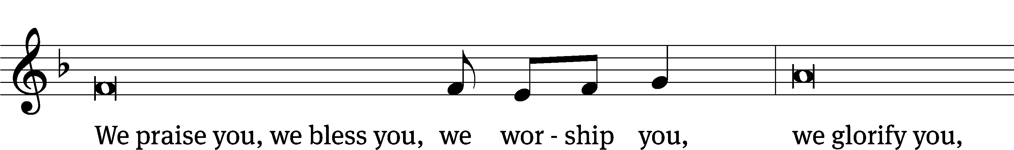
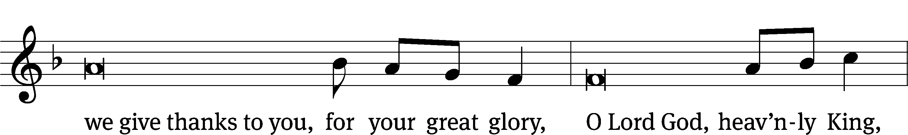
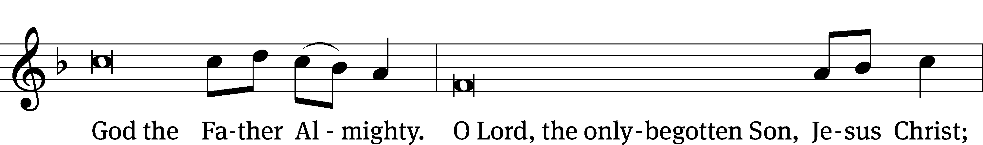
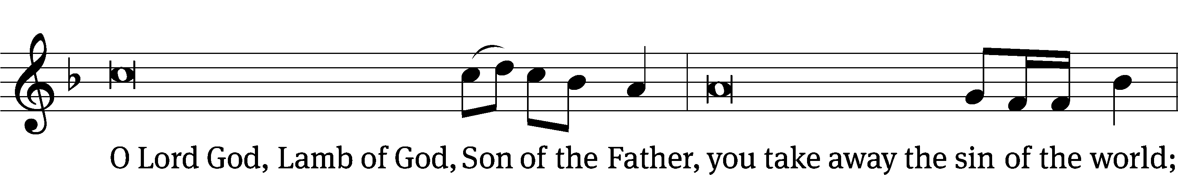
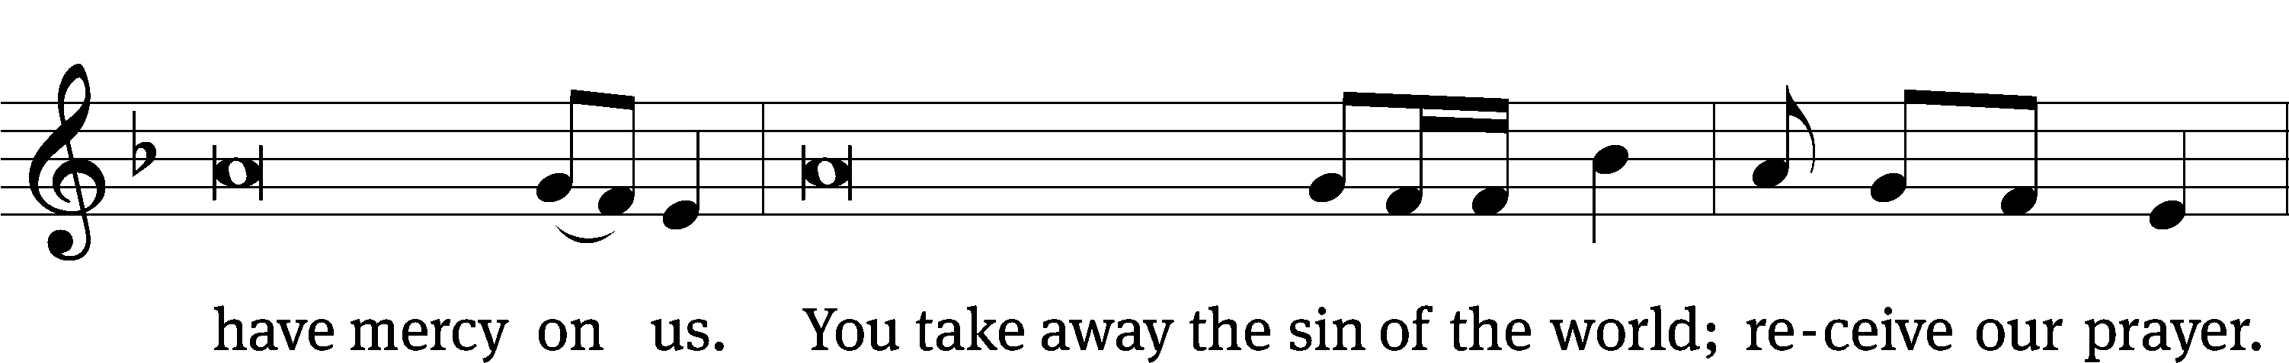
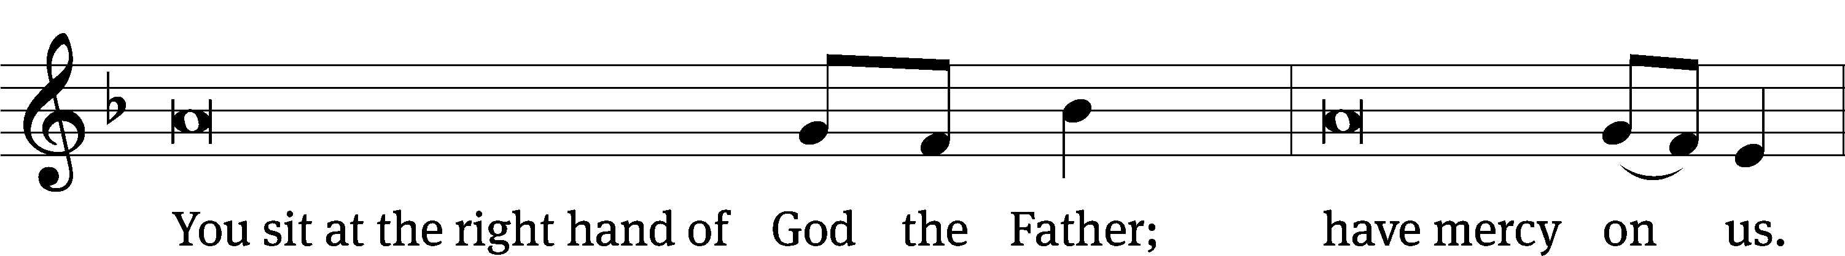
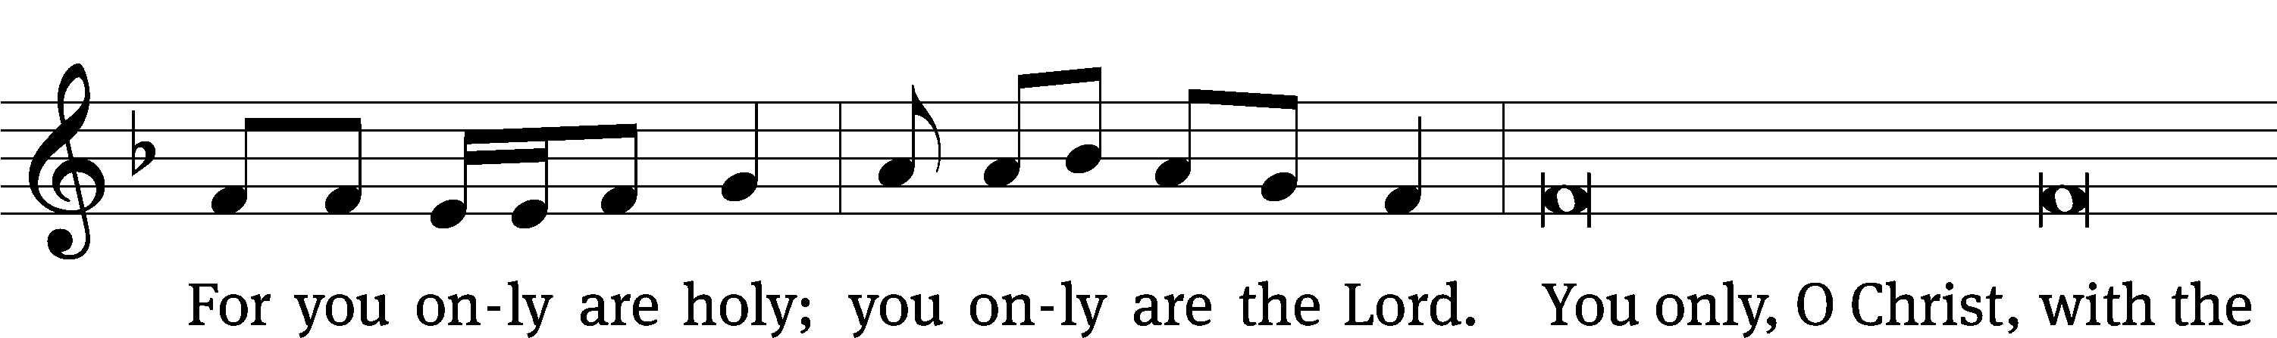
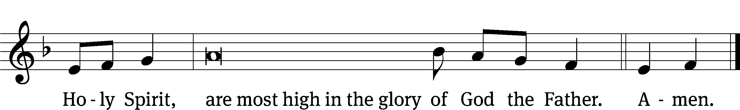

The Lord be with you.
And also with you.
Prayer of the Day
Let us pray.

Mercifully grant, O God, that your Holy Spirit may in all things direct and rule our hearts, for without your help we are unable to please you; through your Son, Jesus Christ our Lord, who lives and reigns with you and the Holy Spirit, one God, now and forever.
Amen.

Please be seated

First Reading Ezekiel 18:1-4, 25-32
¹ The word of the Lord came to me. ² What do you mean, you who keep repeating this proverb concerning the soil of Israel, “Fathers eat sour grapes, and their sons’ teeth are set on edge”? ³ As surely as I live, declares the Lord God, you will never again use this proverb in Israel. ⁴ Indeed, all souls are mine. The soul of the father is mine just like the soul of the son. The soul who sins is the one who will die.
²⁵ But you say, “The Lord’s way is not fair.” Listen now, house of Israel. Is it my way that is not fair? Is it not your ways that are not fair? ²⁶ If a righteous man turns away from his righteousness and practices unrighteousness, he will die because of it. Because of the unrighteousness that he has practiced, he will die.
²⁷ But if a wicked man turns from his wickedness that he has done and practices justice and righteousness, he will preserve his life. ²⁸ Because he has seen and turned away from^{[e]} all the rebellious acts that he had committed, he will surely live, and he will not die. ²⁹ But the house of Israel says, “The Lord’s way is not fair.” Is it really my ways that are not fair, O house of Israel? Is it not your ways that are not fair?
³⁰ Therefore, I will judge each one of you according to his ways, O house of Israel, declares the Lord God. Repent and turn away from all your rebellious acts, so that you will not set out a stumbling block that makes you guilty. ³¹ Throw off from yourselves all your rebellious actions by which you have rebelled, and obtain a new heart and a new spirit for yourselves. Why should you die, O house of Israel? ³² For I take no pleasure in the death of anyone who dies, declares the Lord God. So repent and live!
The Word of the Lord.
Thanks be to God.
25A To You, O LORD, I Lift My Soul Psalm 25A
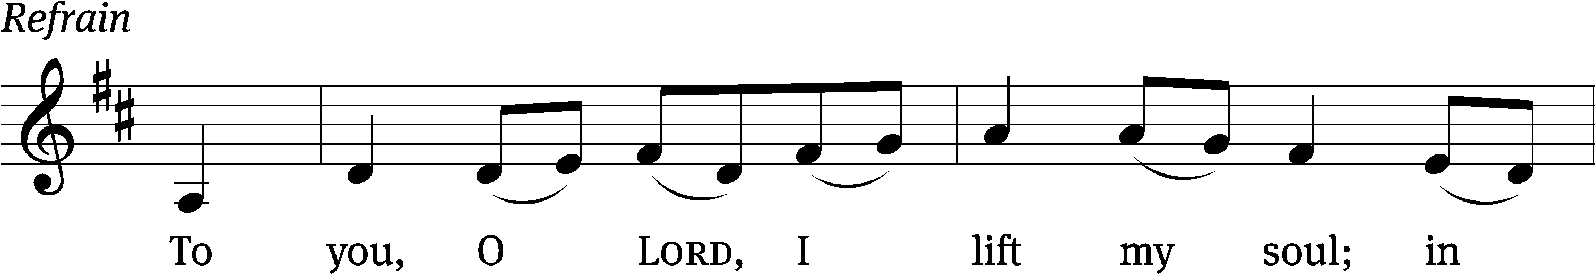
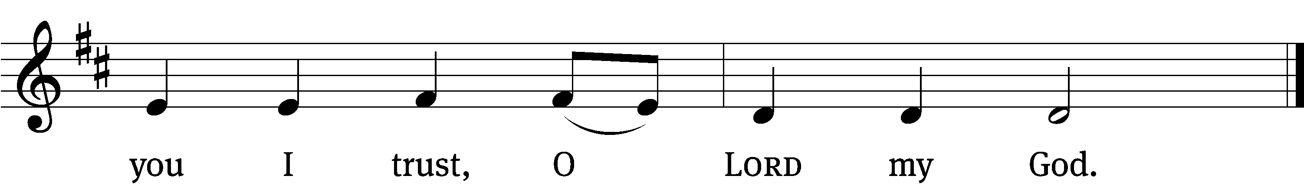
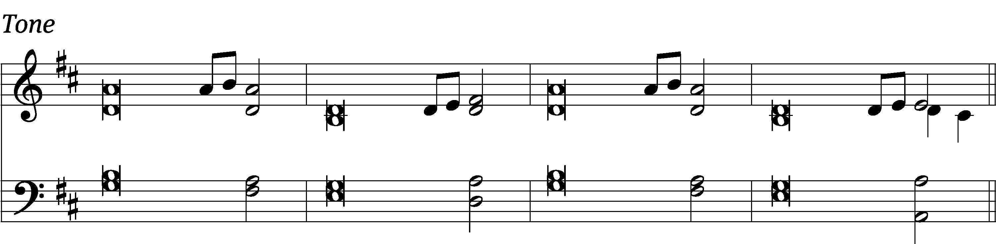

In you, Lord my God, I / put my trust.
I trust in you; do not let me be / put to shame.
Show me your ways, Lord, teach me / your paths.
Guide me in your truth and teach me, for you are God my / Savior.

Remember, Lord, your great mer- / cy and love,
for they are / from of old.
Do not remember the sins of my youth and my re- / bellious ways;
according to your love remember me, for you, Lord, / are good. Refrain

Lord, forgive my iniquity, though / it is great.
Turn to me and be gracious to me, for I am lonely and af- / flicted.
Look on my affliction and / my distress
and take away / all my sins.

Glory be to the Father and / to the Son
and to the Holy / Spirit,
as it was in the be- / ginning,
is now, and will be forever. / Amen. Refrain
Tune: Mark Haas
Setting: Mark Haas
Music: © 2014 Mark Haas. Used by permission: OneLicense no. 727703

Second Reading Philippians 2:1-11
¹ So if there is any encouragement in Christ, if any comfort from his love, if any fellowship with the Spirit, if any affection and compassion, ² then make my joy complete by being like-minded, having the same love, being united in spirit, and having one mind. ³ Do nothing out of selfish ambition or empty conceit, but in humility consider one another better than yourselves. ⁴ Let each of you look carefully not only to your own interests, but also to the interests of others.
⁵ Indeed, let this attitude be in you, which was also in Christ Jesus. ⁶ Though he was by nature God, he did not consider equality with God as a prize to be displayed, ⁷ but he emptied himself by taking the nature of a servant. When he was born in human likeness, and his appearance was like that of any other man, ⁸ he humbled himself and became obedient to the point of death—even death on a cross. ⁹ Therefore God also highly exalted him and gave him the name that is above every name, ¹⁰ so that at the name of Jesus every knee will bow, in heaven and on earth and under the earth, ¹¹ and every tongue will confess that Jesus Christ is Lord, to the glory of God the Father.

The Word of the Lord.
Thanks be to God.
Please stand, if you are able
Gospel Acclamation Psalm 51:17
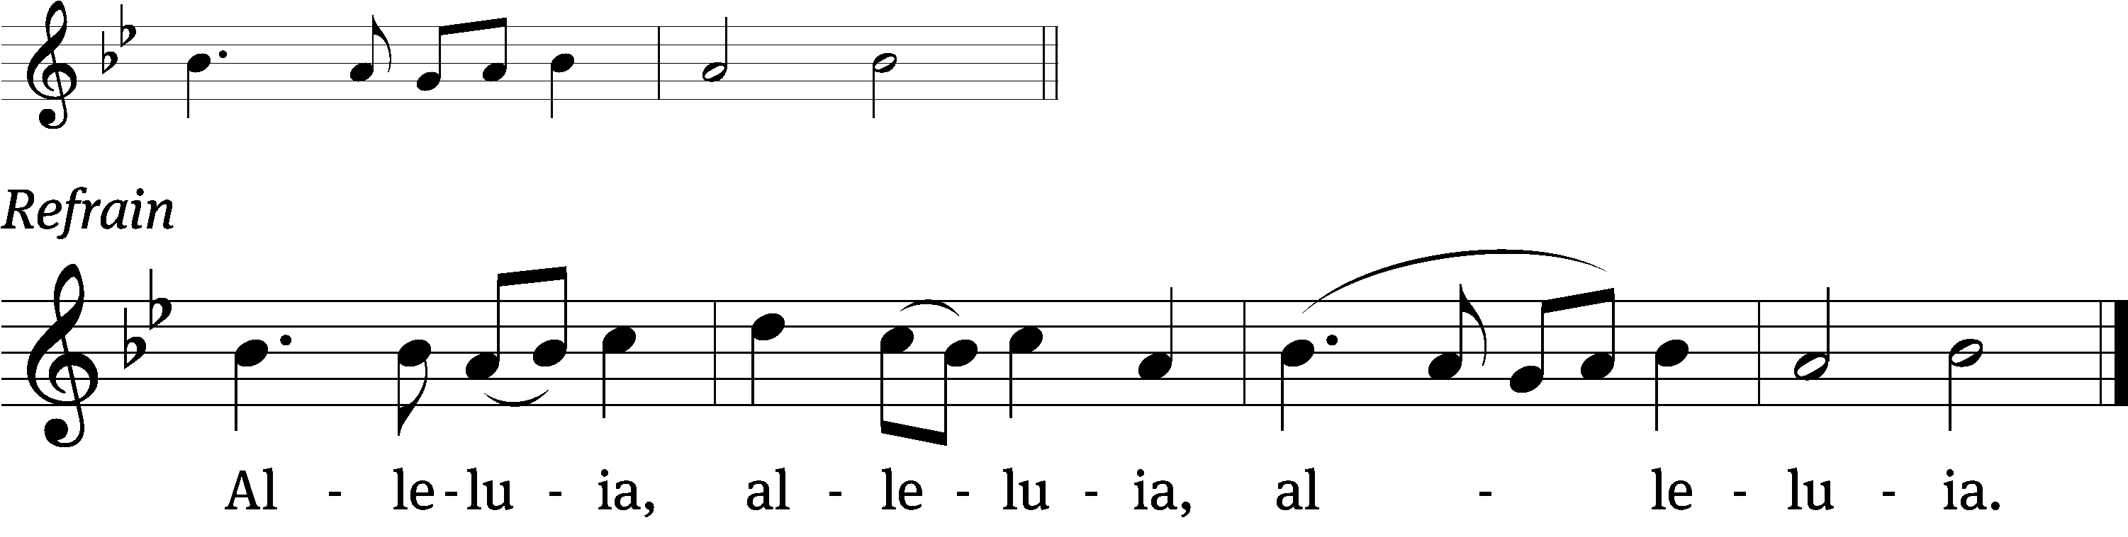
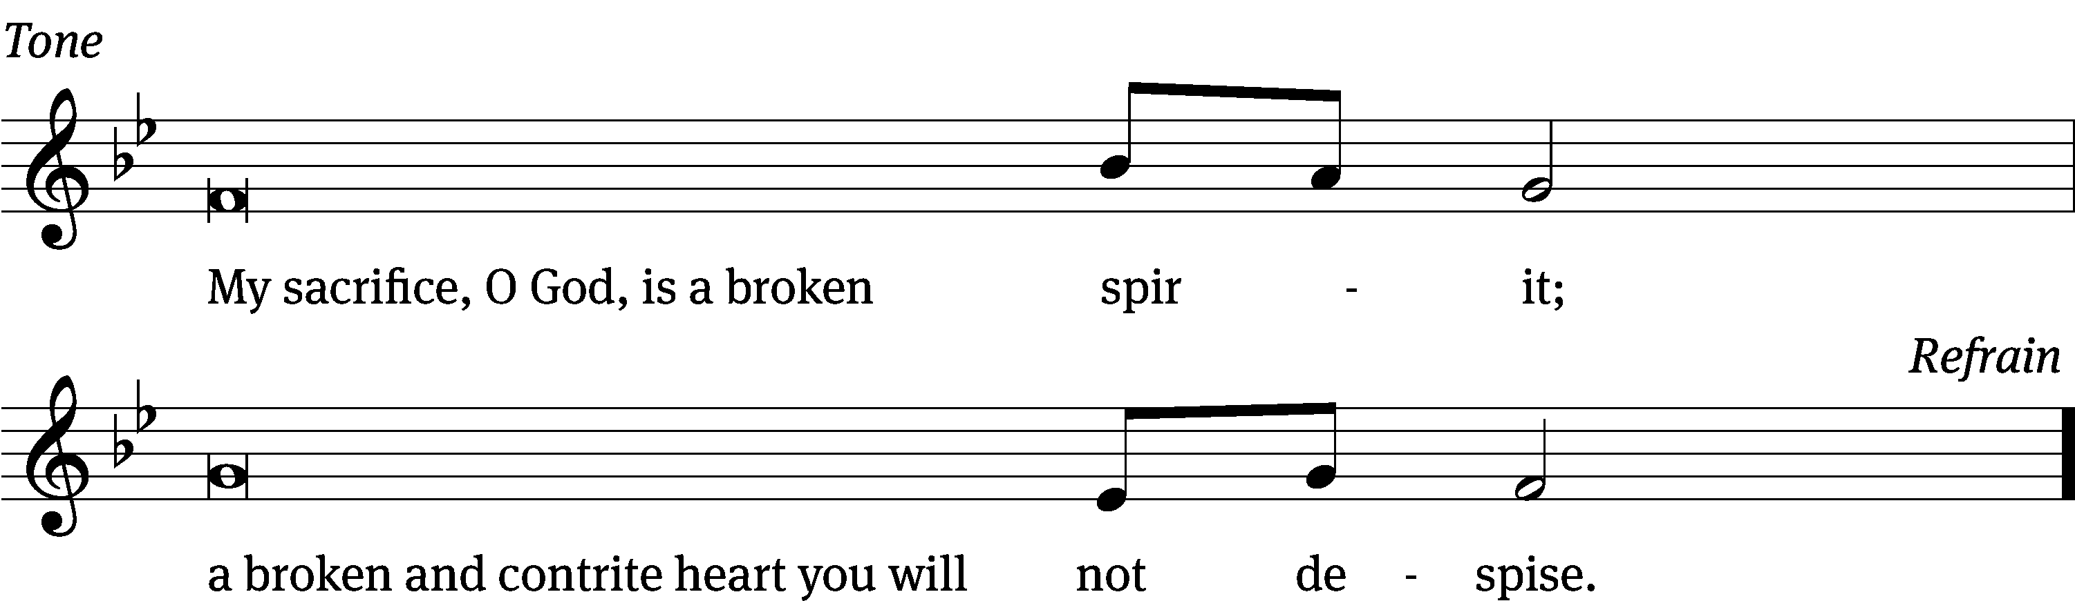
Tune: © 2021 Northwestern Publishing House. Used by permission: OneLicense no. 727703

Gospel Matthew 21:23-32
²³ When Jesus went into the temple courts, the chief priests and the elders of the people came to him while he was teaching and said, “By what authority are you doing these things?” and “Who gave you this authority?”
²⁴ Jesus answered them, “I will also ask you one question. If you answer it, I will tell you by what authority I do these things. ²⁵ The baptism of John, where was it from? From heaven or from men?”
They discussed it among themselves, saying, “If we say, ‘From heaven,’ he will say to us, ‘Then why did you not believe him?’ ²⁶ But if we say, ‘From men,’ we are afraid of the crowd, since they all regard John as a prophet.” ²⁷ So they answered Jesus, “We do not know.”
He said to them, “Then I will not tell you by what authority I do these things.”
²⁸ “What do you think? A man had two sons. He went to the first and said, ‘Son, go work today in my vineyard.’ ²⁹ He answered, ‘I will not,’ but later he changed his mind and went. ³⁰ He came to the second and said the same thing. The second son answered, ‘I will go, sir,’ but he did not go. ³¹ Which of the two did the will of his father?”
They said to him, “The first.”
Jesus said to them, “Amen I tell you: The tax collectors and the prostitutes are entering the kingdom of God ahead of you. ³² For John came to you in the way of righteousness, but you did not believe him. However, the tax collectors and prostitutes did believe him. Even when you saw this, you did not change your mind and believe him.
The Gospel of the Lord.
Praise be to you, O Christ!

Please be seated

749 God, Whose Giving Knows No Ending CW 749
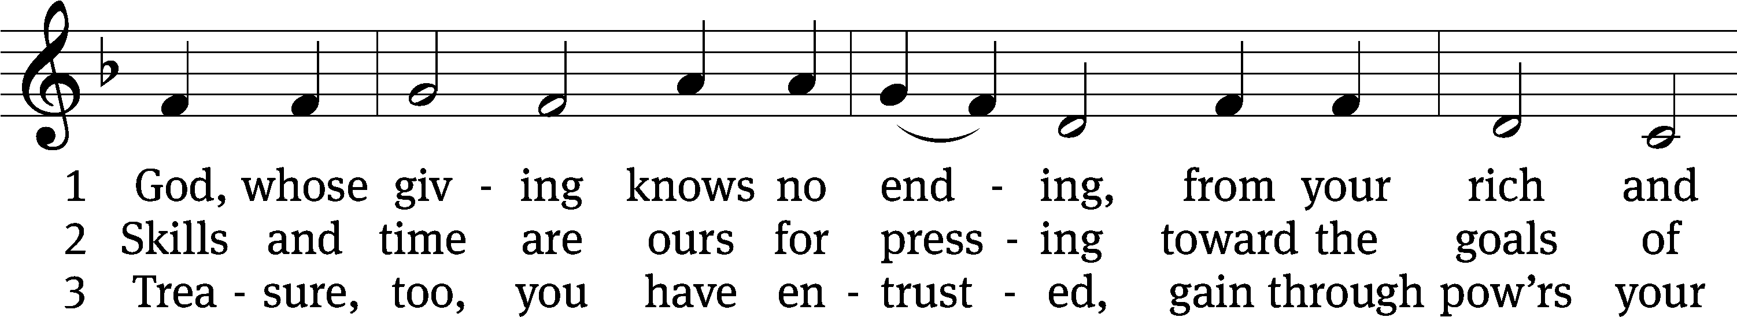
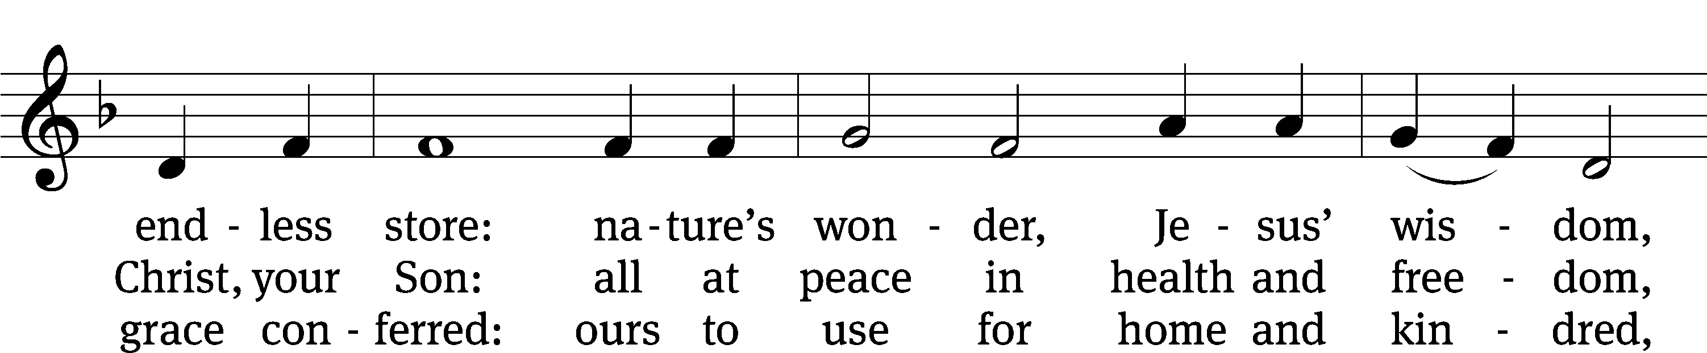
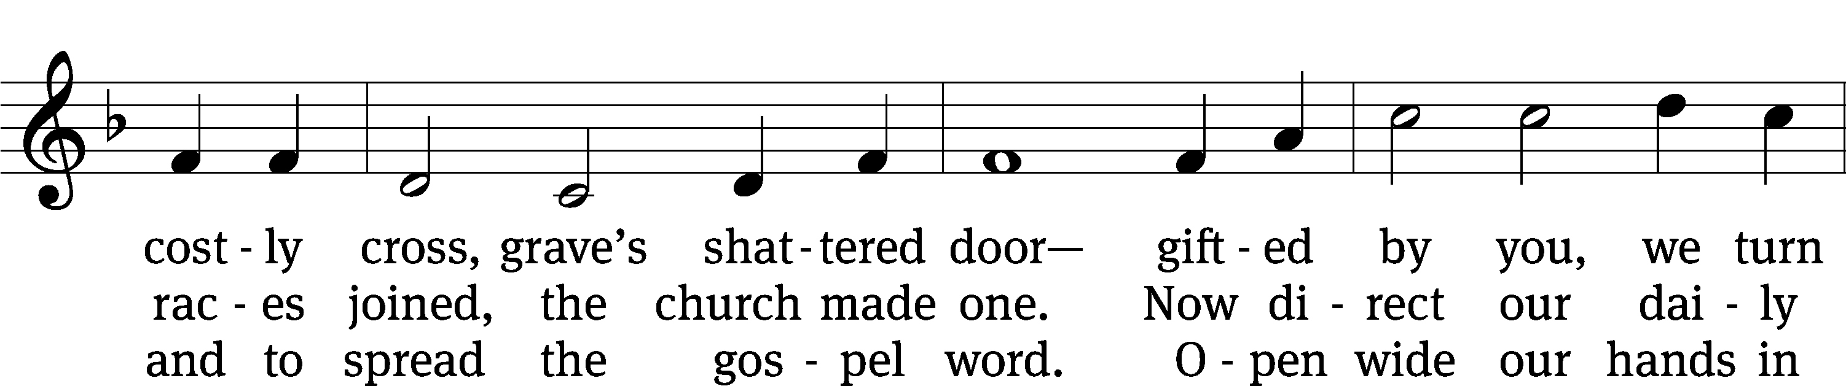
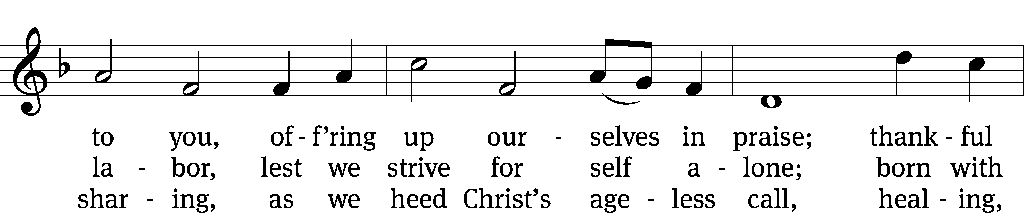
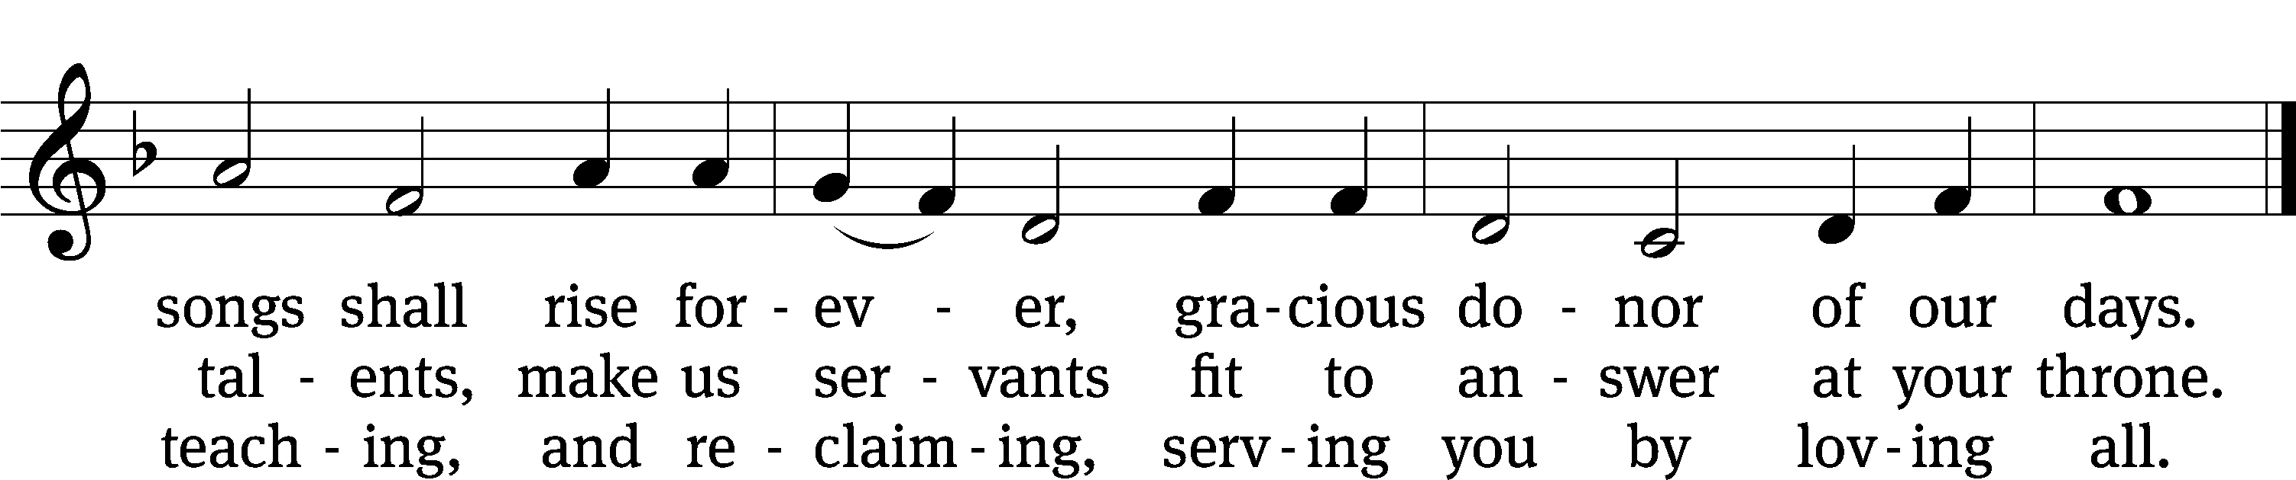
Text: Robert L. Edwards, 1915–2006
Tune: The Sacred Harp, Philadelphia, 1844
Text: © 1961, ren. 1989 The Hymn Society, admin. Hope Publishing Co. Used by permission: OneLicense no. 727703
Tune: Public domain

SERMON Mark 12:41-44
“Our Two Cents Worth”

⁴¹ Jesus sat down opposite the offering box and was watching how the crowd put money into it. Many rich people put in large amounts. ⁴² One poor widow came and put in two small bronze coins, worth less than a penny. ⁴³ He called his disciples together and said to them, “Amen I tell you: This poor widow put more into the offering box than all the others. ⁴⁴ For they all gave out of their surplus, but she, out of her poverty, put in everything—all that she had to live on.”

Please stand, if you are able

nicene creed
We believe in one God, the Father, the Almighty, maker of heaven and earth, of all that is, seen and unseen.
We believe in one Lord, Jesus Christ, the only Son of God, eternally begotten of the Father, God from God, Light from Light, true God from true God, begotten, not made, of one being with the Father. Through him all things were made. For us and for our salvation, he came down from heaven, was incarnate of the Holy Spirit and the virgin Mary, and became truly human. For our sake he was crucified under Pontius Pilate. He suffered death and was buried. On the third day he rose again in accordance with the Scriptures. He ascended into heaven and is seated at the right hand of the Father. He will come again in glory to judge the living and the dead, and his kingdom will have no end.
We believe in the Holy Spirit, the Lord, the giver of life, who proceeds from the Father and the Son, who in unity with the Father and the Son is worshiped and glorified, who has spoken through the prophets. We believe in one holy Christian and apostolic Church. We acknowledge one baptism for the forgiveness of sins. We look for the resurrection of the dead and the life of the world to come. Amen.

Prayer of the Church

The Sacrament
Preface CW 165
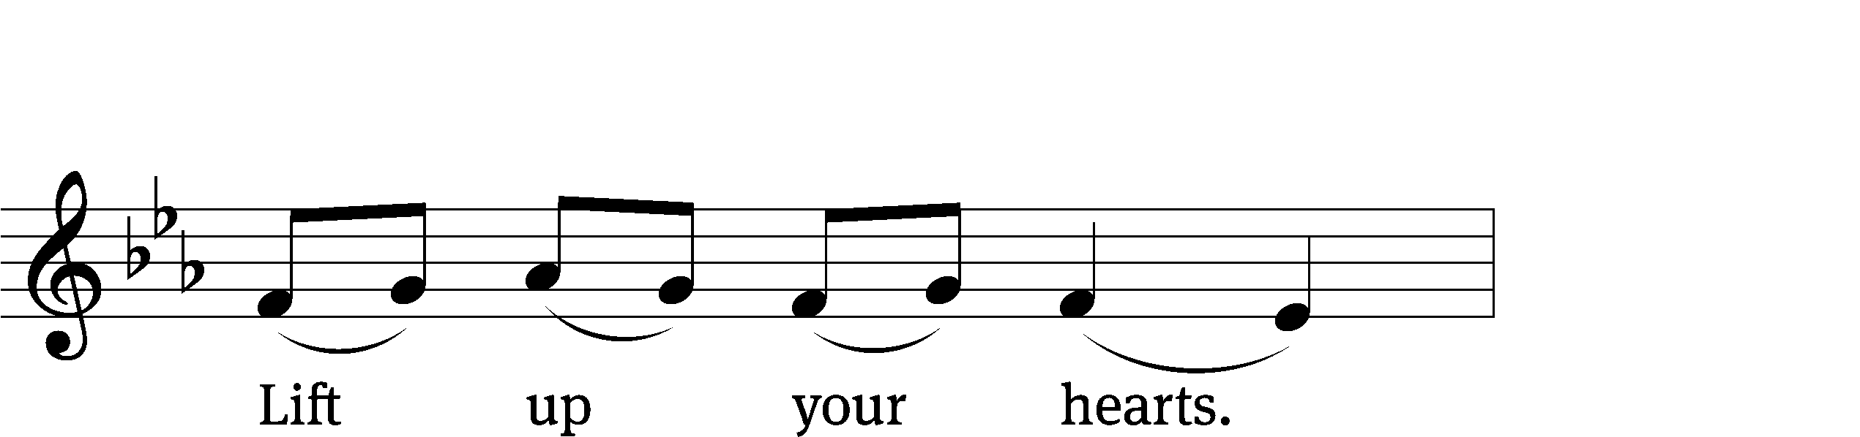
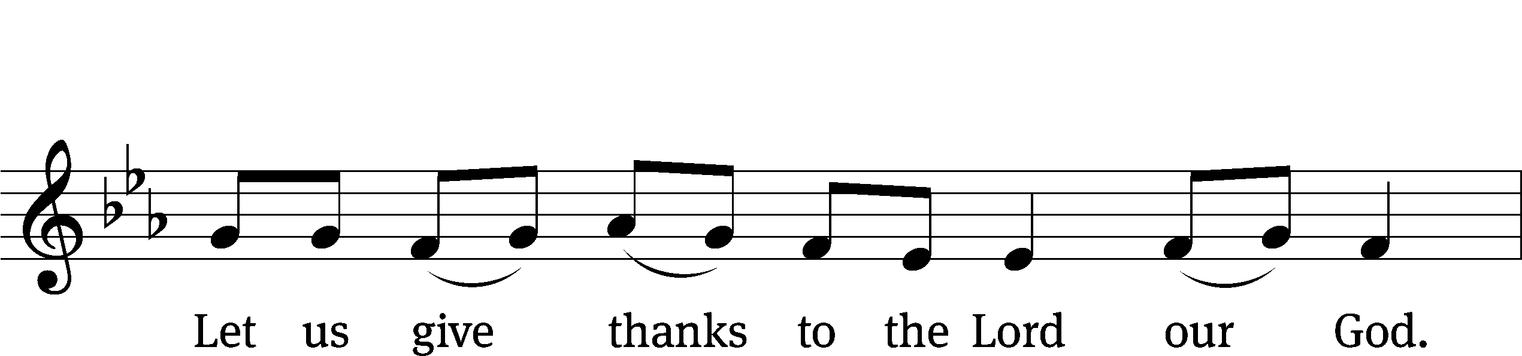
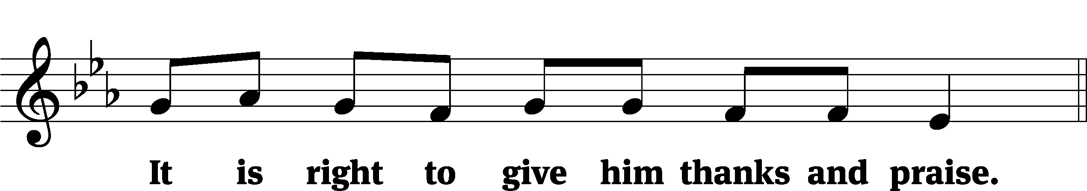

It is truly good and right that we should at all times and in all places give you thanks, O Lord, holy Father, almighty and everlasting God, through Jesus Christ our Lord, who by his willing sacrifice on the cross took away the sins of the world and by his glorious resurrection restored everlasting life. Therefore, with all the saints on earth and hosts of heaven, we praise your holy name and join their glorious song:

Holy, Holy, Holy CW 167
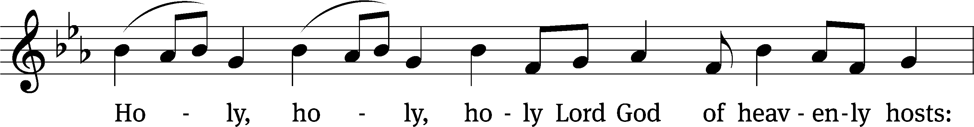
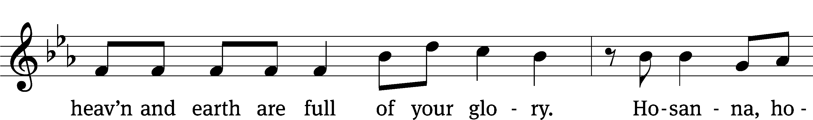
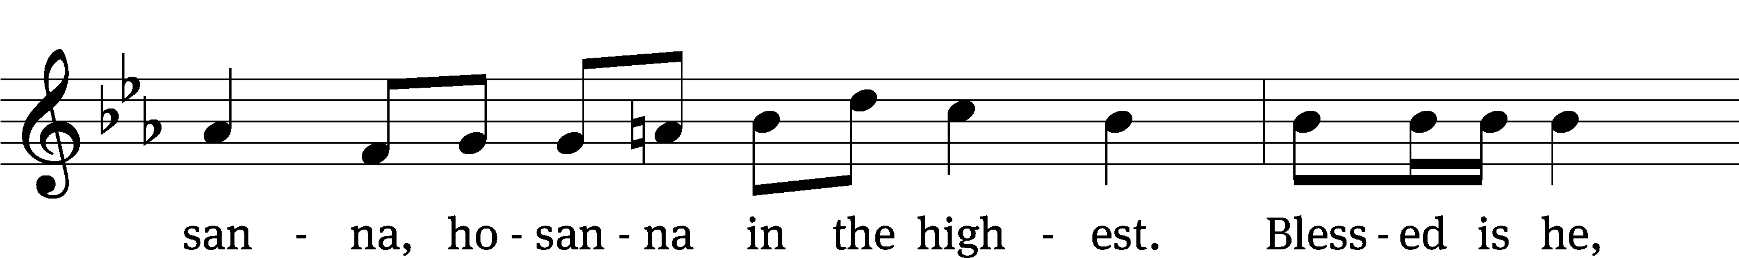
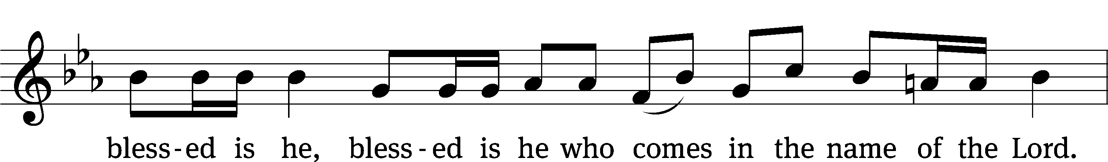
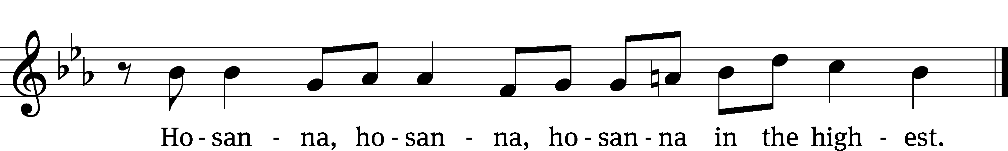

Prayer of Thanksgiving
We give thanks to you, O God, through your dear Son, Jesus Christ, whom you sent to be our Savior, our Redeemer, and the messenger of your grace. Through him you made all things; in him you are well pleased. He is the incarnate Word, conceived by the Holy Spirit and born of the Virgin Mary. To fulfill your promises, he stretched out his hands on the cross and released from eternal death all who believe in you.

As we remember Jesus’ death and resurrection, we thank you that you have gathered us together to receive your Son’s body and blood. Send us your Spirit, unite us as one, and strengthen our faith so that we may praise you in your Son, Jesus Christ. Through him, we glorify and honor you, O God our Father, with the Holy Spirit, one God, now and forever.
Amen.

Lord’s Prayer
Our Father, who art in heaven, hallowed be thy name, thy kingdom come, thy will be done on earth as it is in heaven. Give us this day our daily bread; and forgive us our trespasses, as we forgive those who trespass against us; and lead us not into temptation, but deliver us from evil. For thine is the kingdom and the power and the glory forever and ever. Amen.

Words of Institution
Our Lord Jesus Christ, on the night he was betrayed, took bread; and when he had given thanks, he broke it and gave it to his disciples, saying, “Take and eat; this is my body, which is given for you. Do this in remembrance of me.”
Then he took the cup, gave thanks, and gave it to them, saying, “Drink from it, all of you; this is my blood of the new covenant, which is poured out for you for the forgiveness of sins. Do this, whenever you drink it, in remembrance of me.”

The peace of the Lord be with you always.
Amen.
O Christ, Lamb of God CW 169
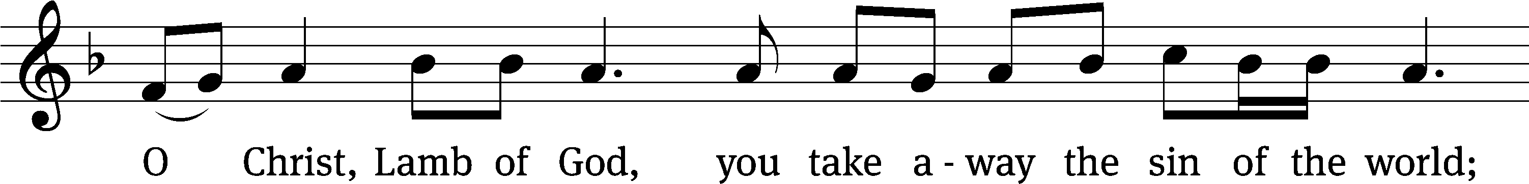
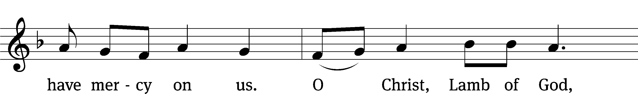
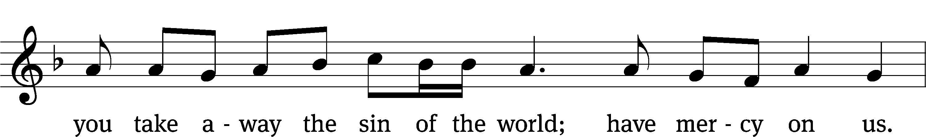
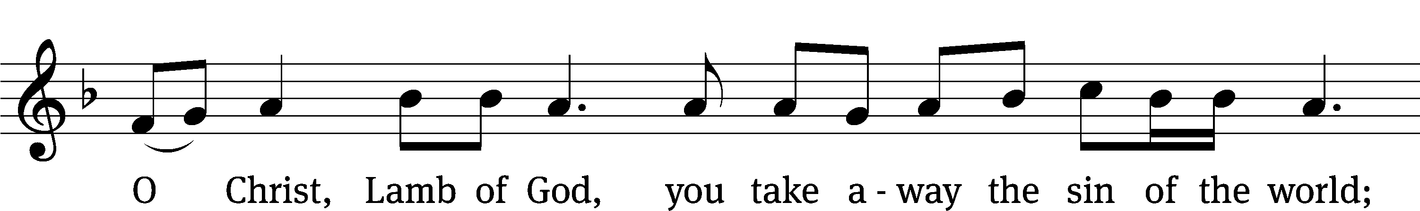
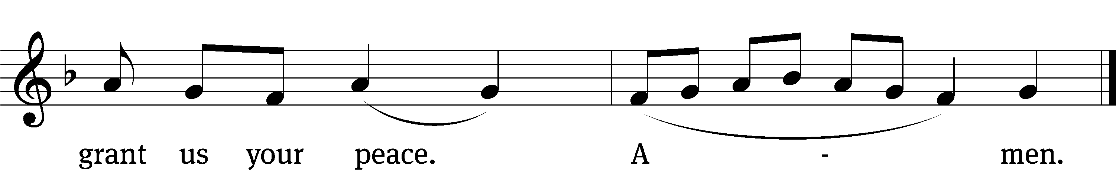
663 Soul, Adorn Yourself with Gladness CW 663
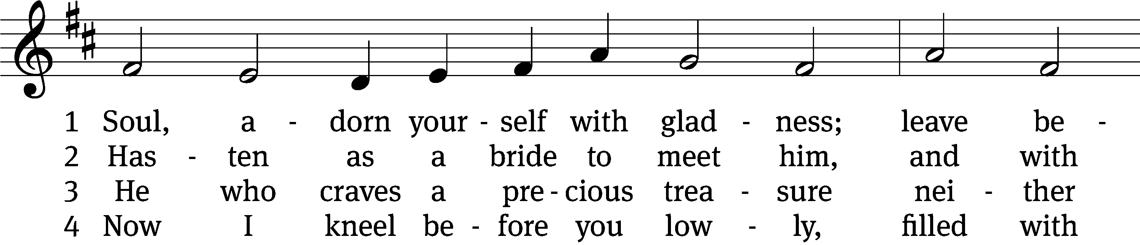
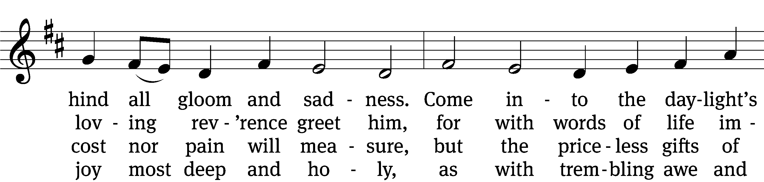
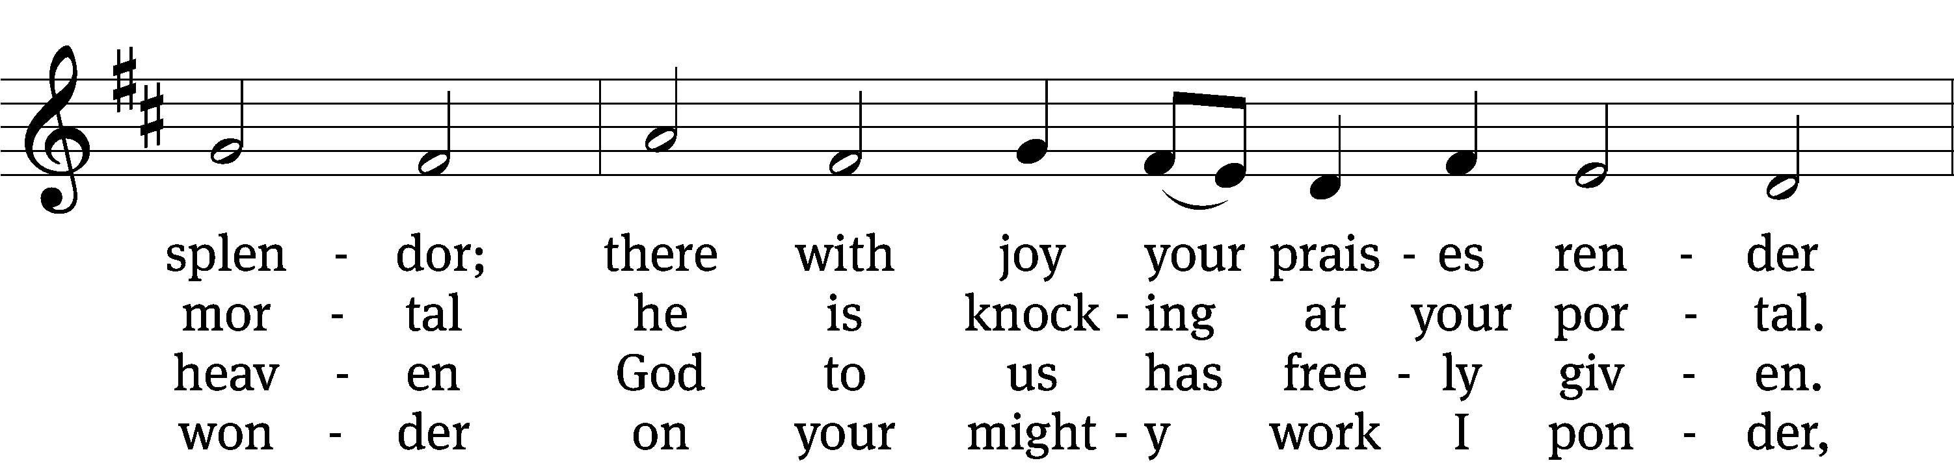
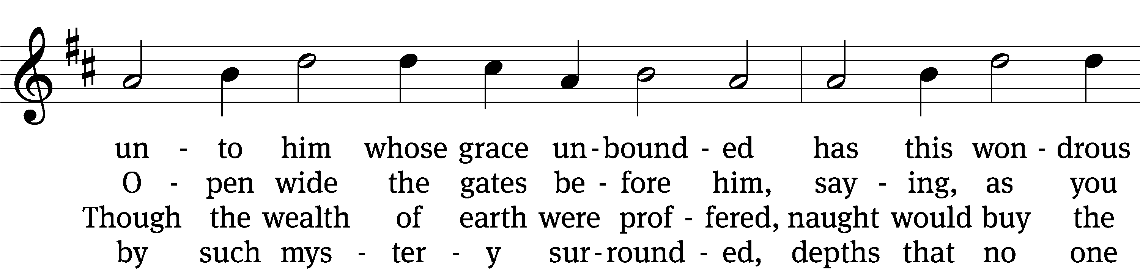
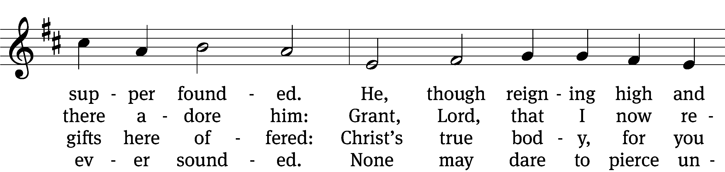
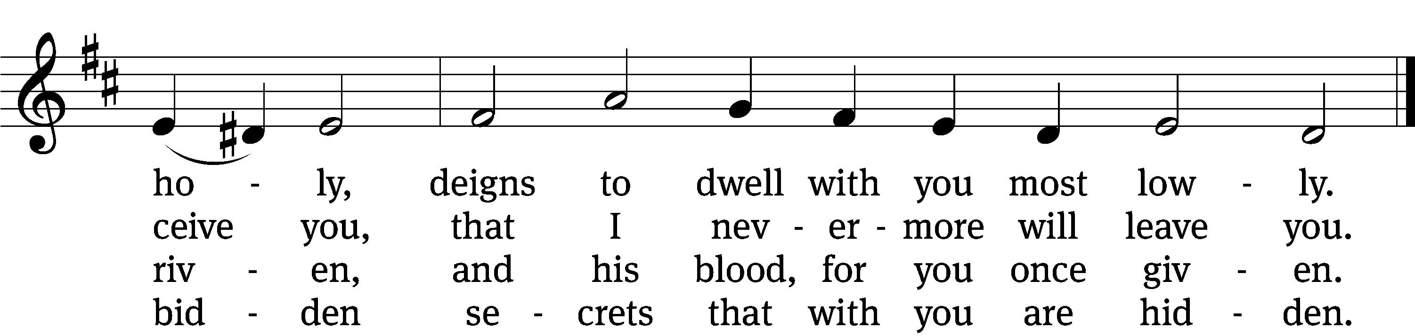

5 Human reason, though it ponders,
cannot fathom these great wonders,
that Christ’s body must be boundless
since the souls it feeds are countless,
and that he his blood is giving
with the wine we are receiving.
These great mysteries unsounded
are by God alone expounded.

6 Lord, by love and mercy driven,
you have left your throne in heaven
on the cross for me to languish
and to die in bitter anguish,
to forgo all joy and gladness
and to shed your blood in sadness.
By this blood redeemed and living,
Lord, I praise you with thanksgiving.

7 Jesus, sun of life, my splendor,
Jesus, friend of friends most tender,
Jesus, joy of my desiring,
fount of life, my soul inspiring:
at your feet I cry, my maker,
let me be a fit partaker
of this blessèd food from heaven
for our good, your glory, given.

8 Jesus, Lord of life in heaven,
help me when this meal is given
to receive it for my blessing
as I come, my sins confessing.
In this supper let me measure,
Lord, how deep is your love’s treasure,
that, as I on earth have eaten,
I may be your guest in heaven.
Text: Johann Franck, 1618–1677, abr.; (sts. 1–2, 4, 7): tr. Catherine Winkworth, 1827–1878, alt.; (sts. 3, 5–6): tr. The Lutheran Hymnal, 1941, alt.; (st. 8): tr. Peter M. Prange, b. 1972
Tune: Johann Crüger, 1598–1662
Text (st. 8): © 2021 Northwestern Publishing House. Used by permission: OneLicense no. 727703
Text (sts. 1–7) and tune: Public domain

Please stand, if you are able

Give thanks to the Lord, for he is good;
his mercy endures forever.

Whenever we eat this bread and drink this cup,
we proclaim the Lord’s death until he comes.

We give thanks, almighty God, that you have refreshed us with this saving gift. We pray that through it you will strengthen our faith in you and increase our love for one another. We ask this in the name of Jesus Christ our Lord, who lives and reigns with you and the Holy Spirit, one God, now and forever.
Amen.

Blessing
The Lord bless you and keep you.
The Lord make his face shine on you and be gracious to you.
The Lord look on you with favor and give you peace.
Amen.

Please be seated

695 Take My Life and Let It Be CW 695 sts. 1, 4, 6
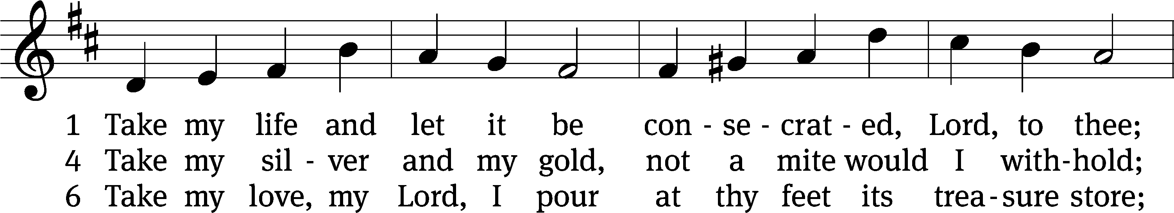
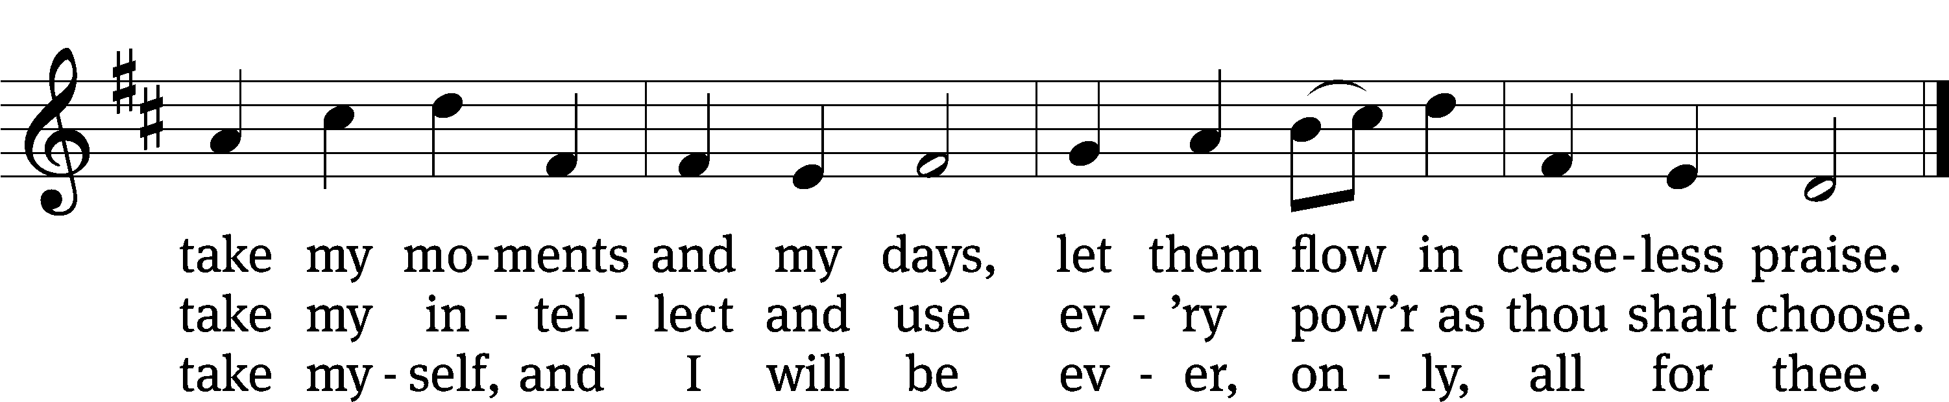
Text: Frances R. Havergal, 1836–1879
Tune: William H. Havergal, 1793–1870
Text and tune: Public domain
Acknowledgments
Setting One from Christian Worship
Software distributed in partnership with Northwestern Publishing House.
Created by Christian Worship: Service Builder © 2022 Concordia Publishing House.
Serving in Worship
Officiant Pastor William Natsis
Organist Sarah Hanke
Deacons (8:30) Dave Stevenson and Jim Tice
Deacons (11:00) Steve Hoeft and Jeff Neuburger
Ushers (8:30) Dale Finkbeiner and Mark Finkbeiner
Ushers (11:00) Ed Sala and Al Whitley
Altar Guild Barb Neuburger and Karen Tice
Videographer Ann Latowski

