THE SEVENTEENTH SUNDAY
AFTER PENTECOST

TRINITY EVANGELICAL LUTHERAN CHURCH | Saline, Michigan
WELCOME TO WORSHIP October 2, 2022
Thank you for joining us in God’s house today! We cordially ask that our Guests sign one of the guestbooks located at either the front or back entryways, or fill out a “Let’s Get Acquainted” card located in the hymnal pew rack and place it in the collection plate.

THANK OFFERING: Members of Trinity give their offering as an expression of love and thankfulness to the Lord and to help support the Lord’s work in our community and around the world. Visitors need not feel obligated to participate in this offering which supports our ministry.

Restrooms are located at the back of the upper level (the annex), and in the basement (down the back stairs of the sanctuary or annex). Handicap access is available, please ask an usher for assistance.

Young Families / Toddler Bags – We are GLAD YOU BROUGHT YOUR CHILDREN to our worship service. Jesus said: “Let the little children come to me and do not hinder them, for the kingdom of God belongs to such as these.” We know that having little children in church can be a challenge, but DO NOT WORRY about it. Many of your fellow worshippers have been in your shoes and are just happy you brought your children with you. For your convenience, we have reserved the back rows of seating for parents with small children. These areas provide more flexibility for your family, as well as, easy access to move downstairs if necessary. A closed-circuit TV system allows families to continue participating in the service while downstairs. Pre-school toddler bags and children’s bulletins are available for their enjoyment. Ask an usher for one to use during the service and please return the toddler bag afterwards.

celebration of holy communion:
In His Word, God makes it clear that the Lord’s Supper is to be shared by people of a common proclamation of faith (1 Corinthians 11:26; 1 Corinthians 10:16-17). Without judging anyone’s hearts, we invite those who share in our confession by their membership in our congregation or another congregation of the Wisconsin Evangelical Lutheran Synod (WELS) or the Evangelical Lutheran Synod (ELS) and who are properly prepared (1 Corinthians 11;27-29) to receive the Sacrament. Page 295 in Christian Worship provides a guide for preparation.
Guests, we would love to have you join us in communion fellowship in the future, and for that to be possible, we ask that you speak with one of the pastors so that we may speak with you on how that would be possible. We thank you for respecting the way we celebrate the Lord’s Supper in our congregations.
the SERVICE – setting one - WITH HOLY COMMUNION CW, page 154
740 O God, My Faithful God CW 740
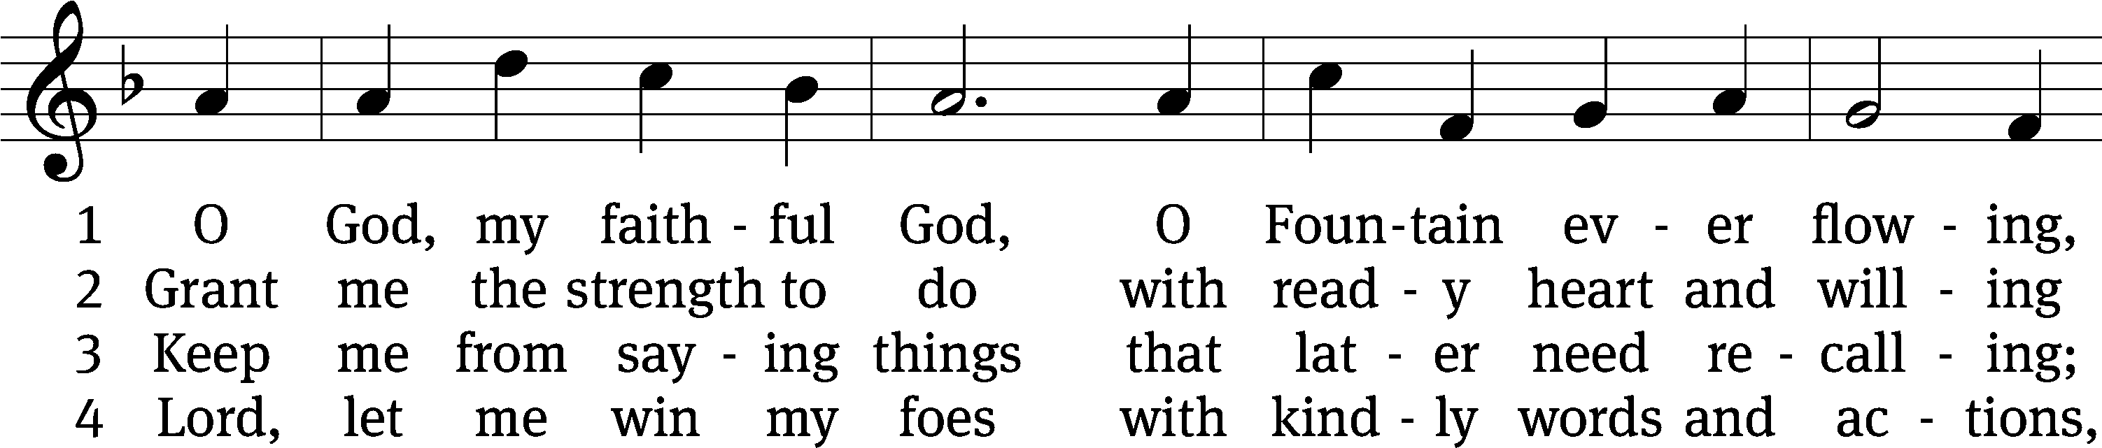
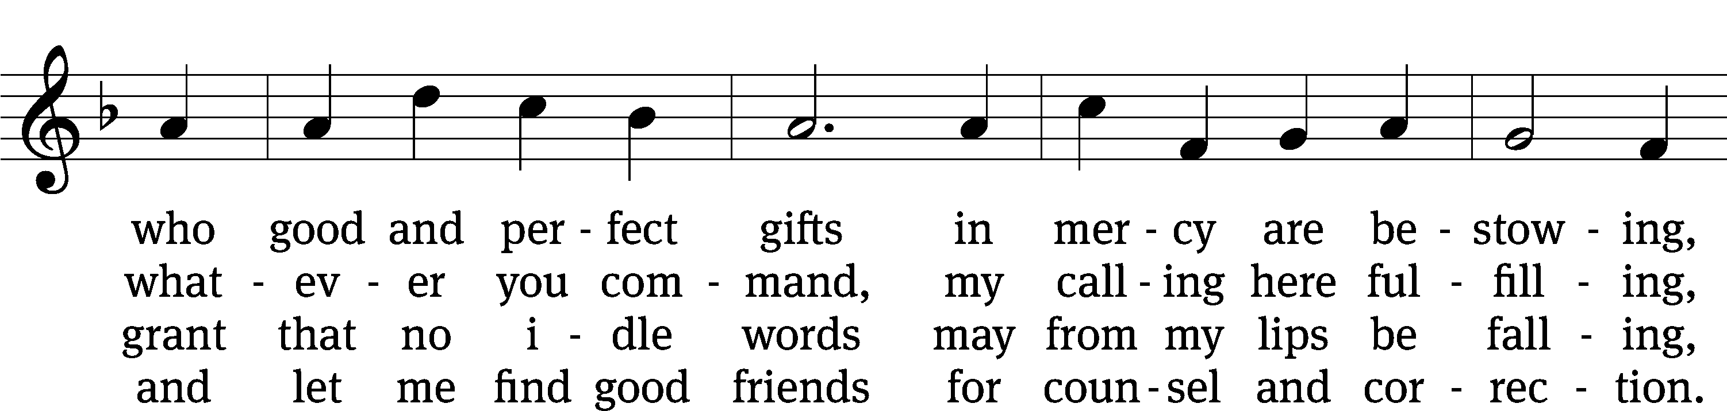
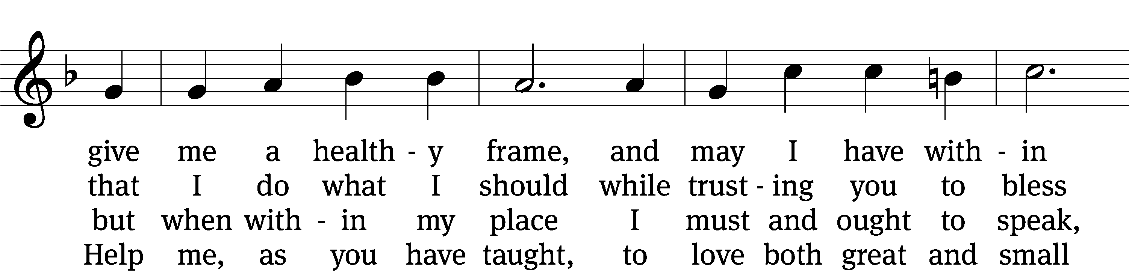
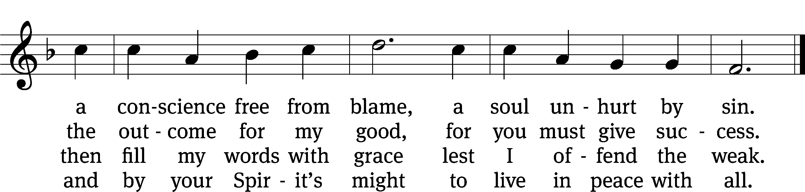
Text: tr. Catherine Winkworth, 1827–1878, alt.; Johann Heermann, 1585–1647, abr.
Tune: Neu-vermehrtes . . . Gesangbuch, 3rd ed., Meiningen, 1693
Text and tune: Public domain

Please stand, if you are able
Invocation
In the name of the Father and of the Son and of the Holy Spirit.
Amen.
Confession
If we claim to be without sin, we deceive ourselves and the truth is not in us.
If we confess our sins, God is faithful and just
and will forgive us our sins
and purify us from all unrighteousness.

Let us confess our sins to the Lord.
Holy God, gracious Father,
I am sinful by nature
and have sinned against you in my thoughts, words, and actions.
I have not loved you with my whole heart;
I have not loved others as I should.
I deserve your punishment both now and forever.
But Jesus, my Savior, paid for my sins
with his innocent suffering and death.
Trusting in him, I pray: God, have mercy on me, a sinner.

Our gracious Father in heaven has been merciful to us. He sent his only Son, Jesus Christ, who gave his life as the atoning sacrifice for the sins of the whole world. Therefore, as a called servant of Christ and by his authority, I forgive you all your sins in the name of the Father and of the Son and of the Holy Spirit.
Amen.

Lord, Have Mercy

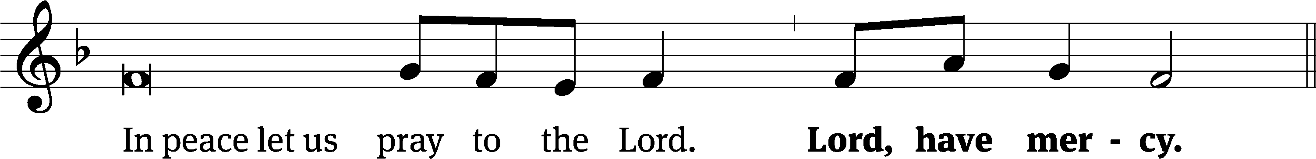
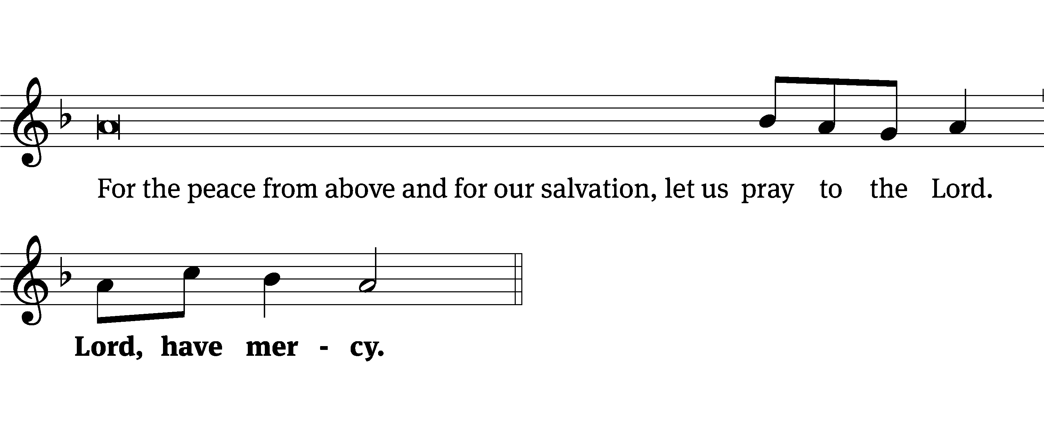
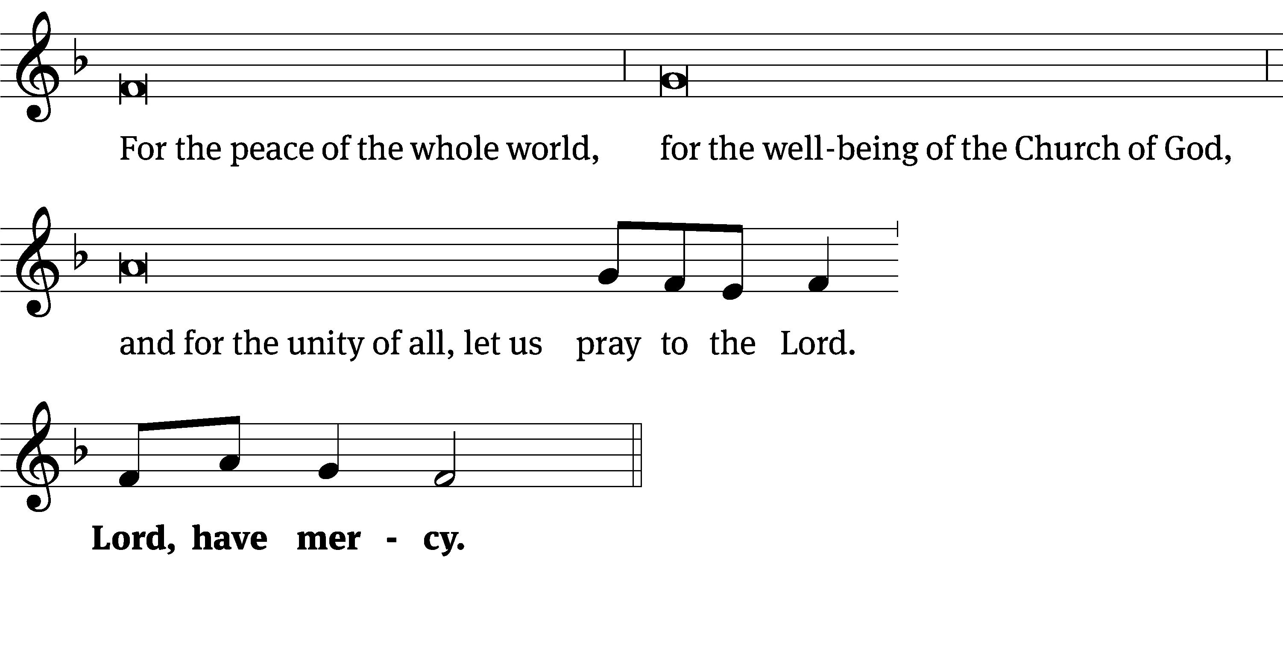
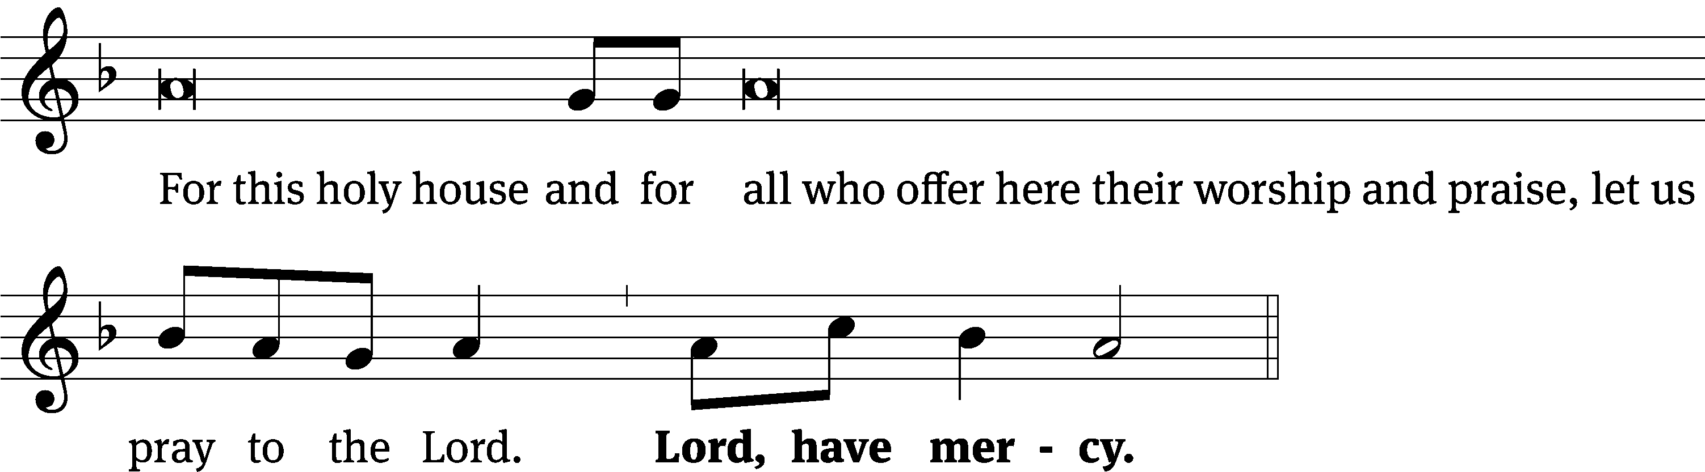
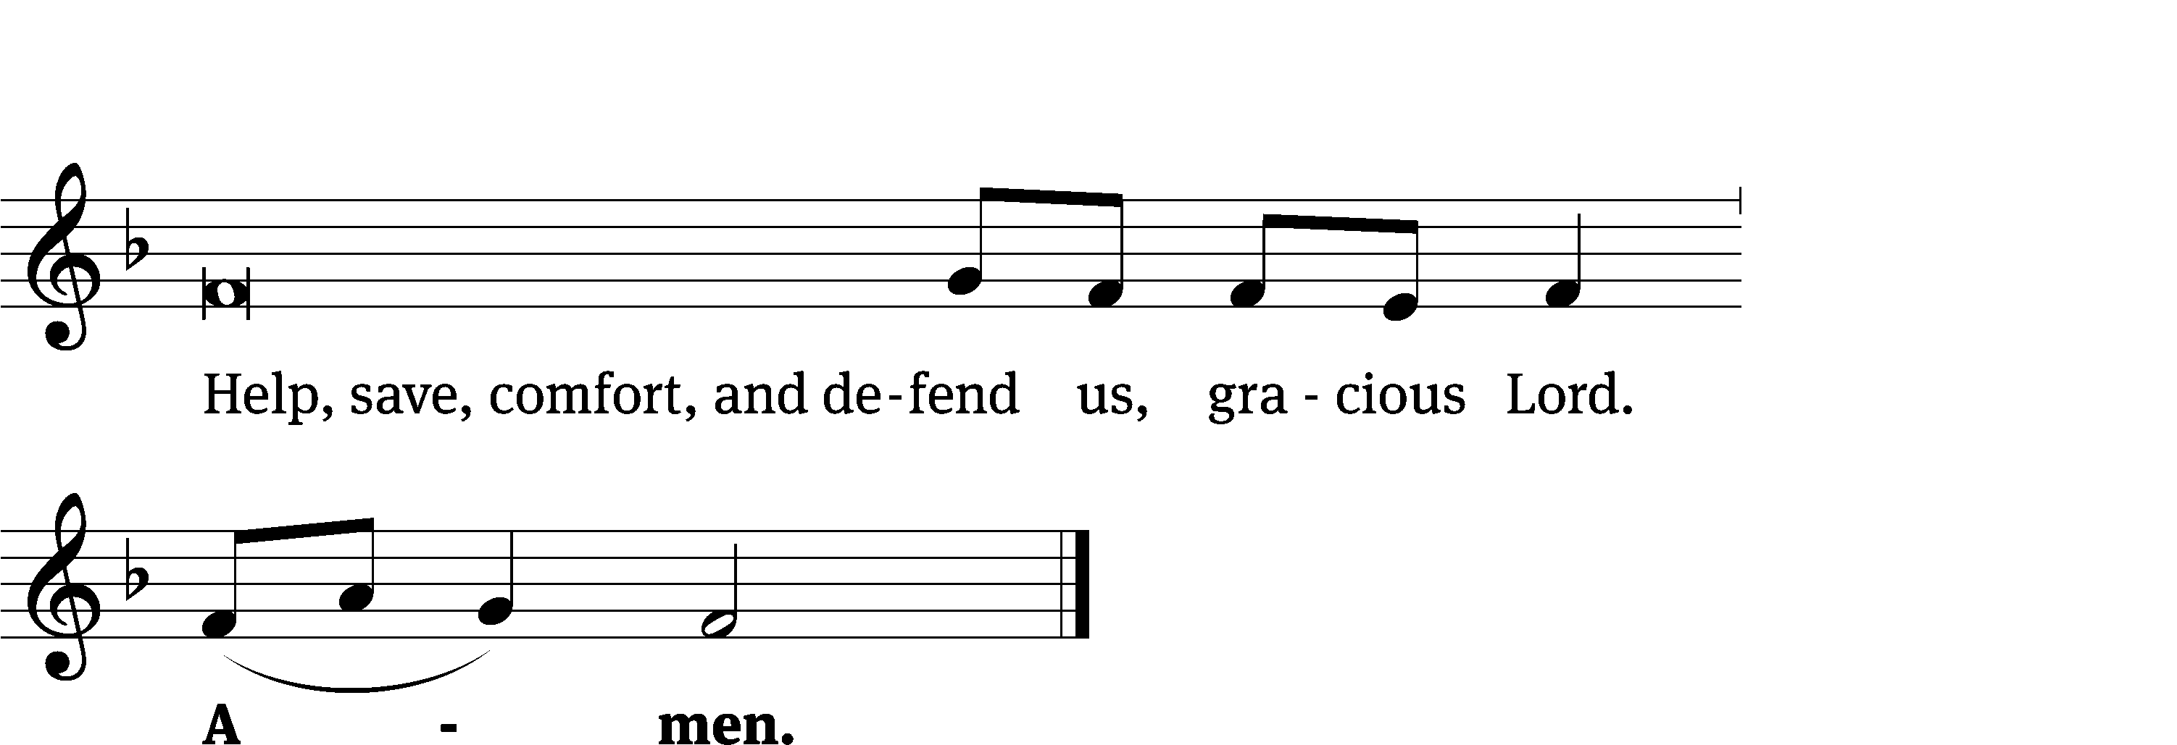
Tune: Kevin Becker
Tune: © 2021 Northwestern Publishing House. Used by permission: OneLicense no. 727703

Glory Be to God CW 157
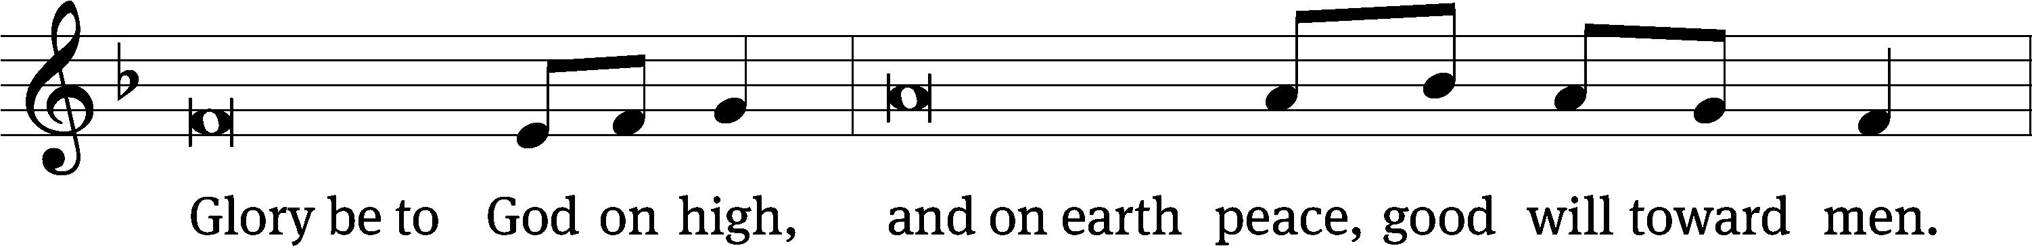
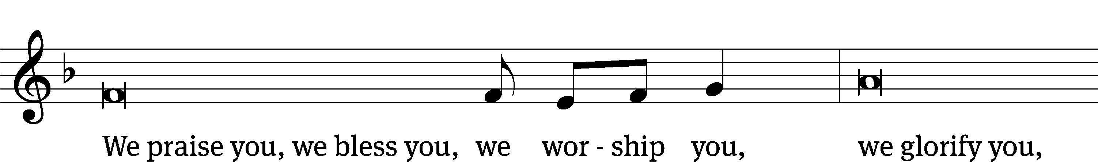
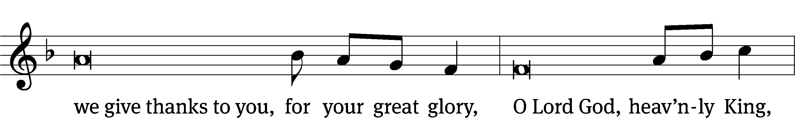
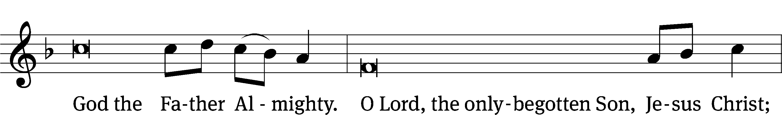
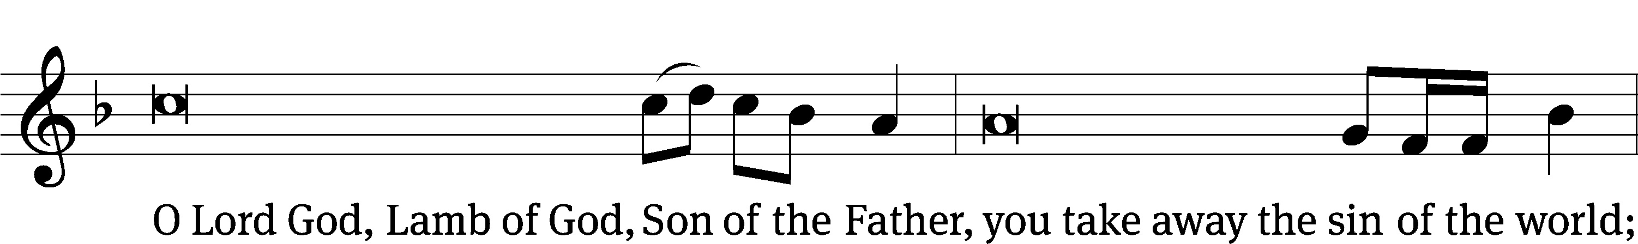
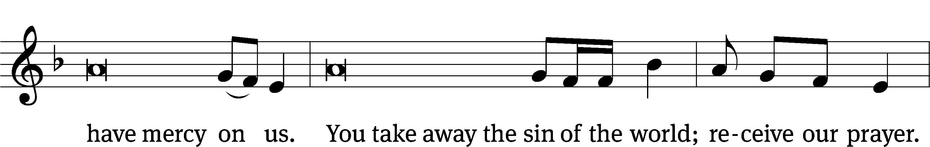
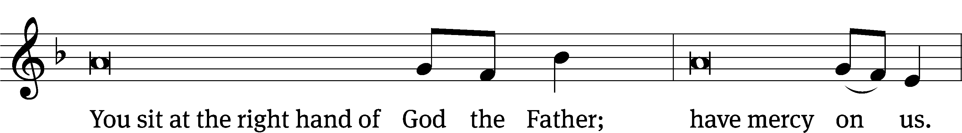
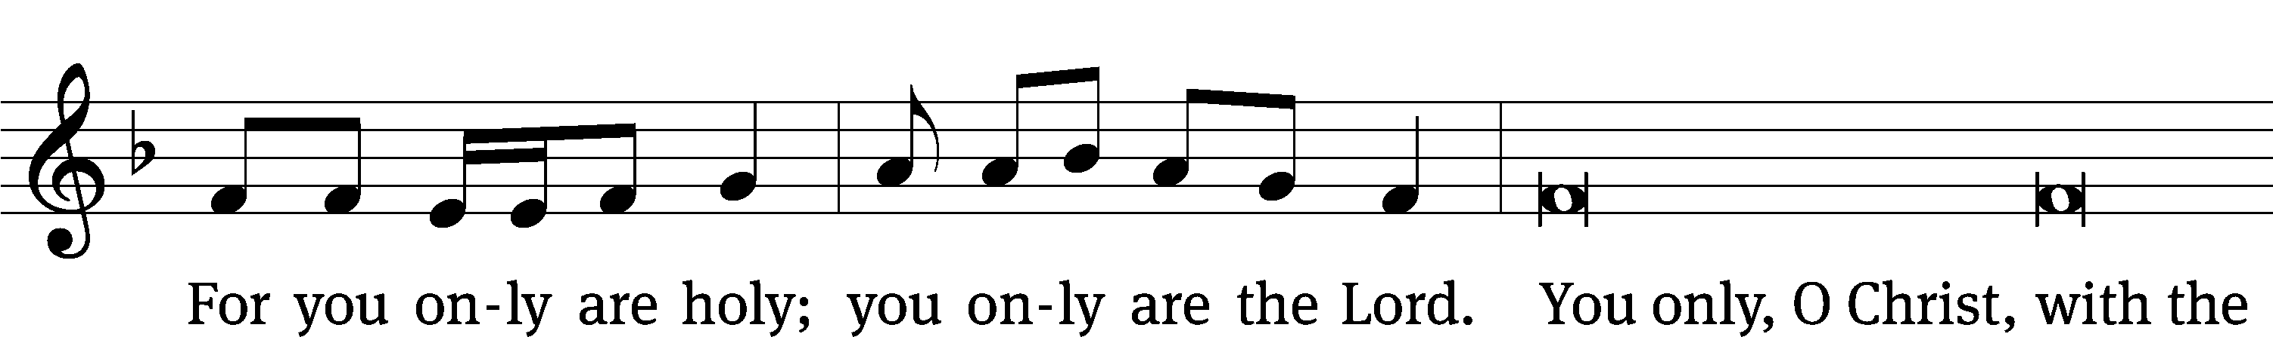
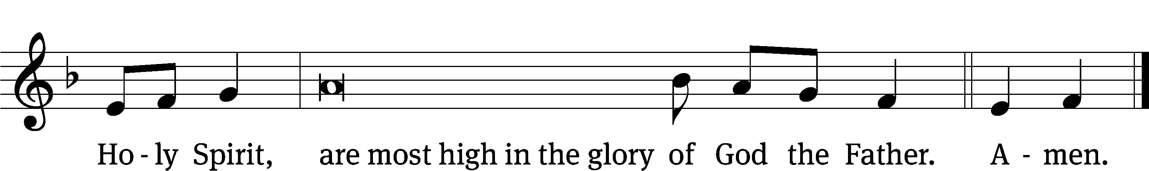

The Lord be with you.
And also with you.
Prayer of the Day
Let us pray.

Almighty God, in your bountiful goodness, keep us safe from every evil of body and soul. Make us ready, with cheerful hearts, to do whatever pleases you; through your Son, Jesus Christ our Lord, who lives and reigns with you and the Holy Spirit, one God, now and forever.
Amen.

Please be seated

First Reading 1 Chronicles 29:1-2, 10-18
King David said this to the whole assembly:
My son Solomon, the one God has chosen, is young and inexperienced. The work is great because this citadel is not for a man. It is for the Lord God. ² According to all my strength, I have provided these things for the house of my God: gold for the gold items, silver for the silver, bronze for the bronze, iron for the iron, wood for the wooden, onyx stones and settings, antimony, stones of many different colors, every kind of precious stone, and alabaster in abundance.
¹⁰ David blessed the Lord in the presence of the entire assembly. He said:
Blessed are you, Lord, the God of Israel, our father, from eternity to eternity. ¹¹ To you, O Lord, belong greatness, power, glory, victory, and majesty, because everything in the heavens and on the earth belongs to you. You, Lord, are exalted as head above everything. The kingdom belongs to you. ¹² Riches and honor come from you. You are ruling over everything. In your hand are power and strength. It is in your power to make anyone great and strong. ¹³ Now, our God, we are thanking you and praising your glorious name.
¹⁴ Who am I? Who are my people that we are able to offer willingly like this? For everything comes from you. What we have given to you came from your hand. ¹⁵ We are aliens and temporary residents before you, as were all our fathers. Our days on the earth are like a shadow, and there is no hope of staying.
¹⁶ Lord, our God, all this abundance, which we have provided for building a house for you, for your holy name, is from your hand. This abundance belongs to you.
¹⁷ I know, my God, that you test the heart, and you take pleasure in uprightness. In the uprightness of my heart I have freely offered all these things. Now with joy I see your people, who are present here to bring the offering freely to you.
¹⁸ Lord, the God of our fathers, Abraham, Isaac, and Israel, preserve forever this purpose and way of thinking in the heart of your people. Direct their heart to you.

The Word of the Lord.
Thanks be to God.

62D I’ll Not Be Shaken (DUET) Psalm 62D
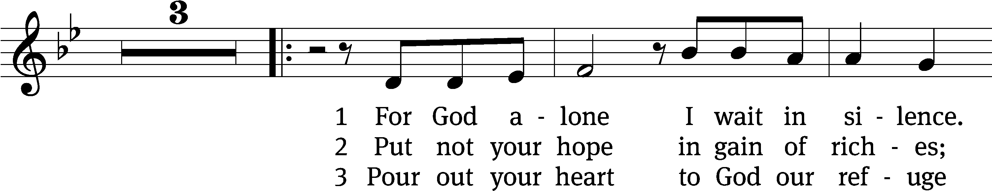
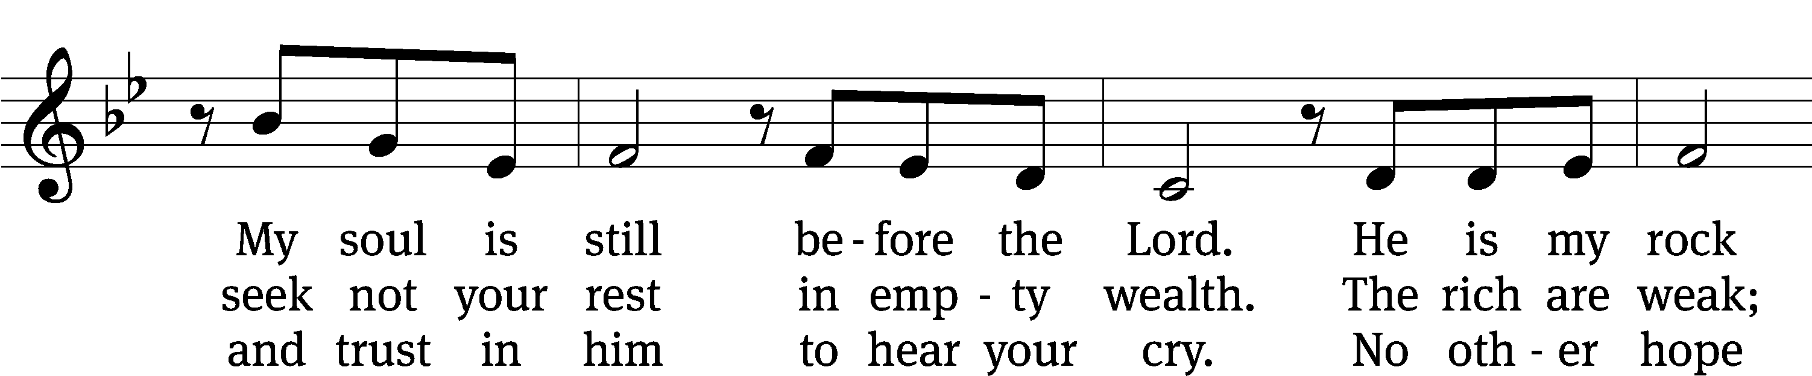

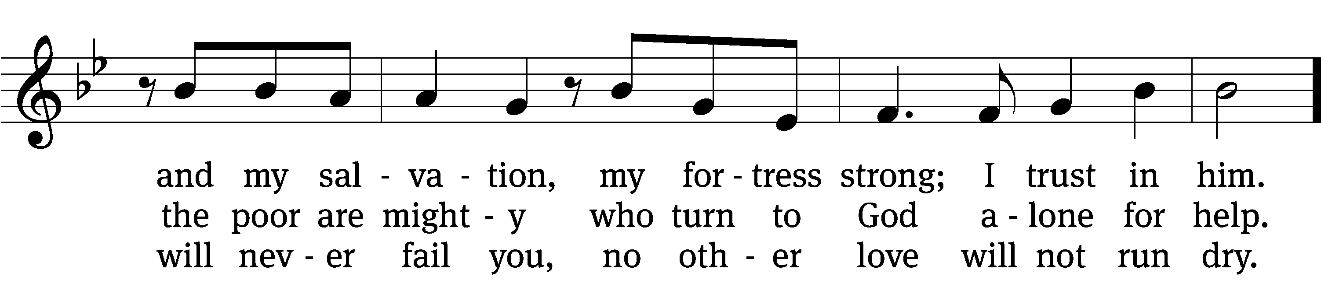
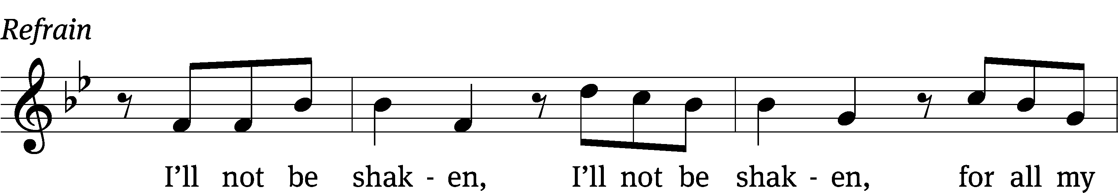
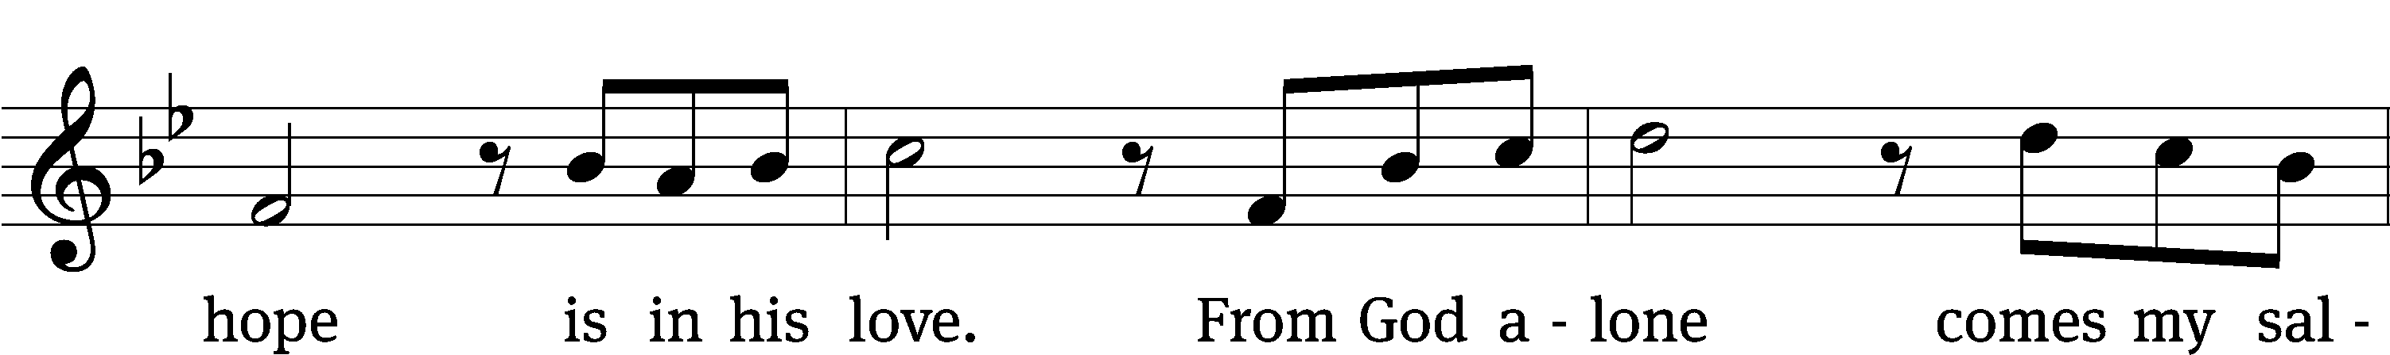
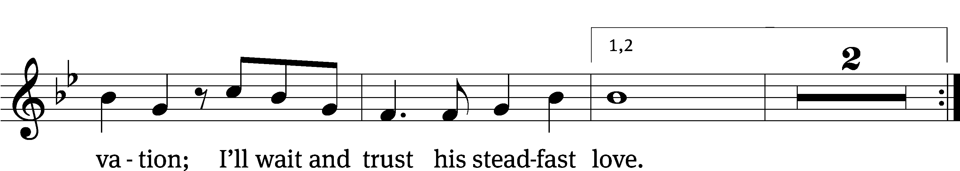
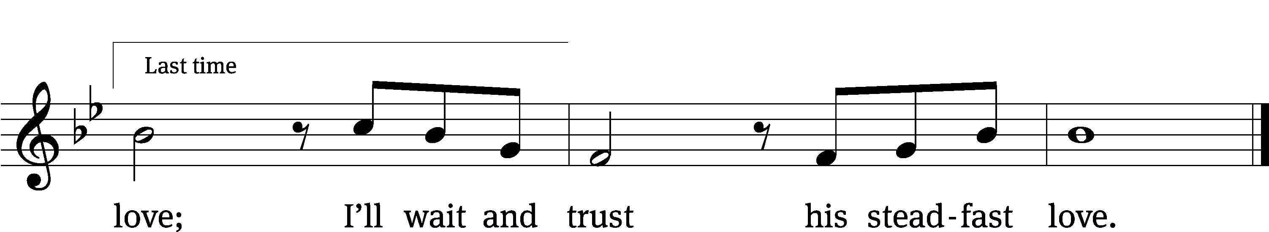
Text: Wendell Kimbrough
Tune: Wendell Kimbrough
Text and tune: © 2015 Wendell Kimbrough. Used by permission: OneLicense no. 727703

Second Reading 2 Thessalonians 1:1-5, 11-12
Paul, Silas, and Timothy,
To the church of the Thessalonians in God our Father and the Lord Jesus Christ:
² Grace to you and peace from God our Father and the Lord Jesus Christ.
³ We are always obligated to thank God for you, brothers,^{[b]} as is fitting, because your faith is growing more and more, and the love that each and every one of you has for one another is increasing. ⁴ So we ourselves boast about you in God’s churches in regard to your patient endurance and faith in all your persecutions and in the trials that you are enduring. ⁵ This is evidence of God’s righteous verdict that resulted in your being counted worthy of God’s kingdom, for which you also suffer.
¹¹ For this reason, we are always praying for you, that our God will make you worthy of your calling and use his power to fulfill every good desire and work of your faith, ¹² so that the name of our Lord Jesus Christ may be glorified in you and you in him, in keeping with the grace of our God and Lord Jesus Christ.

The Word of the Lord.
Thanks be to God.

Please stand, if you are able

Gospel Acclamation 1 Chronicles 29:14
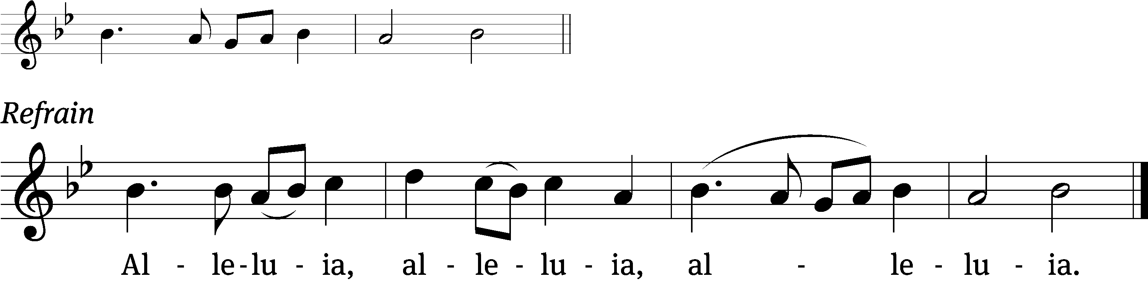
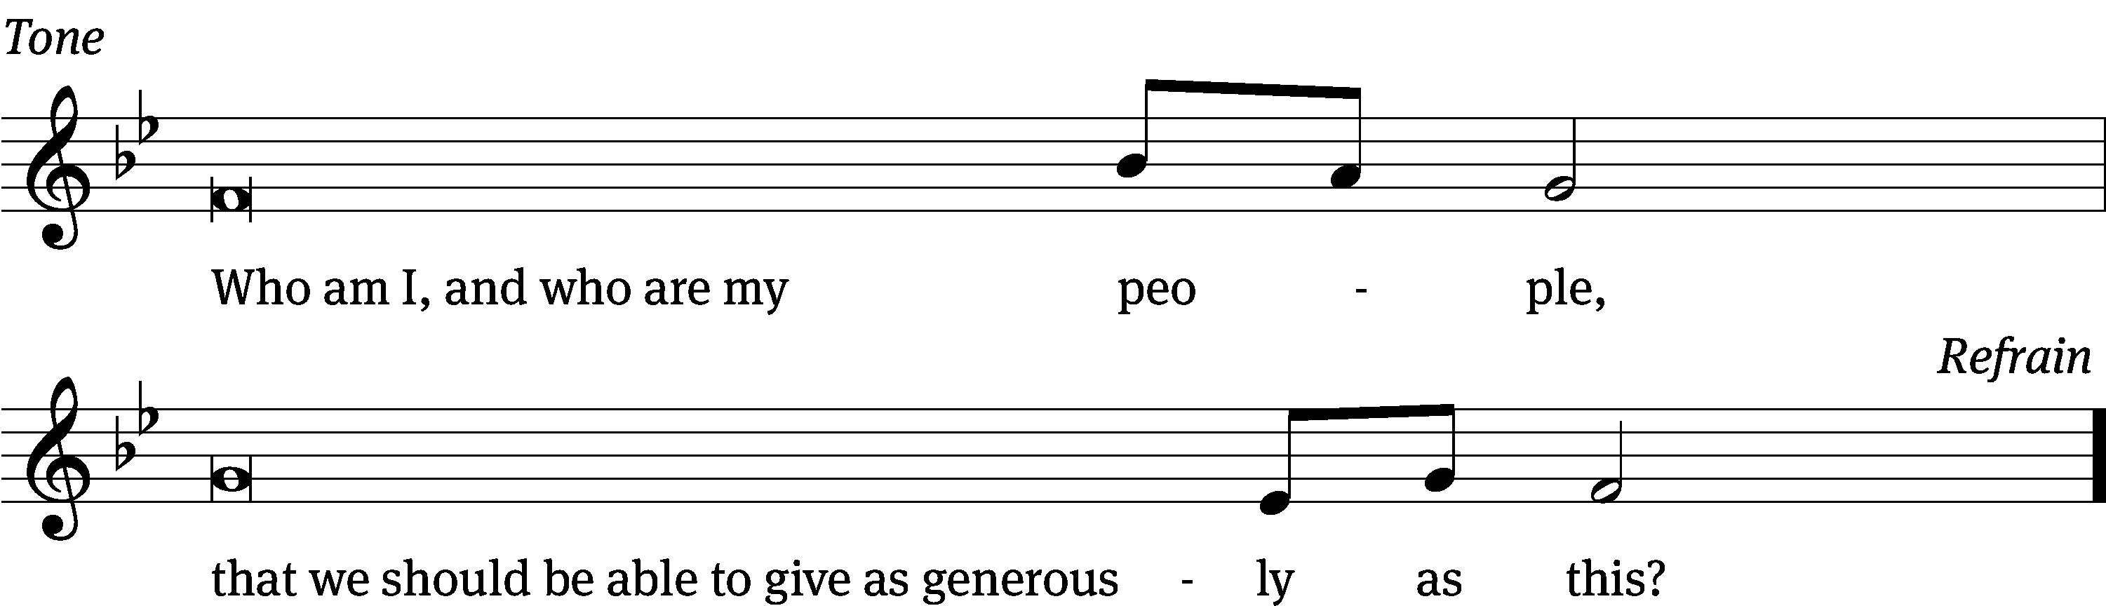
Tune: © 2021 Northwestern Publishing House. Used by permission: OneLicense no. 727703

Gospel Luke 17:1-10
Jesus said to his disciples, “Temptations to sin are sure to come, but woe to the one through whom they come! ² It would be better for that person if a millstone would be hung around his neck and he would be thrown into the sea than for him to cause one of these little ones to sin. ³ Watch yourselves.
“If your brother sins, rebuke him. If he repents, forgive him. ⁴ Even if he sins against you seven times in a day, and seven times returns to you and says, ‘I repent,’ forgive him.”
⁵ The apostles said to the Lord, “Increase our faith.”
⁶ The Lord said, “If you had faith like a mustard seed, you could tell this mulberry tree, ‘Be uprooted and planted in the sea,’ and it would obey you. ⁷ Which one of you who has a servant plowing or taking care of sheep will say to him when he comes in from the field, ‘Come at once and recline at the table’? ⁸ Won’t the master tell him instead, ‘Prepare my supper, and after you are properly dressed, serve me while I eat and drink. After that you may eat and drink’? ⁹ He does not thank the servant because he did what he was commanded to do, does he? ¹⁰ So also you, when you have done all that you were commanded, say, ‘We are unworthy servants. We have only done what we were supposed to do.’”

The Gospel of the Lord.
Praise be to you, O Christ!

Please be seated

743 I Hear the Savior Calling CW 743
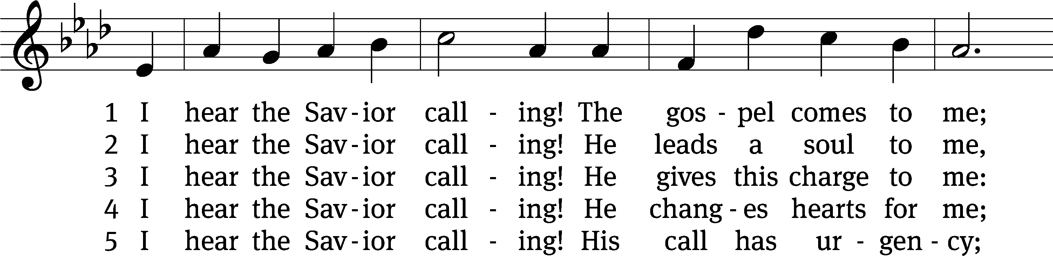
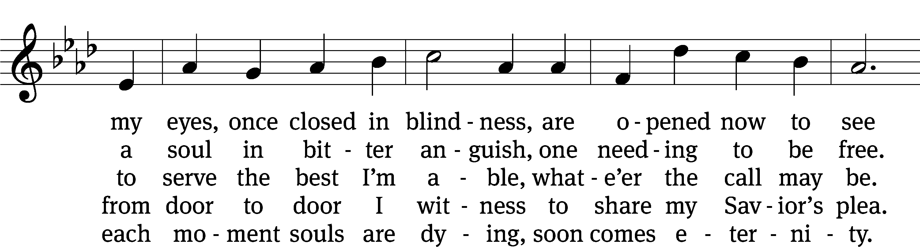
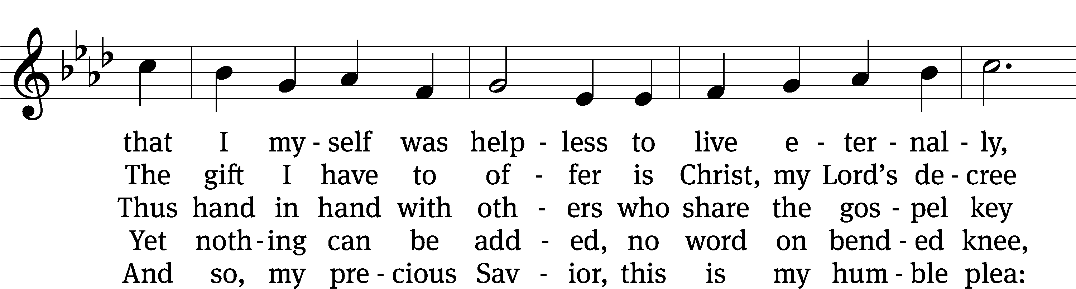
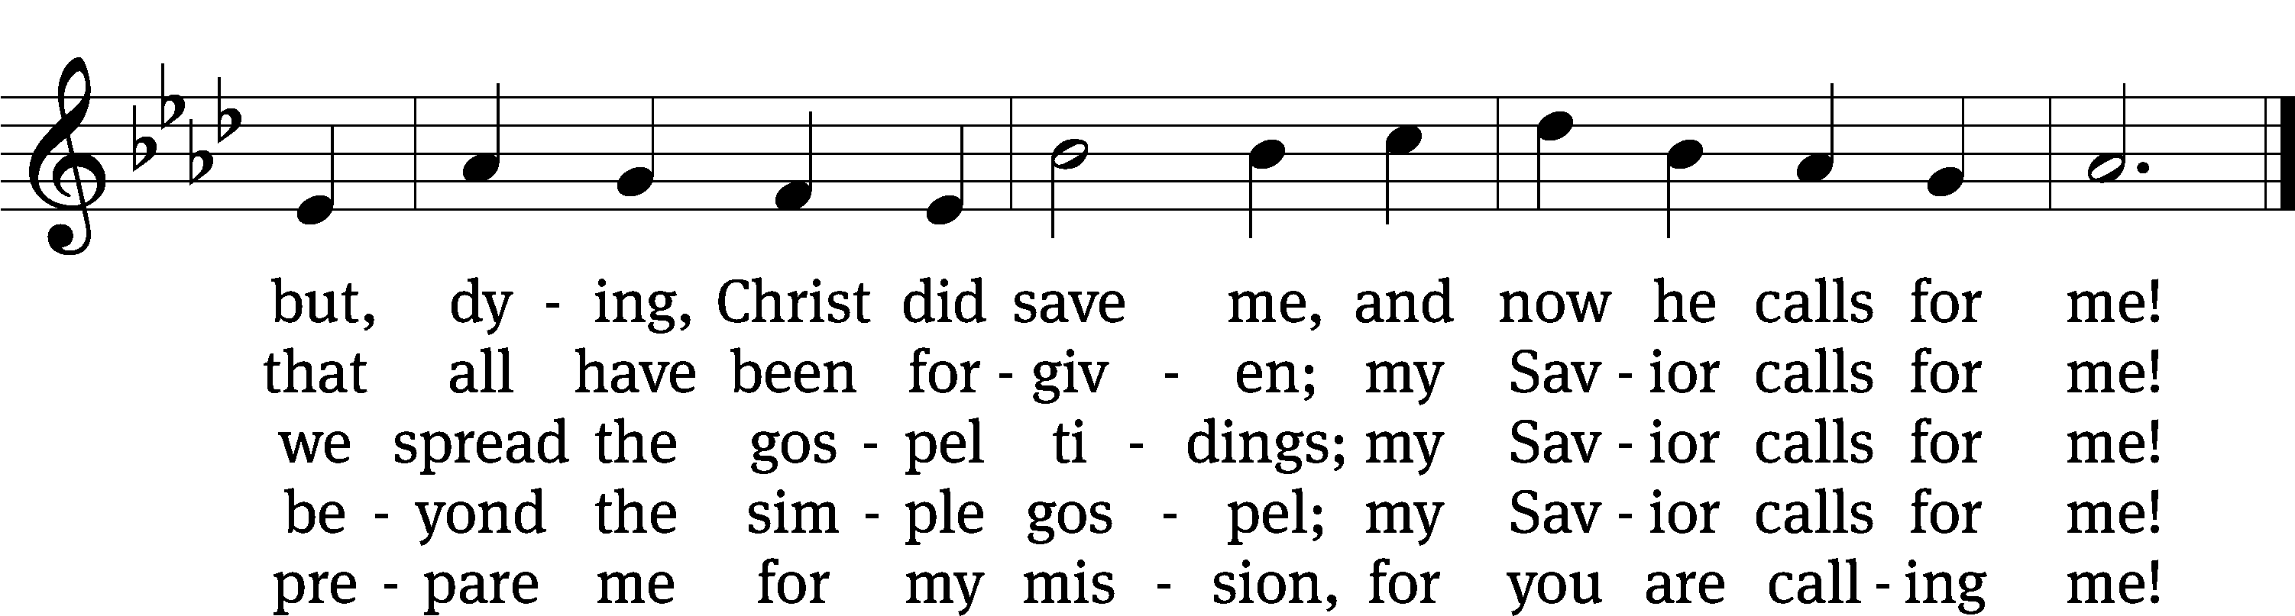
Text: John C. Lawrenz, b. 1943
Tune: Friedrich K. Anthes, 1812–1874
Text: © 1993 John C. Lawrenz, admin. Northwestern Publishing House. Used by permission: OneLicense no. 727703
Tune: Public domain

VIDEO PRESENTATION One By One (Part One)

Please stand, if you are able
Nicene Creed
We believe in one God, the Father, the Almighty,
maker of heaven and earth,
of all that is,
seen and unseen.
We believe in one Lord, Jesus Christ, the only Son of God,
eternally begotten of the Father,
God from God, Light from Light, true God from true God,
begotten, not made,
of one being with the Father.
Through him all things were made.
For us and for our salvation, he came down from heaven,
was incarnate of the Holy Spirit and the Virgin Mary,
and became truly human.
For our sake he was crucified under Pontius Pilate.
He suffered death and was buried.
On the third day he rose again in accordance with the Scriptures.
He ascended into heaven
and is seated at the right hand of the Father.
He will come again in glory to judge the living and the dead,
and his kingdom will have no end.
We believe in the Holy Spirit,
the Lord, the giver of life,
who proceeds from the Father and the Son,
who in unity with the Father and the Son
is worshiped and glorified,
who has spoken through the prophets.
We believe in one holy Christian and apostolic Church.
We acknowledge one baptism for the forgiveness of sins.
We look for the resurrection of the dead
and the life of the world to come. Amen.
Offertory
Prayer of the Church

The Sacrament
Preface CW 165
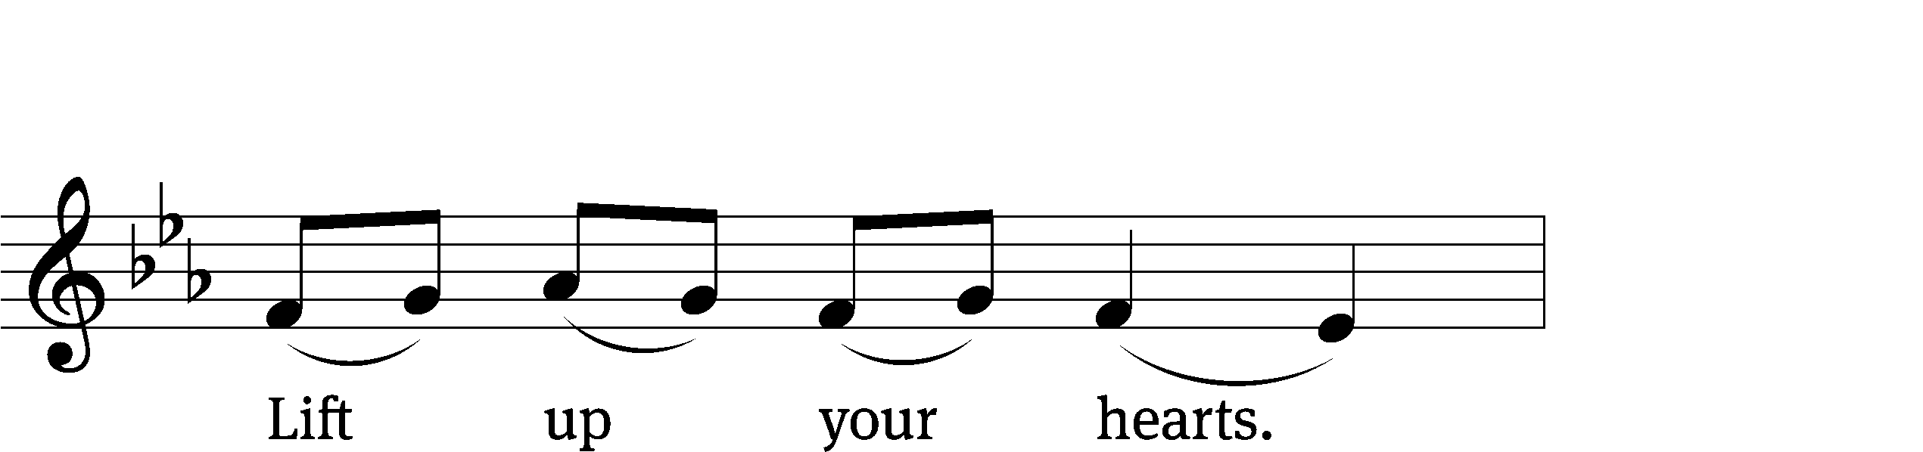
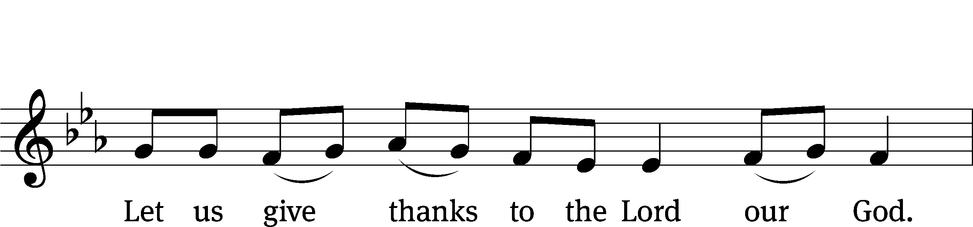
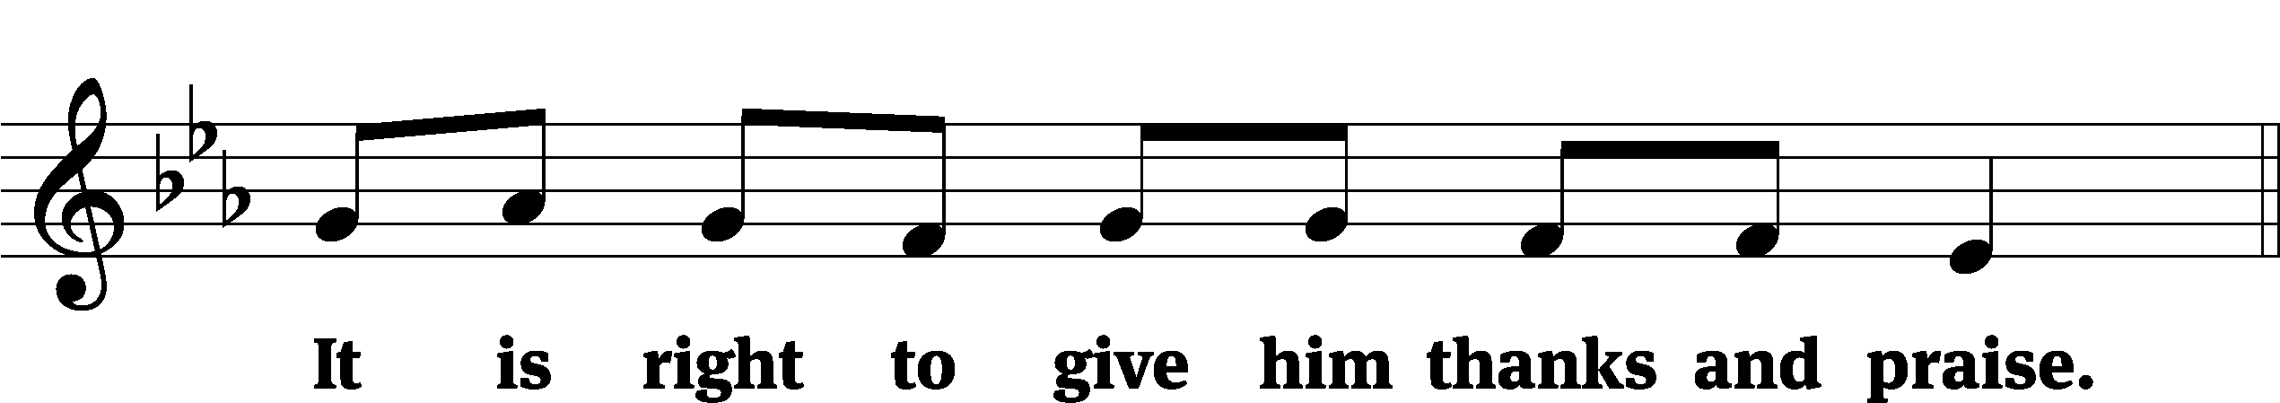

It is truly good and right that we should at all times and in all places give you thanks, O Lord, holy Father, almighty and everlasting God, through Jesus Christ our Lord, who promised that wherever two or three come together in his name, there he is with them to shepherd his flock until he comes again in glory. Therefore, with all the saints on earth and hosts of heaven, we praise your holy name and join their glorious song:
Holy, Holy, Holy CW 167
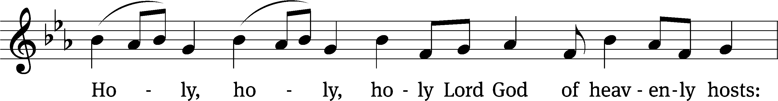
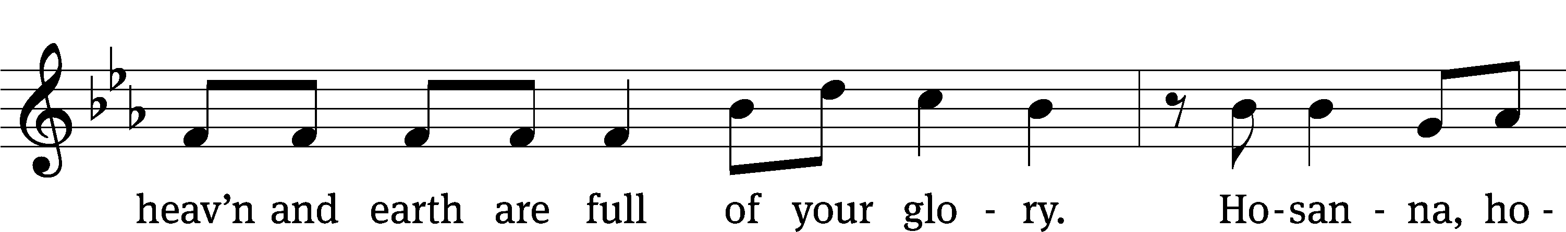
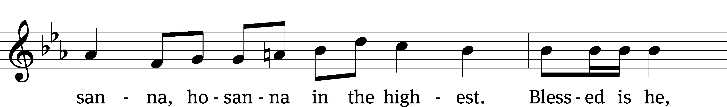
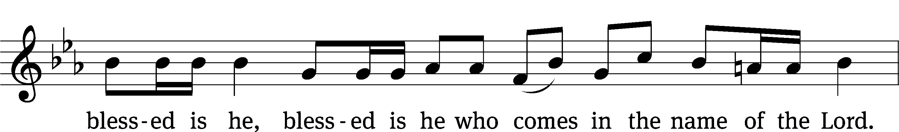
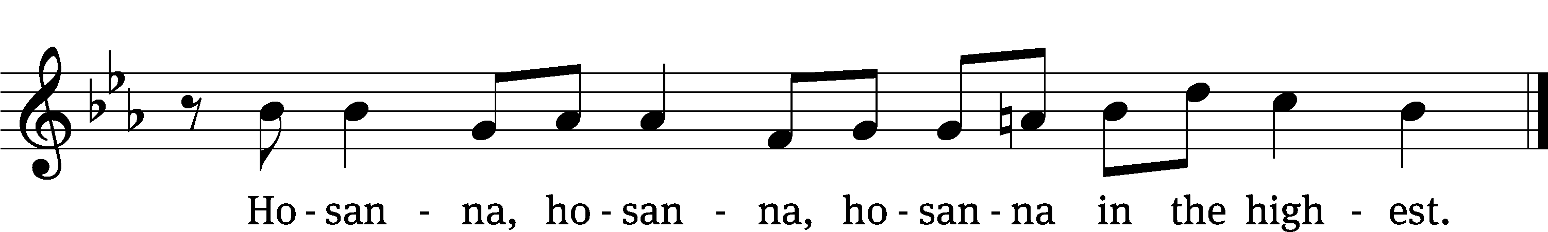

Prayer of Thanksgiving
We give thanks to you, O God, through your dear Son, Jesus Christ, whom you sent to be our Savior, our Redeemer, and the messenger of your grace. Through him you made all things; in him you are well pleased. He is the incarnate Word, conceived by the Holy Spirit and born of the Virgin Mary. To fulfill your promises, he stretched out his hands on the cross and released from eternal death all who believe in you.

As we remember Jesus’ death and resurrection, we thank you that you have gathered us together to receive your Son’s body and blood. Send us your Spirit, unite us as one, and strengthen our faith so that we may praise you in your Son, Jesus Christ. Through him, we glorify and honor you, O God our Father, with the Holy Spirit, one God, now and forever.
Amen.

Lord’s Prayer
Our Father, who art in heaven, hallowed be thy name, thy kingdom come, thy will be done on earth as it is in heaven. Give us this day our daily bread; and forgive us our trespasses, as we forgive those who trespass against us; and lead us not into temptation, but deliver us from evil. For thine is the kingdom and the power and the glory forever and ever. Amen.

Words of Institution
Our Lord Jesus Christ, on the night he was betrayed, took bread; and when he had given thanks, he broke it and gave it to his disciples, saying, “Take and eat; this is my body, which is given for you. Do this in remembrance of me.”
Then he took the cup, gave thanks, and gave it to them, saying, “Drink from it, all of you; this is my blood of the new covenant, which is poured out for you for the forgiveness of sins. Do this, whenever you drink it, in remembrance of me.”

The peace of the Lord be with you always.
Amen.
O Christ, Lamb of God CW 169
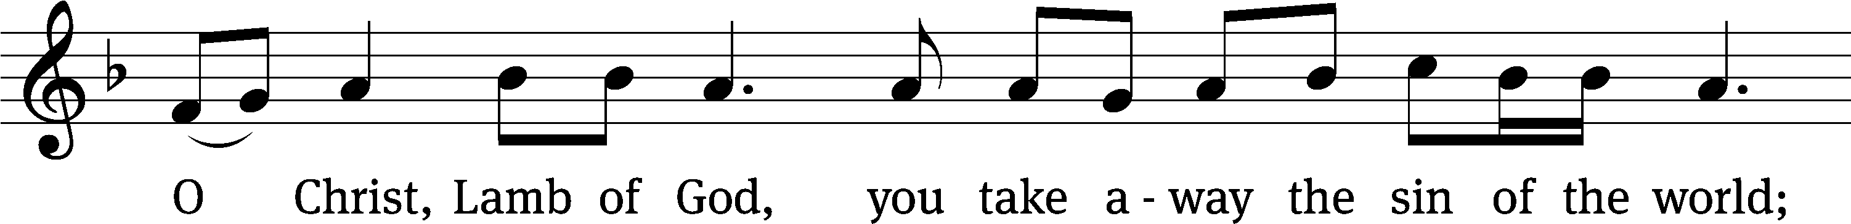
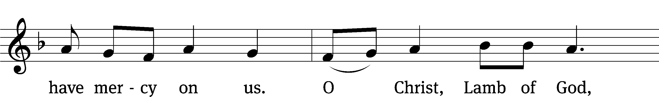
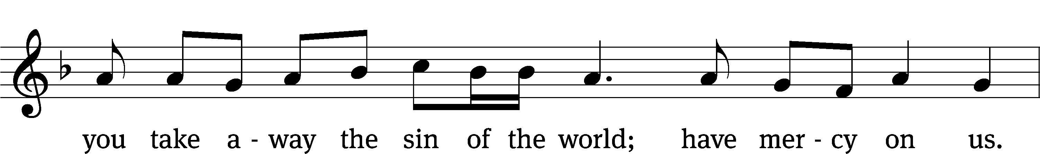
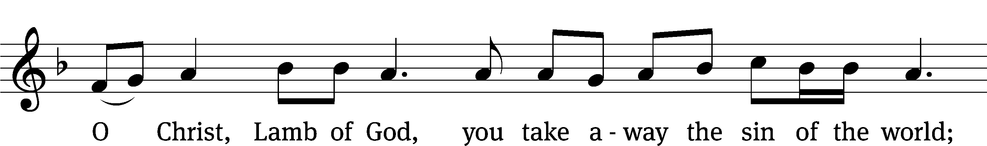
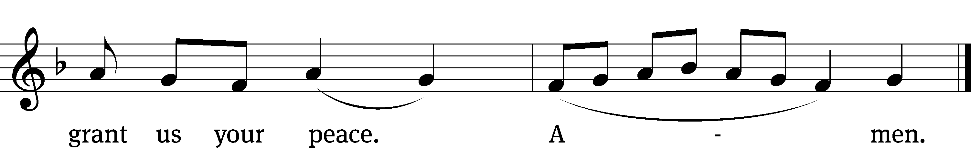
Please be seated
766 Lord, Whose Love in Humble Service CW 766
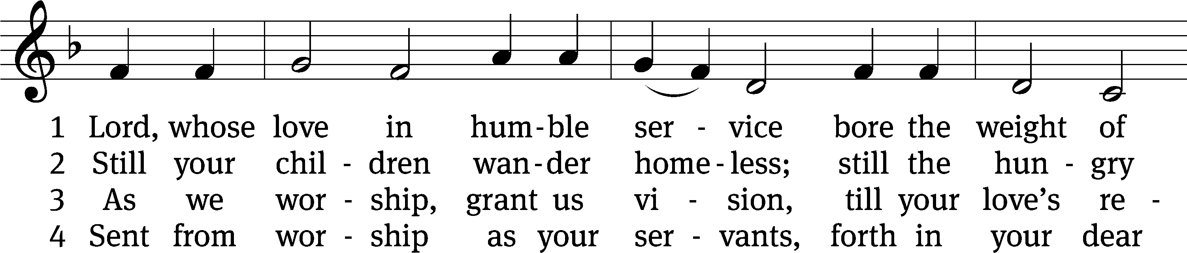
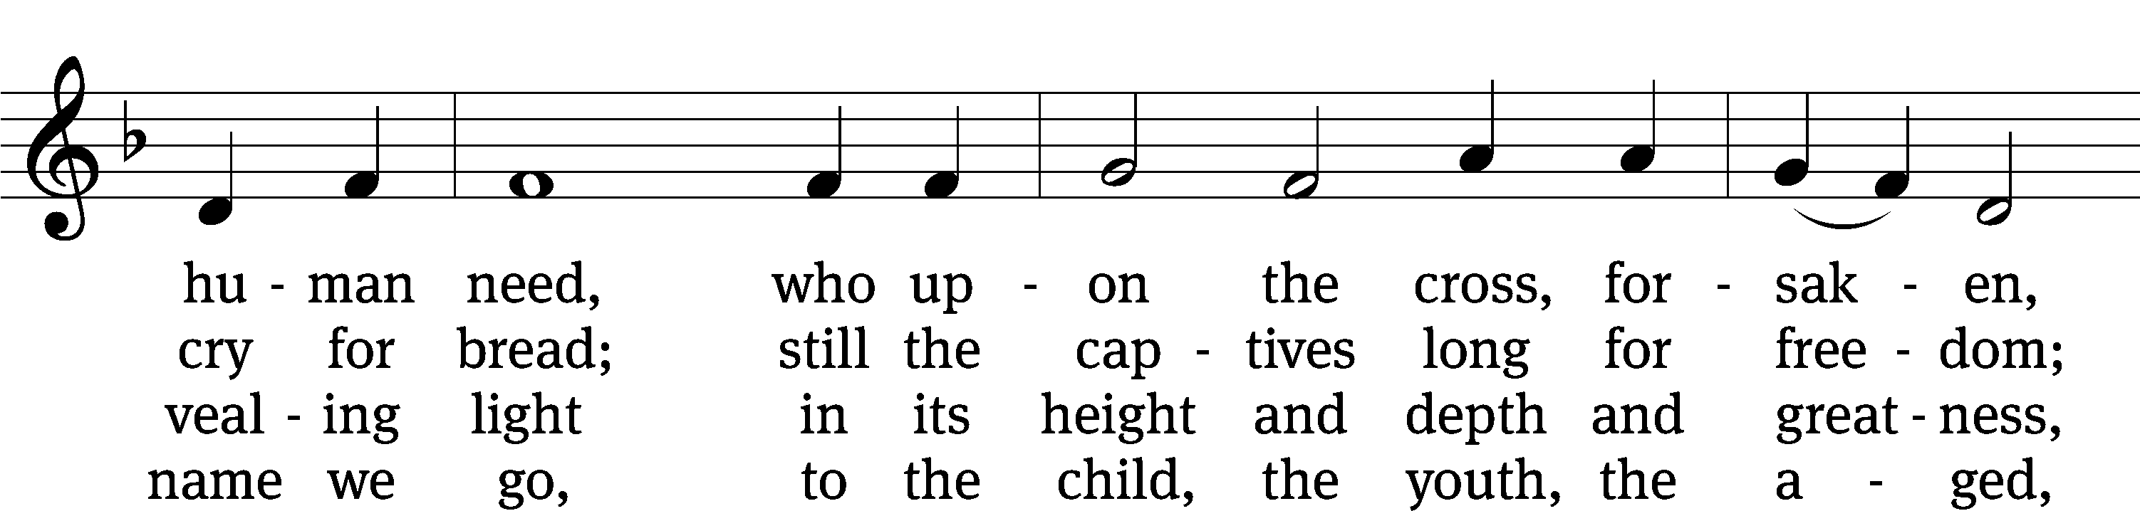
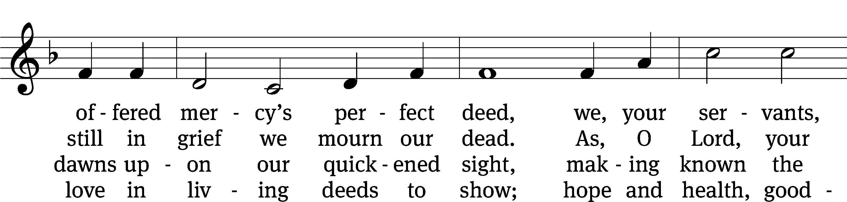
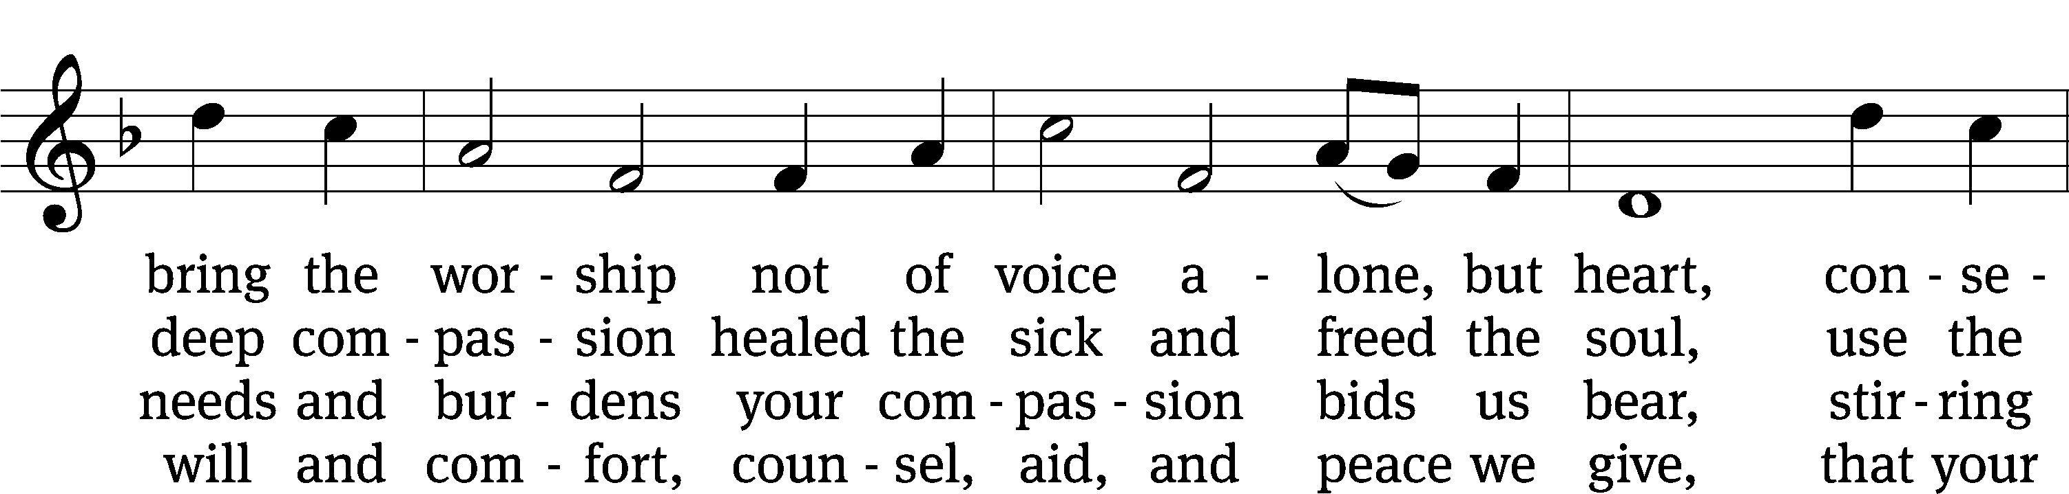
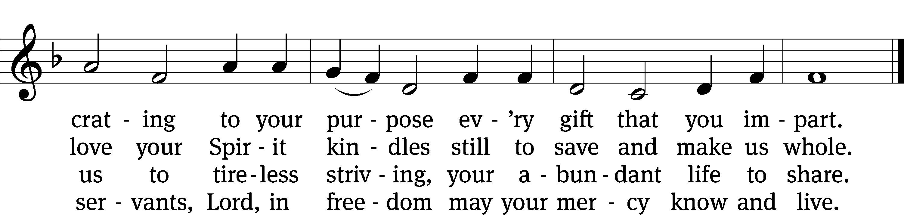
Text: Albert F. Bayly, 1901–1984, alt.
Tune: The Sacred Harp, Philadelphia, 1844
Text: © 1988 Oxford University Press. Used by permission: OneLicense no. 727703
Tune: Public domain

517 Praise the One Who Breaks the Darkness CW 517
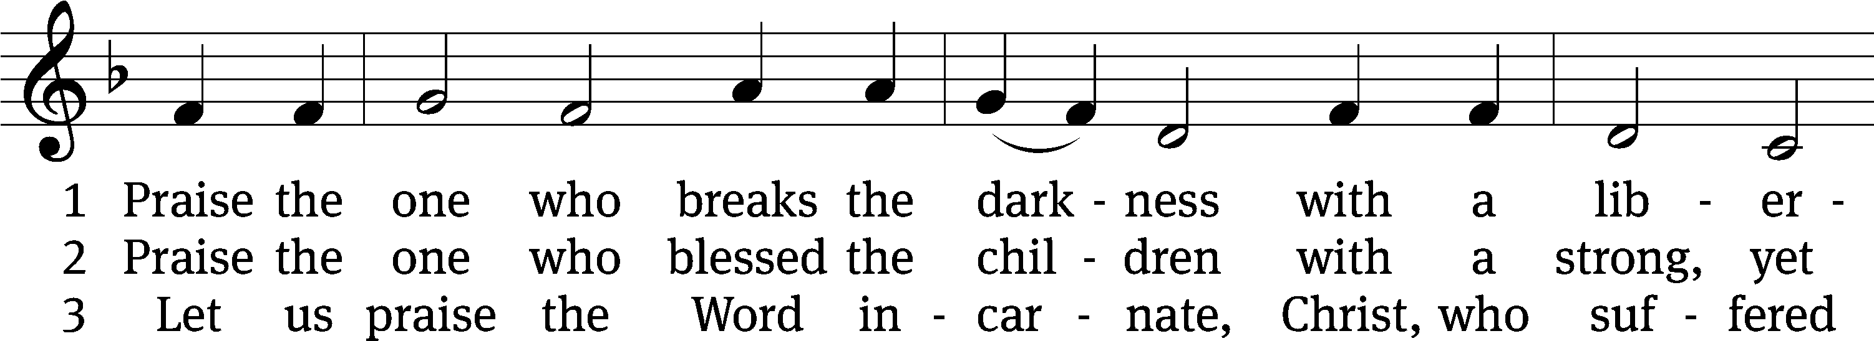
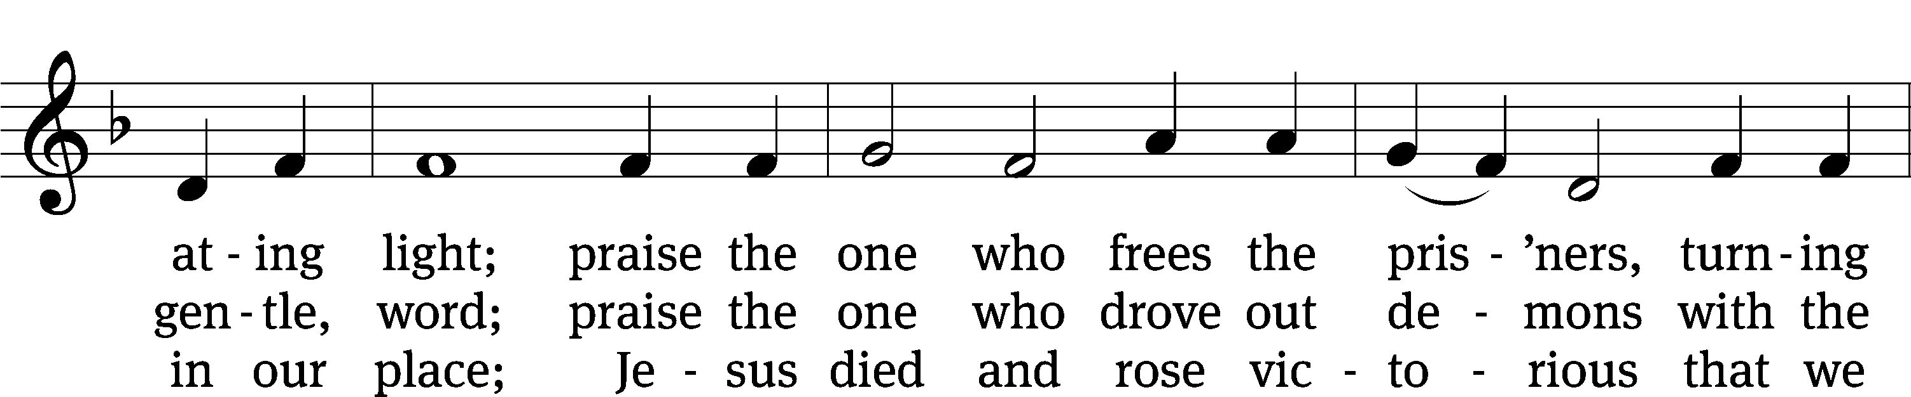
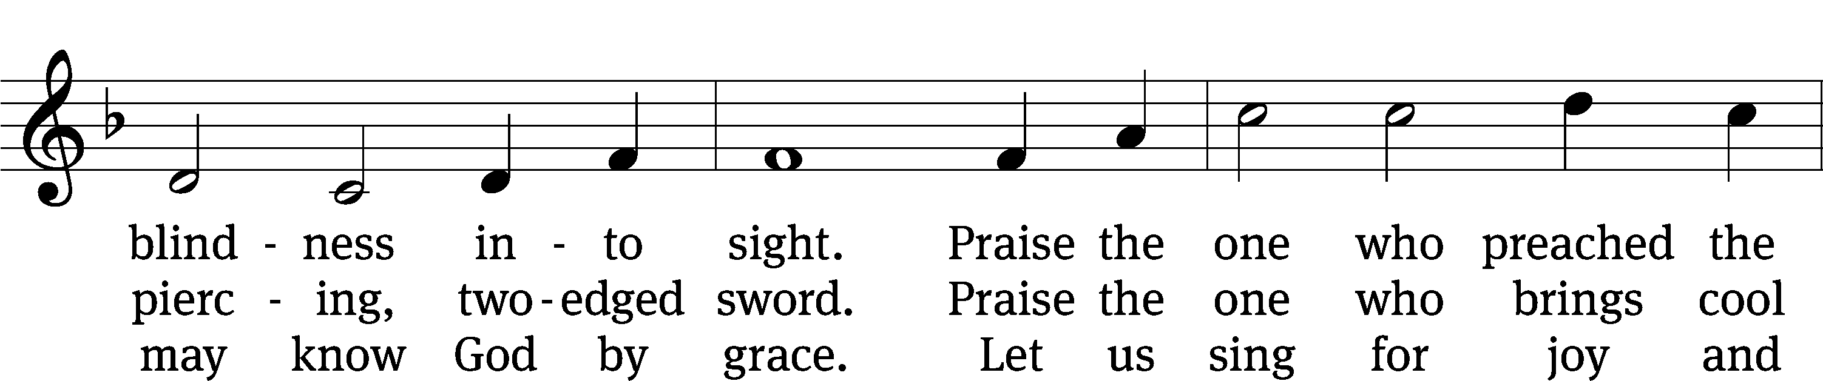
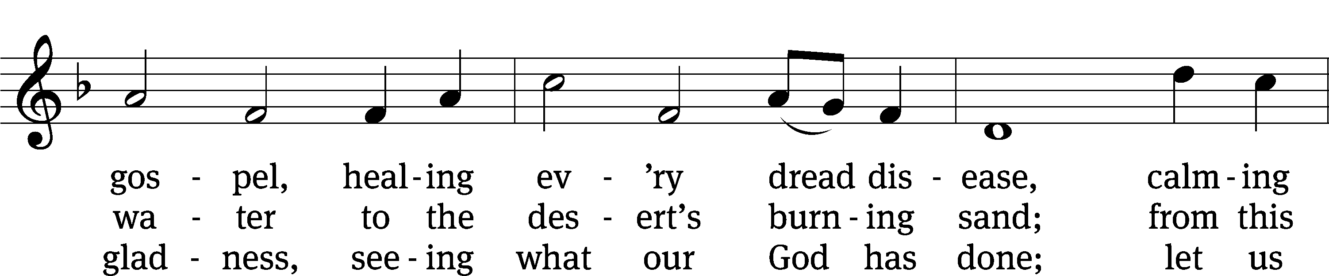
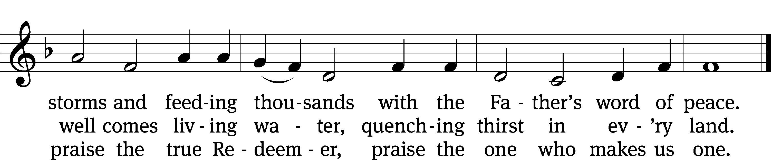
Text: Rusty Edwards, b. 1955, alt.
Tune: The Sacred Harp, Philadelphia, 1844
Text: © 1987 Hope Publishing Co. Used by permission: OneLicense no. 727703
Tune: Public domain

Please stand, if you are able

Give thanks to the Lord, for he is good;
his mercy endures forever.
Whenever we eat this bread and drink this cup,
we proclaim the Lord’s death until he comes.
We give thanks, almighty God, that you have refreshed us with this saving gift. We pray that through it you will strengthen our faith in you and increase our love for one another. We ask this in the name of Jesus Christ our Lord, who lives and reigns with you and the Holy Spirit, one God, now and forever.
Amen.

Blessing
The Lord bless you and keep you.
The Lord make his face shine on you and be gracious to you.
The Lord look on you with favor and give you peace.
Amen.
872 Stand Up, Stand Up for Jesus CW 872
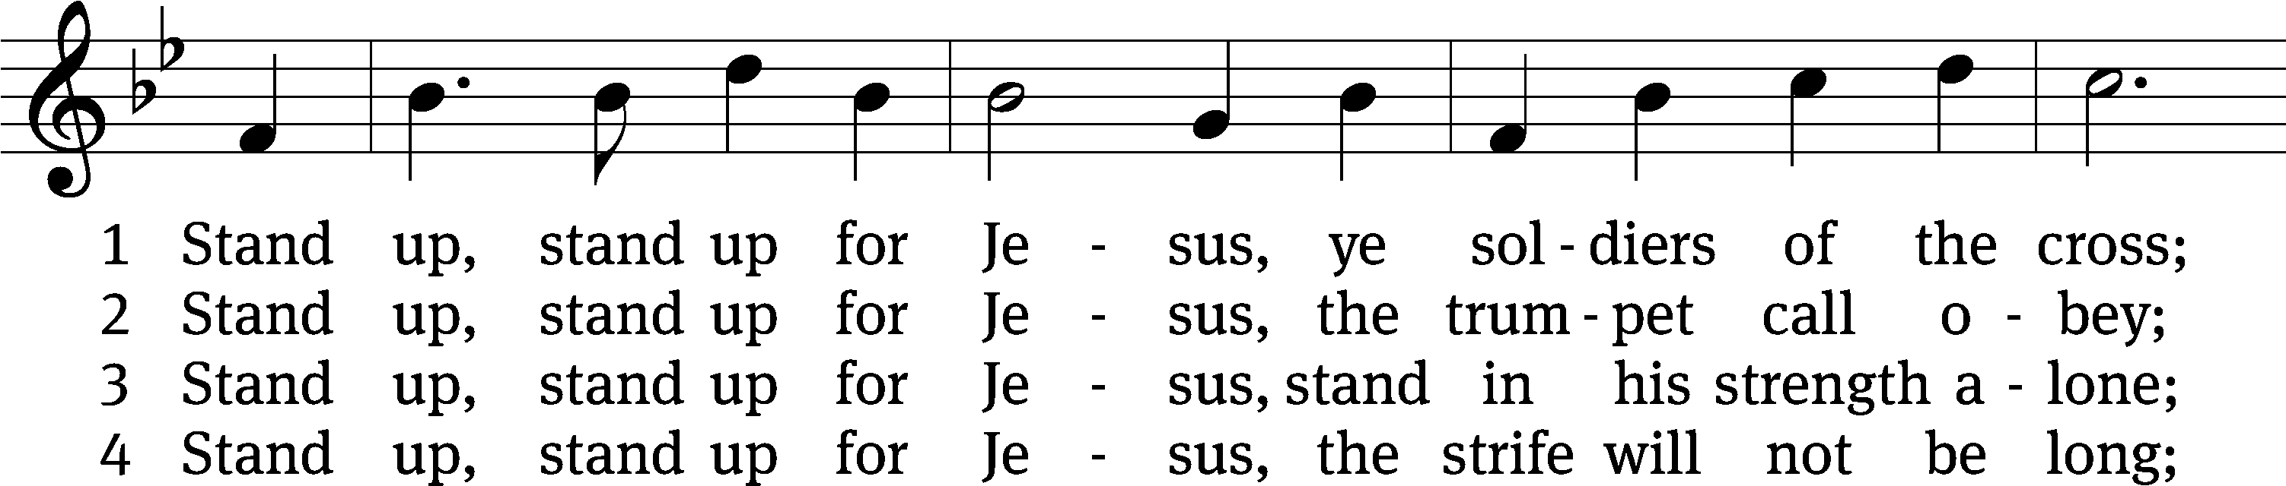
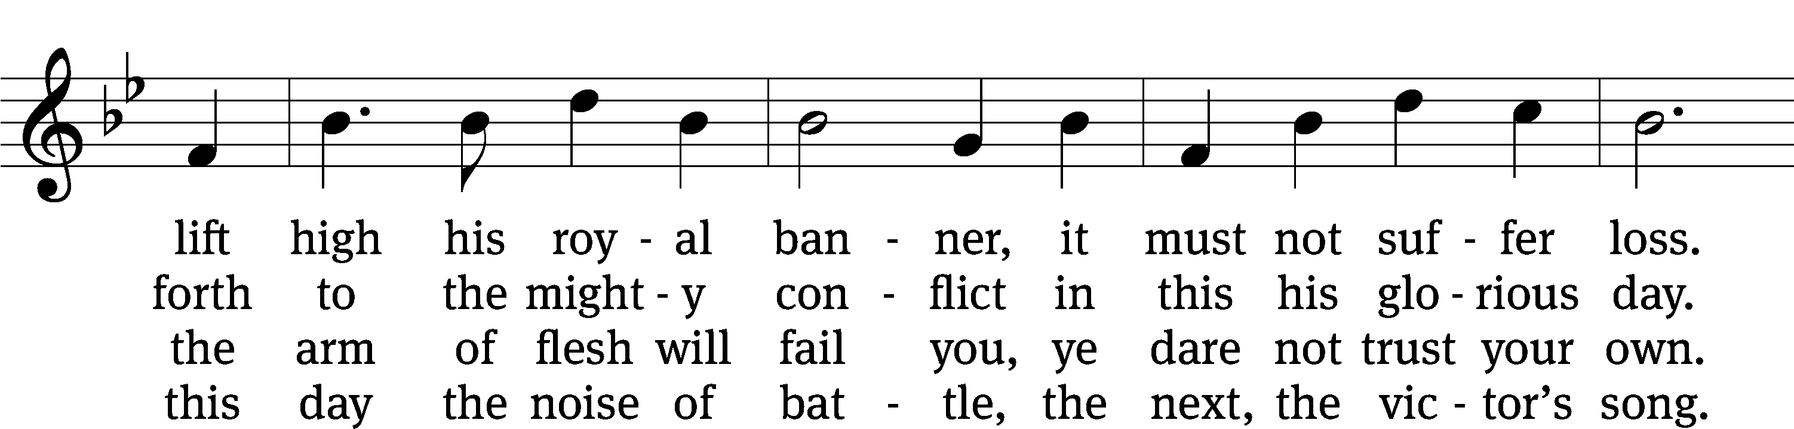
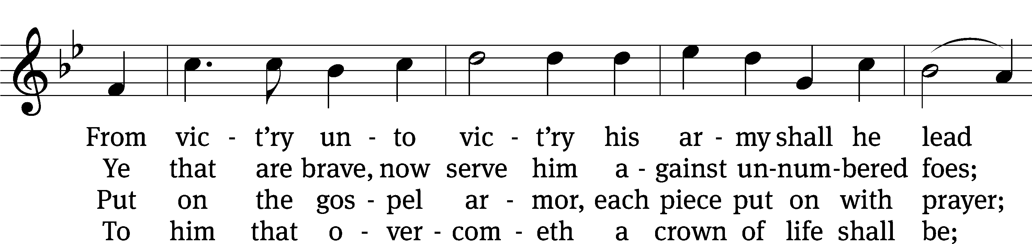
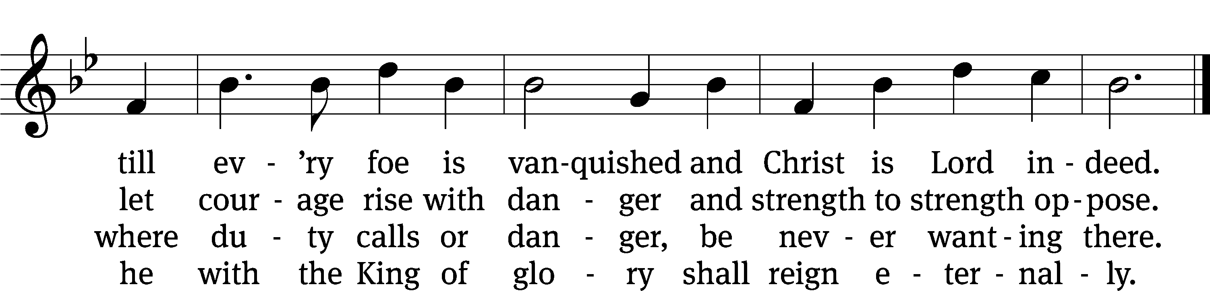
Text: George Duffield, Jr., 1818–1888, abr., alt.
Tune: George J. Webb, 1803–1887
Text and tune: Public domain

Acknowledgments
Setting One from Christian Worship
Software distributed in partnership with Northwestern Publishing House.
Created by Christian Worship: Service Builder © 2022 Concordia Publishing House.

Serving in Worship
Officiant Pastor Natsis
Organist Ann Hoeft
Accompanist Sarah Hanke
Duet Tom and Diane Amerman
Deacons (8:30) Dave Frey and Dave Stevenson
(11:00) Steve Hoeft and Jeff Neuburger
Ushers (8:30) Dale Finkbeiner and Mark Finkbeiner
(11:00) Ed Sala and Al Whitley
Altar Guild Sandy Kirkpatrick and Barb Neuburger
Videographer Jake Vershum

