THE twenty-second SUNDAY
AFTER PENTECOST

TRINITY EVANGELICAL LUTHERAN CHURCH | Saline, Michigan
WELCOME TO WORSHIP November 6, 2022
Thank you for joining us in God’s house today! We cordially ask that our Guests sign one of the guestbooks located at either the front or back entryways, or fill out a “Let’s Get Acquainted” card located in the hymnal pew rack and place it in the collection plate.

THANK OFFERING: Members of Trinity give their offering as an expression of love and thankfulness to the Lord and to help support the Lord’s work in our community and around the world. Visitors need not feel obligated to participate in this offering which supports our ministry.

Restrooms are located at the back of the upper level (the annex), and in the basement (down the back stairs of the sanctuary or annex). Handicap access is available, please ask an usher for assistance.

Young Families / Toddler Bags – We are GLAD YOU BROUGHT YOUR CHILDREN to our worship service. Jesus said: “Let the little children come to me and do not hinder them, for the kingdom of God belongs to such as these.” We know that having little children in church can be a challenge, but DO NOT WORRY about it. Many of your fellow worshippers have been in your shoes and are just happy you brought your children with you. For your convenience, we have reserved the back rows of seating for parents with small children. These areas provide more flexibility for your family, as well as, easy access to move downstairs if necessary. A closed-circuit TV system allows families to continue participating in the service while downstairs. Pre-school toddler bags and children’s bulletins are available for their enjoyment. Ask an usher for one to use during the service and please return the toddler bag afterwards.

celebration of holy communion:
In His Word, God makes it clear that the Lord’s Supper is to be shared by people of a common proclamation of faith (1 Corinthians 11:26; 1 Corinthians 10:16-17). Without judging anyone’s hearts, we invite those who share in our confession by their membership in our congregation or another congregation of the Wisconsin Evangelical Lutheran Synod (WELS) or the Evangelical Lutheran Synod (ELS) and who are properly prepared (1 Corinthians 11;27-29) to receive the Sacrament. Page 295 in Christian Worship provides a guide for preparation.
Guests, we would love to have you join us in communion fellowship in the future, and for that to be possible, we ask that you speak with one of the pastors so that we may speak with you on how that would be possible. We thank you for respecting the way we celebrate the Lord’s Supper in our congregations.
the SERVICE – setting one - WITH HOLY COMMUNION CW, page 154
Sunday School “Come, Oh Come, Let Us Sing to The Lord”
890 Jerusalem the Golden CW 890
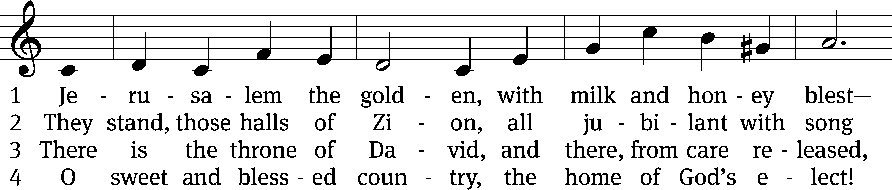
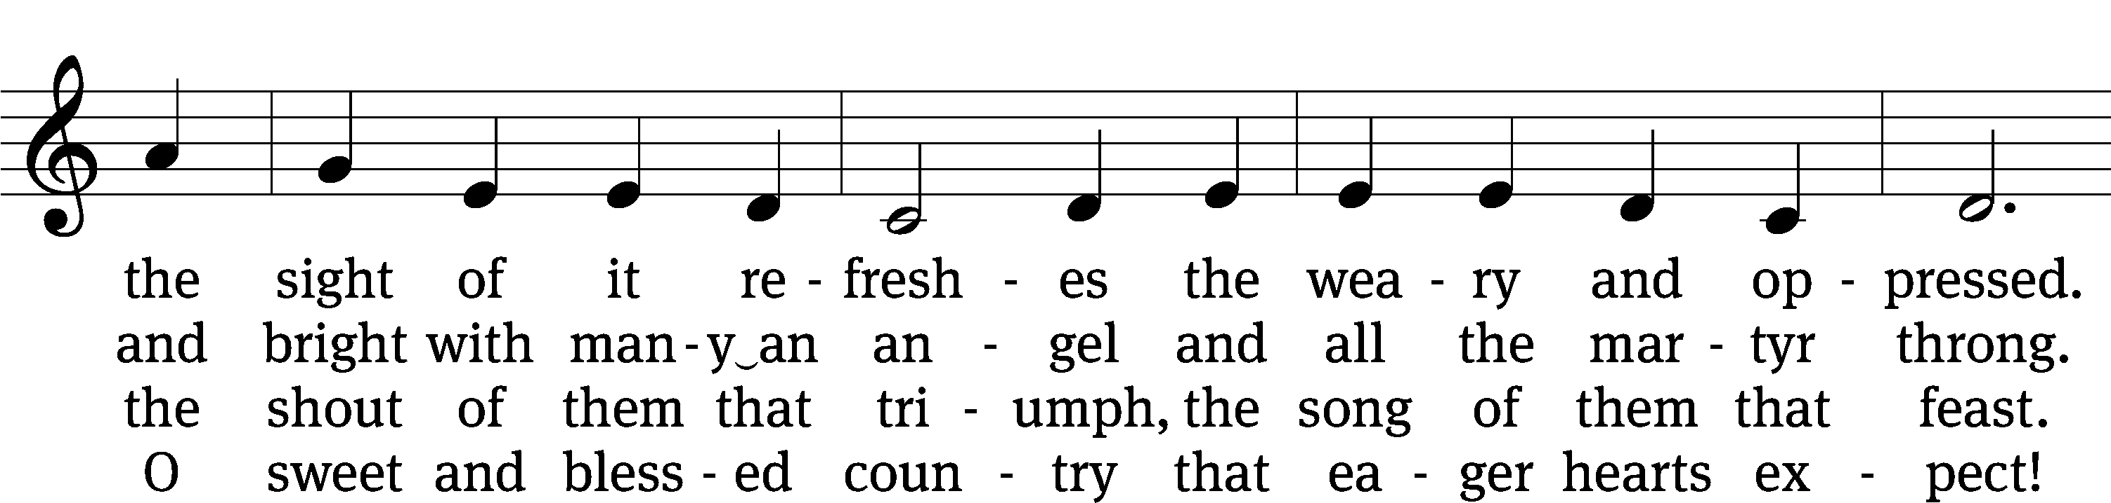
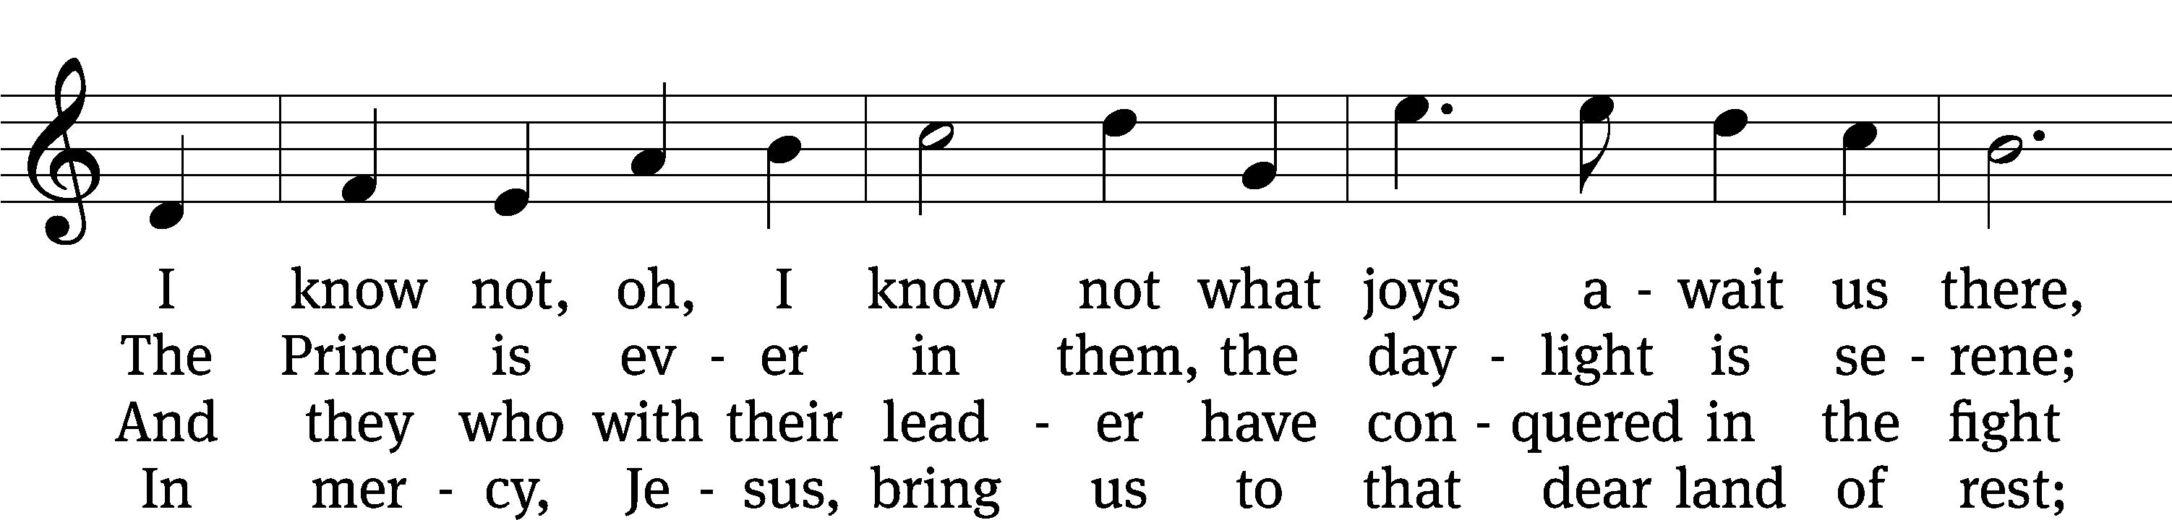
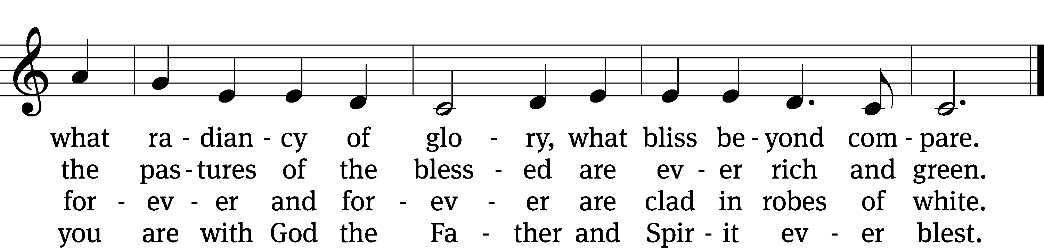
Text: tr. John Mason Neale, 1818–1866, alt.; Bernard of Cluny, 12th cent., abr.
Tune: Alexander C. Ewing, 1830–1895
Text and tune: Public domain

Please stand, if you are able
Invocation
In the name of the Father and of the Son and of the Holy Spirit.
Amen.
Confession
If we claim to be without sin, we deceive ourselves and the truth is not in us.
If we confess our sins, God is faithful and just
and will forgive us our sins
and purify us from all unrighteousness.

Let us confess our sins to the Lord.
Holy God, gracious Father,
I am sinful by nature
and have sinned against you in my thoughts, words, and actions.
I have not loved you with my whole heart;
I have not loved others as I should.
I deserve your punishment both now and forever.
But Jesus, my Savior, paid for my sins
with his innocent suffering and death.
Trusting in him, I pray: God, have mercy on me, a sinner.

Our gracious Father in heaven has been merciful to us. He sent his only Son, Jesus Christ, who gave his life as the atoning sacrifice for the sins of the whole world. Therefore, as a called servant of Christ and by his authority, I forgive you all your sins in the name of the Father and of the Son and of the Holy Spirit.
Amen.

Lord, Have Mercy

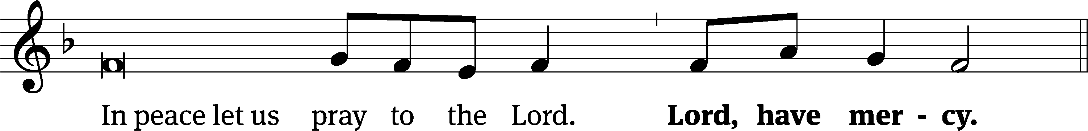
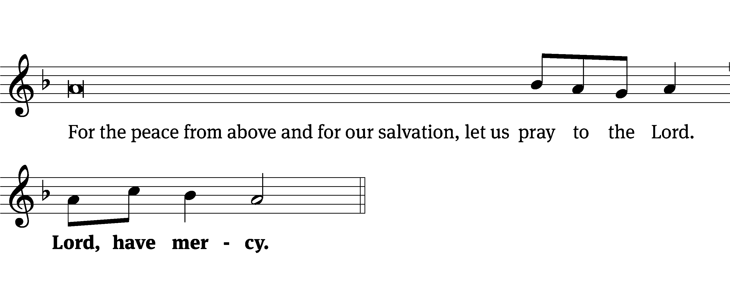
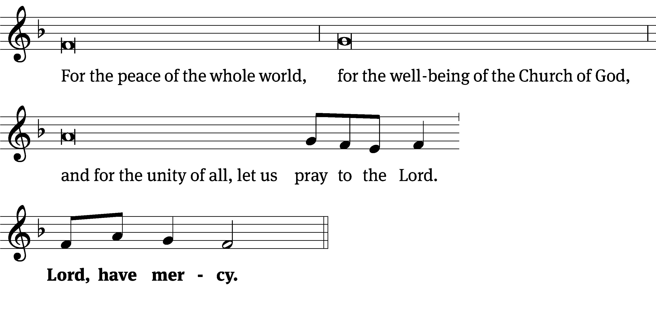
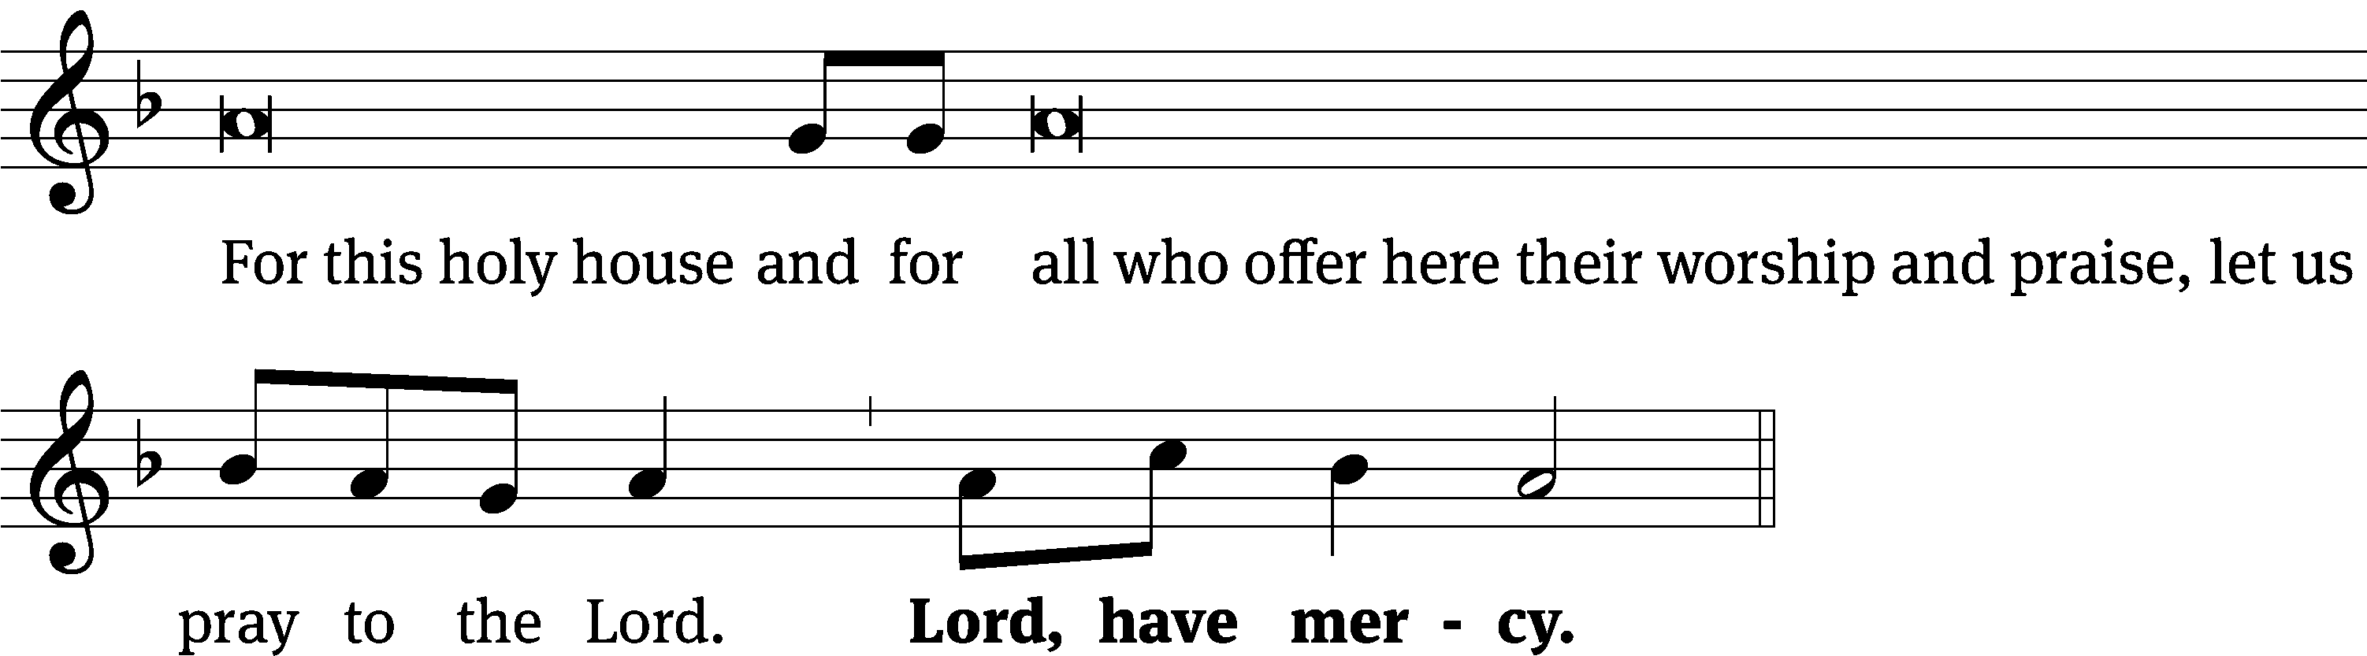
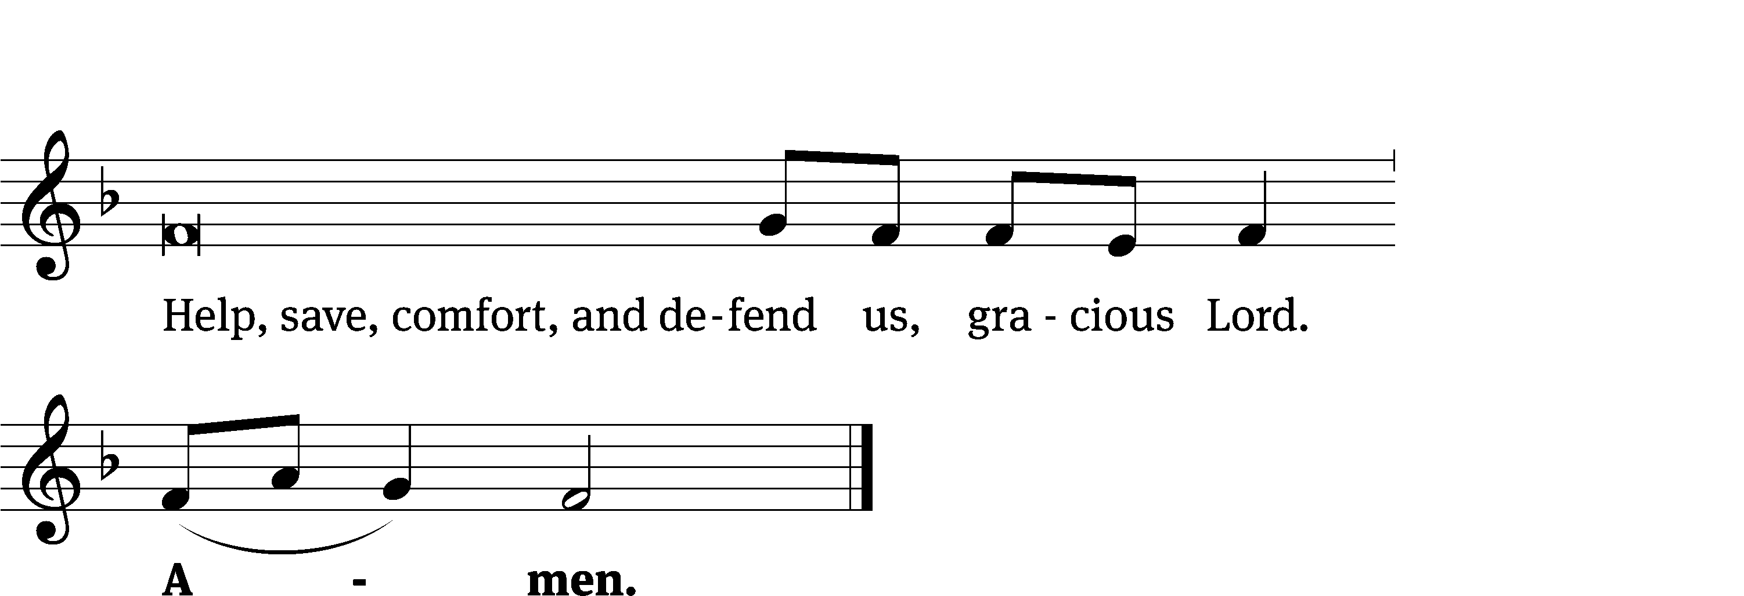
Tune: Kevin Becker
Tune: © 2021 Northwestern Publishing House. Used by permission: OneLicense no. 727703
Glory Be to God CW 157
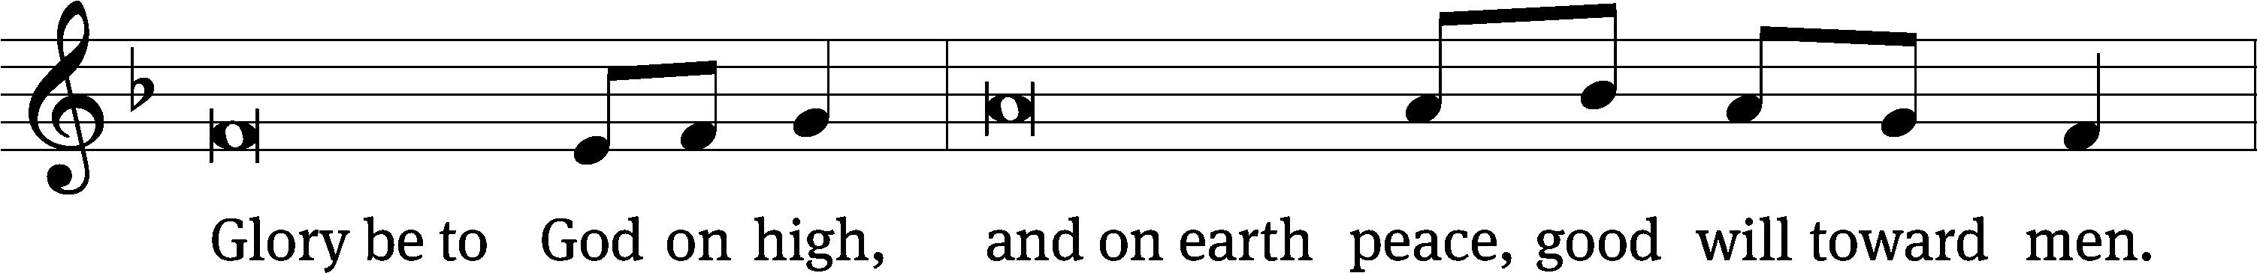
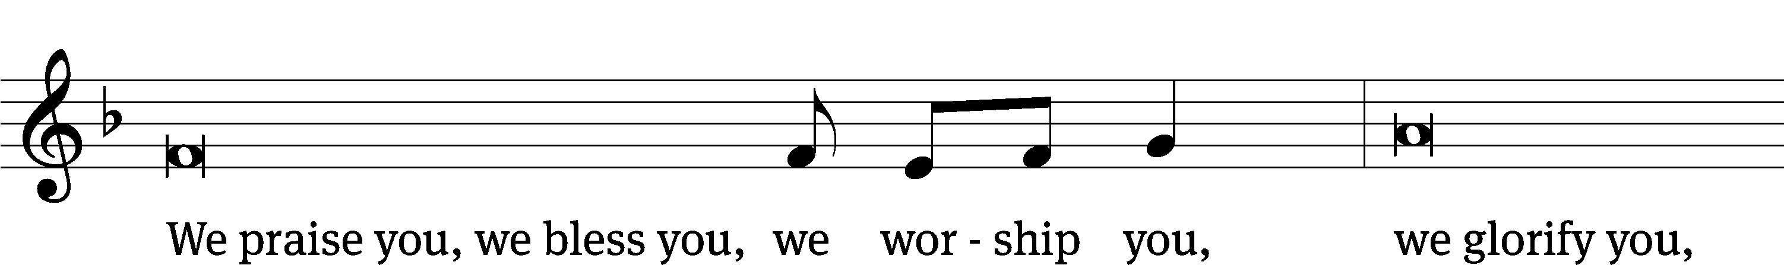
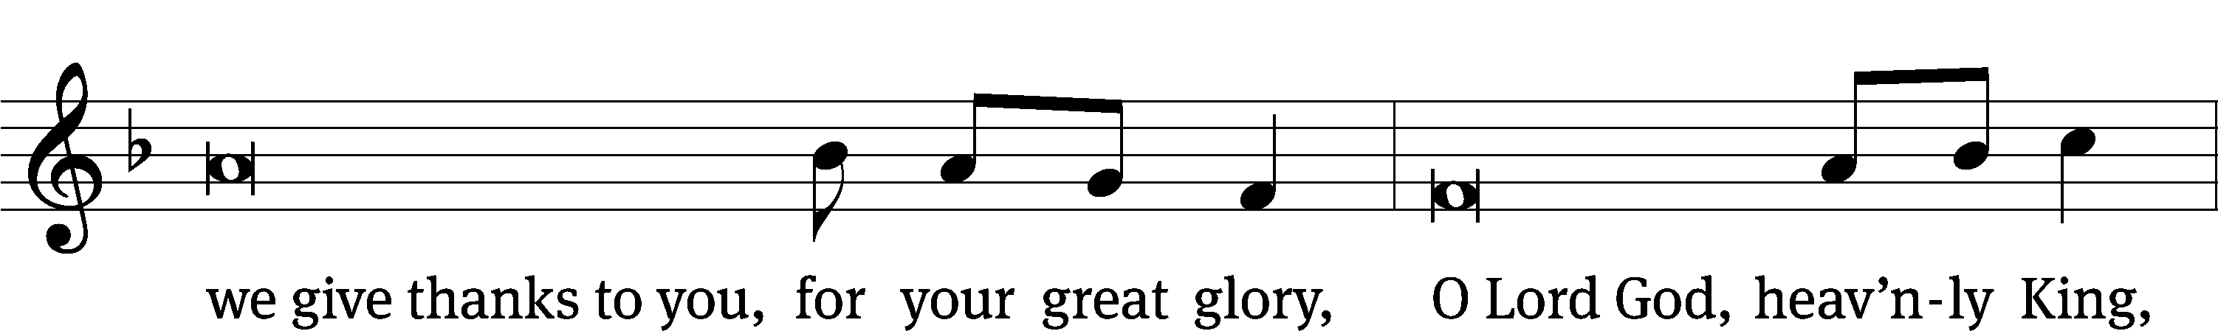
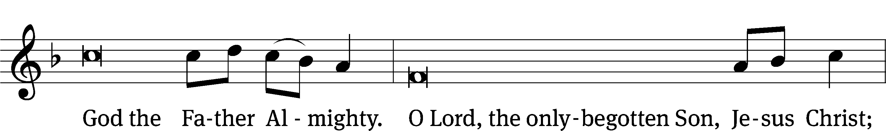
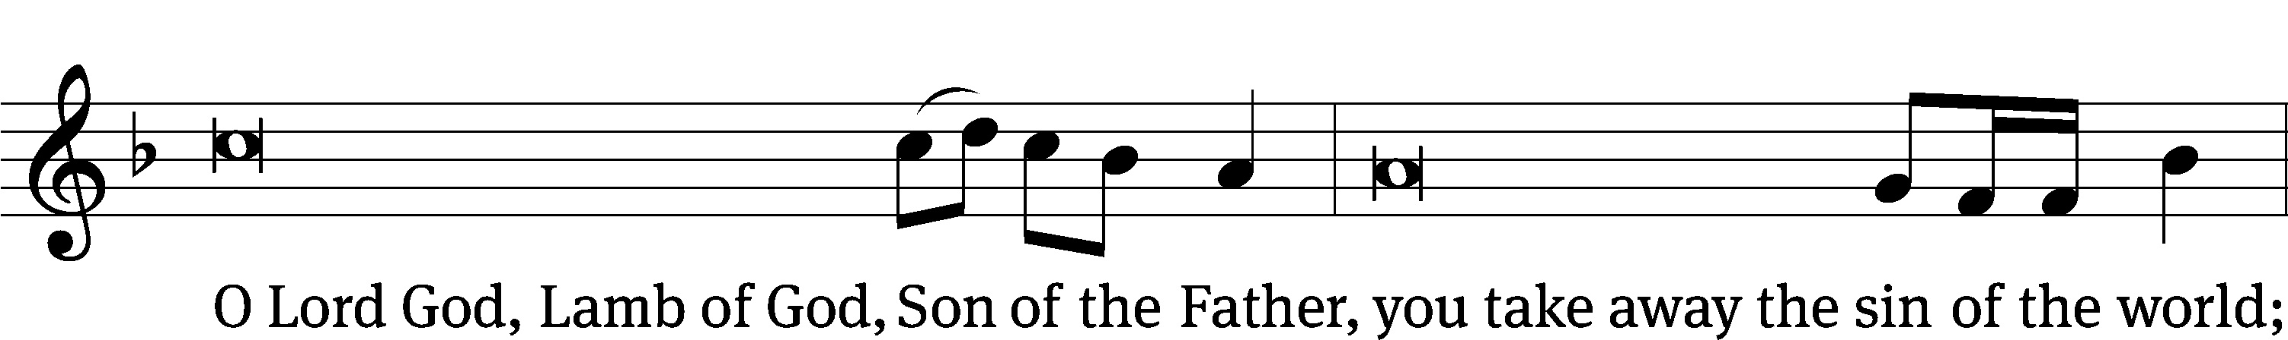
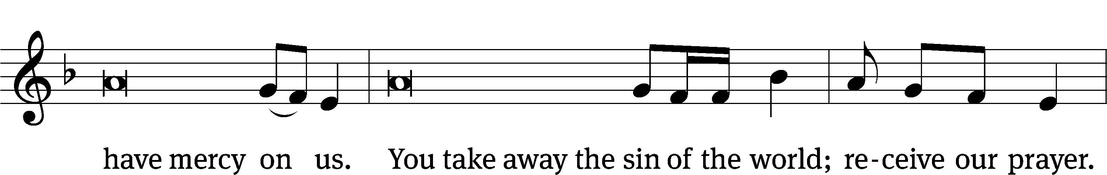
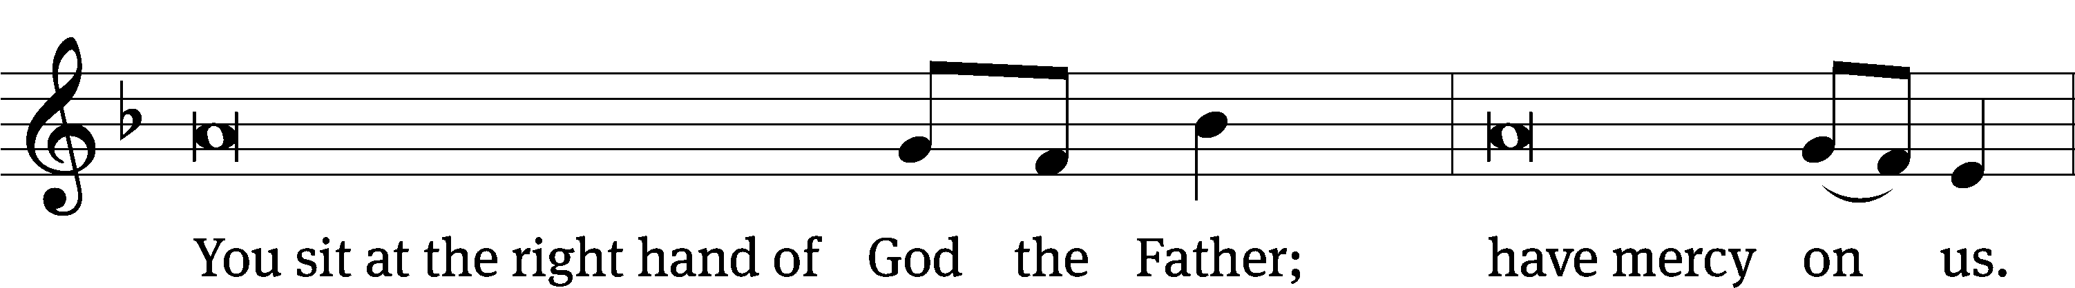
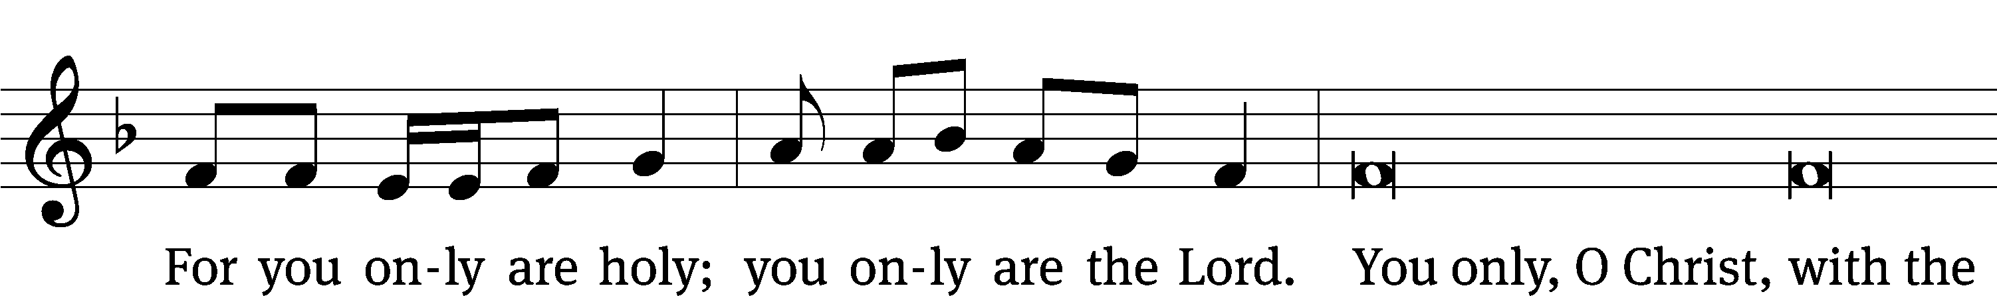
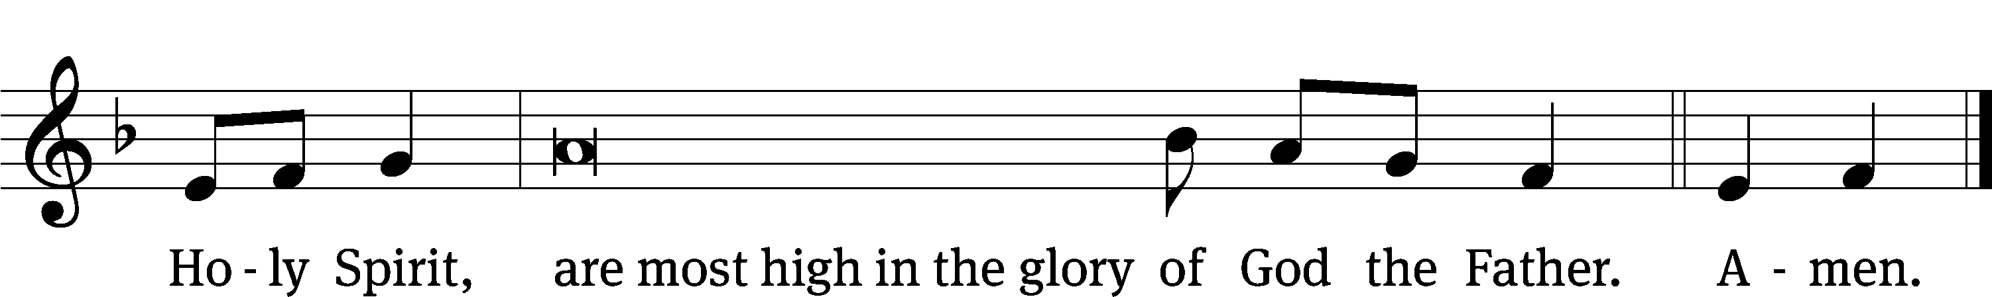
The Lord be with you.
And also with you.
Prayer of the Day
Let us pray.

Living God, your almighty power is made known chiefly in showing mercy and pity. Grant us the fullness of your grace to lay hold of your promises and live forever in your presence; through your Son, Jesus Christ our Lord, who lives and reigns with you and the Holy Spirit, one God, now and forever.
Amen.

Please be seated

First Reading Isaiah 65:17-25

¹⁷ Watch this! I am about to create new heavens and a new earth.
The former things will not be remembered.
They will not come to mind.
¹⁸ Instead, rejoice and celebrate forever, because of what I am creating.
Watch this! I am about to create Jerusalem to be a source of gladness,
and her people will be a source of joy.
¹⁹ I also will be glad because of Jerusalem,
and I will rejoice over my people.
The sound of weeping will not be heard in her again,
nor will the sound of crying.
²⁰ There will never again be an infant there who lives for only a few days,
or an elderly man who does not fill out all his days,
for one who dies at a hundred will be considered a young man,
and one who fails to attain the age of one hundred will be regarded
as cursed.
²¹ Then they will build houses and live in them.
They will plant vineyards and eat their fruit.
²² They will not build a house and have another person live in it.
They will not plant and have another person eat the crop,
for the days of my people will be like the days of a tree,
and my chosen ones will enjoy all the work of their hands.
²³ They will not labor only to receive nothing,
and they will not give birth to children doomed to disaster,
for they will be offspring who are blessed by the Lord,
and their descendants will be with them.
²⁴ Then even before they call, I will answer.
While they are still speaking, I will hear.
²⁵ The wolf and the lamb will graze together,
and lions will eat straw like cattle,
but the serpent will eat dust as its food.
They will not harm or destroy anywhere on my holy mountain,
says the Lord.

The Word of the Lord.
Thanks be to God.

148D Alleluia! Praise the LORD Psalm 148D
(Sung to the tune of CW 465 “Christ the Lord Is Risen Today”

1 Let the whole creation cry,
“Glory to the LORD on high.”
Heav’n and earth, awake and sing,
“God is our eternal King.”

2 Men and women, young and old,
raise the anthem manifold.
Join with children’s songs of praise;
worship God through length of days.

4 Praise the LORD, you hosts above,
ever shining forth in love.
Sun and moon, uplift your voice;
night and stars, in God rejoice!

4 From the north to southern pole
let the mighty chorus roll:
“Holy, holy, holy One,
glory be to God alone!”
Text: Stopford A. Brooke
Text: Public domain

Second Reading Revelation 22:1-5
¹ The angel showed me the river of the water of life, which was as clear as crystal, flowing from the throne of God and the Lamb. ² In the middle of the city’s street and on each side of the river was a tree of life that yielded twelve kinds of fruit. The tree yields its fruit every month, and its leaves are for the healing of the nations.
³ There will no longer be any curse. The throne of God and of the Lamb will be in the city. His servants will worship him. ⁴ They will see his face. His name will be on their foreheads. ⁵ There will no longer be any night or any need for lamplight or sunlight, because the Lord God will shine on them. And they will reign forever and ever.

The Word of the Lord.
Thanks be to God.

Please stand, if you are able

Gospel Acclamation Luke 20:38
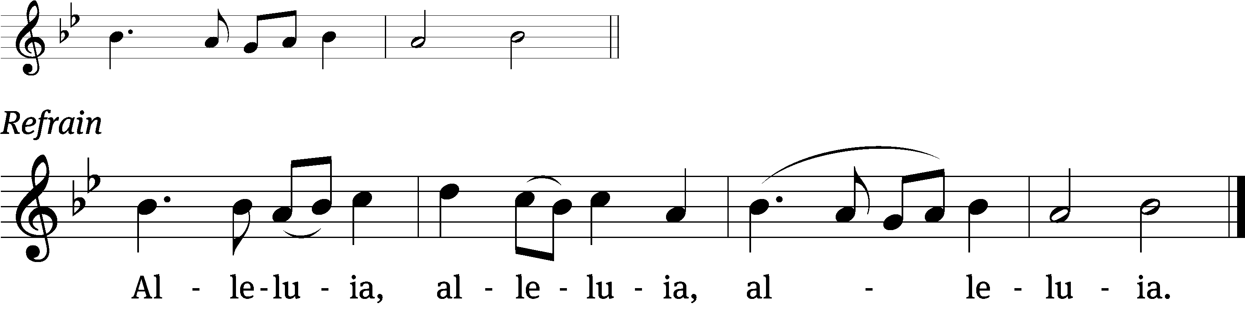
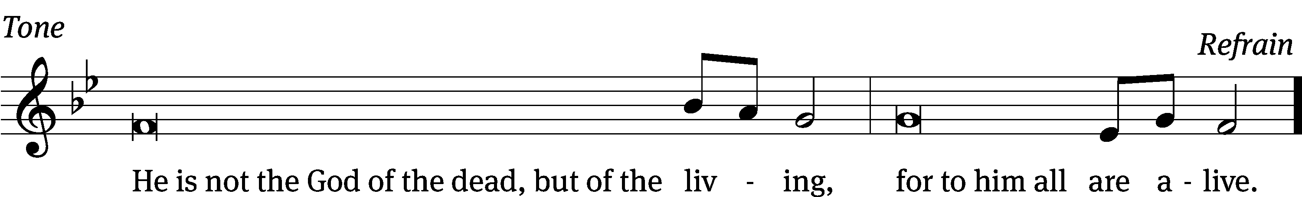
Tune: © 2021 Northwestern Publishing House. Used by permission: OneLicense no. 727703

Gospel Luke 20:27-38
²⁷ Some of the Sadducees (who say there is no resurrection) came to him. ²⁸ They asked him a question, “Teacher, Moses wrote for us that if a man’s brother dies leaving a wife but no children, his brother should take the wife and raise up children for his brother. ²⁹ So there were seven brothers. The first took a wife and died childless. ³⁰ The second took her as a wife, ³¹ and so did the third, and in the same way the seven died and left no children. ³² Finally the woman died too. ³³ So in the resurrection, whose wife will she be? For the seven had her as a wife.”
³⁴ Jesus said to them, “The people of this age marry and are given in marriage. ³⁵ But those who are considered worthy to experience that age and the resurrection from the dead neither marry nor are given in marriage. ³⁶ In fact, they cannot die any more, for they are like the angels. They are sons of God, because they are sons of the resurrection.
³⁷ “Even Moses showed in the account about the burning bush that the dead are raised, when he called the Lord: ‘The God of Abraham, the God of Isaac, and the God of Jacob.’ ³⁸ He is not the God of the dead, but of the living, for all are alive to him.”

The Gospel of the Lord.
Praise be to you, O Christ!

Please be seated

574 The Tree of Life CW 574
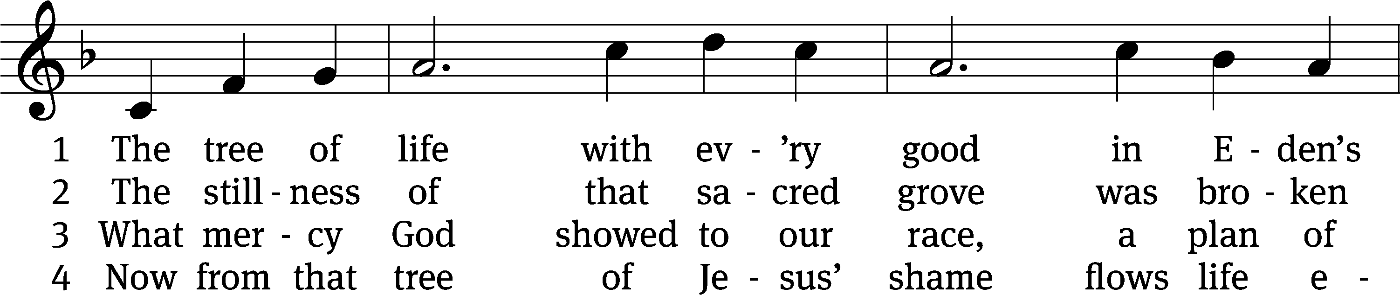
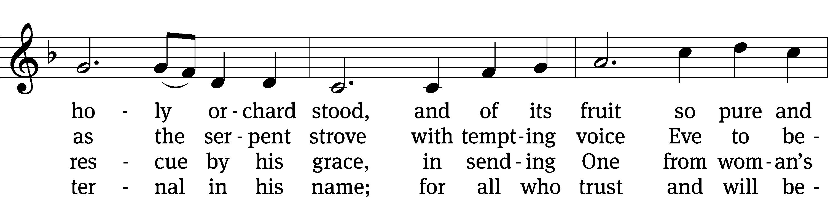
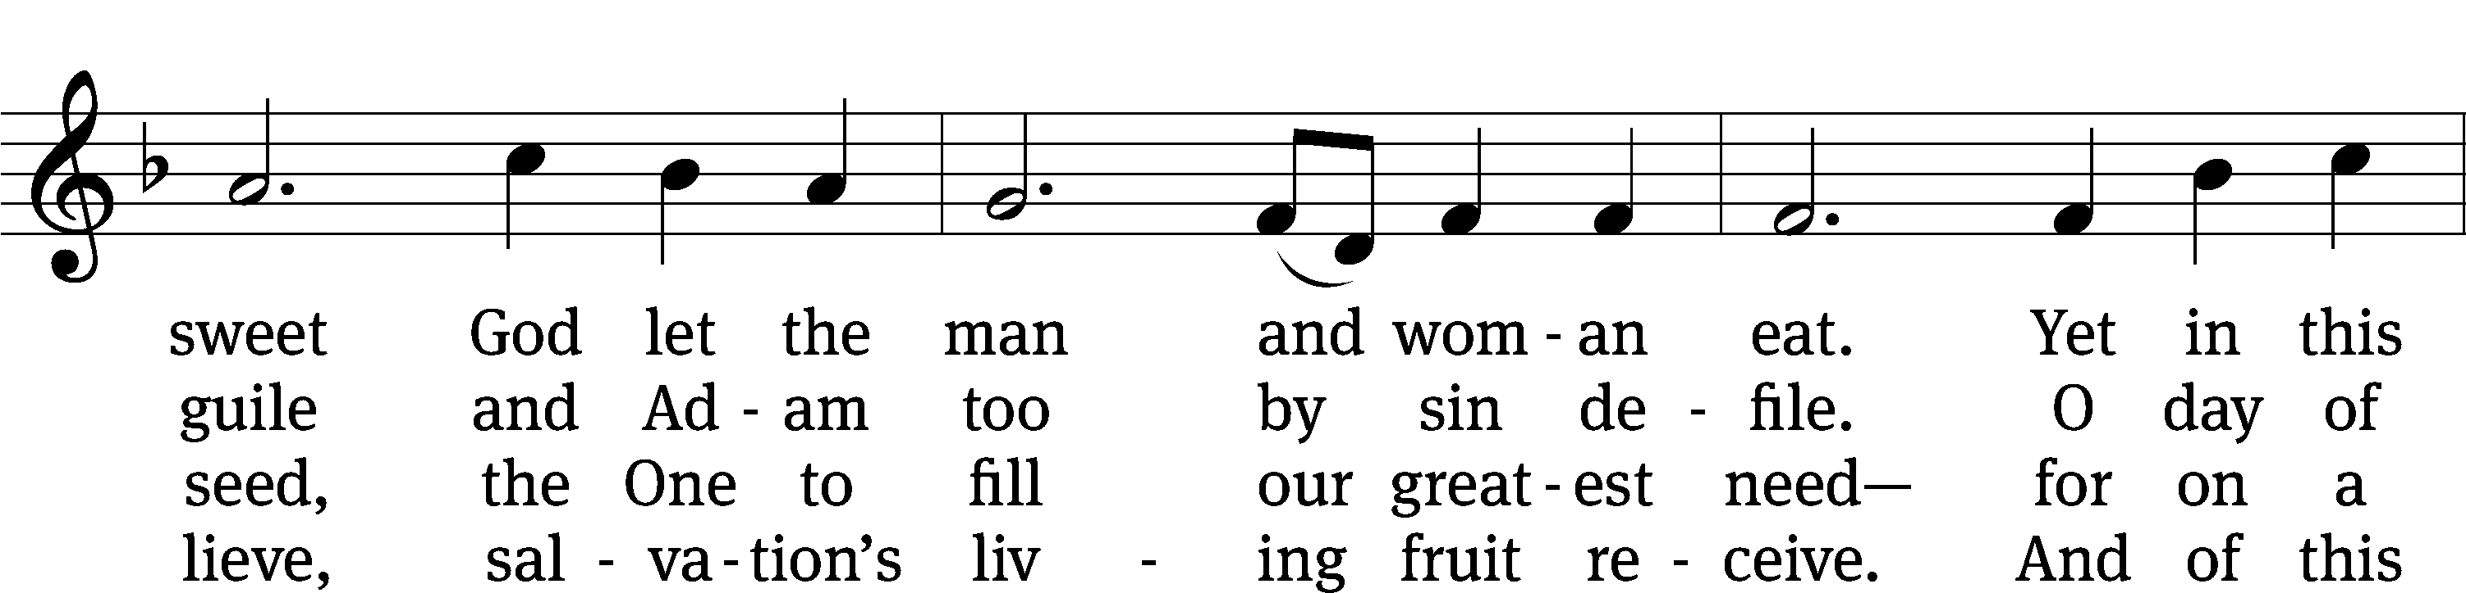
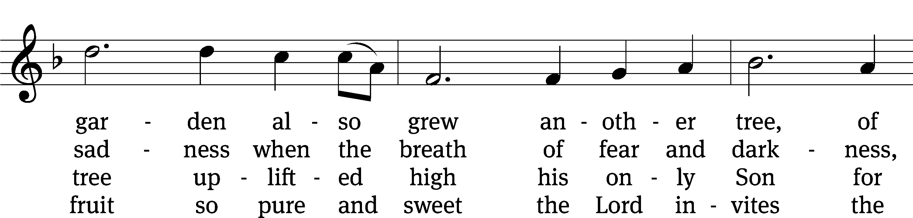
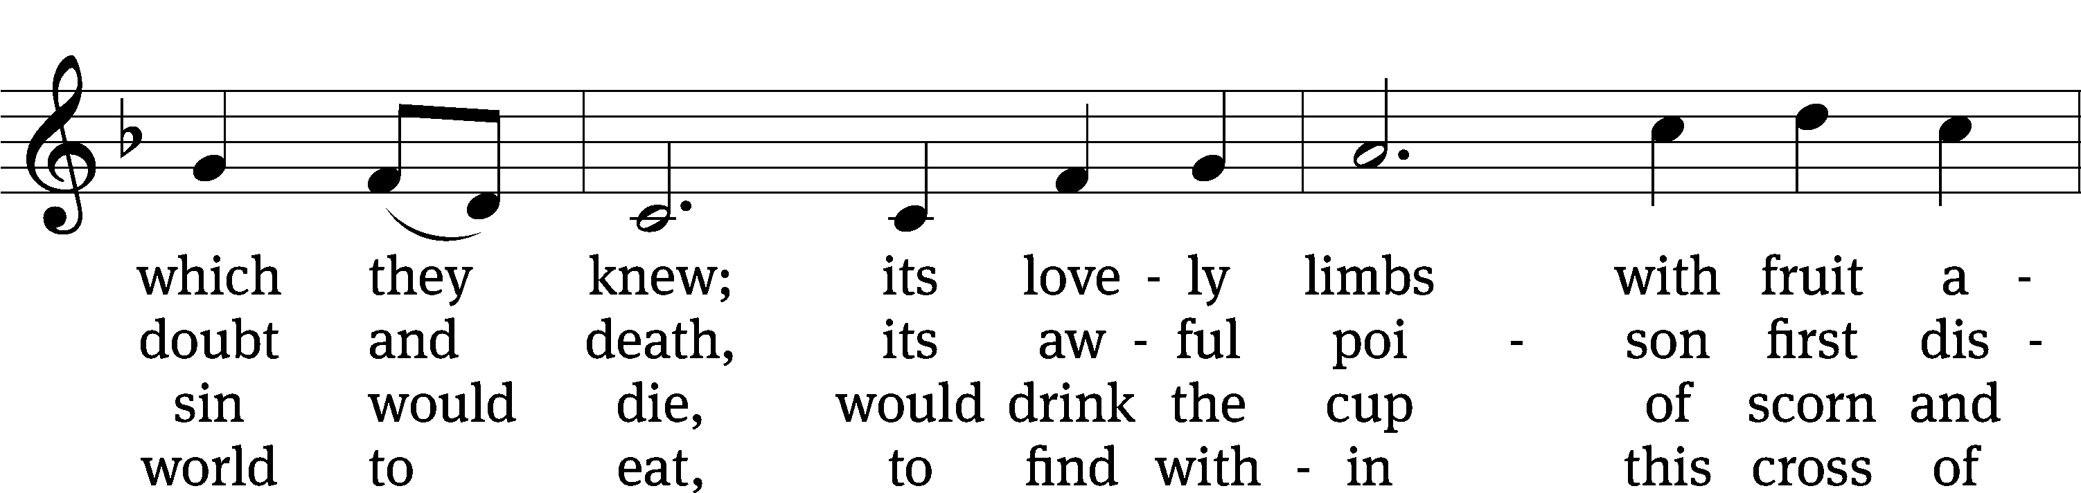
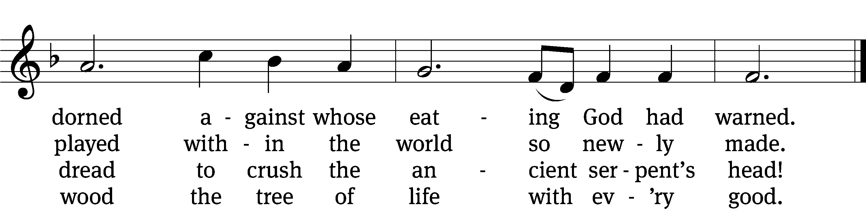
Text: Stephen P. Starke, b. 1955
Tune: Bruce W. Becker, b. 1952
Text: © 1993 Stephen P. Starke, admin. Concordia Publishing House. Used by permission: OneLicense no. 727703
Tune: © 1995 Bruce W. Becker. Used by permission: OneLicense no. 727703
SERMON Revelation 22:1-5
“The Tree of Life”
Please stand, if you are able
Nicene Creed
We believe in one God, the Father, the Almighty,
maker of heaven and earth,
of all that is,
seen and unseen.
We believe in one Lord, Jesus Christ, the only Son of God,
eternally begotten of the Father,
God from God, Light from Light, true God from true God,
begotten, not made,
of one being with the Father.
Through him all things were made.
For us and for our salvation, he came down from heaven,
was incarnate of the Holy Spirit and the Virgin Mary,
and became truly human.
For our sake he was crucified under Pontius Pilate.
He suffered death and was buried.
On the third day he rose again in accordance with the Scriptures.
He ascended into heaven
and is seated at the right hand of the Father.
He will come again in glory to judge the living and the dead,
and his kingdom will have no end.
We believe in the Holy Spirit,
the Lord, the giver of life,
who proceeds from the Father and the Son,
who in unity with the Father and the Son
is worshiped and glorified,
who has spoken through the prophets.
We believe in one holy Christian and apostolic Church.
We acknowledge one baptism for the forgiveness of sins.
We look for the resurrection of the dead
and the life of the world to come. Amen.
Offertory
Prayer of the Church

The Sacrament
Preface CW 165
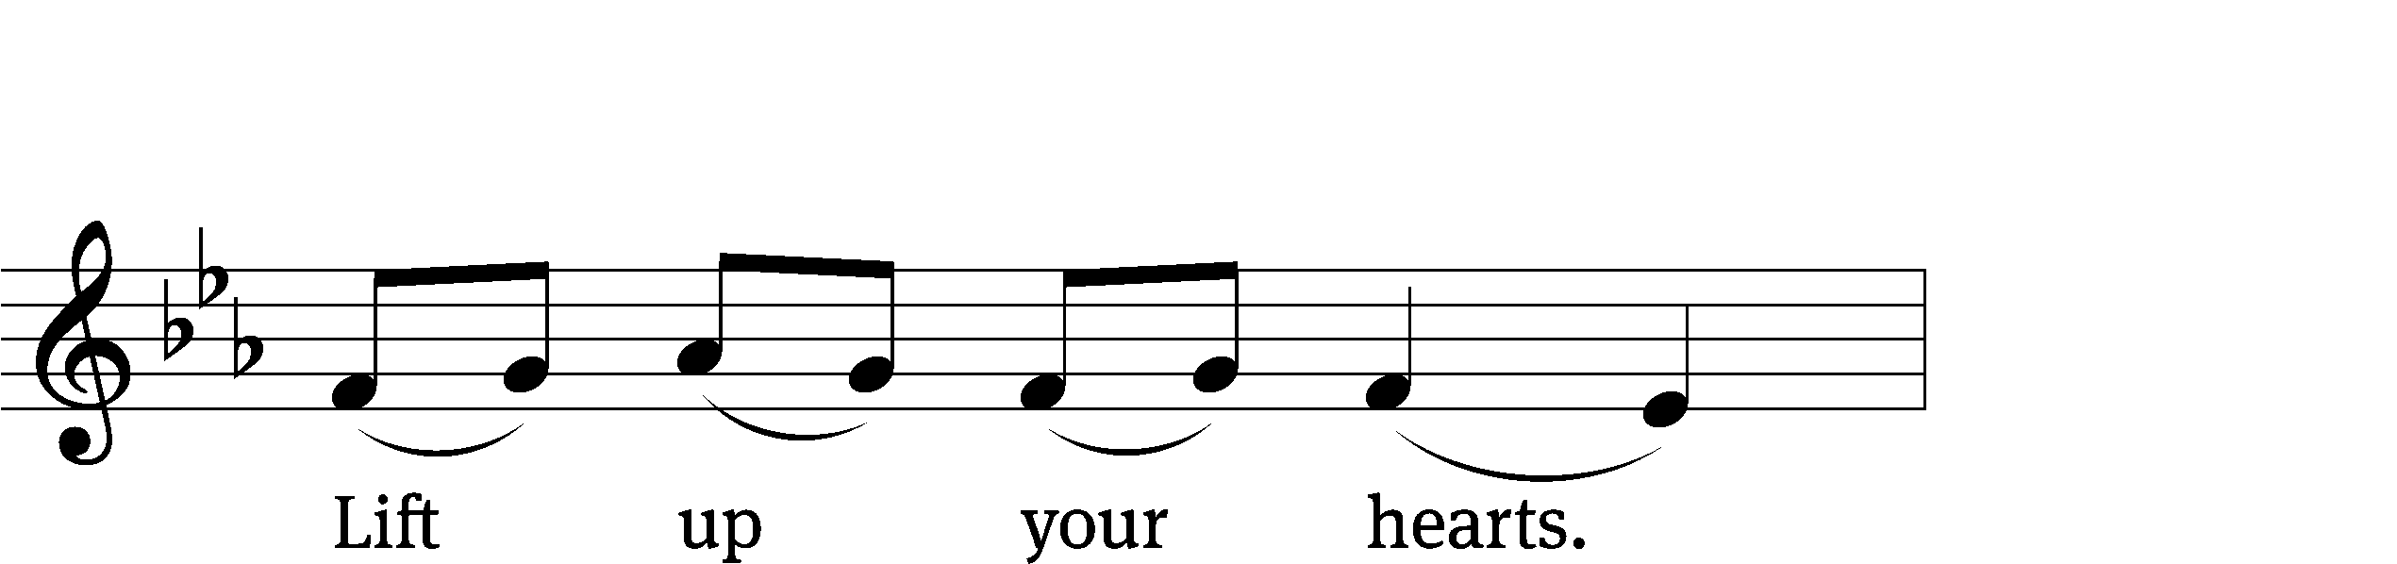
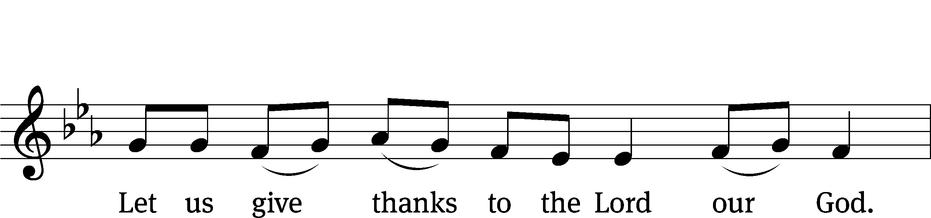
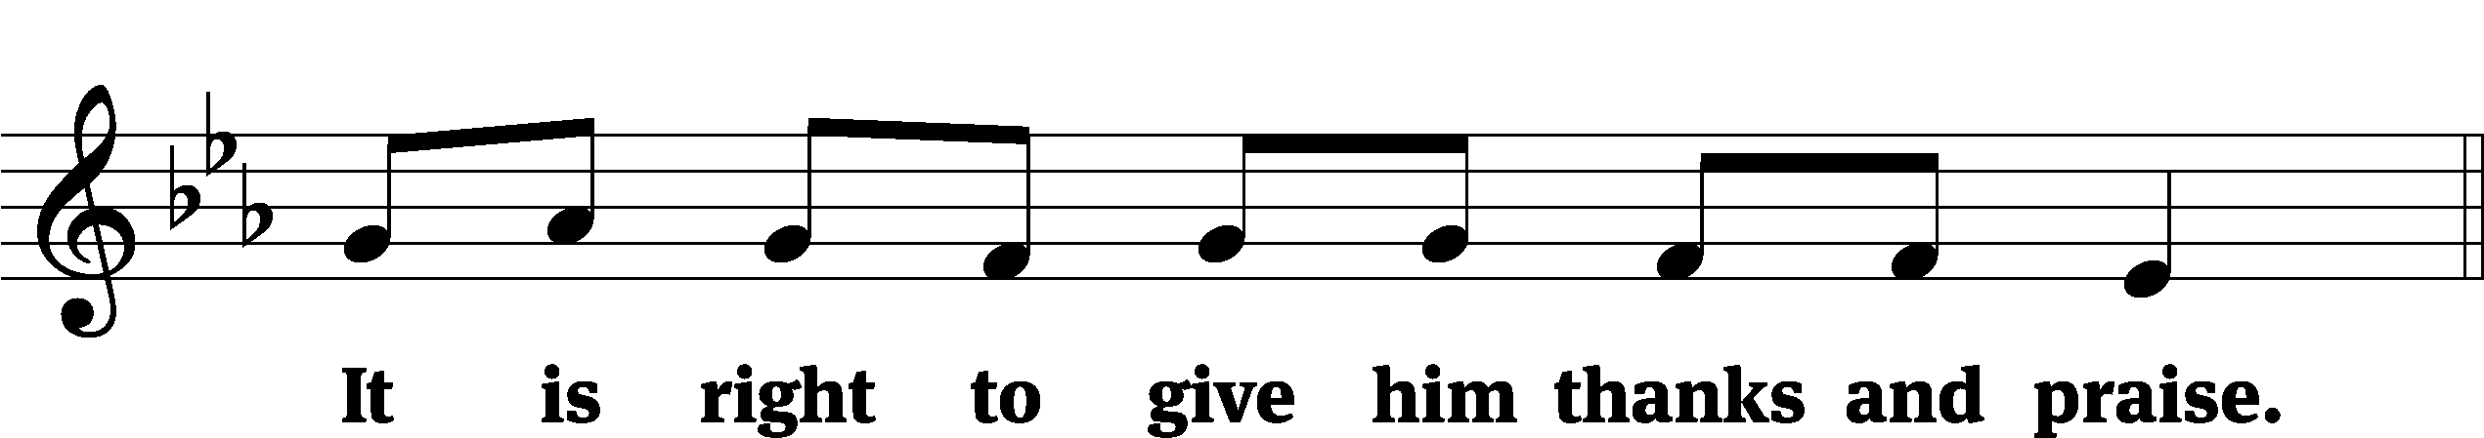

It is truly good and right that we should at all times and in all places give you thanks, O Lord, holy Father, almighty and everlasting God, through Jesus Christ our Lord, who promised that wherever two or three come together in his name, there he is with them to shepherd his flock until he comes again in glory. Therefore, with all the saints on earth and hosts of heaven, we praise your holy name and join their glorious song:
Holy, Holy, Holy CW 167
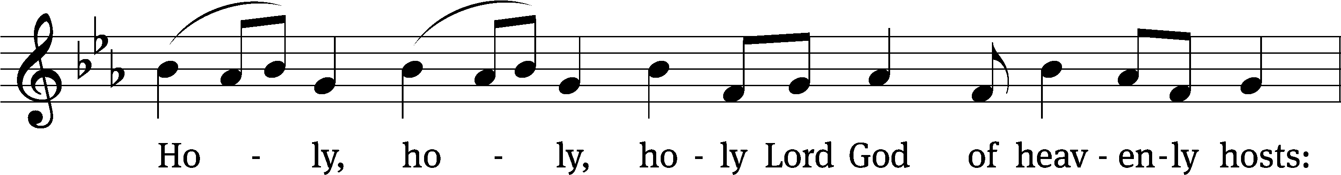
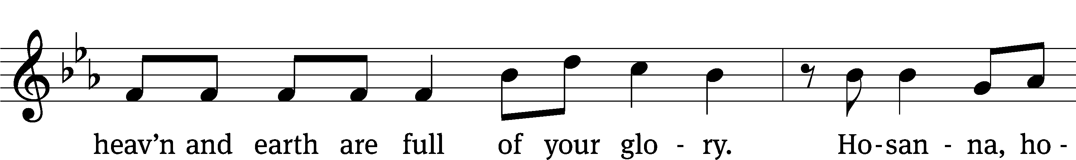
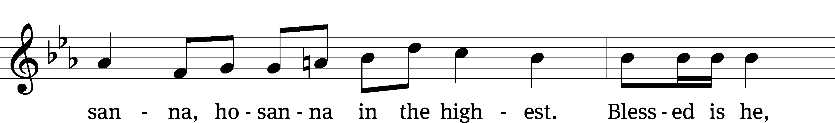
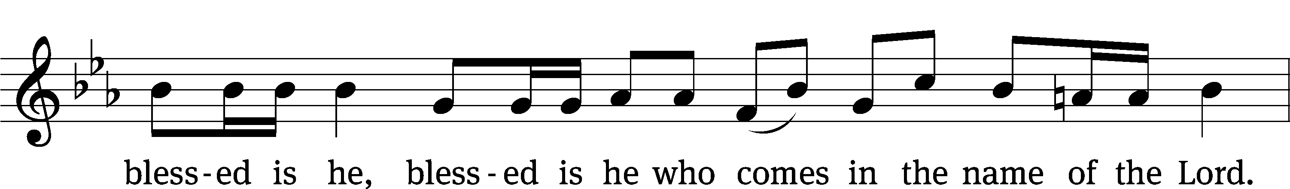
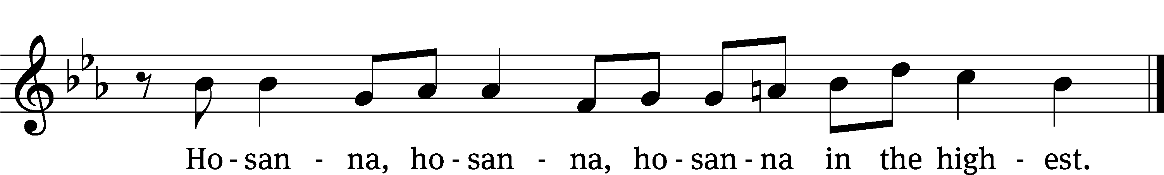

Prayer of Thanksgiving
We give thanks to you, O God, through your dear Son, Jesus Christ, whom you sent to be our Savior, our Redeemer, and the messenger of your grace. Through him you made all things; in him you are well pleased. He is the incarnate Word, conceived by the Holy Spirit and born of the Virgin Mary. To fulfill your promises, he stretched out his hands on the cross and released from eternal death all who believe in you.

As we remember Jesus’ death and resurrection, we thank you that you have gathered us together to receive your Son’s body and blood. Send us your Spirit, unite us as one, and strengthen our faith so that we may praise you in your Son, Jesus Christ. Through him, we glorify and honor you, O God our Father, with the Holy Spirit, one God, now and forever.
Amen.

Lord’s Prayer
Our Father, who art in heaven, hallowed be thy name, thy kingdom come, thy will be done on earth as it is in heaven. Give us this day our daily bread; and forgive us our trespasses, as we forgive those who trespass against us; and lead us not into temptation, but deliver us from evil. For thine is the kingdom and the power and the glory forever and ever. Amen.

Words of Institution
Our Lord Jesus Christ, on the night he was betrayed, took bread; and when he had given thanks, he broke it and gave it to his disciples, saying, “Take and eat; this is my body, which is given for you. Do this in remembrance of me.”
Then he took the cup, gave thanks, and gave it to them, saying, “Drink from it, all of you; this is my blood of the new covenant, which is poured out for you for the forgiveness of sins. Do this, whenever you drink it, in remembrance of me.”

The peace of the Lord be with you always.
Amen.
O Christ, Lamb of God CW 169
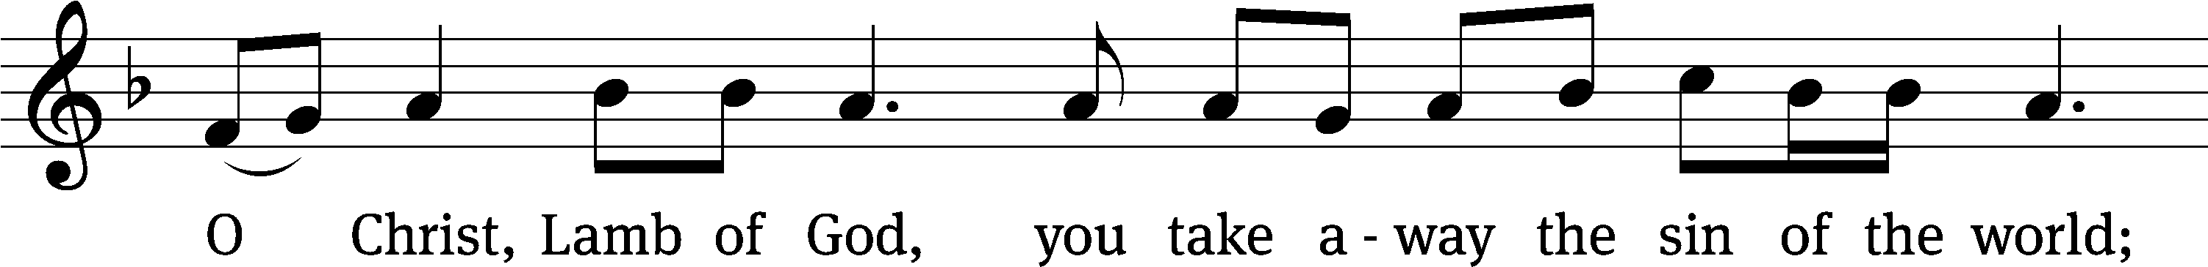
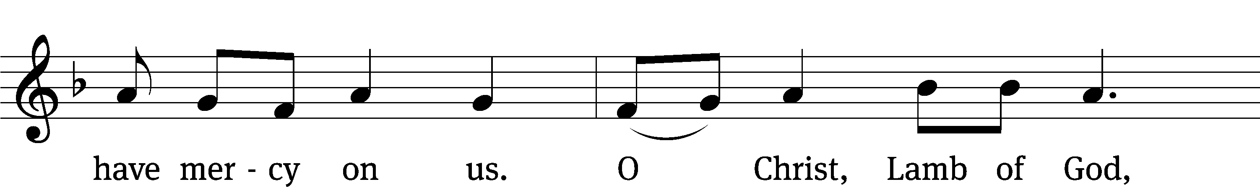
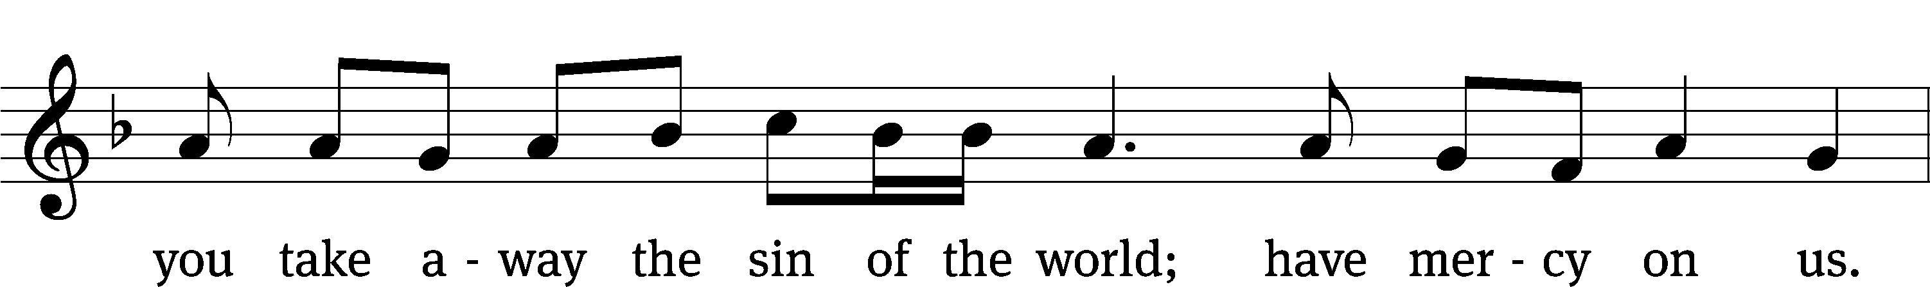
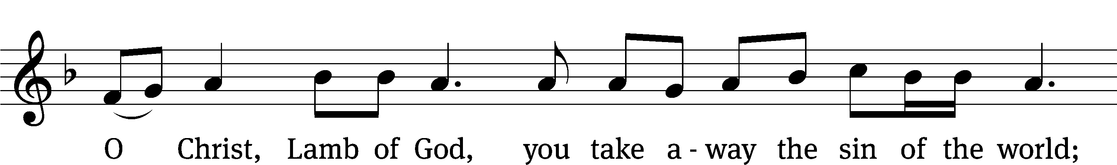
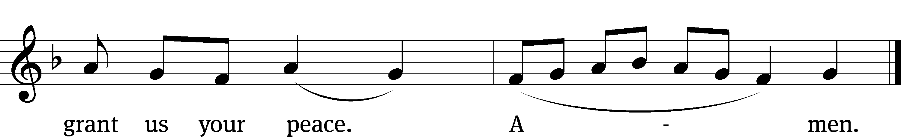

Please be seated
450 The Day of Resurrection CW 450
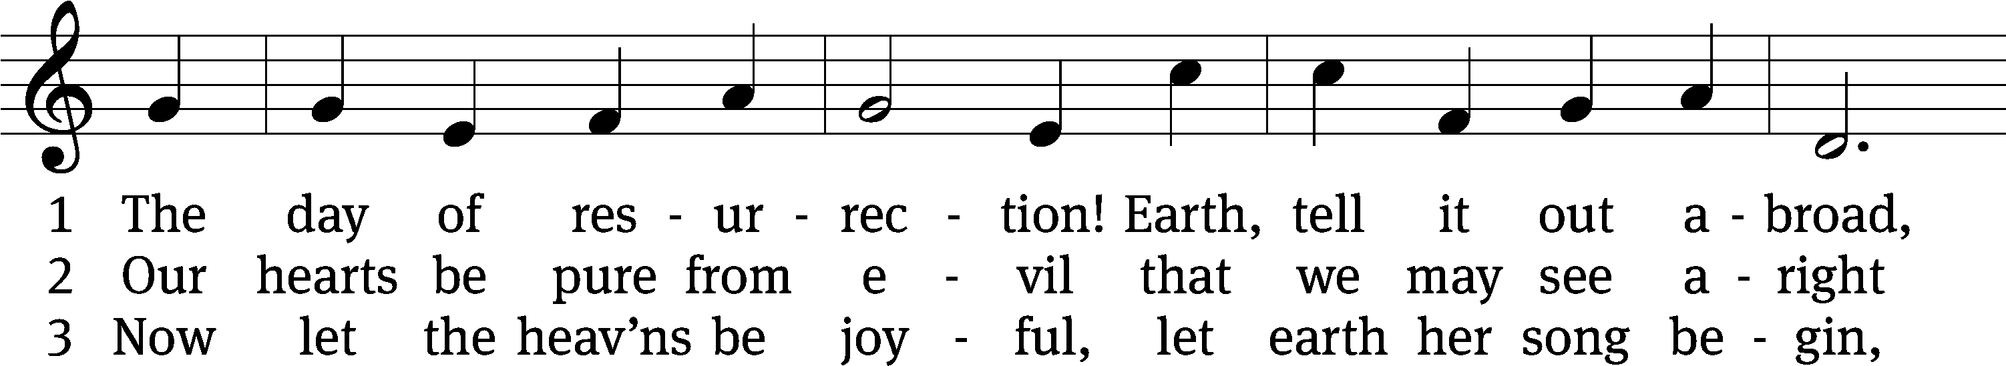
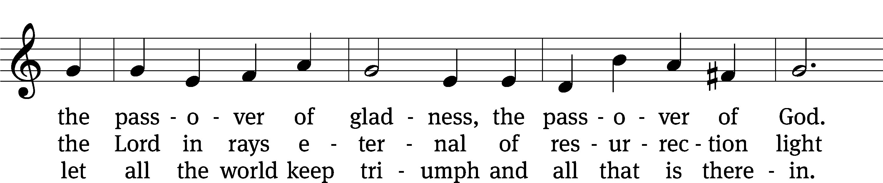
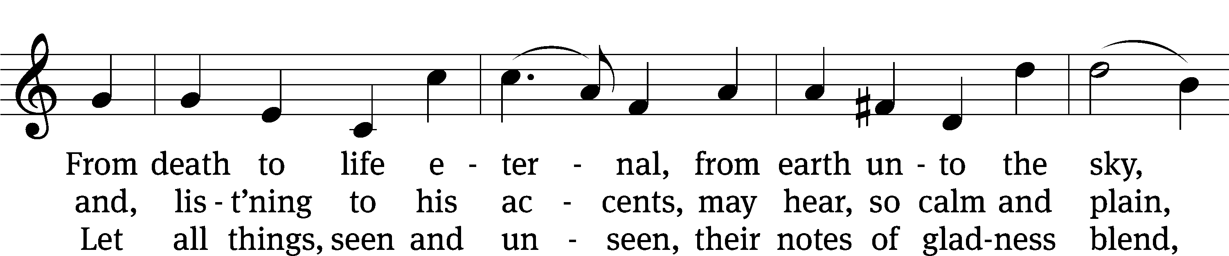
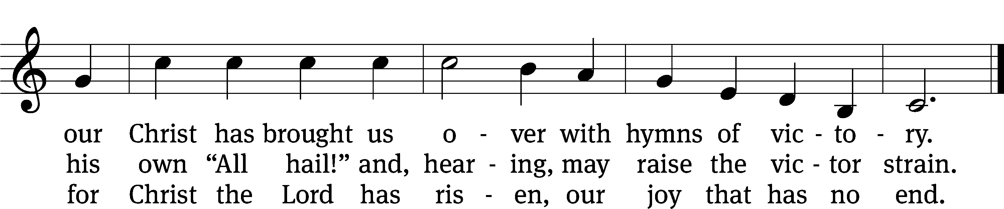
Text: tr. John Mason Neale, 1818–1866, alt.; John of Damascus, c. 696–c. 754
Tune: Henry T. Smart, 1813–1879
Text and tune: Public domain

446 Jesus Christ, My Sure Defense CW 446
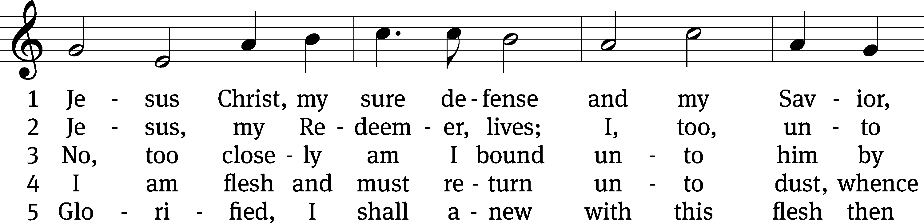
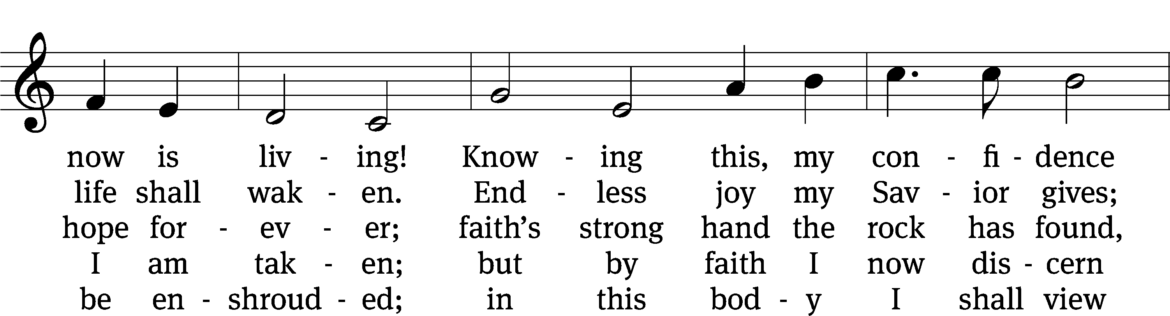
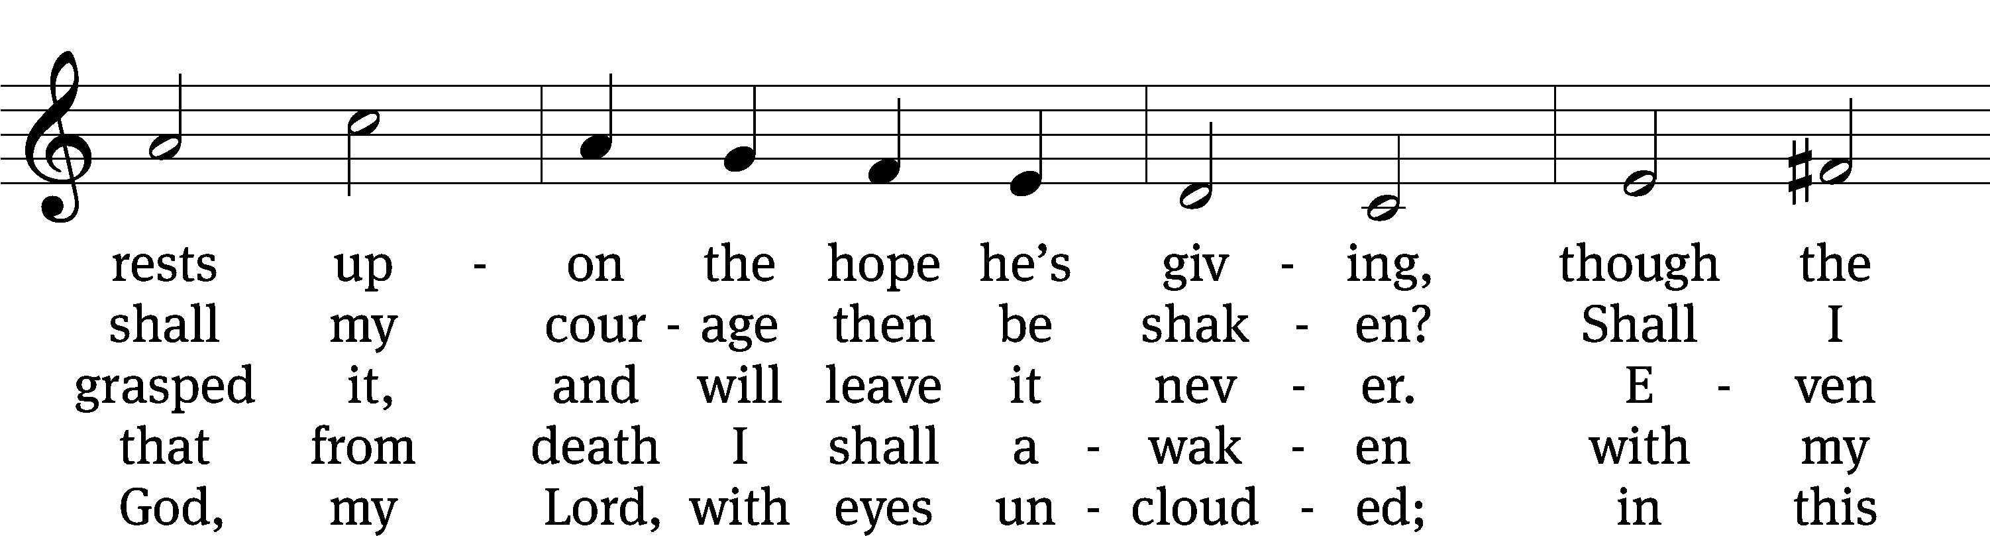
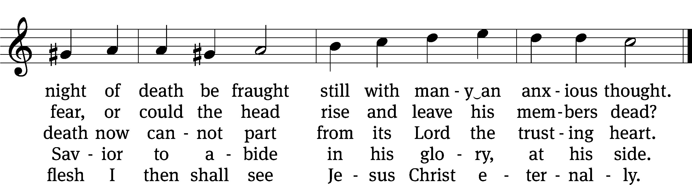
Text: Otto von Schwerin, 1616–1679; (sts. 1–3): tr. Catherine Winkworth, 1827–1878, alt.; (st. 4): tr. The Lutheran Hymnal, 1941,; (st. 5): tr. Evangelical Lutheran Hymn-Book, 1912, alt.
Tune: Johann Crüger, 1598–1662
Text and tune: Public domain

Please stand, if you are able

Give thanks to the Lord, for he is good;
his mercy endures forever.
Whenever we eat this bread and drink this cup,
we proclaim the Lord’s death until he comes.
We give thanks, almighty God, that you have refreshed us with this saving gift. We pray that through it you will strengthen our faith in you and increase our love for one another. We ask this in the name of Jesus Christ our Lord, who lives and reigns with you and the Holy Spirit, one God, now and forever.
Amen.

Blessing
The Lord bless you and keep you.
The Lord make his face shine on you and be gracious to you.
The Lord look on you with favor and give you peace.
Amen.

884 Lord, When Your Glory I Shall See CW 884
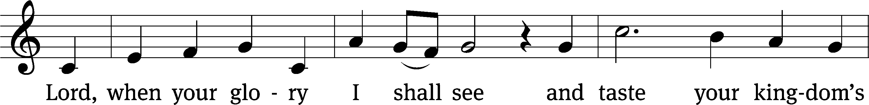
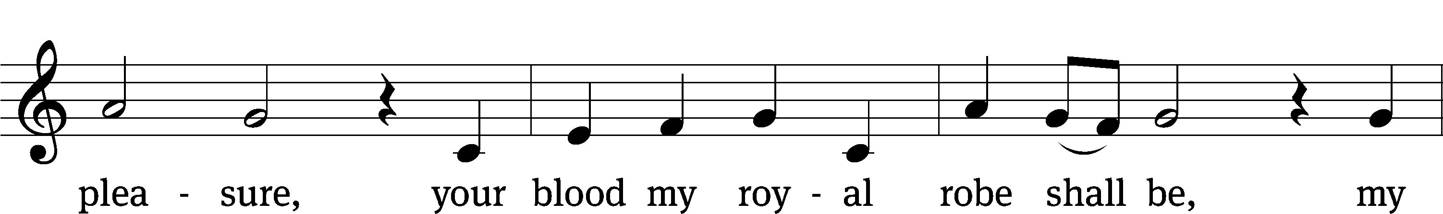
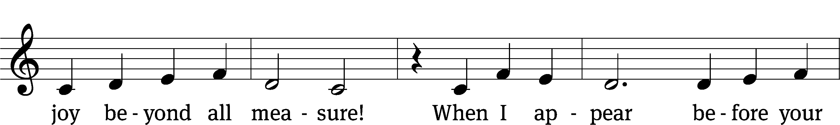
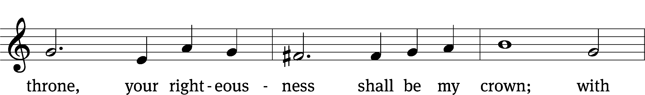
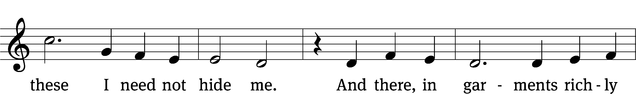
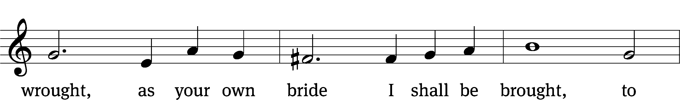
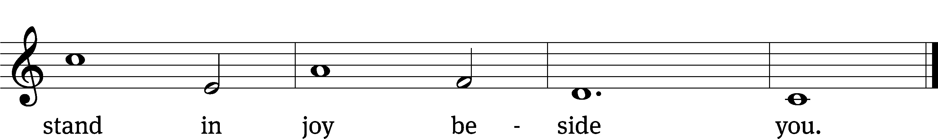
Text: tr. The Lutheran Hymnal, 1941, alt.; Paul Gerhardt, 1607–1676
Tune: Kurt J. Eggert, 1923–1993
Text: Public domain
Tune: © 1993 Kurt J. Eggert, admin. Northwestern Publishing House. Used by permission: OneLicense no. 727703

Acknowledgments
Setting One from Christian Worship
Software distributed in partnership with Northwestern Publishing House.
Created by Christian Worship: Service Builder © 2022 Concordia Publishing House.

Serving in Worship
Officiant Pastor Natsis
Organist Marcia Marion Ackling
Deacons (8:30) Dave Stevenson and Ed Wheeler
(11:00) Dave Frey and Steve Hoeft
Ushers (8:30) Dale Radak
(11:00) Ron Zahn
Altar Guild Margaret Hoeft and Brenda Stevenson
Videographer Richard Schneider

