First sunday in advent

TRINITY EVANGELICAL LUTHERAN CHURCH | Saline, Michigan
WELCOME TO WORSHIP November 27, 2022
Thank you for joining us in God’s house today! We cordially ask that our Guests sign one of the guestbooks located at either the front or back entryways, or fill out a “Let’s Get Acquainted” card located in the hymnal pew rack and place it in the collection plate.

THANK OFFERING: Members of Trinity give their offering as an expression of love and thankfulness to the Lord and to help support the Lord’s work in our community and around the world. Visitors need not feel obligated to participate in this offering which supports our ministry.

Restrooms are located at the back of the upper level (the annex), and in the basement (down the back stairs of the sanctuary or annex). Handicap access is available, please ask an usher for assistance.

Young Families / Toddler Bags – We are GLAD YOU BROUGHT YOUR CHILDREN to our worship service. Jesus said: “Let the little children come to me and do not hinder them, for the kingdom of God belongs to such as these.” We know that having little children in church can be a challenge, but DO NOT WORRY about it. Many of your fellow worshippers have been in your shoes and are just happy you brought your children with you. For your convenience, we have reserved the back rows of seating for parents with small children. These areas provide more flexibility for your family, as well as, easy access to move downstairs if necessary. A closed-circuit TV system allows families to continue participating in the service while downstairs. Pre-school toddler bags and children’s bulletins are available for their enjoyment. Ask an usher for one to use during the service and please return the toddler bag afterwards.

the SERVICE – setting one - WITHOUT HOLY COMMUNION CW, page 154

305 Lift Up Your Heads, You Mighty Gates CW 305
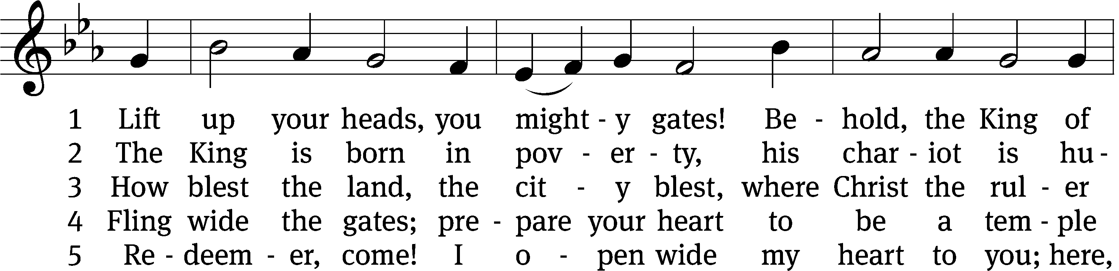
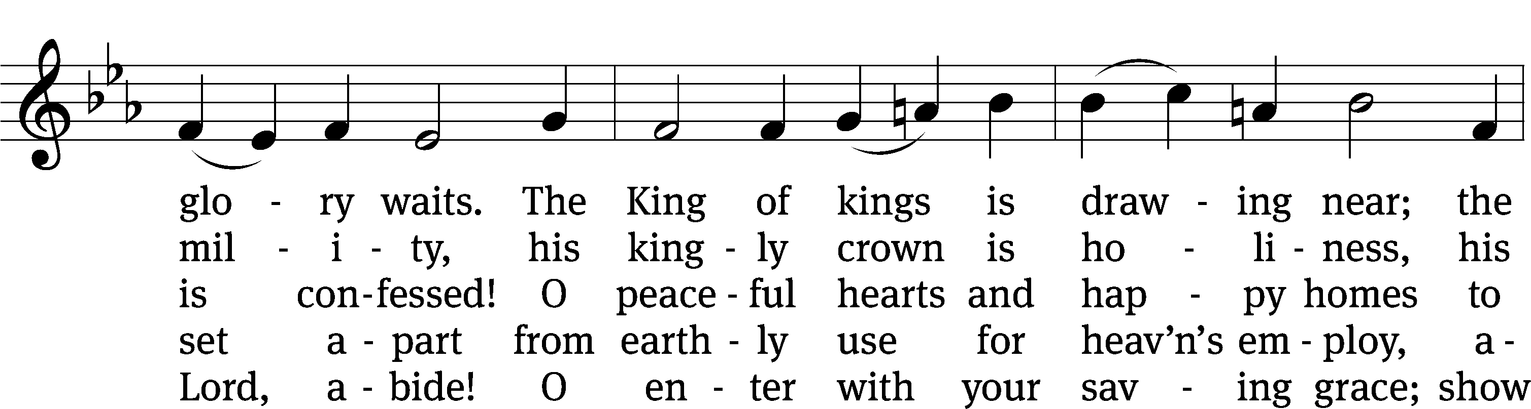
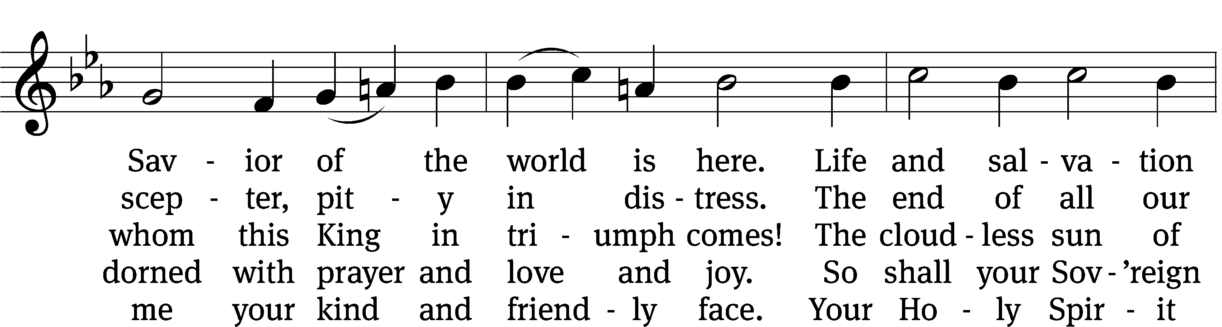
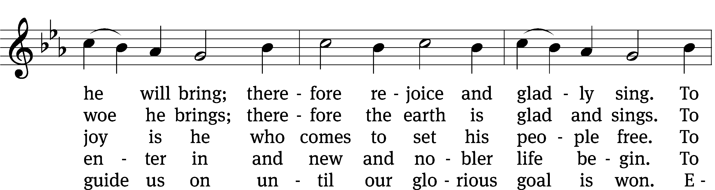
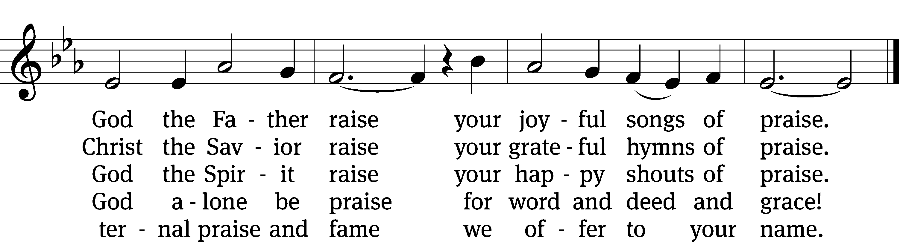
Text: tr. Catherine Winkworth, 1827–1878, alt.; Georg Weissel, 1590–1635
Tune: Geist-reiches Gesang-Buch, Halle, 1704, ed. Johann A. Freylinghausen, alt.
Text and tune: Public domain
Please stand, if you are able
Please stand, if you are able
Invocation
In the name of the Father and of the Son and of the Holy Spirit.
Amen.
Confession
If we claim to be without sin, we deceive ourselves and the truth is not in us.
If we confess our sins, God is faithful and just
and will forgive us our sins
and purify us from all unrighteousness.

Let us confess our sins to the Lord.
Holy God, gracious Father,
I am sinful by nature
and have sinned against you in my thoughts, words, and actions.
I have not loved you with my whole heart;
I have not loved others as I should.
I deserve your punishment both now and forever.
But Jesus, my Savior, paid for my sins
with his innocent suffering and death.
Trusting in him, I pray: God, have mercy on me, a sinner.

Our gracious Father in heaven has been merciful to us. He sent his only Son, Jesus Christ, who gave his life as the atoning sacrifice for the sins of the whole world. Therefore, as a called servant of Christ and by his authority, I forgive you all your sins in the name of the Father and of the the Son and of the Holy Spirit.
Amen.

Lord, Have Mercy

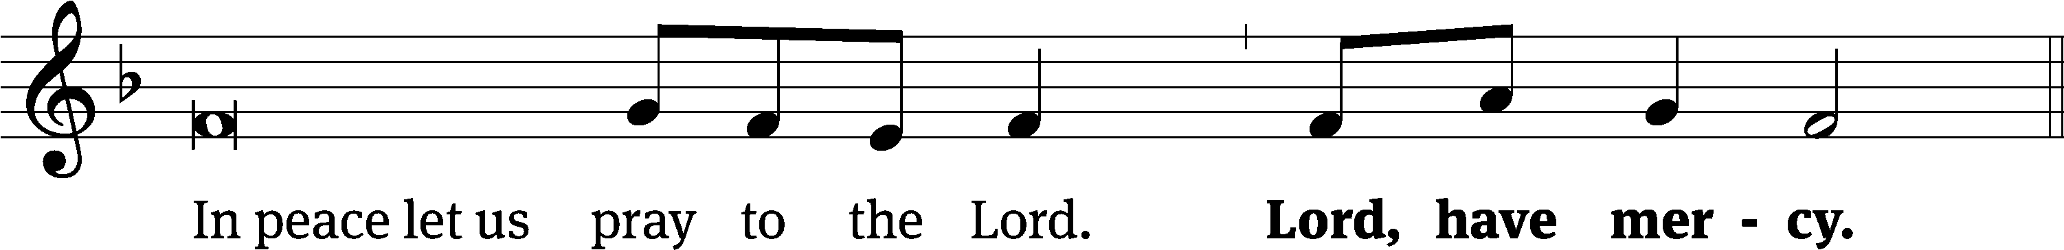
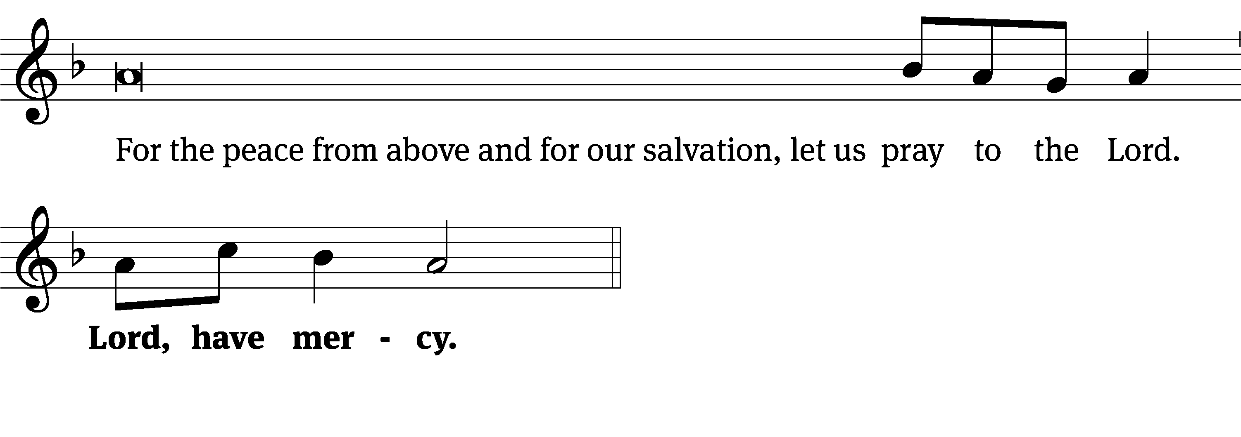
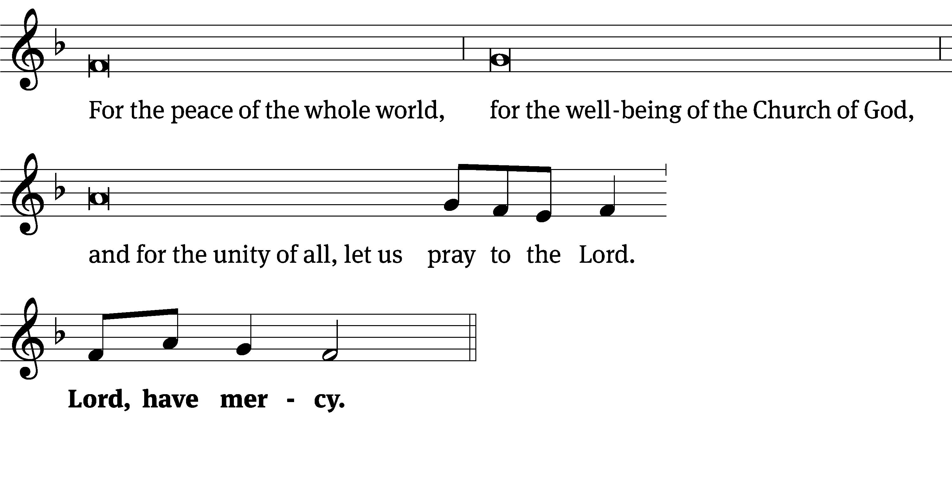
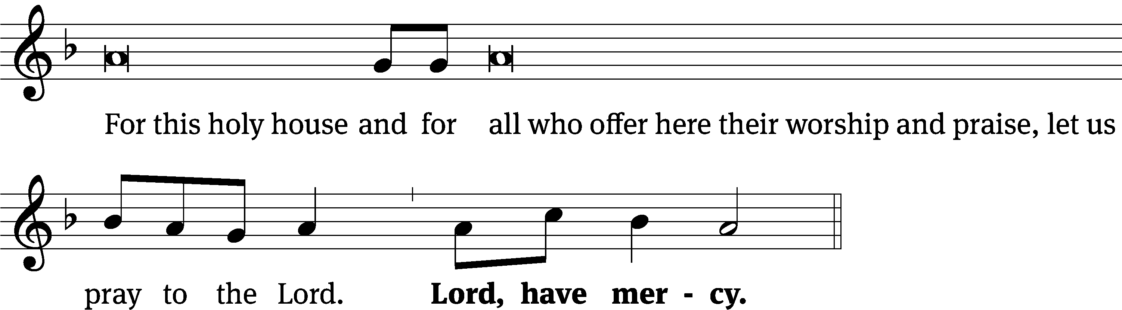
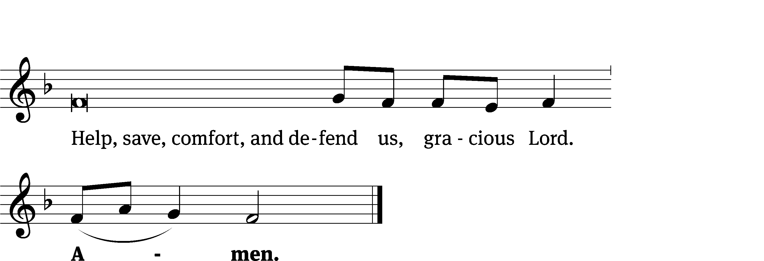
Glory Be to God CW 157
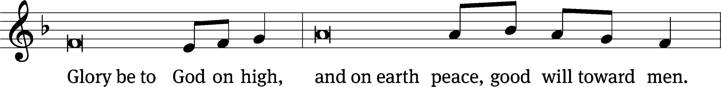
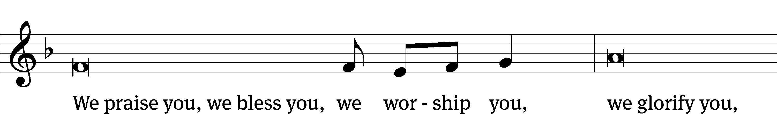
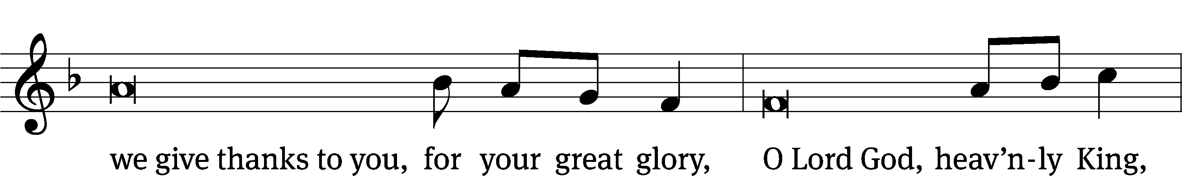
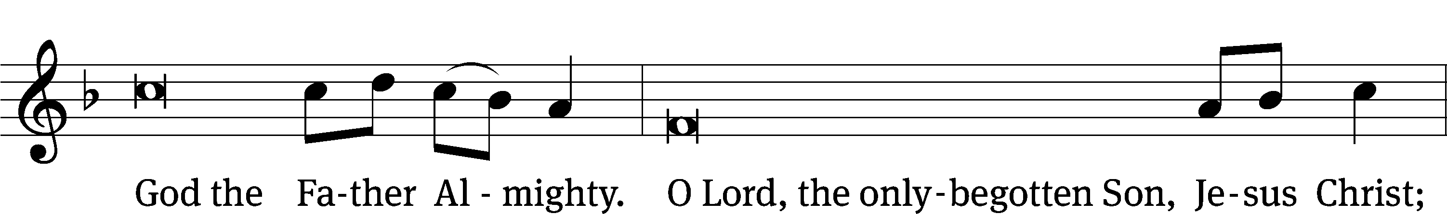
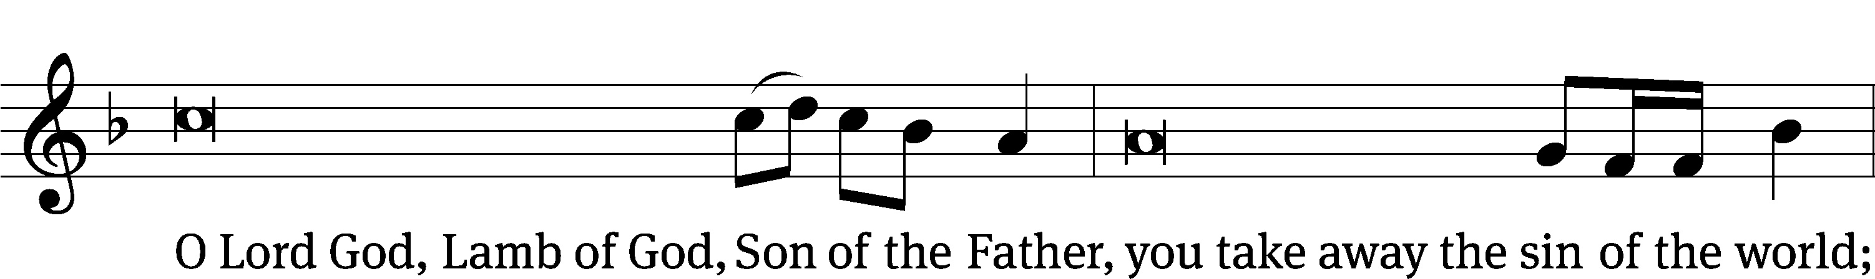
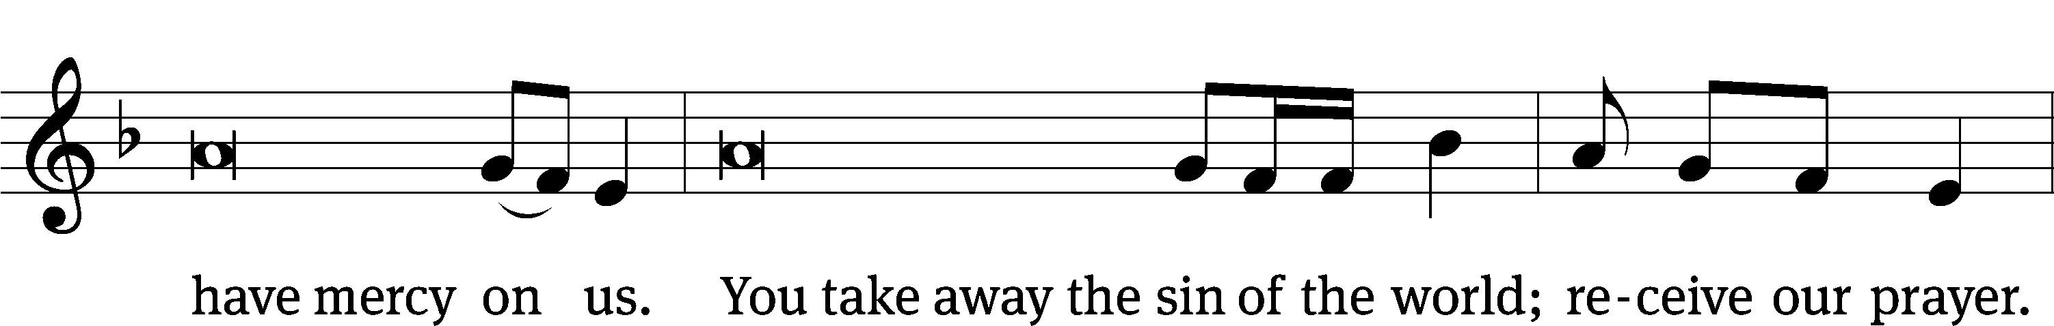
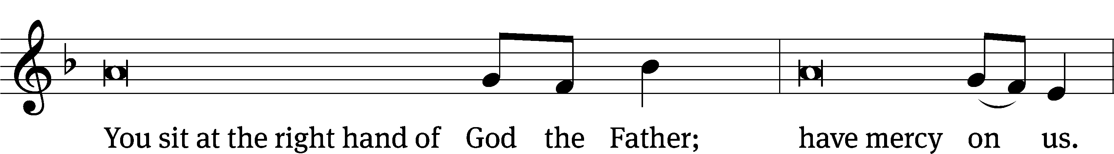
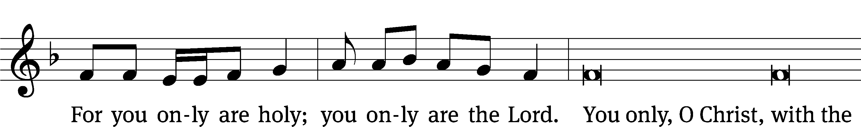
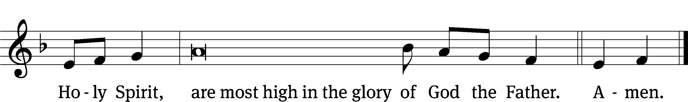

Tune: © 2021 Northwestern Publishing House. Used by permission: OneLicense no. 727703
The Lord be with you.
And also with you.
Prayer of the Day
Let us pray.

Stir up your power, O Lord, and come. Protect us by your strength, and save us from the threatening dangers of our sins; for you live and reign with the Father and the Holy Spirit, one God, now and forever.
Amen.

Please be seated

First Reading Isaiah 2:1-5
¹ This is the message that Isaiah son of Amoz saw concerning Judah and Jerusalem.
² This will take place in the latter days:
The mountain of the Lord’s house will be established
as the chief of the mountains.
It will be raised above the hills,
and all nations will stream to it like a river.
³ Many peoples will come and say,
“Come, let us go up to the mountain of the Lord,
to the house of the God of Jacob.
Then he will instruct us about his ways,
and we will walk in his paths.”
For from Zion the law^{[a]} will go out,
and the Lord’s word will go out from Jerusalem.
⁴ He will judge between the nations,
and he will mediate for many peoples.
Then they will beat their swords into plowshares,
and their spears into blades for trimming vines.
Nation will not lift up sword against nation,
nor will they learn war anymore.
⁵ O house of Jacob, come,
and let us walk in the light of the Lord.
The Word of the Lord.
Thanks be to God.
130C By Grace Alone (Solo) Psalm 130C
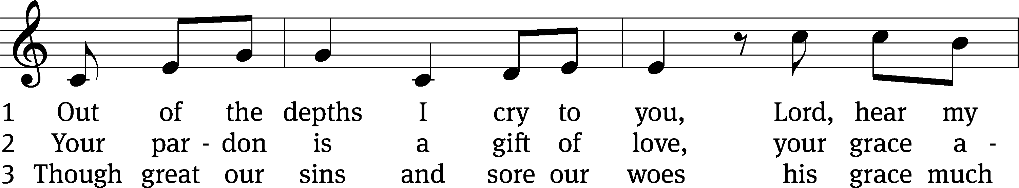
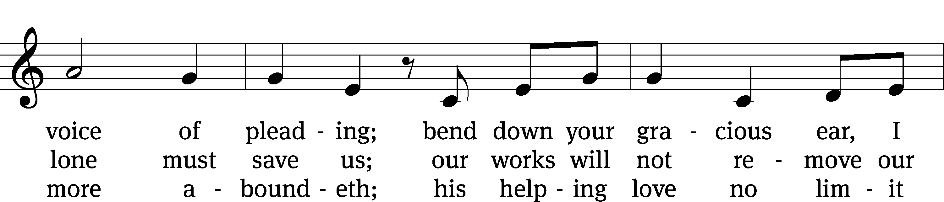
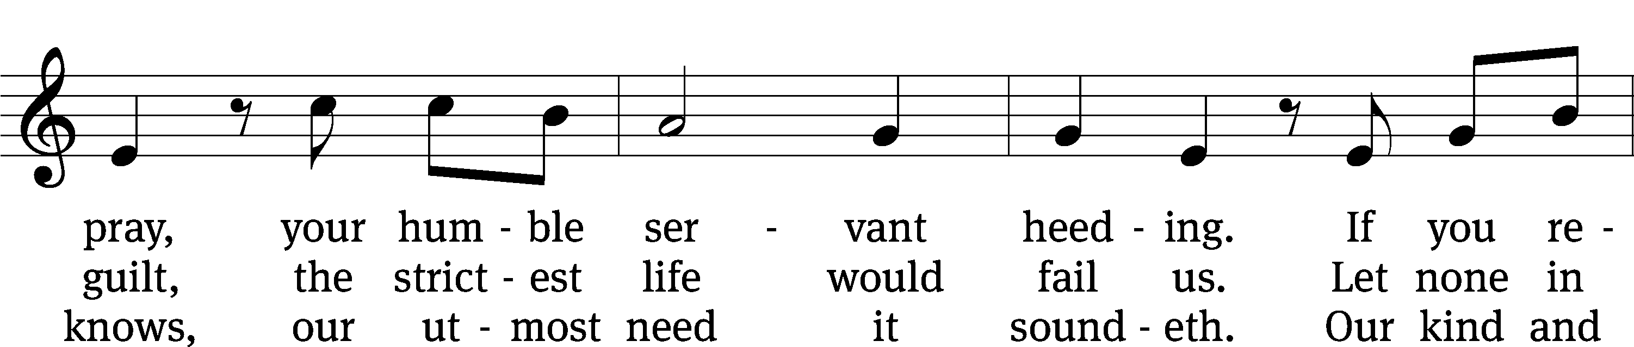
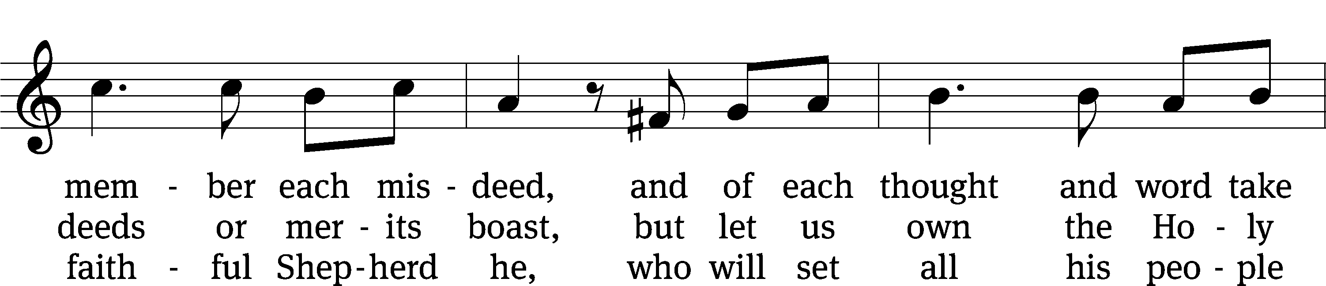
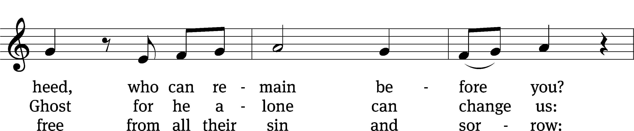
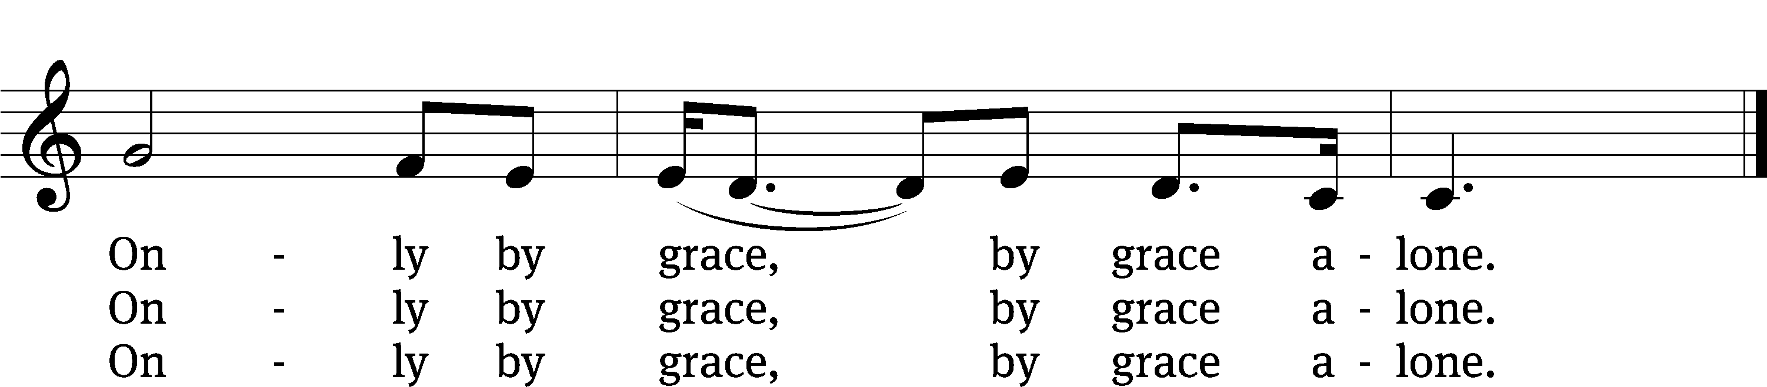
Text: David Ward; Martin Luther
Tune: David Ward
Text and tune: © 2002 Hymnicity. Used by permission: OneLicense no. 727703

Second Reading Romans 13:11-14
¹¹ And do this since you understand the present time. It is already the hour for you to wake up from sleep, because our salvation is nearer now than when we first believed. ¹² The night is almost over, and the day is drawing near. So let us put away the deeds of darkness and put on the weapons of light. ¹³ Let us walk decently as in the daytime, not in carousing and drunkenness, not in sexual sin and wild living, not in strife and jealousy. ¹⁴ Instead, clothe yourselves with the Lord Jesus Christ, and do not give any thought to satisfying the desires of your sinful flesh.

The Word of the Lord.
Thanks be to God.

Please stand, if you are able
Gospel Acclamation Revelation 22:20
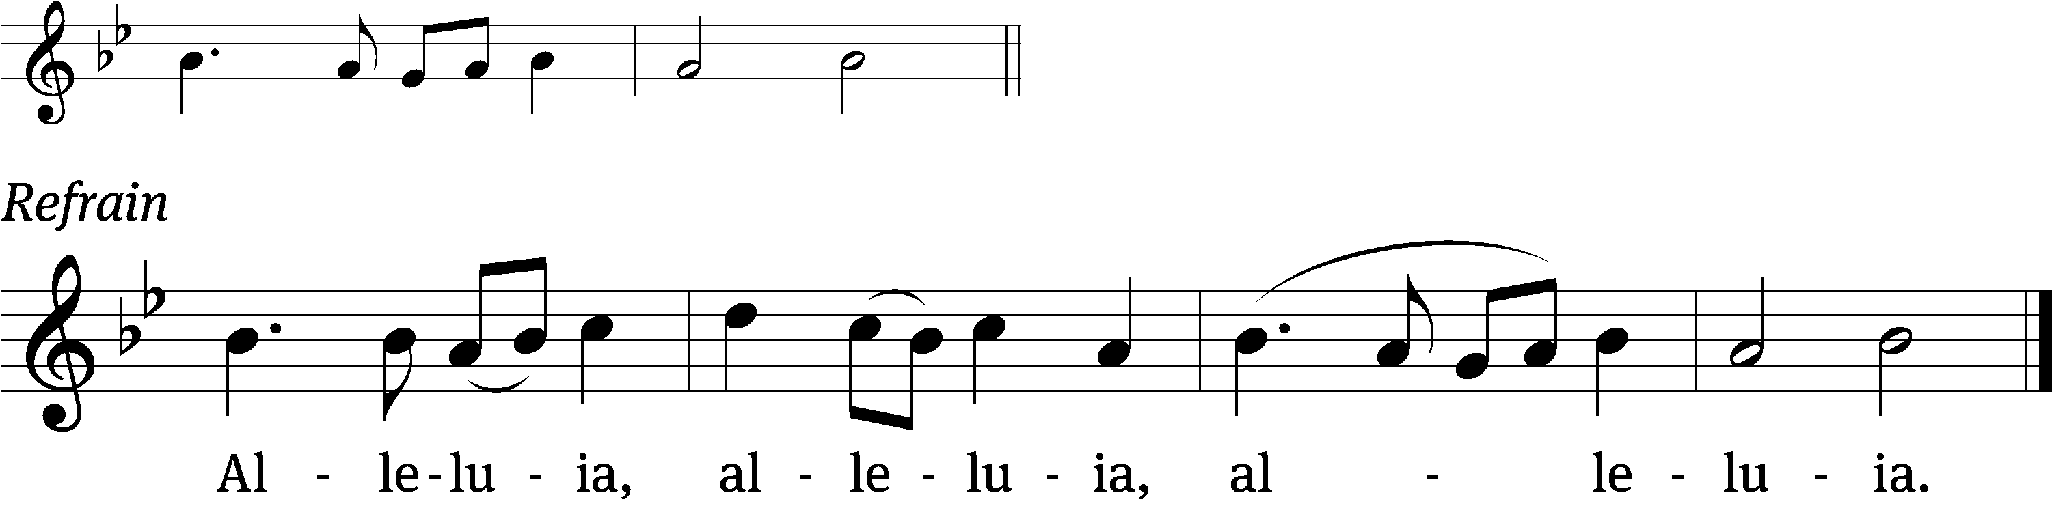
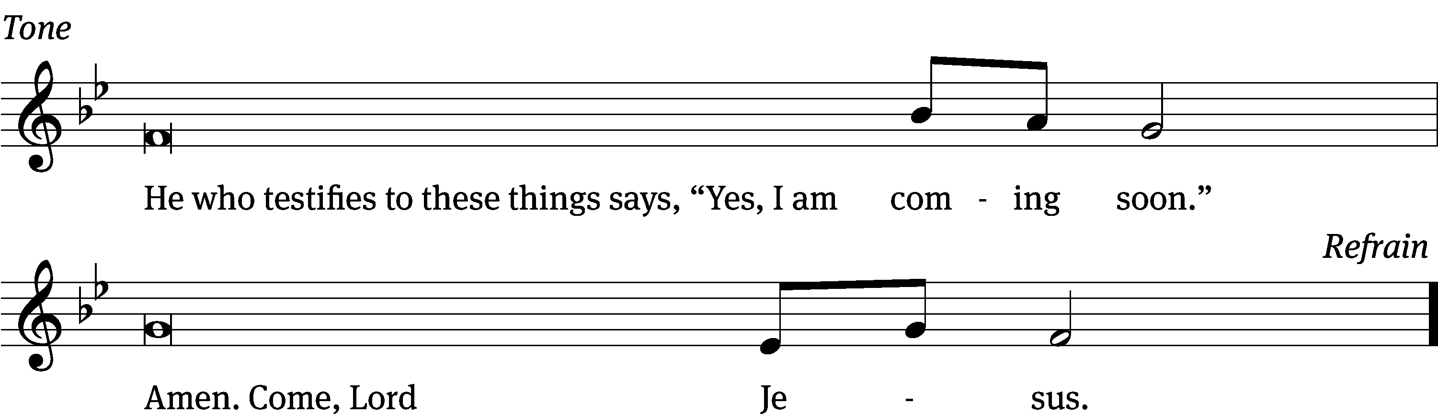
Tune: © 2021 Northwestern Publishing House. Used by permission: OneLicense no. 727703

Gospel Matthew 24:36-44
³⁶ “No one knows when that day and hour will be, not the angels of heaven, not even the Son, but only the Father. ³⁷ Just as it was in the days of Noah, so it will be when the Son of Man returns. ³⁸ In fact, in the days before the flood people were eating and drinking, marrying and giving in marriage, until the very day that Noah entered the ark. ³⁹ And they did not realize what was coming until the flood came and took them all away. That is how it will be when the Son of Man returns.
⁴⁰ “At that time two men will be in the field; one will be taken and one will be left. ⁴¹ Two women will be grinding at the mill; one will be taken and one will be left. ⁴² So be alert, because you do not know on what day your Lord is coming. ⁴³ But understand this: If the master of the house had known at what time of night the thief was coming, he would have stayed awake and would not have let his house be broken into. ⁴⁴ You also need to be ready for this reason: The Son of Man is coming at an hour when you do not expect him.

The Gospel of the Lord.
Praise be to you, O Christ!

Please be seated

Hymn 303 O Bride of Christ, Rejoice! CW 303
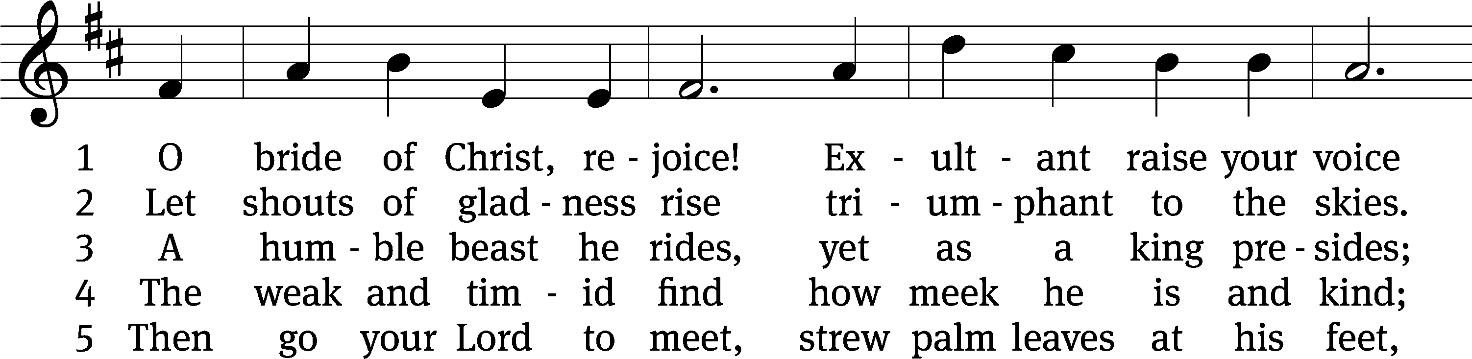
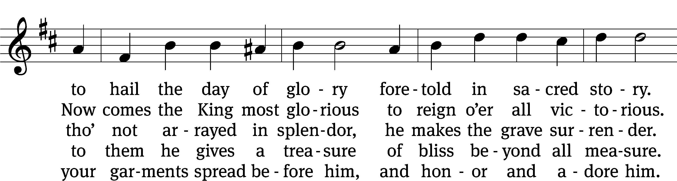
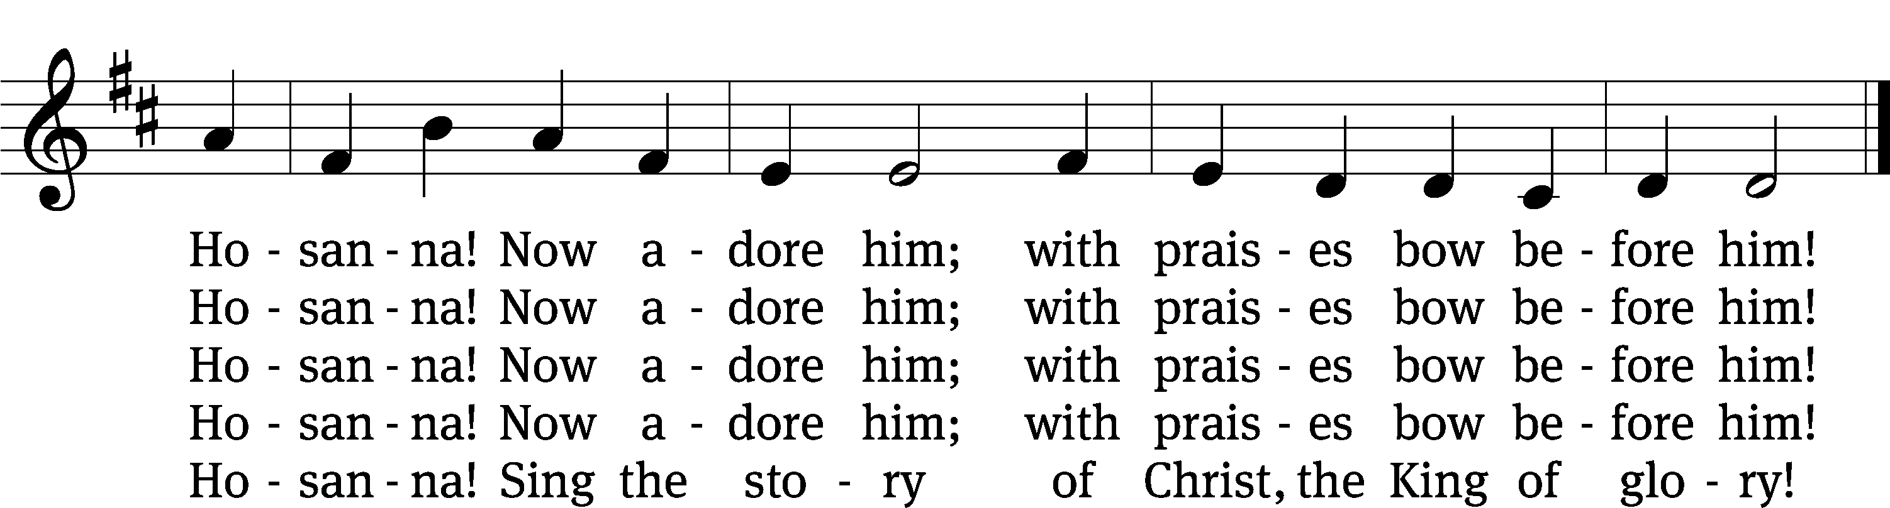
Text: tr. Victor O. Petersen, 1864–1929, alt.; Danish, c. 1600
Tune: Der Bussfertige Sünder, Nürnberg, 1679
Text and tune: Public domain

Sermon Matthew 24:36-44
“Christ’s Unexpected Coming”

Please stand, if you are able

Apostles’ Creed
I believe in God, the Father Almighty,
maker of heaven and earth.

I believe in Jesus Christ, his only Son, our Lord,
who was conceived by the Holy Spirit,
born of the Virgin Mary,
suffered under Pontius Pilate,
was crucified, died, and was buried.
He descended into hell.
The third day he rose again from the dead.
He ascended into heaven
and is seated at the right hand of God the Father Almighty.
From there he will come to judge the living and the dead.

I believe in the Holy Spirit,
the holy Christian Church,
the communion of saints,
the forgiveness of sins,
the resurrection of the body,
and the life everlasting. Amen.

Prayer of the Church

Please be seated

Hymn 310 Arise, O Christian People! CW 310
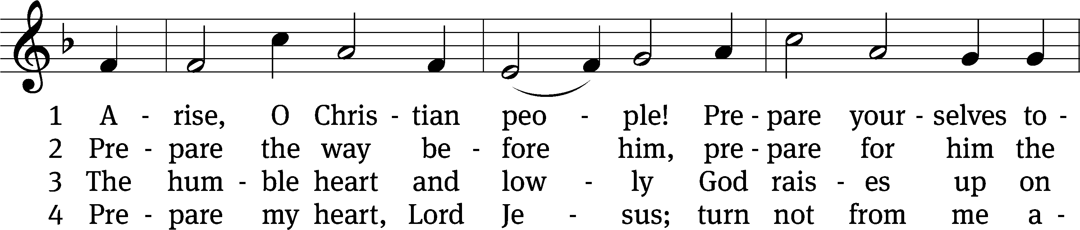
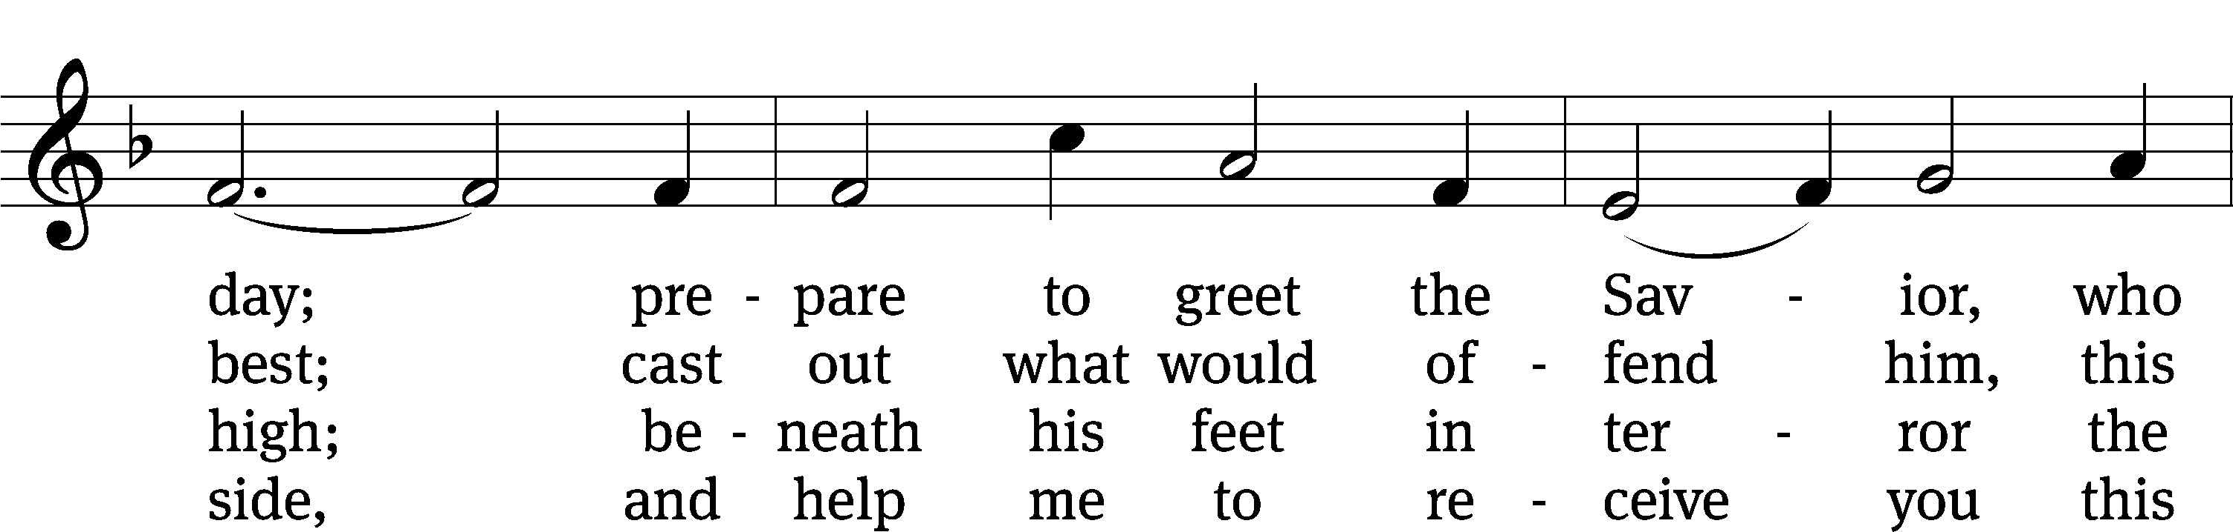
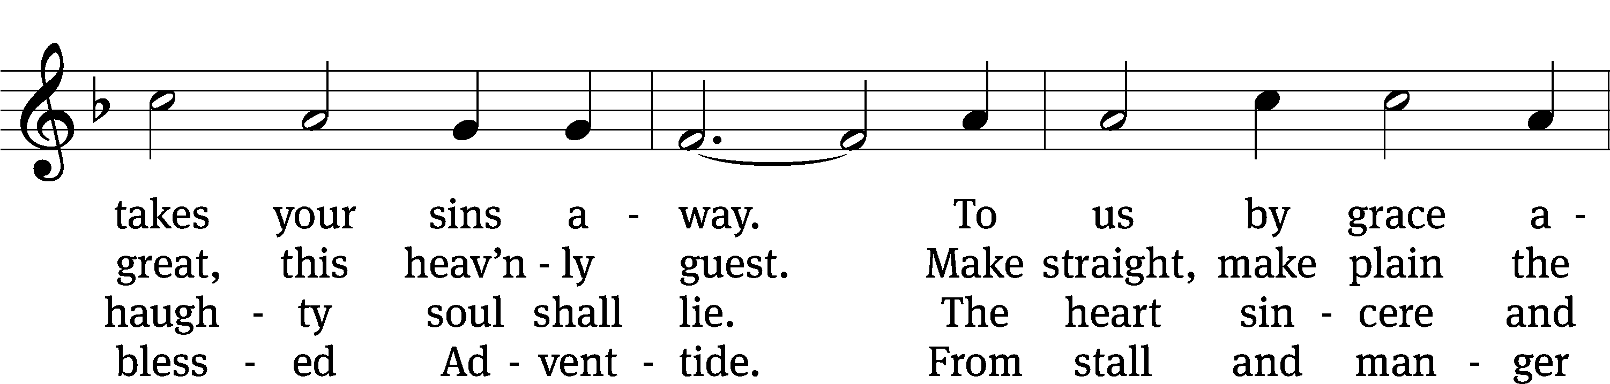
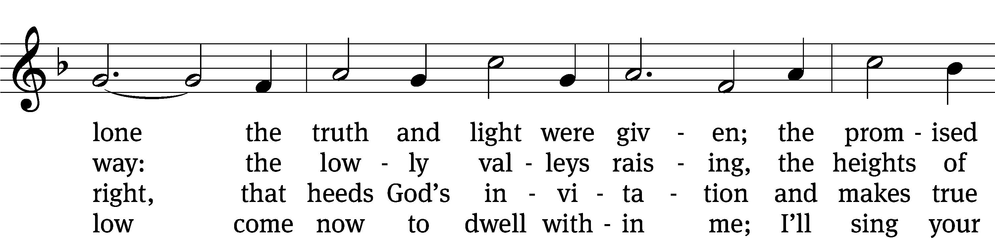
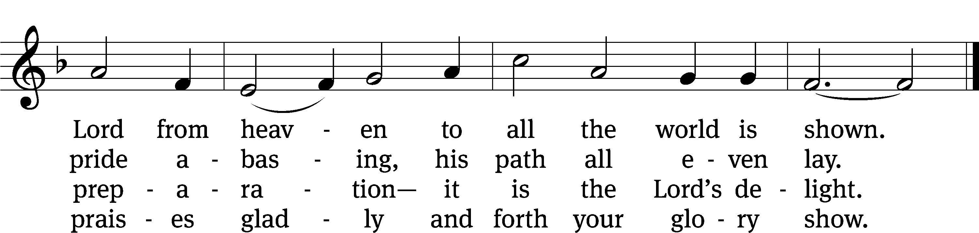
Text: Valentin Thilo, 1607–1662; (sts. 1–3): tr. Arthur T. Russell, 1806–1874, alt.; (st. 4): tr. unknown, alt.
Tune: New Catechismus Gesangbüchlein, Hamburg, 1598, alt.
Text and tune: Public domain

Please stand, if you are able

Prayer
Blessed Lord, you have given us your Holy Scriptures for our learning. May we so hear them, read, learn, and take them to heart that, being strengthened and comforted by your holy Word, we may cling to the blessed hope of everlasting life; through Jesus Christ our Lord, who lives and reigns with you and the Holy Spirit, one God, now and forever.
Amen.
Lord’s Prayer
Our Father, who art in heaven, hallowed be thy name, thy kingdom come, thy will be done on earth as it is in heaven. Give us this day our daily bread; and forgive us our trespasses, as we forgive those who trespass against us; and lead us not into temptation, but deliver us from evil. For thine is the kingdom and the power and the glory forever and ever. Amen.

Blessing
The Lord bless you and keep you.
The Lord make his face shine on you and be gracious to you.
The Lord look on you with favor and give you peace.
Amen.

Please be seated

313 Hark the Glad Sound! The Savior Comes CW 313
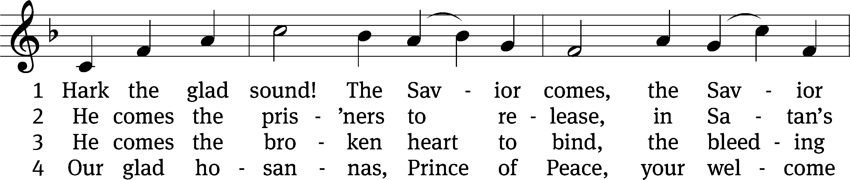
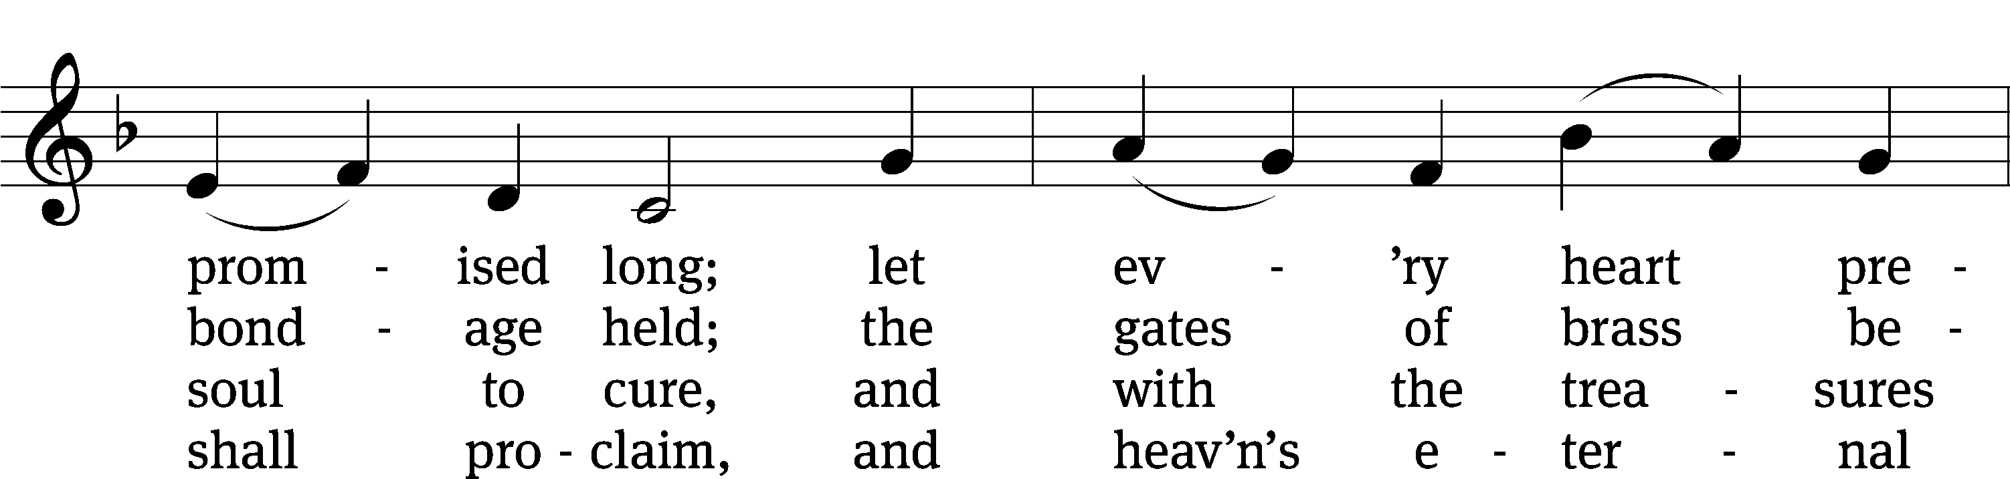
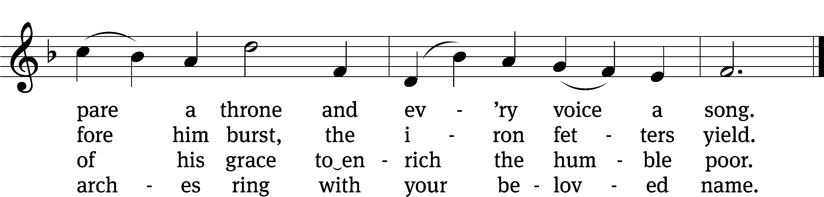
Text: Philip Doddridge, 1702–1751, abr., alt.
Tune: Thomas Haweis, 1734–1820, alt.
Text and tune: Public domain

Acknowledgments
Setting One from Christian Worship
Software distributed in partnership with Northwestern Publishing House.
Created by Christian Worship: Service Builder © 2022 Concordia Publishing House.

Serving in Worship
Officiant Pastor Natsis
Organist Ann Hoeft
Soloist Jim Tice
Accompanist Sarah Hanke
Deacons (8:30) Dave Stevenson and Ed Wheeler
(11:00) Dave Frey and Steve Hoeft
Ushers (8:30) Dale Radak
(11:00) Ron Zahn
Altar Guild Margaret Hoeft and Brenda Stevenson
Videographer Richard Schneider

