THE third SUNDAY in advent
tRINITY EVANGELICAL LUTHERAN CHURCH | Saline, Michigan
December 11, 2022

WELCOME TO WORSHIP

Thank you for joining us in God’s house today! We cordially ask that our Guests with us this morning sign one of the guestbooks located at either the front or back entryways.

THANK OFFERING: Members of Trinity give their offering as an expression of love and thankfulness to the Lord and to help support the Lord’s work in our community and around the world. Visitors need not feel obligated to participate in this offering which supports our ministry.

Restrooms are located at the back of the upper level (the annex), and in the basement (down the back stairs of the sanctuary or annex). Handicap access is available, please ask an usher for assistance.

Young Families / Toddler Bags – We are GLAD YOU BROUGHT YOUR CHILDREN to our worship service. Jesus said: “Let the little children come to me and do not hinder them, for the kingdom of God belongs to such as these.” We know that having little children in church can be a challenge, but DO NOT WORRY about it. Many of your fellow worshippers have been in your shoes and are just happy you brought your children with you. For your convenience, we have reserved the back rows of seating for parents with small children. These areas provide more flexibility for your family, as well as, easy access to move downstairs if necessary. A closed-circuit TV system allows families to continue participating in the service while downstairs. Pre-school toddler bags and children’s bulletins are available for their enjoyment. Ask an usher for one to use during the service and please return the toddler bag afterwards.

SERVICE of the word
302 Prepare the Royal Highway CW 302
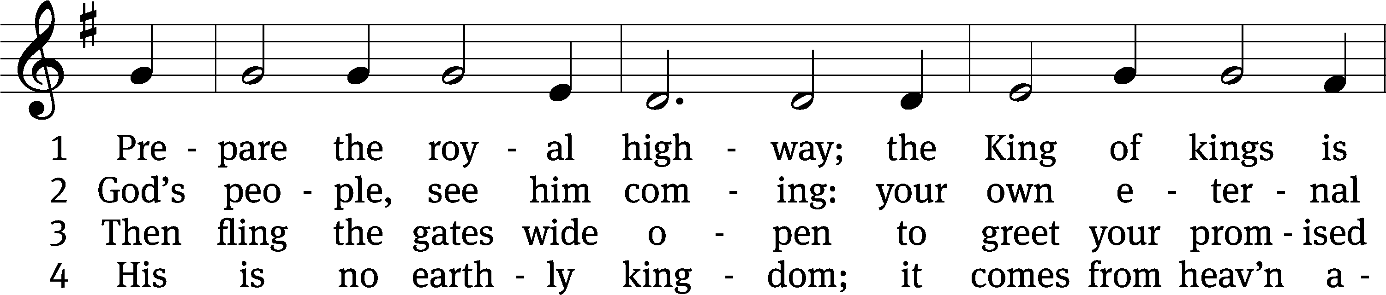
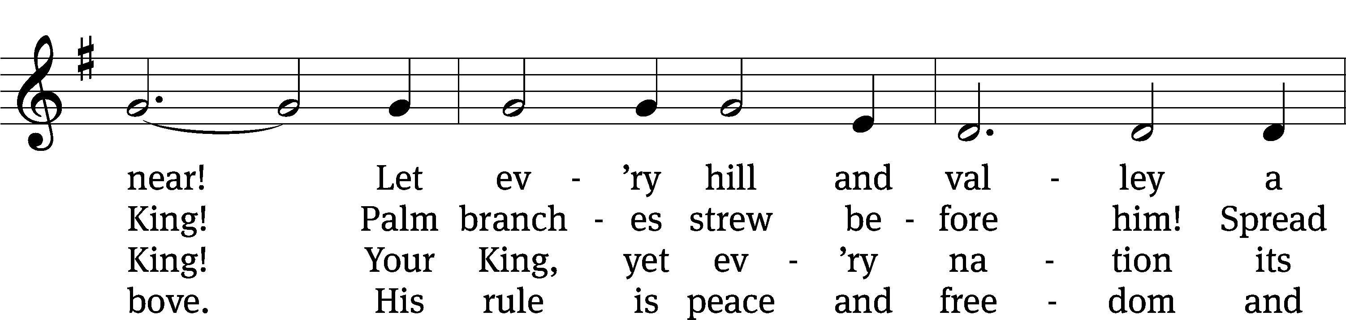
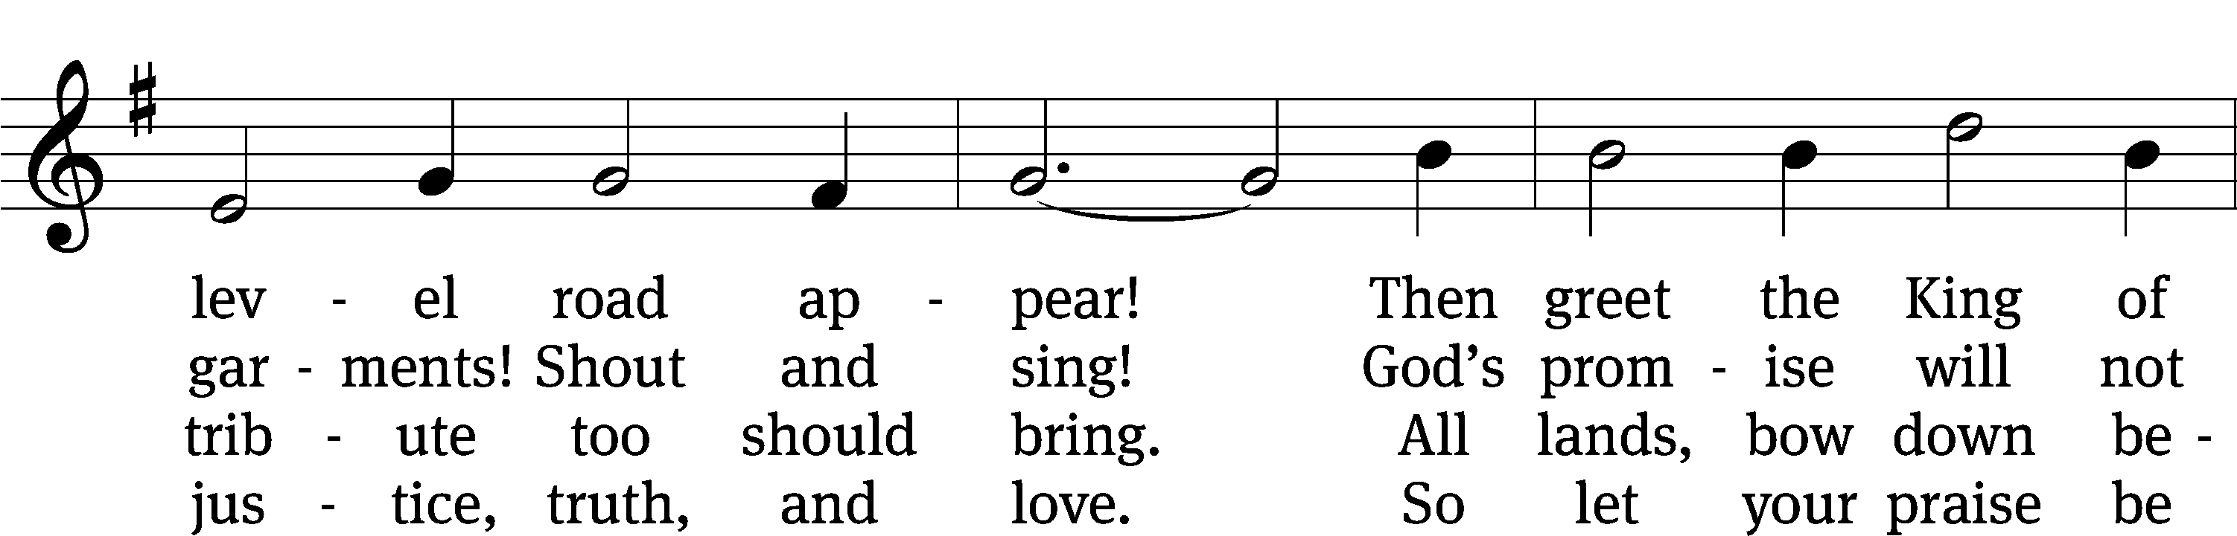
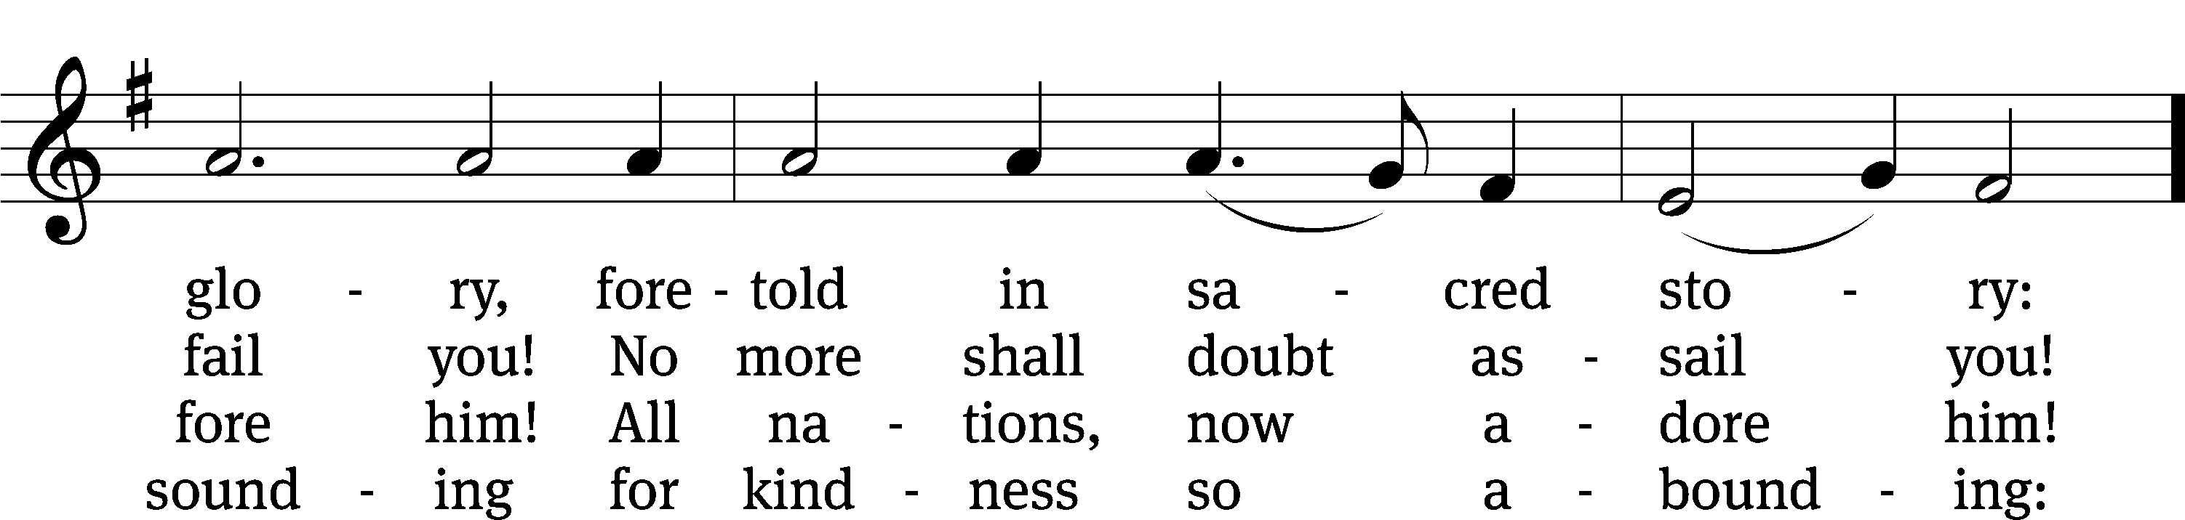
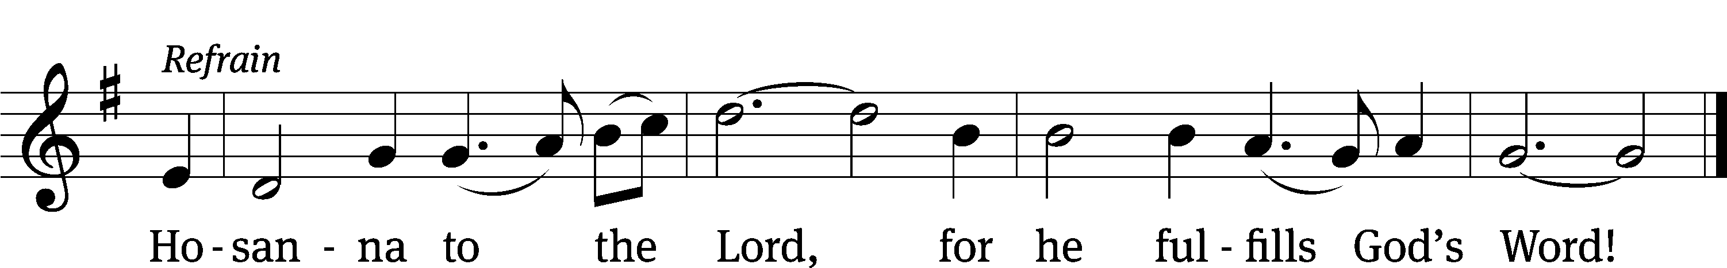
Text: tr. Lutheran Book of Worship, 1978, alt.; Frans Mikael Franzén, 1772–1847
Tune: Swedish, 17th cent.
Text: © 1978 Lutheran Book of Worship, admin. Augsburg Fortress. Used by permission: OneLicense no. 727703
Tune: Public domain

PLEASE STAND, IF YOU ARE ABLE

invocation
M: The grace of our Lord (+) Jesus Christ and the love of God and the fellowship of the Holy Spirit be with you.
C: And also with you.
CONFESSION OF SINS
M: We have come into the presence of God, who created us to love and serve him as his dear children. But we have disobeyed him and deserve only his wrath and punishment. Therefore, let us confess our sins to him and plead for his mercy.

C: Merciful Father in heaven, I am altogether sinful from birth. In countless ways I have sinned against you and do not deserve to be called your child. But trusting in Jesus, my Savior, I pray: Have mercy on me according to your unfailing love. Cleanse me from my sin, and take away my guilt.

M: God, our heavenly Father, has forgiven all your sins. By the perfect life and innocent death of our Lord Jesus Christ, he has removed your guilt forever. You are his own dear child. May God give you strength to live according to his will.

C: Amen.

PRAYER AND PRAISE

M: In the peace of forgiveness, let us praise the Lord.

OH, TASTE AND SEE

PRAYER OF THE DAY

Let us pray.

Hear our prayers, Lord Jesus Christ, and come with the good news of your mighty deliverance. Drive the darkness from our hearts, and fill us with your light; for you live and reign with the Father and the Holy Spirit, one God, now and forever.

PLEASE BE SEATED

The Word

the FIRST LESSON Isaiah 35:1-10

¹ The wilderness and the desert will be glad.
The wasteland of the Arabah will rejoice and blossom like a crocus.
² It will bloom lavishly,
and there will be great joy and singing.
The glory of Lebanon will be given to it.
It will be excellent like Carmel and Sharon.
They will see the glory of the Lord,
the majesty of our God.
³ Strengthen the weak hands,
and make the shaky knees steady.
⁴ Tell those who have a fearful heart:
Be strong.
Do not be afraid.
Look! Your God will come with vengeance.
With God’s own retribution, he will come and save you.
⁵ Then the eyes of the blind will be opened,
and the ears of the deaf will be unplugged.
⁶ The crippled will leap like a deer,
and the tongue of the mute will sing for joy.
Waters will flow in the wilderness,
and streams in the wasteland.
⁷ The burning sand will become a pool,
and in the thirsty ground there will be springs of water.
There will be grass, reeds, and rushes where the haunts
of jackals once lay.
⁸ A highway will be there,
a road that will be called the holy way.
The impure will not walk there.
It will be reserved for those who walk in that holy way.
Wicked fools will not wander onto it.
⁹ No lion will be there,
nor will any ferocious animal go up on it.
They will not be found there,
but only the redeemed will walk there.
¹⁰ Then those ransomed by the Lord will return.
They will enter Zion with a joyful shout,
and everlasting joy will crown their heads.
Happiness and joy will overtake them,
and sorrow and sighing will flee away.

THE SECOND LESSON James 5:7-11

⁷ Therefore, brothers, be patient until the coming of the Lord. See how the farmer waits for the valuable harvest from the ground, patiently waiting for it, until it receives the early and late rain. ⁸ You be patient too. Strengthen your hearts because the coming of the Lord is near.
⁹ Do not complain about one another, brothers, so that you will not be judged. Look! The Judge is standing at the doors! ¹⁰ Brothers, take the prophets who spoke in the name of the Lord as an example of suffering with patient endurance. ¹¹ See, we consider those who endured to be blessed. You have heard of the patient endurance of Job and have seen what the Lord did in the end, because the Lord is especially compassionate and merciful.

please stand, if you are able

Verse of the day

Alleluia. I will send my messenger ahead of you, who will prepare your way before you. Alleluia. (Matthew 11:10)

THE GOSPEL LESSON Matthew 11:2-11
M: The Gospel according to Matthew chapter 11, verses 2-11
² While John was in prison, he heard about the things Christ was doing. He sent two of his disciples ³ to ask him, “Are you the Coming One or should we wait for someone else?”
⁴ Jesus answered them, “Go, report to John what you hear and see: ⁵ The blind receive sight, the lame walk, those who have leprosy are cured, the deaf hear, the dead are raised, and the gospel is preached to the poor. ⁶ Blessed is the one who does not take offense at me.”
⁷ As these two were leaving, Jesus began to talk to the crowds about John. “What did you go out into the wilderness to see? A reed shaken by the wind? ⁸ What did you go out to see? A man dressed in soft clothing? No, those who wear soft clothing are in kings’ houses. ⁹ So what did you go out to see? A prophet? Yes, I tell you! And he is much more than a prophet. ¹⁰ This is the one about whom it is written, ‘Look, I am sending my messenger ahead of you, who will prepare your way before you.’ ¹¹ Amen I tell you: Among those born of women there has not appeared anyone greater than John the Baptist. Yet whoever is least in the kingdom of heaven is greater than he.

M: This is the Gospel of the Lord.

PLEASE BE SEATED

320 As Angels Joyed with One Accord CW 320
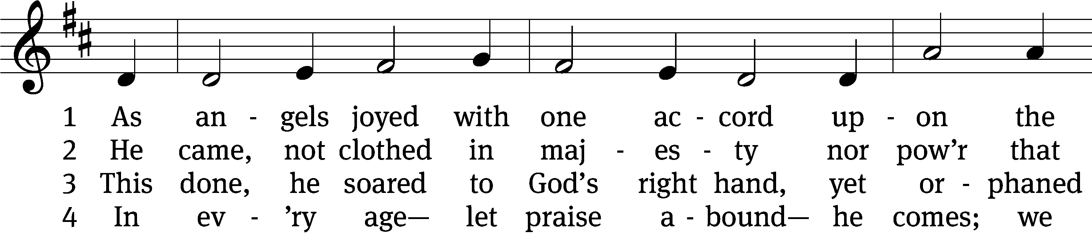
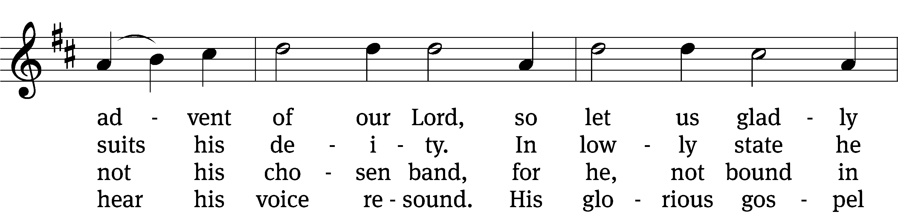
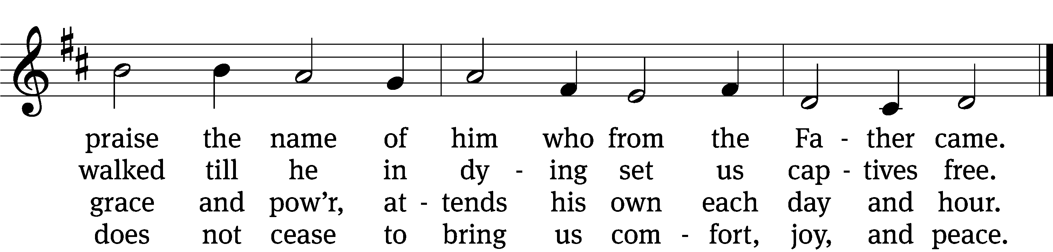

5 He comes in water to the child
and cleanses it, from birth defiled.
This washing seals his pard’ning grace
and shows the Father’s kindly face.

6 He comes to us in bread and wine
to give himself and gifts divine.
O praise him for this sacrament,
redeeming love’s great testament!

7 Lift up your heads! All grief and pain
shall vanish when he comes again.
Where we shall see him face to face,
there joy alone shall have a place.
Text: Werner H. Franzmann, 1905–1996, abr., alt.
Tune: Latin, 15th cent., adapt. Michael Praetorius, 1571–1621
Text: © 1993 Werner H. Franzmann, admin. Northwestern Publishing House. Used by permission: OneLicense no. 727703
Tune: Public domain

SERMON Matthew 11:5
“Christ’s Greatest Gift”

PLEASE STAND, IF YOU ARE ABLE

THE APOSTLES’ CREED
I believe in God, the Father almighty,
maker of heaven and earth.
I believe in Jesus Christ, his only Son, our Lord,
who was conceived by the Holy Spirit,
born of the virgin Mary,
suffered under Pontius Pilate,
was crucified, died, and was buried.
He descended into hell.
The third day he rose again from the dead.
He ascended into heaven
and is seated at the right hand of God the Father almighty.
From there he will come to judge the living and the dead.
I believe in the Holy Spirit,
the holy Christian Church,
the communion of saints,
the forgiveness of sins,
the resurrection of the body,
and the life everlasting. Amen.

PRAYER OF THE CHURCH

THE LORD’S PRAYER

C: Our Father, who art in heaven, hallowed be thy name, thy kingdom come, thy will be done on earth as it is in heaven. Give us this day our daily bread; and forgive us our trespasses, as we forgive those who trespass against us; and lead us not into temptation, but deliver us from evil. For thine is the kingdom and the power and the glory forever and ever. Amen.
PLEASE BE SEATED

321 God’s Own Son Most Holy CW 321
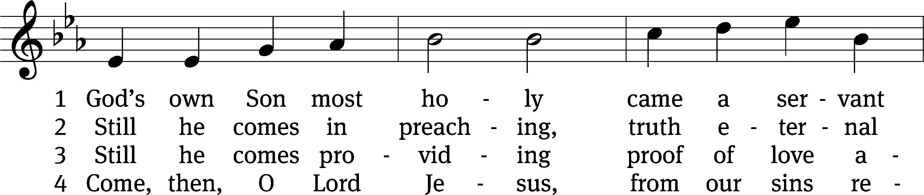
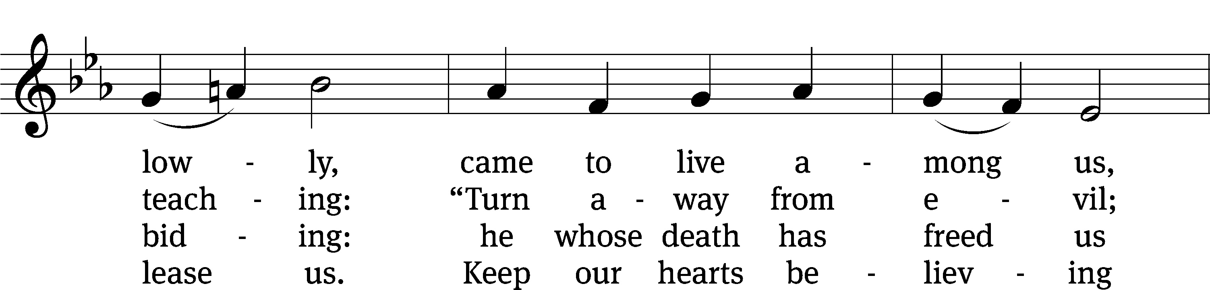
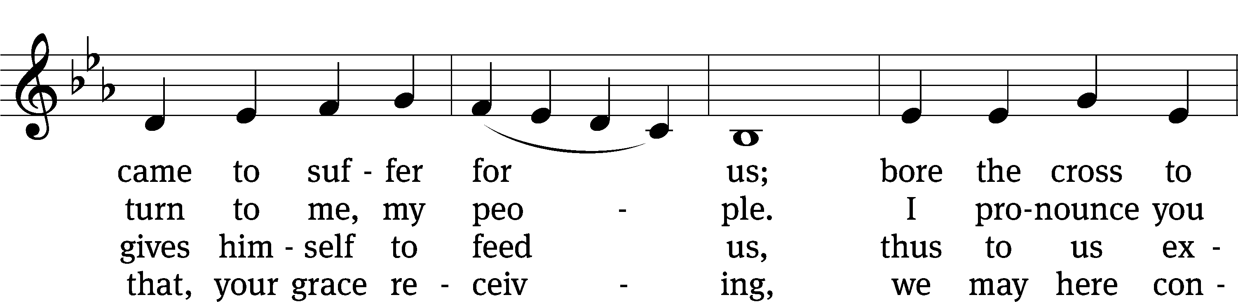
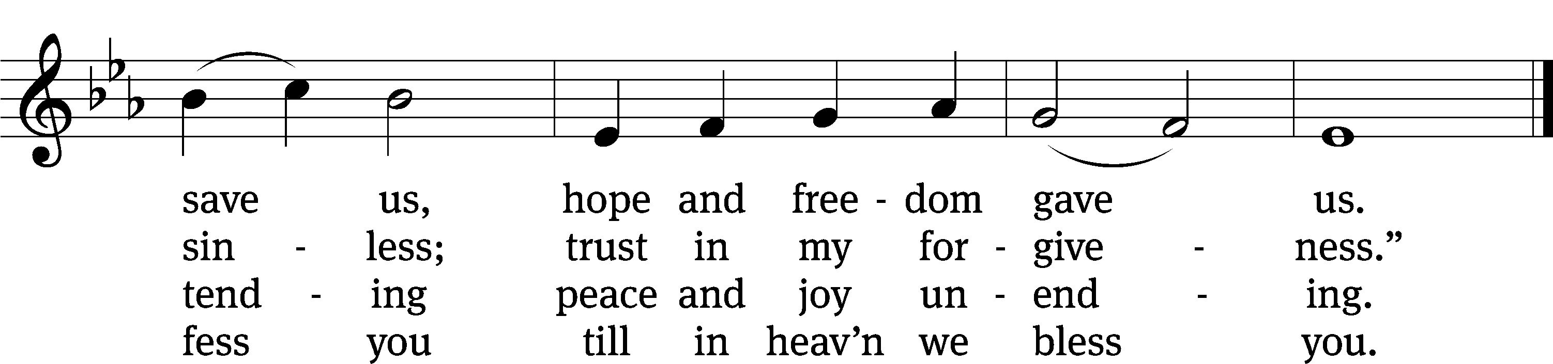
Text: Johann Horn, c. 1490–1547, abr.; (sts. 1, 4): tr. Catherine Winkworth, 1827–1878, alt.; (sts. 2–3): tr. Michael D. Schultz, b. 1963
Tune: attr. Michael Weisse, c. 1480–1534
Text (sts. 2–3): © 2021 Northwestern Publishing House. Used by permission: OneLicense no. 727703
Text (sts. 1, 4) and tune: Public domain

PLEASE STAND, IF YOU ARE ABLE

CLOSING PRAYER
M: Almighty God, we thank you for teaching us the things you want us to believe and do. Help us by your Holy Spirit to keep your Word in pure hearts that we may be strengthened in faith, guided in holiness, and comforted in life and in death, through Jesus Christ, our Lord, who lives and reigns with you and the Holy Spirit, one God, now and forever.

M: Brothers and sisters, go in peace. Live in harmony with one another. Serve the Lord with gladness.
The Lord bless you and keep you.
The Lord make his face shine on you and be gracious to you.
The Lord look on you with favor and (+) give you peace.

PLEASE BE SEATED

326 O Jesus, Grant Me Hope and Comfort CW 326
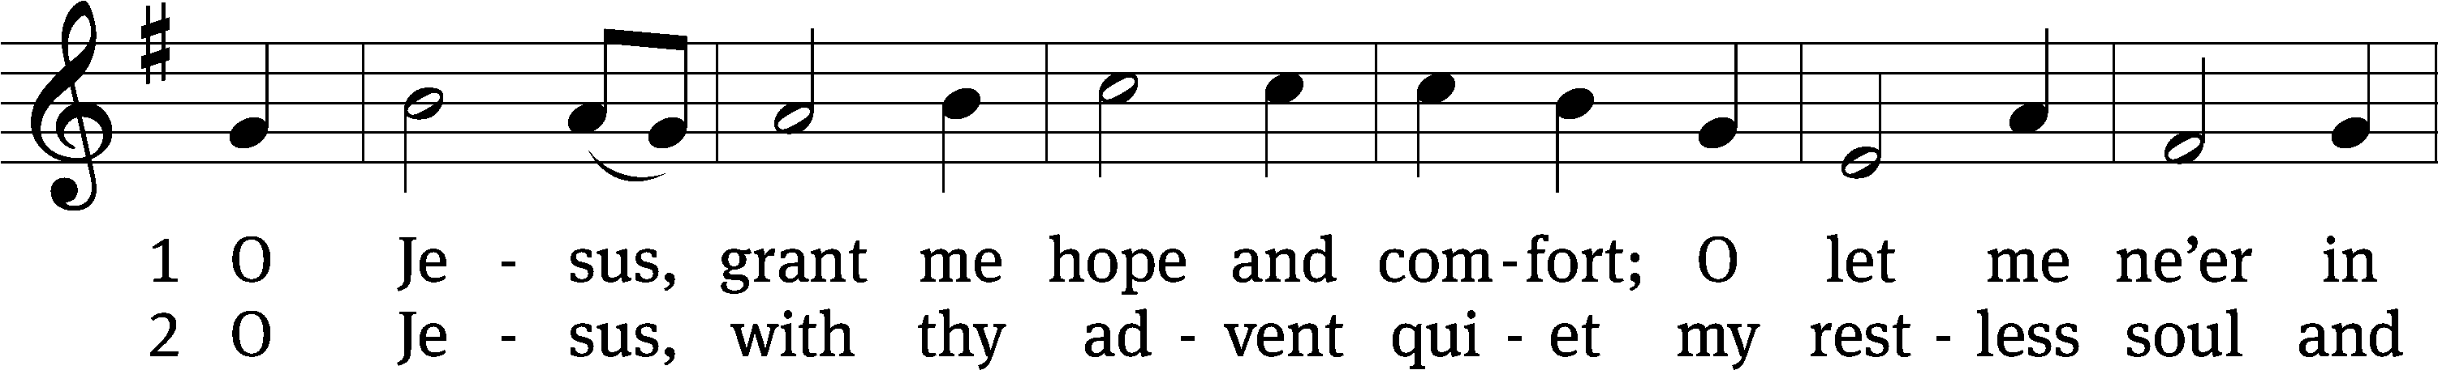
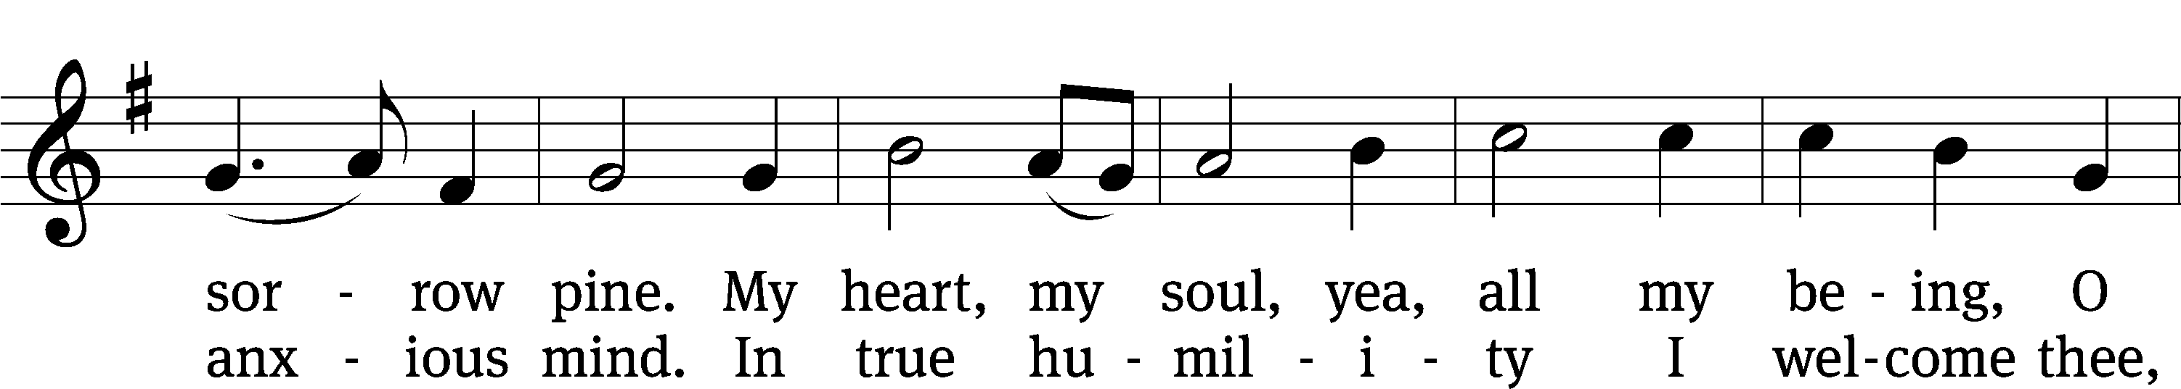
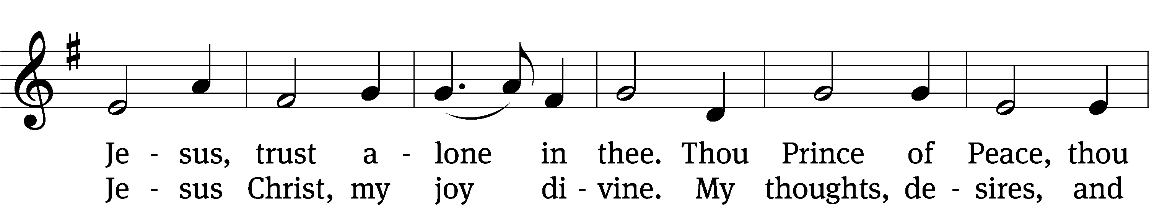
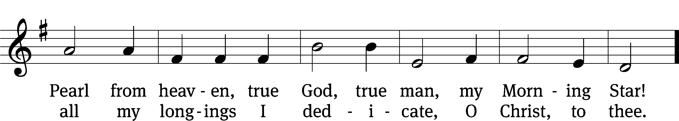
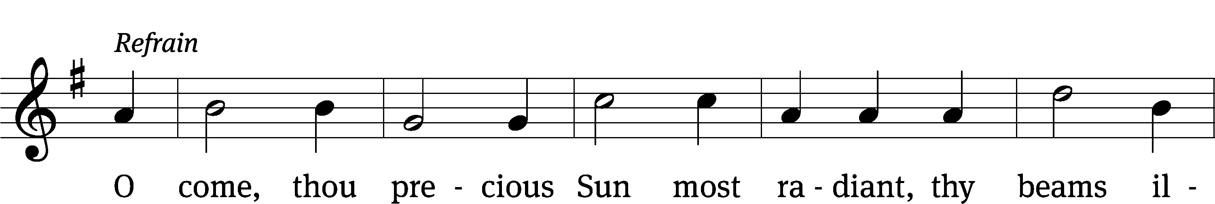
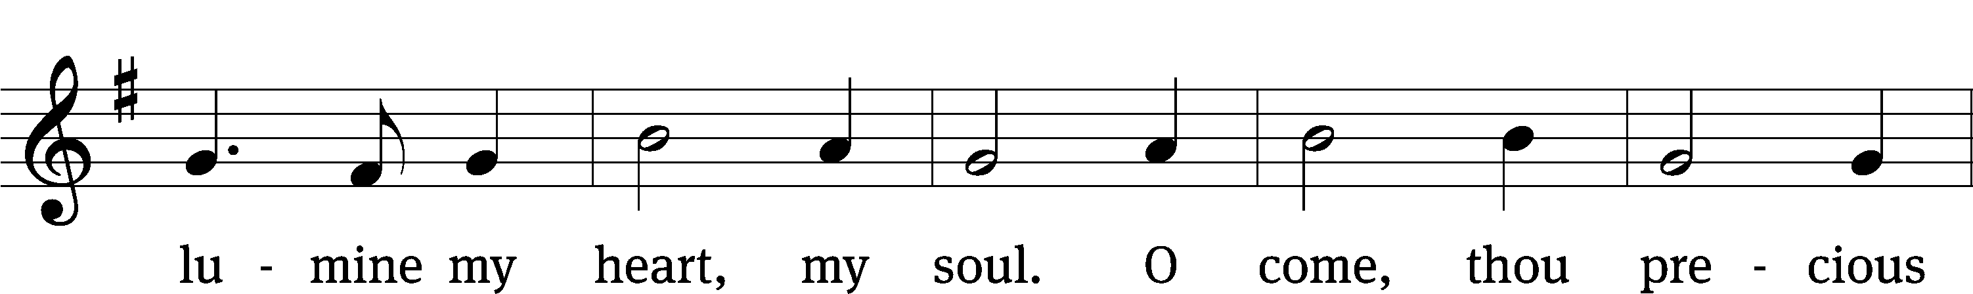
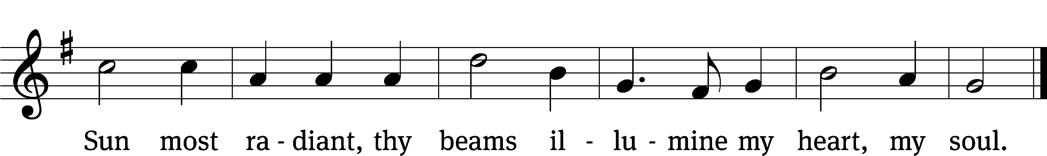
Text: tr. Walter E. Buszin, 1899–1973; Wilhelm Osterwald, 1820–1887
Tune: Johann Franck, 1618–1677
Text and tune: © 1939 Paul A. Schmitt Music Co.; ren. 1967 Schmitt, Hall & McCreary Company, admin. Jubilate Music Group. Used by permission: OneLicense no. 727703

Serving In Worship
Officiant Pastor Natsis
Organist Sarah Hanke
Choir Director Cynthia Natsis
Accompanist Sarah Hanke
Deacons (8:30) Dave Frey and Jim Tice
(11:00) Jeff Neuburger and Ed Wheeler
Ushers (8:30) Bob Newman and Henry Schneider
(11:00) Bill Barnett and Jake Vershum
Altar Guild Sharon Boswell and Connie Marion
Videographer Richard Schneider

Copyright information
Service of the Word: Christian Worship. © 1993 Northwestern Publishing House. All rights reserved.
Reprinted with permission under ONE LICENSE #A-727703 and CCLI #1151741/CSPL126093

Words and Music: All rights reserved. Reprinted with permission under ONE LICENSE #A-727703 and
CCLI #1151741/CSPL126093

tlcsaline.church

