the SEVENTH sunday
AFTER EPIPHANY

TRINITY EVANGELICAL LUTHERAN CHURCH | Saline, Michigan
WELCOME TO WORSHIP February 20, 2022

Thank you for joining us in God’s house today! We cordially ask that our guests sign one of the guestbooks located at either the front or back entryways.

THANK OFFERING: Members of Trinity give their offering as an expression of love and thankfulness to the Lord and to help support the Lord’s work in our community and around the world. Visitors need not feel obligated to participate in this offering which supports our ministry.

Restrooms are located at the back of the upper level (the annex), and in the basement (down the back stairs of the sanctuary or annex). Handicap access is available, please ask an usher for assistance.

celebration of holy communion:
In His Word, God makes it clear that the Lord’s Supper is to be shared by people of a common proclamation of faith (1 Corinthians 11:26; 1 Corinthians 10:16-17). Without judging anyone’s hearts, we invite those who share in our confession by their membership in our congregation or another congregation of the Wisconsin Evangelical Lutheran Synod (WELS) or the Evangelical Lutheran Synod (ELS) and who are properly prepared (1 Corinthians 11;27-29) to receive the Sacrament. Page 295 in the front of Christian Worship provides a guide for preparation.

Guests, we would love to have you join us in communion fellowship in the future, and for that to be possible, we ask that you speak with one of the pastors so that we may speak with you on how that would be possible. We thank you for respecting the way we celebrate the Lord’s Supper in our congregations.

SERVICE OF WORD AND SACRAMENT

Opening hymn CW #733

733 Forgive Our Sins as We Forgive CW 733
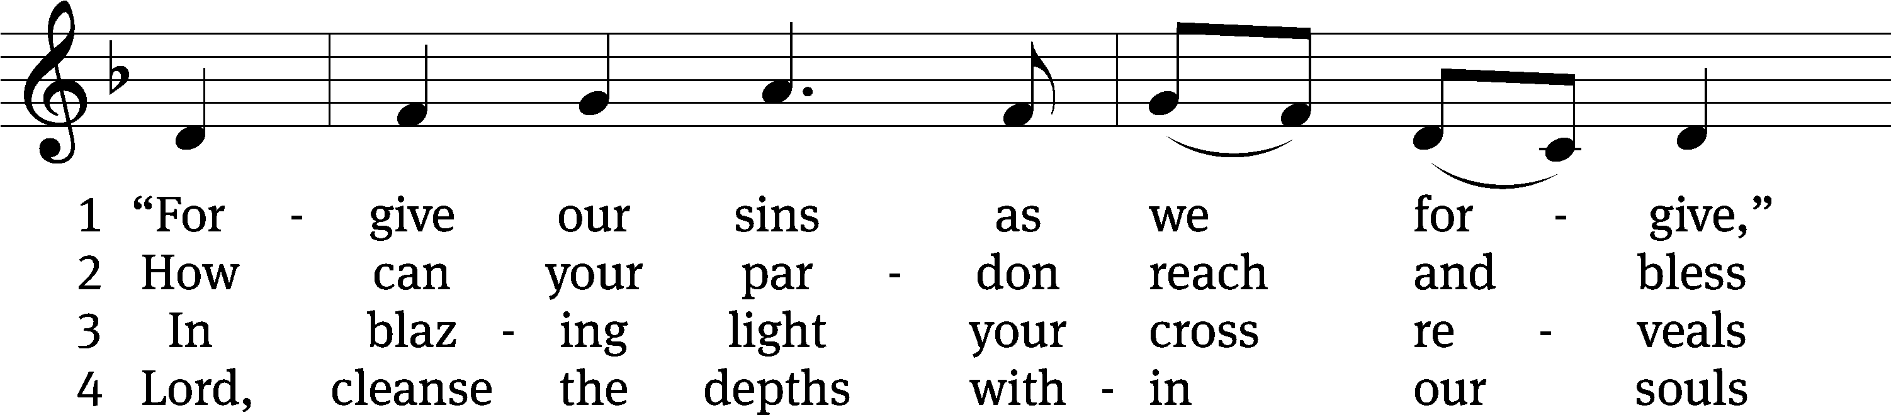
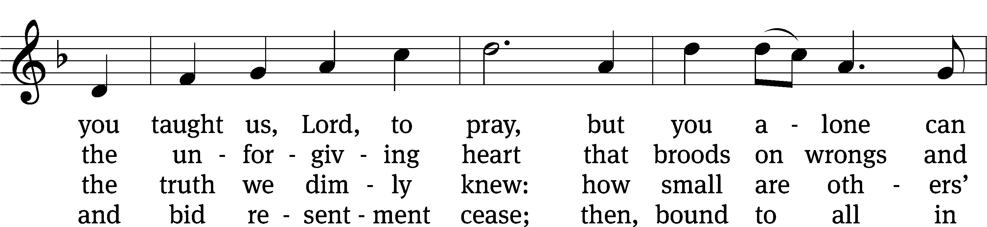
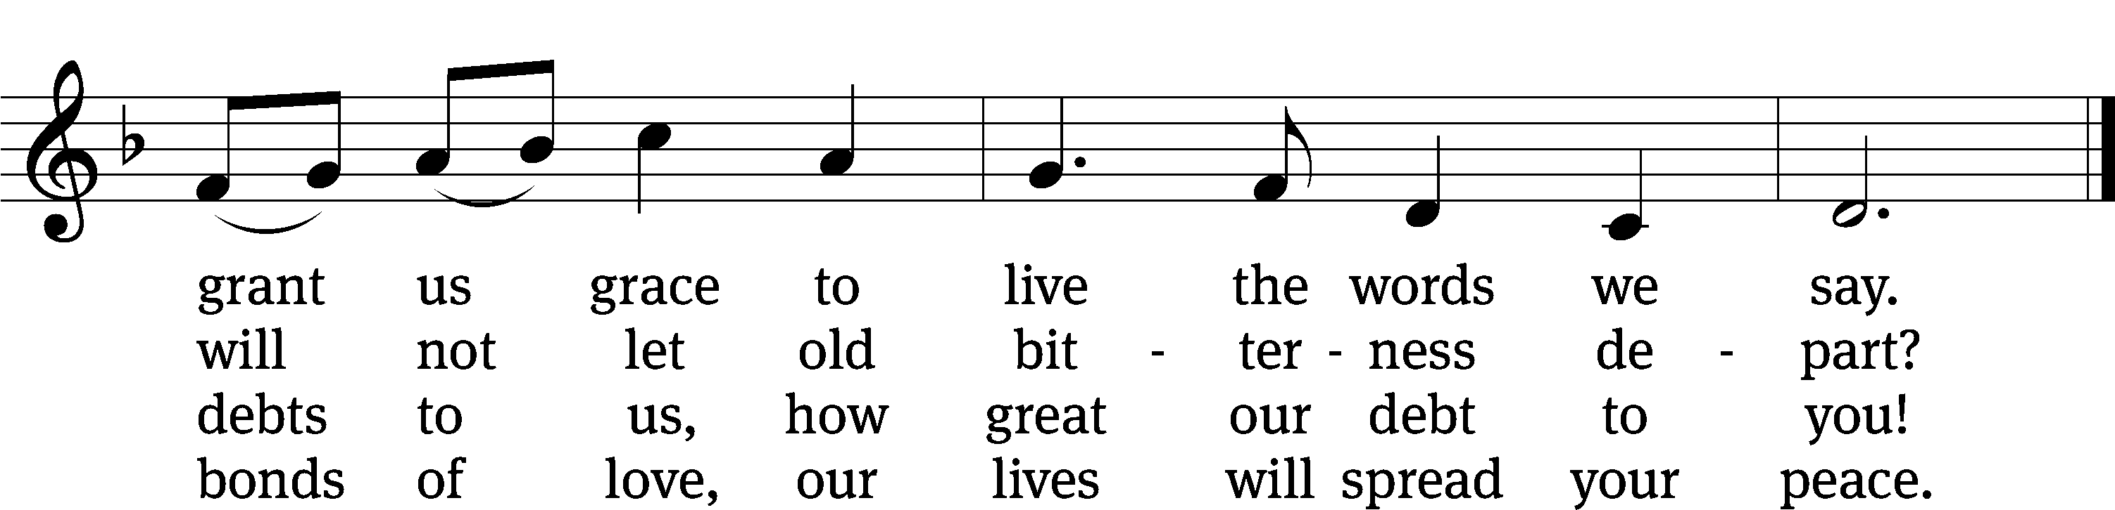
Text: Rosamond E. Herklots, 1905–1987, alt.
Tune: Rosamond E. Herklots, 1905–1987, alt.
Text: © 1969 Oxford University Press. Used by permission: OneLicense no. 727703
Tune: Public domain

PLEASE STAND, IF YOU ARE ABLE

invocation

M: The grace of our Lord (+) Jesus Christ and the love of God and the fellowship of the Holy Spirit be with you.
C: And also with you.
CONFESSION OF SINS
M: God invites us to come into his presence and worship him with humble and penitent hearts. Therefore, let us acknowledge our sinfulness and ask him to forgive us.
C: Holy and merciful Father, I confess that I am by nature sinful, and that I have disobeyed you in my thoughts, words, and actions. I have done what is evil and failed to do what is good. For this I deserve your punishment both now and in eternity. But I am truly sorry for my sins, and trusting in my Savior Jesus Christ, I pray: Lord, have mercy on me, a sinner.
M: God, our heavenly Father, has been merciful to us and has given his only Son to be the atoning sacrifice for our sins. Therefore, as a called servant of Christ and by his authority, I forgive you all your sins in the name of the Father and of the Son (+) and of the Holy Spirit.
C: Amen.

PRAYER AND PRAISE

LORD, HAVE MERCY
Kyrie
M: For all that we need in life and for the wisdom to use all your gifts with gratitude and joy, hear our prayer, O Lord.

M: For the steadfast assurance that nothing can separate us from your love and for the courage to stand firm against the assaults of Satan and every evil, hear our prayer, O Christ.

M: For the well-being of your holy Church in all the world and for those who offer here their worship and praise, hear our prayer, O Lord.

M: Merciful God, maker and preserver of life, uphold us by your power and keep us in your tender care:

M: The works of the Lord are great and glorious; his name is worthy of praise.

Prayer of the day

M: Let us pray.

The minister says the Prayer of the Day.

PLEASE BE SEATED

The Word

first lesson Genesis 45:3-15
³ Joseph said to his brothers, “I am Joseph! Is my father still alive?”

His brothers could not answer him, because they were terrified by his presence. ⁴ Joseph said to his brothers, “Come closer to me, please.”

They came closer. He said, “I am Joseph, your brother, whom you sold into Egypt. ⁵ Now do not be upset or angry with yourselves for selling me to this place, since God sent me ahead of you to preserve life. ⁶ For two years now the famine has been in the land, and there are still five more years in which there will be neither plowing nor harvest. ⁷ God sent me ahead of you to preserve you as survivors on the earth, and to keep you alive by a great act of deliverance. ⁸ So it was not you who sent me here, but God, and he has made me a father to Pharaoh, lord over his entire household, and ruler over the whole land of Egypt. ⁹ Hurry, go up to my father and tell him, ‘This is what your son Joseph says: “God has made me lord of all Egypt. Come down to me. Do not delay. ¹⁰ You shall live in the land of Goshen, where you will be close to me—you, your children, your grandchildren, your flocks, your herds, and all that you have. ¹¹ I will take care of you here, for there are still five years of famine. Otherwise you will come to ruin, you, and your household, and all that you have.”’ ¹² Pay attention. Your eyes and the eyes of my brother Benjamin see that it is my mouth that speaks to you. ¹³ You shall tell my father all about my position of honor in Egypt and about everything that you have seen. Hurry and bring my father down here.”

¹⁴ He threw his arms around his brother Benjamin’s neck and wept, and Benjamin wept on his shoulder. ¹⁵ He kissed all his brothers and wept over them. After that his brothers talked with him.

Psalm of the day PSALM 103
103B Praise, My Soul, the King of Heaven Psalm 103B
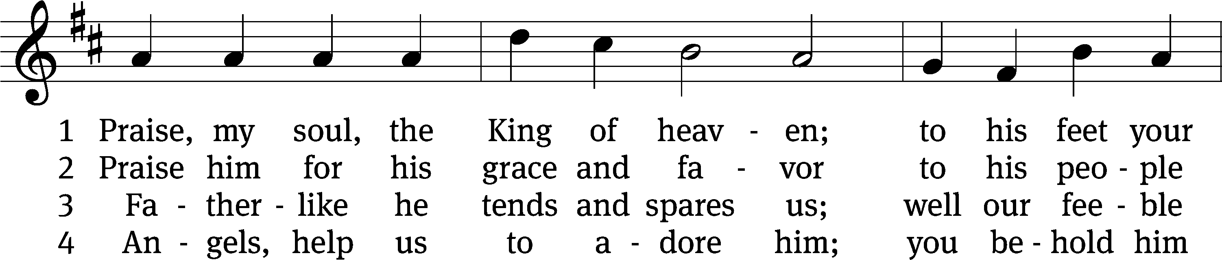
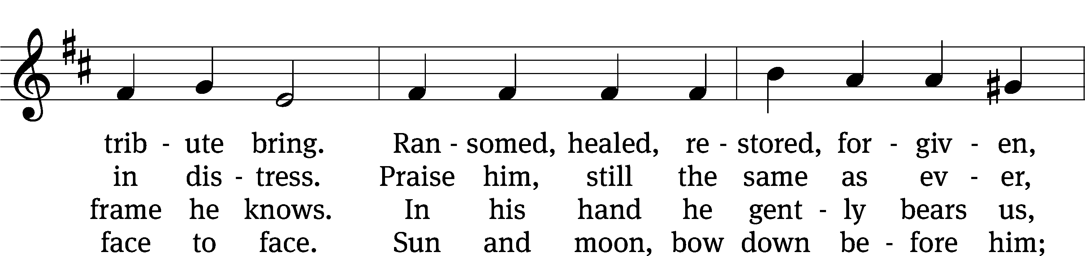
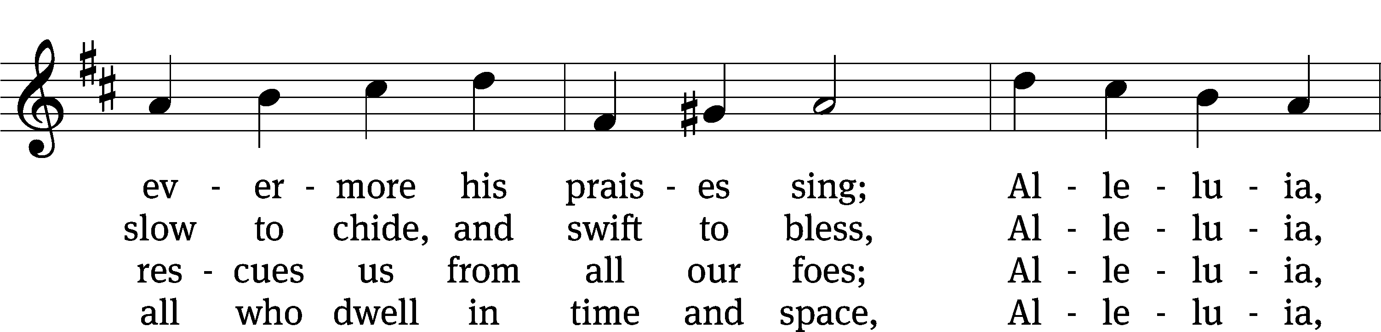
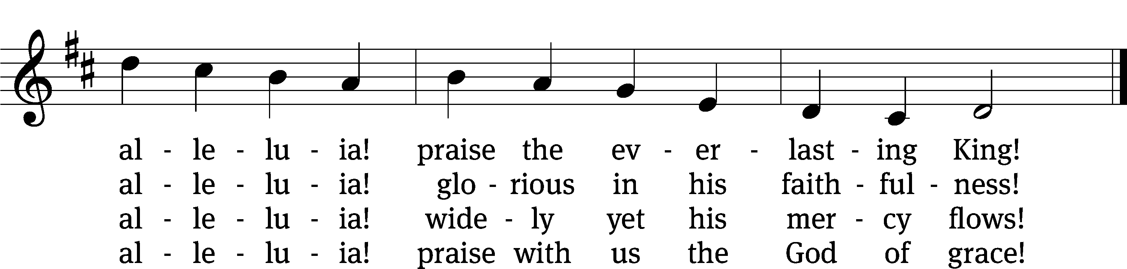
Text: Henry F. Lyte
Tune: John Goss
Text and tune: Public domain

second lesson ROMANS 12:14-21
¹⁴ Bless those who persecute you; bless, and do not curse. ¹⁵ Rejoice with those who are rejoicing; weep with those who are weeping. ¹⁶ Have the same respect for one another. Do not be arrogant, but associate with the humble. Do not think too highly of yourselves.
¹⁷ Do not pay anyone back evil for evil. Focus on those things that everyone considers noble. ¹⁸ If it is possible, as far as it depends on you, maintain peace with everyone. ¹⁹ Do not take revenge, dear friends, but leave room for God’s wrath. For it is written, “Vengeance is mine; I will repay,” says the Lord. ²⁰ But:
If your enemy is hungry, feed him;
if he is thirsty, give him a drink.
For by doing this, you will heap burning coals on his head.
²¹ Do not be overcome by evil, but overcome evil with good.

Verse of the day

plEASE STAND, if you are able

gospel LUKE 6:27-38
M: The Gospel according to St. Luke chapter 6, verses 27-38
²⁷ “But I say to you who are listening: Love your enemies. Do good to those who hate you. ²⁸ Bless those who curse you. Pray for those who mistreat you. ²⁹ If someone strikes you on one cheek, offer the other too. If someone takes away your coat, do not withhold your shirt. ³⁰ Give to everyone who asks you, and if anyone takes away your things, do not demand them back.
³¹ “Treat others just as you would want them to treat you. ³² If you love those who love you, what credit is that to you? To be sure, even the sinners love those who love them. ³³ And if you do good to those who do good to you, what credit is that to you? Even the sinners do the same thing. ³⁴ If you lend to those from whom you expect to be repaid, what credit is that to you? Even the sinners lend to sinners in order to be paid back in full. ³⁵ Instead, love your enemies, do good and lend, expecting nothing in return. Your reward will be great, and you will be sons of the Most High, because he is kind to the unthankful and the evil. ³⁶ Be merciful, just as your Father is merciful.
³⁷ “Do not judge, and you will not be judged. Do not condemn, and you will not be condemned. Forgive, and you will be forgiven. ³⁸ Give, and it will be given to you. A good measure pressed down, shaken together, and running over will be poured into your lap. In fact, the measure with which you measure will be measured back to you.”

M: This is the Gospel of the Lord.

PLEASE BE SEATED

SERMON HYMN CW #729
729 Son of God, Eternal Savior CW 729
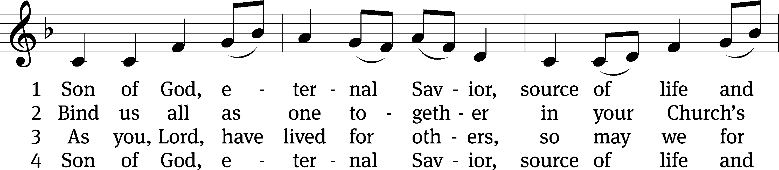
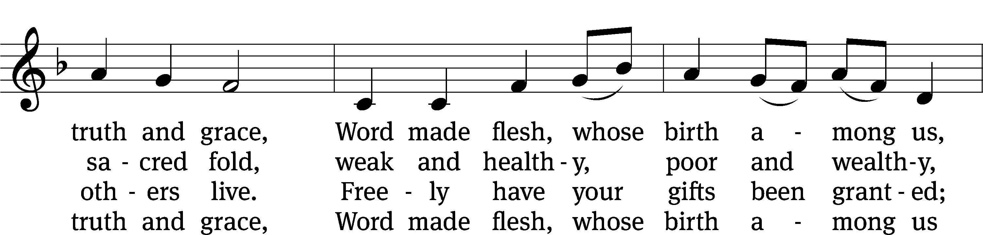
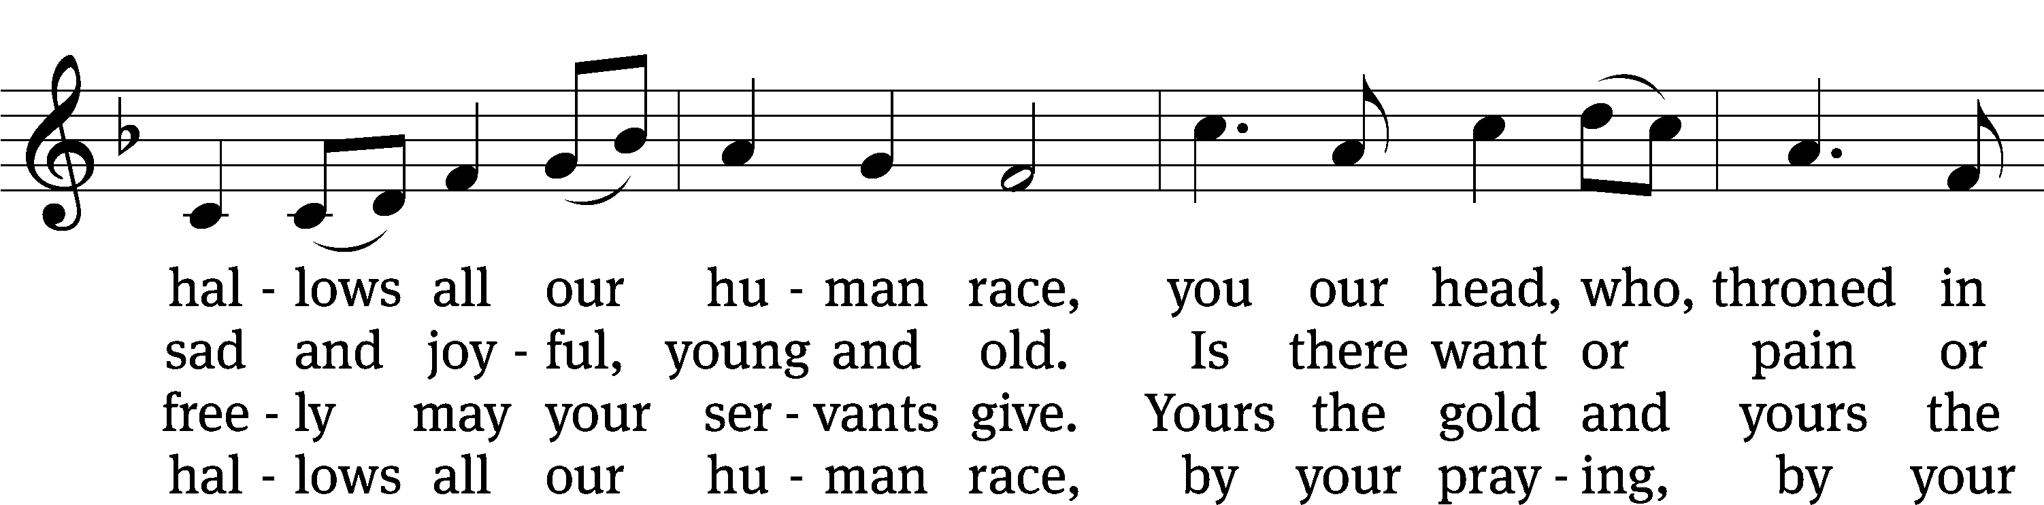
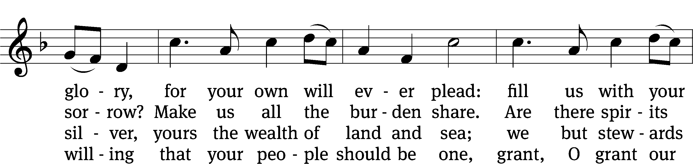
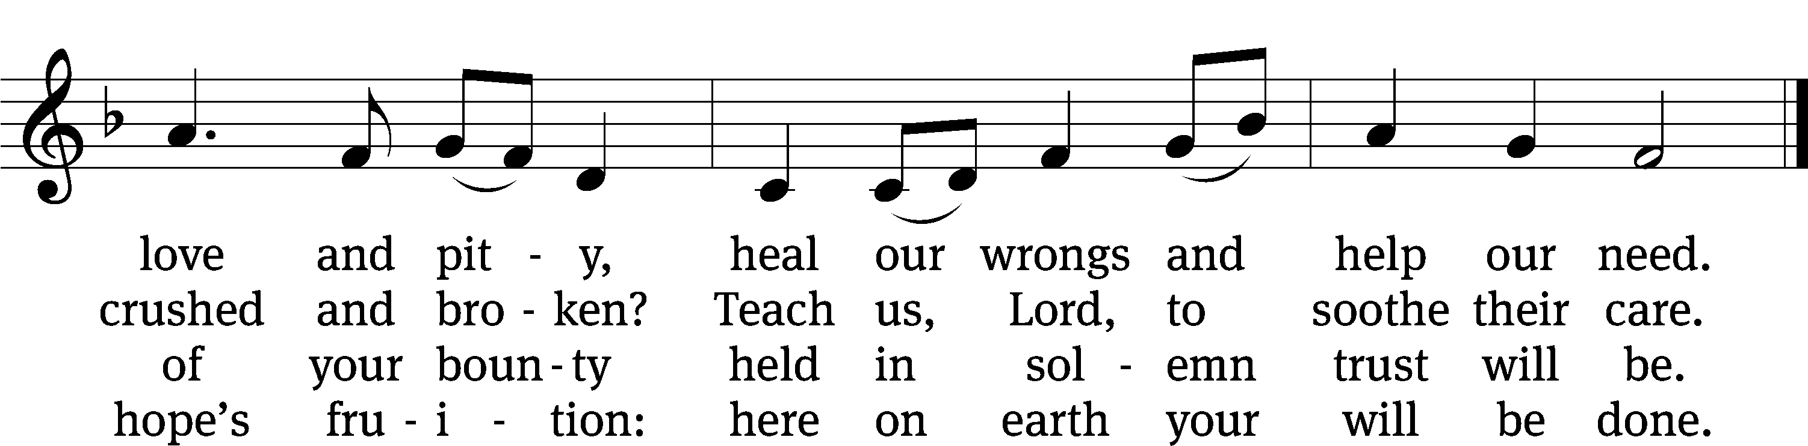
Text: Somerset T. C. Lowry, 1855–1932, abr., alt.
Tune: The Revivalist, Troy, 1868, ed. Joseph Hillman
Text and tune: Public domain

Sermon LUKE 6:27-38
“Why Should I Love My Enemy?”

please stand, if you are able

nicene creed
We believe in one God, the Father, the Almighty, maker of heaven and earth, of all that is, seen and unseen.
We believe in one Lord, Jesus Christ, the only Son of God, eternally begotten of the Father, God from God, Light from Light, true God from true God, begotten, not made, of one being with the Father. Through him all things were made. For us and for our salvation, he came down from heaven, was incarnate of the Holy Spirit and the virgin Mary, and became fully human. For our sake he was crucified under Pontius Pilate. He suffered death and was buried. On the third day he rose again in accordance with the Scriptures. He ascended into heaven and is seated at the right hand of the Father. He will come again in glory to judge the living and the dead, and his kingdom will have no end.
We believe in the Holy Spirit, the Lord, the giver of life, who proceeds from the Father and the Son, who in unity with the Father and the Son is worshiped and glorified, who has spoken through the prophets. We believe in one holy Christian and apostolic Church. We acknowledge one baptism for the forgiveness of sins. We look for the resurrection of the dead and the life of the world to come. Amen.

PLEASE BE SEATED

offertory

PLEASE STAND, IF YOU ARE ABLE

prayer of the church prayer of the church

lord’s prayer

C: Our Father, who art in heaven,
hallowed be thy name,
thy kingdom come,
thy will be done
on earth as it is in heaven.
Give us this day our daily bread;
and forgive us our trespasses,
as we forgive those
who trespass against us;
and lead us not into temptation,
but deliver us from evil.
For thine is the kingdom
and the power and the glory
forever and ever. Amen.

The Sacrament of Holy Communion
Trinity Lutheran Church follows the historic Christian practice of close communion. We ask that only members of Trinity or one of our sister congregations partake of the sacrament. If you are not a member, please see the note about Holy Communion in the beginning of the Worship Folder.

M: The Lord be with you.

M: Lift up your hearts.

M: Let us give thanks to the Lord our God.

M: Praise to the God and Father of our Lord Jesus Christ! In love he has blessed us with every spiritual blessing. In the past he spoke to us through the prophets, but in these last days he has spoken to us by his Son, who is the radiance of his glory. Now have come the salvation and the power and the kingdom of our God and the authority of his Christ. To him who sits on the throne and to the Lamb be praise and thanks and honor and glory for ever and ever:

Holy, Holy, Holy

Words of institution
M: Our Lord Jesus Christ, on the night he was betrayed, took bread; and when he had given thanks, he broke it and gave it to his disciples, saying: “Take and eat. This is my ✙ body, which is given for you. Do this in remembrance of me.”
Then he took the cup, gave thanks, and gave it to them, saying, “Drink from it all of you; this is my ✙ blood of the new covenant, which is poured out for you for the forgiveness of sins. Do this, whenever you drink it, in remembrance of me.”
The peace of the Lord be with you always.

O CHRIST, LAMB OF GOD

663 Soul, Adorn Yourself with Gladness CW 663
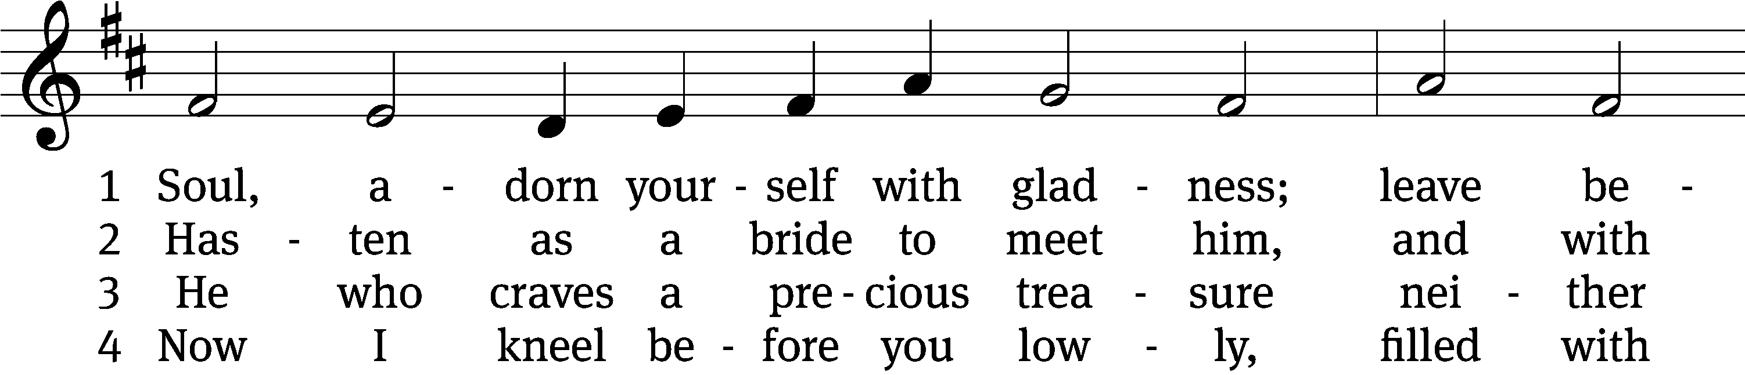
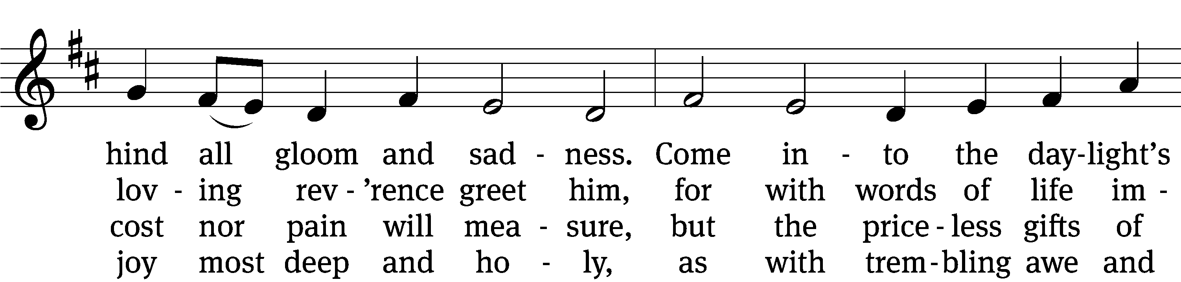
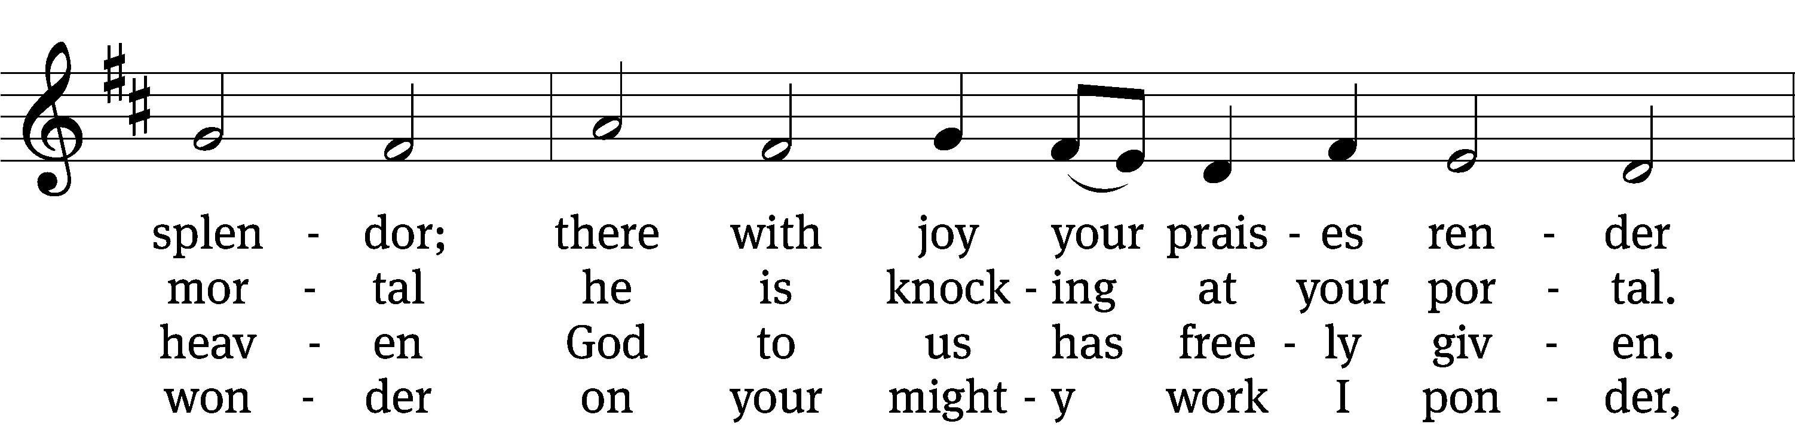
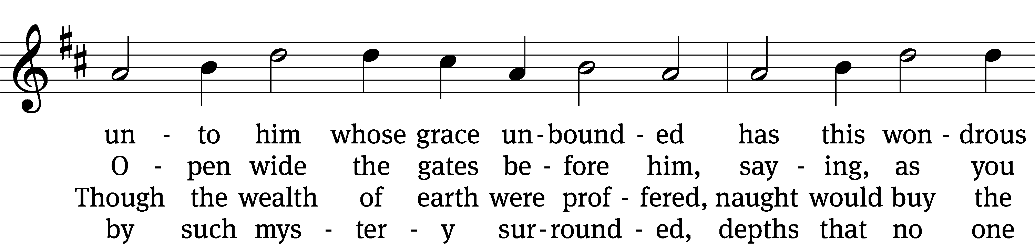
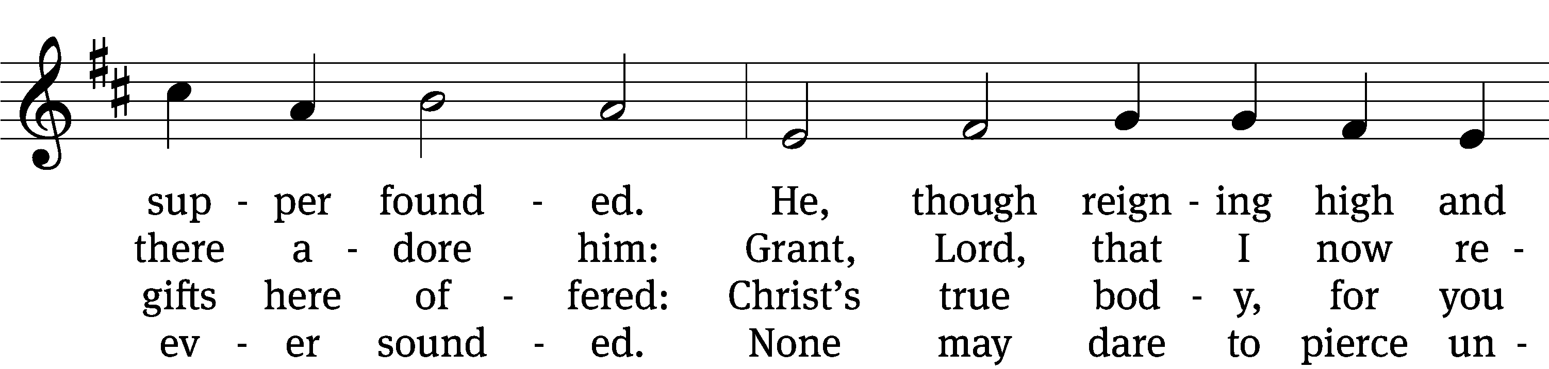
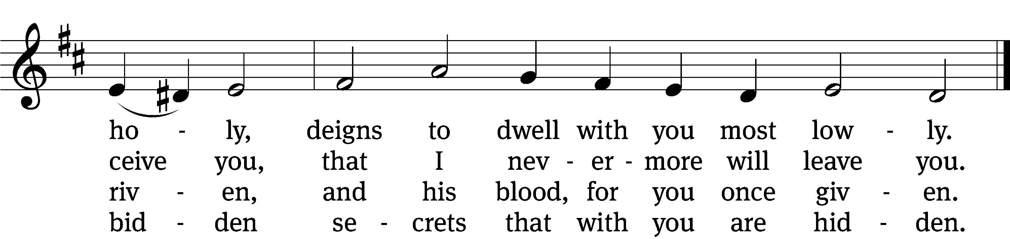

5 Human reason, though it ponders,
cannot fathom these great wonders,
that Christ’s body must be boundless
since the souls it feeds are countless,
and that he his blood is giving
with the wine we are receiving.
These great mysteries unsounded
are by God alone expounded.

6 Lord, by love and mercy driven,
you have left your throne in heaven
on the cross for me to languish
and to die in bitter anguish,
to forgo all joy and gladness
and to shed your blood in sadness.
By this blood redeemed and living,
Lord, I praise you with thanksgiving.

7 Jesus, sun of life, my splendor,
Jesus, friend of friends most tender,
Jesus, joy of my desiring,
fount of life, my soul inspiring:
at your feet I cry, my maker,
let me be a fit partaker
of this blessèd food from heaven
for our good, your glory, given.

8 Jesus, Lord of life in heaven,
help me when this meal is given
to receive it for my blessing
as I come, my sins confessing.
In this supper let me measure,
Lord, how deep is your love’s treasure,
that, as I on earth have eaten,
I may be your guest in heaven.
Text: Johann Franck, 1618–1677, abr.; (sts. 1–2, 4, 7): tr. Catherine Winkworth, 1827–1878, alt.; (sts. 3, 5–6): tr. The Lutheran Hymnal, 1941, alt.; (st. 8): tr. Peter M. Prange, b. 1972
Tune: Johann Crüger, 1598–1662
Text (st. 8): © 2021 Northwestern Publishing House. Used by permission: OneLicense no. 727703
Text (sts. 1–7) and tune: Public domain

THANKSGIVING

PLEASE STAND, IF YOU ARE ABLE

THANK THE LORD

M: Hear the prayer of your people, O Lord, that the lips which have praised you here may glorify you in the world, that the eyes which have seen the coming of your Son may long for his coming again, and that all who have received in his true body and blood the pledge of your forgiveness may be restored to live a new and holy life, through Jesus Christ, our Lord, who lives and reigns with you and the Holy Spirit, one God, now and forever.

M: Brothers and sisters, go in peace. Live in harmony with one another.
Serve the Lord with gladness.

The Lord bless you and keep you.
The Lord make his face shine on you and be gracious to you.
The Lord look on you with favor and (+) give you peace.

CLOSING HYMN CW #728
728 This Is My Will CW 728
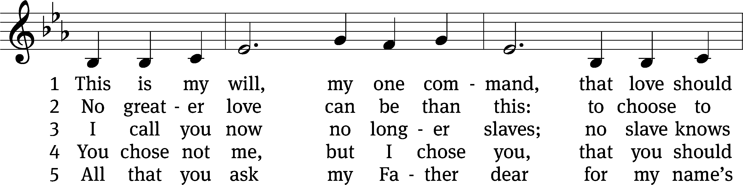
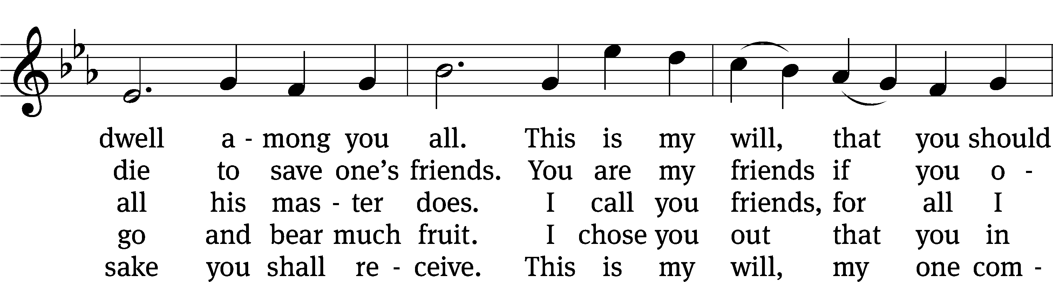
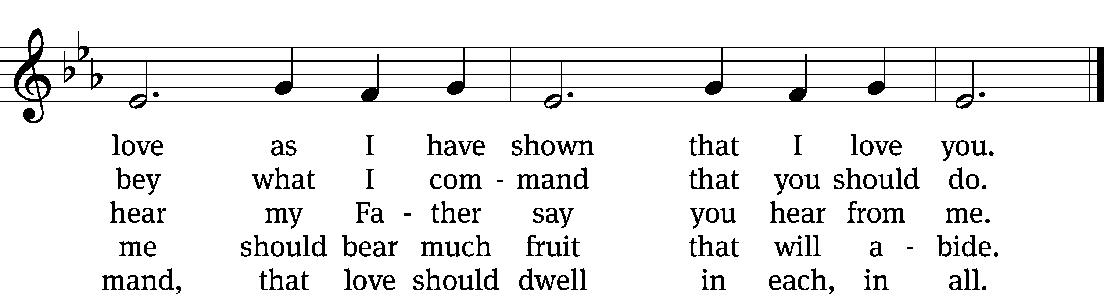
Text: James Quinn, SJ, 1919–2010, alt.
Tune: Gaelic, 19th cent.
Text: © 1969 James Quinn, SJ, admin. OCP Publications. Used by permission: OneLicense no. 727703
Tune: Public domain

Serving In Worship

Officiant Pastor Natsis
Organist Marcia Marion Ackling
Deacons (8:30) Dave Frey and Dave Stevenson
(11:00) Steve Hoeft and Ed Wheeler
Ushers (8:30) Dale Radak
(11:00) Ron Zahn
Altar Guild Margaret Hoeft and Brenda Stevenson
Videographer Jake Vershum

Copyright information
Service of Word and Sacrament: Christian Worship. © 1993 Northwestern Publishing House. All rights reserved. Reprinted under ONE LICENSE #A-727703 and CCLI #1151741/ CSPL126093
Words and Music: All rights reserved. Reprinted/Podcast/Streamed with permission under ONE LICENSE #A-727703 and CCLI #1151741/CSPL126093

