the seventh sunday
AFTER PENTECOST

TRINITY EVANGELICAL LUTHERAN CHURCH | Saline, Michigan
WELCOME TO WORSHIP July 21/24, 2022
Thank you for joining us in God’s house today! We cordially ask that our Guests sign one of the guestbooks located at either the front or back entryways, or fill out a “Let’s Get Acquainted” card located in the hymnal pew rack and place it in the collection plate.

THANK OFFERING: Members of Trinity give their offering as an expression of love and thankfulness to the Lord and to help support the Lord’s work in our community and around the world. Visitors need not feel obligated to participate in this offering which supports our ministry.

Restrooms are located at the back of the upper level (the annex), and in the basement (down the back stairs of the sanctuary or annex). Handicap access is available, please ask an usher for assistance.

Young Families / Toddler Bags – We are GLAD YOU BROUGHT YOUR CHILDREN to our worship service. Jesus said: “Let the little children come to me and do not hinder them, for the kingdom of God belongs to such as these.” We know that having little children in church can be a challenge, but DO NOT WORRY about it. Many of your fellow worshippers have been in your shoes and are just happy you brought your children with you. For your convenience, we have reserved the back rows of seating for parents with small children. These areas provide more flexibility for your family, as well as, easy access to move downstairs if necessary. A closed-circuit TV system allows families to continue participating in the service while downstairs. Pre-school toddler bags and children’s bulletins are available for their enjoyment. Ask an usher for one to use during the service and please return the toddler bag afterwards.

the SERVICE – setting one - WITHOUT HOLY COMMUNION CW, page 154

871 Rise! To Arms! With Prayer Employ You CW 871
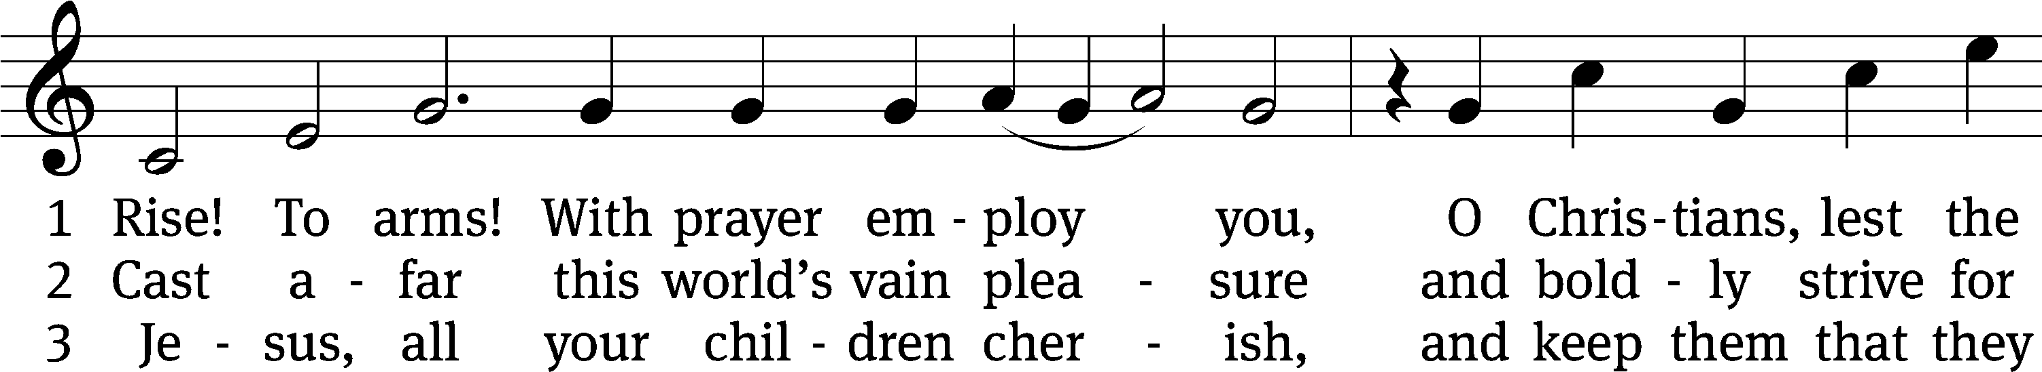
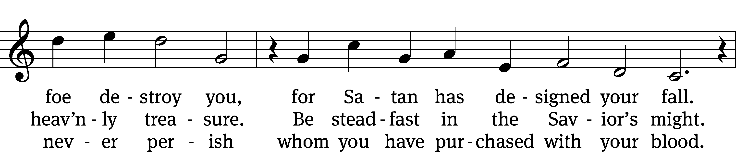
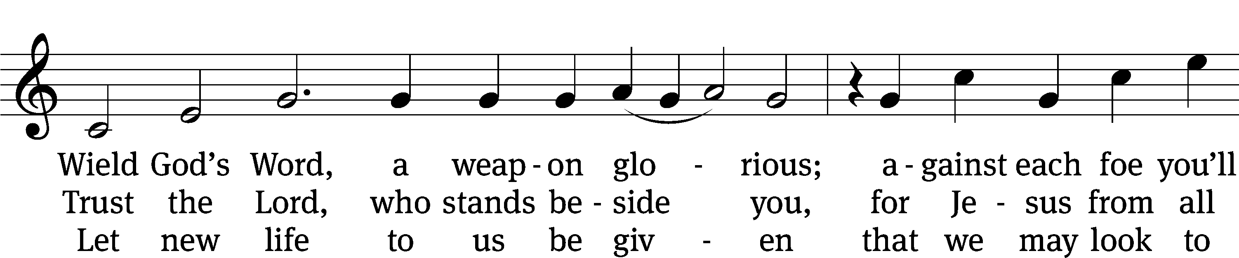
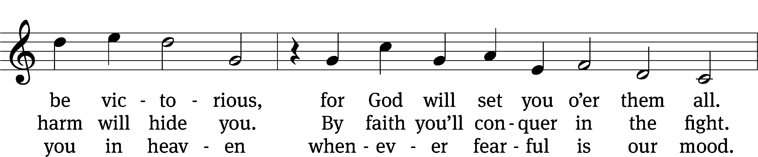
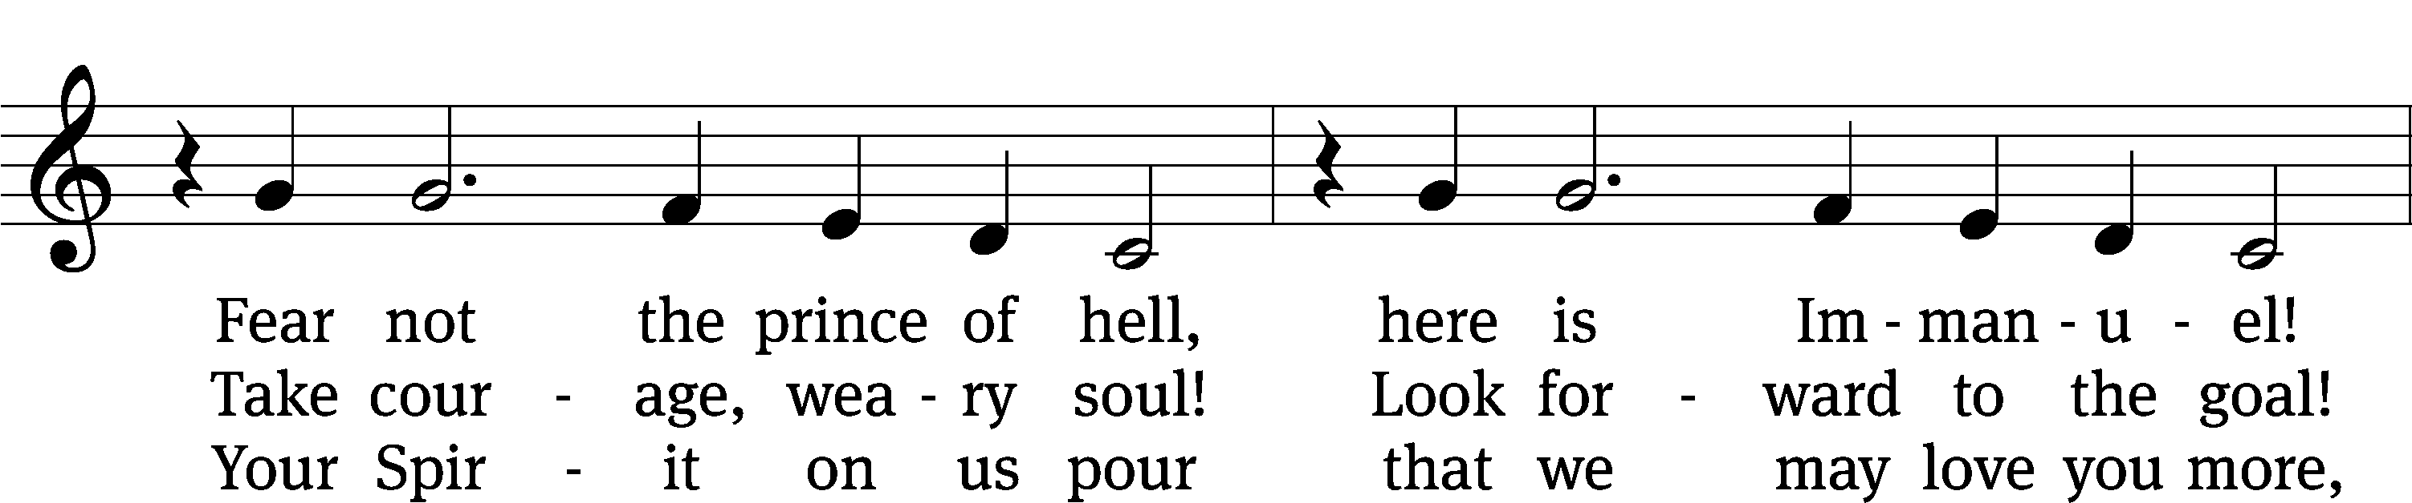
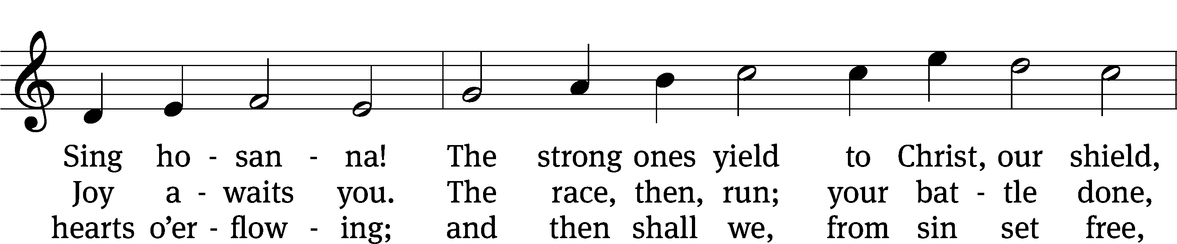
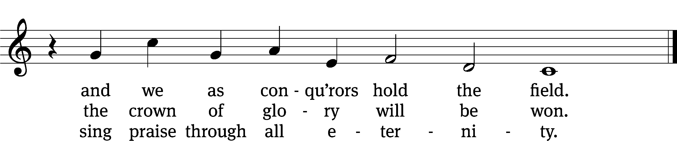
Text: tr. John M. Sloan, 1835–after 1890, alt.; Wilhelm E. Arends, 1677–1721, abr.
Tune: Philipp Nicolai, 1556–1608
Text and tune: Public domain

Please stand, if you are able
Invocation
In the name of the Father and of the Son and of the Holy Spirit.
Amen.
Confession
If we claim to be without sin, we deceive ourselves and the truth is not in us.
If we confess our sins, God is faithful and just
and will forgive us our sins
and purify us from all unrighteousness.

Let us confess our sins to the Lord.
Holy God, gracious Father,
I am sinful by nature
and have sinned against you in my thoughts, words, and actions.
I have not loved you with my whole heart;
I have not loved others as I should.
I deserve your punishment both now and forever.
But Jesus, my Savior, paid for my sins
with his innocent suffering and death.
Trusting in him, I pray: God, have mercy on me, a sinner.

Our gracious Father in heaven has been merciful to us. He sent his only Son, Jesus Christ, who gave his life as the atoning sacrifice for the sins of the whole world. Therefore, as a called servant of Christ and by his authority, I forgive you all your sins in the name of the Father and of the the Son and of the Holy Spirit.
Amen.

Lord, Have Mercy

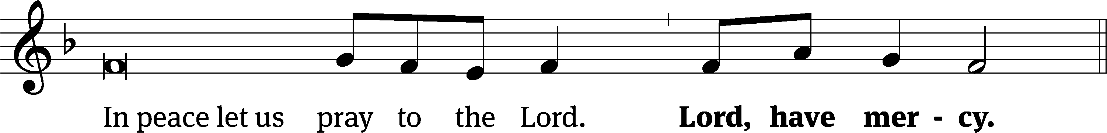
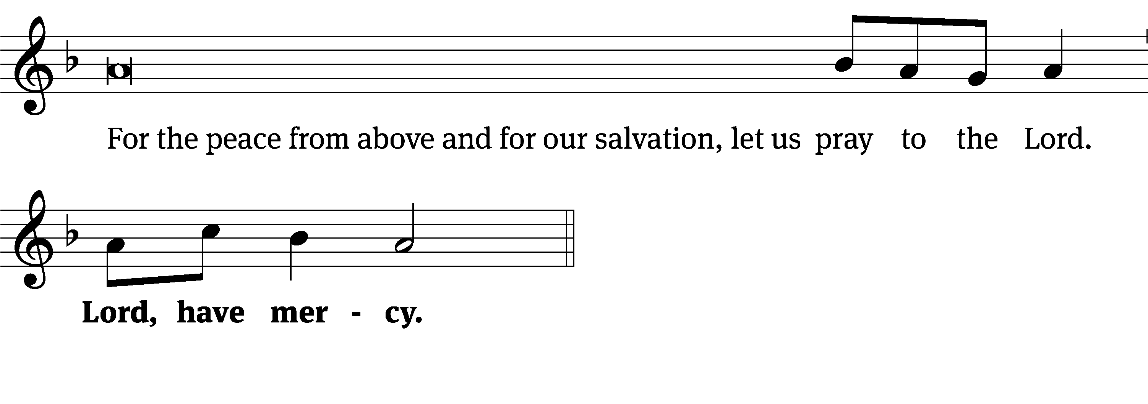
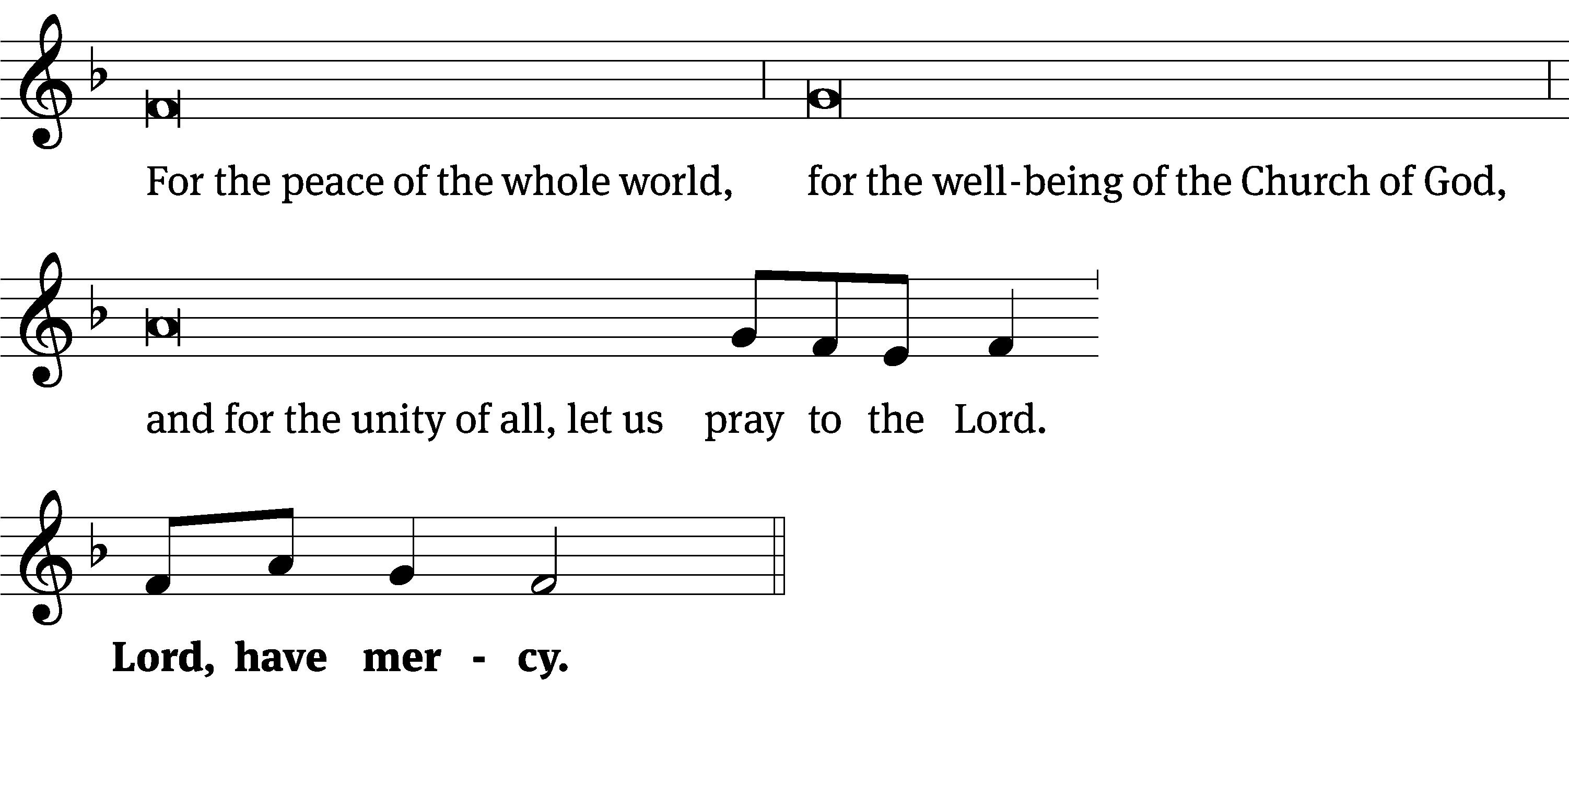
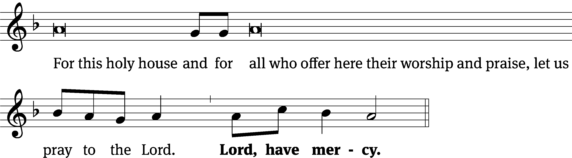
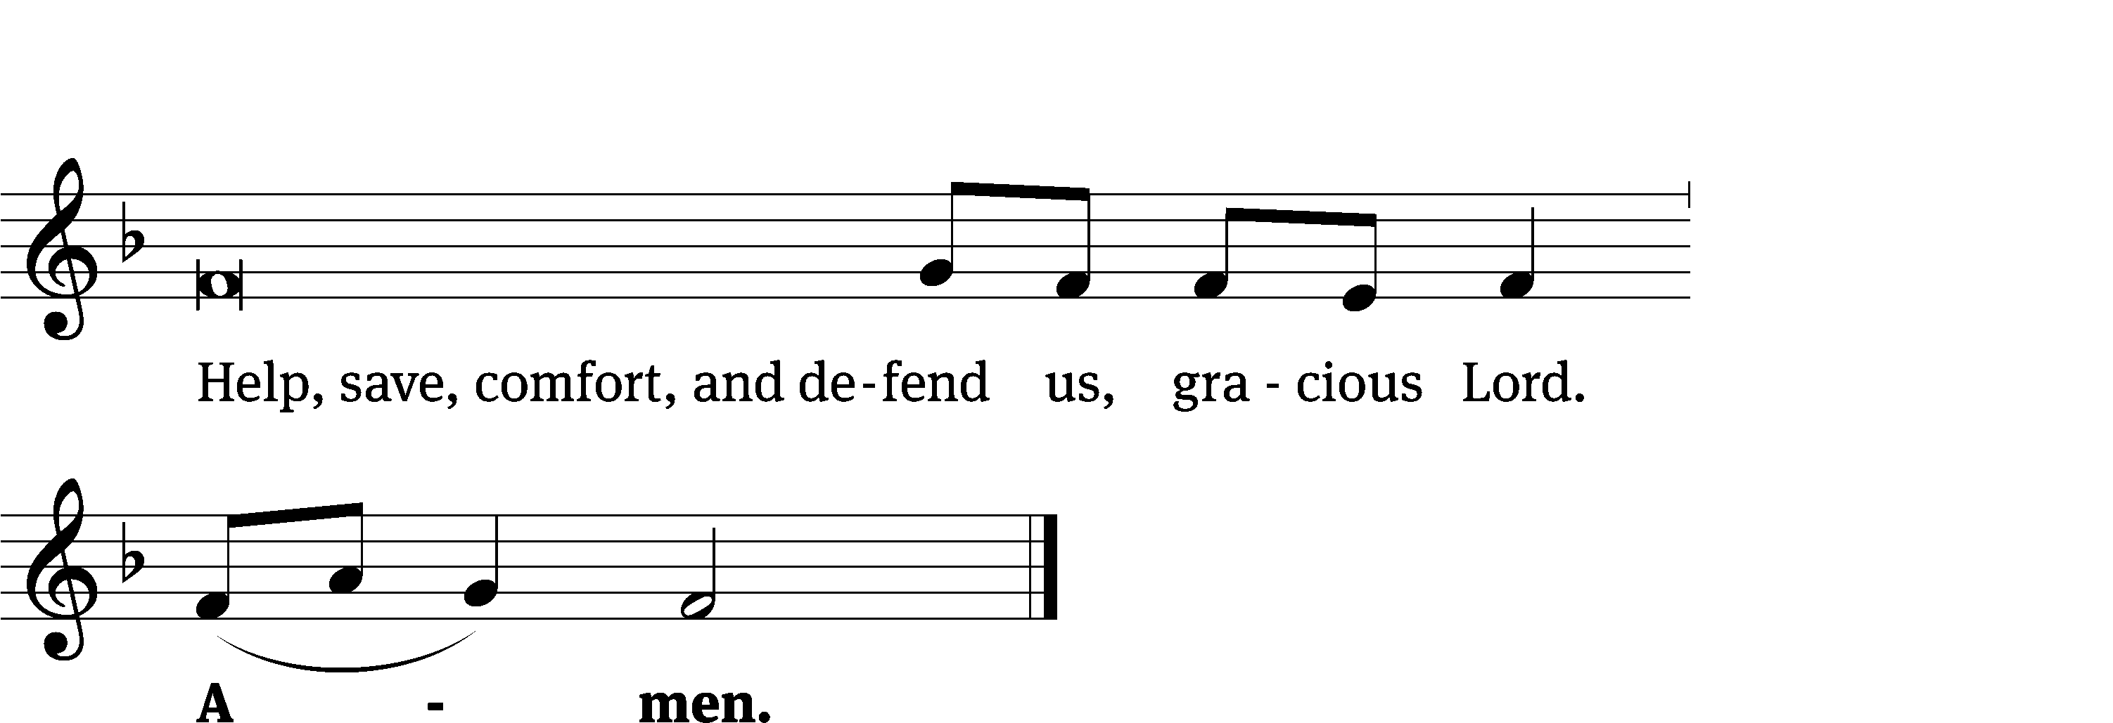

Glory Be to God CW 157
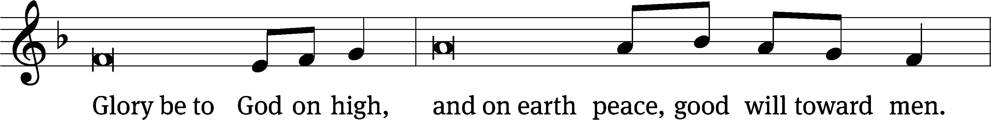
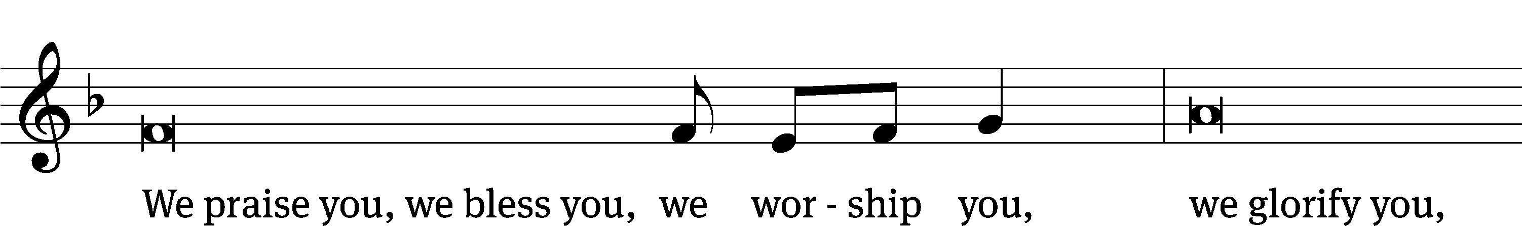
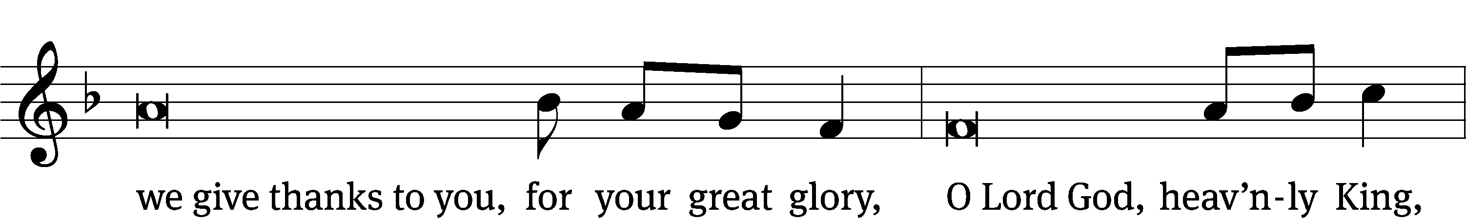
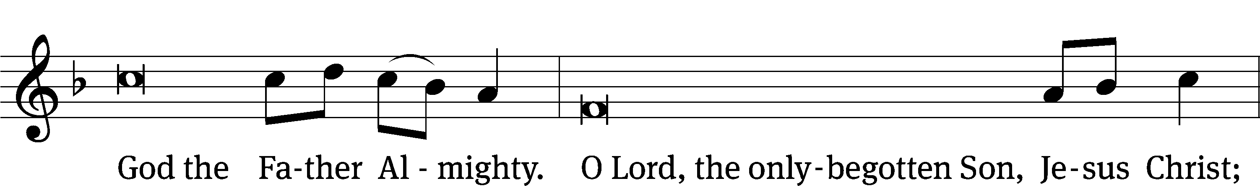
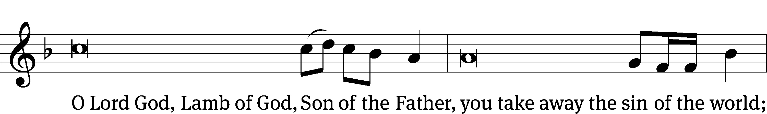
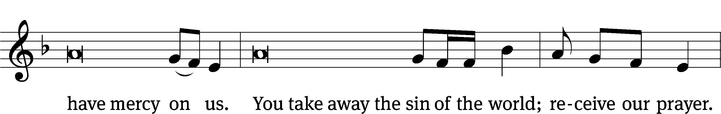
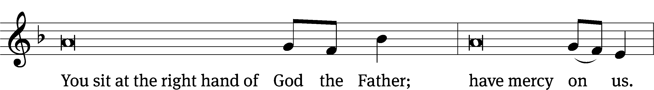
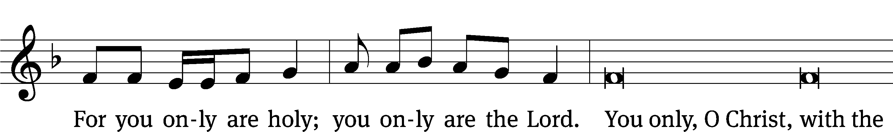
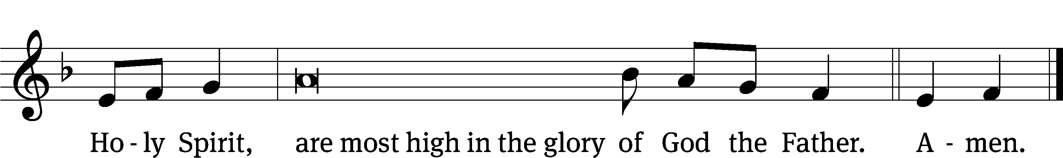

Tune: © 2021 Northwestern Publishing House. Used by permission: OneLicense no. 727703

The Lord be with you.
And also with you.
Prayer of the Day
Let us pray.

O Lord, your ears are always open to the prayers of your humble servants who come to you in Jesus’ name. Teach us always to ask according to your will that we may never fail to obtain the blessings you have promised; through your Son, Jesus Christ our Lord, who lives and reigns with you and the Holy Spirit, one God, now and forever.
Amen.

Please be seated

First Reading Genesis 18:20-32
²⁰ So the Lord said, “Because the outcry against Sodom and Gomorrah is great, and because their sin is very flagrant, ²¹ I will go down now and see if what they have done is as bad as the outcry that has come to me. If not, I will know.”
²² The two men turned from there and went toward Sodom, but Abraham remained standing before the Lord. ²³ Abraham approached him and said, “Will you really sweep away the righteous along with the wicked? ²⁴ What if there are fifty righteous people in the city? Will you really sweep them away and not spare the place for the sake of the fifty righteous who are in it? ²⁵ You would never do such a thing, killing the righteous along with the wicked, treating the righteous the same as the wicked. You would never do such a thing. The Judge of all the earth should do right, shouldn’t he?”
²⁶ The Lord said, “If I find fifty righteous people within the city of Sodom, then I will spare the entire place for their sake.”
²⁷ Abraham answered, “See now, I who am but dust and ashes have taken it on myself to speak to my Lord. ²⁸ What if there are five fewer than fifty righteous? Will you destroy the entire city if the number is five short?”
He said, “I will not destroy it if I find forty-five there.”
²⁹ He spoke to him yet again and said, “What if only forty are found there?”
He said, “I will not do it for the sake of the forty.”
³⁰ He said, “Please, do not be angry, my Lord, but I will speak again. What if thirty are found there?”
He said, “I will not do it if I find thirty there.”
³¹ He said, “See now, I have taken it upon myself to speak to my Lord. What if there are twenty found there?”
He said, “I will not destroy it for the sake of the twenty.”
³² He said, “Please, do not be angry, my Lord, but I will speak just once more. What if ten are found there?”
He said, “I will not destroy it for the sake of the ten.”

The Word of the Lord.
Thanks be to God.

Psalm of the Day
138A Your Praises, God, I’m Bringing Psalm 138A
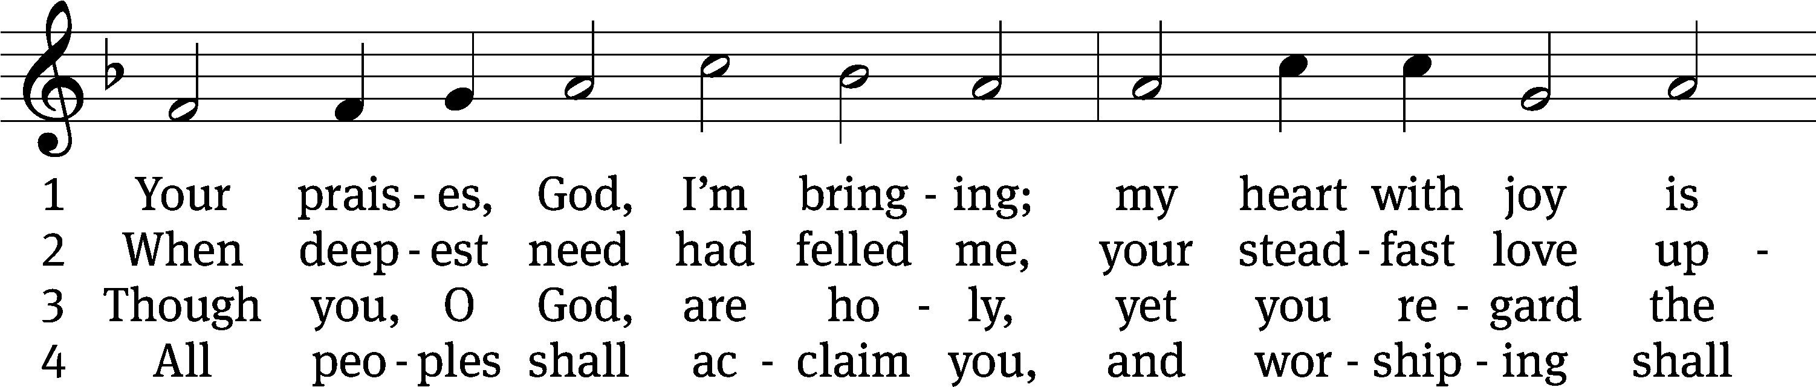
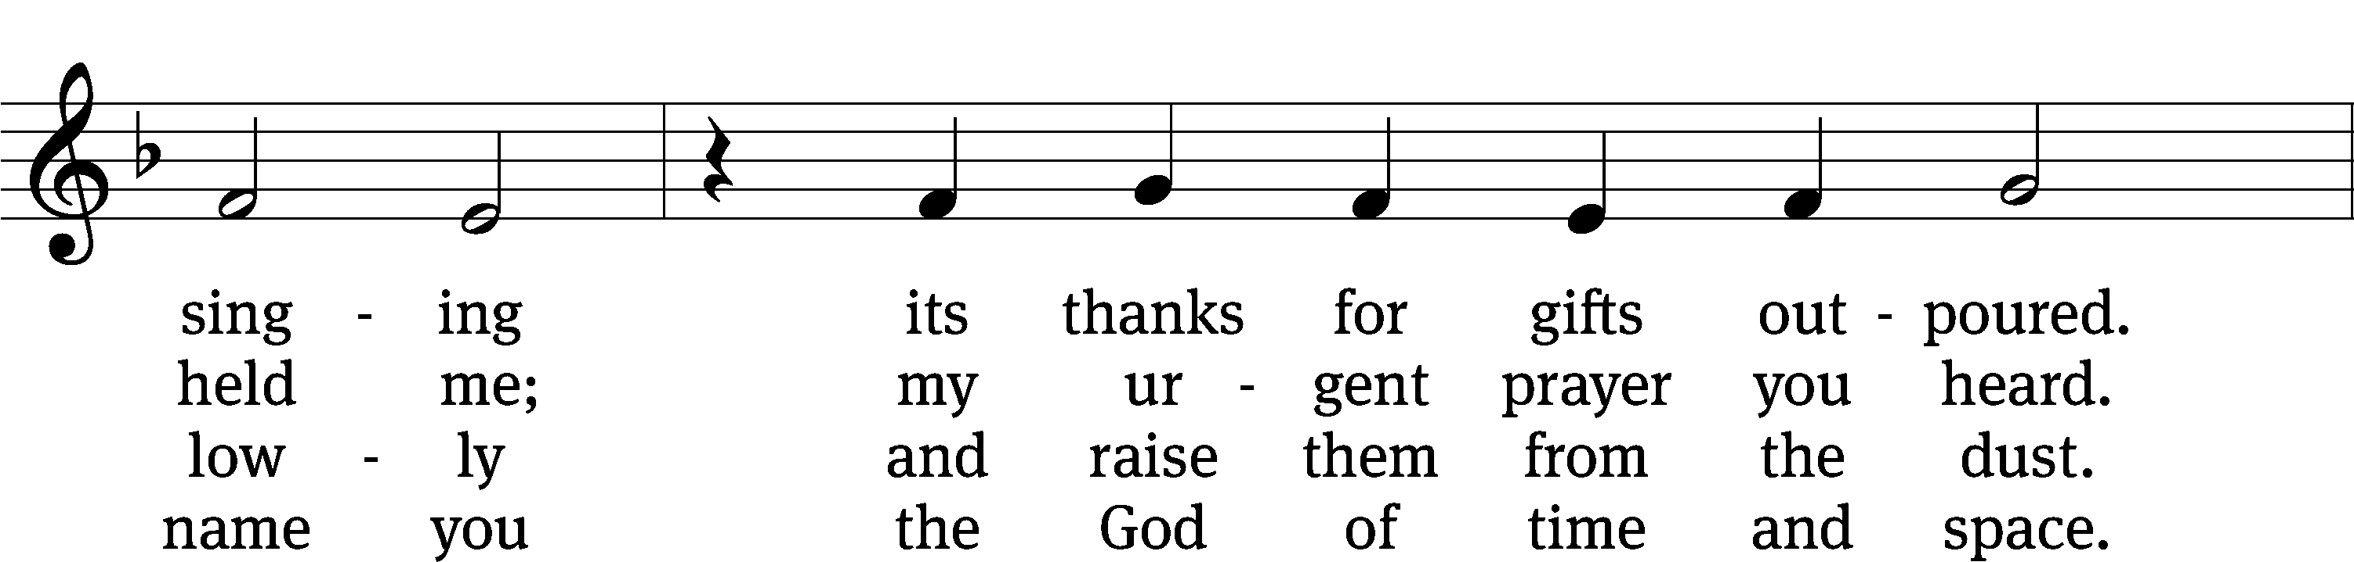
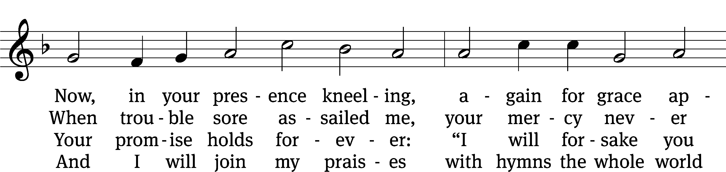
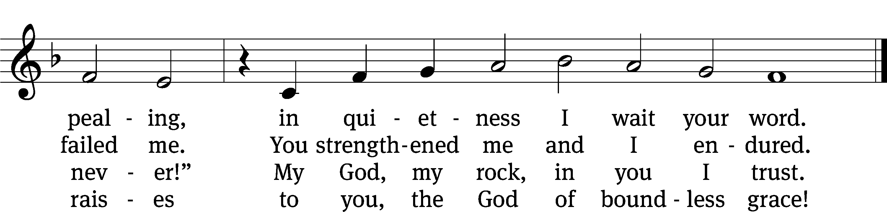
Text: Herman G. Stuempfle
Tune: Heinrich Isaac
Text: © 1997 GIA Publications, Inc. Used by permission: OneLicense no. 727703
Tune: Public domain

Second Reading 1 Timothy 2:1-7
¹ First of all, then, I urge that petitions, prayers, intercessions, and thanksgivings be made for all people, ² for kings and all those who are in authority, in order that we might live a quiet and peaceful life in all godliness and dignity. ³ This is good and pleasing in the sight of God our Savior, ⁴ who wants all people to be saved and to come to the knowledge of the truth. ⁵ For there is one God and one mediator between God and mankind, the man Christ Jesus, ⁶ who gave himself as a ransom for all, the testimony given at the proper time. ⁷ For this testimony, I was appointed a herald and an apostle—I speak the truth; I am not lying—a teacher of the Gentiles in faith and truth.

The Word of the Lord.
Thanks be to God.

Please stand, if you are able

Gospel Acclamation Luke 11:9
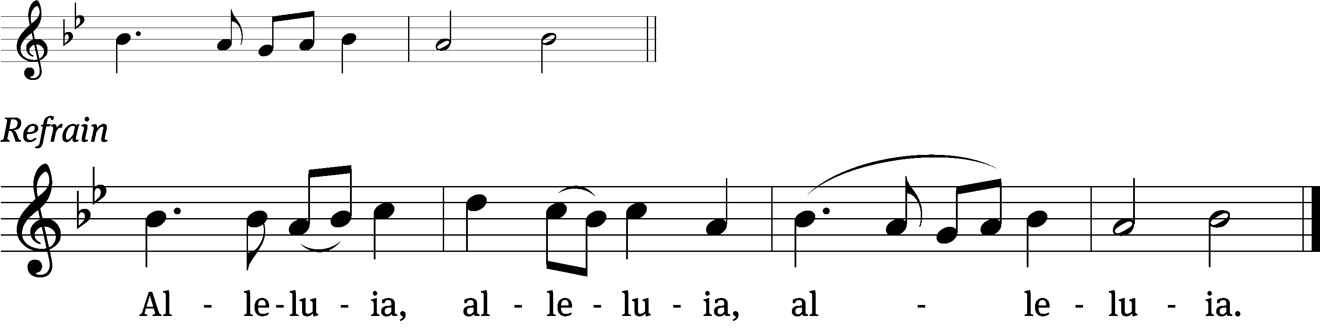
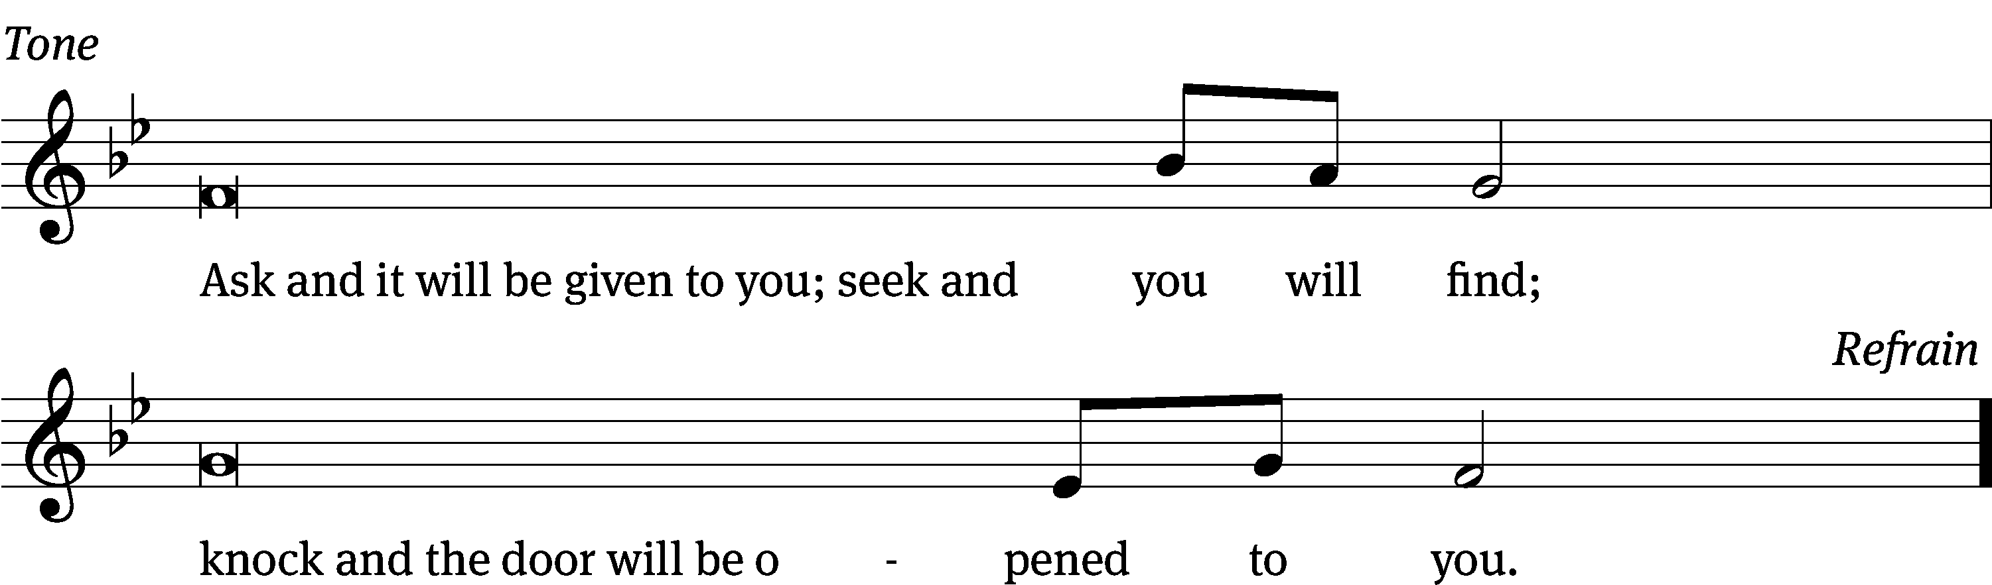
Tune: © 2021 Northwestern Publishing House. Used by permission: OneLicense no. 727703

Gospel Luke 11:1-13
¹ On another occasion, Jesus was praying in a certain place. When he finished, one of his disciples said to him, “Lord, teach us to pray, just as John also taught his disciples.”
² He said to them, “When you pray, say, ‘Our Father in heaven, hallowed be your name. Your kingdom come. Your will be done on earth as it is in heaven. ³ Give us each day our daily bread. ⁴ Forgive us our sins, as we also forgive everyone who sins against us. And lead us not into temptation, but deliver us from evil.’”
⁵ He said to them, “Suppose one of you has a friend, and you go to him at midnight and tell him, ‘Friend, lend me three loaves of bread, ⁶ because a friend of mine who is on a journey has come to me, and I do not have anything to set before him.’ ⁷ And the one inside replies, ‘Don’t bother me. The door is already locked, and my children and I are in bed. I can’t get up and give it to you.’ ⁸ I tell you, even if he will not get up and give him anything because he is his friend, yet because of his bold persistence, he will get up and give him as much as he needs.
⁹ “I tell you, keep asking, and it will be given to you. Keep seeking, and you will find. Keep knocking, and it will be opened to you. ¹⁰ For everyone who asks receives. The one who seeks finds. And to the one who knocks, it will be opened.
¹¹ “What father among you, if your son asks for bread, would give him a stone? Or if he asks for a fish, would give him a snake instead of a fish? ¹² Or if he asks for an egg, would give him a scorpion? ¹³ If you then, though you are evil, know how to give good gifts to your children, how much more will your heavenly Father give the Holy Spirit to those who ask him?”

The Gospel of the Lord.
Praise be to you, O Christ!

Please be seated

719 Lord, Teach Us How to Pray CW 719
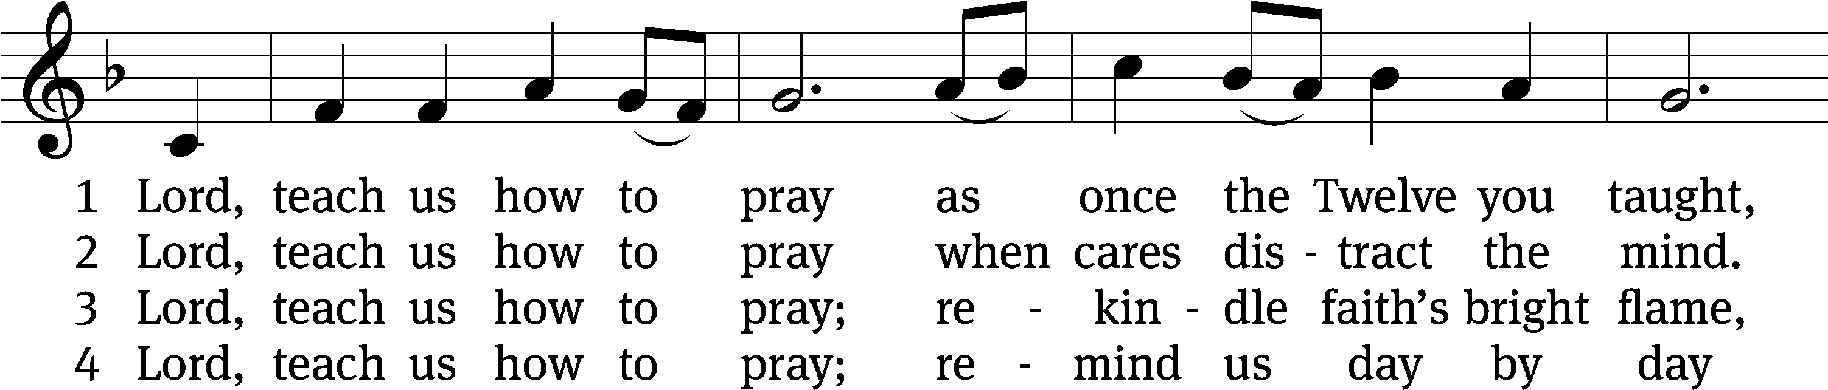
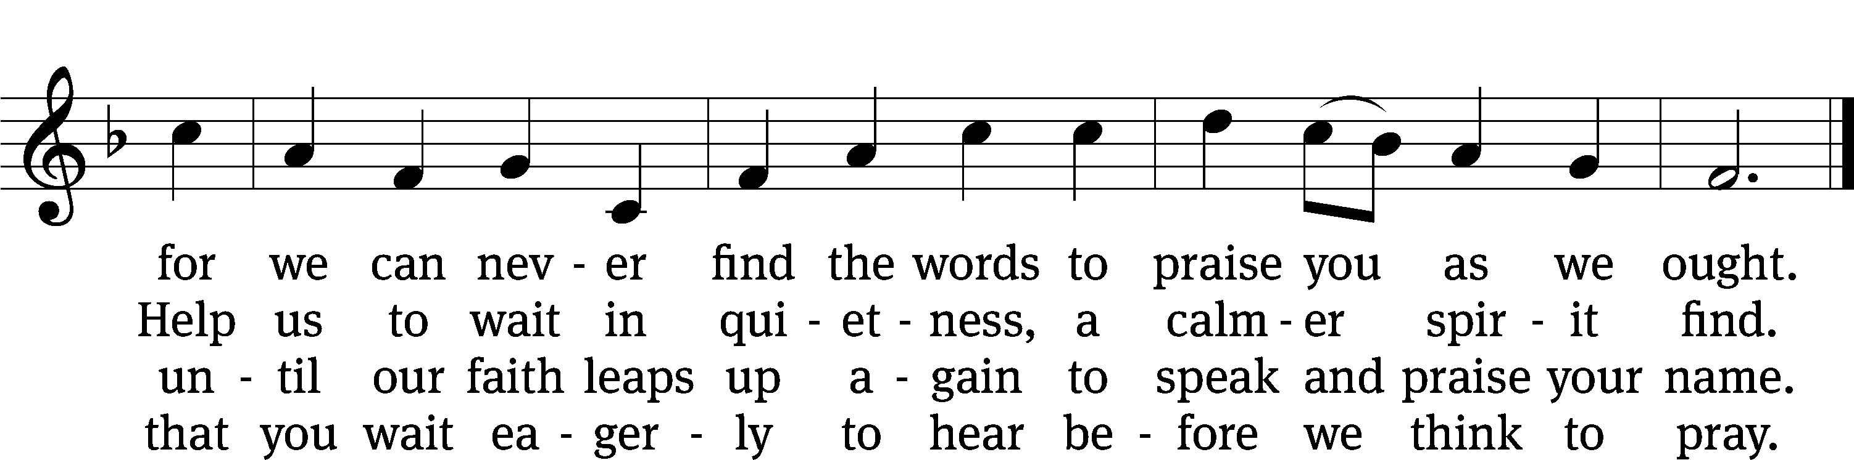
Text: Herman G. Stuempfle, Jr., 1923–2007
Tune: Aaron Williams, 1731–1776
Text: © 2000 GIA Publications, Inc. Used by permission: OneLicense no. 727703
Tune: Public domain

Sermon Luke 11:1-13
“Pray to Our Father”

Please stand, if you are able
Apostles’ Creed
I believe in God, the Father Almighty,
maker of heaven and earth.

I believe in Jesus Christ, his only Son, our Lord,
who was conceived by the Holy Spirit,
born of the Virgin Mary,
suffered under Pontius Pilate,
was crucified, died, and was buried.
He descended into hell.
The third day he rose again from the dead.
He ascended into heaven
and is seated at the right hand of God the Father Almighty.
From there he will come to judge the living and the dead.

I believe in the Holy Spirit,
the holy Christian Church,
the communion of saints,
the forgiveness of sins,
the resurrection of the body,
and the life everlasting. Amen.

Prayer of the Church
722 In Holy Conversation CW 722
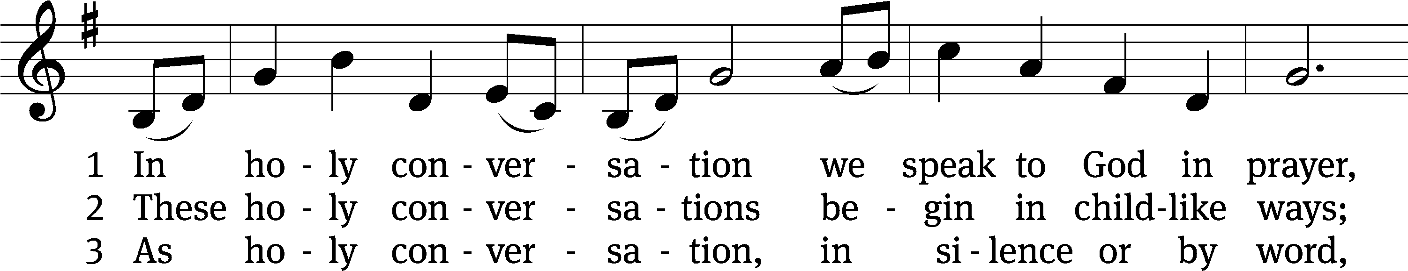
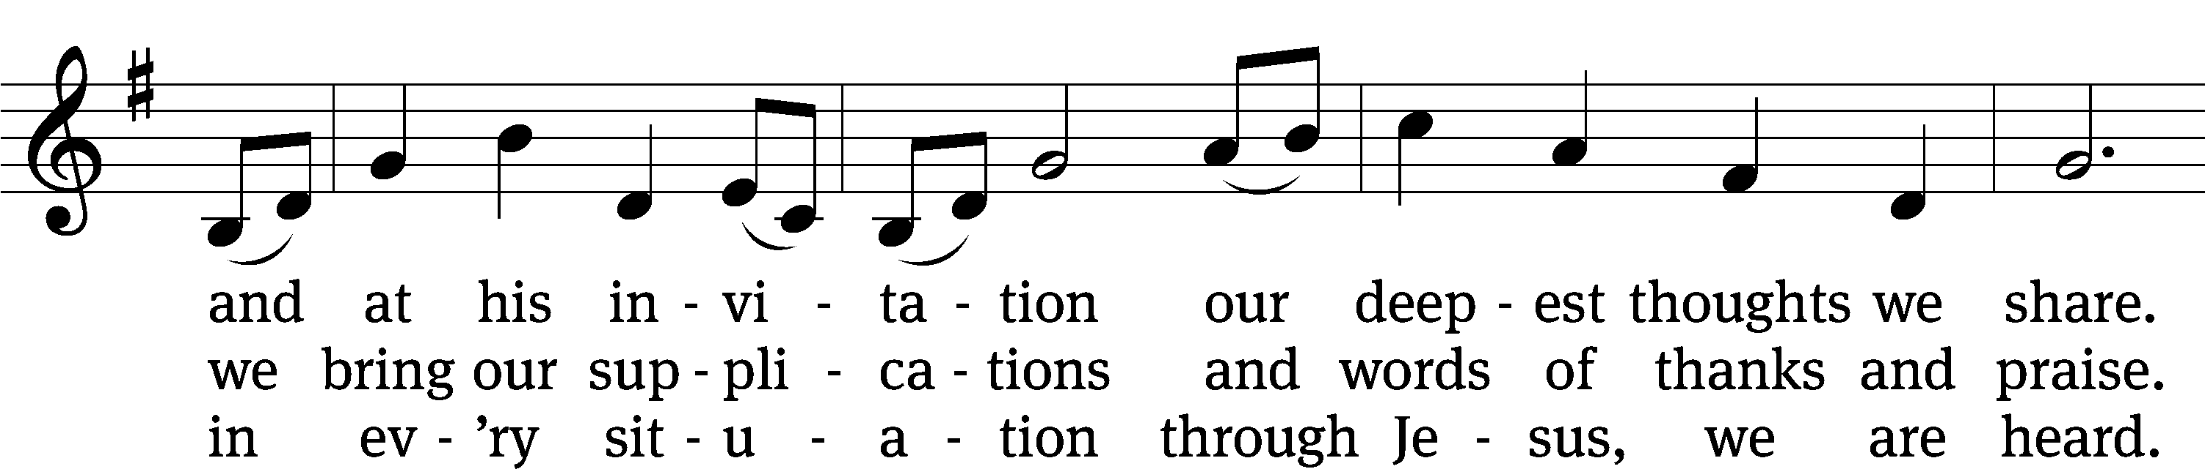
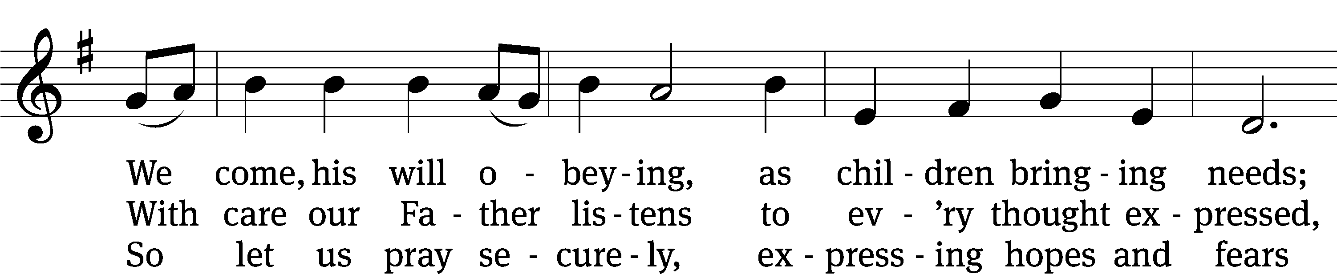
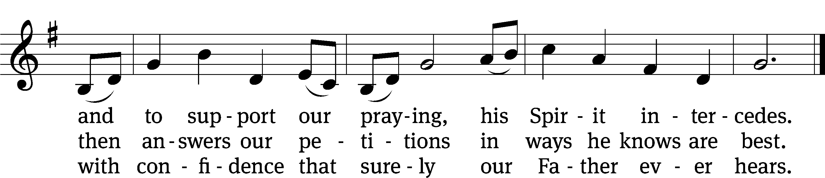
Text: Gregory J. Wismar, b. 1946
Tune: Swedish
Text: © 2004 Gregory J. Wismar. Used by permission: OneLicense no. 727703
Tune: Public domain

Prayer

Blessed Lord, you have given us your Holy Scriptures for our learning. May we so hear them, read, learn, and take them to heart that, being strengthened and comforted by your holy Word,
we may cling to the blessed hope of everlasting life; through Jesus Christ our Lord, who lives and reigns with you and the Holy Spirit, one God, now and forever.
Amen.
Lord’s Prayer
Our Father, who art in heaven, hallowed be thy name, thy kingdom come, thy will be done on earth as it is in heaven. Give us this day our daily bread; and forgive us our trespasses, as we forgive those who trespass against us; and lead us not into temptation, but deliver us from evil. For thine is the kingdom and the power and the glory forever and ever. Amen.

Blessing
The Lord bless you and keep you.
The Lord make his face shine on you and be gracious to you.
The Lord look on you with favor and give you peace.
Amen.

Please be seated

925 On What Has Now Been Sown CW 925
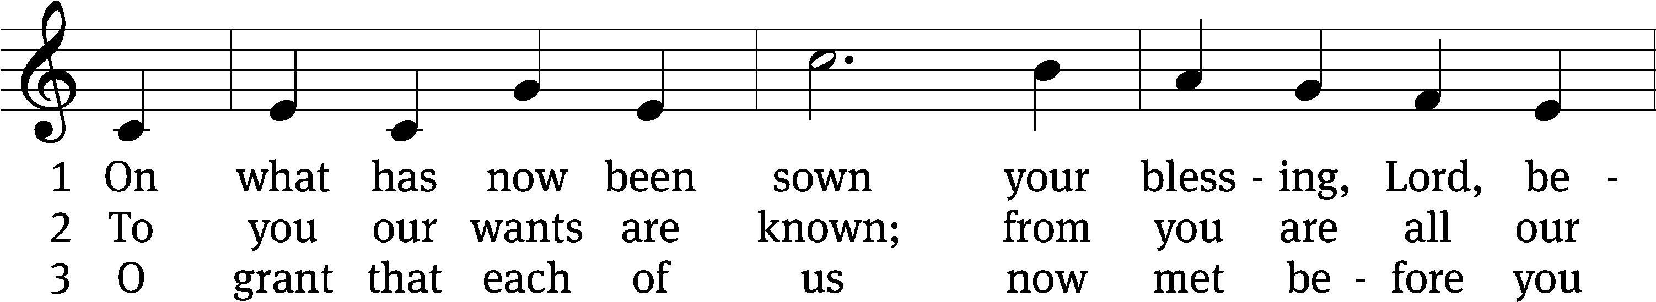
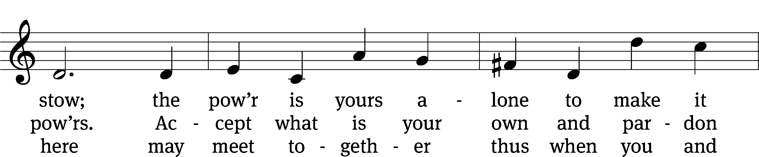
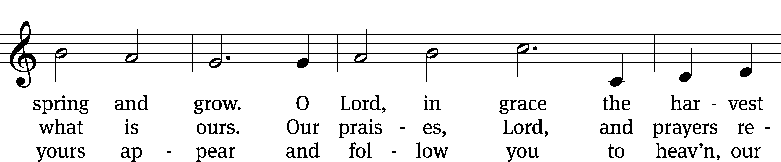
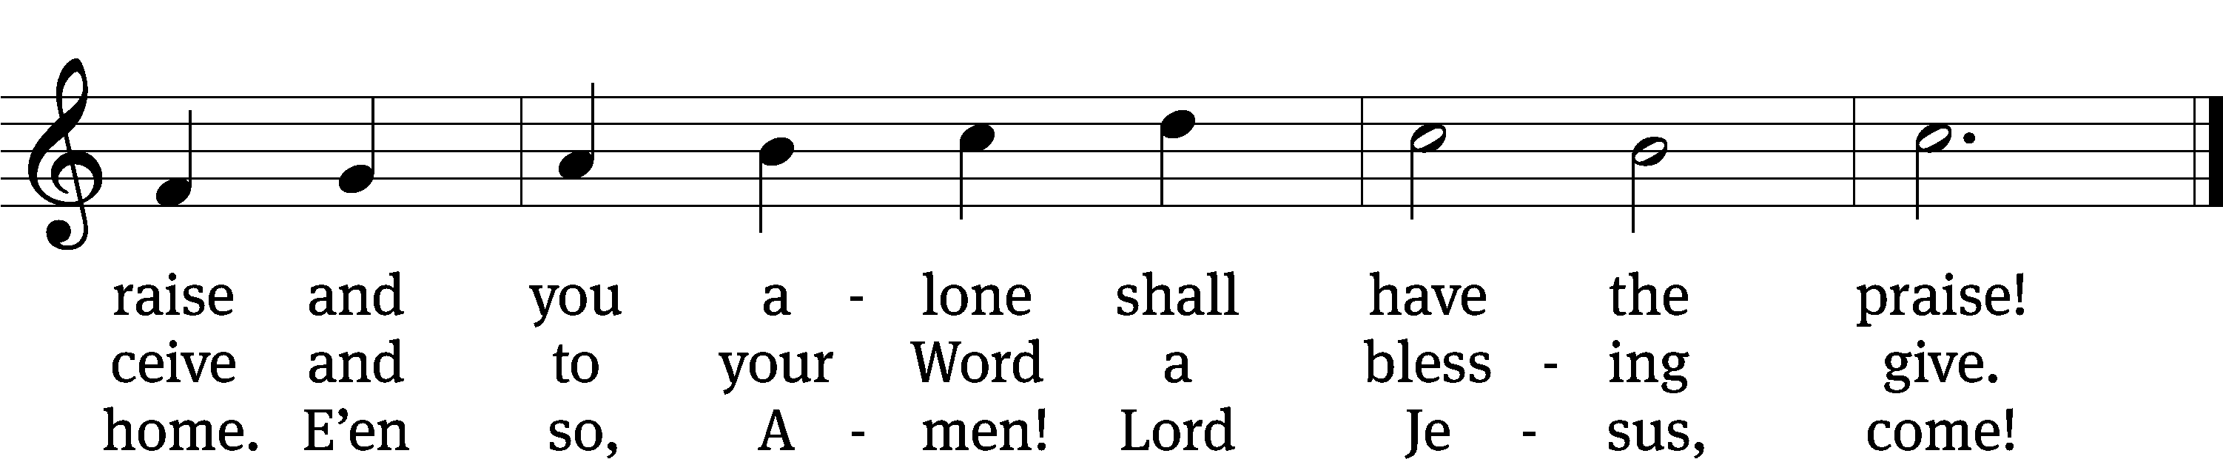
Text: John Newton, 1725–1807, adapt., alt.
Tune: John Darwall, 1731–1789
Text and tune: Public domain

Acknowledgments
Setting One from Christian Worship
Software distributed in partnership with Northwestern Publishing House.
Created by Christian Worship: Service Builder © 2022 Concordia Publishing House.

Serving in Worship
Officiant Pastor Natsis
Organist Marcia Marion Ackling
Deacons (Thursday) Steve Hoeft and Jim Tice
(Sunday) Jeff Neuburger and Dave Stevenson
Ushers (Thursday) Dale Finkbeiner and Mark Finkbeiner
(Sunday) Ed Sala and Al Whitley
Altar Guild Esther Gross and Diane Stevenson
Videographer Cindy Dresch

