EIGHTH SUNDAY AFTER PRENTECOST

TRINITY EVANGELICAL LUTHERAN CHURCH | Saline, Michigan
WELCOME TO WORSHIP July 28/31, 2022
Thank you for joining us in God’s house today! We cordially ask that our Guests sign one of the guestbooks located at either the front or back entryways, or fill out a “Let’s Get Acquainted” card located in the hymnal pew rack and place it in the collection plate.

THANK OFFERING: Members of Trinity give their offering as an expression of love and thankfulness to the Lord and to help support the Lord’s work in our community and around the world. Visitors need not feel obligated to participate in this offering which supports our ministry.

Restrooms are located at the back of the upper level (the annex), and in the basement (down the back stairs of the sanctuary or annex). Handicap access is available, please ask an usher for assistance.

Young Families / Toddler Bags – We are GLAD YOU BROUGHT YOUR CHILDREN to our worship service. Jesus said: “Let the little children come to me and do not hinder them, for the kingdom of God belongs to such as these.” We know that having little children in church can be a challenge, but DO NOT WORRY about it. Many of your fellow worshippers have been in your shoes and are just happy you brought your children with you. For your convenience, we have reserved the back rows of seating for parents with small children. These areas provide more flexibility for your family, as well as, easy access to move downstairs if necessary. A closed-circuit TV system allows families to continue participating in the service while downstairs. Pre-school toddler bags and children’s bulletins are available for their enjoyment. Ask an usher for one to use during the service and please return the toddler bag afterwards.

the SERVICE – setting one – american hymn tunes
717 What Is the World to Me CW 717
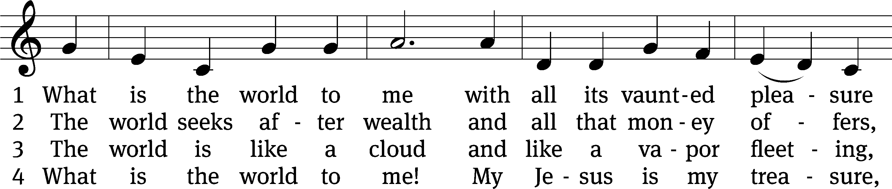
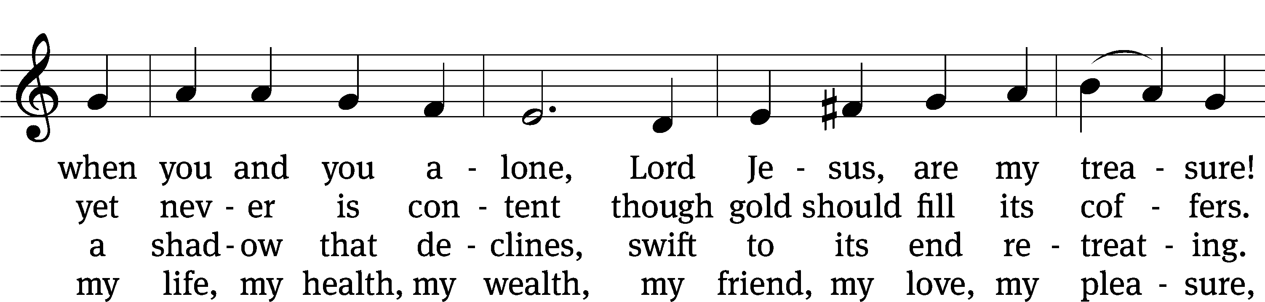
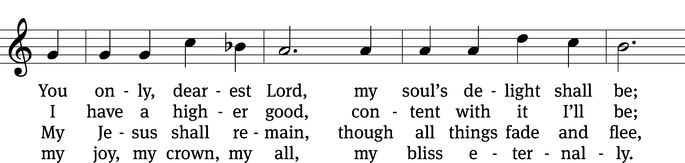
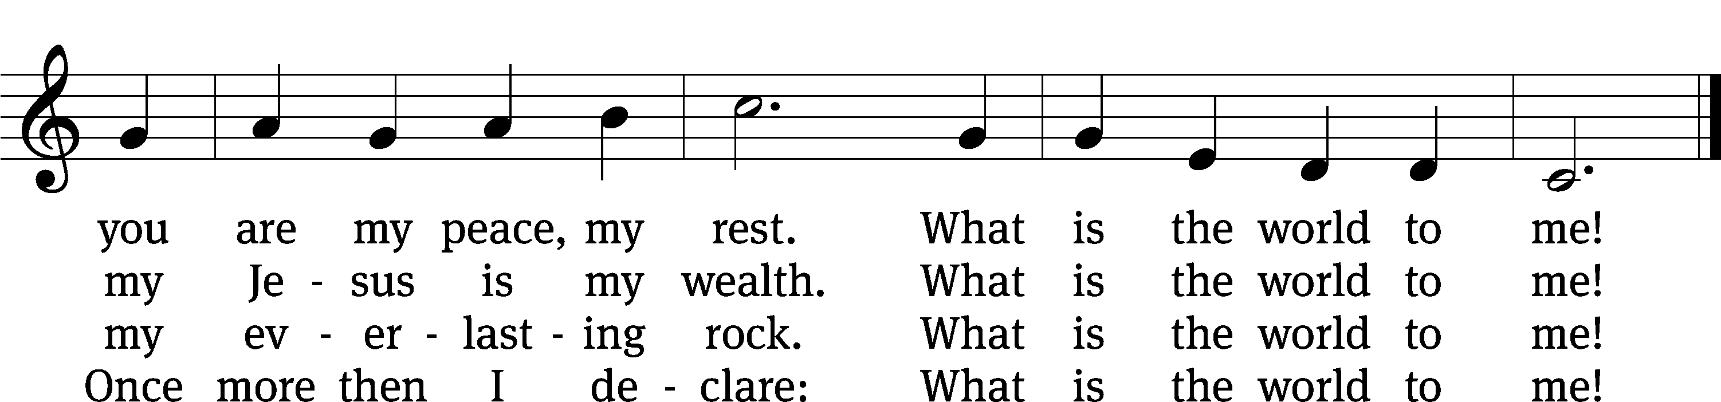
Text: tr. August Crull, 1845–1923, alt.; Georg M. Pfefferkorn, 1645–1732, abr.
Tune: Ahasverus Fritsch, 1629–1701
Text and tune: Public domain

Please stand, if you are able
Invocation
In the name of the Father and of the Son and of the Holy Spirit.
Amen.
Confession
If we claim to be without sin, we deceive ourselves and the truth is not in us.
If we confess our sins, God is faithful and just
and will forgive us our sins
and purify us from all unrighteousness.

Let us confess our sins to the Lord.
Holy God, gracious Father,
I am sinful by nature
and have sinned against you in my thoughts, words, and actions.
I have not loved you with my whole heart;
I have not loved others as I should.
I deserve your punishment both now and forever.
But Jesus, my Savior, paid for my sins
with his innocent suffering and death.
Trusting in him, I pray: God, have mercy on me, a sinner.

Our gracious Father in heaven has been merciful to us. He sent his only Son, Jesus Christ, who gave his life as the atoning sacrifice for the sins of the whole world. Therefore, as a called servant of Christ and by his authority, I forgive you all your sins in the name of the Father and of the the Son and of the Holy Spirit.
Amen.
Lord, Have Mercy
In peace let us pray to the Lord.
Lord, have mercy.

For the peace from above and for our salvation, let us pray to the Lord.
Lord, have mercy.

For the peace of the whole world, for the well-being of the Church of God, and for the unity of all, let us pray to the Lord.
Lord, have mercy.

For this holy house and for all who offer here their worship and praise, let us pray to the Lord.
Lord, have mercy.

Help, save, comfort, and defend us, gracious Lord.
Amen.
Glory to God in the Highest
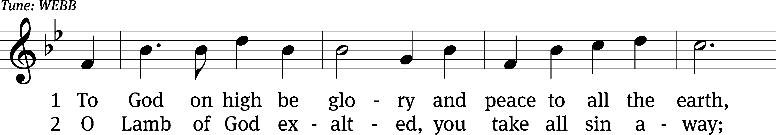
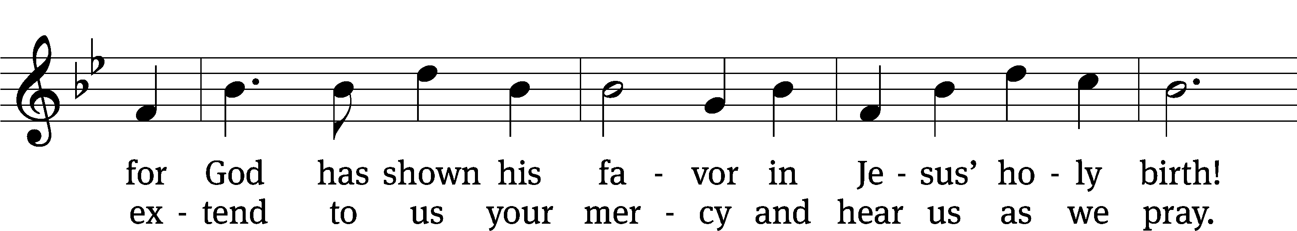
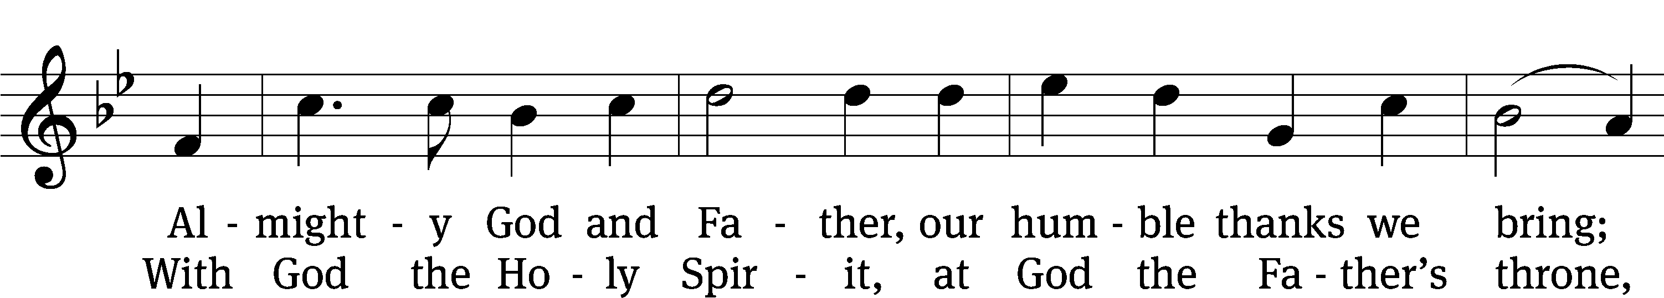
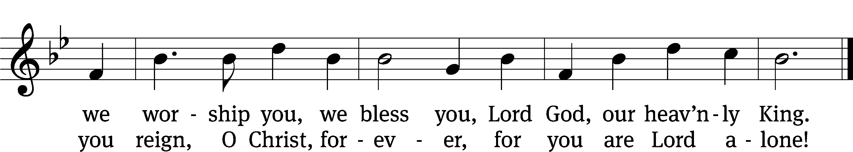
Text: Michael D. Schultz
Text: © 2021 Northwestern Publishing House. Used by permission: OneLicense no. 727703

The Lord be with you.
And also with you.
Prayer of the Day
Let us pray.

O Lord, grant us wisdom to recognize the treasures you have stored up for us in heaven that we may never despair but always rejoice and be thankful for the riches of your grace; through your Son, Jesus Christ our Lord, who lives and reigns with you and the Holy Spirit, one God, now and forever.
Amen.
Please be seated

First Reading Ecclesiastes 1:1-2, 12-14; 2:18-26
¹ The words of Ecclesiastes, David’s son, king in Jerusalem.
² “Nothing but vapor,” Ecclesiastes said. “Totally vapor. Everything is just vapor that vanishes.”
¹² I, Ecclesiastes, have been king over Israel in Jerusalem. ¹³ I applied my heart to seek out and explore with wisdom everything done under the sky. (What a burdensome task^{[b]} God has given the children of Adam to keep them busy!) ¹⁴ I have seen all the actions done under the sun, and, look, it is all nothing but vapor. It is all chasing the wind.
¹⁸ I also hated all the results of my hard work, for which I worked so hard under the sun, since I must leave it all to the man who comes after me. ¹⁹ And who knows—will he be wise, or a fool? Yet he will have control over all the results of my hard work, for which I worked so hard and so wisely, under the sun. This too is vapor that vanishes.
²⁰ So I changed my course, and my heart began to despair over all my hard work at which I worked so hard under the sun. ²¹ Sure, there may be a man who has worked hard—wisely, aptly, and skillfully. But he must hand over whatever he accumulated by all his hard work to a man who has not worked hard for it. This too is vapor. It’s so unfair! ²² For what does a man gain through all his hard work, through all the turmoil in his heart, as he works so hard under the sun?
²³ Pain fills all his days. His occupation is frustration. Even at night his heart does not rest. This too is vapor.
²⁴ There is nothing better for a man than to eat and to drink and to find joy in his work. This too, I saw, is from God’s hand. ²⁵ For who can eat or enjoy himself apart from him?^{[a]} ²⁶ Yes, God gives wisdom, knowledge, and happiness to the man whom he considers good, but to the person who goes on sinning God gives the task of gathering and collecting, but only so that he can give it all to a person whom God considers good. This too is vapor, nothing but chasing wind.

The Word of the Lord.
Thanks be to God.

Psalm of the Day
90D O God, Our Help in Ages Past Psalm 90D
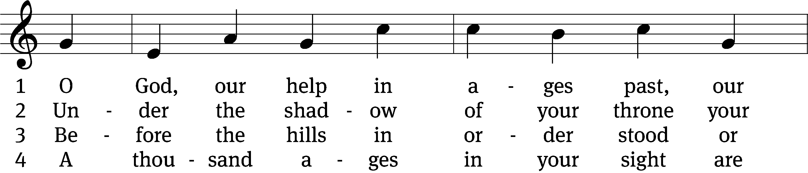
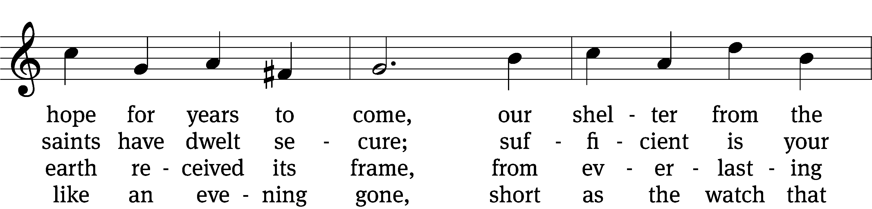
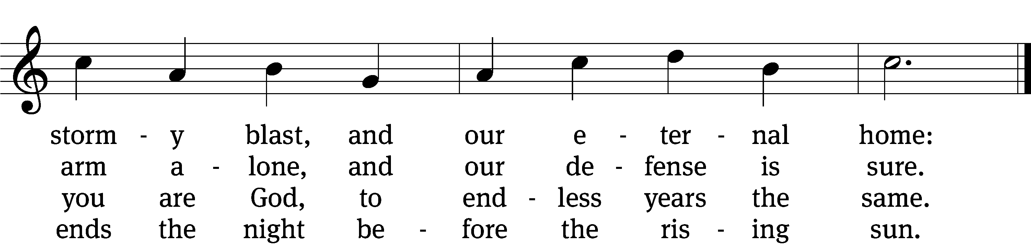

5 Time, like an everrolling stream,
soon bears us all away;
we fly forgotten, as a dream
dies at the op’ning day.

6 O God, our help in ages past,
our hope for years to come,
still be our guard while troubles last
and our eternal home!
Text: Isaac Watts, abr., alt.
Tune: William Croft
Text and tune: Public domain

Second Reading Colossians 3:1-11
¹ Therefore, because you were raised with Christ, seek the things that are above, where Christ is seated at the right hand of God. ² Set your mind on things above, not on earthly things. ³ For you died, and your life is hidden with Christ in God. ⁴ When Christ, who is your life, appears, then you also will appear with him in glory.
⁵ So put to death whatever is worldly in you: sexual immorality, uncleanness, lust, evil desire, and greed, which is idolatry. ⁶ It is because of these things that the wrath of God is coming on the sons of disobedience. ⁷ You too once walked in these things, when you were living in them.
⁸ But now, you too are to rid yourselves of all of these: wrath, anger, malice, slander, and filthy language from your mouth. ⁹ Do not lie to each other since you have put off the old self with its practices, ¹⁰ and put on the new self, which is continually being renewed in knowledge, according to the image of its Creator. ¹¹ Here there is no Greek or Jew, circumcision or uncircumcision, barbarian, Scythian, slave or free, but rather Christ is all and is in all.

The Word of the Lord.
Thanks be to God.

Please stand, if you are able
Gospel Acclamation Matthew 6:20,21
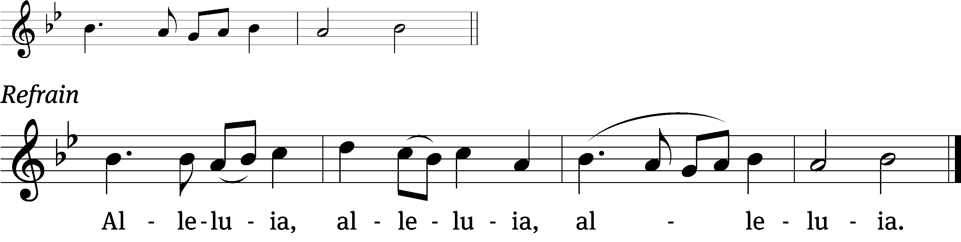
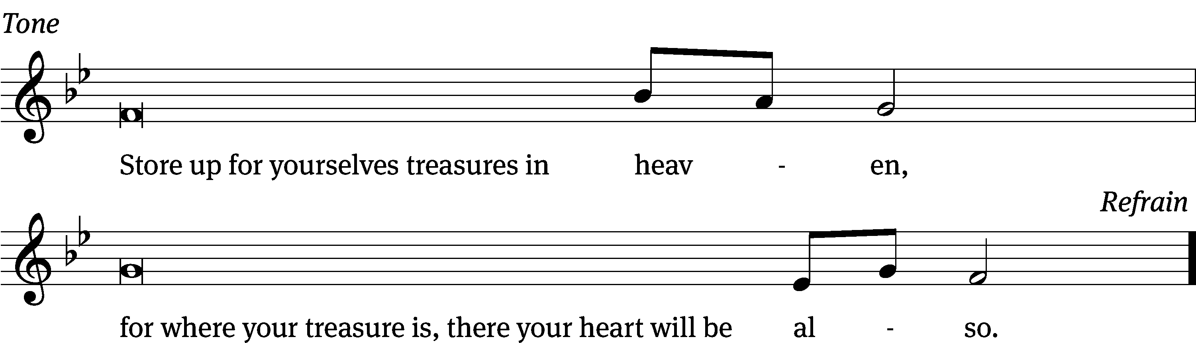
Tune: © 2021 Northwestern Publishing House. Used by permission: OneLicense no. 727703

Gospel Luke 12:13-21
¹³ Someone from the crowd said to him, “Teacher, tell my brother to divide the inheritance with me.” ¹⁴ But Jesus said to him, “Man, who appointed me to be a judge or an arbitrator over you?”
¹⁵ Then he said to them, “Watch out and be on guard against all greed, because a man’s life is not measured by how many possessions he has.”
¹⁶ He told them a parable: “The land of a certain rich man produced very well. ¹⁷ He was thinking to himself, ‘What will I do, because I do not have anywhere to store my crops?’ ¹⁸ He said, ‘This is what I will do. I will pull down my barns and build bigger ones, and there I will store all my grain and goods. ¹⁹ And I will tell my soul, “Soul, you have many goods stored up for many years. Take it easy. Eat, drink, and be merry.”’
²⁰ “But God said to him, ‘You fool, this night your soul will be demanded from you. Now who will get what you have prepared?’
²¹ “That is how it will be for anyone who stores up treasure for himself and is not rich toward God.”

The Gospel of the Lord.
Praise be to you, O Christ!

Please be seated
Sermon Hymn
807 All Depends on Our Possessing CW 807
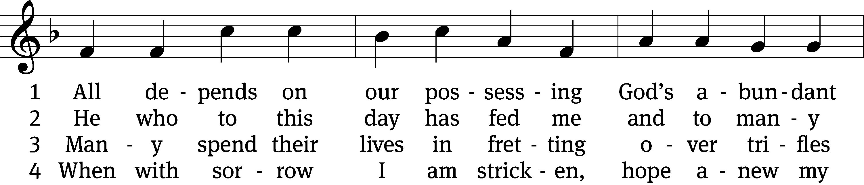
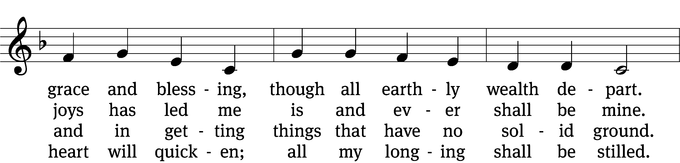
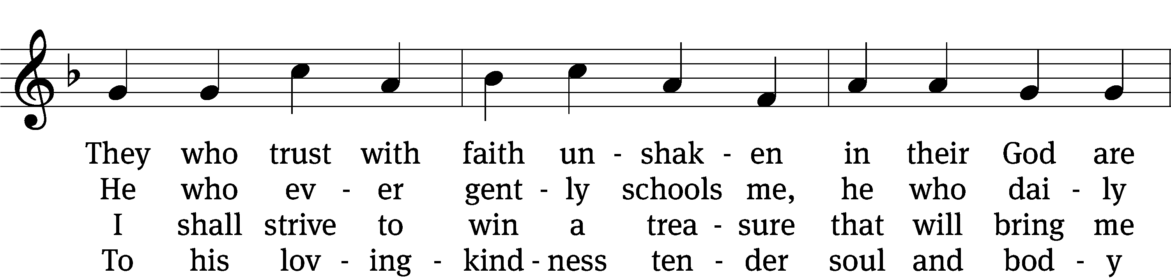
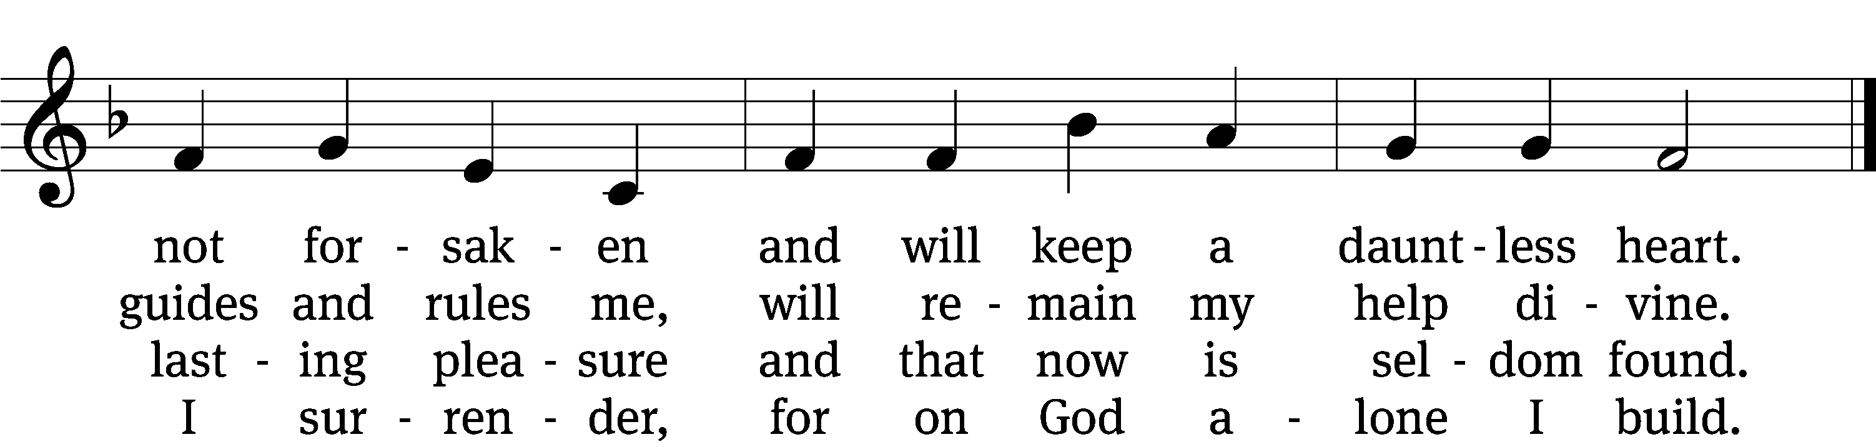

5 Well he knows what best to grant me;
all the longing hopes that haunt me,
joy and sorrow, have their day.
I shall doubt his wisdom never;
as God wills, so be it ever;
I commit to him my way.

6 If my days on earth he lengthen,
he my weary soul will strengthen;
all my trust in him I place.
Earthly wealth is not abiding,
like a stream away is gliding;
safe I anchor in his grace.
Text: tr. Catherine Winkworth, 1827–1878, alt.; Andächtige Haus-Kirche, Nürnberg, 1676
Tune: adapt. Johann Balthasar König, 1691–1758; Johann Löhner, 1645–1705
Text and tune: Public domain

Sermon Luke 12:13-21
“Guard against Greed”

Please stand, if you are able
Apostles’ Creed
I believe in God, the Father Almighty,
maker of heaven and earth.

I believe in Jesus Christ, his only Son, our Lord,
who was conceived by the Holy Spirit,
born of the Virgin Mary,
suffered under Pontius Pilate,
was crucified, died, and was buried.
He descended into hell.
The third day he rose again from the dead.
He ascended into heaven
and is seated at the right hand of God the Father Almighty.
From there he will come to judge the living and the dead.

I believe in the Holy Spirit,
the holy Christian Church,
the communion of saints,
the forgiveness of sins,
the resurrection of the body,
and the life everlasting. Amen.

Prayer of the Church
698 Seek Where You May to Find a Way CW 698
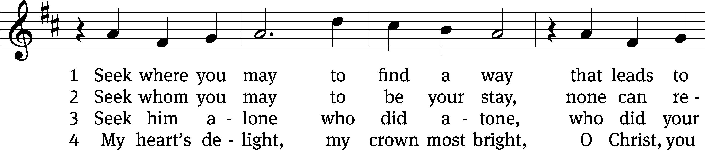
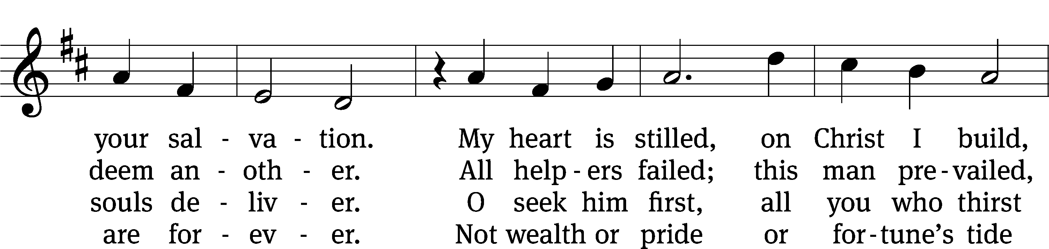
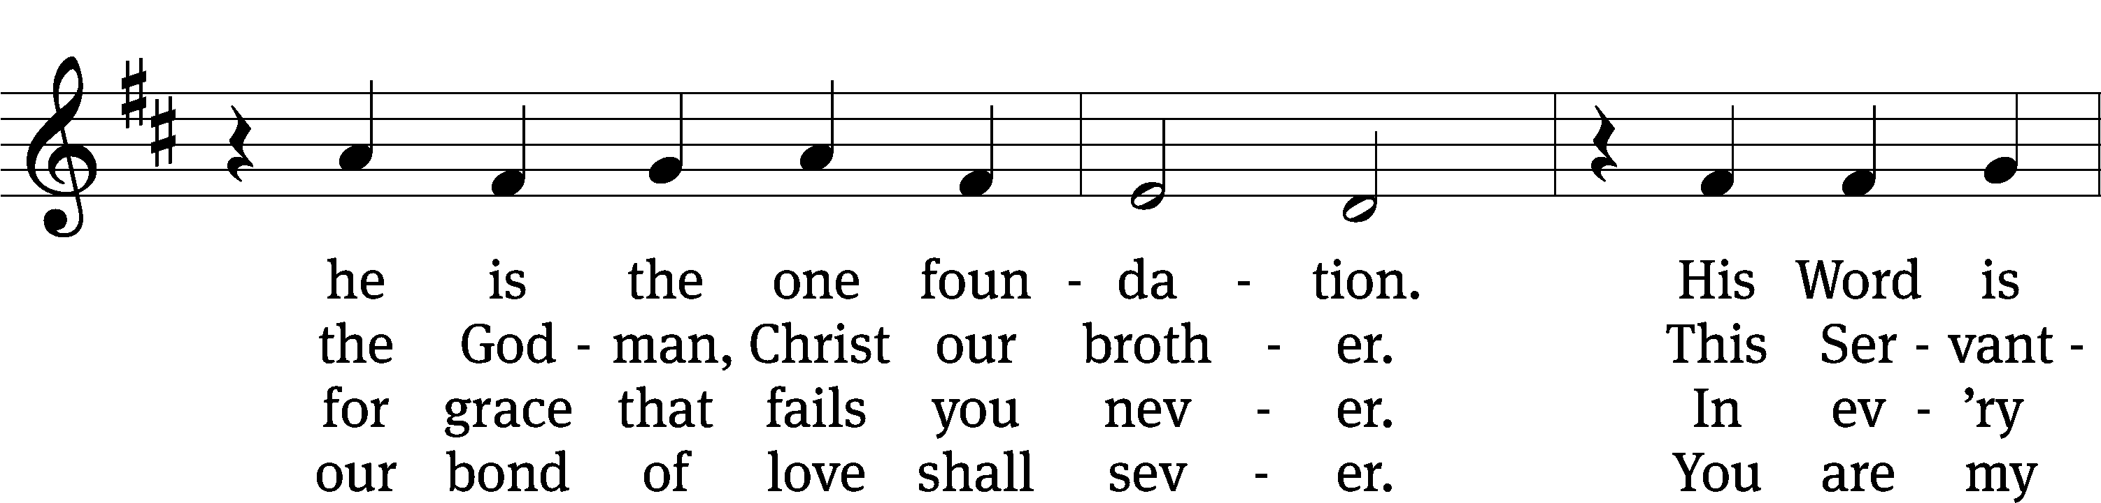
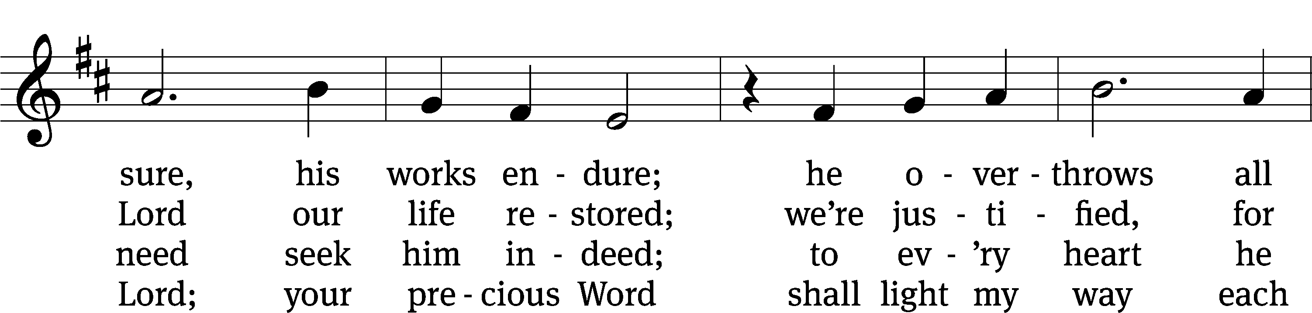
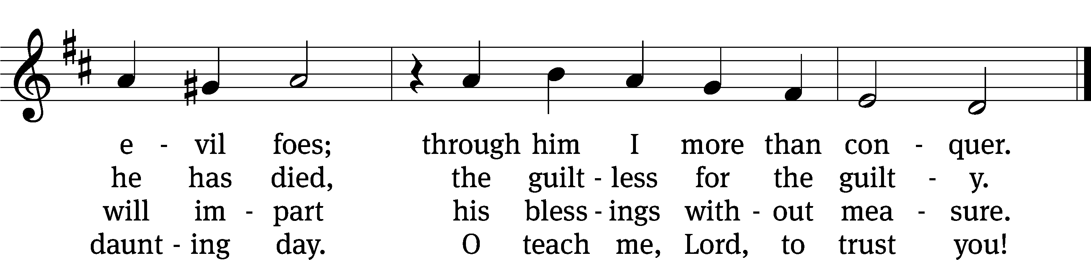
Text: tr. Arthur P. Voss, 1899–1955, alt.; Georg Weissel, 1590–1635, abr.
Tune: Johann Stobäus, 1580–1646
Text: © 1941 Concordia Publishing House. Used by permission: OneLicense no. 727703
Tune: Public domain

Prayer
Blessed Lord, you have given us your Holy Scriptures for our learning. May we so hear them, read, learn, and take them to heart that, being strengthened and comforted by your holy Word, we may cling to the blessed hope of everlasting life; through Jesus Christ our Lord, who lives and reigns with you and the Holy Spirit, one God, now and forever.
Amen.
Lord’s Prayer
Our Father, who art in heaven, hallowed be thy name, thy kingdom come, thy will be done on earth as it is in heaven. Give us this day our daily bread; and forgive us our trespasses, as we forgive those who trespass against us; and lead us not into temptation, but deliver us from evil. For thine is the kingdom and the power and the glory forever and ever. Amen.

Blessing

The Lord bless you and keep you.
The Lord make his face shine on you and be gracious to you.
The Lord look on you with favor and give you peace.
Amen.

Please be seated

748 Brothers, Sisters, Let Us Gladly CW 748
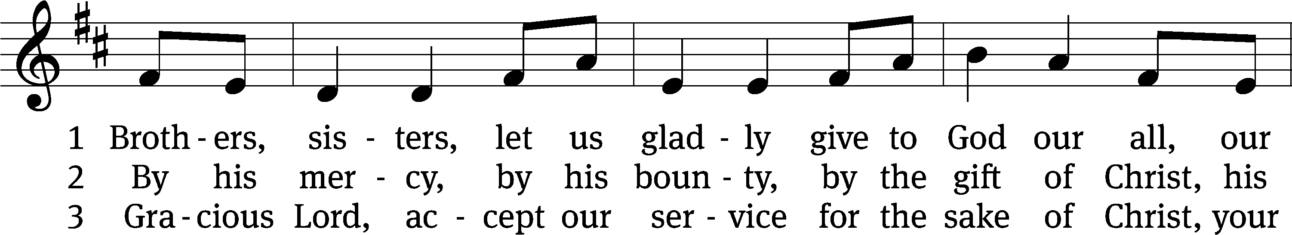
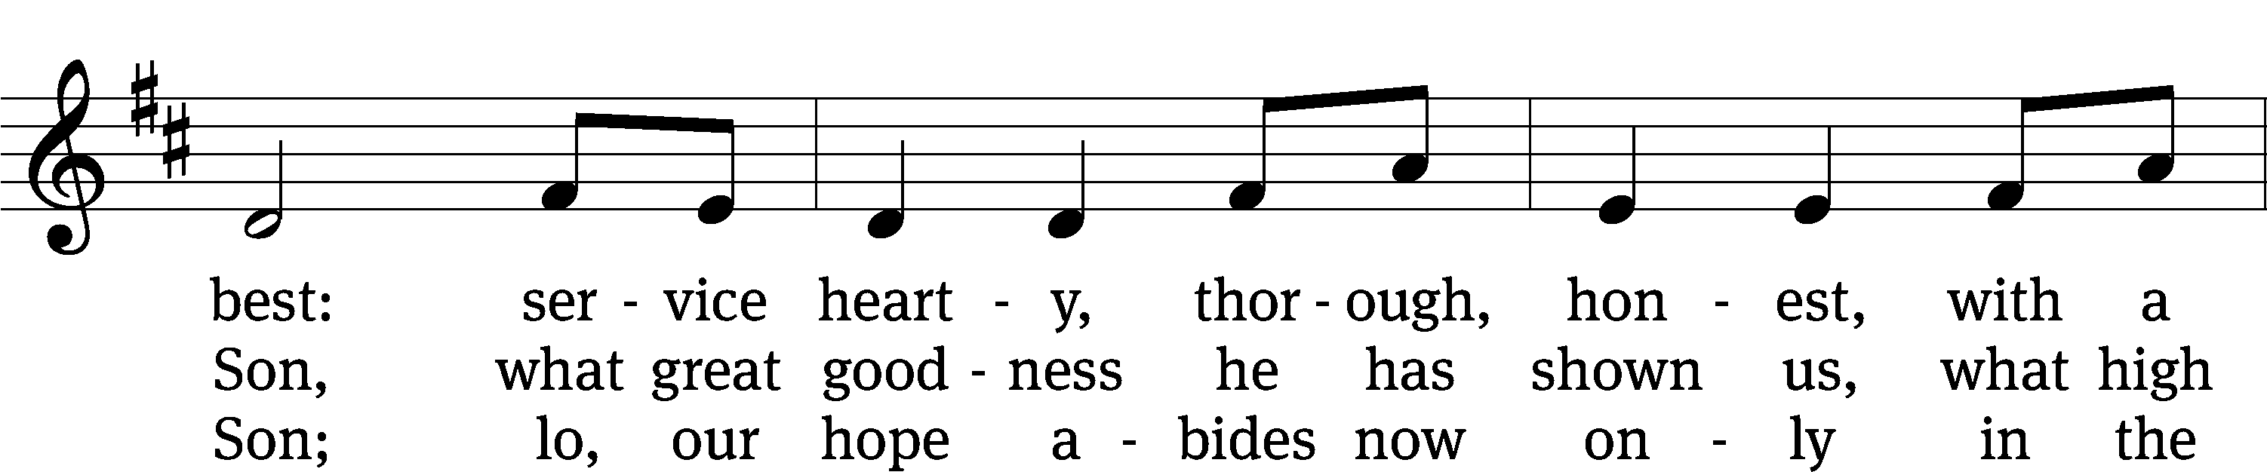
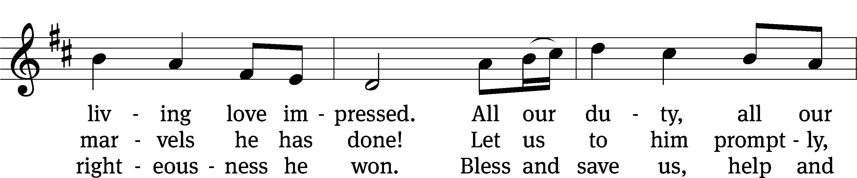
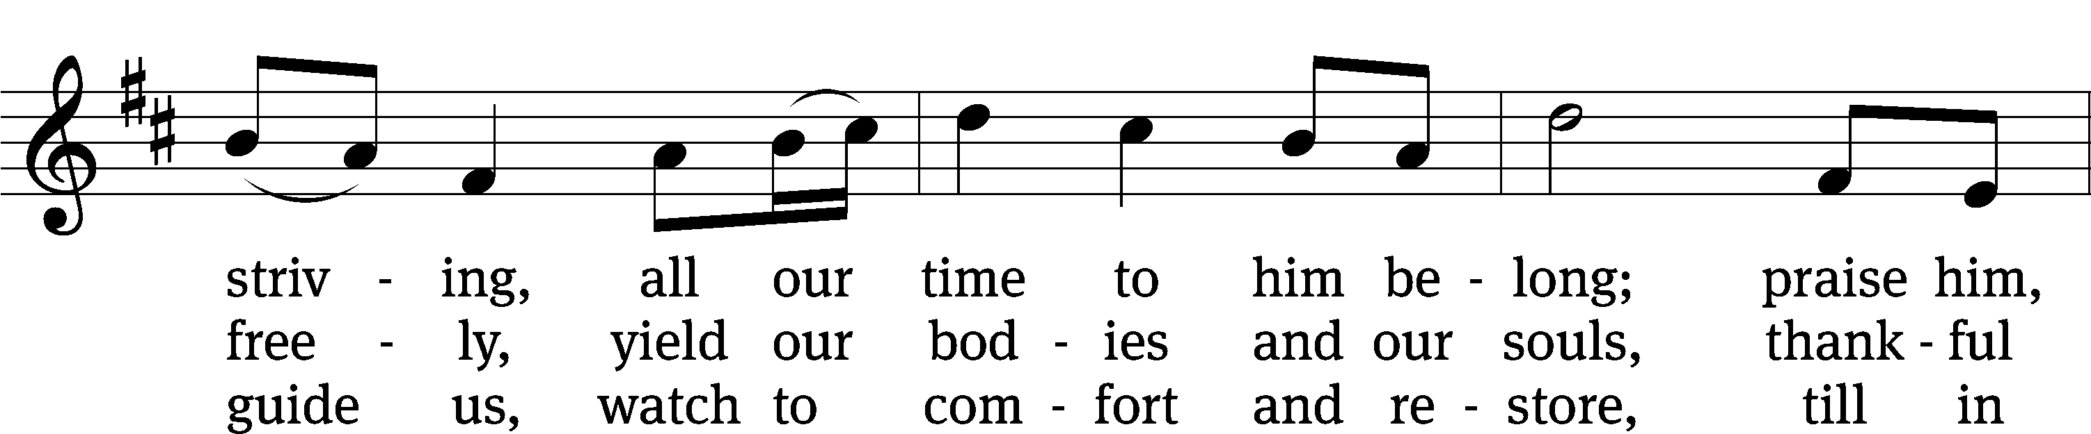
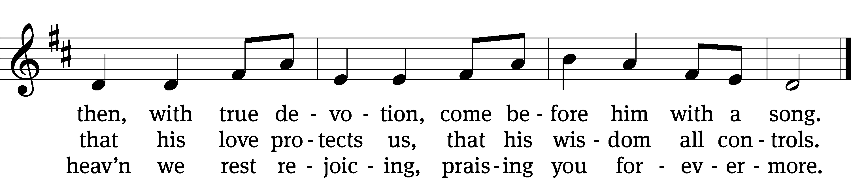
Text: Henry Bateman, 1802–1872
Tune: adapt. William Bradbury, 1816–1868; Repository of Sacred Music, Part Second, Harrisburg, 1813, ed. John Wyeth
Text and tune: Public domain

Acknowledgments
American Hymn Tunes from Christian Worship
Software distributed in partnership with Northwestern Publishing House.
Created by Christian Worship: Service Builder © 2022 Concordia Publishing House.

Serving in Worship
Officiant Pastor Natsis
Organist Marcia Marion Ackling
Deacons (Thursday) Steve Hoeft and Jim Tice
Deacons (Sunday) Jeff Neuburger and Dave Stevenson
Ushers (Thursday) Dale Finkbeiner and Mark Finkbeiner
Ushers (Sunday) Ed Sala and All Whitley
Altar Guild Esther Gross and Diane Stevenson
Videographer Ann Latowski

