THE NINTH SUNDAY
AFTER PENTECOST

TRINITY EVANGELICAL LUTHERAN CHURCH | Saline, Michigan
WELCOME TO WORSHIP August 4/7, 2022
Thank you for joining us in God’s house today! We cordially ask that our Guests sign one of the guestbooks located at either the front or back entryways, or fill out a “Let’s Get Acquainted” card located in the hymnal pew rack and place it in the collection plate.

THANK OFFERING: Members of Trinity give their offering as an expression of love and thankfulness to the Lord and to help support the Lord’s work in our community and around the world. Visitors need not feel obligated to participate in this offering which supports our ministry.

Restrooms are located at the back of the upper level (the annex), and in the basement (down the back stairs of the sanctuary or annex). Handicap access is available, please ask an usher for assistance.

Young Families / Toddler Bags – We are GLAD YOU BROUGHT YOUR CHILDREN to our worship service. Jesus said: “Let the little children come to me and do not hinder them, for the kingdom of God belongs to such as these.” We know that having little children in church can be a challenge, but DO NOT WORRY about it. Many of your fellow worshippers have been in your shoes and are just happy you brought your children with you. For your convenience, we have reserved the back rows of seating for parents with small children. These areas provide more flexibility for your family, as well as, easy access to move downstairs if necessary. A closed-circuit TV system allows families to continue participating in the service while downstairs. Pre-school toddler bags and children’s bulletins are available for their enjoyment. Ask an usher for one to use during the service and please return the toddler bag afterwards.

celebration of holy communion:
In His Word, God makes it clear that the Lord’s Supper is to be shared by people of a common proclamation of faith (1 Corinthians 11:26; 1 Corinthians 10:16-17). Without judging anyone’s hearts, we invite those who share in our confession by their membership in our congregation or another congregation of the Wisconsin Evangelical Lutheran Synod (WELS) or the Evangelical Lutheran Synod (ELS) and who are properly prepared (1 Corinthians 11;27-29) to receive the Sacrament. Page 295 in Christian Worship provides a guide for preparation.
Guests, we would love to have you join us in communion fellowship in the future, and for that to be possible, we ask that you speak with one of the pastors so that we may speak with you on how that would be possible. We thank you for respecting the way we celebrate the Lord’s Supper in our congregations.
the SERVICE – setting one - WITH HOLY COMMUNION CW, page 154

Hymn 811 My Faith looks Up to Thee CW 811
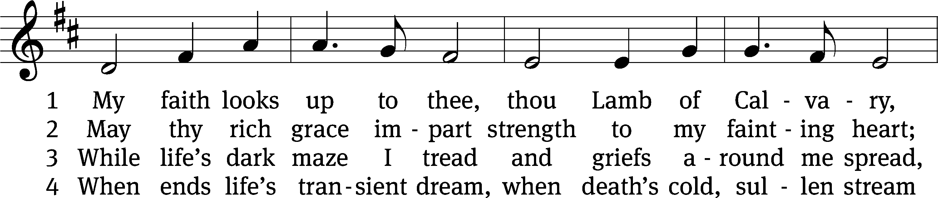
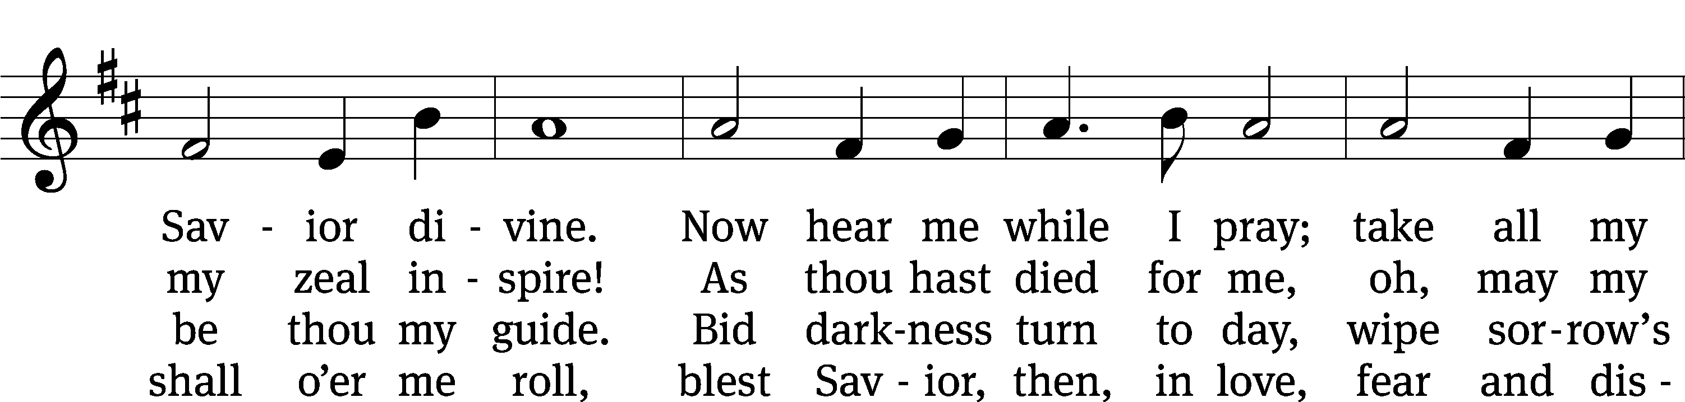
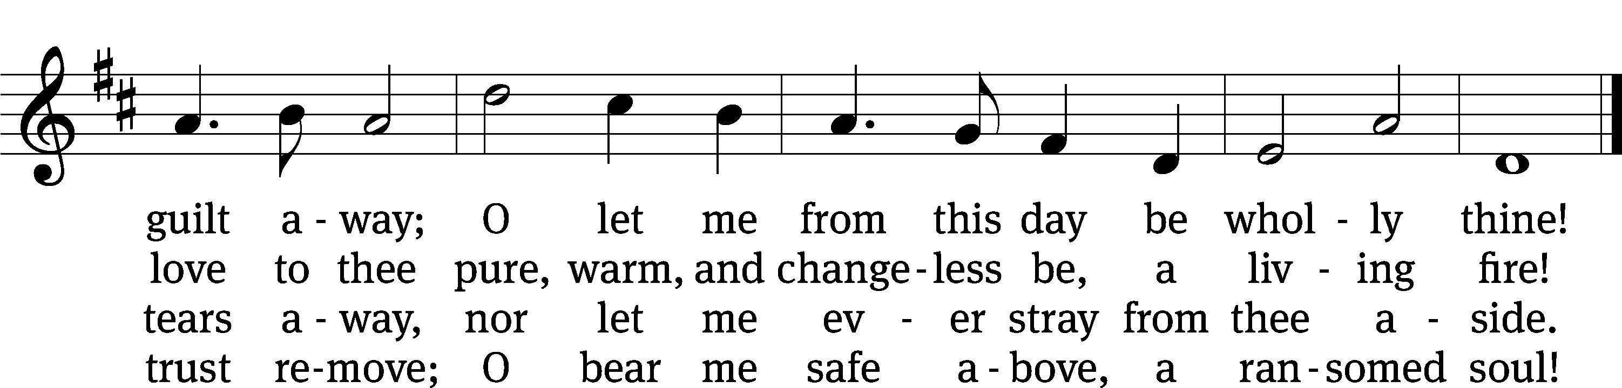
Text: Ray Palmer, 1808–1887
Tune: Lowell Mason, 1792–1872
Text and tune: Public domain

Please stand, if you are able
Invocation
In the name of the Father and of the Son and of the Holy Spirit.
Amen.
Confession
If we claim to be without sin, we deceive ourselves and the truth is not in us.
If we confess our sins, God is faithful and just
and will forgive us our sins
and purify us from all unrighteousness.

Let us confess our sins to the Lord.
Holy God, gracious Father,
I am sinful by nature
and have sinned against you in my thoughts, words, and actions.
I have not loved you with my whole heart;
I have not loved others as I should.
I deserve your punishment both now and forever.
But Jesus, my Savior, paid for my sins
with his innocent suffering and death.
Trusting in him, I pray: God, have mercy on me, a sinner.

Our gracious Father in heaven has been merciful to us. He sent his only Son, Jesus Christ, who gave his life as the atoning sacrifice for the sins of the whole world. Therefore, as a called servant of Christ and by his authority, I forgive you all your sins in the name of the Father and of the Son and of the Holy Spirit.
Amen.

Lord, Have Mercy

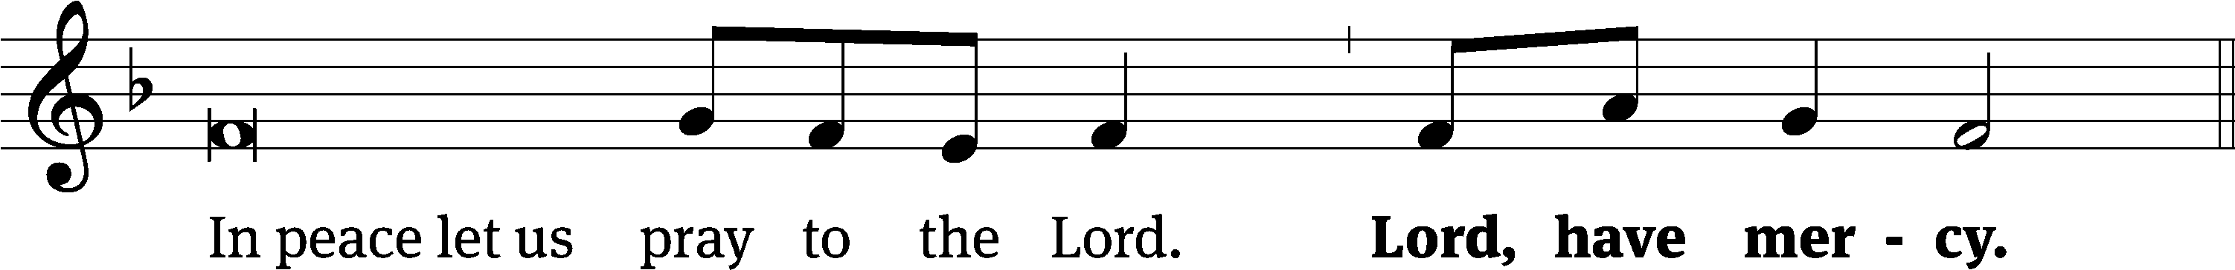
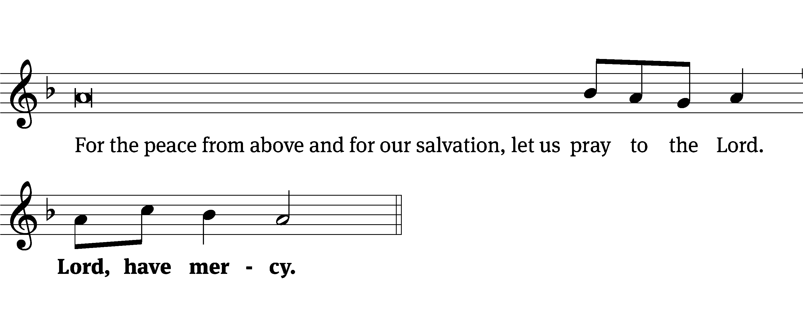
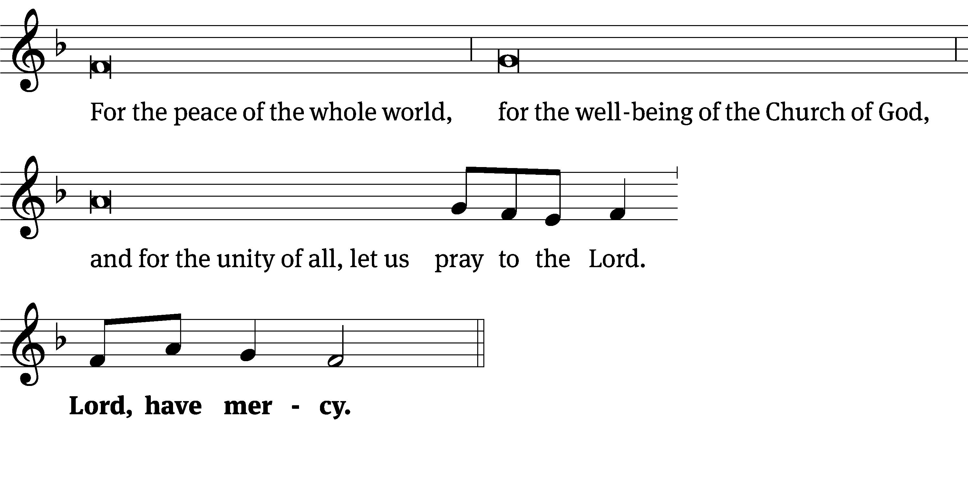
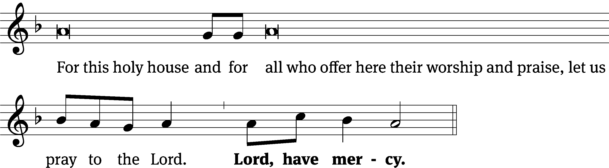
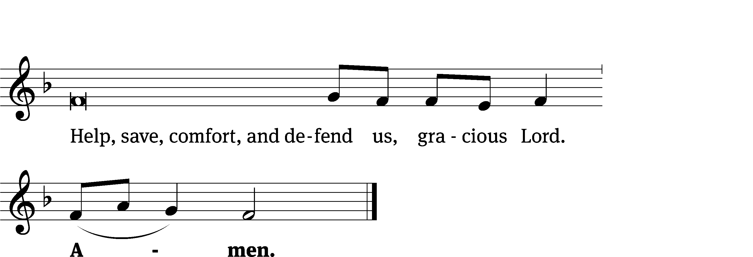
Tune: Kevin Becker
Tune: © 2021 Northwestern Publishing House. Used by permission: OneLicense no. 727703

Glory Be to God CW 157
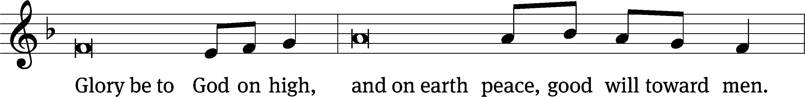
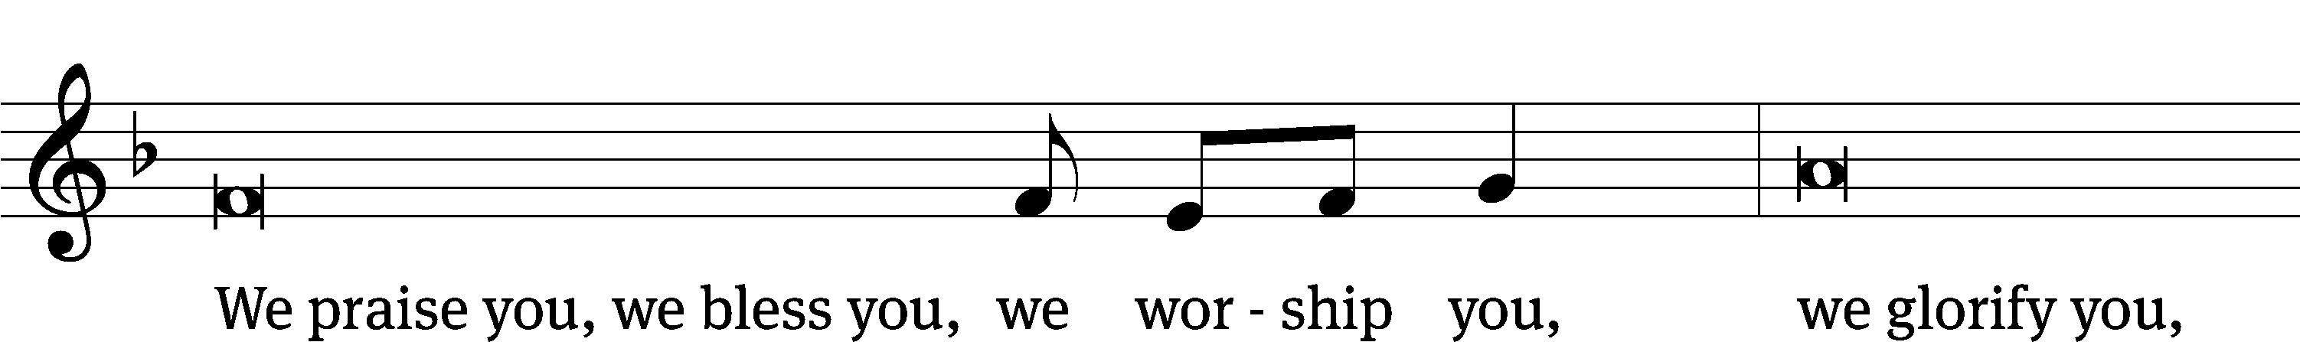
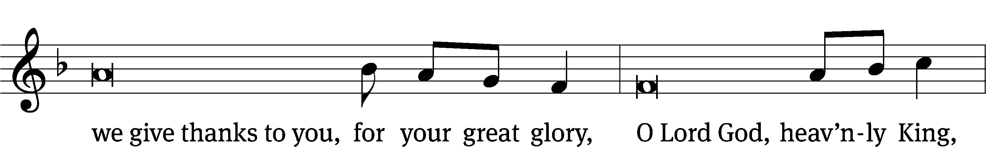
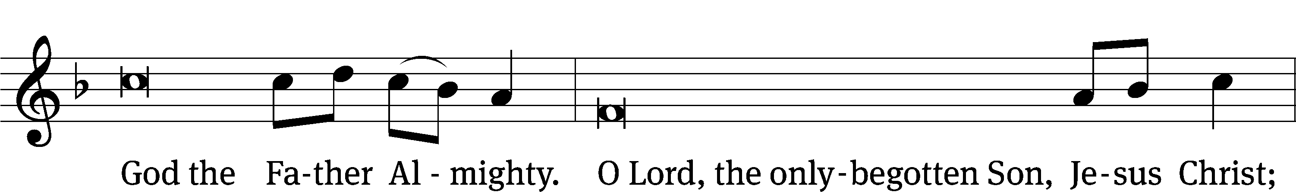
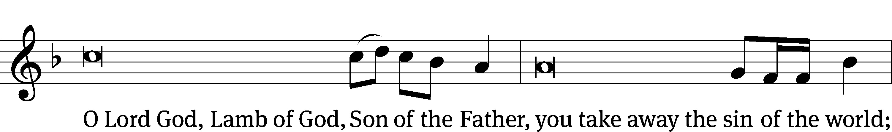
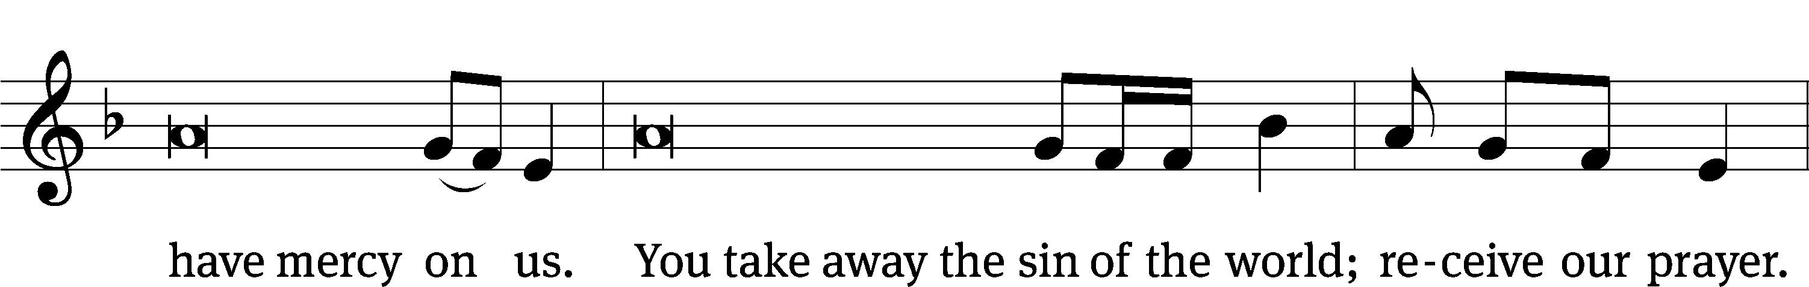
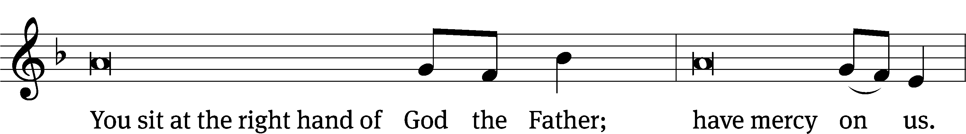
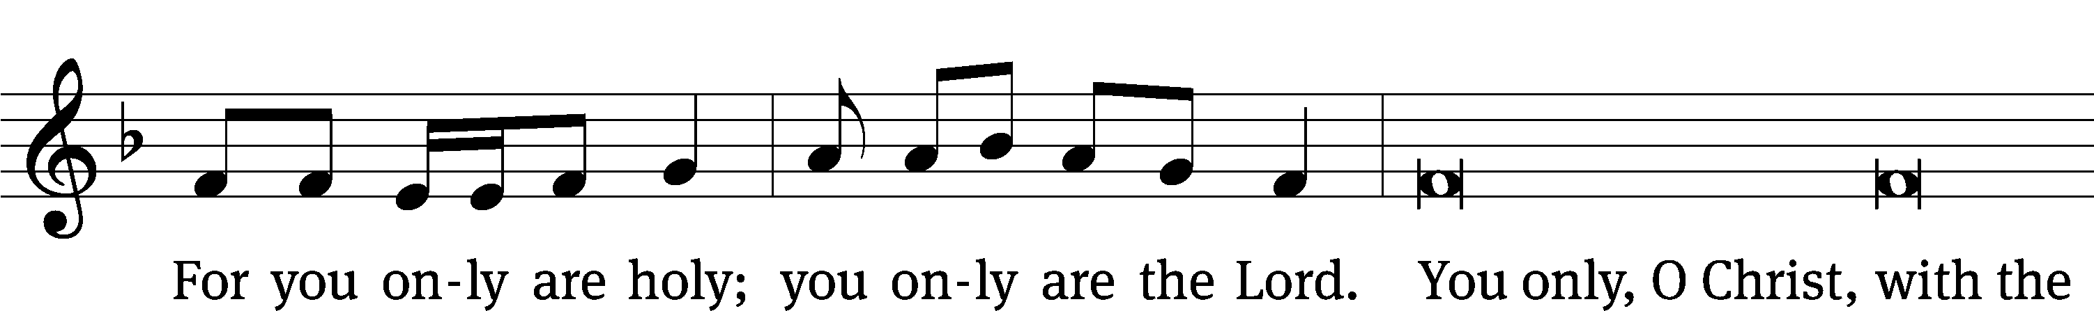
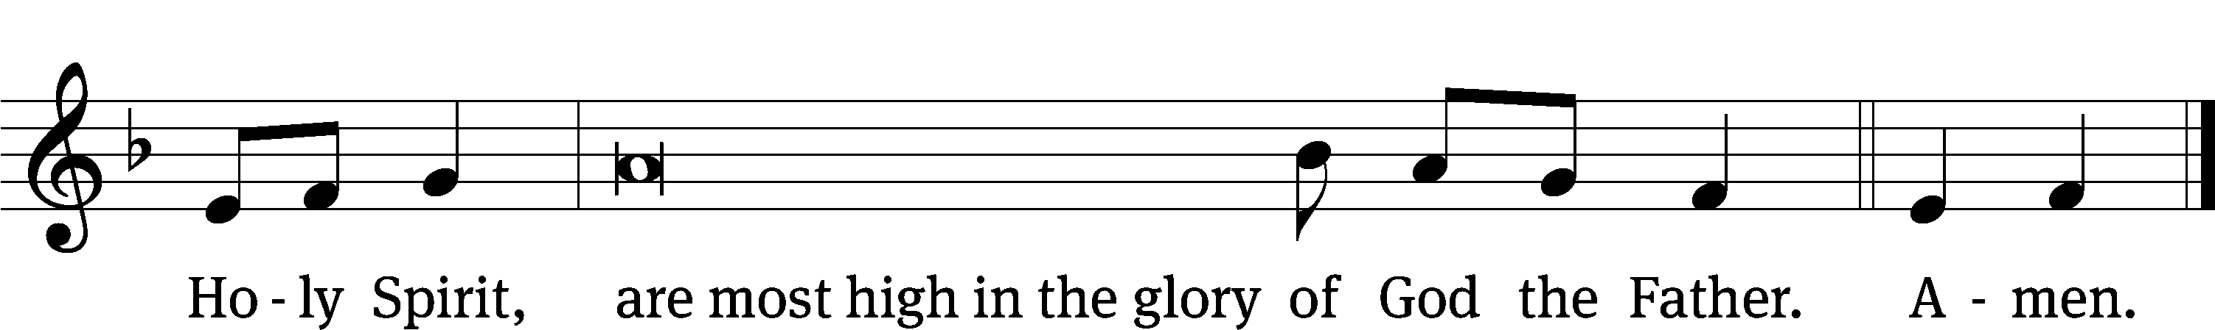

The Lord be with you.
And also with you.
Prayer of the Day
Let us pray.

Almighty and everlasting God, you are always more ready to hear than we to pray and willing to give far more than we either desire or deserve. Pour upon us the abundance of your mercy, forgiving us those things of which our conscience is afraid, and giving us those good things for which we are not worthy to ask except through the merits and mediation of your Son, Jesus Christ our Lord, who lives and reigns with you and the Holy Spirit, one God, now and forever.
Amen.

Please be seated

First Reading Genesis 15:1-6
¹ After these events the word of the Lord came to Abram in a vision. He said, “Do not be afraid, Abram. I am your shield, your very great reward.”
² Abram said, “Lord God^{[a]} what can you give me, since I remain childless, and the one who will inherit my estate is Eliezer of Damascus?” ³ Abram also said, “Look, you have given me no offspring, so a servant born in my house will be my heir.”
⁴ Just then, the word of the Lord came to him. God said, “This man will not be your heir, but instead one who will come out of your own body will be your heir.” ⁵ The Lord then brought him outside and said, “Now look toward the sky and count the stars, if you are able to count them.” He said to Abram, “This is what your descendants will be like.” ⁶ Abram believed in the Lord, and the Lord credited it to him as righteousness.

The Word of the Lord.
Thanks be to God.

121D Keep Me as the Apple of Your Eye Psalm 121D
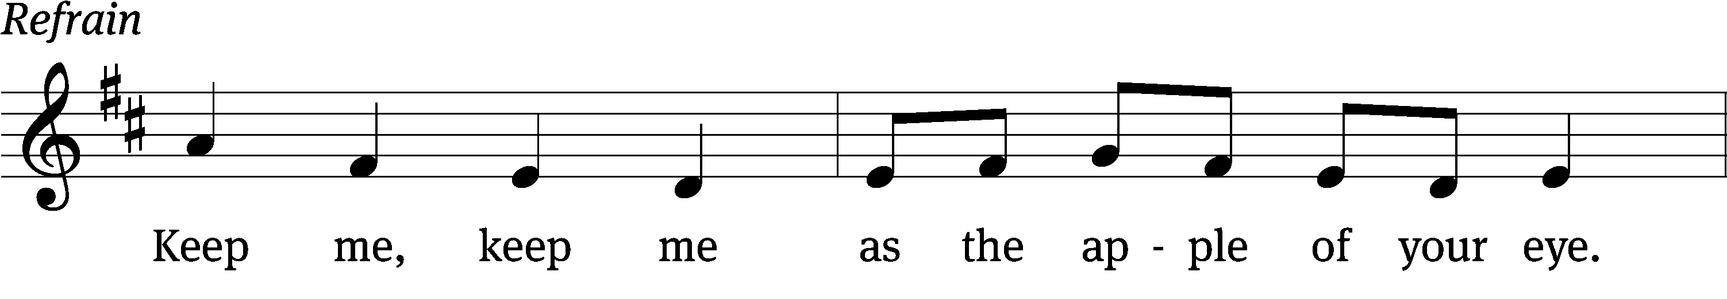
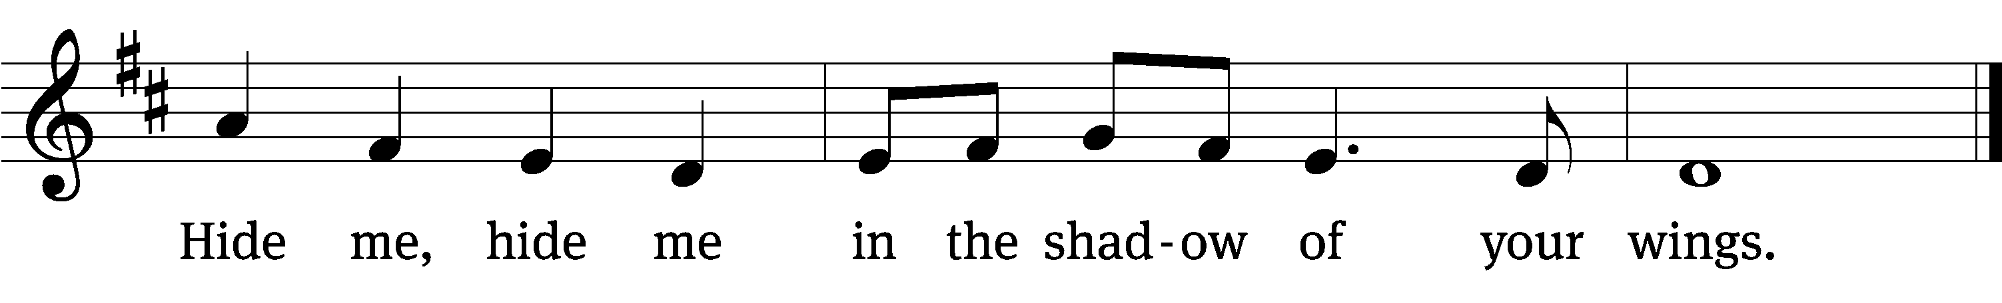

I lift up my eyes to the / mountains—
where does my help / come from?
My help comes / from the Lord,
the maker of heav- / en and earth.
He will not let your / foot slip—
he who watches over you will not / slumber;
indeed, he who watches over / Israel
will neither slum- / ber nor sleep. Refrain

The Lord watches / over you—
the Lord is your shade at / your right hand;
the sun will not harm / you by day,
nor the / moon by night.
The Lord will keep you / from all harm—
he will watch o- / ver your life;
the Lord will watch over your coming and / going
both now and for- / evermore.
Glory be to the Father and / to the Son
and to the Holy / Spirit,
as it was in the be- / ginning,
is now, and will be forever. / Amen. Refrain
Tune: Jane Marshall
Tune: © 1986 Choristers Guild. Used by permission: OneLicense no. 727703
Setting: © 1993 Kermit G. Moldenhauer, admin. Northwestern Publishing House. Used by permission: OneLicense no. 727703

Second Reading Hebrews 11:1-3:8-16
¹ Faith is being sure about what we hope for, being convinced about things we do not see. ² For by this faith the ancients were commended in Scripture.
³ By faith we know that the universe was created by God’s word, so that what is seen did not come from visible things.
⁸ By faith Abraham obeyed when he was called to go to a place that he was going to receive as an inheritance, and he left without knowing where he was going.
⁹ By faith he lived as a stranger in the Promised Land, as if it did not belong to him, dwelling in tents along with Isaac and Jacob, who were heirs with him of the same promise. ¹⁰ For he was looking forward to the city that has foundations, whose architect and builder is God.
¹¹ By faith Abraham also received the ability to conceive children, even though Sarah herself was barren and he was past the normal age, because he considered him faithful who made the promise. ¹² And so from one man, and he as good as dead, descendants were born as numerous as the stars in the sky and as countless as the sand along the seashore.
¹³ One by one, all of these died in faith, without having received the things that were promised, but they saw and welcomed them from a distance. They confessed that they were strangers and pilgrims on the earth. ¹⁴ Indeed, people who say things like that make it clear that they are looking for a land of their own. ¹⁵ And if they were remembering the land they had come from, they would have had an opportunity to return. ¹⁶ Instead, they were longing for a better land—a heavenly one. For that reason, God is not ashamed to be called their God, because he prepared a city for them.

The Word of the Lord.
Thanks be to God.

Please stand, if you are able

Gospel Acclamation Luke 12:32
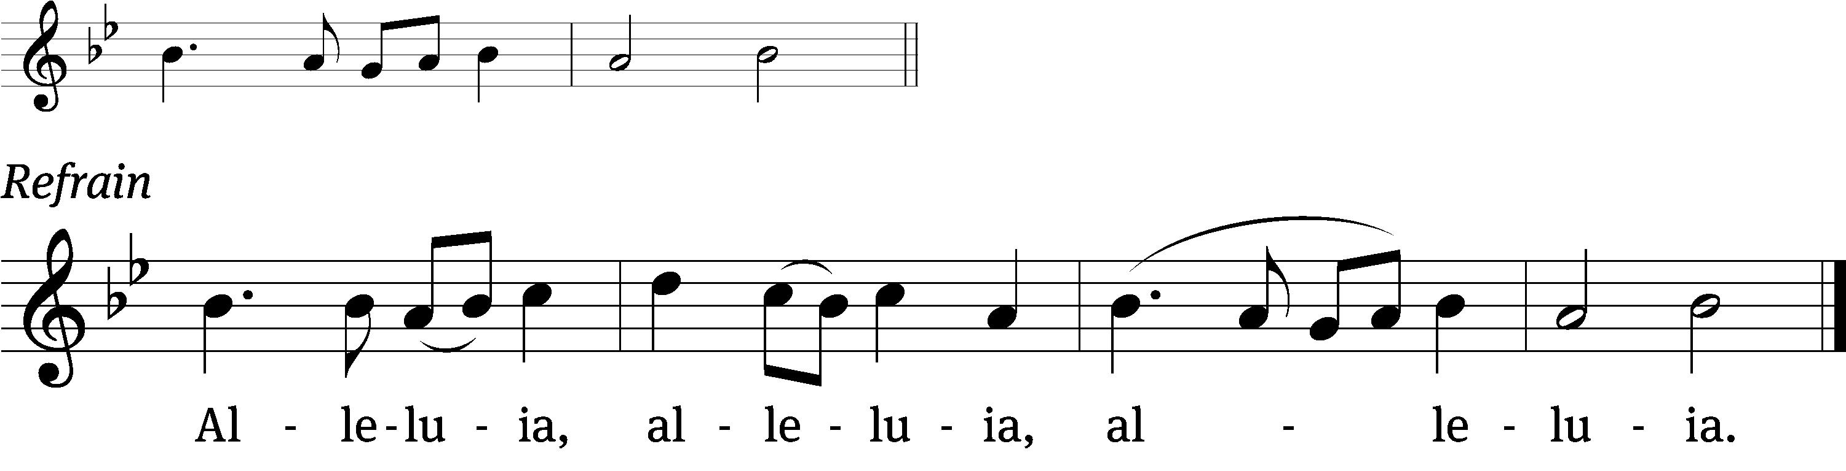
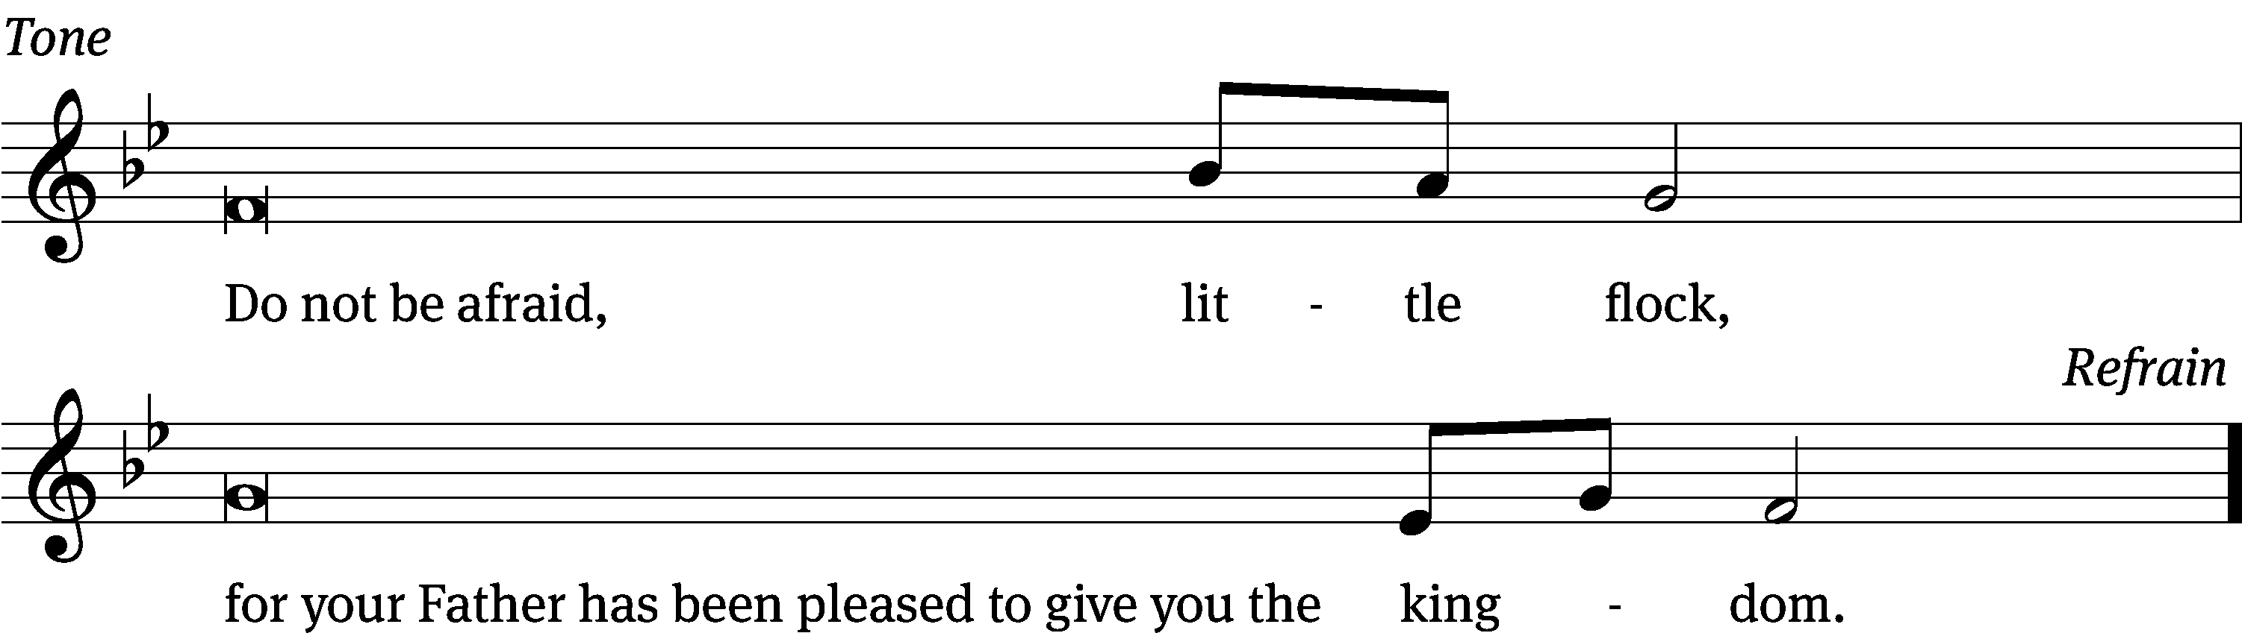
Tune: © 2021 Northwestern Publishing House. Used by permission: OneLicense no. 727703

Gospel Luke 12:22-34
²² Jesus said to his disciples, “For that reason I tell you, stop worrying about your life, about what you will eat, or about your body, what you will wear. ²³ Certainly life is more than food, and the body is more than clothing. ²⁴ Consider the ravens: They do not sow or reap; they have no warehouse or barn; and yet God feeds them. How much more valuable are you than birds! ²⁵ And who of you by worrying can add a single moment to his lifespan? ²⁶ Since you are not able to do this little thing, why do you worry about the rest? ²⁷ Consider how the wild flowers grow. They do not labor or spin. But I tell you, not even Solomon in all his glory was dressed like one of these. ²⁸ If this is how God clothes the grass in the field, which is alive today and tomorrow is thrown into the furnace, how much more will he clothe you, you of little faith? ²⁹ Do not constantly chase after what you will eat or what you will drink. Do not be worried about it. ³⁰ To be sure, the nations of the world chase after all of these things, but your Father knows that you need them. ³¹ Instead, continue to seek the kingdom of God, and all these things will be added to you. ³² Do not be afraid, little flock, because your Father is pleased to give you the kingdom. ³³ Sell your possessions and give to the needy. Provide money bags for yourselves that do not become old, a treasure in the heavens that will not fail, where no thief comes near and no moth destroys. ³⁴ For where your treasure is, there your heart will be also.

The Gospel of the Lord.
Praise be to you, O Christ!
Please be seated

Hymn 830 We Walk by Faith CW 830
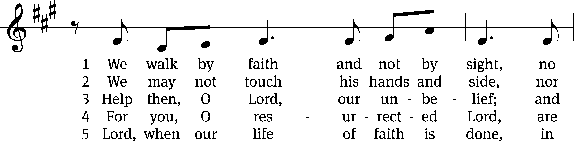
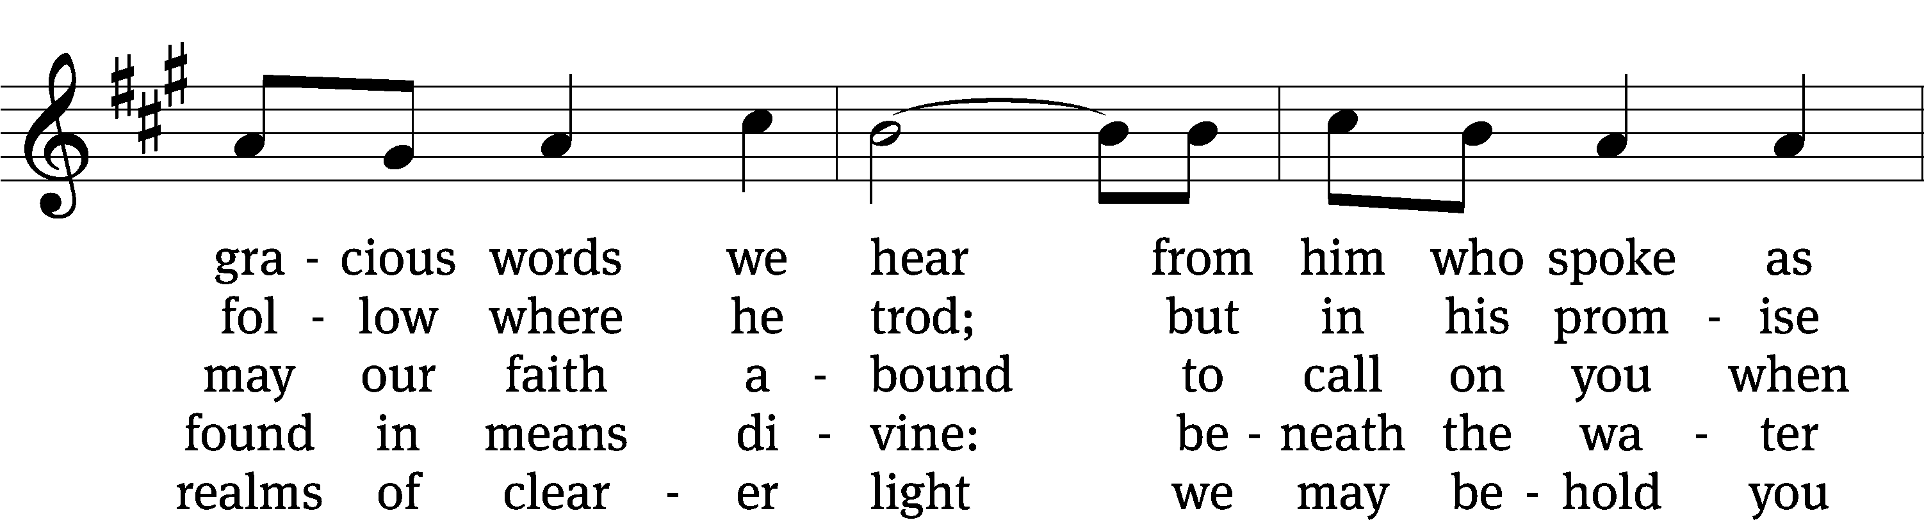
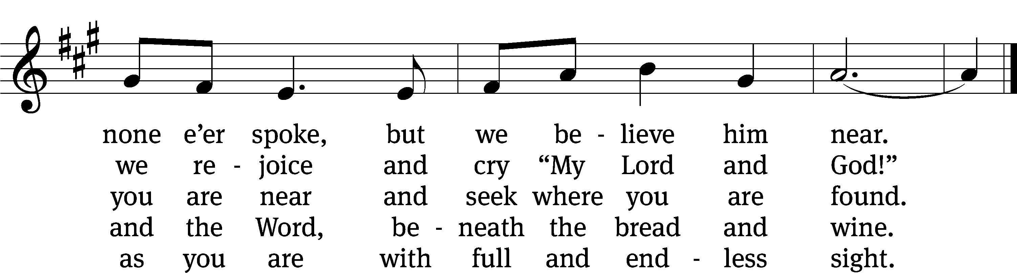
Text: Henry Alford, 1810–1871, alt.
Tune: Marty Haugen, b. 1950
Text: Public domain
Tune: © 1984, 2006 GIA Publications, Inc. Used by permission: OneLicense no. 727703

SERMON Hebrews 11
“By Faith (State Your Name)”

Please stand, if you are able
Nicene Creed
We believe in one God, the Father, the Almighty,
maker of heaven and earth,
of all that is,
seen and unseen.
We believe in one Lord, Jesus Christ, the only Son of God,
eternally begotten of the Father,
God from God, Light from Light, true God from true God,
begotten, not made,
of one being with the Father.
Through him all things were made.
For us and for our salvation, he came down from heaven,
was incarnate of the Holy Spirit and the Virgin Mary,
and became truly human.
For our sake he was crucified under Pontius Pilate.
He suffered death and was buried.
On the third day he rose again in accordance with the Scriptures.
He ascended into heaven
and is seated at the right hand of the Father.
He will come again in glory to judge the living and the dead,
and his kingdom will have no end.
We believe in the Holy Spirit,
the Lord, the giver of life,
who proceeds from the Father and the Son,
who in unity with the Father and the Son
is worshiped and glorified,
who has spoken through the prophets.
We believe in one holy Christian and apostolic Church.
We acknowledge one baptism for the forgiveness of sins.
We look for the resurrection of the dead
and the life of the world to come. Amen.
Offertory
Prayer of the Church

The Sacrament
Preface CW 165
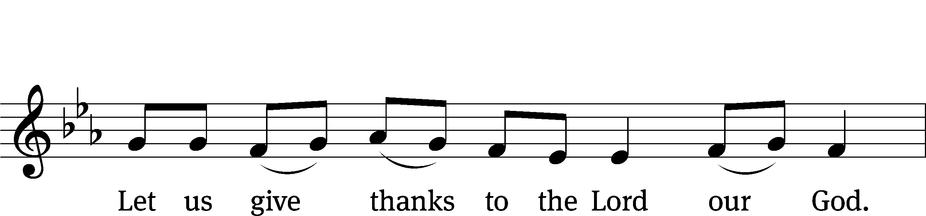
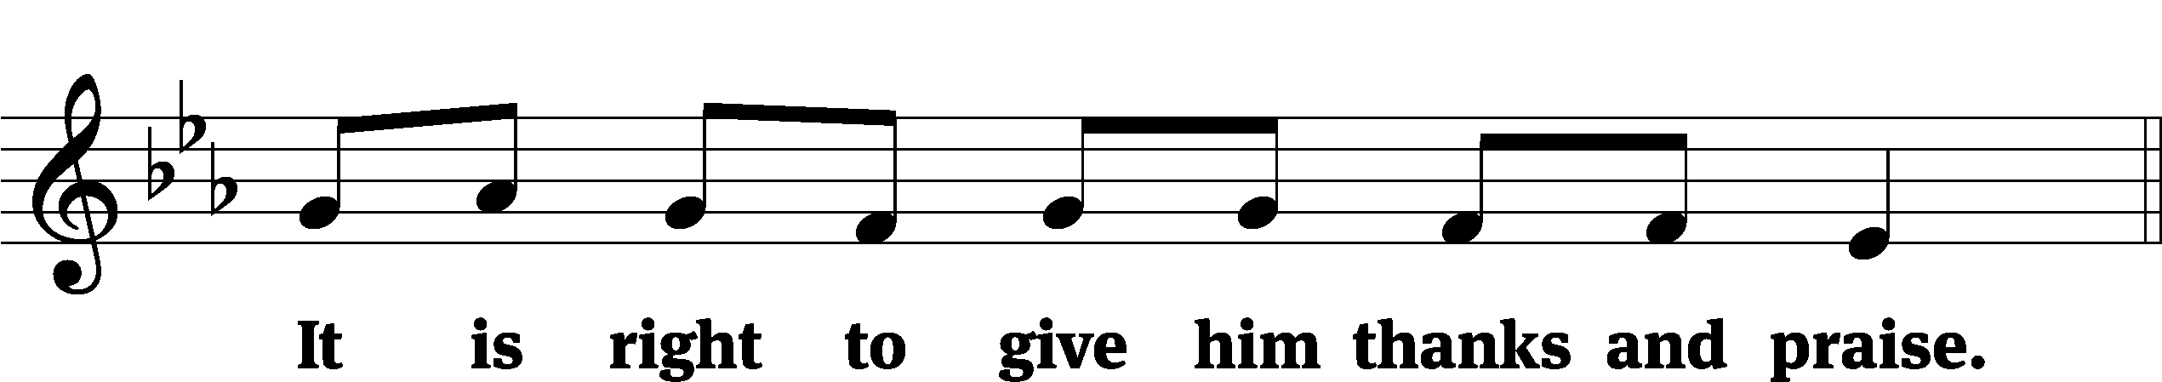

It is truly good and right that we should at all times and in all places give you thanks, O Lord, holy Father, almighty and everlasting God, through Jesus Christ our Lord, who promised that wherever two or three come together in his name, there he is with them to shepherd his flock until he comes again in glory. Therefore, with all the saints on earth and hosts of heaven, we praise your holy name and join their glorious song:

Holy, Holy, Holy CW 167
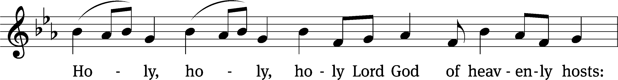
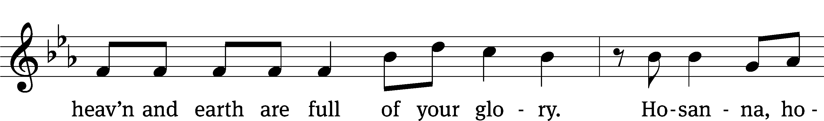
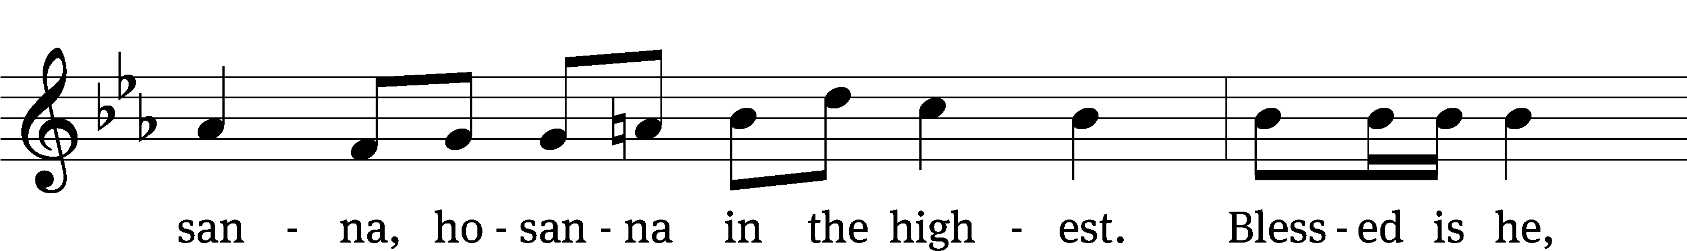
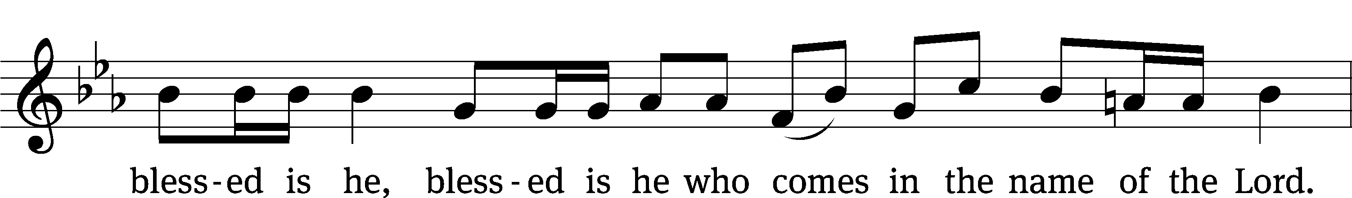
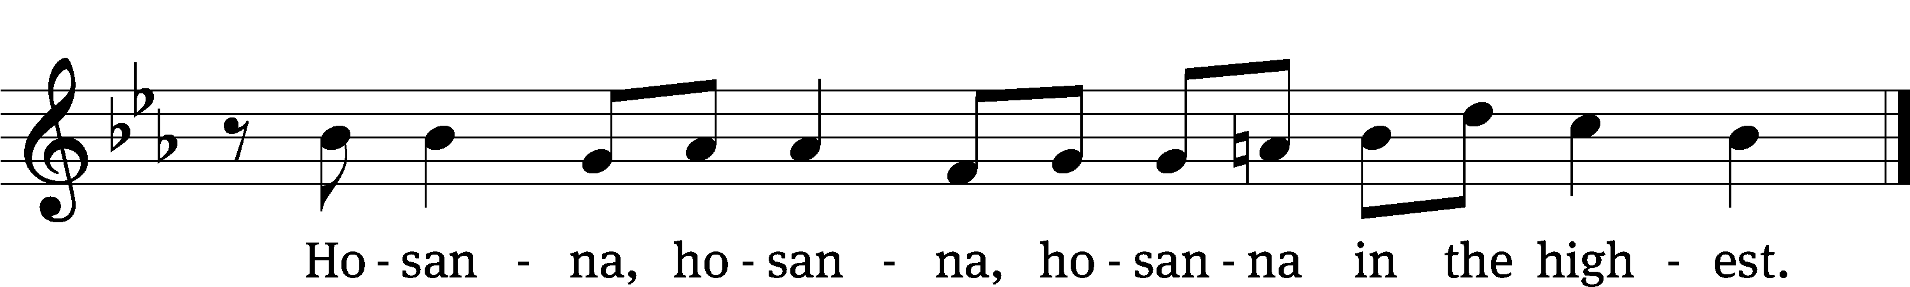

Prayer of Thanksgiving
We give thanks to you, O God, through your dear Son, Jesus Christ, whom you sent to be our Savior, our Redeemer, and the messenger of your grace. Through him you made all things; in him you are well pleased. He is the incarnate Word, conceived by the Holy Spirit and born of the Virgin Mary. To fulfill your promises, he stretched out his hands on the cross and released from eternal death all who believe in you.

As we remember Jesus’ death and resurrection, we thank you that you have gathered us together to receive your Son’s body and blood. Send us your Spirit, unite us as one, and strengthen our faith so that we may praise you in your Son, Jesus Christ. Through him, we glorify and honor you, O God our Father, with the Holy Spirit, one God, now and forever.
Amen.

Lord’s Prayer
Our Father, who art in heaven, hallowed be thy name, thy kingdom come, thy will be done on earth as it is in heaven. Give us this day our daily bread; and forgive us our trespasses, as we forgive those who trespass against us; and lead us not into temptation, but deliver us from evil. For thine is the kingdom and the power and the glory forever and ever. Amen.

Words of Institution
Our Lord Jesus Christ, on the night he was betrayed, took bread; and when he had given thanks, he broke it and gave it to his disciples, saying, “Take and eat; this is my body, which is given for you. Do this in remembrance of me.”
Then he took the cup, gave thanks, and gave it to them, saying, “Drink from it, all of you; this is my blood of the new covenant, which is poured out for you for the forgiveness of sins. Do this, whenever you drink it, in remembrance of me.”

The peace of the Lord be with you always.
Amen.
O Christ, Lamb of God CW 169
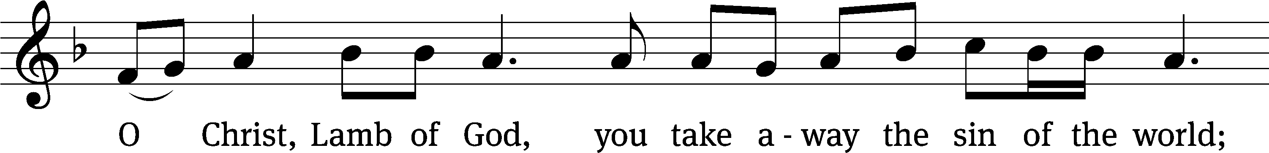
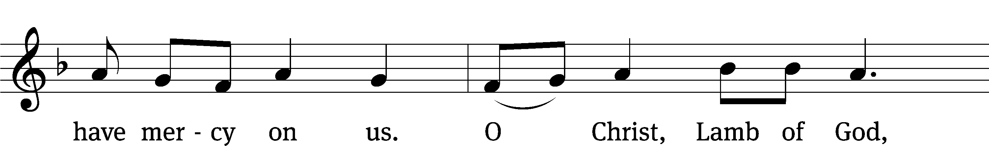
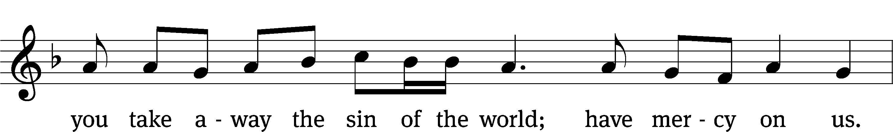
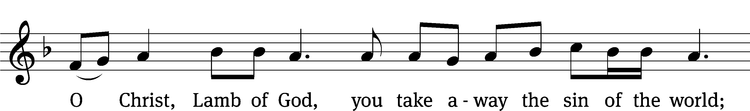
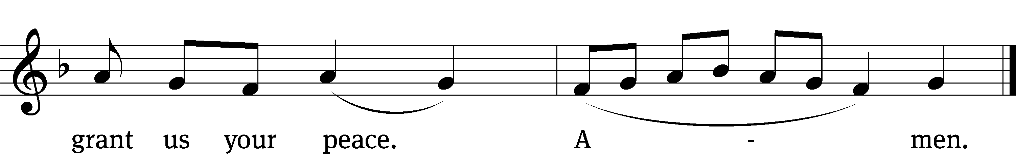
Please be seated
Distribution Hymn CW 816
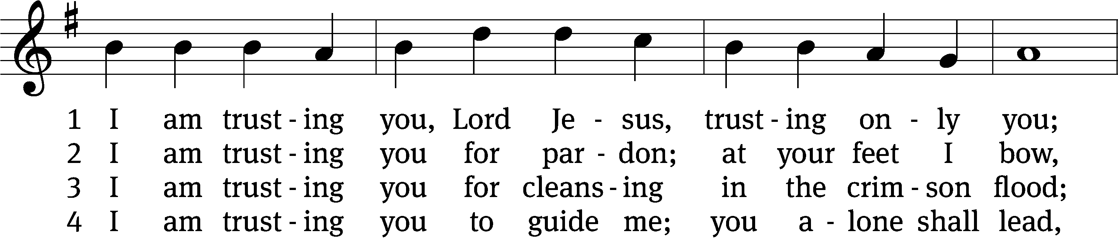
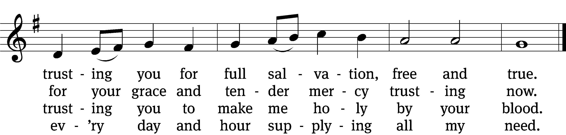

5 I am trusting you for power;
you can never fail.
Words which you yourself shall give me
must prevail.

6 I am trusting you, Lord Jesus;
never let me fall.
I am trusting you forever
and for all.
Text: Frances R. Havergal, 1836–1879, alt.
Tune: Henry W. Baker, 1821–1877
Text and tune: Public domain

Distribution Hymn 797 CW 797
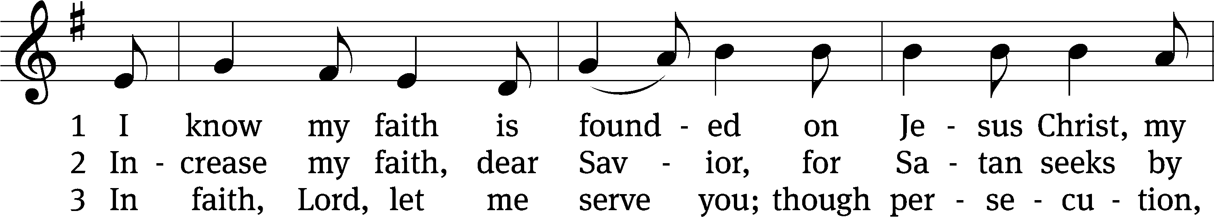
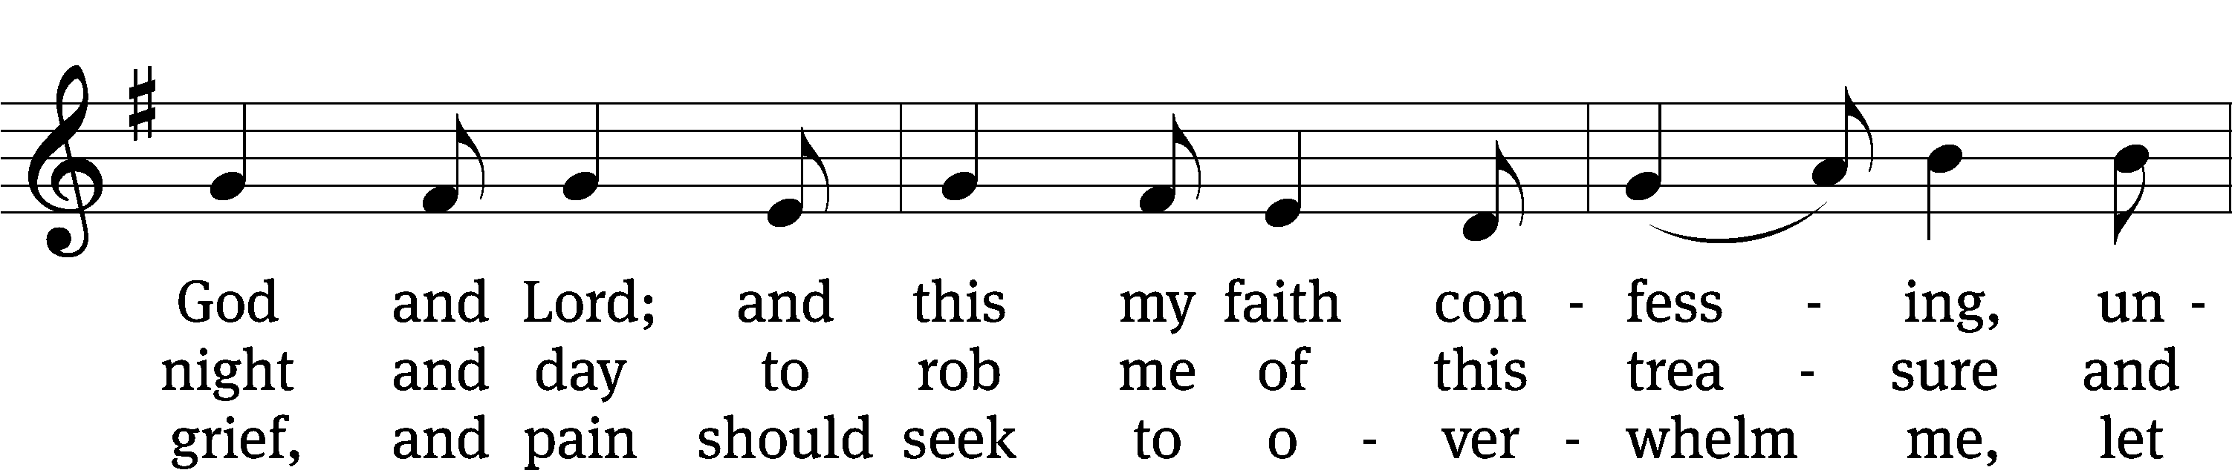
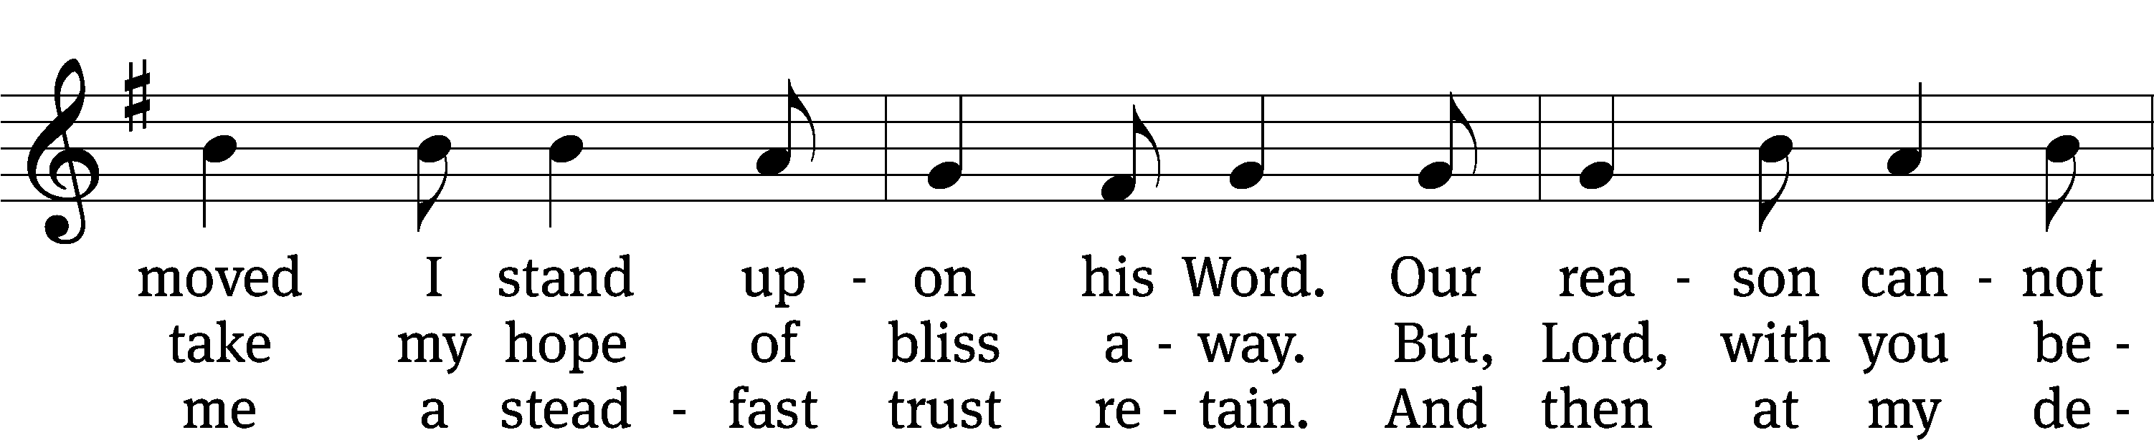
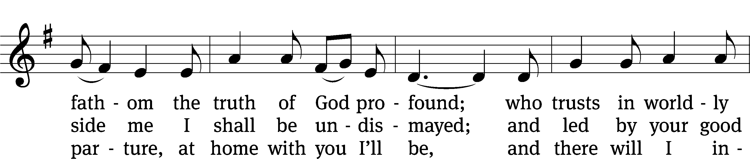
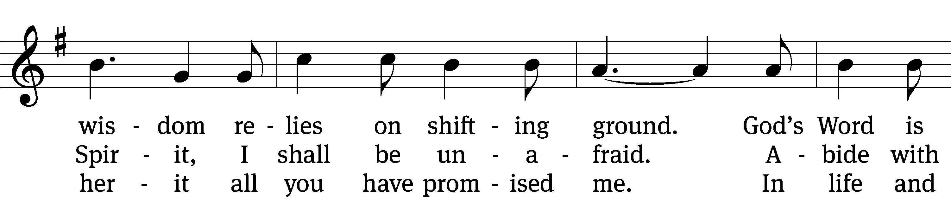
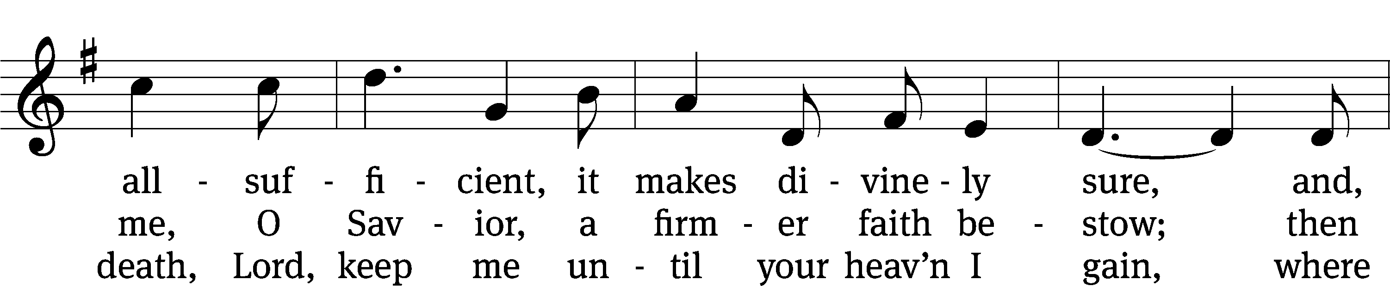
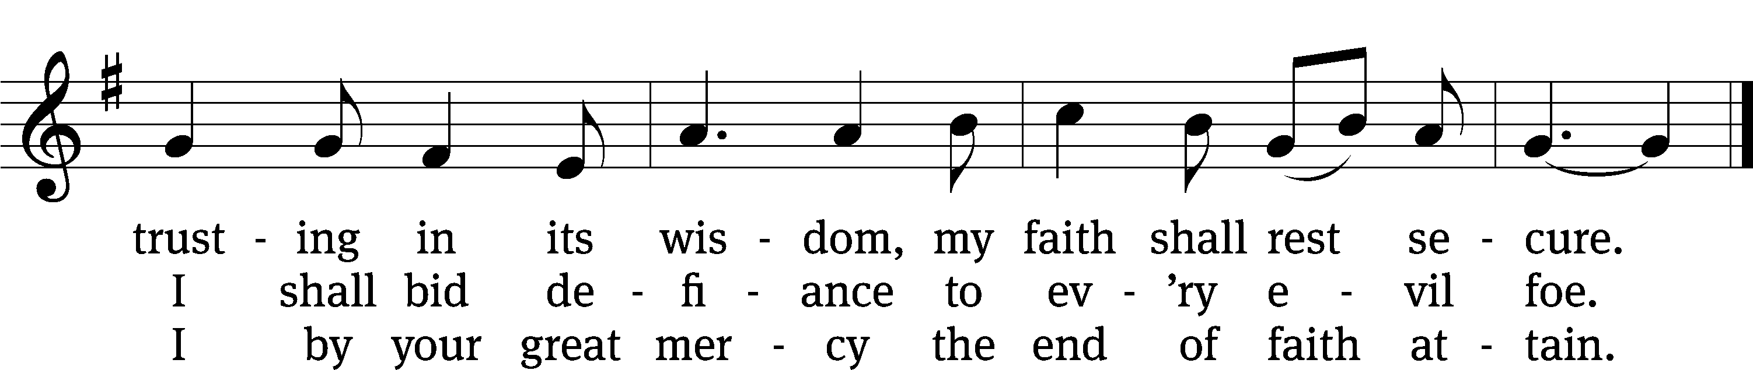
Text: tr. The Lutheran Hymnal, 1941, alt.; Erdmann Neumeister, 1671–1756
Tune: Concentus novi, Augsburg, 1540, ed. Johann Kugelmann
Text and tune: Public domain

Please stand, if you are able

Give thanks to the Lord, for he is good;
his mercy endures forever.
Whenever we eat this bread and drink this cup,
we proclaim the Lord’s death until he comes.

We give thanks, almighty God, that you have refreshed us with this saving gift. We pray that through it you will strengthen our faith in you and increase our love for one another. We ask this in the name of Jesus Christ our Lord, who lives and reigns with you and the Holy Spirit, one God, now and forever.
Amen.

Blessing
The Lord bless you and keep you.
The Lord make his face shine on you and be gracious to you.
The Lord look on you with favor and give you peace.
Amen.

Please be seated

Hymn 803 Day by Day CW 803
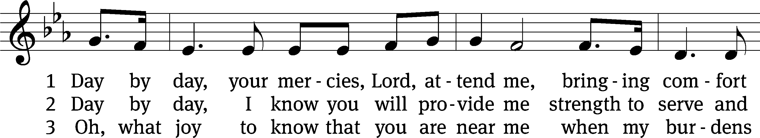
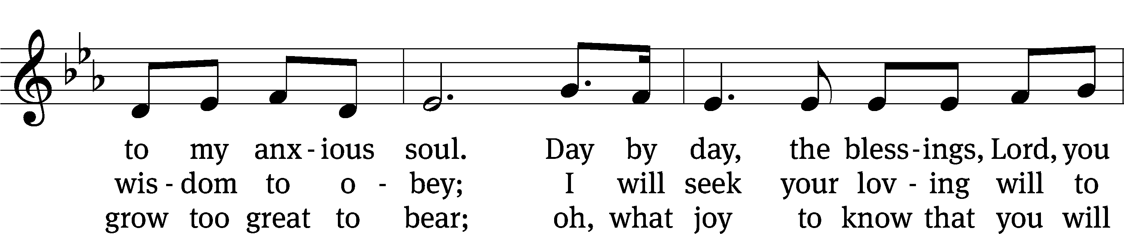
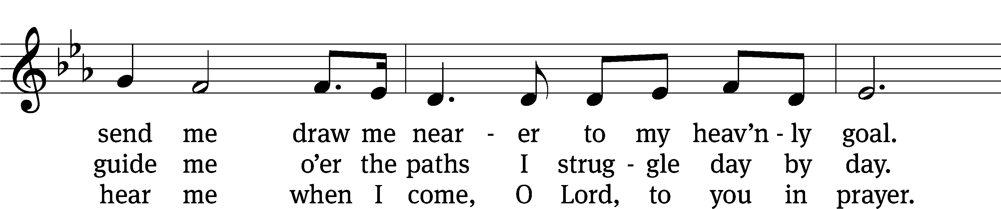
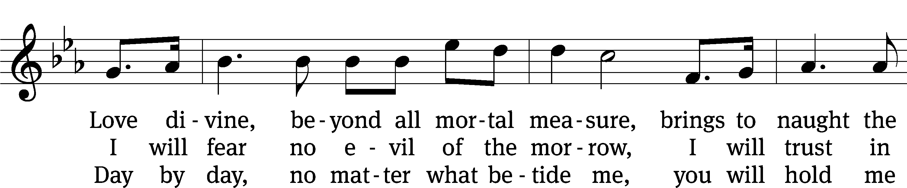
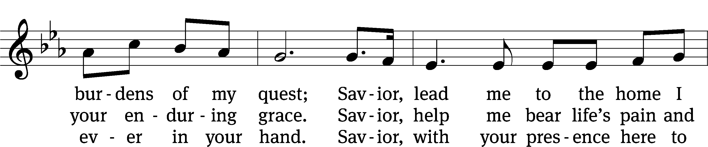
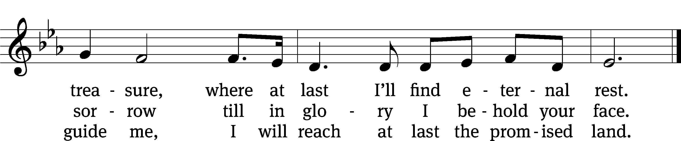
Text: tr. Robert Leaf, 1936–2005; Carolina Sandell Berg, 1832–1903
Tune: Oskar Ahnfelt, 1813–1882
Text: © 1992 Augsburg Fortress. Used by permission: OneLicense no. 727703
Tune: Public domain

Acknowledgments
Setting One from Christian Worship
Software distributed in partnership with Northwestern Publishing House.
Created by Christian Worship: Service Builder © 2022 Concordia Publishing House.

Serving in Worship
Officiant Pastor Natsis
Organist Ann Hoeft
Deacons (Thursday) Steve Hoeft and Dave Frey
(Sunday) Dave Stevenson and Ed Wheeler
Ushers (Thursday) Dale Radak
(Sunday) Ron Zahn
Altar Guild Scott Ackling and Maria Marion Ackling
Videographer Jake Vershum

